2023688030 Mehmet Akif EROL
Goruntu isleme 1.odev
import cv2
import matplotlib.pyplot as plt

resim = cv2.imread("blackeagle.jpg")
resim = cv2.cvtColor(resim, cv2.COLOR_BGR2RGB)

resim[50:100, 50:100] = (255, 0, 0)
resim[150:200, 150:200] = (0, 255, 0)
resim[250:300, 250:300] = (0, 0, 255)
resim[350:400, 350:400] = (255, 255, 0)
resim[100:150, 400:450] = (255, 0, 255)
resim[200:250, 50:100] = (0, 255, 255)
resim[300:350, 500:550] = (128, 0, 128)
resim[400:450, 200:250] = (255, 165, 0)

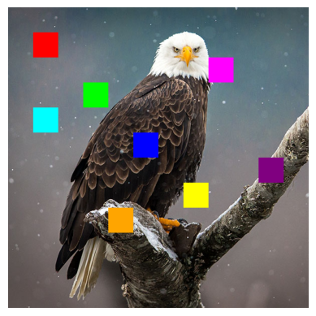
plt.imshow(resim)
plt.axis("off")
plt.show()

