GOOGLE DATA ANALYTICS CAPSTONE | CASE STUDY 2
How Can a Wellness Technology Company Play It Smart?
What Fitbit users' daily habits mean for marketing Bellabeat Leaf
Eromosele Smart Ochie
Data: FitBit Fitness Tracker Data (Mobius, Kaggle, CC0): 33 users, 12 April - 11 May 2016, 844 valid user-days; plus published health guidelines
Tools: Excel (Power Query, pivot tables, COUNTIFS / AVERAGEIFS), SQL (DuckDB), Visio
Files: excel/Bellabeat_Smart_Device_Analysis.xlsx | sql/ | power-query/ | visio/Bellabeat_Diagrams.vsdx

At a glance
Urška Sršen, Bellabeat's cofounder and Chief Creative Officer, asked how people use smart devices that aren't made by Bellabeat, and how those habits should shape Bellabeat's marketing. I analysed a month of Fitbit data from 33 people, compared it with published health guidelines, and applied what I found to Bellabeat Leaf, the wellness tracker that can be worn as a bracelet, a necklace or a clip.

What I found
- People use what is automatic and skip what is manual. All 33 users recorded steps and 24 (73%) recorded sleep at least once, but only 8 (24%) logged their weight, mostly by typing it in.
- The tracker comes off at night. It was worn to bed on fewer than half of the valid days (47.5%). Nine people wore it almost every day but rarely or never to sleep.
- Use fades within a month. The number of people wearing their device each day fell from 31 in the first week to 24 in the last (-22%). Twelve users (36%) wore it on fewer than 25 of 30 days, and they were the least active group: about 6,100 steps a day against 9,100 for everyone else.
- Most people are fairly active but miss step targets. The average was 8,419 steps a day. 70% of users met the CDC's 150 active minutes a week, yet only 27% averaged 10,000 steps and 21% averaged under 5,000.
- Activity has a clear daily rhythm. On weekdays steps peak at lunchtime and again from 5 to 7 pm, with a dip at 3 pm. At weekends the peak moves to 1-2 pm. Sunday is the least active day.
- Sleep sits right on the line. People slept 6 hours 59 minutes a night on average; 56% of nights reached 7 hours. Most main sleep starts between 9 pm and midnight.

What I recommend
- Sell Leaf as the tracker you don't take off, jewellery you can sleep in, with sleep insights as the reason to keep it on at night.
- Build a first-30-days habit programme in the Bellabeat app to stop the drop-off before it starts.
- Set realistic goals and time the nudges to the hours when people already move: 8,000 steps and 150 active minutes, reminders at 3 pm and before the evening walk.
- Keep tracking automatic and use the membership for guidance, offering personal coaching to the least active users rather than asking everyone to log data by hand.

1. Ask

1.1 The business task
Bellabeat is a successful small company that makes health-focused smart products for women. Sršen believes that understanding how people use smart devices in general can unlock new growth, and she asked the marketing analytics team for high-level recommendations. I framed my task as:
Analyse smart device usage data from non-Bellabeat devices to find trends in how people use them, apply those trends to one Bellabeat product (Leaf), and recommend how they should shape Bellabeat's marketing strategy.
Three questions guided the work: what are the trends in smart device usage, how could they apply to Bellabeat customers, and how could they influence Bellabeat's marketing strategy?

1.2 Key stakeholders
Stakeholder | Role | What they need from me
Urška Sršen | Cofounder and Chief Creative Officer; asked for this analysis | Usage trends she can turn into marketing and product messages
Sando Mur | Cofounder, mathematician, executive team | A sound method: clear sample, clear rules, honest limits
Marketing analytics team | My team | Documented work they can re-run with Bellabeat's own data

1.3 Why Bellabeat Leaf
I chose Leaf because the biggest gaps in the data are about wearing the device consistently, especially at night and from week to week, and Leaf's design speaks directly to that: it can be a bracelet, a necklace or a clip. Leaf also tracks activity, sleep and stress, so most of what the Fitbit data measures carries over without stretching. Leaf connects to the Bellabeat app, which is where several of my recommendations would run.

2. Prepare

2.1 Data source
Sršen pointed me to the FitBit Fitness Tracker Data set on Kaggle, made available by Mobius under a CC0 public-domain licence. It was originally published on Zenodo by Furberg, Brinton, Keating and Ortiz (2016) and comes from people who answered a survey on Amazon Mechanical Turk and agreed to share their Fitbit data. The download has two folders; I used the 12 April - 12 May 2016 folder (Fitabase Data 4.12.16-5.12.16), which is the more complete of the two.
File | Rows | Users | What I used it for
dailyActivity_merged | 940 | 33 | Steps, distance, active and sedentary minutes, calories
sleepDay_merged | 413 (410 after duplicates) | 24 | Minutes asleep and time in bed
hourlySteps, hourlyIntensities, hourlyCalories | 22,099 each | 33 | Time-of-day patterns
minuteSleep_merged | 188,521 (187,978 after duplicates) | 24 | When people fall asleep
weightLogInfo_merged | 67 | 8 | How many people log their weight

I didn't load dailySteps, dailyCalories or dailyIntensities: I joined each one to dailyActivity and found zero mismatches, so they are copies of columns I already had. Heart rate and minute-level steps weren't needed for these questions.

2.2 Where the data is stored and how it is organized
The CSV files sit unchanged in data/raw/; every change happens in Power Query or SQL. The data is in long format, one row per user per day, hour or minute, and the files join on the user Id plus the date or time.

2.3 Does the data ROCCC?
Criterion | Rating | Why
Reliable | Low | 33 self-selected users and no age or gender, so I can't confirm they resemble Bellabeat's customers (women)
Original | Low | Collected by a third party through Amazon Mechanical Turk, not by Fitbit or Bellabeat
Comprehensive | Partial | Activity for everyone, sleep for 24 users, weight for 8, and only one month
Current | Low | 2016; devices and habits have changed since
Cited | Medium | Published on Zenodo with named authors and shared on Kaggle with a clear licence

Because the data scores low, I treat the findings as directional: good enough to point marketing in a direction and to design tests, not good enough to size a market.

2.4 Adding data to address the limitations
Sršen suggested adding another data set. The gap I could close was context: a step count means little on its own. I built a small reference table of published benchmarks (data/reference/health_guidelines.csv, and the Guidelines sheet in the workbook):
- CDC: adults need 150 minutes of moderate-intensity activity a week, or 75 minutes of vigorous activity, or an equivalent mix.
- American Academy of Sleep Medicine and Sleep Research Society (via CDC): adults aged 18-60 should sleep 7 or more hours a night.
- Tudor-Locke and Bassett (2004), Sports Medicine: step categories from sedentary (under 5,000 a day) to highly active (over 12,500).
- Paluch et al. (2022), The Lancet Public Health: for adults under 60, the drop in mortality risk levels off at about 8,000-10,000 steps a day.
It doesn't fix the small, unrepresentative sample. Only Bellabeat's own app data can do that, which is my first next step.

2.5 Licensing, privacy, security and accessibility
The data is CC0, so it can be used freely. Users are identified only by a 10-digit Id, there are no names, and I report results in aggregate. Charts in the workbook use text labels as well as colour.

2.6 Problems I found
- The data set is described as covering 30 users, but there are 33 distinct Ids. I kept all 33 and noted it.
- Dates are stored as text, in two formats: 4/12/2016 in the daily file and 4/12/2016 12:00:00 AM in the hourly and sleep files.
- Exact duplicate rows: 3 in sleepDay and 543 in minuteSleep.
- 77 days have zero steps; 72 of them also show 1,440 sedentary minutes, which is a device sitting on a table, not a person sitting still.
- 12 May 2016 is only partly recorded (the export cut-off), with 757 tracked minutes on average.
- Fitbit stops counting activity minutes while you sleep. On nights the device isn't worn, the whole night shows up as sedentary time. This turned out to matter a lot (section 3.4).

3. Process

3.1 Tools and why I chose them
Tool | What I used it for | Why
Excel Power Query | Loading the files, fixing dates, removing duplicates, joining sleep to activity, flagging valid days | Every step is recorded and repeatable; no hand edits
SQL (DuckDB) | The same cleaning, quality checks, and the summaries that need the minute-level sleep file | Runs locally on the CSVs; plain .sql files version well on GitHub
Excel (pivot tables, COUNTIFS / AVERAGEIFS, conditional formatting, charts) | Per-user profile, benchmark scorecard, segments, dashboard | The clean tables are small enough to analyse directly, and formulas stay live
Visio | Data-flow chart, valid-day rules, segment rules | Shows exactly what happens to the data and how users are grouped

3.2 Transformations
- Converted the date text into real dates and timestamps.
- Removed exact duplicate rows from sleepDay and minuteSleep.
- Joined each day's sleep record to that day's activity on user Id and date, so every day knows whether the device was worn overnight.
- Added: day of week (1 = Sunday, the same as Excel's WEEKDAY(date,1)), weekday or weekend, study day (1-30), moderate-to-vigorous minutes (very + fairly active), a CDC-equivalent version (fairly + 2 x very, because one vigorous minute counts as two moderate ones) and sleep efficiency (asleep / in bed).
- Joined the three hourly files on user and hour, and kept only the hours that belong to valid days.

3.3 Which days count
A day only tells us something about a person if they actually wore the device. I used three rules, applied in order:
Rule | Condition | Reason | User-days removed
D1 | Date is 12 May 2016 | Export cut-off: only part of the day was recorded | 21
D2 | 0 steps all day | Device not worn | 73
D3 | Activity + sleep minutes under 600 | Less than 10 hours of data, the usual wear-time rule in accelerometer studies | 2
 | Valid user-days kept |  | 844 of 940 (33 users)

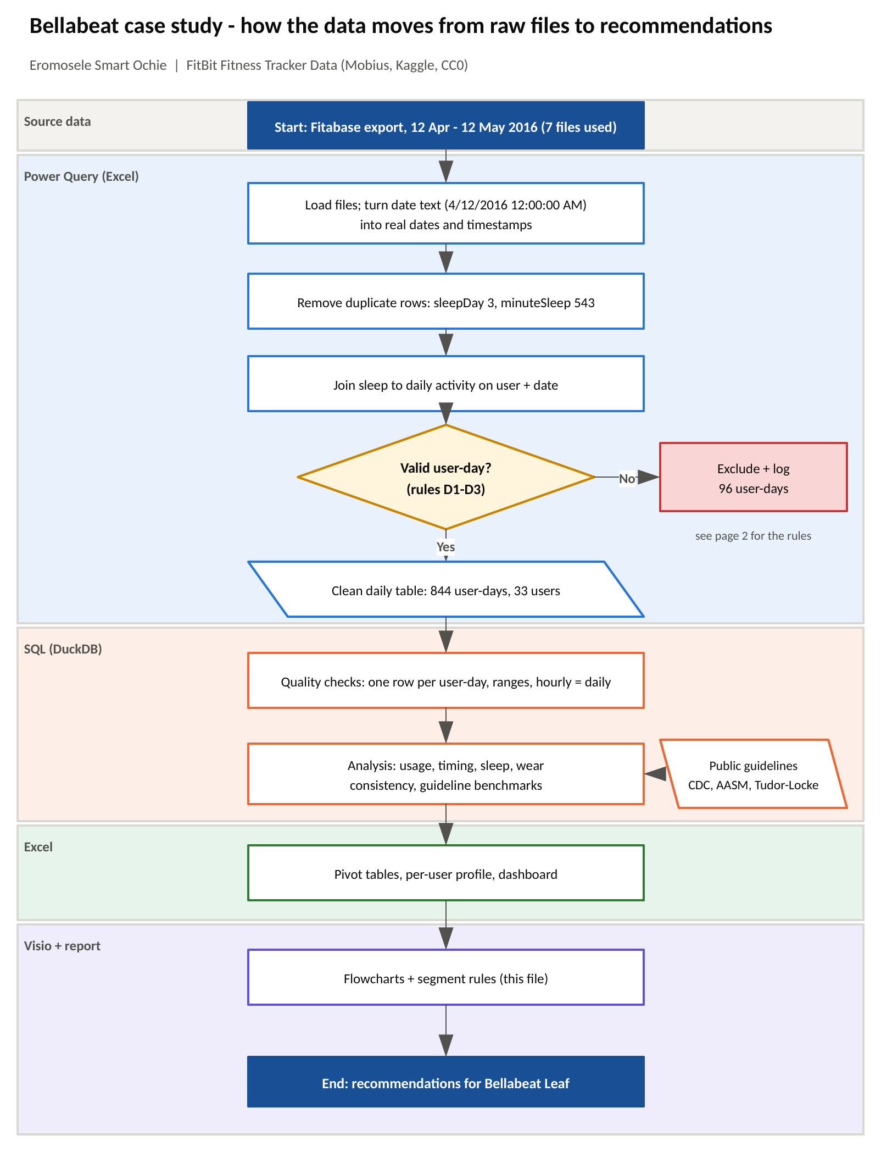
Figure 1. How the data moves from the raw files to the recommendations (Visio, page 1 of visio/Bellabeat_Diagrams.vsdx).
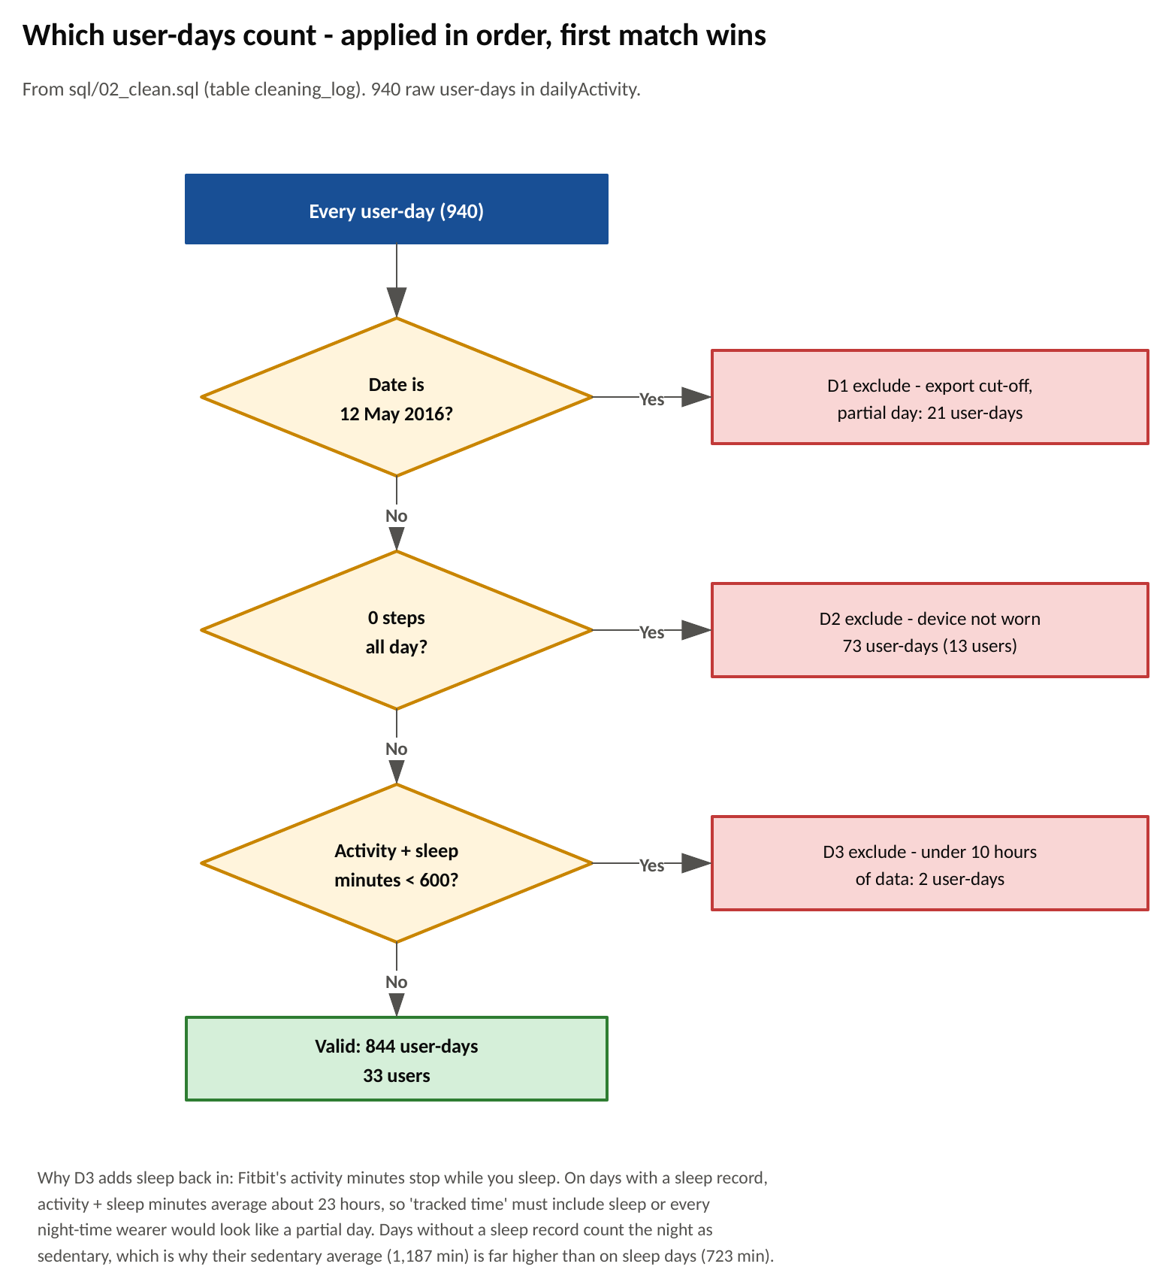
Figure 2. The valid-day rules as a decision flow (Visio, page 2).

3.4 The sedentary-minutes trap
The first average I calculated said these users were sedentary for 16 hours a day. That didn't sound right, so I looked at which days produced it. On days with a sleep record, activity minutes plus sleep add up to about 23 hours: the device stops counting activity while you sleep. On days without a sleep record there is no sleep to subtract, so the night is counted as sedentary time.
Split that way, the average is 723 sedentary minutes (about 12 hours) on days the tracker was worn to bed, against 1,187 minutes (almost 20 hours) on days it wasn't. The 12-hour figure is the honest one. This matters for Bellabeat too: a tracker that isn't worn overnight doesn't only miss sleep, it also gives a misleading picture of the day.
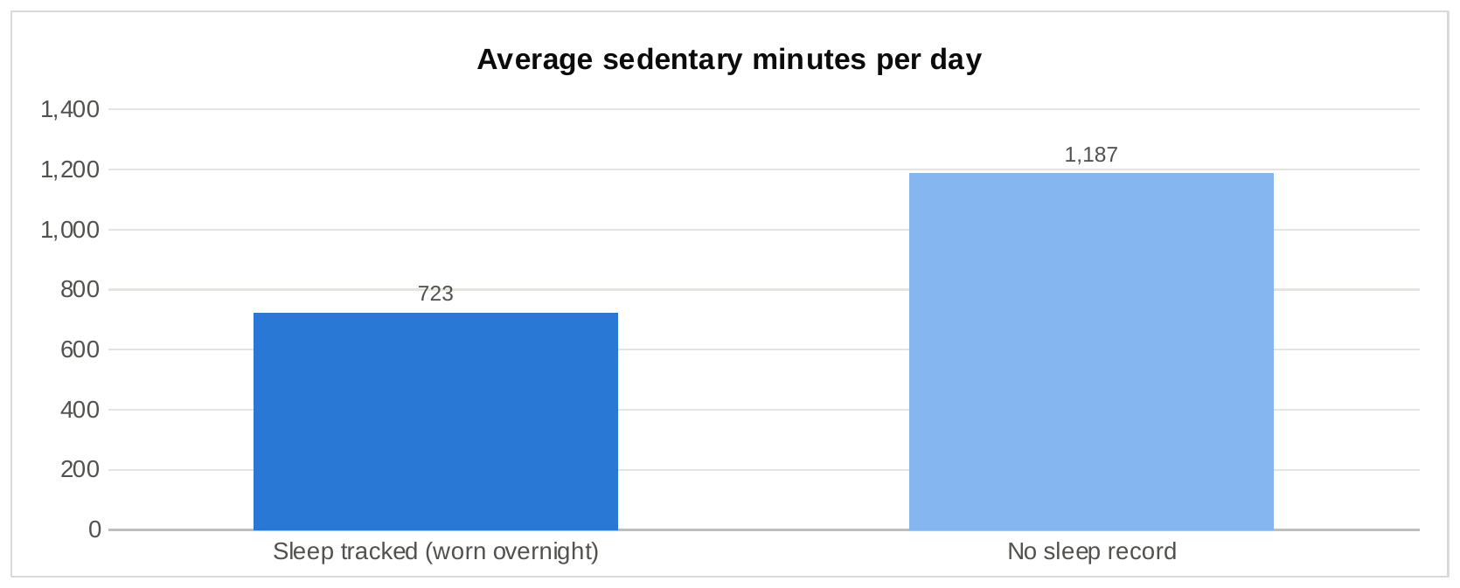
Figure 3. Average sedentary minutes on days with and without a sleep record.

3.5 How I checked the data is clean
Check (sql/04_quality_checks.sql) | Result
Every raw daily row was flagged; none lost (940) | Pass
Valid days in the cleaning log = rows in the clean table (844) | Pass
One row per user per day | Pass
One sleep row per user per night | Pass
No zero-step days left | Pass
Minutes asleep never exceed time in bed | Pass
Hourly rows only from valid days | Pass
Hourly steps add up to the daily total within 5% on at least 95% of days (actual: 97%) | Pass

4. Analyze

4.1 How I organized the data
After cleaning, the data is small enough for Excel to handle directly: 844 user-days and 20,177 user-hours, each loaded as an Excel table. I built a one-row-per-user profile with COUNTIFS and AVERAGEIFS (days worn, nights with sleep, average steps, weekly active minutes, average sleep), then scored every user against the benchmarks and placed them in a segment. Three pivot tables cover day of week, hour of day and users. The sleep-start analysis needs the minute-level sleep file, so it comes from SQL.

4.2 Summary of the analysis
Measure | Result
Users / valid user-days | 33 users / 844 days
Average (median) steps a day | 8,419 (8,162)
Average moderate-to-vigorous minutes a day | 38.5
Users who recorded steps / sleep / weight | 100% / 73% / 24%
Days the tracker was worn to bed | 47.5%
Users wearing it each day, first week vs last week | 31 vs 24 (-22%)
Users averaging 8,000+ / 10,000+ steps | 45% / 27%
Users meeting 150 active minutes a week (CDC) | 70%
Average sleep; nights with 7+ hours | 6 h 59 min; 56%
Users who sleep 7+ hours on average (of 24 who tracked sleep) | 46%
Average time awake in bed | 39 min
Correlation: steps vs calories; very active minutes vs calories | r = 0.55; r = 0.62
Correlation: awake sedentary minutes vs minutes asleep | r = -0.67

4.3 What surprised me
- The sedentary figure everyone quotes from this data set (about 16 hours a day) is mostly a measurement artefact, as section 3.4 shows.
- The people who stopped wearing the device were not the fitness enthusiasts. Of the 15 users averaging under 7,500 steps, 9 wore it on fewer than 25 days; of the 18 more active users, only 3 did.
- Nine users wore the tracker every day and averaged 9,274 steps as a group, yet rarely or never wore it to bed. Active people are taking it off at night.
- Very active minutes predict calories better than total steps (r = 0.62 against 0.55): intensity matters more than volume.

5. Share: key findings and visualizations
My audience is Bellabeat's executive team and the marketing team, so each chart has a plain title, uses one colour unless it compares two groups, and comes from a table in excel/Bellabeat_Smart_Device_Analysis.xlsx that can be checked. The live versions are on the Dashboard sheet.

Finding 1: automatic features get used; manual ones don't
Everyone recorded steps, which needs no effort. Sleep needs the device to stay on overnight, and 73% of users recorded it at least once. Weight needs a smart scale or typing a number in, and only 24% did it; 41 of the 67 weight entries were typed by hand.
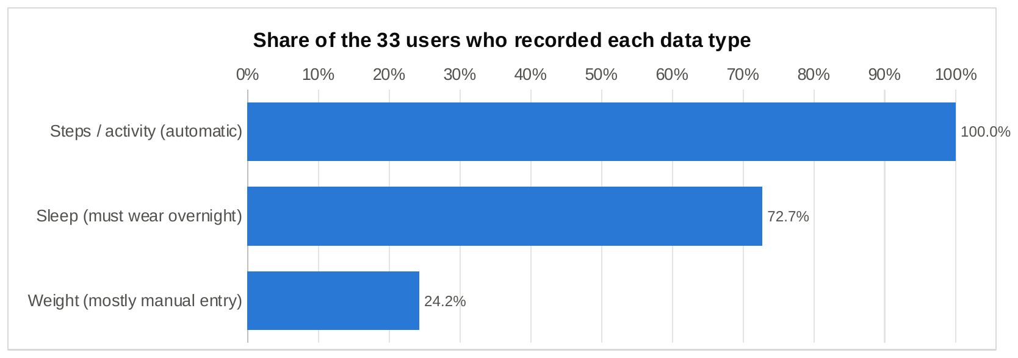
Figure 4. Share of the 33 users who recorded each type of data.

Finding 2: wear fades within the first month
Thirty-one people wore their device on an average day in the first week; by the last week it was 24. Sleep tracking barely moved, from about 13 people a night in the first week to 12 in the last, so the people who track sleep are the committed ones and the casual users are the ones drifting off.
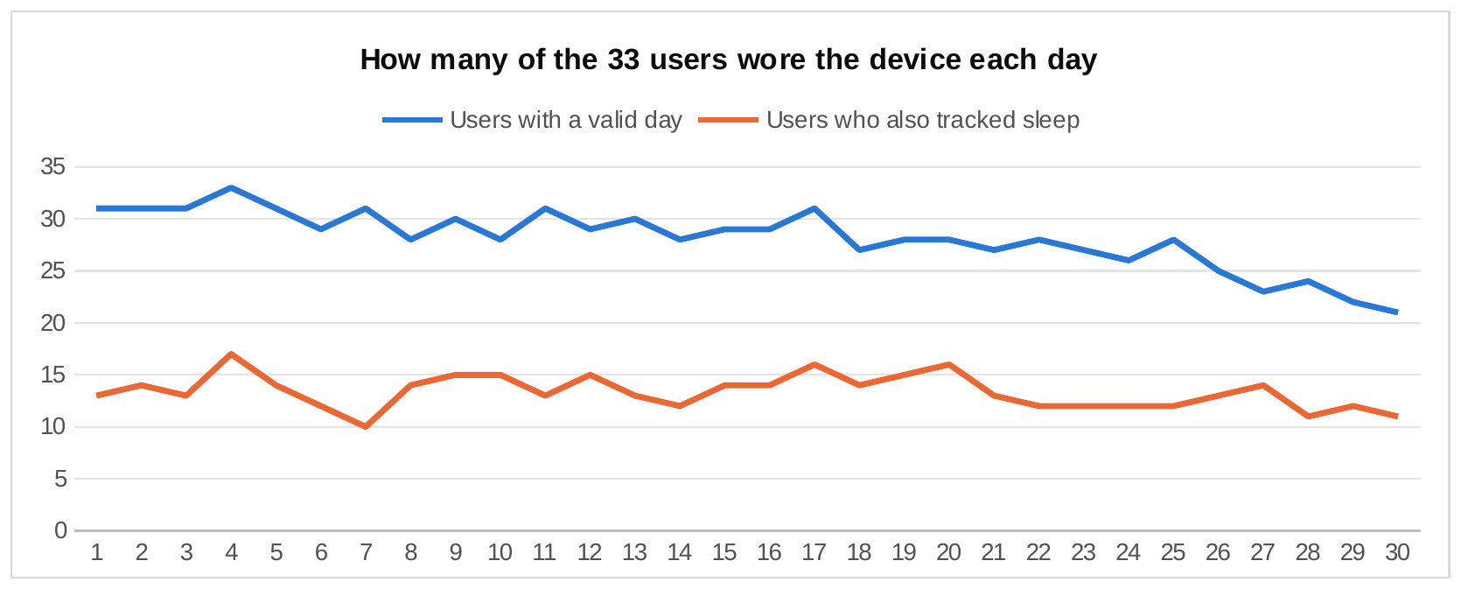
Figure 5. Users with a valid day, and users who also tracked sleep, for each of the 30 days.
Grouping users by how they wear the device (rules in Figure 15) shows where the problem sits: 12 users are at risk of dropping off, 9 wear it only in the daytime, and only 10 are both engaged and active.
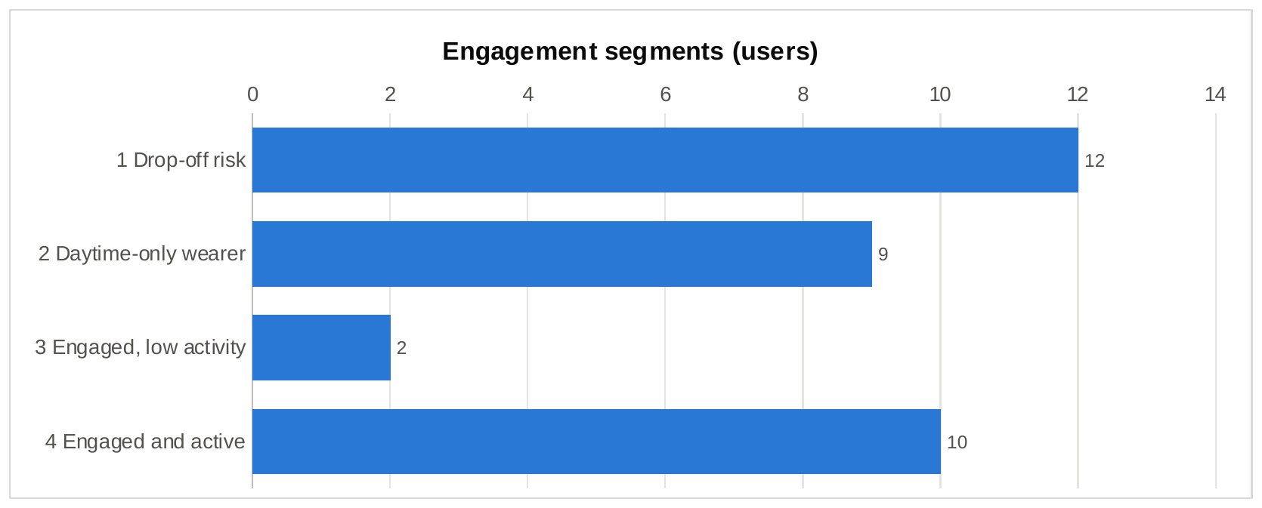
Figure 6. Users in each engagement segment.

Finding 3: most people are moderately active but miss step targets
Users are spread across every step category, from 7 sedentary users to 3 highly active ones. Against the benchmarks, 70% met the CDC's 150 active minutes a week, but only 45% averaged 8,000 steps and 27% averaged 10,000. People are getting some exercise; what they lack is everyday movement.
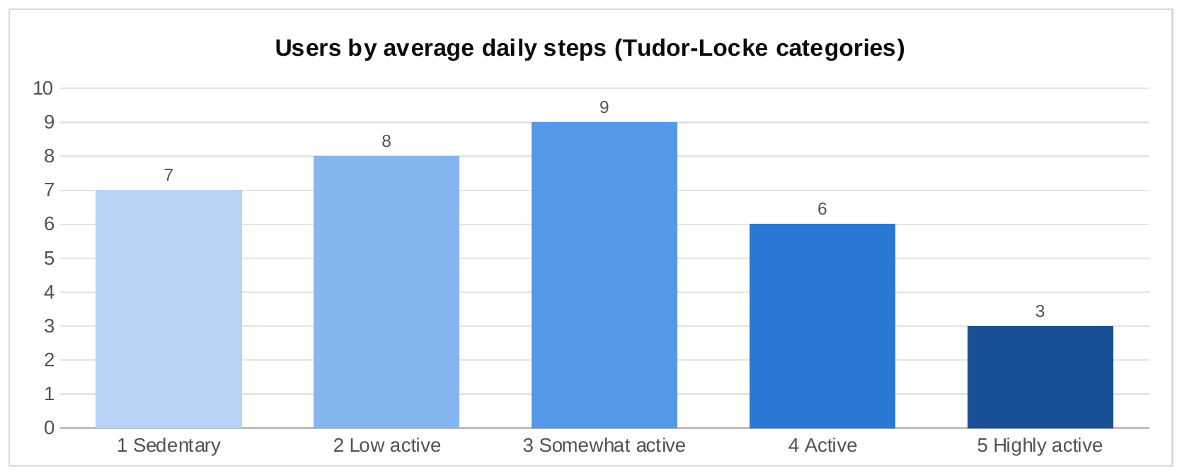
Figure 7. Users by average daily steps (Tudor-Locke and Bassett categories).
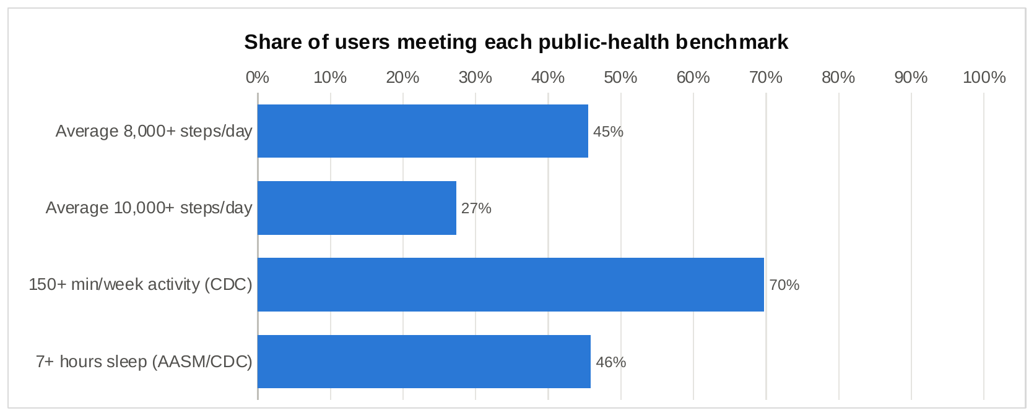
Figure 8. Share of users meeting each public-health benchmark.

Finding 4: activity follows the working day
On weekdays steps climb from 6 am, peak at lunchtime, dip to their lowest daytime point at 3 pm and then reach the highest peak of the day between 5 and 7 pm. At weekends people start later and are most active from 1 to 2 pm. Across the week, Tuesday and Saturday are the most active days and Sunday the least.
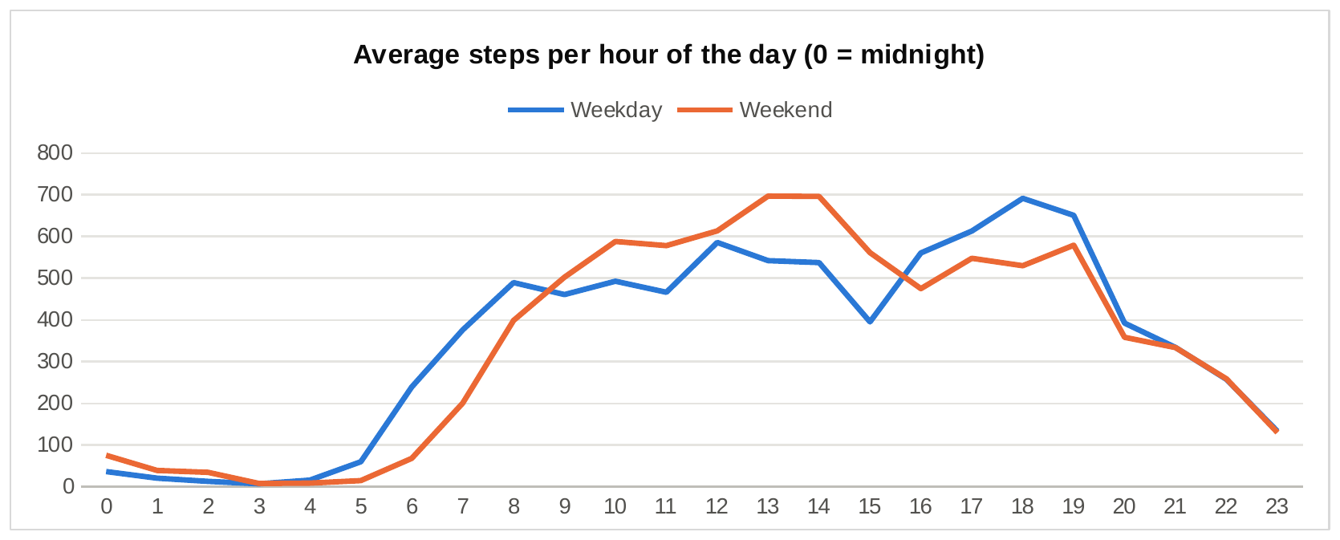
Figure 9. Average steps per hour, weekdays vs weekends.
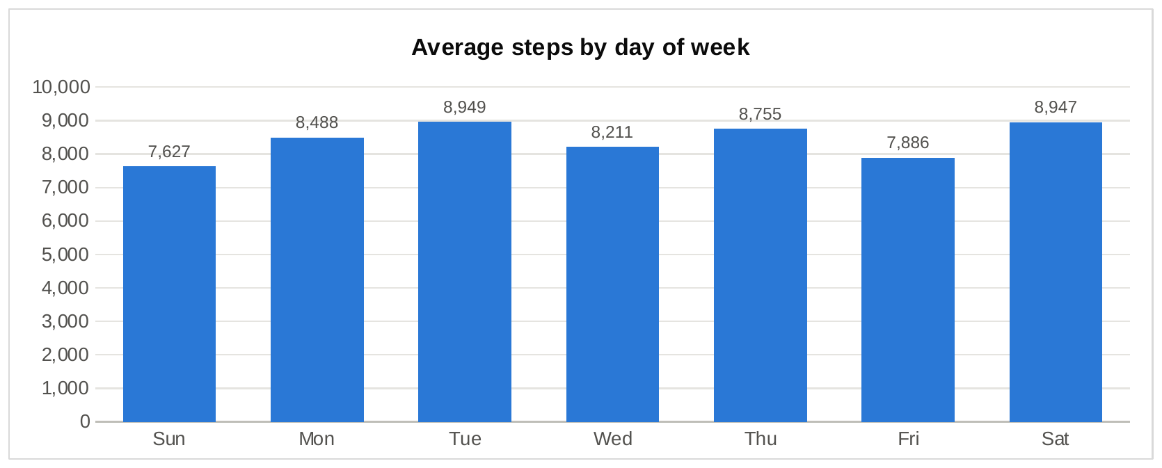
Figure 10. Average steps by day of week.

Finding 5: sleep is just short of the target, and bedtime is predictable
On nights with a record, users slept 6 hours 59 minutes and spent another 39 minutes awake in bed. 56% of nights reached 7 hours, and 11 of the 24 sleep trackers (46%) averaged 7 hours or more. 57% of main sleep periods start between 9 pm and midnight, with 10 pm the single most common hour, which gives a clear window for a bedtime reminder.
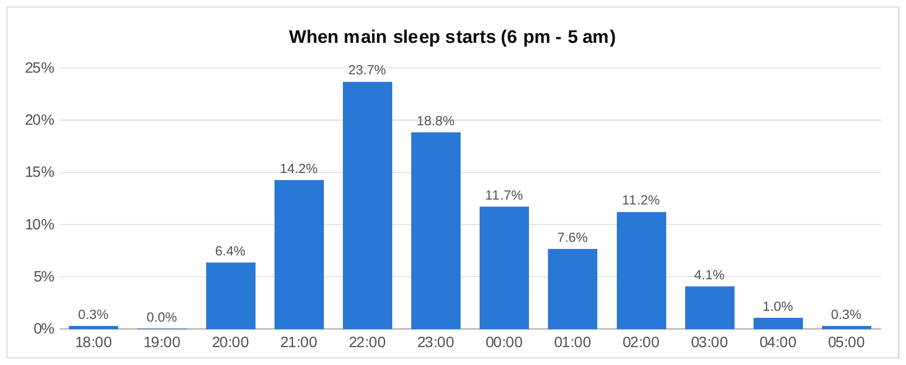
Figure 11. When the main sleep of the night starts (sleep logs of 3+ hours).
Days with more awake sedentary time come with less sleep (r = -0.67). Part of that is arithmetic, because both share the same 24 hours, so I don't read it as cause and effect. It is still a useful message: less sitting leaves more room for sleep.
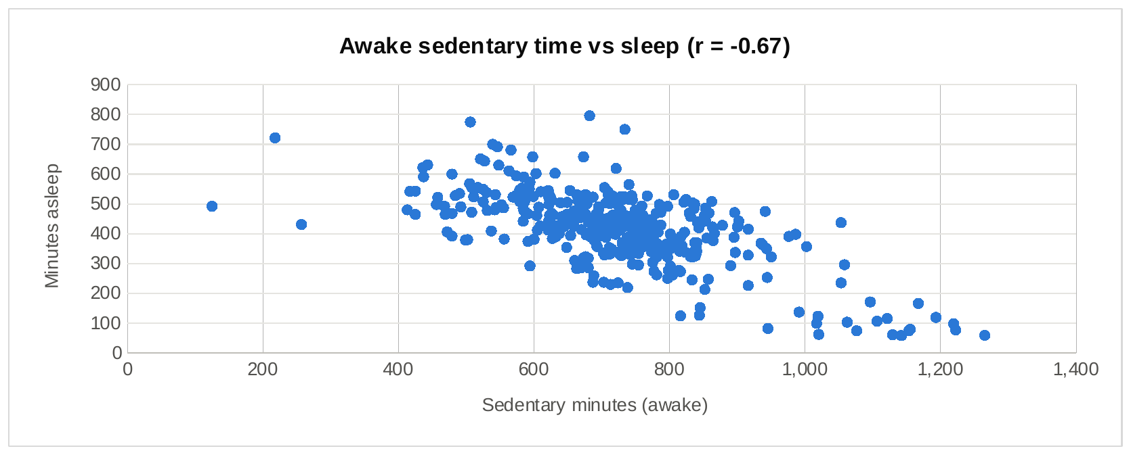
Figure 12. Awake sedentary minutes against minutes asleep, days with a sleep record.

6. Act: recommendations
My conclusion is that the habit of wearing a tracker is the weak point, not people's interest in their health. Users happily collect data that takes no effort, but the device comes off at night, use fades within weeks, and the least active people, who would benefit most, are the first to stop. Bellabeat Leaf, worn as jewellery and connected to the Bellabeat app, is well placed to fix exactly that.

Recommendation 1: sell Leaf as the tracker you don't take off
- Content: campaigns that show Leaf worn as a necklace or bracelet from morning to night, with sleep as the hook ("see how you really slept"). In the app, a bedtime reminder between 9 and 10 pm to put Leaf on.
- Why: the tracker was worn to bed on only 47.5% of days, and nine regular daytime users rarely or never wore it to sleep. Overnight wear also fixes the day's numbers (12 hours sedentary rather than an inflated 20).
- Measure: share of days with a sleep record among Leaf users, before and after the campaign.

Recommendation 2: a first-30-days habit programme
- Content: an onboarding programme in the Bellabeat app with daily streaks, a weekly recap, a gentle nudge after two days with no data, and a small reward for the first full week and the first full month.
- Why: daily wearers fell 22% within a month, and 36% of users wore the device on fewer than 25 of 30 days. Those users were the least active, so the people Bellabeat can help most are the ones it loses first.
- Measure: 30-day retention (share of new Leaf users still syncing in week 4).

Recommendation 3: realistic goals and well-timed nudges
- Content: default goals of 8,000 steps a day and 150 active minutes a week, the levels the evidence supports, with the option to raise them. Move reminders at 3 pm, the weekday low point, and before the 5-7 pm peak. A Sunday challenge, since Sunday is the least active day.
- Why: 70% of users already meet the CDC's active-minutes guideline but only 27% reach 10,000 steps, so a 10,000-step default mostly produces failure. Messages land best when they match when people already move.
- Measure: goal completion rate and reminder-to-activity conversion (steps in the hour after a nudge).

Recommendation 4: keep tracking automatic and use the membership for guidance
- Content: lead marketing with "no logging needed": Leaf tracks activity, sleep and stress on its own. For features that need input, cut the effort to one tap. Offer the Bellabeat membership's personalised guidance to users who average under 7,500 steps.
- Why: automatic features were used by everyone, manual weight logging by only 24% of users. Fifteen of 33 users averaged under 7,500 steps, and they are the group most likely to value coaching.
- Measure: membership trial uptake among low-activity users and their step trend after joining.
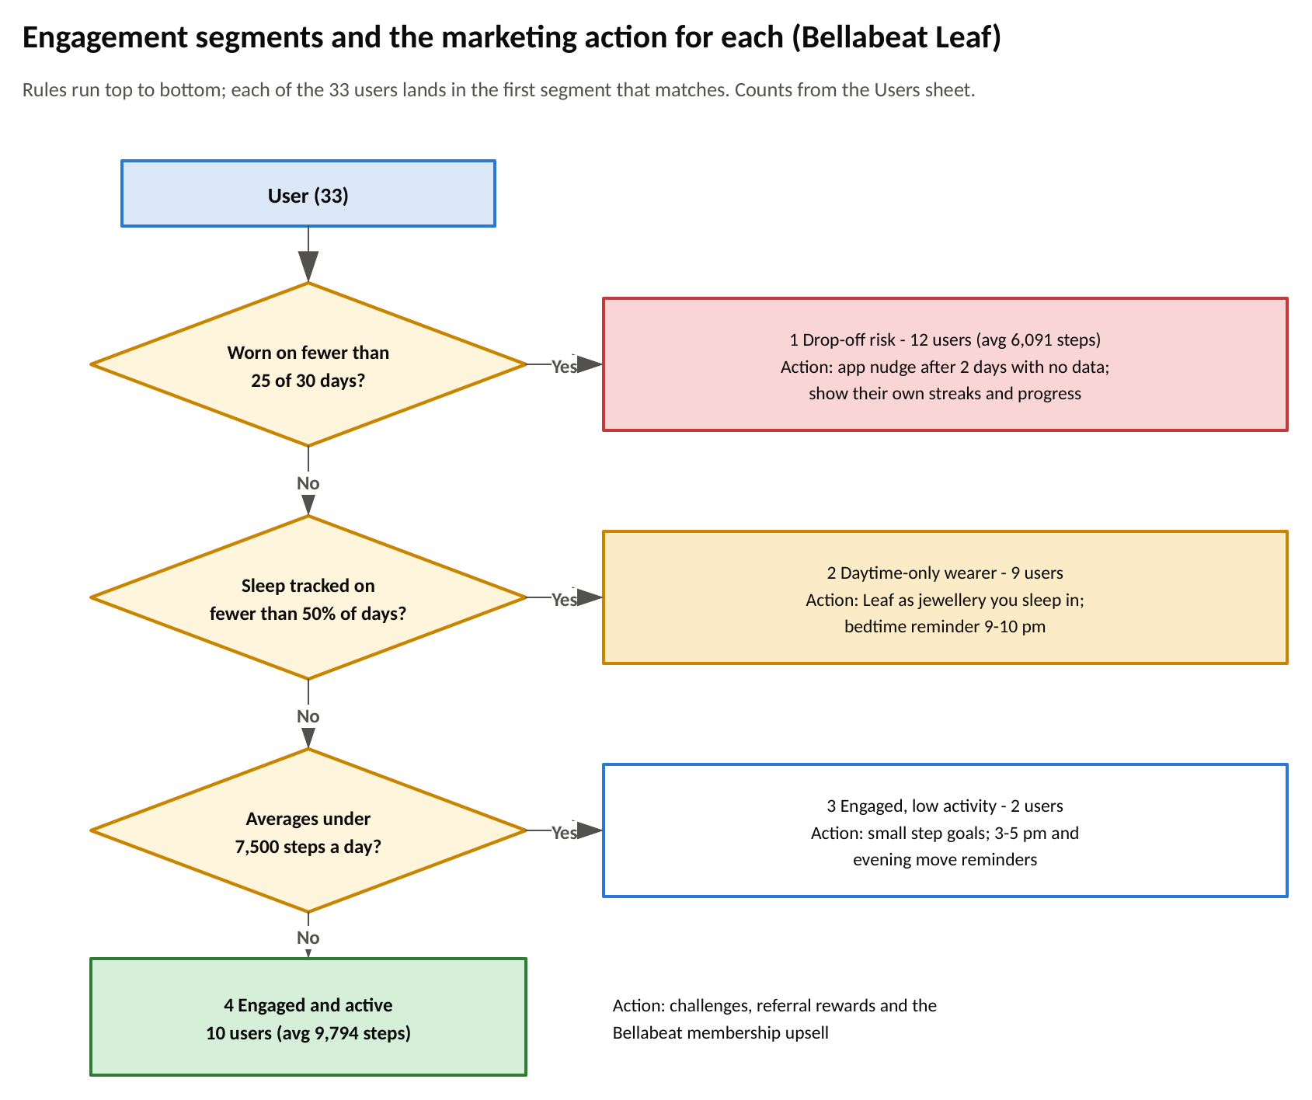
Figure 15. The segment rules behind the recommendations and the action for each segment (Visio, page 3).

6.1 Next steps and data I would add
- Bellabeat's own app data (anonymised): thousands of women rather than 33 unknown users, with stress and cycle data the Fitbit set doesn't have.
- A longer period, at least three months, to see whether the drop-off levels out or continues.
- A short survey of users who stop wearing the device at night or stop altogether: comfort, battery, forgetfulness or lost interest.
- A/B tests of the bedtime reminder and the 30-day programme before a full launch.

6.2 Limitations
- 33 users, self-selected through Amazon Mechanical Turk, with no age or gender: I can't assume they behave like Bellabeat's customers.
- One month of data from 2016.
- Different Fitbit models measure different things, and some users may simply own a model without sleep tracking.
- Correlations describe relationships, not causes.

Appendix

A. What is in the repository
Folder / file | What it holds
data/raw/ | The seven Fitbit CSV files used (CC0)
data/reference/health_guidelines.csv | The added benchmark table with sources and links
data/processed/ | Every summary exported by the SQL scripts, plus daily_clean and hourly_clean
sql/01-04_*.sql, run_all.sql | Load, clean, analyse and quality-check (DuckDB)
power-query/*.pq | The same cleaning in Excel Power Query (M), one file per query
excel/Bellabeat_Smart_Device_Analysis.xlsx | Dashboard, analysis formulas, user profile, SQL results, guidelines, cleaning log, business rules, Visio data, pivot tables, clean tables
visio/Bellabeat_Diagrams.vsdx | Data flow, valid-day rules, engagement segments (plus PNG exports)
visuals/ | PNG exports of the workbook charts used in this report

B. Clean daily table (daily_clean)
Column | Meaning
user_id, activity_date, study_day | Anonymous user Id, date, and day number 1-30
day_of_week, day_label, day_type | 1 = Sunday ... 7 = Saturday; label like "1 Sun"; Weekday or Weekend
total_steps, total_distance_km, calories | As recorded by the device
very / fairly / lightly_active_min, sedentary_min | Minutes at each intensity (sleep not included)
mvpa_min, mvpa_equivalent_min | Very + fairly active; fairly + 2 x very (CDC equivalent)
has_sleep_record, minutes_asleep, minutes_in_bed, sleep_efficiency | Last night's sleep, if the device was worn
activity_tracked_min, total_tracked_min | Activity minutes; activity + sleep minutes (used for rule D3)

C. The valid-day rule (sql/02_clean.sql)
CASE
WHEN activity_date = DATE '2016-05-12' THEN 'D1_export_cutoff_day'
WHEN total_steps = 0 THEN 'D2_not_worn'
WHEN activity_tracked_min
+ COALESCE(minutes_asleep, 0) < 600 THEN 'D3_under_10h_tracked'
ELSE 'valid'
END AS day_flag

D. Sources
- Furberg, R., Brinton, J., Keating, M. and Ortiz, A. (2016). Crowd-sourced Fitbit datasets 03.12.2016-05.12.2016. Zenodo. Shared on Kaggle by Mobius as "FitBit Fitness Tracker Data" (CC0).
- Centers for Disease Control and Prevention. Adult Activity: An Overview (Physical Activity Guidelines for Americans).
- Centers for Disease Control and Prevention (2016). 1 in 3 adults don't get enough sleep (citing the American Academy of Sleep Medicine and Sleep Research Society).
- Tudor-Locke, C. and Bassett, D.R. (2004). How many steps/day are enough? Preliminary pedometer indices for public health. Sports Medicine 34(1), 1-8.
- Paluch, A.E. et al. (2022). Daily steps and all-cause mortality: a meta-analysis of 15 international cohorts. The Lancet Public Health.
Bellabeat, its products and staff are as described in the Google Data Analytics case study.

