GOOGLE DATA ANALYTICS CAPSTONE | CASE STUDY 1
How Does a Bike-Share Navigate Speedy Success?
How annual members and casual riders use Cyclistic bikes differently, and what marketing should do about it
Eromosele Smart Ochie
Data: Divvy trip data, January-March 2019 and January-March 2020 (783,799 rides after cleaning)
Tools: Excel (Power Query, pivot tables, SUMIFS), SQL (DuckDB), Visio
Files: excel/Cyclistic_Rider_Analysis.xlsx | sql/ | power-query/ | visio/Cyclistic_Diagrams.vsdx

At a glance
I was asked one question: how do annual members and casual riders use Cyclistic bikes differently? To answer it I used two quarters of real trip data from Divvy, the Chicago bike-share system that the fictional Cyclistic is modelled on. After cleaning I had 783,799 rides from January to March 2019 and January to March 2020.

What I found
- Members commute, casual riders go out. Member rides peak at 8 am and 5 pm on weekdays. Casual rides peak in the early afternoon, and almost half of them (47%) happen on a Saturday or Sunday.
- Casual rides are about three times longer. The median casual ride is 23.2 minutes against 8.5 for members, and 35% of casual rides run past 30 minutes compared with 4% of member rides.
- Casual riders start at the lakefront. At the three busiest casual stations (Streeter Dr & Grand Ave, Lake Shore Dr & Monroe St and Shedd Aquarium) 61-72% of rides are casual. One casual ride in seven is a round trip.
- Casual riding is growing and follows the weather. Casual rides grew 92% between the two first quarters, member rides 10%. The casual share of rides roughly doubles from January to March in both years.
- There is already a pool to convert. 11,069 casual rides (16%) look exactly like commutes: a weekday, rush hour, under 30 minutes.
- Members show early signs of churn. Member rides fell at four busy commuter stations while the network grew 35.5%, and when commuting stopped in late March 2020 member rides dropped 66% against 41% for casual riders.

What I recommend
- Commuter membership offer aimed at the casual riders who already ride like commuters, at the Loop and West Loop stations they use, during rush hour.
- Spring-to-summer weekend campaign at lakefront and museum stations, with a membership or trial that makes sense for long leisure rides.
- Churn early-warning report and a membership pause option, so falling member use is spotted by station and a change in someone's commute doesn't turn into a cancellation.

1. Ask

1.1 The business task
Lily Moreno, Cyclistic's director of marketing, believes the company's growth depends on increasing the number of annual members, because the finance team has found that members are much more profitable than casual riders. Instead of chasing new customers, she wants to convert people who already ride with Cyclistic. Before the team can design that campaign, it needs to understand how the two groups behave. Moreno assigned me the first of three questions, so I framed my task as:
Use Cyclistic's historical trip data to identify how annual members and casual riders use the bikes differently, so the marketing team can design a campaign that converts casual riders into annual members.

1.2 Key stakeholders
Stakeholder | Role | What they need from me
Lily Moreno | Director of marketing, my manager | Clear, specific differences she can build a campaign on
Cyclistic executive team | Approves the marketing program; known for being detail-oriented | Findings they can trust: documented data, checked numbers, clean visuals
Marketing analytics team | My team | Work they can reuse and re-run: queries, workbook, diagrams

1.3 How the insights drive decisions
I tied every finding to something marketing can act on: who to target, when (time of day, day of week, season), where (stations) and with what message (commute savings or leisure value). Converting casual riders only pays off if members stay, so I also looked for signs that members are drifting away.

2. Prepare

2.1 Data source and why I picked these files
Cyclistic is fictional, so the case study uses public trip data from Divvy, Chicago's bike-share system, made available by Motivate International Inc. under the Divvy Data License Agreement. The case packet offers two options: the most recent 12 months, or the Divvy 2019 Q1 and 2020 Q1 files. I chose the two Q1 files for three reasons:
- Together they have 791,956 rows, which still fits in a single Excel sheet (the limit is 1,048,576). I could work in Excel the whole way and still check every number in SQL.
- Comparing the same three months in two different years separates real change, such as growth or churn, from normal seasonal swings.
- They are the files the case packet points to, so anyone can reproduce my numbers.
The trade-off is that both quarters are winter and early spring. I can't show the summer peak, and I kept that in mind for every seasonal conclusion.
File | Rows | Columns | Period | Notes
Divvy_Trips_2019_Q1.csv | 365,069 | 12 | 1 Jan - 31 Mar 2019 | Older layout: trip_id, start_time, usertype (Subscriber / Customer); also gender and birth year
Divvy_Trips_2020_Q1.csv | 426,887 | 13 | 1 Jan - 31 Mar 2020 | Newer layout: ride_id, started_at, member_casual; adds coordinates; no gender or birth year

2.2 Where the data is stored and how it is organized
I saved the downloaded files in data/raw/ inside the project folder and never edited them. Every change happens in Power Query or SQL, so the raw files stay as an audit trail. They are too big for GitHub, so that folder holds a README with the download links and the SHA-256 checksum of each zip, which lets anyone confirm they are working with the same files. Both files are in long format: one row per ride.

2.3 Does the data ROCCC?
Criterion | Rating | Why
Reliable | Good | Full export from the operator; no duplicate ride IDs. Known issues (test rides, false starts) are listed below and handled
Original | Good | First-party data published by the operator
Comprehensive | Partial | Every ride in the period, but no rider ID, price paid or home location, and winter months only
Current | Limited | 2019-2020 data: good for patterns, not for today's volumes
Cited | Good | Published by the operator under a named licence

2.4 Licensing, privacy, security and accessibility
The licence allows the data to be analysed and reused. It contains no personal information: there is no rider ID and no payment detail, so I can't tell whether two rides came from the same person or whether casual riders live in Chicago. That limits what I can say about conversion and churn for individual people, so I measured both at ride and station level instead. The 2019 file has gender and birth year, which I only report in aggregate. The workbook uses plain tables, text labels next to every colour, and a two-colour scheme (blue and orange) that stays readable for colour-blind viewers.

2.5 Problems I found
- The two files use different column names and different labels for the same rider types (Subscriber / Customer against member / casual).
- The 2019 file stores tripduration as text with thousands separators ("1,783.0"), so it loads as text. I recalculated ride length from the start and end timestamps for both years instead of fixing that column.
- The 2020 file includes 3,768 rides to or from "HQ QR", Divvy's quality-check station. Every one of the 210 rides with a zero or negative length is one of them.
- The 2020 file has 3,908 normal rides shorter than 60 seconds; the 2019 file has none, because Divvy removed them before publishing that year. Left in, they would make 2020 look different from 2019 for no real reason.
- 481 rides last longer than 24 hours, which means the bike wasn't docked properly.
- In 2019, 74% of casual rides have no gender or birth year, so any demographic comparison is weak.

3. Process

3.1 Tools and why I chose them
Tool | What I used it for | Why
Excel Power Query | Loading, renaming, stacking and cleaning both files; building the hourly fact table | Every step is recorded and repeatable; no hand edits to cells
SQL (DuckDB) | The same cleaning rules, quality checks, and the summaries that need individual rides (medians, ride-length bands, stations, year-over-year) | Runs locally straight on the CSV files, handles 800,000 rows in seconds, and plain .sql files version well on GitHub
Excel (pivot tables, SUMIFS, conditional formatting, charts) | Analysis tables, heatmap, dashboard | What the marketing team already uses; formulas stay live when the data is refreshed
Visio | Data-flow chart and business-rule diagrams | Shows non-technical stakeholders exactly what happens to the data

I wrote the cleaning rules twice, once as Power Query steps and once in SQL. SQL is my version of record because it is easier to audit and re-run, and I wrote the expected row counts at the top of each Power Query step so a refresh can be checked against them.

3.2 Transformations
- Renamed the 2019 columns to match 2020 (trip_id to ride_id, start_time to started_at, from_station_ to start_station_, usertype to member_casual).
- Recoded the rider labels: Subscriber to member, Customer to casual.
- Set rideable_type to docked_bike for 2019 (Divvy had no e-bikes yet) and kept only the columns both files share. Gender and birth year stay aside for a 2019-only profile.
- Stacked the two quarters into one table of 791,956 rows.
- Added the columns the analysis needs: ride_length (end minus start, in minutes), ride_date, month, day_of_week (1 = Sunday, the same as Excel's WEEKDAY(date,1)), weekday or weekend, start hour, a round-trip flag and a ride-length band.
- Removed Divvy's "(*)" and "(Temp)" suffixes from station names, and joined stations on station_id, which is the same in both years.

3.3 Cleaning rules
The rules run in this order and the first one that matches wins, so no row is counted twice. Nothing is deleted from the stacked table: every row gets a flag, and the cleaning log counts the flags.
Rule | Condition | Reason | Rows removed
R1 | Start or end station is HQ QR | Quality-check rides, not customers | 3,768
R2 | End station or end time missing | Ride never closed | 0
R3 | Ride length 0 seconds or less | Impossible timestamps | 0 (all were HQ QR)
R4 | Ride length under 60 seconds | False starts and re-docks; keeps 2020 consistent with 2019 | 3,908
R5 | Ride length over 24 hours | Bike not returned | 481
 | Total removed |  | 8,157 (1.0%)

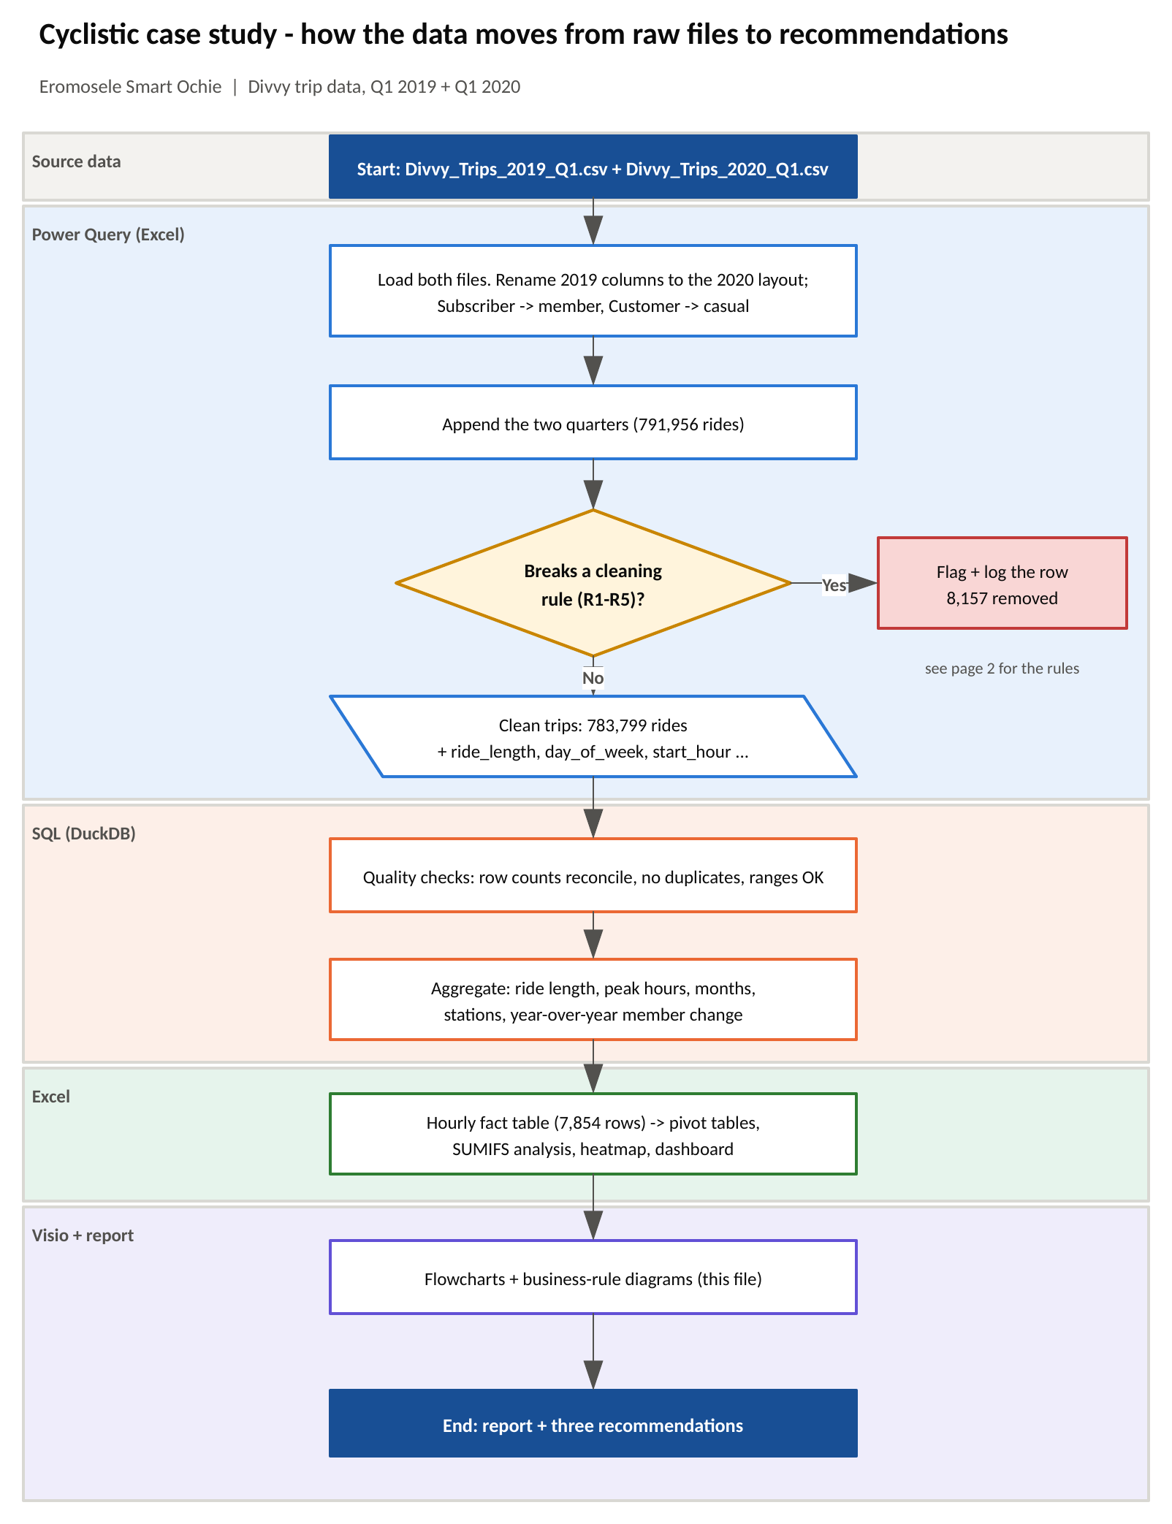
Figure 1. How the data moves from the raw files to the recommendations (Visio, page 1 of visio/Cyclistic_Diagrams.vsdx). Colours mark which tool does each step.
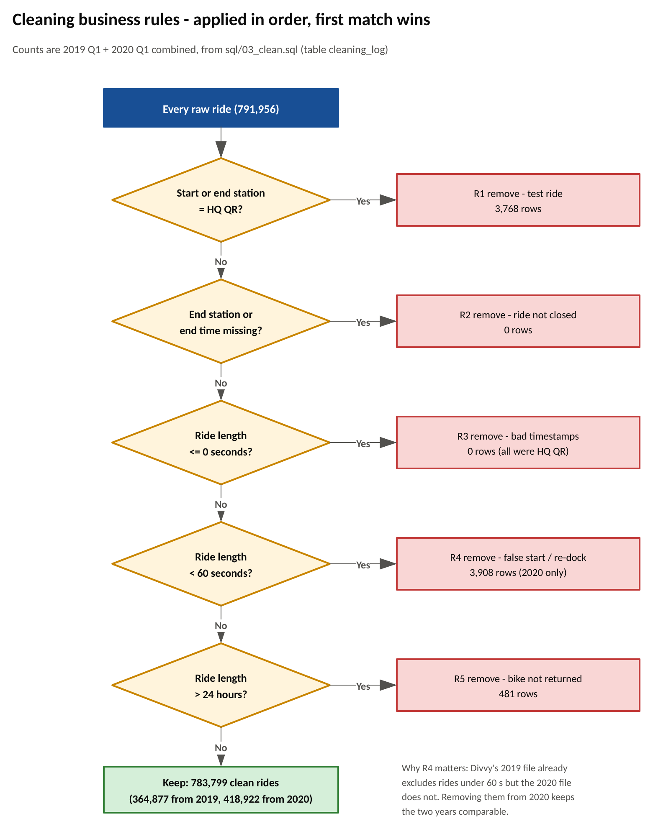
Figure 2. The cleaning rules as a decision flow, with the number of rows each rule removed (Visio, page 2).

3.4 How I checked the data is clean
These checks live in sql/05_quality_checks.sql and all of them must pass before I trust any number:
Check | Result
Rows after stacking = raw rows (791,956) | Pass
Rows kept in the cleaning log = rows in the clean table (783,799) | Pass
Hourly fact table adds back up to the clean table | Pass
No duplicate ride IDs | Pass
No missing rider type | Pass
Every ride is between 60 seconds and 24 hours | Pass
No HQ QR rides left | Pass
Every ride falls between January and March | Pass

The same reconciliation is on the Cleaning_Log sheet of the workbook: raw rows minus removed rows, the SQL count and the total of the hourly fact table all have to agree before the sheet shows PASS.

4. Analyze

4.1 How I organized the data
Pivoting 783,799 individual rides in Excel is slow, so I aggregated them into an hourly fact table: one row per date, start hour and rider type, with the number of rides, total ride minutes, round trips and rides over 30 minutes. It has 7,854 rows and adds up exactly to the clean ride count. Averages are rebuilt from it as total minutes divided by rides, so they match the ride-level averages. Medians and ride-length bands need individual rides, so those come from SQL. The workbook then has four pivot tables, a sheet of SUMIFS tables over named ranges, and a weekday-by-hour heatmap.

4.2 Summary of the analysis
Measure | Members | Casual riders
Rides (share of all rides) | 716,406 (91.4%) | 67,393 (8.6%)
Growth, Q1 2019 to Q1 2020 | +9.6% | +91.8%
Average ride | 11.5 min | 38.5 min
Median ride | 8.5 min | 23.2 min
Rides under 10 minutes | 59.1% | 16.3%
Rides over 30 minutes | 4.0% | 35.3%
Rides on Saturday or Sunday | 16.6% | 47.4%
Round trips (start = end station) | 1.4% | 14.1%
Busiest weekday start hour | 5 pm (14.6%), then 8 am (12.3%) | 5 pm (12.2%)
Busiest weekend start hour | 1 pm (9.4%) | 2 pm (14.5%)
Rides that look like commutes* | 52.2% | 16.4% (11,069 rides)
Casual share of all rides, January to March |  | 2019: 4.4% to 9.6%  2020: 5.4% to 17.6%
* Weekday, starting 6-9 am or 4-6 pm, shorter than 30 minutes.

4.3 What surprised me
- I expected casual riders to stay away on weekdays. They don't: their busiest weekday hour is 5 pm, the same as members, and one in six casual rides looks like a commute.
- Casual rides nearly doubled in a year while member rides grew 10%. In the first two weeks of March 2020, casual rides were five times higher than in the same weeks of 2019.
- The second half of March 2020 broke every pattern. Illinois' stay-at-home order started on 21 March, and member rides fell 66% against the same weeks of 2019. Casual rides fell 41%. Members' use is tied to commuting, which makes them exposed when commuting stops.
- Member growth was uneven. Across January and February the network's member rides grew 35.5%, yet they fell at four busy stations, all in the West Loop and Loop next to the commuter-rail terminals.

5. Share: key findings and visualizations
My audience is the marketing team and a detail-oriented executive team, so every chart has a title that says what it shows, uses the same colours throughout (blue for members, orange for casual riders) and is built from a table in the workbook that can be checked. The live versions are on the Dashboard sheet of excel/Cyclistic_Rider_Analysis.xlsx.

Finding 1: casual riders take much longer rides
The average casual ride lasts 38.5 minutes, 3.4 times the member average. Medians remove the effect of a few very long rides and tell the same story: 23.2 minutes against 8.5. Six in ten member rides are under 10 minutes, while most casual rides fall between 10 and 60 minutes.
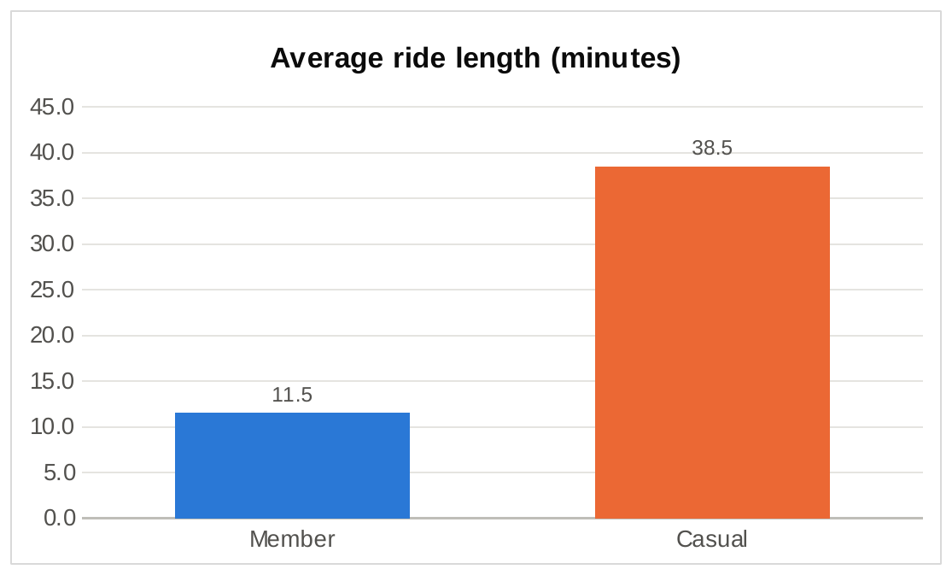
Figure 3. Average ride length by rider type, Q1 2019 + Q1 2020.
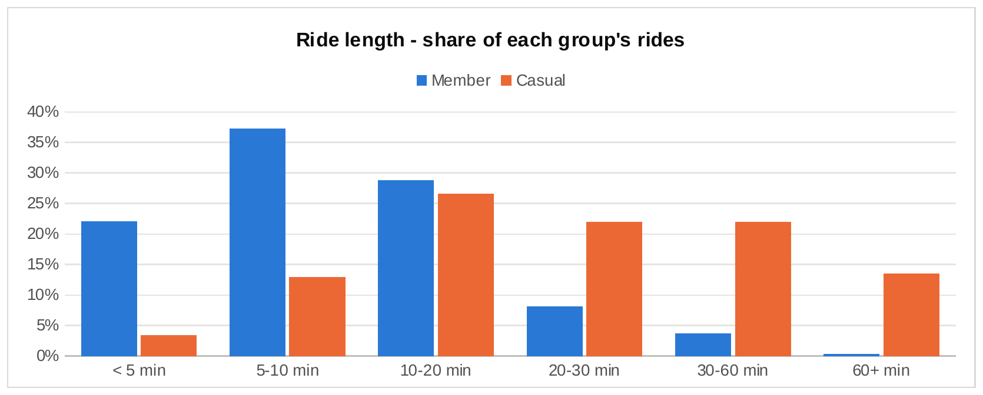
Figure 4. Share of each group's rides by ride length.

Finding 2: members ride on weekdays, casual riders at weekends
Member rides are spread evenly from Monday to Friday and drop by half at the weekend. Casual riders do the opposite: Sunday alone accounts for 27% of their rides and Saturday for another 20%.
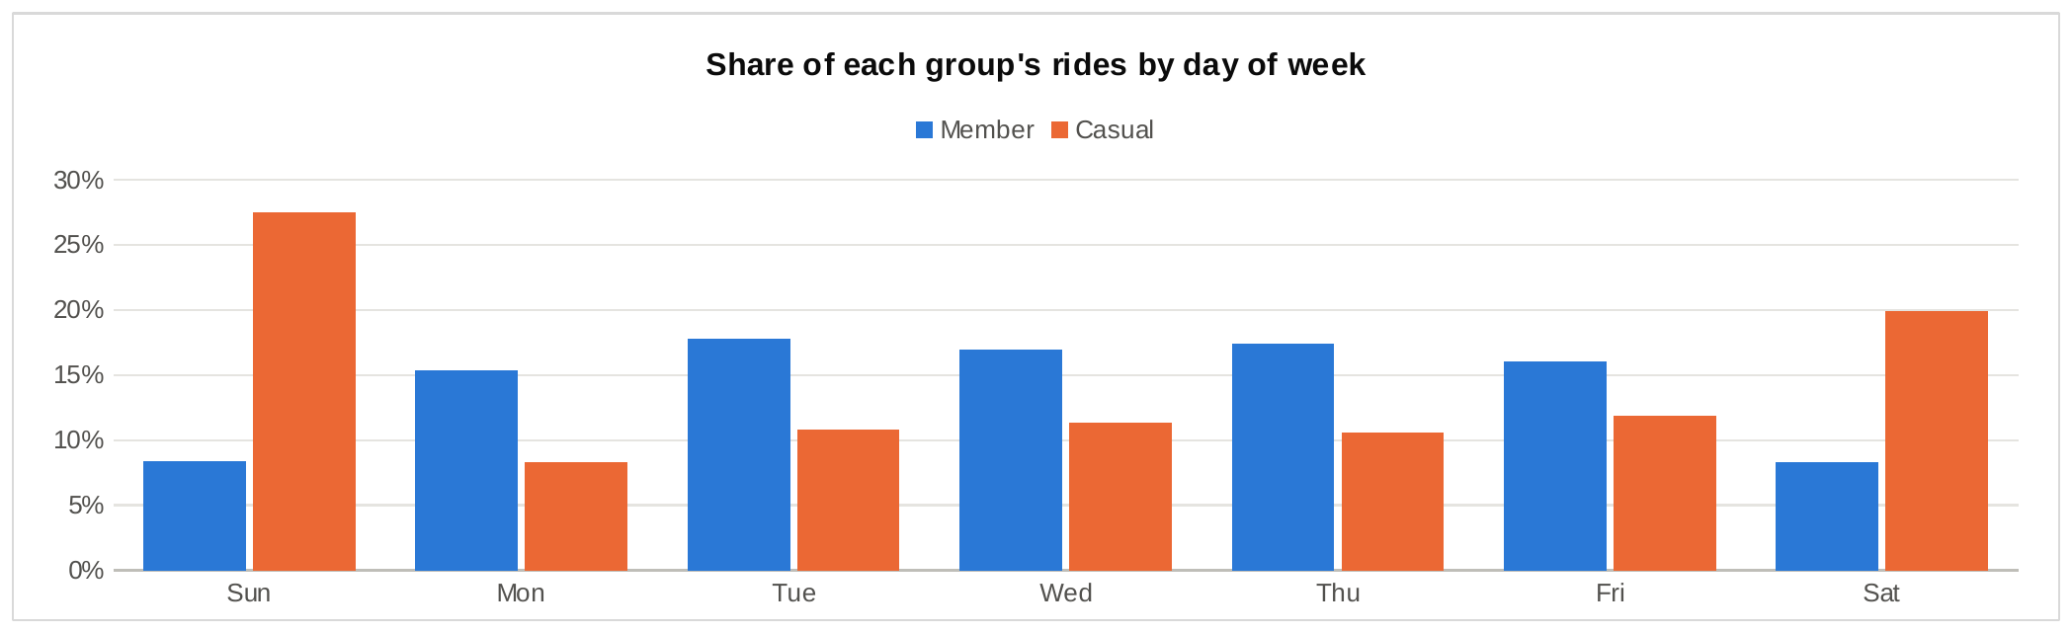
Figure 5. Share of each group's rides by day of week.

Finding 3: members ride at commute times, casual riders in the afternoon
On weekdays member rides have two sharp peaks at 8 am and 5 pm. Casual rides build through the afternoon and peak at 5 pm too, which is the overlap the first recommendation targets. At weekends both groups ride in the early afternoon, but casual riding is far more concentrated: half of all weekend casual rides start between noon and 4 pm.
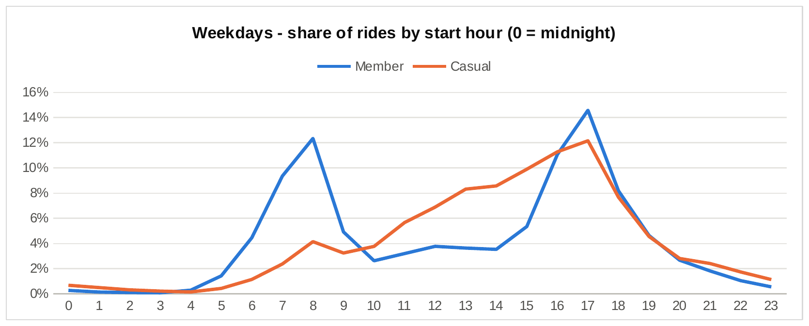
Figure 6. Weekdays: share of rides by start hour.
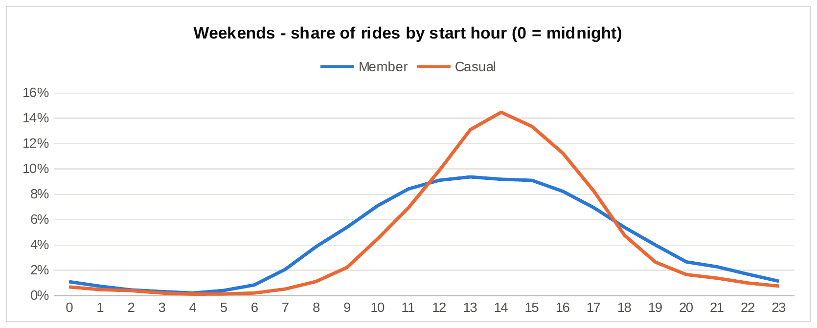
Figure 7. Weekends: share of rides by start hour.
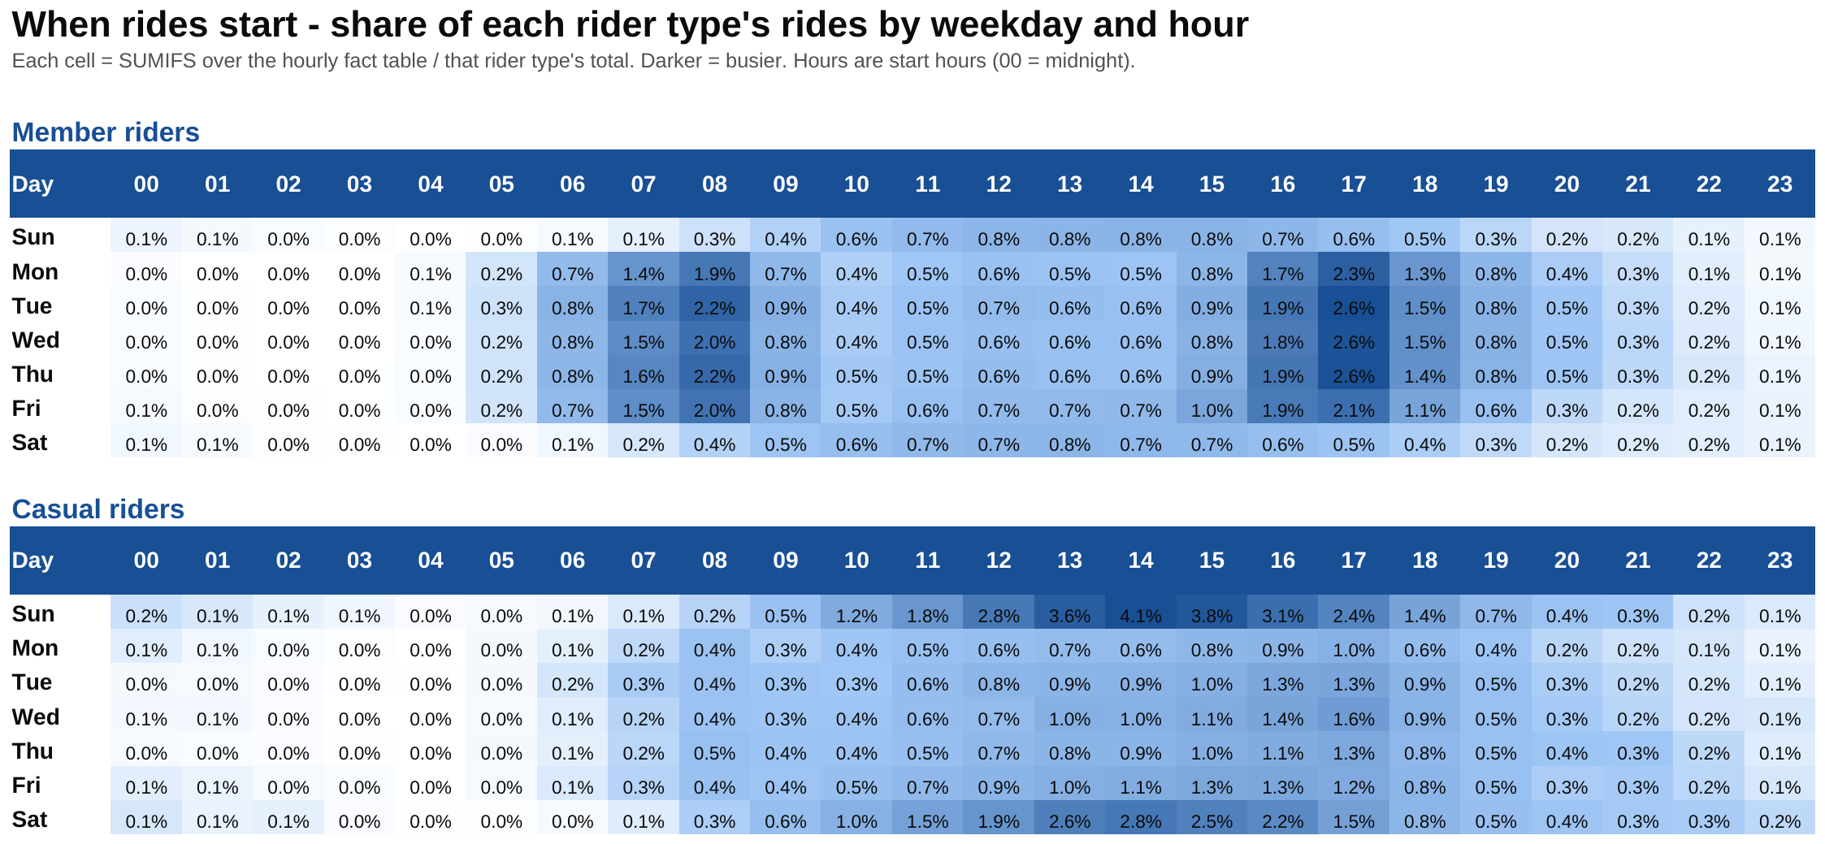
Figure 8. Weekday x hour heatmap built with SUMIFS and an Excel colour scale. Members light up at rush hour Monday to Friday; casual riders light up on weekend afternoons.

Finding 4: casual riding is seasonal and growing fast
Member rides are high all quarter. Casual rides are tiny in January and February and jump in March: the casual share of rides went from 4.4% in January to 9.6% in March 2019, and from 5.4% to 17.6% in 2020. Even with winter-only data, casual demand clearly follows the weather and the season, and it is growing much faster than member demand.
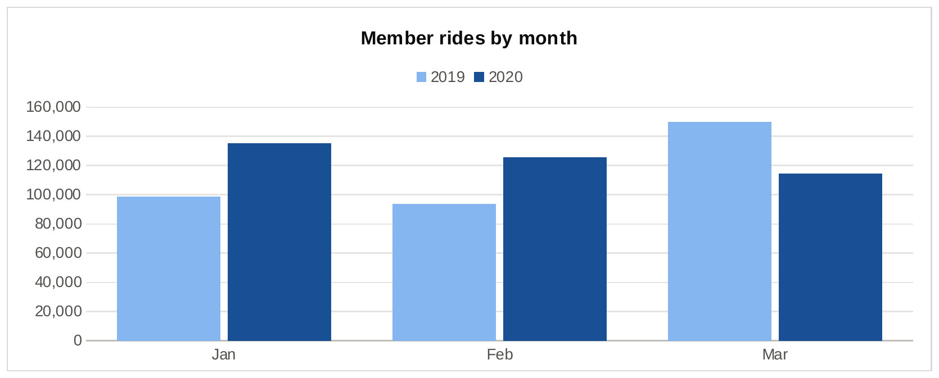
Figure 9. Member rides by month, 2019 vs 2020. March 2020 is lower because of the COVID-19 shutdown.
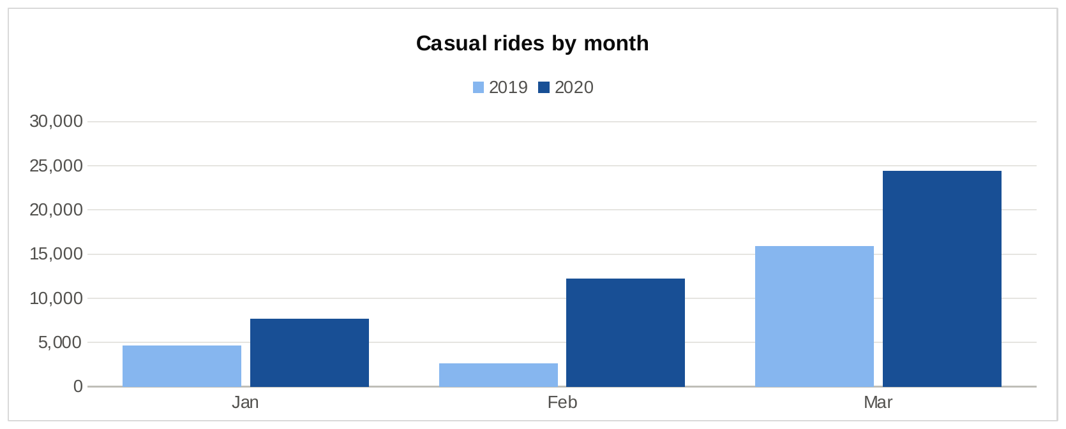
Figure 10. Casual rides by month, 2019 vs 2020.

Finding 5: casual riders start at the lakefront and the museums
The ten busiest casual stations account for 20% of all casual rides. They are lakefront, park and museum stations, and at the top three more than 60% of rides are casual. Members' busiest stations look completely different: Canal St & Adams St, Clinton St & Washington Blvd and Clinton St & Madison St, all beside the West Loop commuter-rail terminals. This tells marketing exactly where each message belongs.
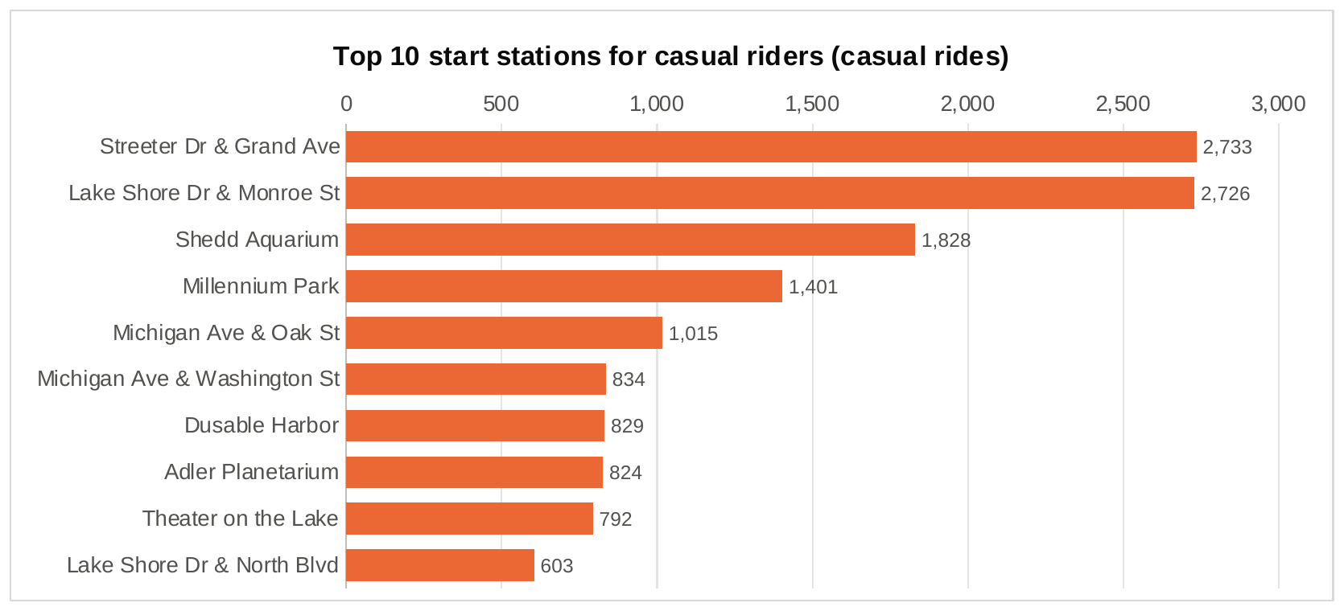
Figure 11. Top 10 start stations for casual riders.

Finding 6: early warning signs of member churn
Without rider IDs I can't follow individual members, so I measured churn signals at station level. Across January and February, member rides grew 35.5% network-wide. Of the 122 busy stations (500+ member rides in Jan-Feb 2019), 4 had fewer member rides and 27 more grew at less than half the network rate. The four declining stations are all commuter hubs in the West Loop and Loop. Then, in the second half of March 2020, member rides fell 66% while casual rides fell 41%.
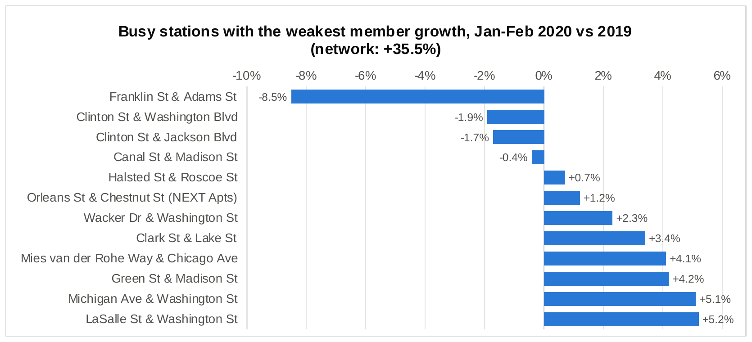
Figure 12. Busy stations with the weakest member growth, Jan-Feb 2020 vs Jan-Feb 2019.
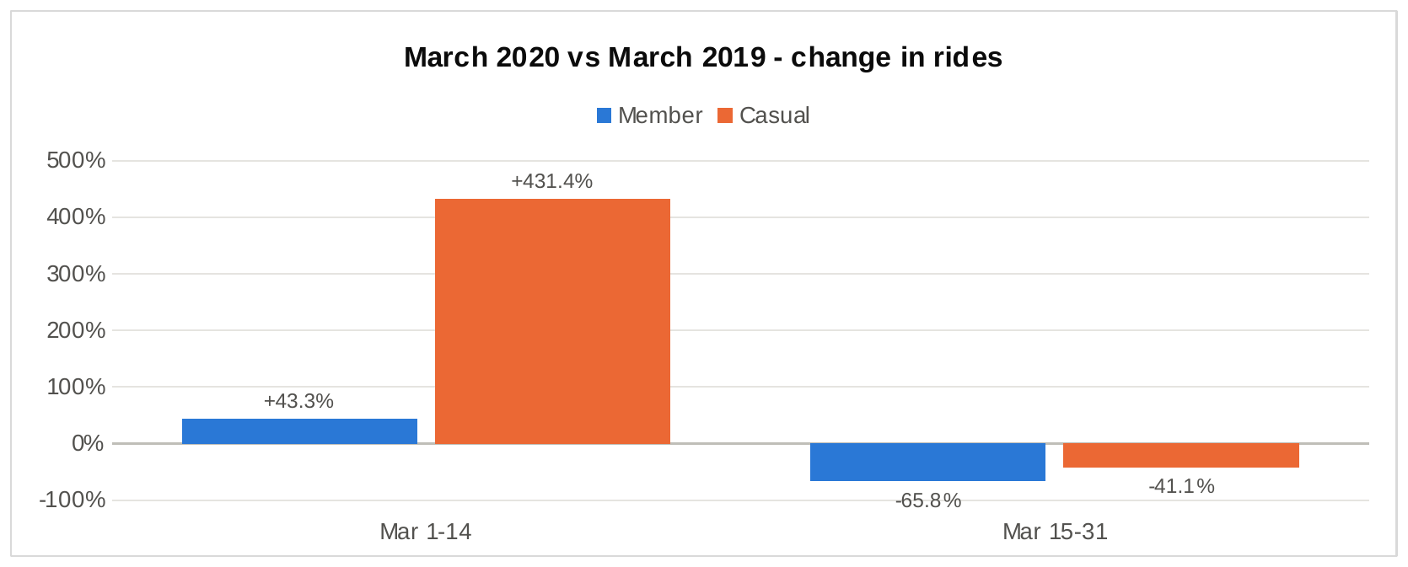
Figure 13. March 2020 against March 2019, first and second half of the month.

6. Act: recommendations
My conclusion is that members use Cyclistic as transport: short weekday rides at commute times from office-area stations. Casual riders use it as an outing: long afternoon and weekend rides that start at the lakefront and the museums. One message won't convert both groups, so I recommend three targeted moves.

Recommendation 1: convert the casual riders who already ride like members
- What: a commuter membership offer shown to casual riders when they unlock a bike on a weekday between 6-9 am or 4-6 pm, plus digital and on-dock ads at Loop and West Loop stations such as Clinton St & Madison St and Canal St & Adams St, next to the commuter-rail terminals.
- Why: 11,069 casual rides (16%) already look like commutes. These riders have the member habit without the member plan, so the message can be a simple cost comparison: what their commute costs in single rides against one membership.
- How to measure it: the share of commute-like casual rides at the targeted stations that turn into member rides over the next quarter.

Recommendation 2: a spring-to-summer weekend campaign at the lakefront
- What: weekend social and digital ads plus dock signage at Streeter Dr & Grand Ave, Lake Shore Dr & Monroe St, Shedd Aquarium and Millennium Park, offering a membership trial or a plan built around longer leisure rides. Start in March, when the casual share starts climbing.
- Why: 47% of casual rides are at weekends, the median casual ride is 23 minutes and 35% run past 30 minutes. Leisure riders won't respond to commute savings; they need to see value in long weekend rides.
- How to measure it: trial sign-ups and trial-to-paid conversion by station, and repeat casual rides during the campaign.

Recommendation 3: protect the member base
- What: a monthly station report using the rules in Figure 14 (Declining: member rides down year over year; Lagging: growth below half the network's), with retention offers and service checks (docks, bike supply) at flagged stations. Add a membership pause option for shocks like March 2020, and promote weekend riding to members so their membership is still worth keeping if their commute changes.
- Why: 31 of 122 busy stations (25%) were declining or lagging while the network grew 35.5%, and March 2020 showed member use collapses when commuting does.
- How to measure it: renewal rate and member rides at flagged stations compared with the rest.
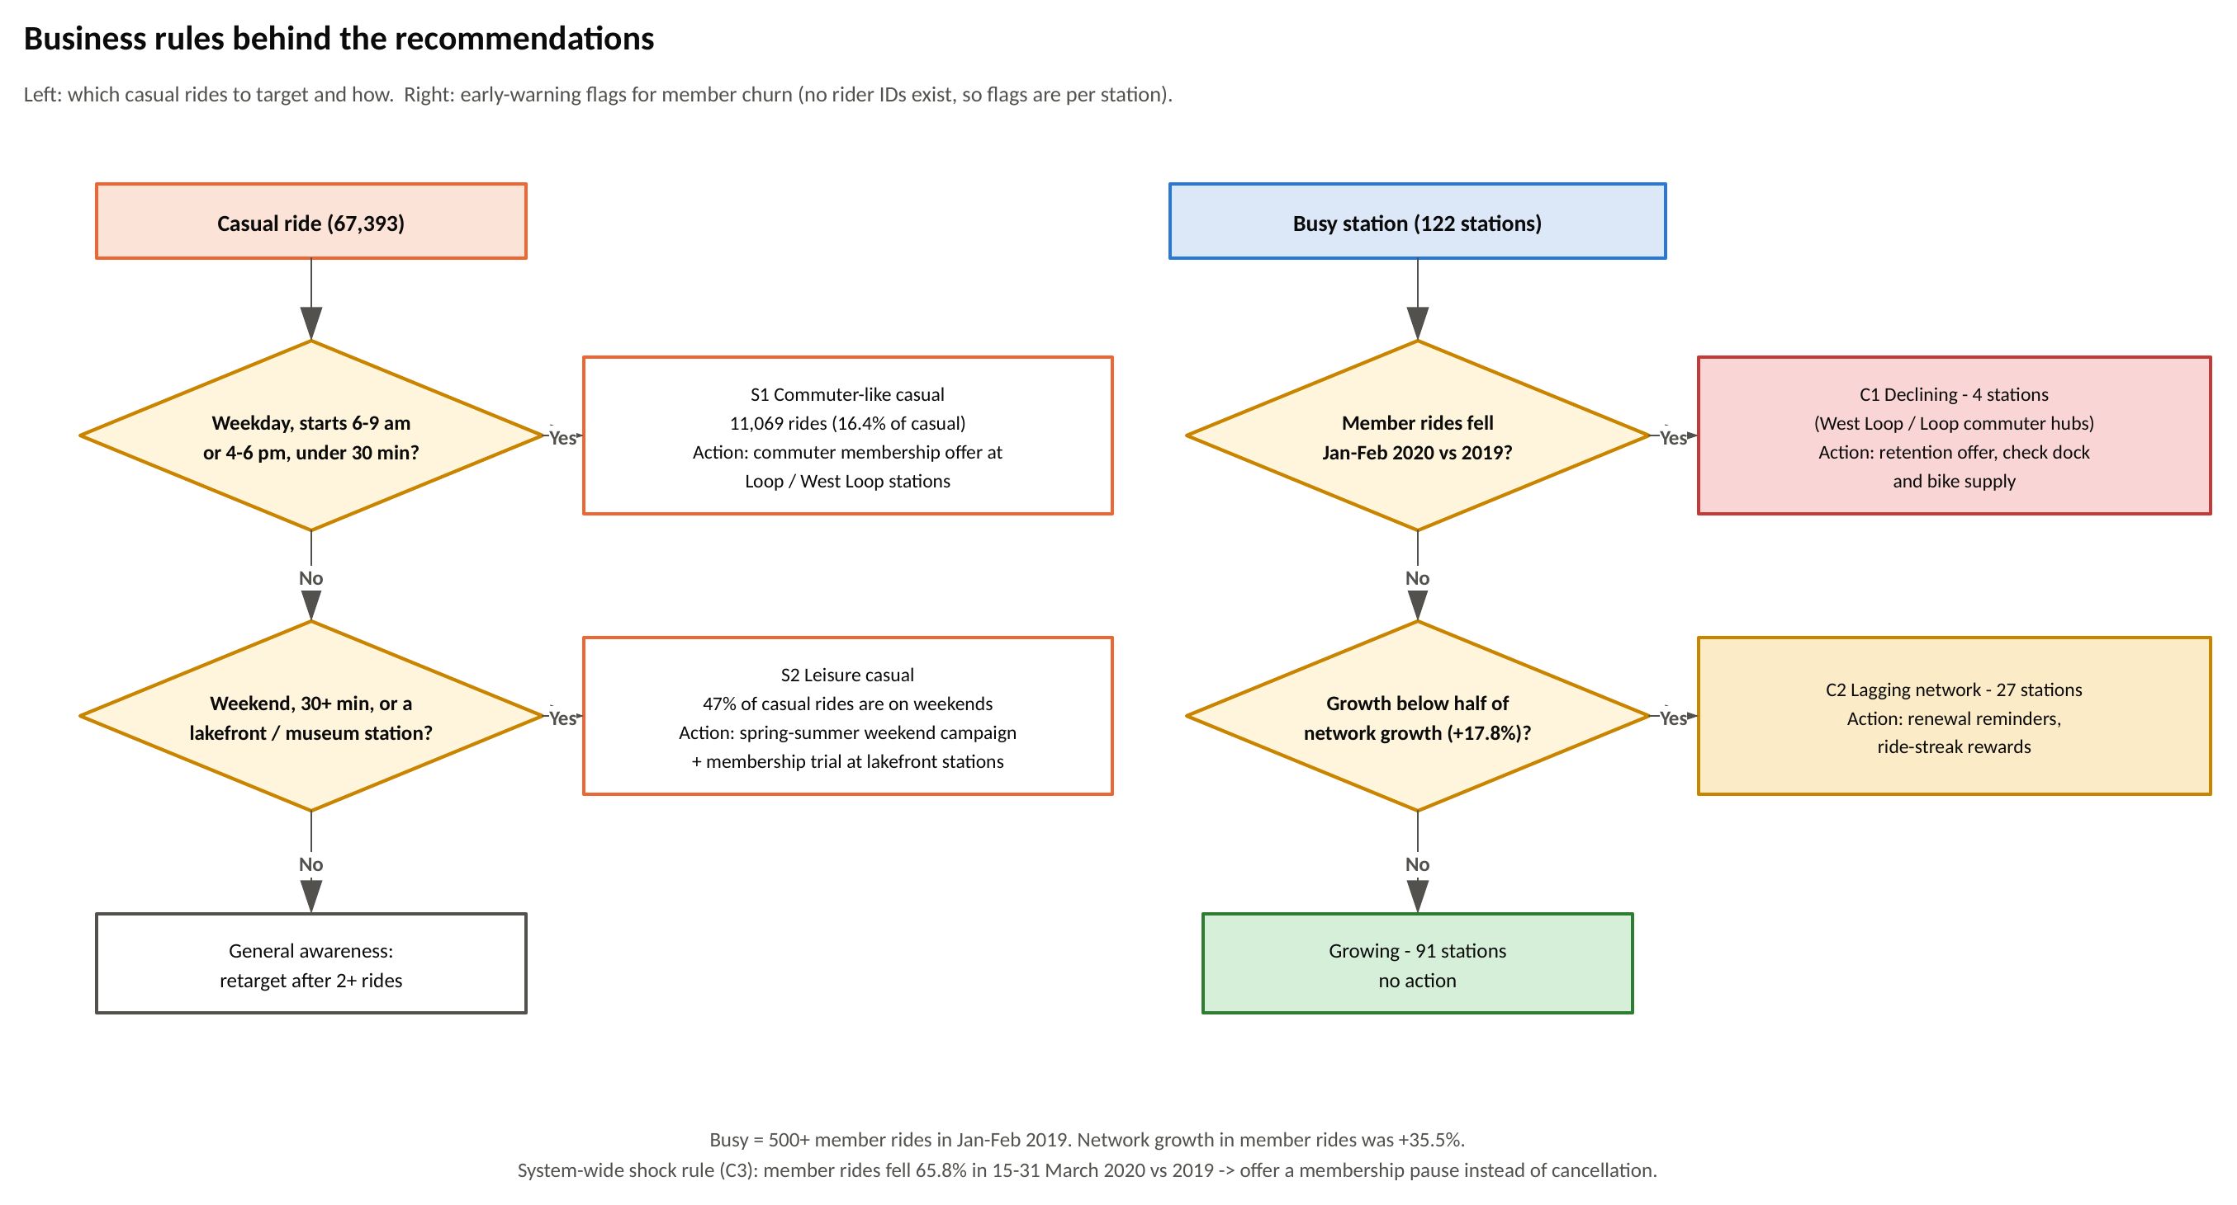
Figure 14. The business rules behind the recommendations (Visio, page 3): which casual rides to target and how, and the station-level churn flags.

6.1 Next steps and data I would add
- A full 12 months of trips, to measure the summer peak and time the campaigns properly.
- Pricing and revenue data, to put a dollar value on each converted rider.
- An anonymous rider ID, so conversion and churn can be measured for people, not just rides and stations.
- Daily weather, to separate the effect of temperature from the effect of the season.
- A short survey of casual riders about why they haven't bought a membership yet.
- 2021 onwards, to see which pandemic-era changes lasted.

6.2 Limitations
- Both quarters are winter and early spring, so summer behaviour is not in the data.
- There are no rider IDs: every result describes rides and stations, not people.
- "Commute-like" is my own proxy (weekday, rush hour, under 30 minutes). Some of those rides will be tourists heading back from the lakefront at 5 pm.
- The second half of March 2020 is distorted by the COVID-19 shutdown, so I kept it out of the station-level comparison.
- The 2019 demographics are missing for three-quarters of casual rides.

Appendix

A. What is in the repository
Folder / file | What it holds
data/raw/ | Download links and checksums (the raw CSVs are not committed because of their size)
data/processed/ | Every summary table exported by the SQL scripts, plus the hourly fact table
sql/01-05_*.sql, run_all.sql | Load, standardise, clean, analyse and quality-check (DuckDB)
power-query/*.pq | The same cleaning in Excel Power Query (M), one file per query
excel/Cyclistic_Rider_Analysis.xlsx | Dashboard, analysis formulas, heatmap, stations, cleaning log, business rules, Visio data, pivot tables, fact table
visio/Cyclistic_Diagrams.vsdx | Data flow, cleaning rules, segment and churn rules (plus PNG exports)
visuals/ | PNG exports of the workbook charts used in this report

B. Hourly fact table (fact_rides_hourly)
Column | Meaning
ride_date, ride_year, ride_month, month_label | Date the ride started, and its parts
day_of_week, day_label, day_type | 1 = Sunday ... 7 = Saturday; label like "1 Sun"; Weekday or Weekend
start_hour | Hour the ride started (0-23)
member_casual | Member or Casual
rides | Number of rides
total_ride_min | Sum of ride lengths in minutes (average = total_ride_min / rides)
round_trips | Rides that started and ended at the same station
rides_over_30_min | Rides longer than 30 minutes

C. The core cleaning query (sql/03_clean.sql)
CASE
WHEN start_station_name = 'HQ QR'
OR end_station_name = 'HQ QR' THEN 'R1_hq_test_ride'
WHEN ended_at IS NULL OR end_station_id IS NULL THEN 'R2_missing_end'
WHEN date_diff('second', started_at, ended_at) <= 0 THEN 'R3_non_positive_length'
WHEN date_diff('second', started_at, ended_at) < 60 THEN 'R4_under_60_seconds'
WHEN date_diff('second', started_at, ended_at) > 86400 THEN 'R5_over_24_hours'
ELSE 'keep'
END AS clean_flag

Data: Divvy trip data, Motivate International Inc., used under the Divvy Data License Agreement. Cyclistic and its staff are fictional characters from the Google Data Analytics case study.

