UX Design Purchasing Subsystem by Eronielle Miranda

# ERD for UX process

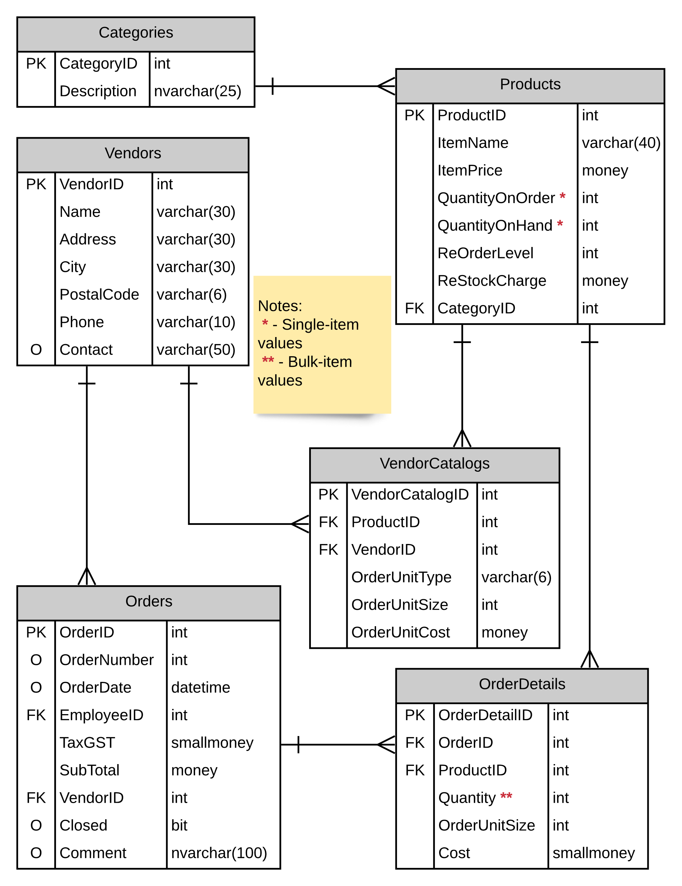

# Possible UX Interface

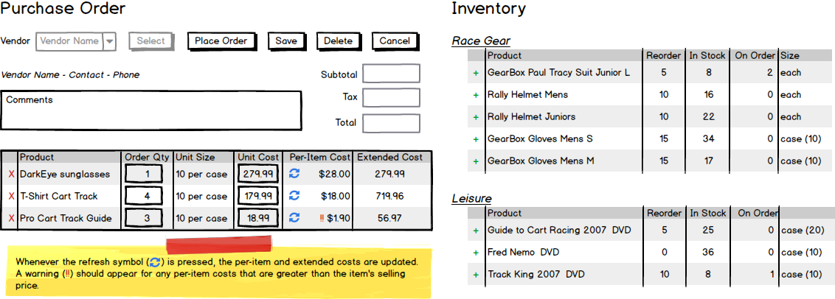

# ViewModel Classes:

public class SelectionList

{

int IdValue {get;set;}

string DisplayText {get;set;}

}

public class PurchaseOrder

{

int PurchaseOrderId {get;set;}

int VendorId {get;set;}

int PurchaseOrderNumber {get;set;}

DateTime PurchaseOrderDate {get;set;}

string VendorName {get;set;}

string VendorContact {get;set;}

string VendorPhone {get;set;}

double Subtotal {get;set;}

double Tax {get;set;}

double Total {get;set;}

string Comments {get;set;}

}

public class PurchaseOrderDetailsList

{

int PurchaseOrderDetailId {get;set;}

int PurchaseOrderId {get;set;}

string ProductName {get;set;}

int PurchaseOrderQuantity {get;set;}

int UnitSize {get;set;}

string UnitType {get;set;}

double UnitCost {get;set;}

double PerItemCost {get;set;}

double ExtendedCost {get;set;}

}

public class InventoryList

{

int VendorId {get;set;}

int ProductId {get;set;}

string CategoryName {get;set;}

string ProductName {get;set;}

int ReOrderLevel {get;set;}

int InStockQuantity {get;set;}

int OnOrderQuantity {get;set;}

string UnitType {get;set;}

int UnitSize {get;set;}

# }

# Event and Wiring Summations

public List<SelectionList> List_Vendor()

{

// use VendorController class

// Retrieve all vendor names and vendor ID for DDL

}

public PurchaseOrder Get_PurchaseOrder(int VendorId)

{

// use OrderController

// Retrieve active order detail where VendorId is equal to ViewModel's VendorId, and where OrderNumber and OrderDate are null

// if there is no active purchase order yet, create new object of Orders with the next OrderId

}

public List<PurchaseOrderDetailsList> List_PurchaseOrderDetails(int PurchaseOrderId)

{

// use OrderDetailsController

// Retrieve list of Purchase Order Details where param PurchaseOrderId is equal to View Model PurchaseId

}

public List<InventoryList> List_InventoryList(int VendorId)

{

// use ProductsController, CategoriesController and VendorCatalogsController

// Retrieve list of Inventory (products) offered by a specific vendor (by VendorId)

}

public void Save_PurchaseOrderDetails(int PurchaseOrderId, List<PurchaseOrderDetailsList> PurchaseOrderDetailsId)

{

// update new details on every PurchaseOrderDetails item

}

public void Place_PurchaseOrder(PurchaseOrder Order)

{

// assign new PurchaseOrderNumber to the next available purchase order number

// get system date and assign it to PurchaseOrderDate.

}

public void Add_ProductInPurchaseOrder(int ProductId, int VendorId, int PurchaseOrderId)

{

// create purchase order if there is no active (existing) purchase order,

// if there is active purchase order, verify that the product is not already on the list, if so reject

// add new product to purchase order

}

public void Remove_ProductInPurchaseOrder(int PurchaseOrderDetailId, int PurchaseOrderId)

{

// remove product in purchase order (delete PurchaseOrderDetail)

}

public void Delete_PurchaseOrder(int PurchaseOrderId, List<int> PurchaseOrderDetailsId)

{

// find all purchase order details

// delete purchase order details

// delete purchase order

}