Module 1.3 Assignment: Building a Web Page Exercise, Part 1

## First-time Validator Results:

## Second-time Validator Results:

## Default Browser, Web Page Screenshot:

Code:

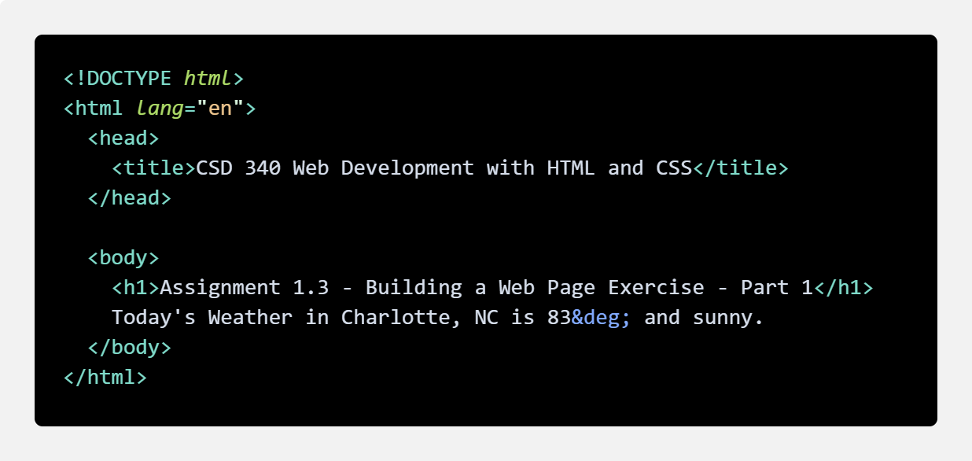

GitHub Link:

<https://github.com/erosales48/csd-340/blob/main/module-1/Rosales_Mod1_3.html>