Java Script Exam
Max Marks: 40 Time: 1:30 Hr.

Q1. How to check if an object is an array or not? Provide some code. 4
Q2. Write the JavaScript code to change the content and color of the HTML element below when we click button?
<h1 id="demo">May the code be with you.</h1> 4
Q3. Write a function that takes the base and height of a triangle and return its area. 4
Q4. Write a JavaScript program to find the maximum number in an array. 4
Q5. Write a JavaScript function that reverses a number. 6
Example x = 32243;
Expected Output : 34223
Q6. Write a JavaScript program to calculate multiplication and division of two numbers (input from the user). 6
Sample form :
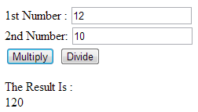
Q7. Write a JavaScript program to display the current day and time in the following format. 6
Today is : Tuesday.
Current time is : 10 PM : 30 : 38
Q8. Write a Java Script Program to create 10-character random password generator. 6

