Bitcoin Market Sentiment Analysis
Fear & Greed Index — Exploratory Data Analysis Report

Submitted by: Pradeep Kumar Verma
Role Applied: Data Science Analyst — Primetrade.ai
Dataset: Bitcoin Fear & Greed Index (February 2018 – May 2025)
Total Records: 2,644 daily observations
Date of Submission: April 2026

1. Introduction & Objective
This report presents a comprehensive Exploratory Data Analysis (EDA) of the Bitcoin Fear & Greed Index dataset spanning February 2018 to May 2025 — a total of 2,644 daily data points. The Fear & Greed Index is a widely-used composite sentiment indicator that aggregates multiple signals including volatility, market momentum, social media buzz, surveys, dominance, and trends into a single 0–100 score.

The primary objectives of this analysis are:
- Understand the historical distribution of Bitcoin market sentiment across five classifications: Extreme Fear, Fear, Neutral, Greed, and Extreme Greed
- Identify multi-year sentiment trends and regime shifts (2018–2025)
- Analyze seasonal patterns: which months/years exhibit the most bullish or bearish sentiment
- Model sentiment regime persistence using transition probability analysis
- Derive mean-reversion insights: how sentiment evolves after extreme readings
- Generate actionable insights applicable to algorithmic trading strategies

Note: The Historical Trader Data from Hyperliquid (Part 2 of the assignment) will be incorporated in the next submission phase once the dataset is accessible. The findings below represent the standalone sentiment analysis which forms the foundation of any trader-performance correlation study.

2. Dataset Overview

2.1 Structure & Basic Statistics
Attribute | Detail
Total Records | 2,644 daily observations
Date Range | 1 February 2018 — 2 May 2025
Columns | timestamp, value (0–100), classification, date
Mean Index Value | 46.98 (slightly below neutral)
Median Index Value | 46.00
Standard Deviation | 21.83 (high volatility of sentiment)
Min / Max | 5 (2019, deep capitulation) / 95 (2021, peak mania)
Missing Values | None — complete daily coverage

2.2 Classification Distribution
Classification | Days | % of Total | Range
Extreme Fear | 508 | 19.2% | 0 – 24
Fear | 781 | 29.5% | 25 – 49
Neutral | 396 | 15.0% | 50 – 54 (approx.)
Greed | 633 | 23.9% | 55 – 74 (approx.)
Extreme Greed | 326 | 12.3% | 75 – 100

Combined Fear (Extreme Fear + Fear) accounts for 48.7% of all days, significantly outweighing combined Greed at 36.2%. This is consistent with Bitcoin's historical narrative of periods of prolonged uncertainty punctuated by shorter but intense bull runs.

3. Visualizations & Analysis

3.1 Full Timeline — Daily Sentiment (2018–2025)
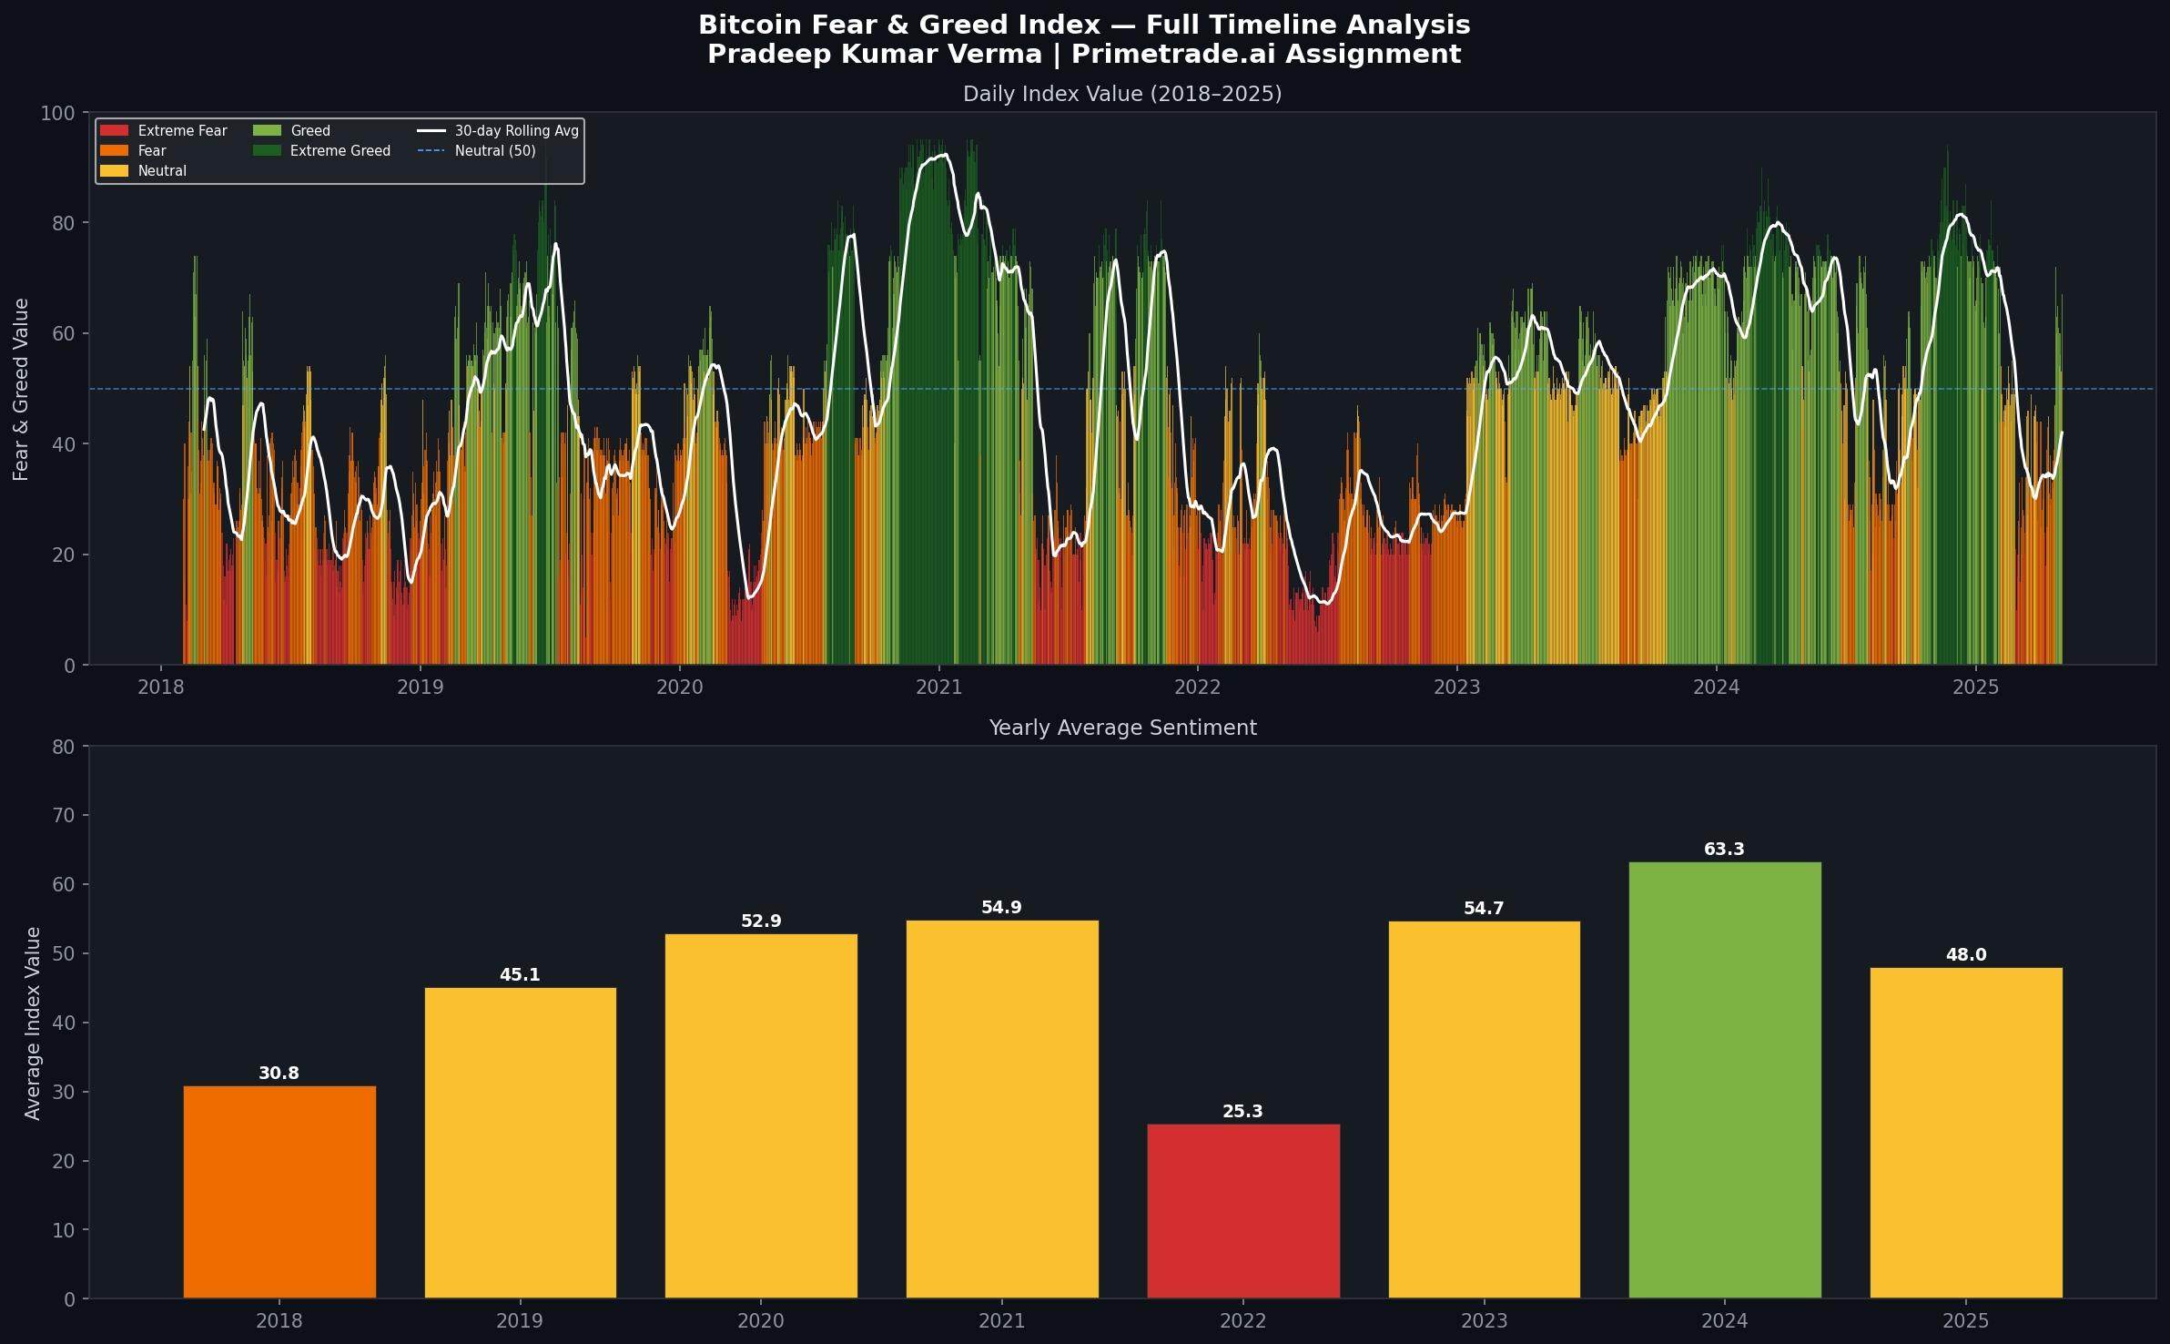
The timeline reveals distinct macroeconomic cycles aligned with Bitcoin's market phases. The 2018 bear market dominated by red (fear), the 2020–2021 bull cycle in green (greed), the brutal 2022 bear market (the most fear-dominated year at avg 25.3), and the strong 2023–2024 recovery into greed territory are all clearly visible. The 30-day rolling average confirms these long-duration regime shifts.

3.2 Distribution, Transitions & Seasonality
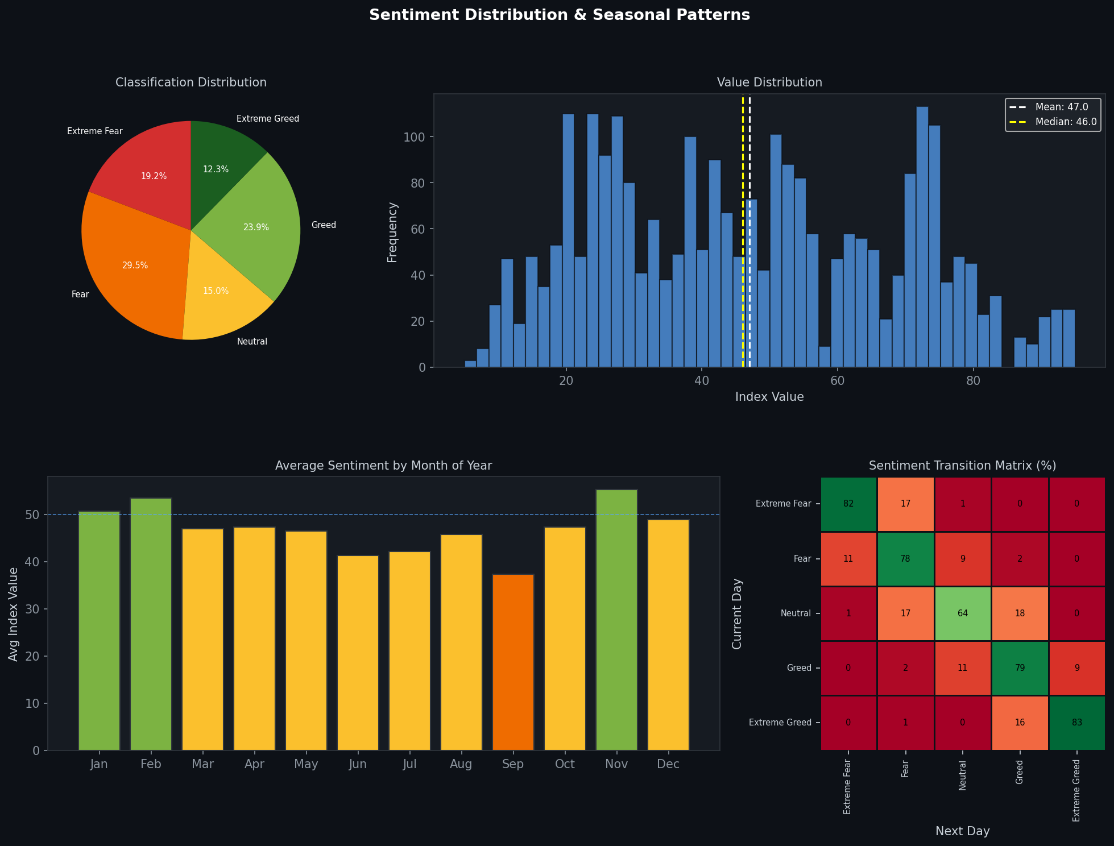
The value distribution is broadly bimodal — with mass concentrated in the 10–35 (fear) and 55–85 (greed) ranges, with a thinner neutral band around 50. The transition matrix is the most strategically valuable chart: diagonal values of 81–83% for Extreme Fear and Extreme Greed confirm that sentiment regimes are highly persistent. Once Bitcoin enters an extreme sentiment zone, it tends to stay there for weeks.

Monthly seasonality reveals a consistent September weakness (avg 37.4) — historically aligned with the 'Septembear' narrative in crypto markets. November is the strongest month (avg 55.3), often driven by year-end momentum and historically coinciding with bull-market acceleration phases.

3.3 Monthly Sentiment Heatmap by Year
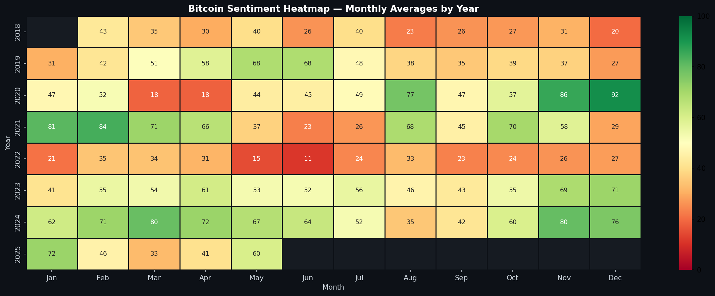
This heatmap offers a granular year-over-year view. Key observations: 2022 is uniformly deep red across almost all months. 2024 is the most uniformly green year in the dataset. The Q4 months (Oct–Dec) show a general tendency toward greed in bull years (2020, 2021, 2024) — a seasonal pattern potentially exploitable in systematic trading strategies.

4. Key Analytical Findings

4.1 Sentiment Regime Persistence (Momentum Effect)
The transition probability matrix demonstrates that Bitcoin sentiment exhibits strong autocorrelation. The probability of remaining in the same sentiment state the next day:
- Extreme Fear → Extreme Fear: 81.9%
- Extreme Greed → Extreme Greed: 83.1%
- Fear → Fear: 78.1%
- Greed → Greed: 78.8%
- Neutral → Neutral: 64.1%
This finding has significant implications for trading strategy design: contrarian entries into extreme zones should expect prolonged drawdown periods before mean reversion occurs. The longest single Extreme Greed streak was 77 days; the longest Extreme Fear streak was 74 days.

4.2 Yearly Trend Analysis
Year | Avg Value | Fear Days | Greed Days | Dominant Regime
2018 | 30.8 | 284 | 23 | Extreme Fear — Post-ATH crash
2019 | 45.1 | 210 | 121 | Fear — Recovery but uncertain
2020 | 52.9 | 160 | 143 | Balanced — COVID crash + halving
2021 | 54.9 | 136 | 199 | Greed — Bull cycle peak
2022 | 25.3 | 338 | 3 | Extreme Fear — LUNA/FTX collapse
2023 | 54.7 | 48 | 165 | Greed — Recovery year
2024 | 63.3 | 59 | 263 | Extreme Greed — ETF + halving bull run
2025* | 48.0 | 54 | 42 | Neutral — Partial year, correction
*2025 data through May 2, 2025 only.

4.3 Mean Reversion Dynamics
After an Extreme Fear day, the 30-day forward average is only 27.2 — indicating that fear regimes persist and recovery is slow. After an Extreme Greed day, the 30-day forward average remains elevated at 73.4. This asymmetry is important: recoveries from fear take significantly longer than continuations in greed.

4.4 Seasonal Patterns
September consistently shows the lowest average sentiment (37.4), validating the 'Septembear' crypto market phenomenon. The Q4 period (October–December) historically trends bullish in non-bear years, with November averaging the highest at 55.3. This suggests potential seasonal entry/exit signals for systematic traders.

5. Strategic Insights for Trading
Based solely on the Fear & Greed Index analysis, the following insights are relevant for designing algorithmic trading strategies:

Insight | Strategic Implication
Regime persistence is high (80%+) | Trend-following strategies outperform contrarian strategies in the short term. Avoid catching a falling knife during Extreme Fear.
September is seasonally weak | Reduce exposure or hedge in September. Historical data supports this across multiple market cycles.
Extreme Greed streaks average 77 days | Bull markets can sustain greed much longer than expected. Premature shorting during Extreme Greed has high failure rates.
2022 had 338 fear days / 3 greed days | Bear market conditions are binary in crypto — once fear takes hold, it dominates for months. A trailing stop-loss strategy is essential.
Neutral zone is transitional | Neutral sentiment (50–54) transitions to either Fear or Greed with ~equal probability (~17–18% each). Use other indicators to determine direction in neutral zones.

6. Next Steps — Trader Performance Correlation
Once the Hyperliquid Historical Trader Data is incorporated, the following analyses will extend this report:
- Correlate individual trader PnL with prevailing Fear & Greed regime on trade execution date
- Identify whether traders using leverage perform differently during Extreme Fear vs Extreme Greed
- Segment long vs short trader performance across sentiment regimes
- Build a predictive model: Does sentiment index predict trader win-rate the following week?
- Detect traders who systematically profit during sentiment reversals (contrarian alpha)
- Apply clustering to identify sentiment-sensitive trader archetypes

7. Conclusion
This EDA reveals that the Bitcoin Fear & Greed Index is a powerful and structured dataset with clear cyclical patterns. Key conclusions:
- Bitcoin markets spend more time in fear (48.7%) than greed (36.2%), reflecting the asymmetric risk profile of the asset
- Sentiment regimes are highly persistent (80–83% same-state probability), suggesting momentum-based strategies are more reliable than contrarian ones in the short term
- 2022 was the most fear-dominated year (avg 25.3), driven by macro tightening and major exchange failures
- 2024 was the most bullish year on record (avg 63.3), driven by Bitcoin ETF approvals and the halving
- September is the most seasonally weak month; November is the strongest
- Mean reversion from Extreme Fear is slow (30-day forward avg still only 27.2)

These patterns, when cross-referenced with trader execution data, are expected to yield actionable alpha signals and behavioral profiles of profitable vs unprofitable traders across market sentiment cycles.

Submitted by Pradeep Kumar Verma | Senior Data Analyst | pradeepkumarverma@example.com | github.com/erprad8 | linkedin.com/in/erprad8

