2. Problem Statement In this assignment students need to predict whether a person makes over 50K per year or not from classic adult dataset using XGBoost. The description of the dataset is as follows: Data Set Information: Extraction was done by Barry Becker from the 1994 Census database. A set of reasonably clean records was extracted using the following conditions: ((AAGE>16) && (AGI>100) && (AFNLWGT>1)&& (HRSWK>0)) Attribute Information: Listing of attributes: >50K, <=50K. age: continuous. workclass: Private, Self-emp-not-inc, Self-emp-inc, Federal-gov, Local-gov, State-gov, Without-pay, Never-worked. fnlwgt: continuous. education: Bachelors, Some-college, 11th, HS-grad, Prof-school, Assoc-acdm, Assoc-voc, 9th, 7th-8th, 12th, Masters, 1st-4th, 10th, Doctorate, 5th-6th, Preschool. education-num: continuous. marital-status: Married-civ-spouse, Divorced, Never-married, Separated, Widowed, Married-spouse-absent, Married-AF-spouse. occupation: Tech-support, Craft-repair, Other-service, Sales, Exec-managerial, Profspecialty, Handlers-cleaners, Machine-op-inspct, Adm-clerical, Farming-fishing, Transport-moving, Priv-house-serv, Protective-serv, Armed-Forces. relationship: Wife, Own-child, Husband, Not-in-family, Other-relative, Unmarried. race: White, Asian-Pac-Islander, Amer-Indian-Eskimo, Other, Black. sex: Female, Male. capital-gain: continuous. capital-loss: continuous. hours-per-week: continuous. native-country: United-States, Cambodia, England, Puerto-Rico, Canada, Germany, Outlying-US(Guam-USVI-etc), India, Japan, Greece, South, China, Cuba, Iran, Honduras, Philippines, Italy, Poland, Jamaica, Vietnam, Mexico, Portugal, Ireland, France, Dominican-Republic, Laos, Ecuador, Taiwan, Haiti, Columbia, Hungary, Guatemala, Nicaragua, Scotland, Thailand, Yugoslavia, El-Salvador, Trinadad&Tobago, Peru, Hong, Holand-Netherlands. Following is the code to load required libraries and data: import numpy as np import pandas as pd train_set = pd.read_csv('http://archive.ics.uci.edu/ml/machine-learningdatabases/adult/adult.data', header = None) test_set = pd.read_csv('http://archive.ics.uci.edu/ml/machine-learningdatabases/adult/adult.test', skiprows = 1, header = None) col_labels = ['age', 'workclass', 'fnlwgt', 'education', 'education_num', 'marital_status', 'occupation','relationship', 'race', 'sex', capital_gain', 'capital_loss', 'hours_per_week', 'native_country', 'wage_class'] train_set.columns = col_labels test_set.columns = col_labels NOTE: The solution shared through Github should contain the source code used and the screenshot of the output.

Answer:

**import** **pandas** **as** **pd** **import** **numpy** **as** **np** **import** **math** **import** **statsmodels** **as** **sm** **import** **sklearn** **as** **skl** **from** **sklearn.preprocessing** **import** StandardScaler **import** **sklearn.linear_model** **as** **linear_model** **from** **sklearn.metrics** **import** classification_report **from** **sklearn.metrics** **import** roc_auc_score **import** **sklearn.metrics** **as** **metrics** **import** **sklearn.tree** **as** **tree** **import** **seaborn** **as** **sns** **import** **matplotlib.pyplot** **as** **plt** %matplotlib inline

Train_data = pd.read_csv('http://archive.ics.uci.edu/ml/machine-learning-databases/adult/adult.data', header = **None**, sep=' *, *', engine='python')

Test_data = pd.read_csv('http://archive.ics.uci.edu/ml/machine-learning-databases/adult/adult.test', skiprows = 1, sep=' *, *', engine='python', header = **None**)

pd.set_option('display.max_columns', **None**)

col_labels = ['age', 'workclass', 'fnlwgt', 'education', 'education_num', 'marital_status','occupation','relationship', 'race', 'sex', 'capital_gain', 'capital_loss', 'hours_per_week','native_country', 'wage_class']

Train_data.columns = col_labels

Test_data.columns = col_labels

Train_data.head()

Train_data.info()

Test_data.head()

Test_data.info()

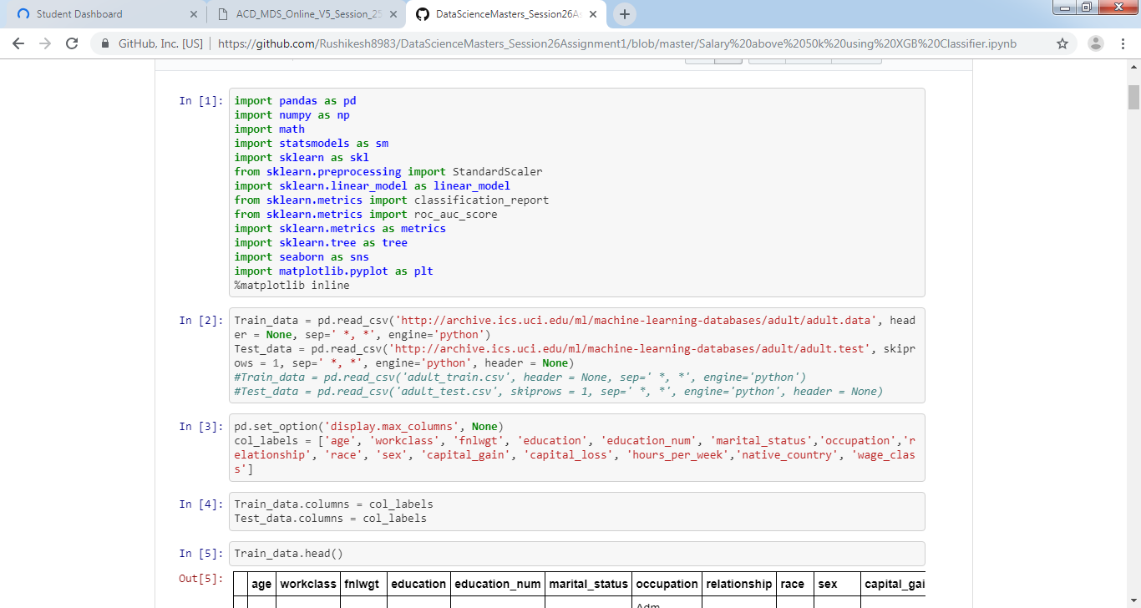

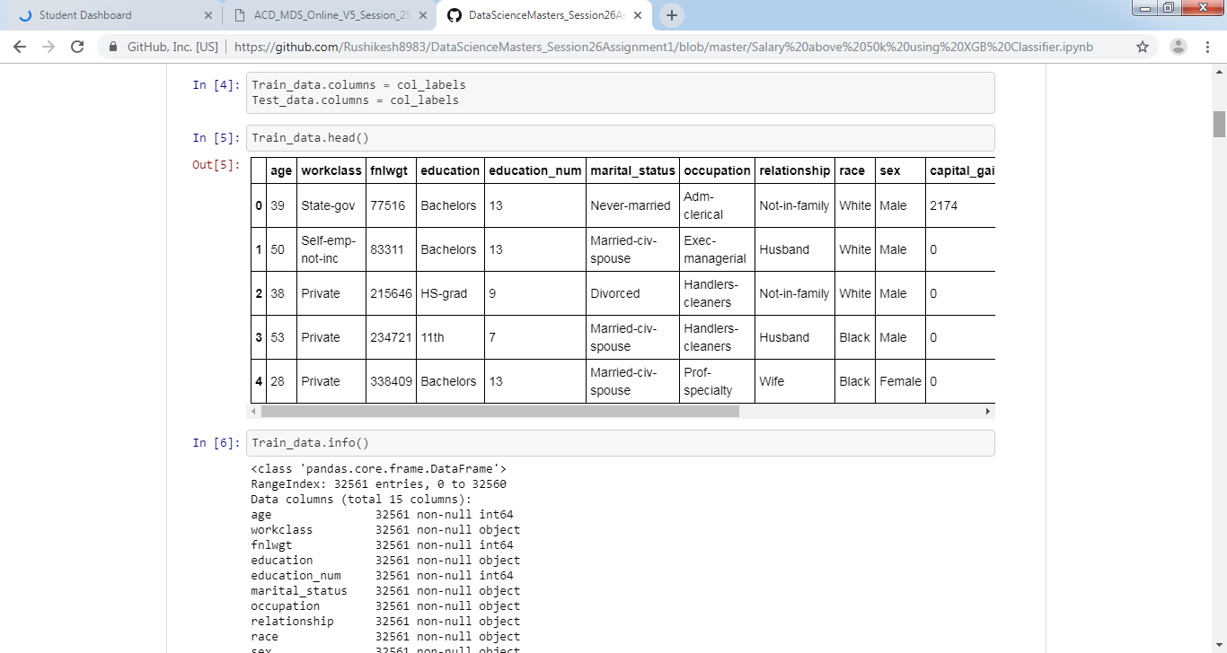

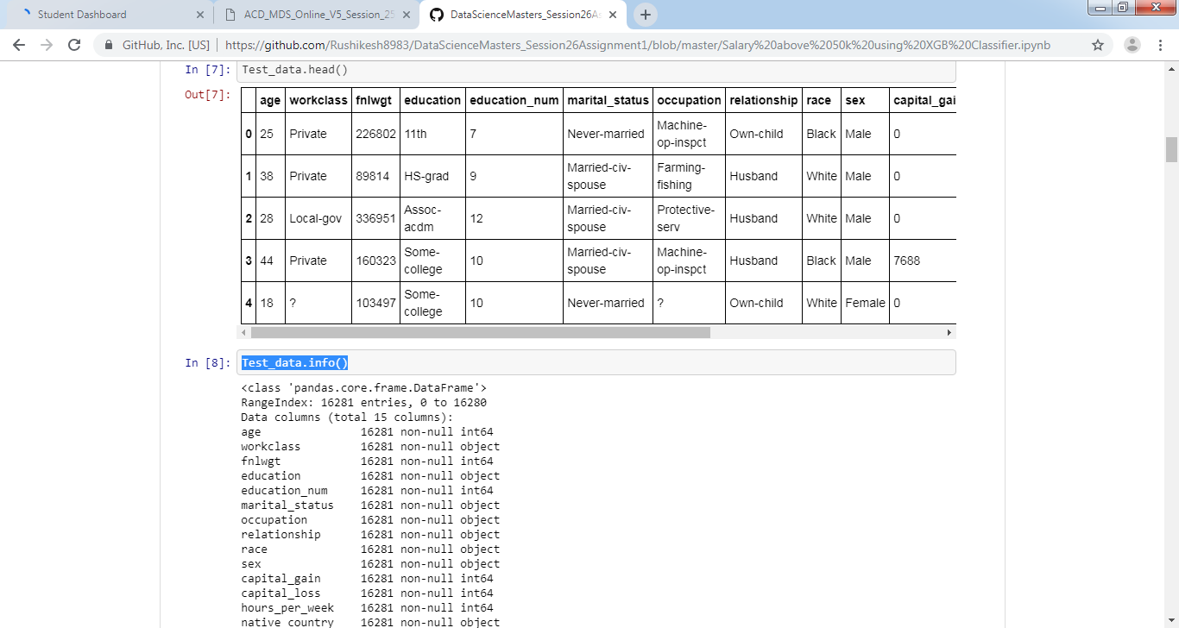

fig = plt.figure(figsize=(20,15))

cols = 5

rows = 3

**for** i, column **in** enumerate(Train_data.columns):

ax = fig.add_subplot(rows, cols, i + 1)

ax.set_title(column)

**if** Train_data.dtypes[column] == np.object:

Train_data[column].value_counts().plot(kind="bar", axes=ax)

**else**:

Train_data[column].hist(axes=ax)

plt.xticks(rotation="vertical")

plt.subplots_adjust(hspace=0.7, wspace=0.2)

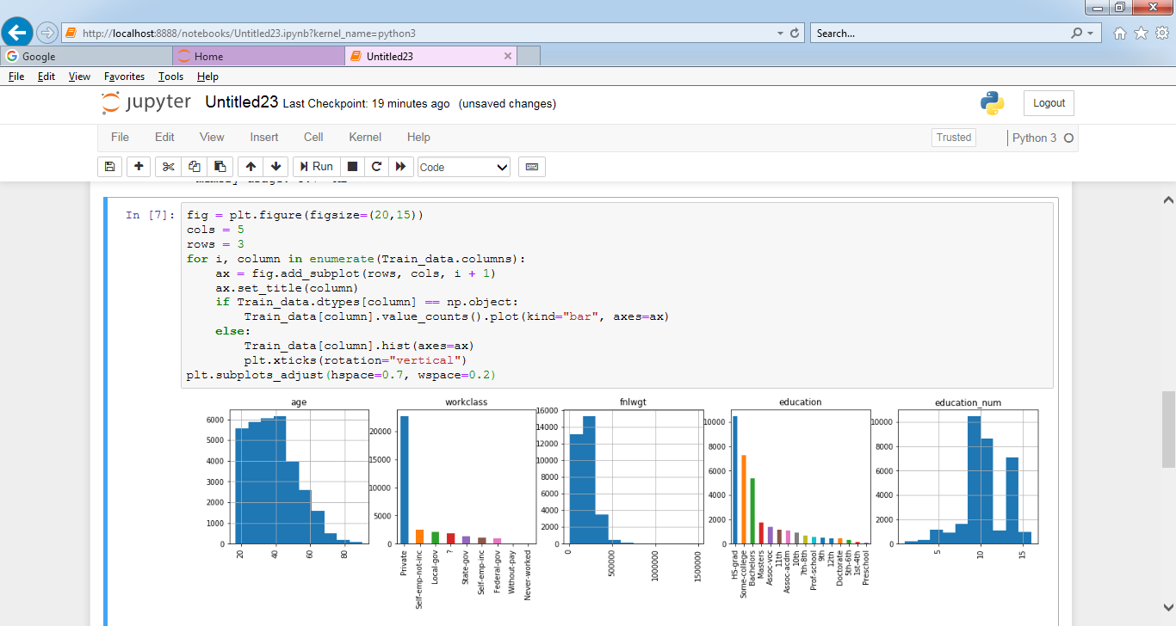

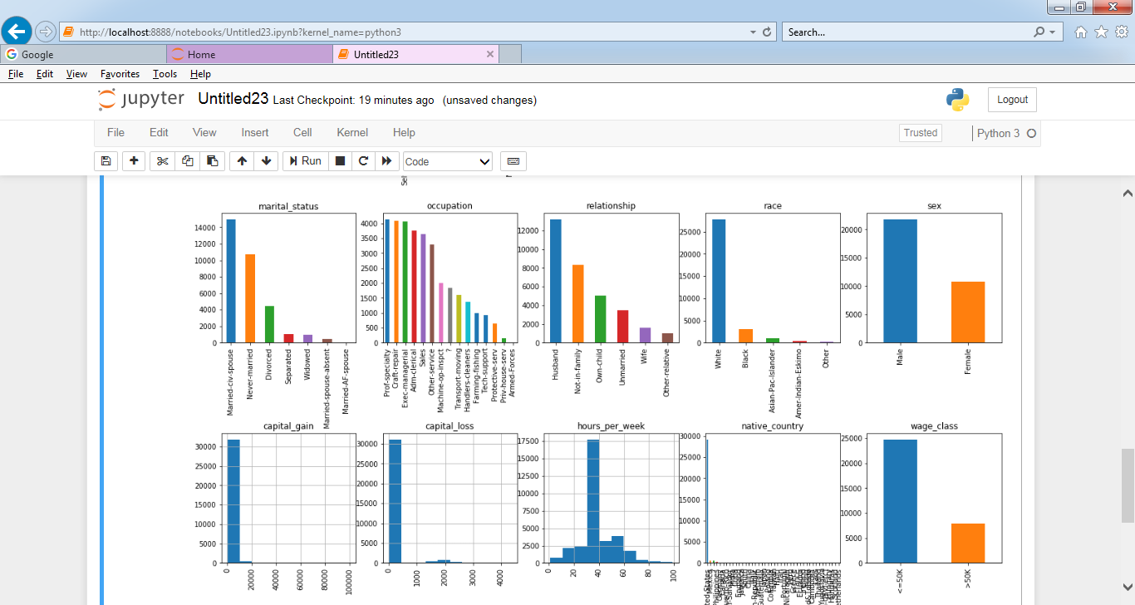

plt.figure(figsize=(15,10))

sns.heatmap(Train_data.corr())

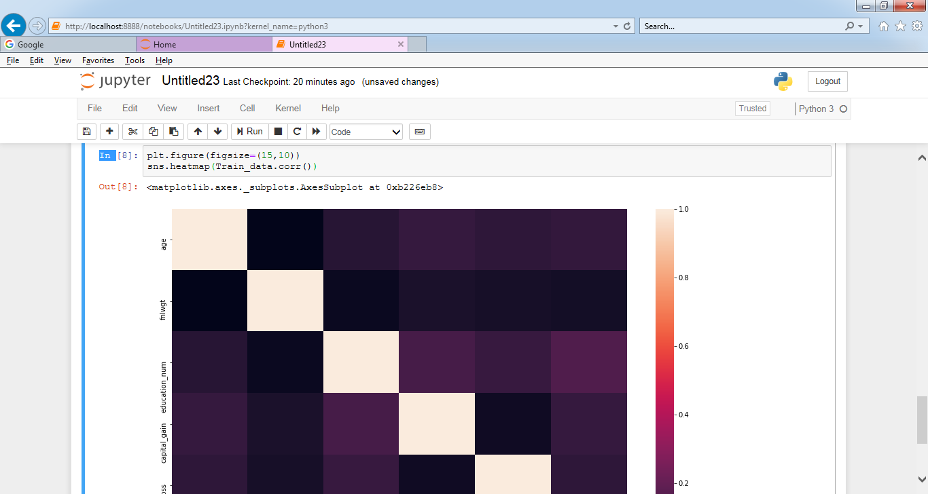

Train_data.replace('?', 'Unknown', inplace=True)

Test_data.replace('?', 'Unknown', inplace=True)

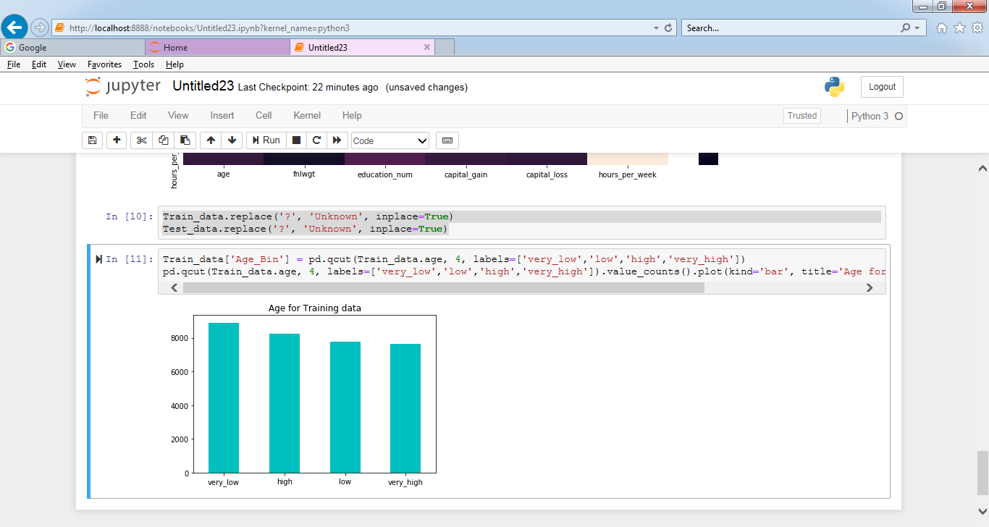

Test_data['Age_Bin'] = pd.qcut(Test_data.age, 4, labels=['very_low','low','high','very_high'])

pd.qcut(Test_data.age, 4, labels=['very_low','low','high','very_high']).value_counts().plot(kind='bar', title='Age for Testing data', color='c', rot=0);

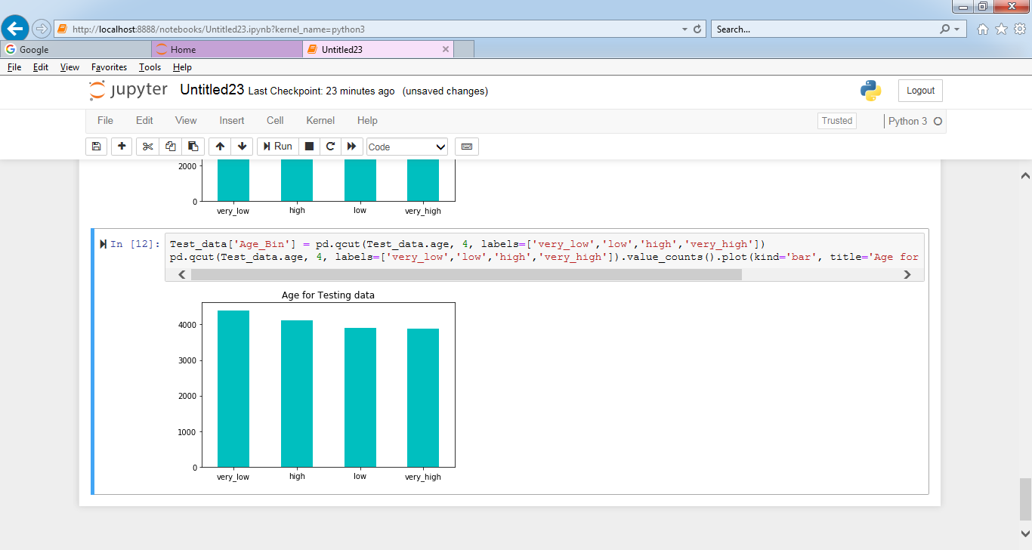

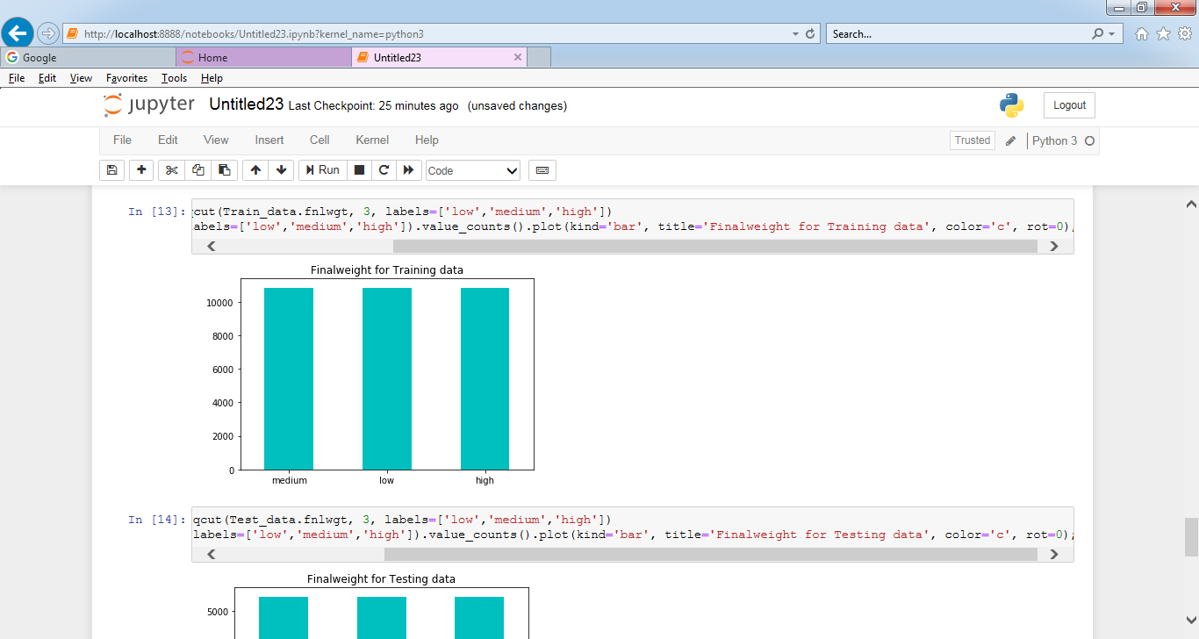

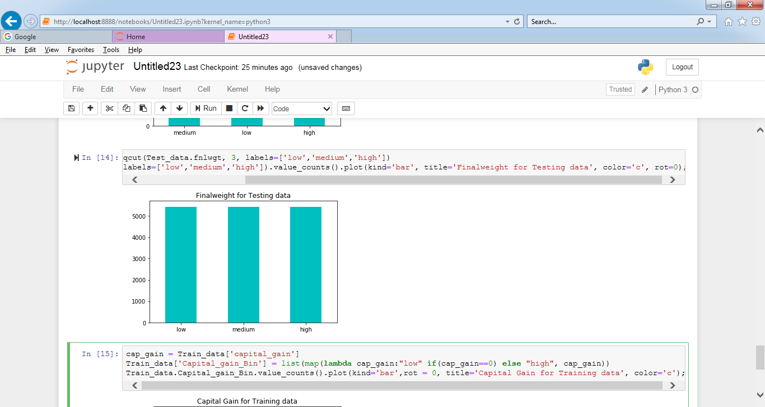

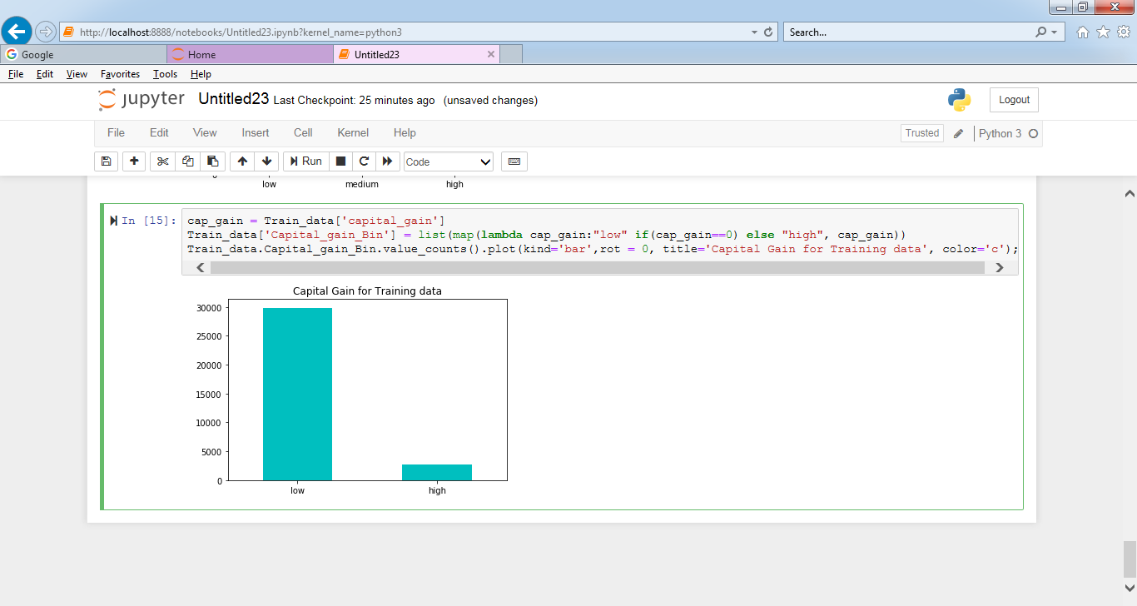

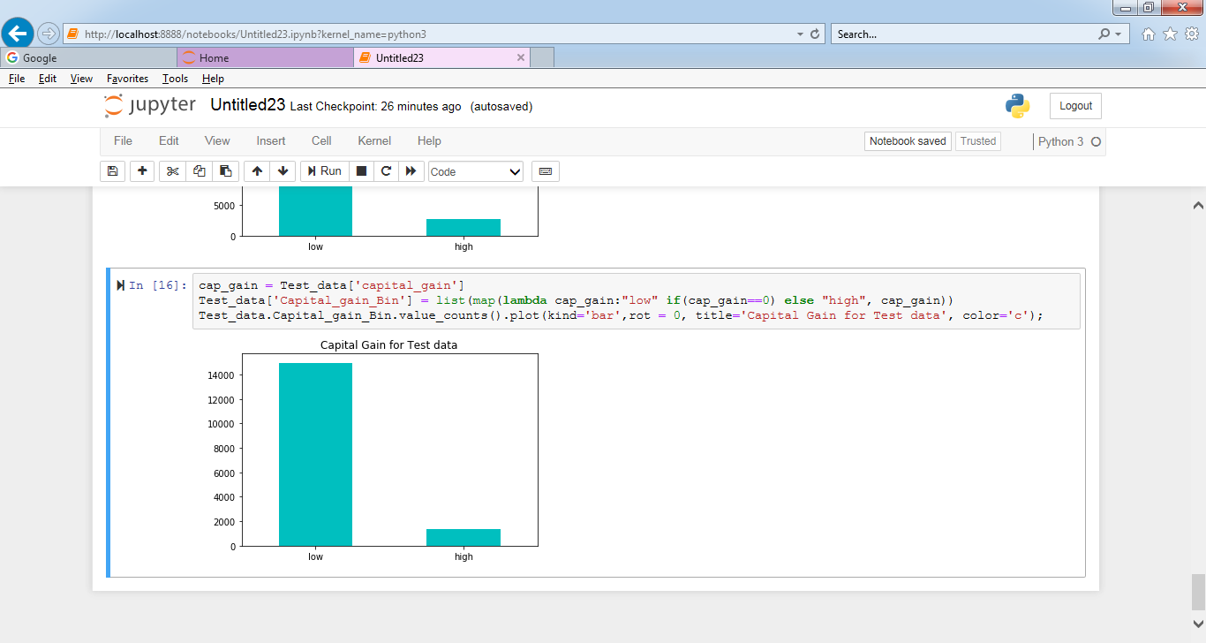

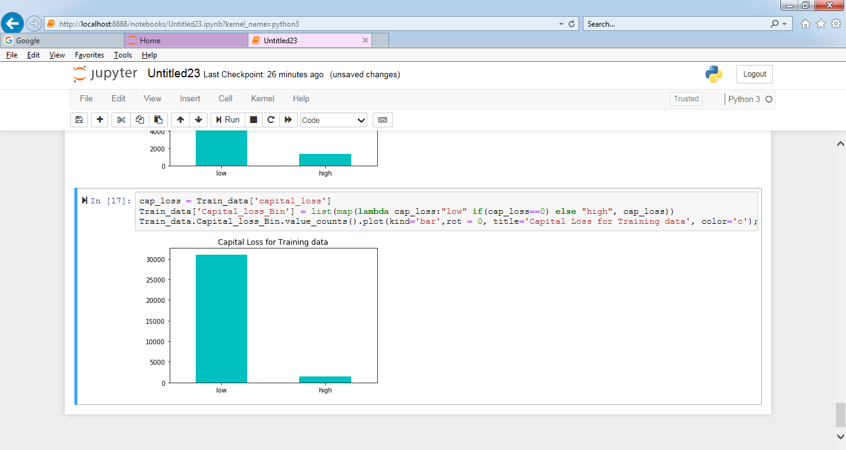

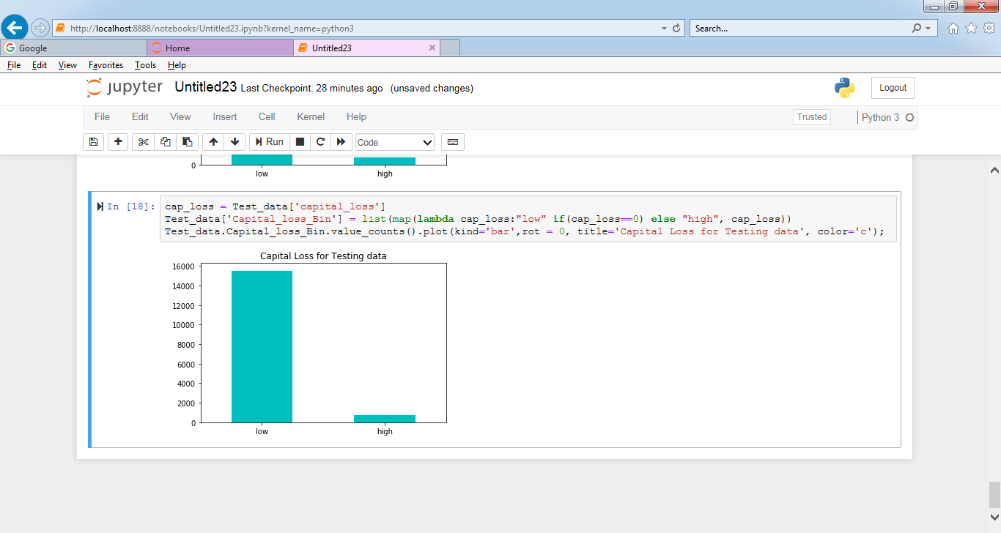

hpw = Train_data['hours_per_week']

Train_data['Hours_per_week_Bin'] = list(map(**lambda** hpw:"low" **if**(hpw<=30) **else** "high" **if** (hpw>30 **and** hpw<=40) **else** "very high", hpw))

Train_data.Hours_per_week_Bin.value_counts().plot(kind='bar',rot = 0, title='Hours per Week for Training data', color='c');

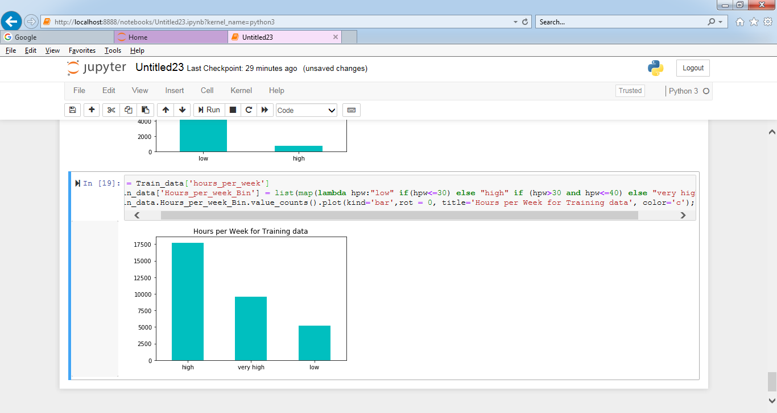

hpw = Test_data['hours_per_week']

Test_data['Hours_per_week_Bin'] = list(map(**lambda** hpw:"low" **if**(hpw<=30) **else** "high" **if** (hpw>30 **and** hpw<=40) **else** "very high", hpw))

Test_data.Hours_per_week_Bin.value_counts().plot(kind='bar',rot = 0, title='Hours per Week for Test data', color='c');

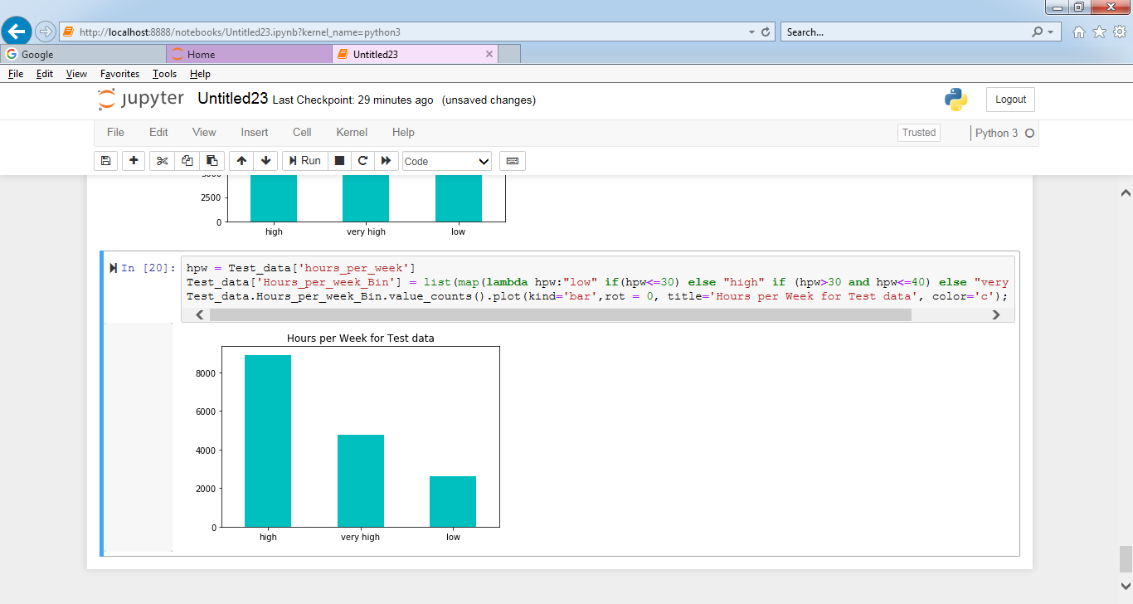

#One Hot Encoding for Feature Age, fnlwgt, capital_gain, capital_loss and hours_per_week across Training and Test dataset

Train_dummies_age_bin = pd.get_dummies(Train_data.Age_Bin, drop_first=True, prefix='Age')

Train_dummies_fnlwgt_bin = pd.get_dummies(Train_data.Fnlwgt_Bin, drop_first=True, prefix='Fnlwgt')

Train_dummies_capital_gain_bin = pd.get_dummies(Train_data.Capital_gain_Bin, drop_first=True, prefix='Capital_gain')

Train_dummies_capital_loss_bin = pd.get_dummies(Train_data.Capital_loss_Bin, drop_first=True, prefix='Capital_loss')

Train_dummies_hours_per_week_bin = pd.get_dummies(Train_data.Hours_per_week_Bin, drop_first=True, prefix='Hours_per_week')

Train_data = Train_data.join([Train_dummies_age_bin,Train_dummies_fnlwgt_bin,Train_dummies_capital_gain_bin,Train_dummies_capital_loss_bin,Train_dummies_hours_per_week_bin])

Train_data = Train_data.drop(['age','Age_Bin','fnlwgt','Fnlwgt_Bin','capital_gain','Capital_gain_Bin','capital_loss','Capital_loss_Bin','hours_per_week','Hours_per_week_Bin'],axis=1)

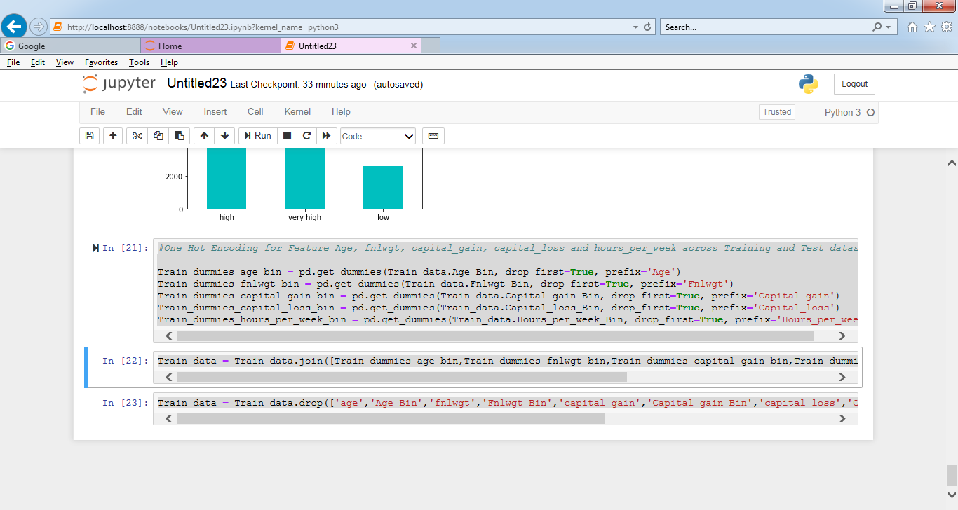

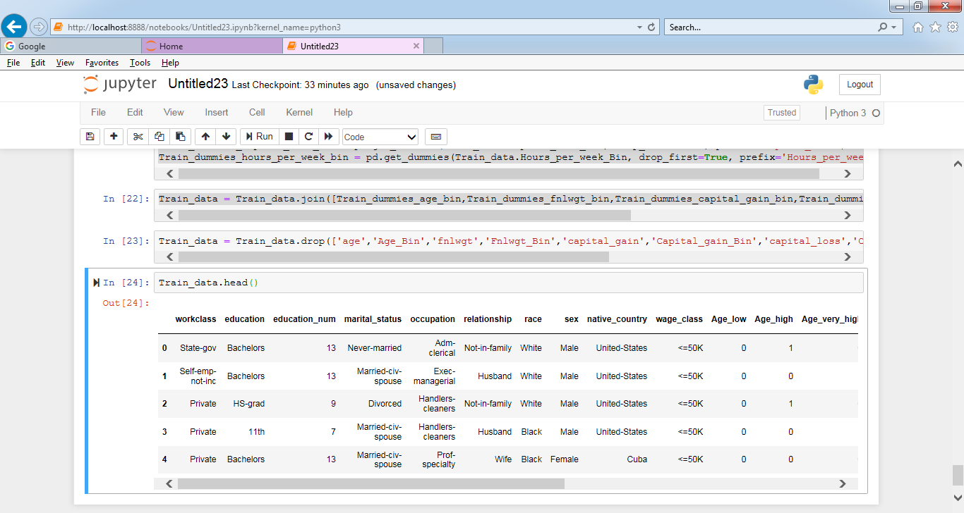

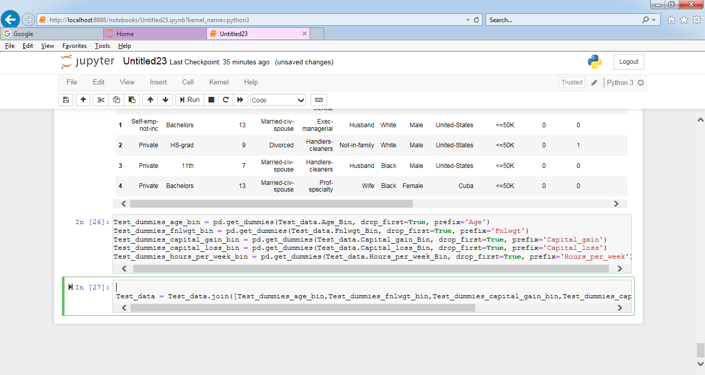

Test_data = Test_data.drop(['age','Age_Bin','fnlwgt','Fnlwgt_Bin','capital_gain','Capital_gain_Bin','capital_loss','Capital_loss_Bin','hours_per_week','Hours_per_week_Bin'],axis=1)

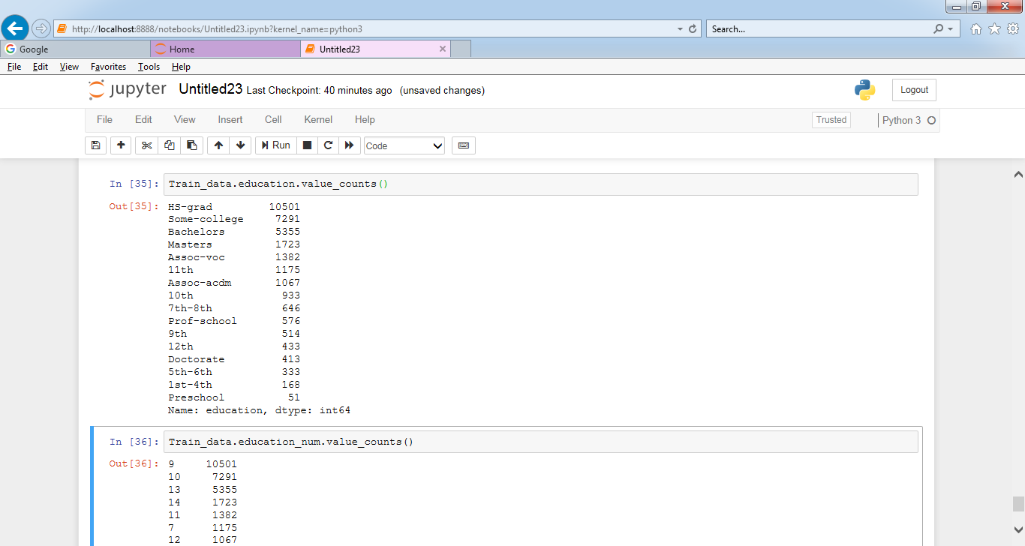

Train_data.drop(['education_num'], axis=1, inplace=**True**)

Test_data.education_num.value_counts()

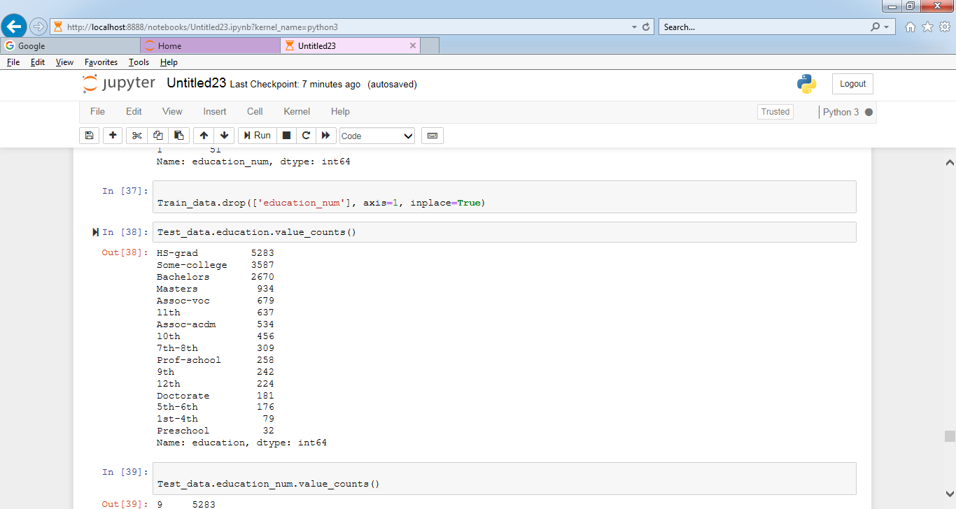

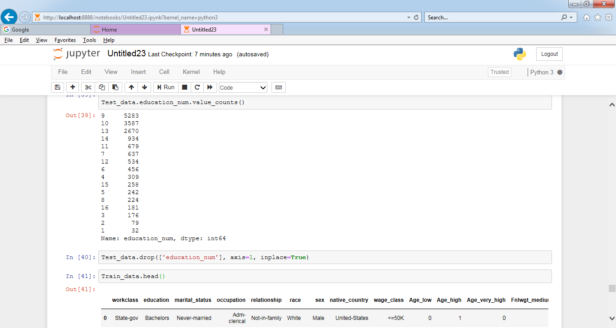

Train_data = pd.get_dummies(Train_data,columns=['workclass','education','marital_status','occupation','relationship','race','sex'],drop_first=True)

Test_data = pd.get_dummies(Test_data,columns=['workclass','education','marital_status','occupation','relationship','race','sex'],drop_first=True)

Train_data['wage_class'] = Train_data['wage_class'].map({'<=50K':0,'>50K':1})

Test_data['wage_class'] = Test_data['wage_class'].map({'<=50K.':0,'>50K.':1})

