APPLICATION OF CLUSTERING MODELS

Dataset Link https://drive.google.com/file/d/1pP0Rr83ri0voscgr95-YnVCBv6BYV22w/view Hint: Problem 1: There are various stocks for which we have collected a data set, which all stocks are apparently similar in performance

Problem 2: How many Unique patterns that exist in the historical stock data set, based on fluctuations in price.

Problem 3: Identify which all stocks are moving together and which all stocks are different from each other.

NOTE: The solution shared through Github should contain the source code used and the screenshot of the output.

import pandas as pd

import numpy as np

import matplotlib.pyplot as plt

%matplotlib inline

from sklearn.cluster import KMeans

from sklearn import metrics

from scipy.spatial.distance import cdist

from sklearn.decomposition import PCA

# Load the dataset

data = pd.read_csv('data_stocks.csv')

data.head(2)

data.info()

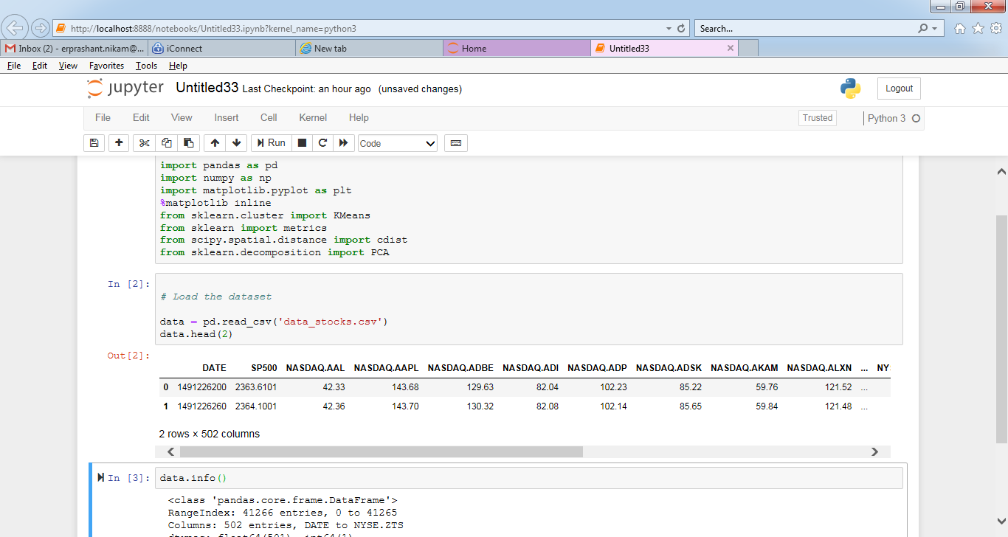

data.info()

data.columns

X = data.copy()

X=X.drop(columns='DATE')

y=X.pop('SP500')

X.columns

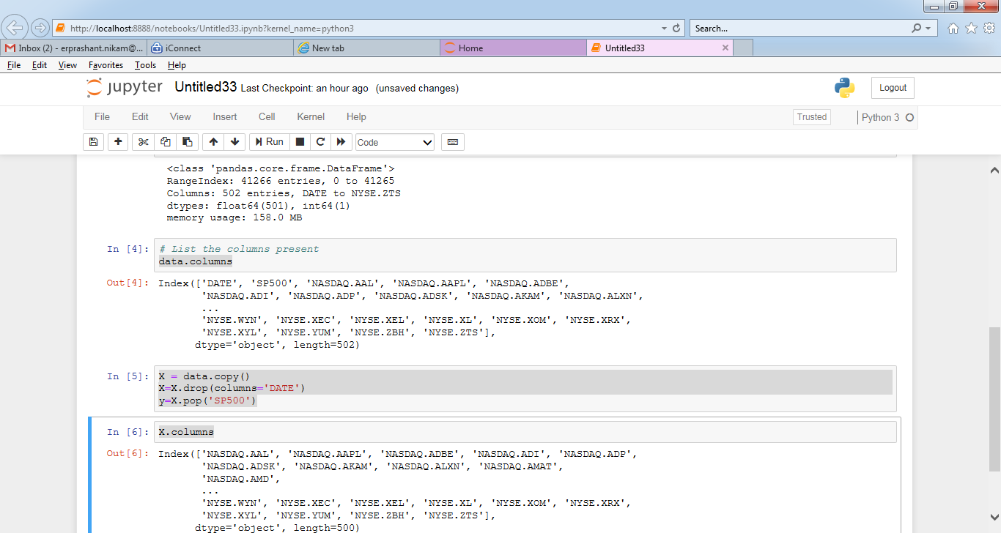

pca = PCA(n_components=5)

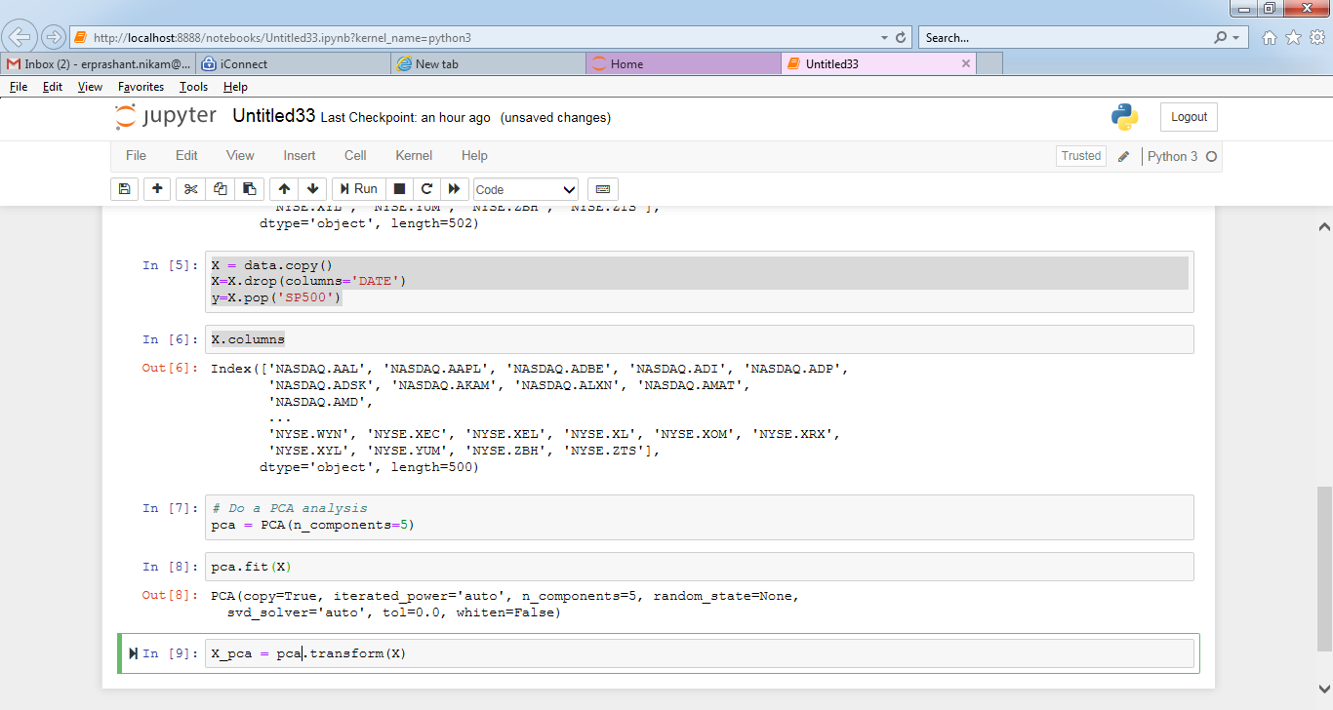

pca.fit(X)

X_pca = pca.transform(X)

*# Plot the PCA components*

plt.figure(figsize=(16,9))

plt.scatter(X_pca[:,0],X_pca[:,1])

plt.ylabel('PC1')

plt.xlabel('PC2')

plt.show()

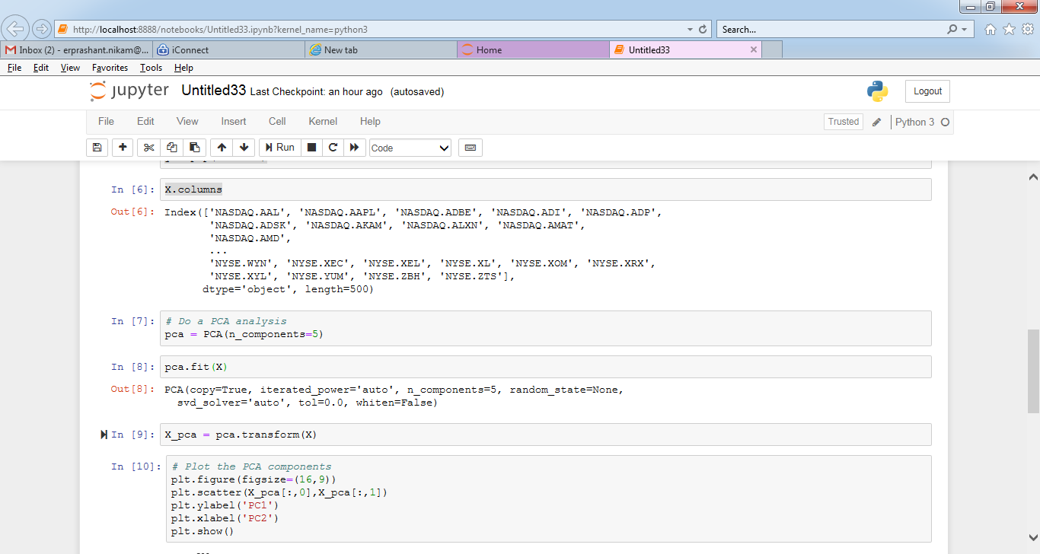

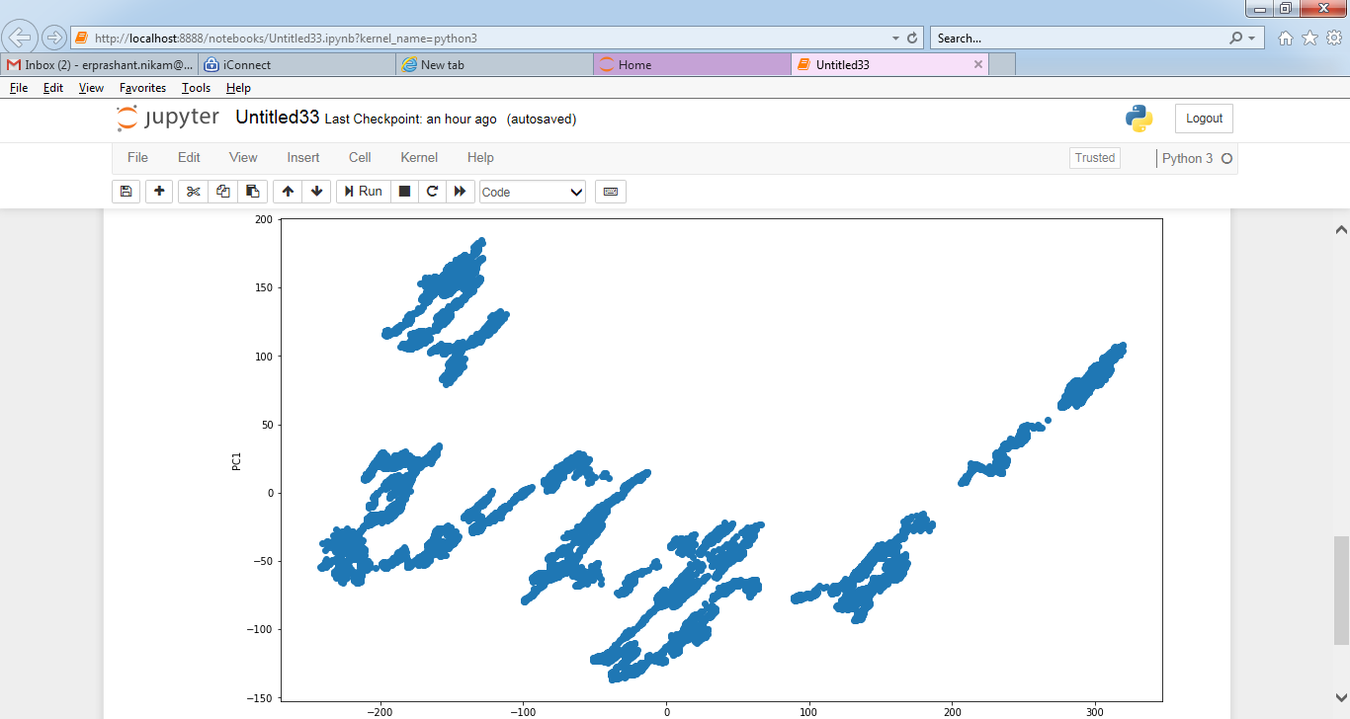

pca.explained_variance_

*# Find the number of clusters*

distortions = []

K = range(1,20)

**for** k **in** K:

kmeanModel = KMeans(n_clusters=k).fit(X)

kmeanModel.fit(X)

distortions.append(sum(np.min(cdist(X, kmeanModel.cluster_centers_, 'euclidean'), axis=1)) / X.shape[0])

*# Plot the elbow*

plt.plot(K, distortions, 'bx-')

plt.xlabel('k')

plt.ylabel('Distortion')

plt.title('The Elbow Method showing the optimal k')

plt.show()

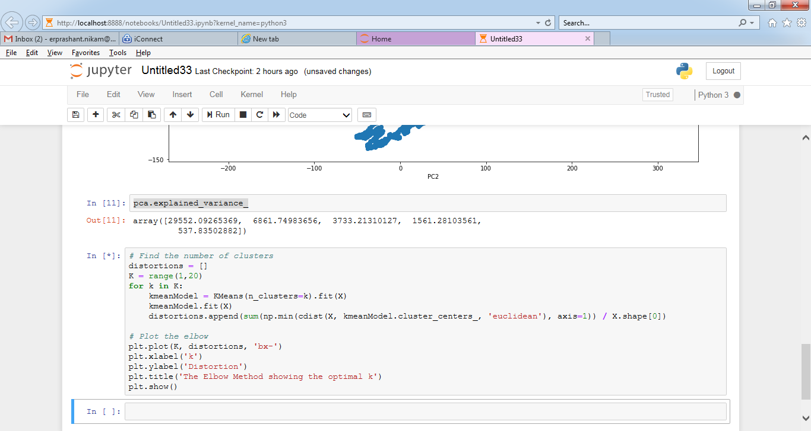

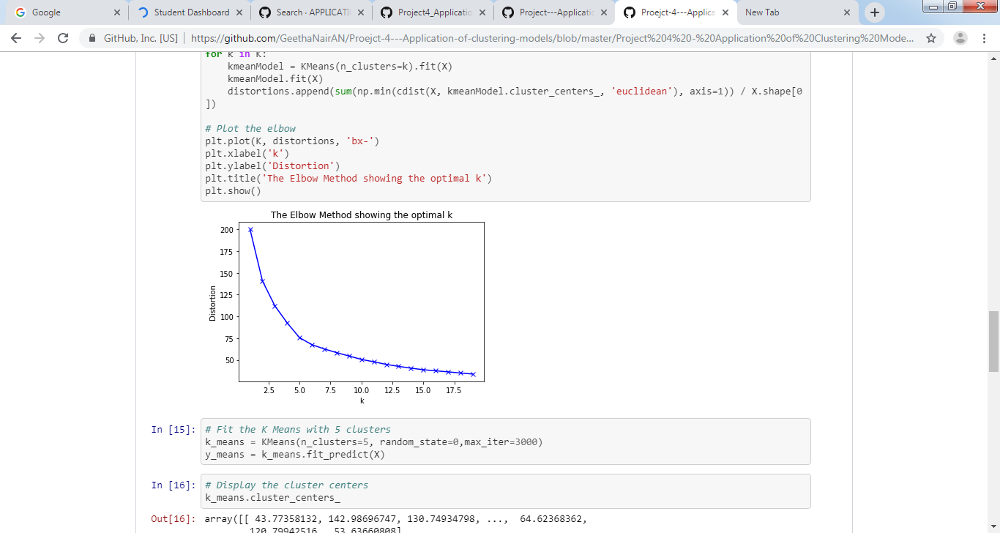

# Fit the K Means with 5 clusters

k_means = KMeans(n_clusters=5, random_state=0,max_iter=3000)

y_means = k_means.fit_predict(X)

k_means.cluster_centers_

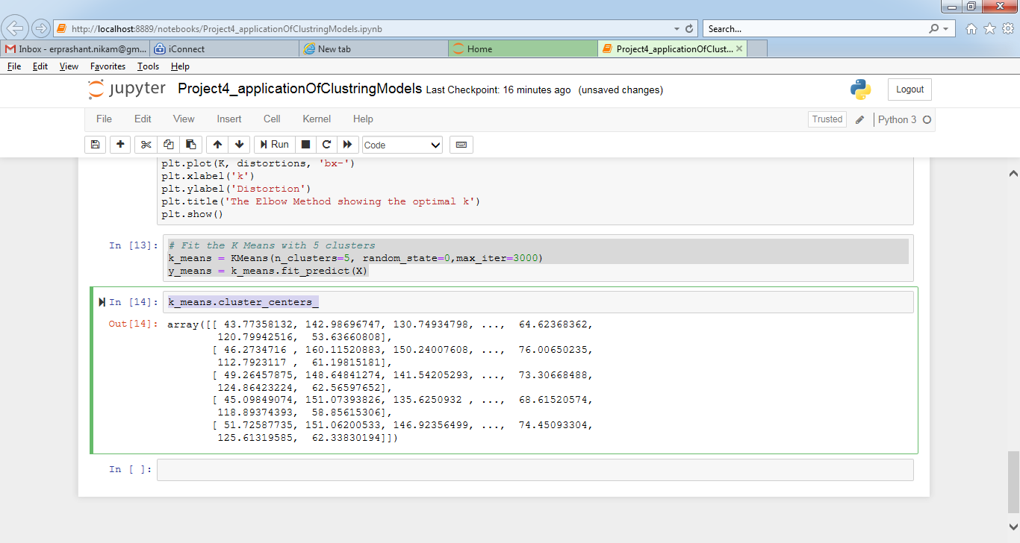

k_means.labels_.ravel()

k_means_cluster_centers = np.sort(k_means.cluster_centers_, axis=0)

k_means_labels = metrics.pairwise_distances_argmin(X, k_means_cluster_centers)

# Plot the cluster values.

plt.figure(figsize=(10,10))

plt.scatter(X.iloc[y_means == 0,0], X.iloc[y_means == 0,499], s= 100, color = 'red')

plt.scatter(X.iloc[y_means == 1,0], X.iloc[y_means == 1,499], s= 100, color = 'blue')

plt.scatter(X.iloc[y_means == 2,0], X.iloc[y_means == 2,499], s= 100, color = 'green')

plt.scatter(X.iloc[y_means == 3,0], X.iloc[y_means == 3,499], s= 100, color = 'magenta')

plt.scatter(X.iloc[y_means == 4,0], X.iloc[y_means == 4,499], s= 100, color = 'cyan')

plt.scatter(k_means.cluster_centers_[:,0], k_means.cluster_centers_[:, 499], s= 300, color = 'yellow')

plt.show()

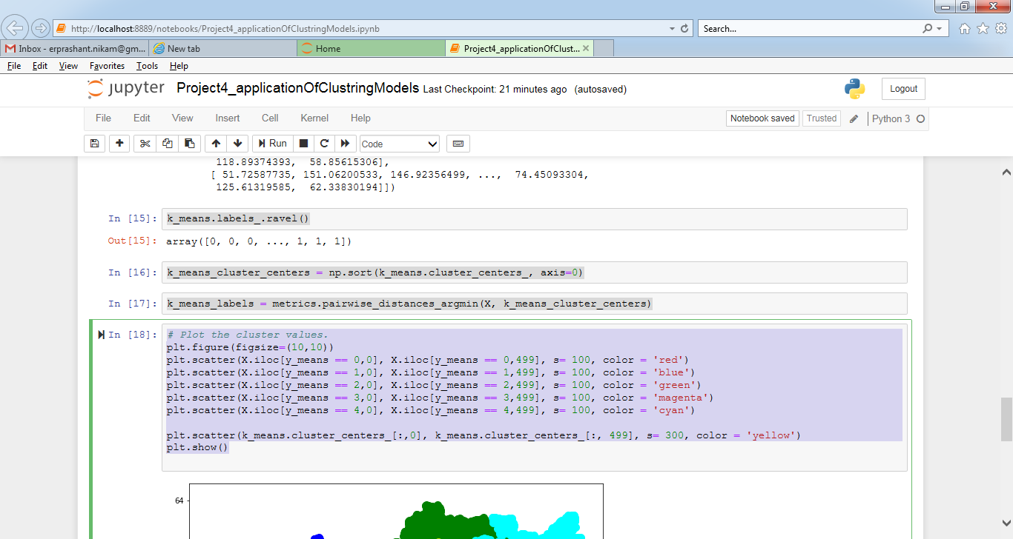

# Plot the cluster values.

plt.figure(figsize=(10,10))

plt.scatter(X.iloc[y_means == 0,0], X.iloc[y_means == 0,499], s= 100, color = 'red')

plt.scatter(X.iloc[y_means == 1,0], X.iloc[y_means == 1,499], s= 100, color = 'blue')

plt.scatter(X.iloc[y_means == 2,0], X.iloc[y_means == 2,499], s= 100, color = 'green')

plt.scatter(X.iloc[y_means == 3,0], X.iloc[y_means == 3,499], s= 100, color = 'magenta')

plt.scatter(X.iloc[y_means == 4,0], X.iloc[y_means == 4,499], s= 100, color = 'cyan')

plt.scatter(k_means.cluster_centers_[:,0], k_means.cluster_centers_[:, 499], s= 300, color = 'yellow')

plt.show()

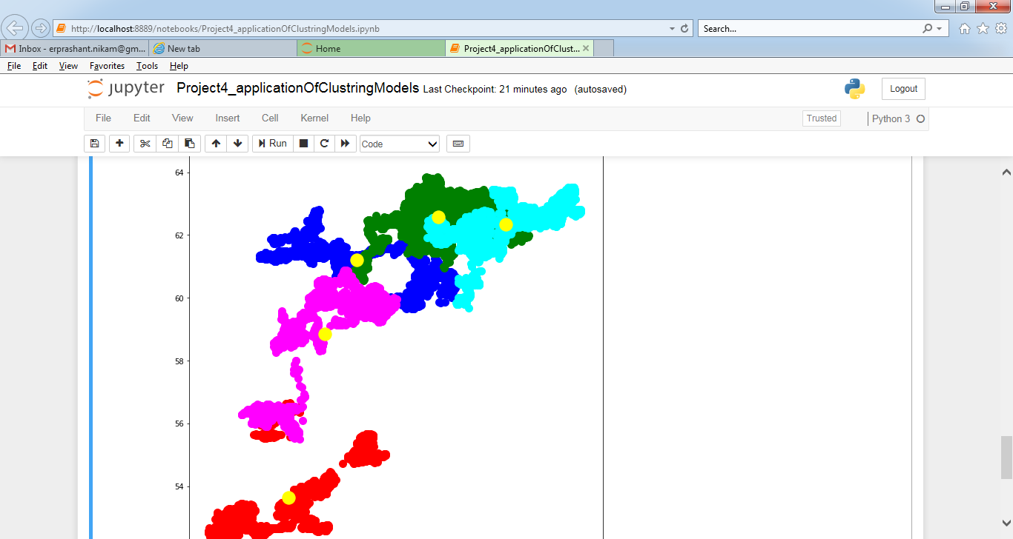

# How many Unique patterns that exist in the historical stock data set, based on fluctuations in price.

print ('Number of patterns in the first cluster : ', X.iloc[y_means == 0,0].size)

print ('Number of patterns in the second cluster : ', X.iloc[y_means == 1,0].size)

print ('Number of patterns in the third cluster : ', X.iloc[y_means == 2,0].size)

print ('Number of patterns in the fourth cluster : ', X.iloc[y_means == 3,0].size)

print ('Number of patterns in the fifth cluster : ', X.iloc[y_means == 4,0].size)

