1.​ Introduction

This assignment will help you to consolidate the concepts learnt in the session.

2.​ Problem Statement

1. Install Jupyter notebook and run the first program and share the screenshot of the output.

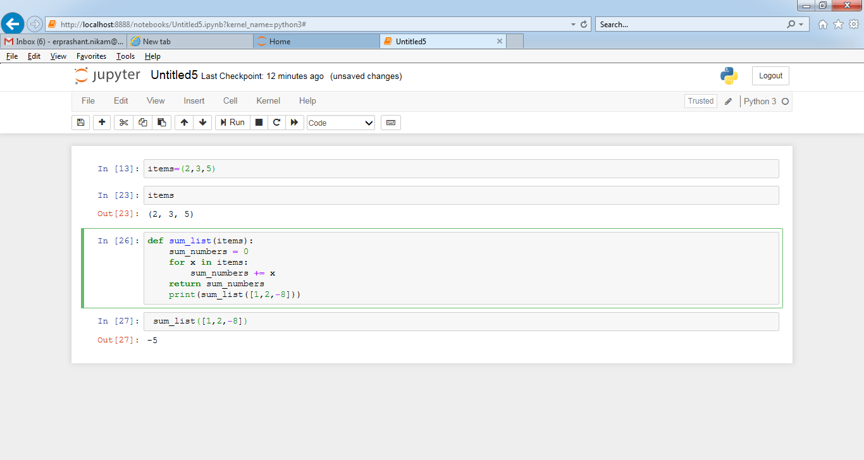

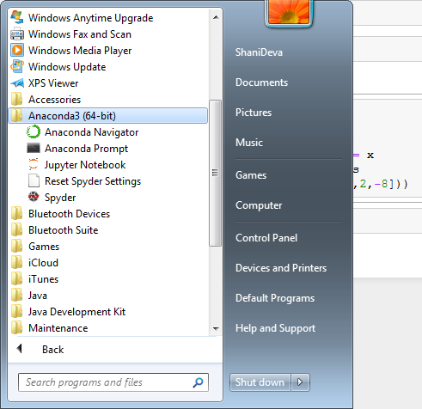

2. Write a program which will find all such numbers which are divisible by 7 but are not a

multiple of 5, between 2000 and 3200 (both included). The numbers obtained should be printed

in a comma-separated sequence on a single line.

Code:

numberdevby7=[]

for x in range(2000, 3200):

if (x%7==0) and (x%5!=0):

numberdevby7.append(str(x))

print (','.join(numberdevby7))

OutPut:

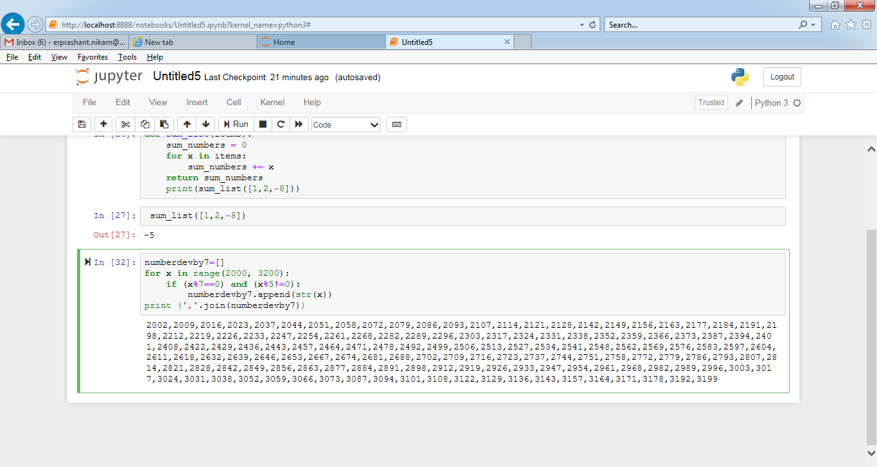

3. Write a Python program to accept the user's first and last name and then getting them printed

in the the reverse order with a space between first name and last name.

Code:

userFrist_name = input("Enter your First Name : ")

UserLast_name = input("Enter your Last Name : ")

print ("Hello " + UserLast_name + " " + userFrist_name)

OutPut:

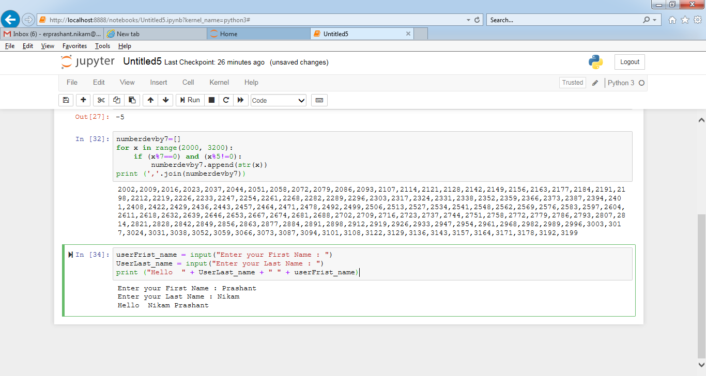

4. Write a Python program to find the volume of a sphere with diameter 12 cm.

Formula: V=4/3 * π * r3

Code:

pi = 3.1415926535897931

radius= 12.0

Vol= 4.0/3.0*pi* radius**3

print('The volume of the sphere is: ',Vol, "cm3")

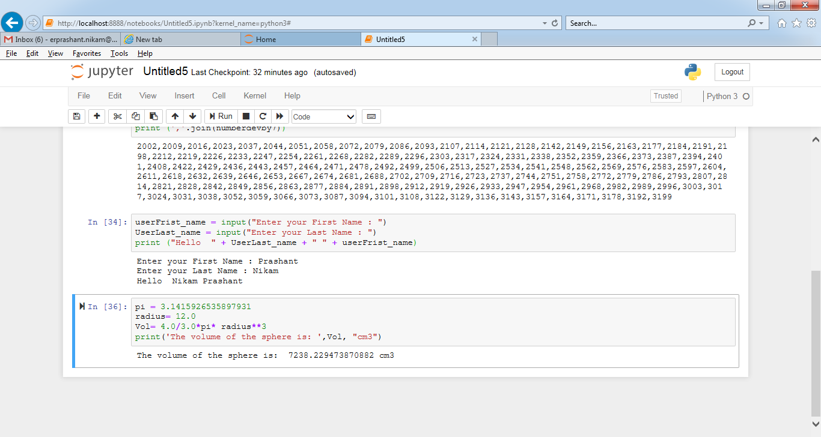

NOTE:​ ​The​ ​solution​ ​shared​ ​through​ ​Github​ ​should​ ​contain​ ​the​ ​source code​ ​used​ ​ and​

​the​ ​screenshot​ ​of​ ​the​ ​output.