2.​ Problem Statement

1. Write a program which accepts a sequence of comma-separated numbers from console and

generate a list.

Code:

number=input("Enter a comma separated numbers:- ")

number=number.split(",")

print(number)

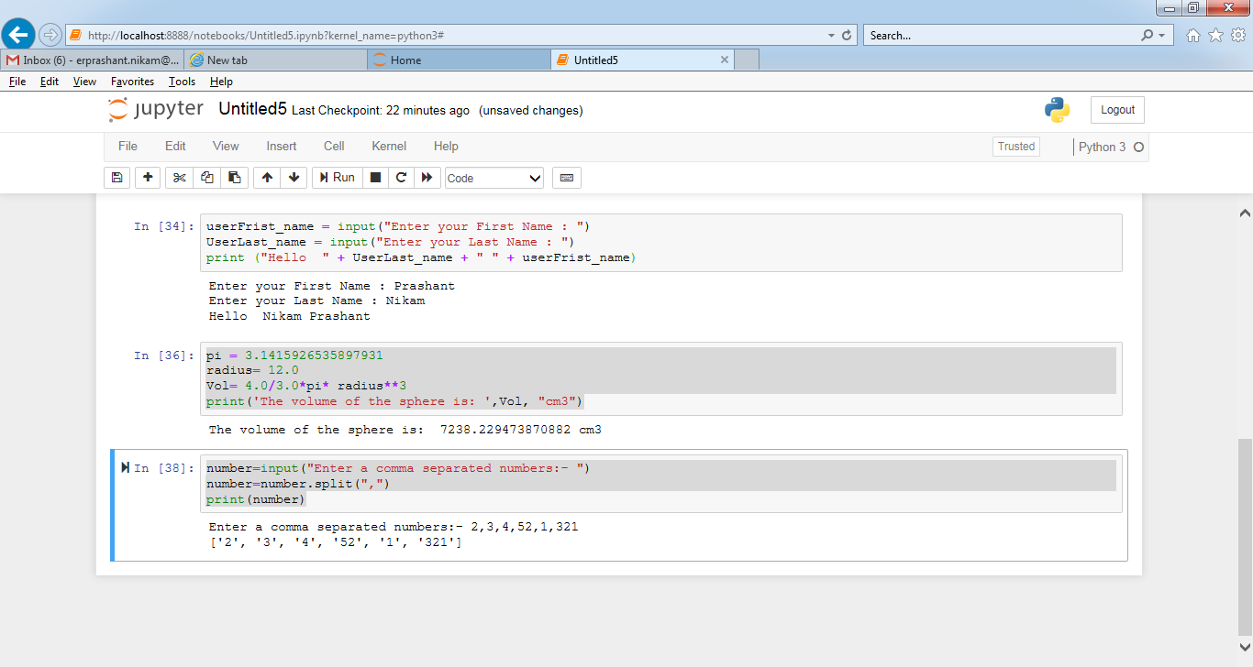

2. Create the below pattern using nested for loop in Python.

*

* *

* * *

* * * *

* * * * *

* * * *

* * *

* *

*

Code:

num=5

for x in range(num):

for y in range(x):

print('*', end="")

print('')

for x in range(num,0,-1):

for y in range(x):

print('*', end="")

print('')

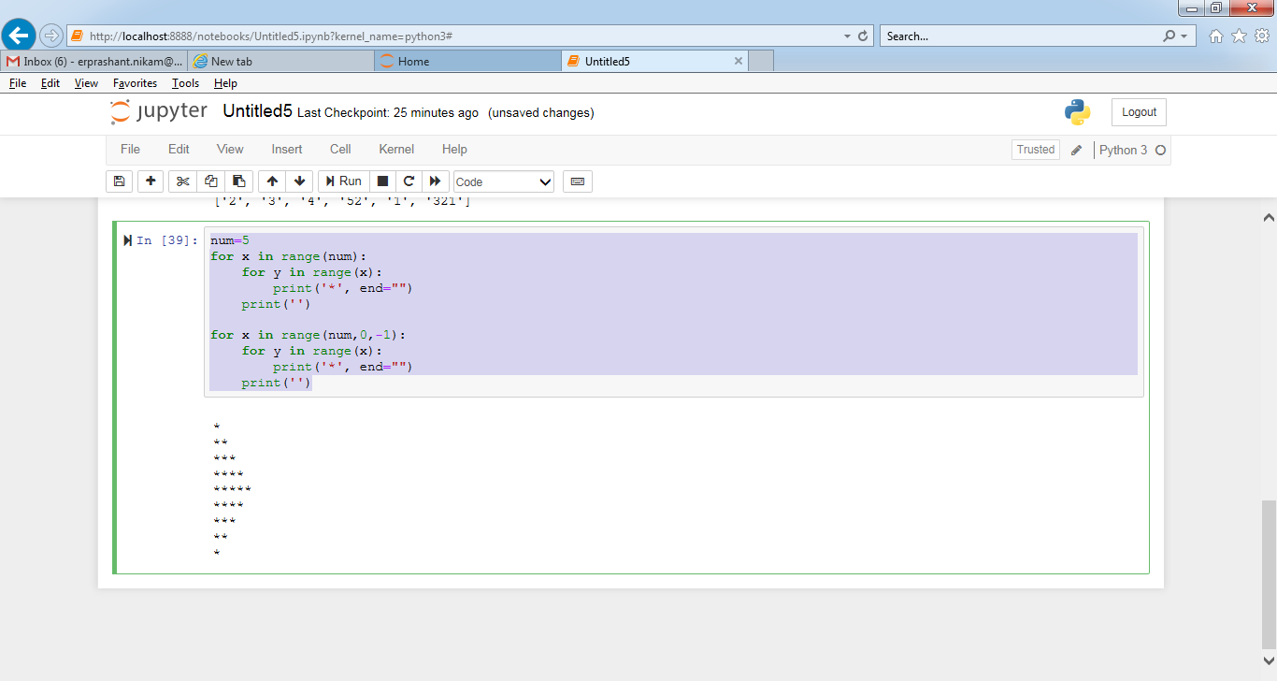

3. Write a Python program to reverse a word after accepting the input from the user.

Sample Output:

Input word: AcadGild

Output: dilGdacA

Code:

revS = input("Enter a string: ")

print(revS[::-1])

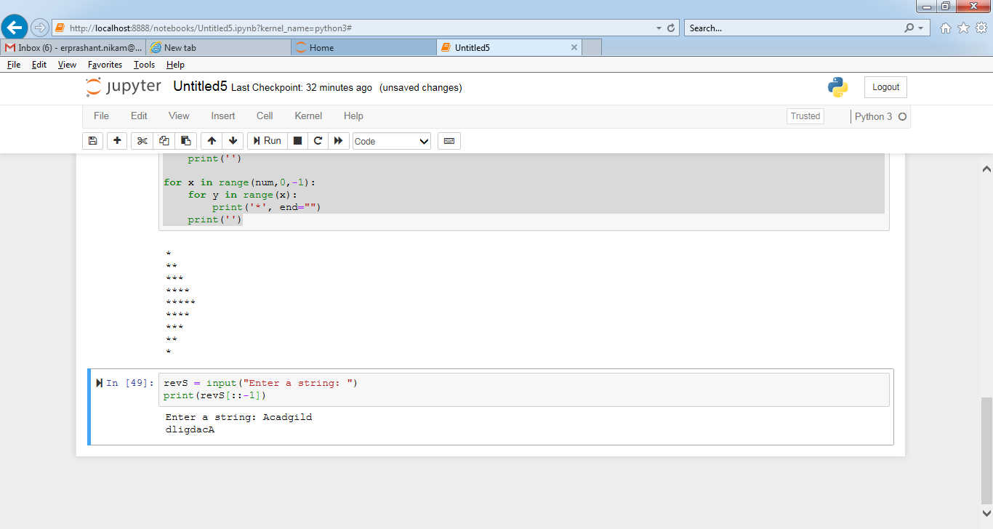

4. Write a Python Program to print the given string in the format specified in the sample

output.

WE, THE PEOPLE OF INDIA, having solemnly resolved to constitute India into a SOVEREIGN,

SOCIALIST, SECULAR, DEMOCRATIC REPUBLIC and to secure to all its citizens

Sample Output:

WE, THE PEOPLE OF INDIA,

having solemnly resolved to constitute India into a SOVEREIGN, !

SOCIALIST, SECULAR, DEMOCRATIC REPUBLIC

and to secure to all its citizens

Code:

my_string = "WE, THE PEOPLE OF INDIA, having solemnly resolved to constitute India into a SOVEREIGN,SOCIALIST, SECULAR, DEMOCRATIC REPUBLIC and to secure to all its citizens"

result = my_string.split(',')

result2=result[5].split('and')

print (result[0],",",result[1],", \n",result[2],"!\n",result[3],",",result[4],",", result2[0],",\n and",result2[1] )

