1. Write a function to compute 5/0 and use try/except to catch the exceptions.

Code:

**def** throws():

**return** 5/0

**try**:

throws()

**except** **ZeroDivisionError**:

print("division by zero!")

**except** **Exception**:

print('Caught an exception')

**finally**:

print('In finally block for cleanup')

OutPut: -

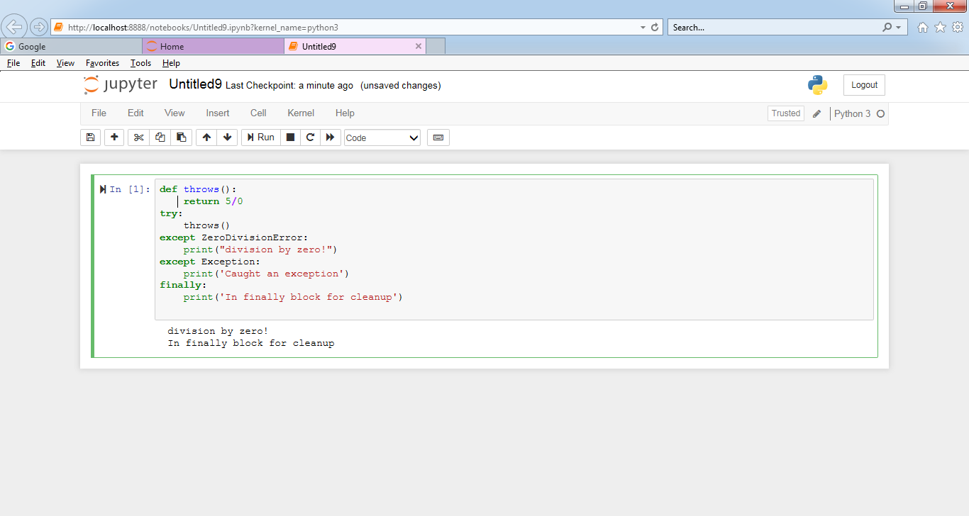

2. Implement a Python program to generate all sentences where subject is in ["Americans",

"Indians"] and verb is in ["Play", "watch"] and the object is in ["Baseball", "cricket"].

Hint: Subject, Verb and Object should be declared in the program as shown below.

subjects=["Americans ","Indians"]

verbs=["play", "watch"]

objects=["Baseball", "Cricket"]

Output should come as below:

Americans play Baseball.

Americans play Cricket.

Americans watch Baseball.

Americans watch Cricket.

Indians play Baseball.

Indians play Cricket.

Indians watch Baseball.

Indians watch Cricket.

Code:

subjects=["Americans","Indians"]

verbs=["play","watch"]

objects=["Baseball","Cricket"]

**for** i **in** range(len(subjects)):

**for** j **in** range(len(verbs)):

**for** k **in** range(len(objects)):

sentence = "**%s** **%s** **%s**." % (subjects[i], verbs[j], objects[k])

print(sentence)

OutPut: -

