2.​ Problem Statement

Read the following data set:

<https://archive.ics.uci.edu/ml/machine-learning-databases/adult/adult.data>

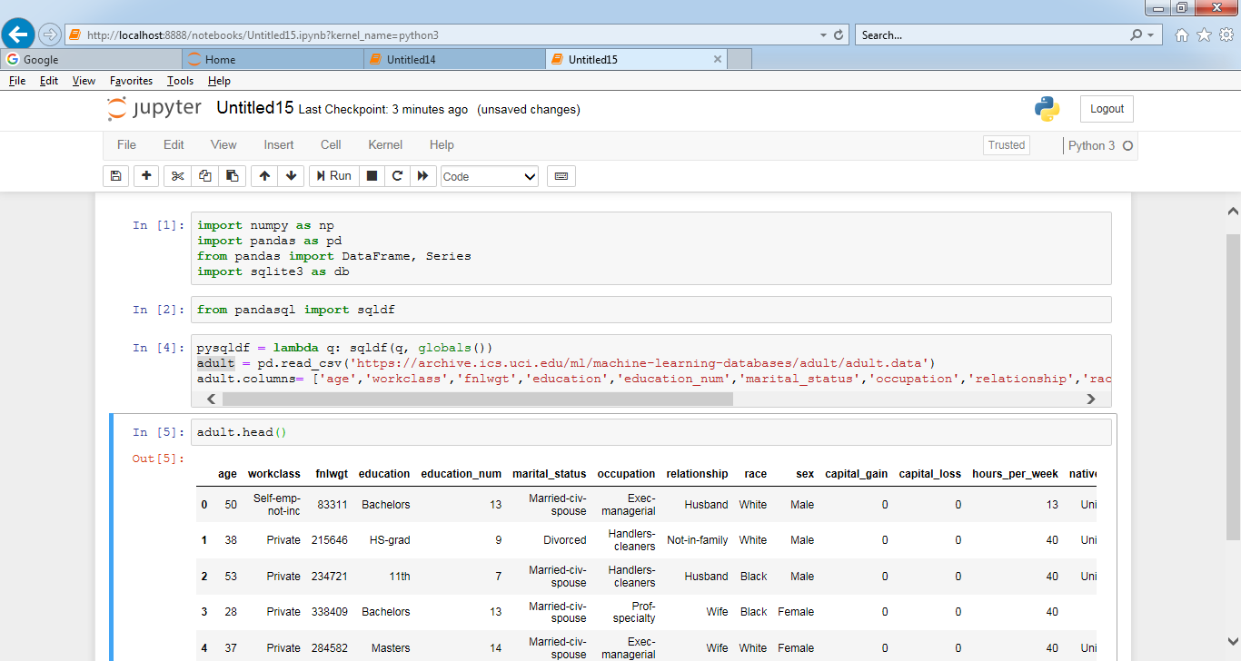

Task:

1. Create an sqlalchemy engine using a sample from the data set

import sqlalchemy

from sqlalchemy import create_engine

engine = create_engine('sqlite:///myData.db')

adult.to_sql('alchemynew', engine)

print(engine.execute('''UPDATE alchemynew SET class= '<30K' WHERE age=39 and workclass='State-gov' and fnlwgt=77516 and education='Bachelors' and education_num=13'''))

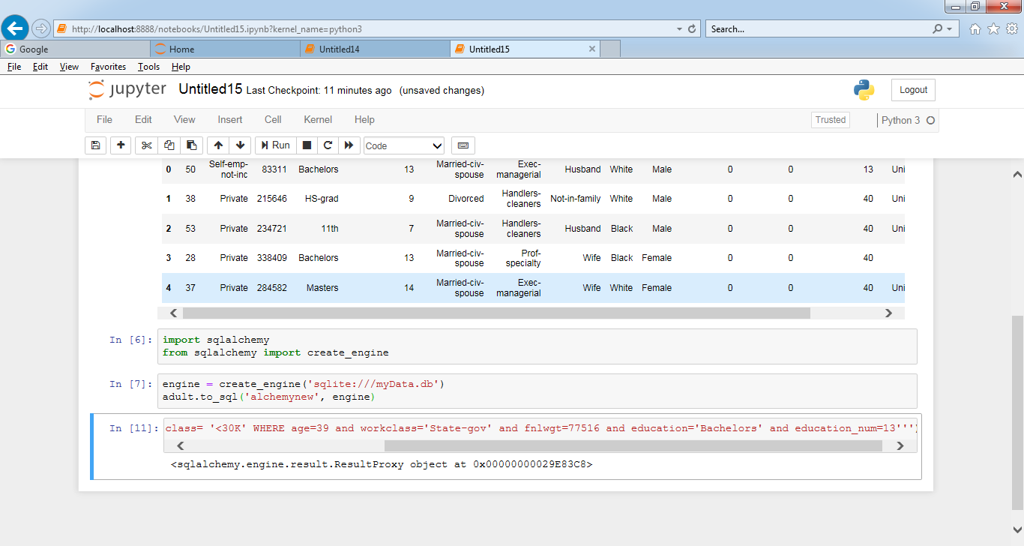

1. Write two basic update queries

#after updating the record

print(engine.execute('''SELECT * FROM alchemynew

WHERE age=38 and workclass=' Private' and fnlwgt=215646

and education=' HS-grad' and education_num=9 ''').fetchall())

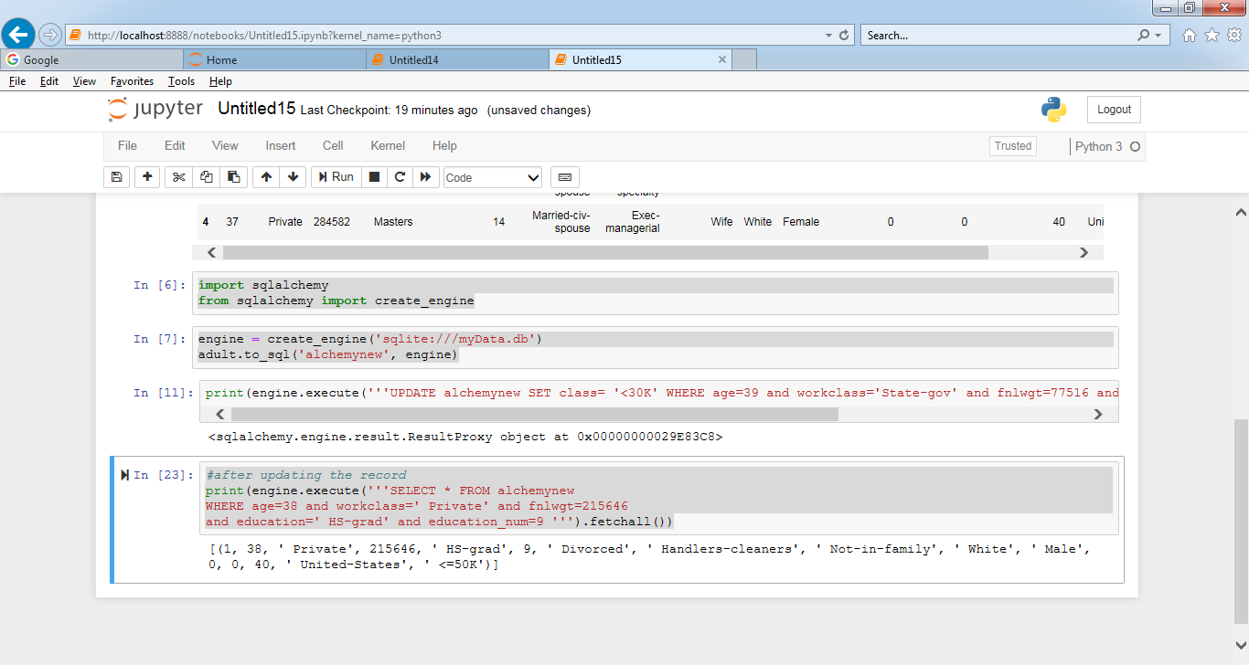

print(engine.execute('''UPDATE alchemynew SET class = '<30K'

WHERE age=38 and workclass=' Private' and fnlwgt=215646

and education=' HS-grad' and education_num=9'''))

#after updating the record

print(engine.execute('''SELECT * FROM alchemynew

WHERE age=38 and workclass=' Private' and fnlwgt=215646

and education=' HS-grad' and education_num=9 ''').fetchall())

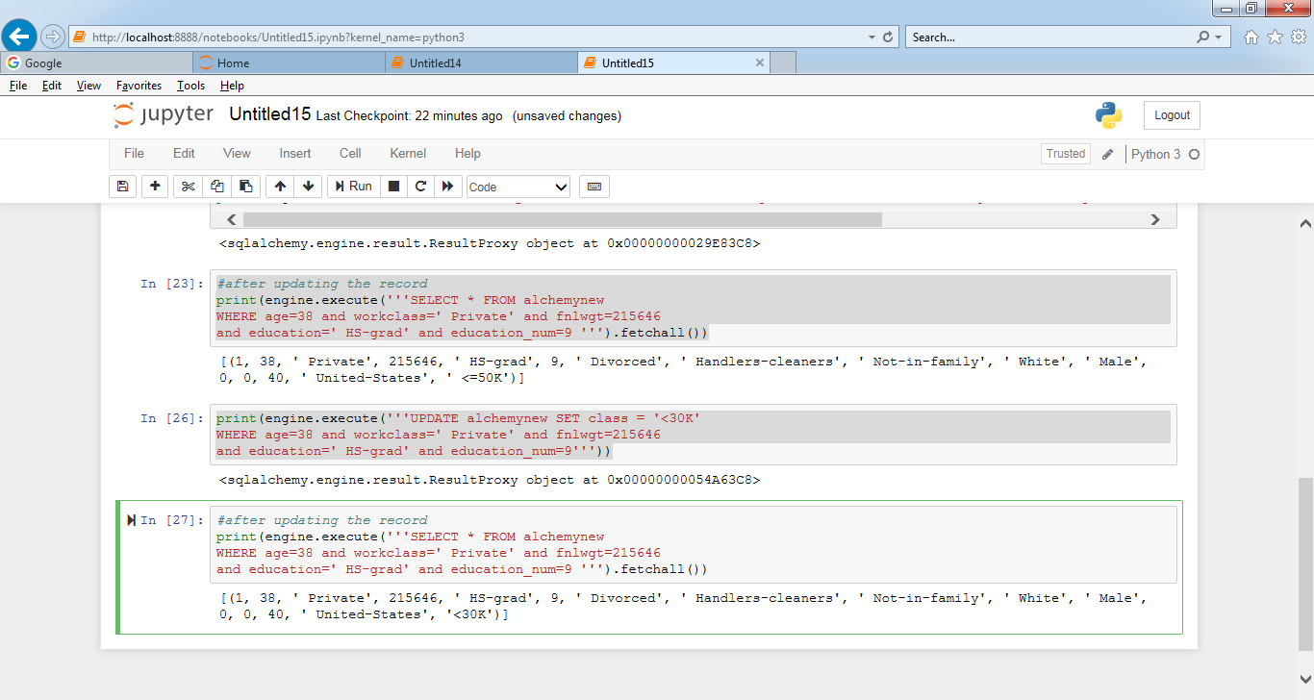

1. Write two delete queries

#deleting the record

print(engine.execute('''DELETE FROM alchemynew

WHERE age=38 and workclass=' Private' and fnlwgt=215646

and education=' HS-grad' and education_num=9'''))

#after deleting the record

print(engine.execute('''SELECT * FROM alchemynew

WHERE age=38 and workclass=' Private' and fnlwgt=215646

and education=' HS-grad' and education_num=9 ''').fetchall())

#deleting the record 2

print(engine.execute('''DELETE FROM alchemynew

WHERE age=37 and workclass=' Private' and fnlwgt=284582

and education=' Masters' and education_num=14'''))

#after deleting the record

print(engine.execute('''SELECT * FROM alchemynew

WHERE age=37 and workclass=' Private' and fnlwgt=284582

and education=' Masters' and education_num=14 ''').fetchall())

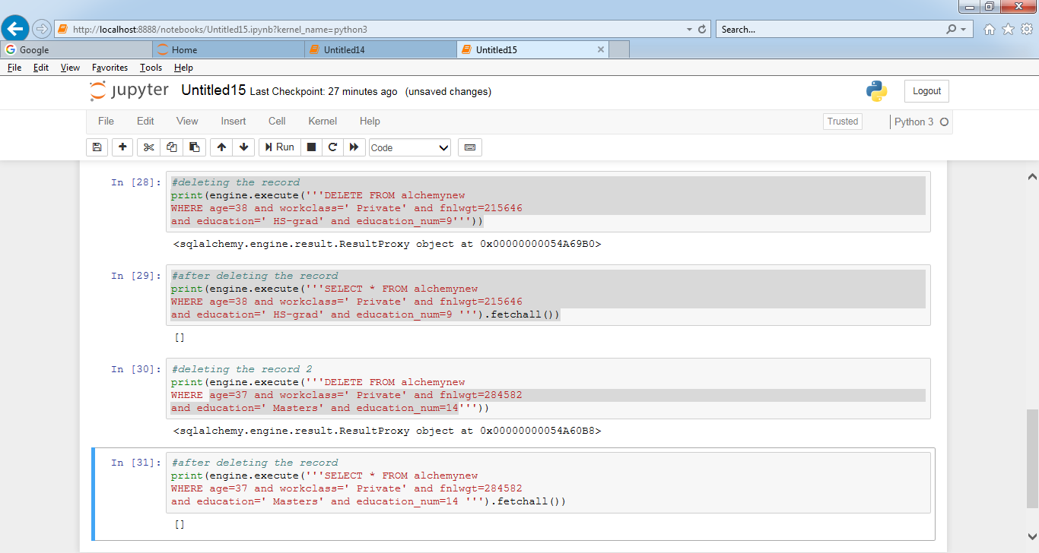

1. Write two filter queries

print(engine.execute('''SELECT * FROM alchemynew WHERE education LIKE ' HS%' ''').fetchall())

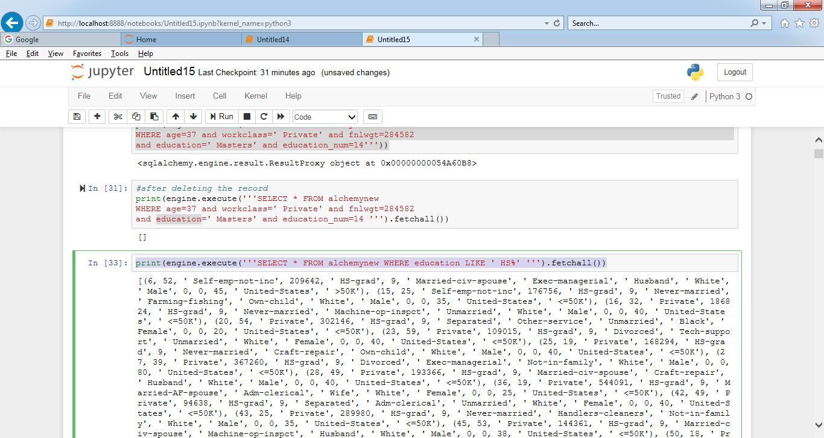

1. Write two function queries

