Scipy:

We have the min and max temperatures in a city In India for each months of the year.

We would like to find a function to describe this and show it graphically, the dataset

given below.

Task:

1. fitting it to the periodic function

2. plot the fit

Data

Max = 39, 41, 43, 47, 49, 51, 45, 38, 37, 29, 27, 25

Min = 21, 23, 27, 28, 32, 35, 31, 28, 21, 19, 17, 18

**Code:**

import numpy as np

temp_max = np.array([39, 41, 43, 47, 49, 51, 45, 38, 37, 29, 27, 25])

temp_min = np.array([21, 23, 27, 28, 32, 35, 31, 28, 21, 19, 17, 18])

import matplotlib.pyplot as plt

months = np.arange(12)

#plt.plot(months, temp_max, 'ro')

#plt.plot(months, temp_min, 'bo')

#plt.xlabel('Month')

#plt.ylabel('Min and max temperature')

from scipy import optimize

def yearly_temps(times, avg, ampl, time_offset):

return (avg

+ ampl * np.cos((times + time_offset) * 2 * np.pi / times.max()))

res_max, cov_max = optimize.curve_fit(yearly_temps, months,

temp_max, [20, 10, 0])

res_min, cov_min = optimize.curve_fit(yearly_temps, months,

temp_min, [-40, 20, 0])

days = np.linspace(0, 12, num=365)

# Plotting

plt.figure()

plt.plot(months, temp_max, 'ro')

plt.plot(days, yearly_temps(days, *res_max), 'r-')

plt.plot(months, temp_min, 'bo')

plt.plot(days, yearly_temps(days, *res_min), 'b-')

plt.xlabel('Month')

plt.ylabel('Temperature ($^\circ$C)')

plt.show()

Output:

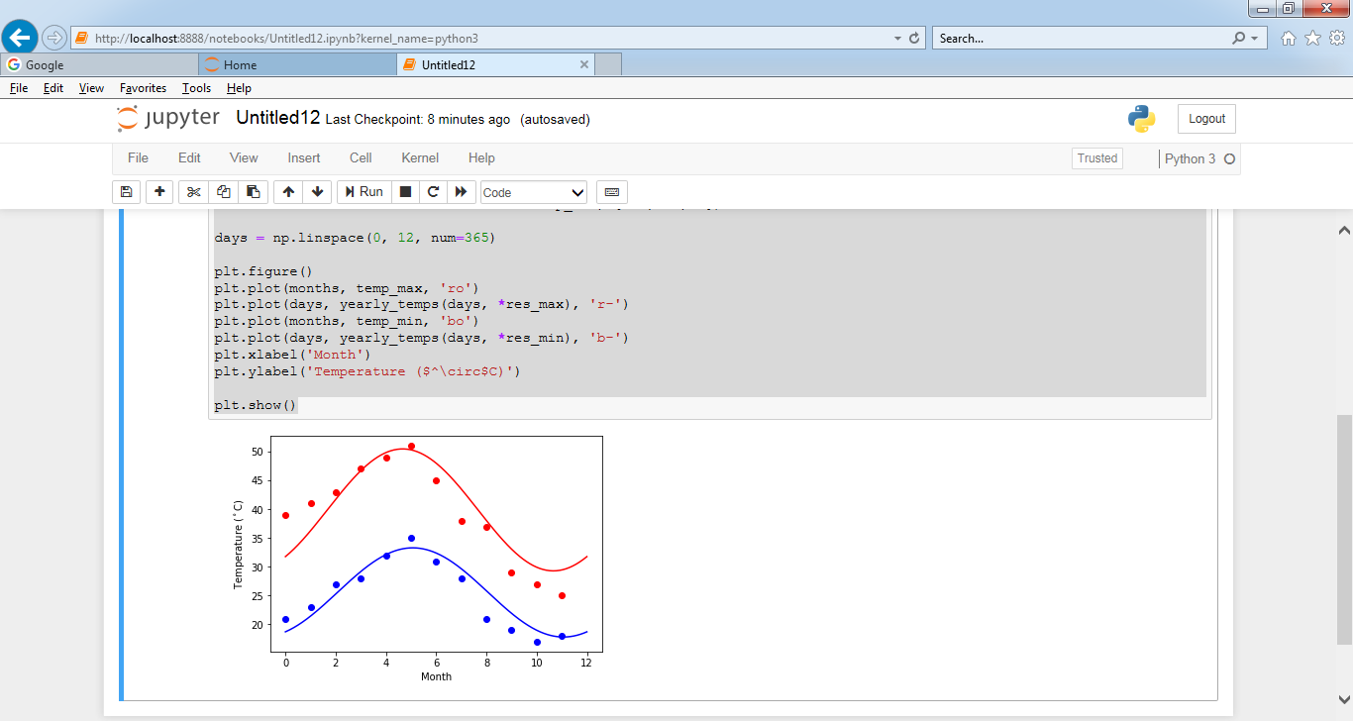

Matplotlib:

This assignment is for visualization using matplotlib:

data to use:

url=https://raw.githubusercontent.com/Geoyi/Cleaning-Titanic-Data/master/titanic_original.csv

titanic = pd.read_csv(url)

Charts to plot:

1. Create a pie chart presenting the male/female proportion

Code:

dfsexf= titanic.iloc[:,[3]].as_matrix()

dfsexfarr=dfsexf.ravel()

countFe=np.count_nonzero(dfsexfarr == 'female' )

print(countFe)

countMe=np.count_nonzero(dfsexfarr == 'male' )

print(countMe)

slices_ratio = [countFe, countMe ]

activities = ['Female', 'Male']

colors = ['r', 'g']

plt.pie(slices_ratio, labels=activities, colors=colors, startangle=90, autopct='%.1f%%')

plt.show()

Out Put :

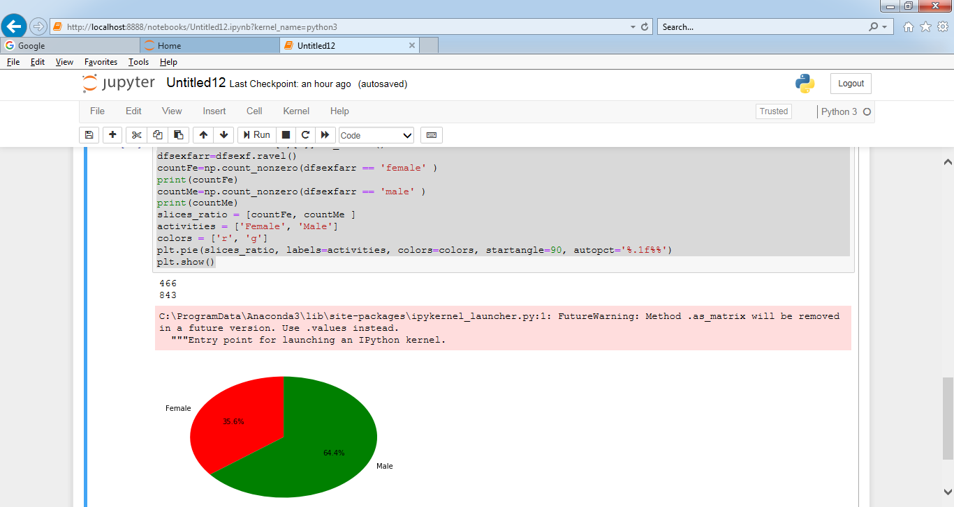

1. Create a scatterplot with the Fare paid and the Age, differ the plot color by gender

Code:

titanic = titanic.dropna(subset=['sex'])

mapping = {'male' : 'blue', 'female' : 'red'}

plt.scatter(titanic['age'], titanic['fare'], alpha=0.5, c=titanic['sex'].map(mapping))

plt.show()

Output:

