2.​ Problem Statement

Problem Statement 1:

A test is conducted which is consisting of 20 MCQs (multiple choices questions) with

every MCQ having its four options out of which only one is correct. Determine the

probability that a person undertaking that test has answered exactly 5 questions wrong.

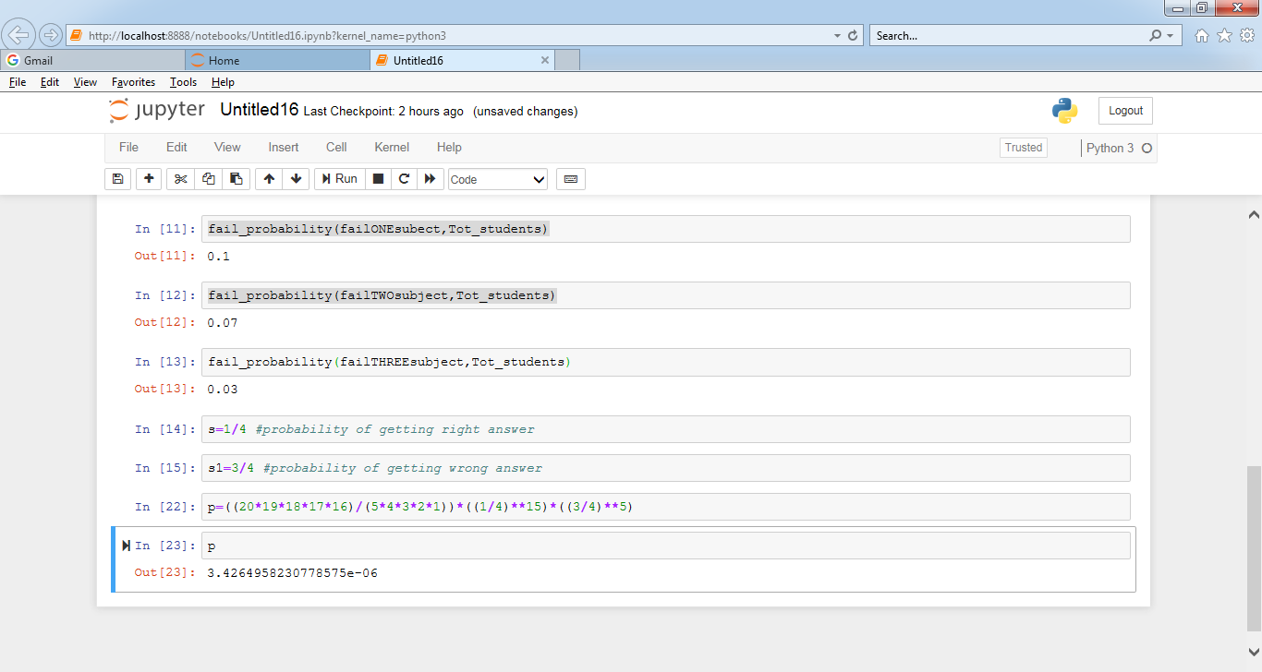

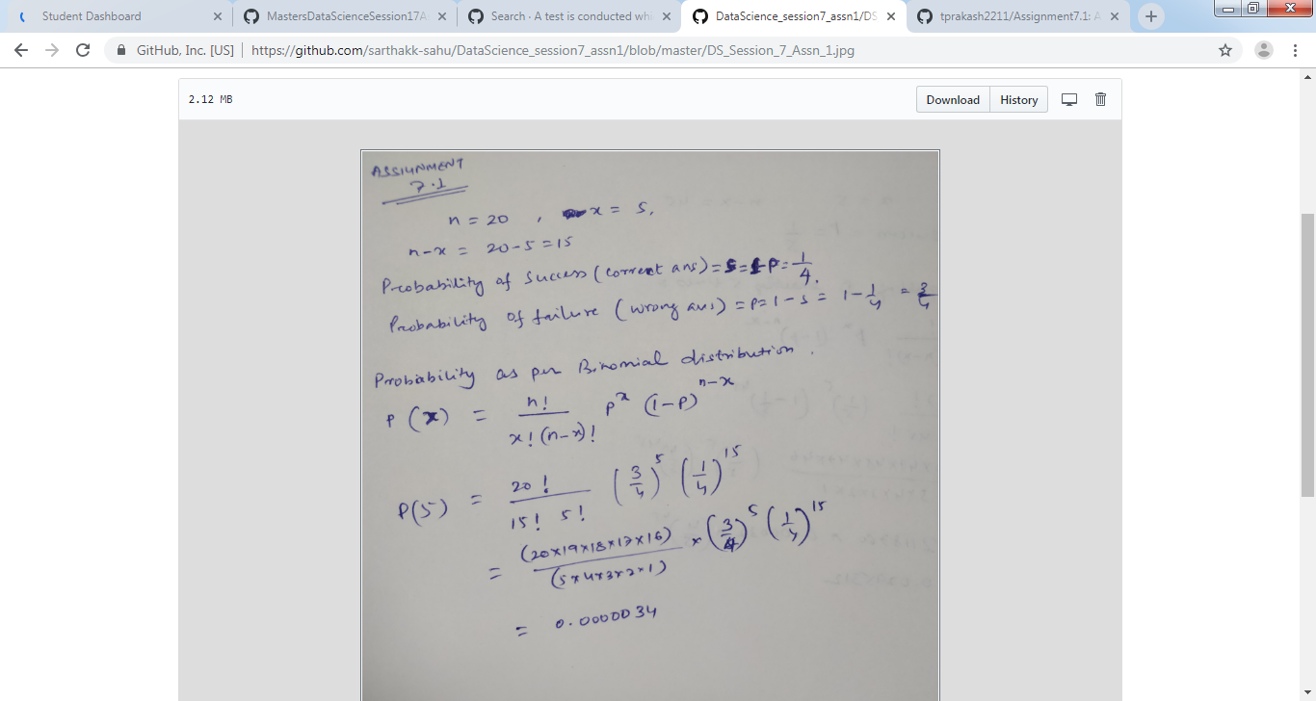

tep 1: Determine the Formula:

Binomial Distribution: Bernoulli trials where n = 1

n = number of trials attempted,

k = number of successes **in** ‘n’ trials

n - k = number of failures

s = probability of success **in** a trial

(1 - s) = probability of failure

P (‘k’ successes **in** ‘n’ trials) = C(n,k)*(s^k)*((1−s)^(n−k))

where,

C (n, k) = n!/(k!(n−k)!)

Step 2: Formula substitution:

n = 20

n - k = 5

k = 20 - 5 = 15

s = (1/4), where probability of success **or** the right answer

1 - s = 1 - (1/4) = (3/4), where probability of failure **or** the wrong answer

Therefore the binomial distribution **is** P (exactly 5 out of 20 answers incorrect) = C (20,5) * ((1/4)^15) * ((3/4)^5)

= P (5 out of 20) = (20∗19∗18∗17∗16)/(5∗4∗3∗2∗1) * (1/4)^15 * (3/4)^5

= 3.4 * 10^(-6) = 0.0000034

Problem Statement 2:

A die marked A to E is rolled 50 times. Find the probability of getting a “D” exactly 5

times.

Step 1: Determine the Formula:

Binomial Distribution: Bernoulli trials where n = 1

n = number of trials attempted,

k = number of successes **in** ‘n’ trials

n - k = number of failures

s = probability of success **in** a trial

(1 - s) = probability of failure

P (‘k’ successes **in** ‘n’ trials) = C(n,k)*(s^k)*((1−s)^(n−k))

where,

C (n, k) = n!/(k!(n−k)!)

Step 2: Formula substitution:

n = 50

k = 5

n - k = 50 - 5 = 45

s = (1/5), where probability of success of getting D

1 - s = 1 - (1/5) = (4/5), where probability of failure of getting D

Therefore the binomial distribution **is** P (getting D, 5 times when rolled 50 times) = C (50,5) * ((1/5)^5) * ((4/5)^45)

= P (5 out of 20) = (20∗19∗18∗17∗16)/(5∗4∗3∗2∗1) * (1/5)^5 * (4/5)^45

= 2.16 * 10^(-4) = 0.000216

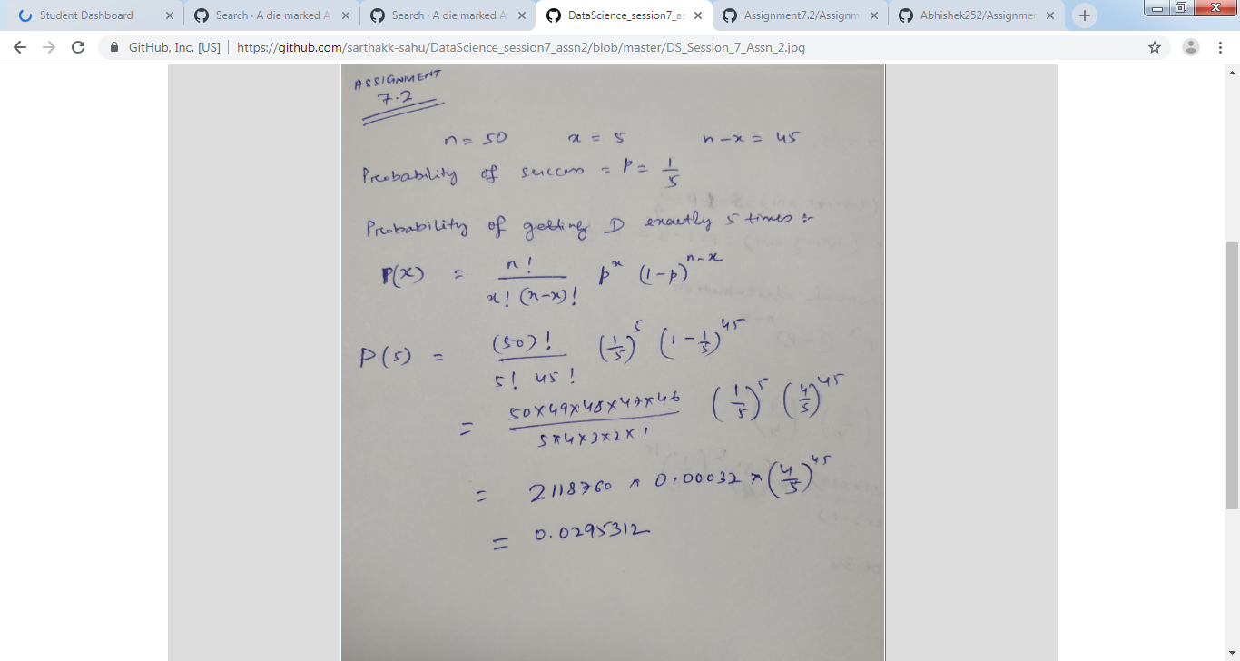

Problem Statement 3:

Two balls are drawn at random in succession without replacement from an urn

containing 4 red balls and 6 black balls.

Find the probabilities of all the possible outcomes.

Probabilities are determined **as** below:

Probability of **not** getting a Red ball **in** the first draw P(A) = (6/10) = 0.60

Probability of **not** getting a Red ball **in** the second draw P(B/A) = (5/9) = 0.56

Probability of getting atleast one ball **is** Red ball = 1 - P(A) * P(B/A) = 1 - (6/10)*(5/9) = 0.66

Probability of **not** getting a Black ball **in** the first draw P(B) = (4/10) = 0.40

Probability of **not** getting a Black ball **in** the second draw P(A/B) = (3/9) = 0.33

Probability of getting atleast one ball **is** Black ball = 1 - P(B) * P(A/B) = 1 - (4/10)*(3/9) = 0.87

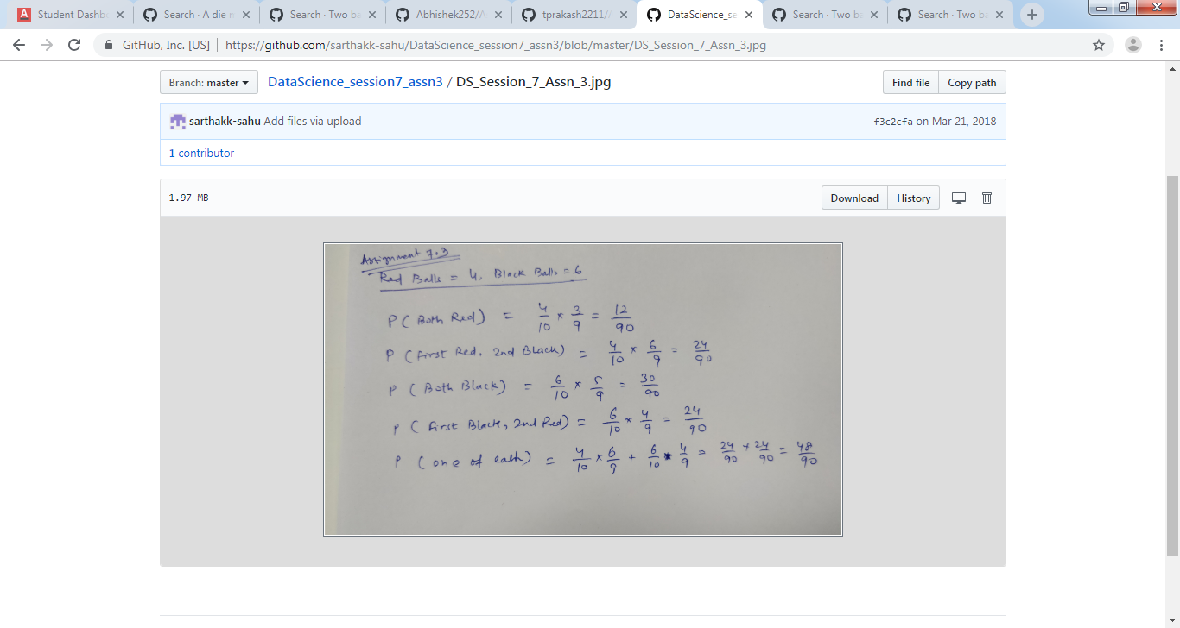

Note: Solution submitted via github must contain all the detailed steps.