Problem Statement 1:

Blood glucose levels for obese patients have a mean of 100 with a standard deviation of

15. A researcher thinks that a diet high in raw cornstarch will have a positive effect on

blood glucose levels. A sample of 36 patients who have tried the raw cornstarch diet

have a mean glucose level of 108. Test the hypothesis that the raw cornstarch had an

effect or not.

Solution:

Step 1: State Null Hypothesis Ho: μ = 100

Step 2: State Alternate Hypothesis H1: μ ≠ 100

Step 3: State your alpha level. We’ll use 0.05 **for** this example. As this **is** a one-tailed test, 0.05 (Due to only positive effect)

Step 4: Find the z-score associated **with** your alpha level. You’re looking **for** the area **in** one tail only. An area of .05 **for** 45% which **is** equal to a z-score of 1.645.

Step 5: Find the test statistic using this formula: z score formula

z=(108-100)/(15/√36)=8/15/6= 48/15 = 16/5 = 3.2

Step 6: If Step 5 **is** greater than 1.645 (Step 3), reject the null hypothesis. In this case,In this case, it **is** greater (3.2>1.645), so you can reject the null hypothesis.

So, we can conclude that a diet high **in** raw cornstarch will have a positive effect **in** blood glucose levels.

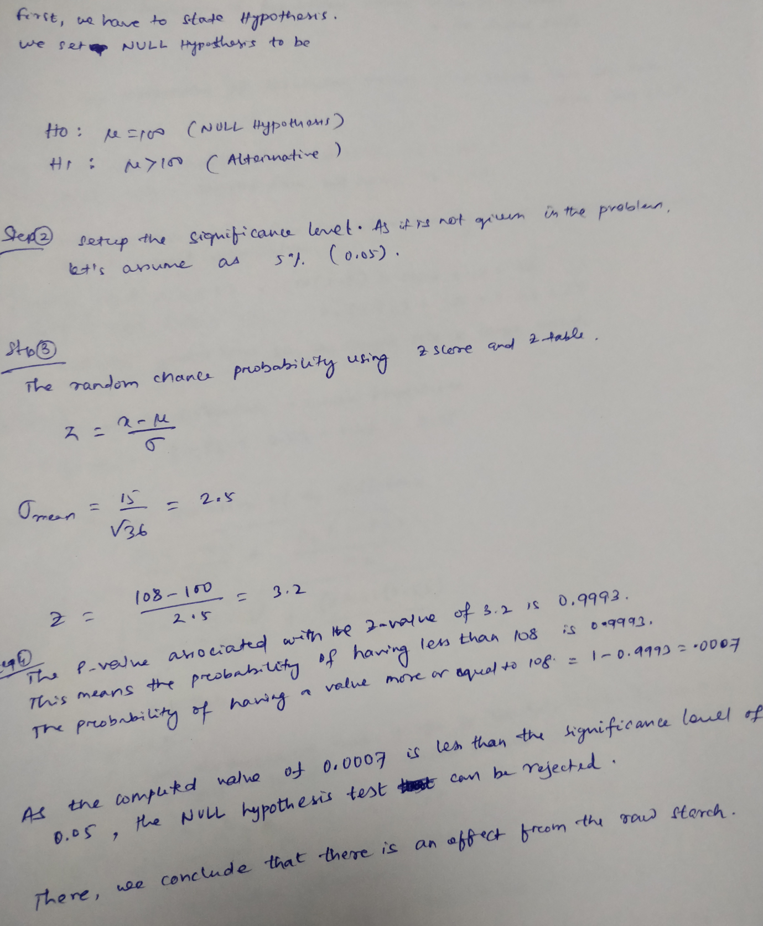

Problem Statement 2:

In one state, 52% of the voters are Republicans, and 48% are Democrats. In a second

state, 47% of the voters are Republicans, and 53% are Democrats. Suppose a simple

random sample of 100 voters are surveyed from each state.

What is the probability that the survey will show a greater percentage of Republican

voters in the second state than in the first state?

Solution:

Step 1: Determine values:

n1 = 100

n2 = 100

P1 (Proportion of Republican voters **in** first state) = 0.52

p1 (Proportion of Republican voters **in** sample form **in** first state) = 0.52

P2 (Proportion of Republican voters **in** second state) = 0.47

p2 (Proportion of Republican voters **in** sample form **in** second state) = 0.53

Step 2: Determine sample **is** large enough

n1P1 = 100 * 0.52 = 52

n1(1 - P1) = 100 * 0.48 = 48

n2P2 = 100 * 0.47 = 47

n2(1 - P2) = 100 * 0.53 = 53

Since the sample size **is** greater than 10 therefore, sample size **is** large enough.

Step 3: Find the mean of the difference **in** sample proportions:

E(p1 - p2) = P1 - P2 = 0.52 - 0.47 = 0.05

Step 4: Find the standard deviation of the difference.

σd = sqrt{ [ P1(1 - P1) / n1 ] + [ P2(1 - P2) / n2 ] }

σd = sqrt{ [ (0.52)(0.48) / 100 ] + [ (0.47)(0.53) / 100 ] }

σd = sqrt (0.002496 + 0.002491) = sqrt(0.004987) = 0.0706

Step 5: Find the probability. This problem requires us to find the probability that p1 < p1

This **is** equivalent to finding the probability that (p1 - p2)< 0 **and**

transform the random variable (p1 - p2) into a z-score.

Sunstituting **in** the formula:

Z(p1 - p2) = (x - μ(p1 - p2)) / σd = (0 - 0.05)/0.0706 = -0.7082

Therefore, the probability of a z-score being -0.7082 **or** less **is** 0.24.

Therefore, the probability that the survey will show a greater percentage of Republican voters **in** the second state

than **in** the first state **is** 0.24.



Problem Statement 3:

You take the SAT and score 1100. The mean score for the SAT is 1026 and the standard

deviation is 209. How well did you score on the test compared to the average test taker?

Solution:

Step 1: Write the formula **and** determine X-value, Mean **and** standard deviation **in** the problem statement.

Where, X-value = 1100, Mean (μ) = 1026 **and** Standard Deviation (σ) = 209

Z = (X - μ) / σ

Step 2: Substitute **and** calculate the answer

Z = (1100 - 1026) / 209 = 0.354

Step 3: Refer the z-value **in** the z-table to determine the percentage of test-takers scored below you.

A z-score of 0.354 **is** 0.1368 which **is** 13.68%

Since, z-table shown has scores **for** the right of the mean. It **is** required to add .500 ( 50%) **for** all of the area left of the mean.

Therefore 0.354 + 0.5000* = .6368 **or** 63.68%.

