2.​ Problem Statement

Problem Statement 1:

Is gender independent of education level? A random sample of 395 people were

surveyed and each person was asked to report the highest education level they

obtained. The data that resulted from the survey is summarized in the following table:

High School Bachelors Masters Ph.d. Total

Female 60 54 46 41 201

Male 40 44 53 57 194

Total 100 98 99 98 395

Question: Are gender and education level dependent at 5% level of significance? In

other words, given the data collected above, is there a relationship between the gender

of an individual and the level of education that they have obtained?

: **The data displayed in tabular format for better understanding.**

|  |  |  |  |  |  |
| --- | --- | --- | --- | --- | --- |
| **Gender/Education** | **High School** | **Bachelors** | **Masters** | **Ph.d.** | **Total** |
| **Female** | **60** | **54** | **46** | **41** | **201** |
| **Male** | **40** | **44** | **53** | **57** | **194** |
| **Total** | **100** | **98** | **99** | **98** | **395** |

**Ho(Null Hypothesis) : Gender and Education are Independent.**

**Ha(Alternative Hypothesis) : Gender and Education are dependent.**

**χ2=∑(O−E)^2/E where χ2 is Chi-square, O is Observed Frequency and E is Expected Frequency**

**E = (Total Row * Total Column)/Size of Sample where Size of Sample is given as 395**

**Hence, 1>Observation value is 60 and it's related Expected value is (201*100)/395 = 50.886**

**2>Observation value is 40 and it's related Expected value is (194*100)/395 = 49.113**

**3> Observation value is 54 and it's related Expected value is (201*98)/395 = 49.868**

**4> Observation value is 44 and it's related Expected value is (194*98)/395 = 48.131**

**5> Observation value is 46 and it's related Expected value is (201*99)/395 = 50.377**

**6> Observation value is 53 and it's related Expected value is (194*99)/395 = 48.622**

**7> Observation value is 41 and it's related Expected value is (201*98)/395 = 49.868**

**8> Observation value is 57 and it's related Expected value is (194*98)/395 = 48.131**

**So, χ2= (60-50.886)^2/50.886 + (40-49.113)^2/49.113 + (54-49.868)^2/49.868 + (44-48.131)^2/48.131 + (46-50.377)^2/50.377 + (53-48.622)^2/48.622 + (41-49.868)^2/49.868 + (57-48.131)^2/48.131 = 1.632 + 1.690 + 0.342 + 0.354 + 0.380 + 0.394 + 1.576 + 1.634 = 8.002**

**Degree of freedom = (Number of Columns -1)*(Number of Rows -1) = (4-1)*(2-1) = 3*1 = 3**

**Now, referring Chi Squared table with input parameters (Degree of freedom = 3 and level of significance = 0.05), the critical value for χ2 is found to be 7.814.**

**It's found that the calculated χ2 value(8.002) is greater than Critical χ2 value(7.814).**

**Hence, I can infer that Alternative Hypothesis is true here which means Gender and Education are dependent each other.**

Problem Statement 2:

Using the following data, perform a oneway analysis of variance using α=.05. Write up

the results in APA format.

[Group1: 51, 45, 33, 45, 67]

[Group2: 23, 43, 23, 43, 45]

[Group3: 56, 76, 74, 87, 56]

**Using one way ANOVA, we conduct Hypothesis Testing.**

**N is total number of data points across all groups**

**n is total number of data points within a individual group**

**a is total number of levels of factor**

**N = 15, n = 5, a = 3 and α=.05**

**df-between = a-1 = 3-1 = 2**

**df-within = N-a = 15-3 = 12**

**df-total = N-1 = 15-1 =14**

**Now, we have to calculate as follows:-**

**Group1 Mean : (51+45+33+45+67)/5 = 241/5 = 48.2**

**Group2 Mean: (23+43+23+43+45)/5 = 177/5 = 35.4**

**Group3 Mean: (56+76+74+87+56)/5 = 349/5 = 69.8**

**Group1 Variance = (51-48.2)^2+(45-48.2)^2+(33-48.2)^2+(45-48.2)^2+(67-48.2)^2/5-1 = 612.8/4 = 153.2**

**Group2 Variance = (23-35.4)^2+(43-35.4)^2+(23-35.4)^2+(43-35.4)^2+(45-35.4)^2/5-1 = 515.2/4 = 128.8**

**Group3 Variance = (56-69.8)^2+(76-69.8)^2+(74-69.8)^2+(87-69.8)^2+(56-69.8)^2/5-1 = 732.8/4 = 183.2**

**Mean Square-within = (153.2+128.8+183.2)/3 = 155.07**

**SumofSquares-within = Mean Square-within * df-within = 155.07*12 = 1860.8**

**Mean of Group Means = (48.2+35.4+69.8)/3 = 153.4/3 = 51.13**

**Variance of Groups Means = (48.2-51.13)^2+(35.4-51.13)^2+(69.8-51.13)^2/3-1 = 604.58/2 = 302.29**

**Mean Square-between = 302.29*5 = 1511.45**

**SumofSquares-between = Mean Square-between* df-between = 1511.45*2 = 3022.9**

**F = Mean Square-between/Mean Square-within = 1511.45/155.07 = 9.75**

**Referring F table for α=.05, the corresponding value for df-between and df-within is 3.8853 which means if the calculated F is greater than F critical(2,12) i.e- 3.8853 then we reject Null Hypothesis.**

**Inference : Reject Null Hypothesis**

**Therfore, the ANOVA table**

**Source SS df MS F**

**Group 3022.9 2 1511.45 9.75**

**Error 1860.8 12 155.07**

**Total 4883.7**

**Effect size**

**η2=3022.9 / 4883.7 = 0.62**

**Step 6: Results in APA writeup**

**F(2, 12)=9.75, p <0.05, η2=0.62.**

Problem Statement 3:

Calculate F Test for given 10, 20, 30, 40, 50 and 5,10,15, 20, 25.

For 10, 20, 30, 40, 50:

**F test is known as ratio of variance of set of values.**

**Set 1 : 10, 20, 30, 40, 50**

**Mean of Set 1 = (10+20+30+40+50)/5= 30**

**Variance of Set 1 =((10-30)^2+(20-30)^2+(30-30)^2+(40-30)^2+(50-30)^2)/5-1 = 250.25**

**Set 2 : 5,10,15, 20, 25**

**Mean of Set 2 = (5+10+15+20+25)/5= 15**

**Variance of Set 2 =((5-15)^2+(10-15)^2+(15-15)^2+(20-15)^2+(25-15)^2)/5-1 = 62.75**

**F Test for 10, 20, 30, 40, 50 = Variance of Set 1/ Variance of Set 2 = 250.25/62.75 = 3.988**

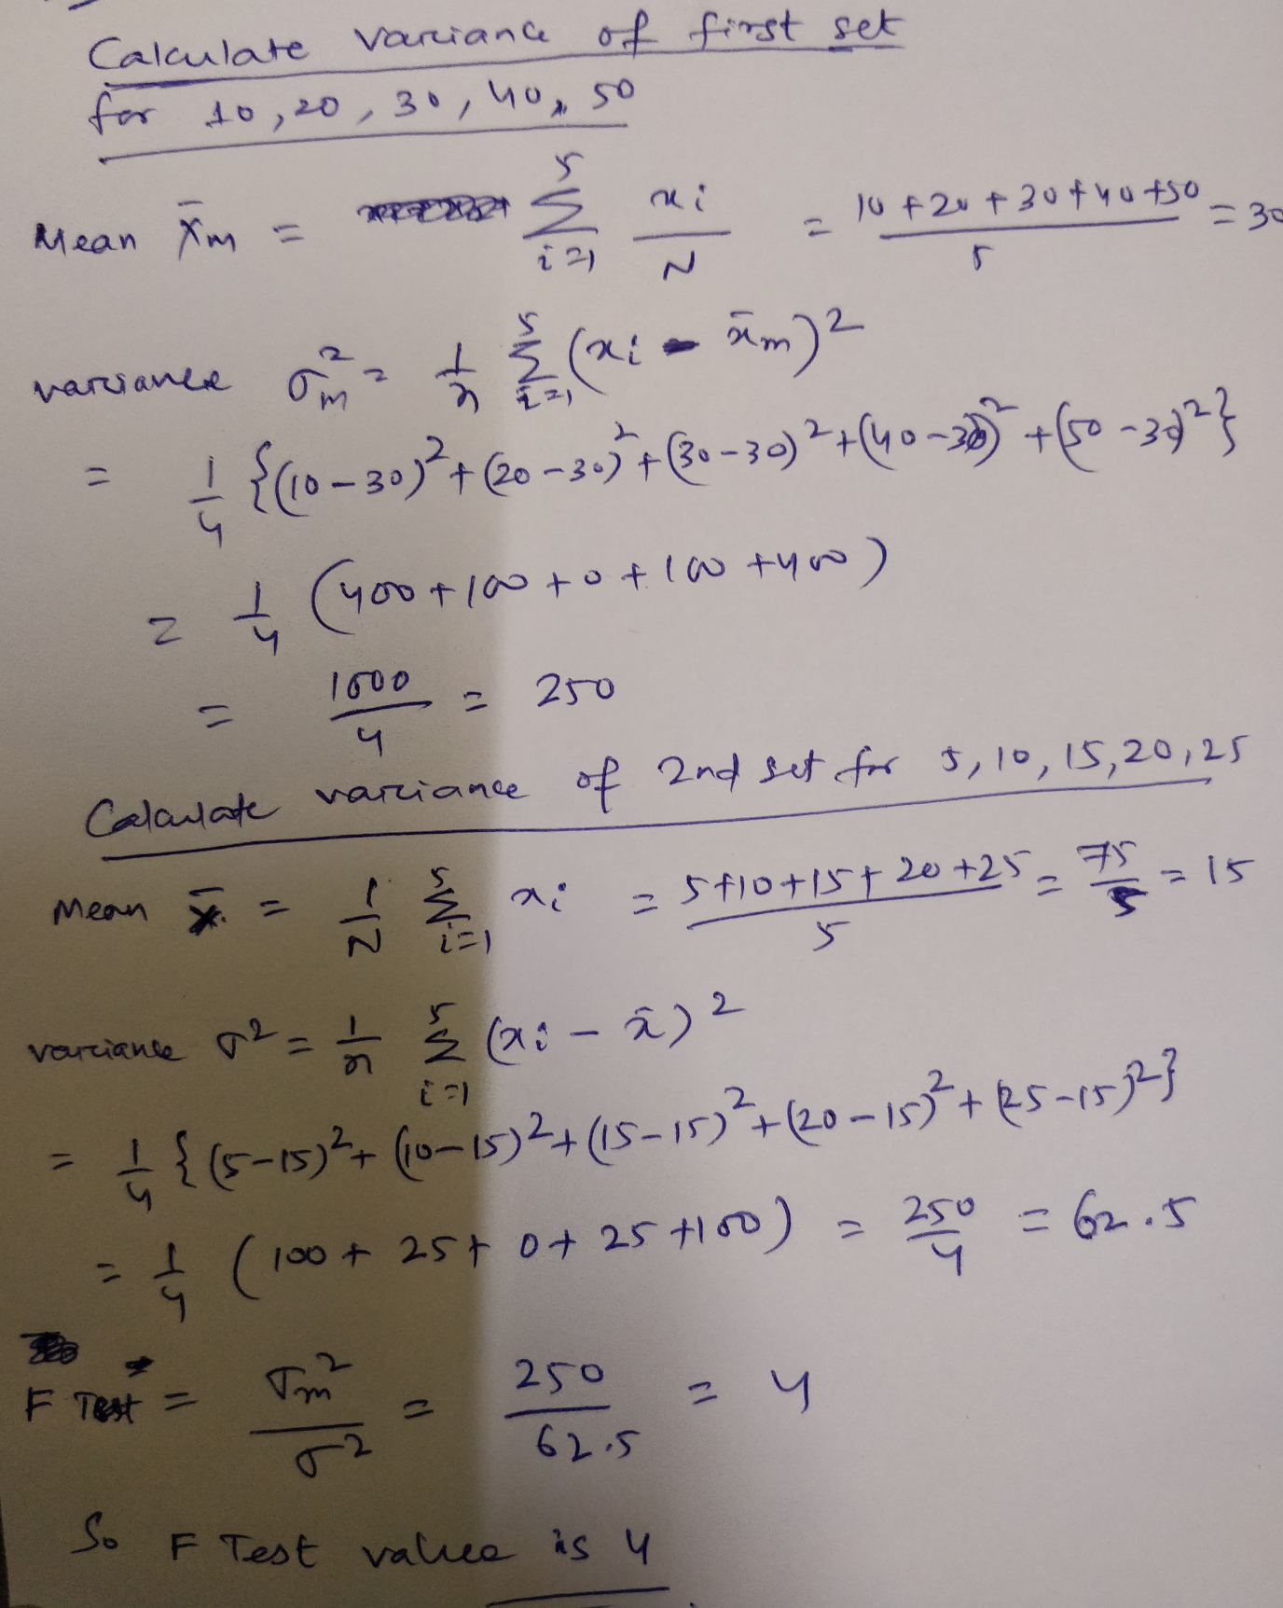

Note: Solution submitted via github must contain all the detailed steps.