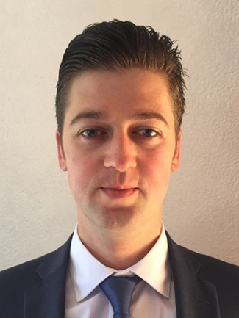**Ievgen Tovtin**

**Contacts:**

**t:** +52(55) 1791 0126

**e:** [zhe.tovtin@gmail.com](mailto:zhe.tovtin@gmail.com)

**Education:** Donetsk National University of economics and trade named after Mikhail Tugan - Baranovsky, specialty - Food Engineer,

education level - Master’s degree, end of education - 07/2011

**Now studying :** Full Stack Development (online courses/end of education 08/04/2019), <http://gofullstack.goit.ua/>

**Course program:** (HTML/CSS, Photoshop, GIT, Chrome devtools, Javascript, ES6, RestFul API, DOM API, JSON, XML, CSV, loDash, AJAX, jQuery, Npm, Gulp, Webpack, Scrum, Agile, React.js, Node.js, MongoDB, Express)

**Portfolio:** <https://erpua.github.io/hiring__demo/>

**Other experience:**

*December 2013 – present*

Princess Cruises Company (cruise lines)

Assistant Waiter: Assist the passengers in every way, always exceeding their expectations

*April 2013 – August 2013*

Resort-hotel «Crimea breez» Waiter («Piazzetta» restaurant and operating in Room Service)

*May 2012 – April 2013*

«Donbass Palace» Hotel ***** Waiter («La Terrazza» restaurant)

**Linguistic Competence:** English – Advanced (Certificate of American English Center **-** 23/12/2010), Russian, Ukrainian – native, Spanish – studying.