Hephaestus
Wildfire & Burnt-Area Analysis — User Manual
A step-by-step guide to drawing an analysis box, running a fire/burnt-area analysis, estimating value at risk, and exporting a shareable PNG report.

1. Overview
Hephaestus is a browser-based tool for exploring active wildfires, estimating the area they have burned, overlaying the buildings in that area, and estimating the monetary value at risk, finishing with a one-click PNG report you can save or share. You draw a box on a map, pick a date range and satellite sensor, and the app does the rest: fetching real active-fire detections, building an estimated burnt-area shape, cross-referencing real OpenStreetMap building footprints, and, for locations in Spain, pricing the affected buildings using Spain's public Catastro service.
This manual walks through the interface end to end: running an analysis, estimating value lost, and exporting the PNG report.

Before you start
Open the app's URL in a browser (ask whoever deployed it for the link), or, if you are running it yourself from the project folder, start it with:
python app.py
Then open http://127.0.0.1:5000/ in your browser.

2. The interface at a glance
- Header (top bar): the app title, a “Draw box” button, and an “Analyze” button (disabled until a box exists). On narrow or mobile screens, a menu button appears on the left to show or hide the sidebar.
- Sidebar (left): the “Boxes” shortcut dropdown, date, day-range and sensor controls, and, once you have run an analysis, the Results panel, the value-lost estimation button, and the Export report button.
- Map (main area): an interactive Leaflet map centered on Madrid by default, with zoom controls (top-left) and a basemap switcher (top-right, OpenStreetMap or Esri satellite imagery).
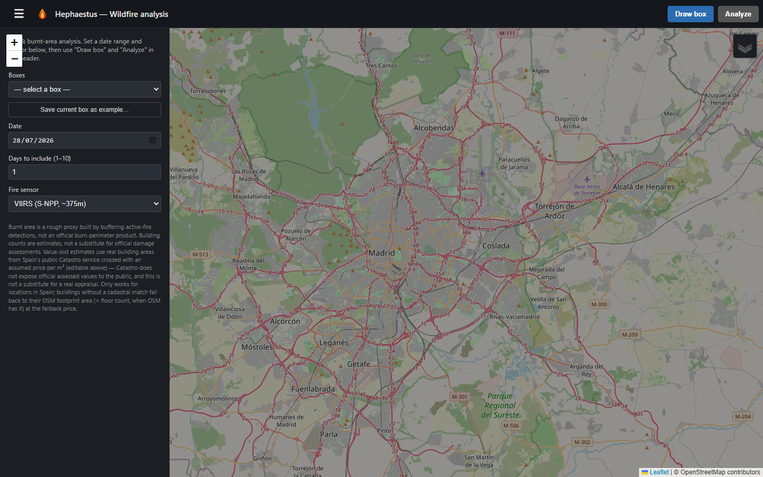
The app on first load: header, sidebar, and map.

3. Step 1 — Choose an analysis box
Every analysis runs against a rectangular box on the map. There are two ways to set one:
- Draw one yourself: click “Draw box” in the header, then click-and-drag on the map to draw a rectangle. Release the mouse to finish; the “Analyze” button lights up (turns orange) once a box exists.
- Reuse a box: open the “Boxes” dropdown in the sidebar. It lists a couple of built-in examples, any box you have saved yourself, and, automatically, boxes you have analyzed recently, so re-running a past analysis is one click.
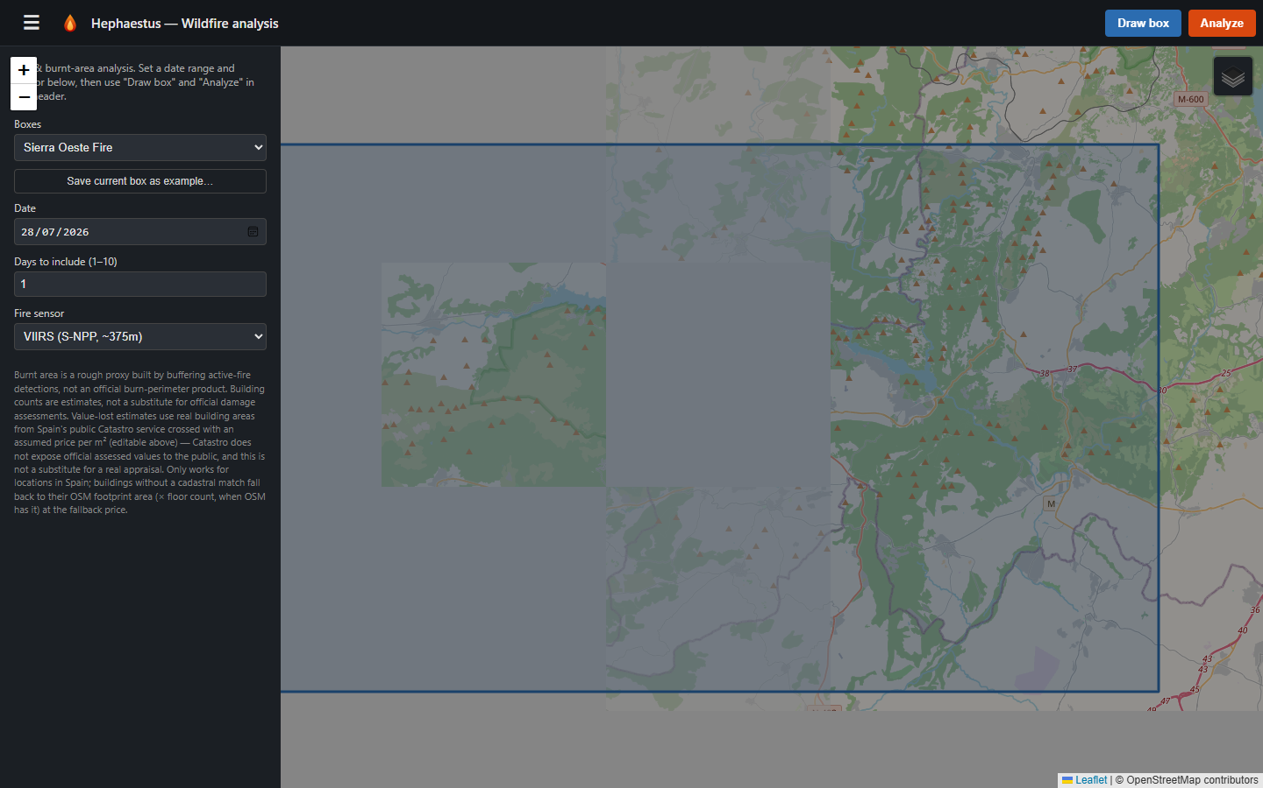
Picking the built-in “Sierra Oeste Fire” example from the Boxes dropdown: the box is drawn on the map automatically and Analyze becomes enabled.
Tip: once you have drawn a box you like, click “Save current box as example...” and give it a name to reuse it any time from the same dropdown.
Keep boxes reasonably sized (roughly 50 km by 50 km or smaller). Oversized boxes are rejected immediately with a clear message rather than left to time out.

4. Step 2 — Set the date, day range, and sensor
- Date: the day (or first day of a range) to search for active-fire detections.
- Days to include (1-10): how many days of detections to pull, starting from Date.
- Fire sensor: VIIRS (S-NPP, NOAA-20, or NOAA-21, about 375 m resolution) for finer detail, or MODIS (about 1 km resolution) as an alternative source.

5. Step 3 — Run Analyze
Click “Analyze” in the header. The app fetches active-fire detections for your box, date range, and sensor from NASA FIRMS; builds an estimated burnt-area shape by buffering each detection by roughly its sensor's pixel footprint; and fetches nearby OpenStreetMap building footprints to work out which ones fall inside that burnt area.
The sidebar's Results panel then shows:
- Active fire detections found
- Estimated burnt area, in square kilometers
- Buildings near the burnt area
- Buildings estimated affected (highlighted)
On the map, you will see the burnt-area shading, the fire detection point(s), and outlines around the affected buildings.
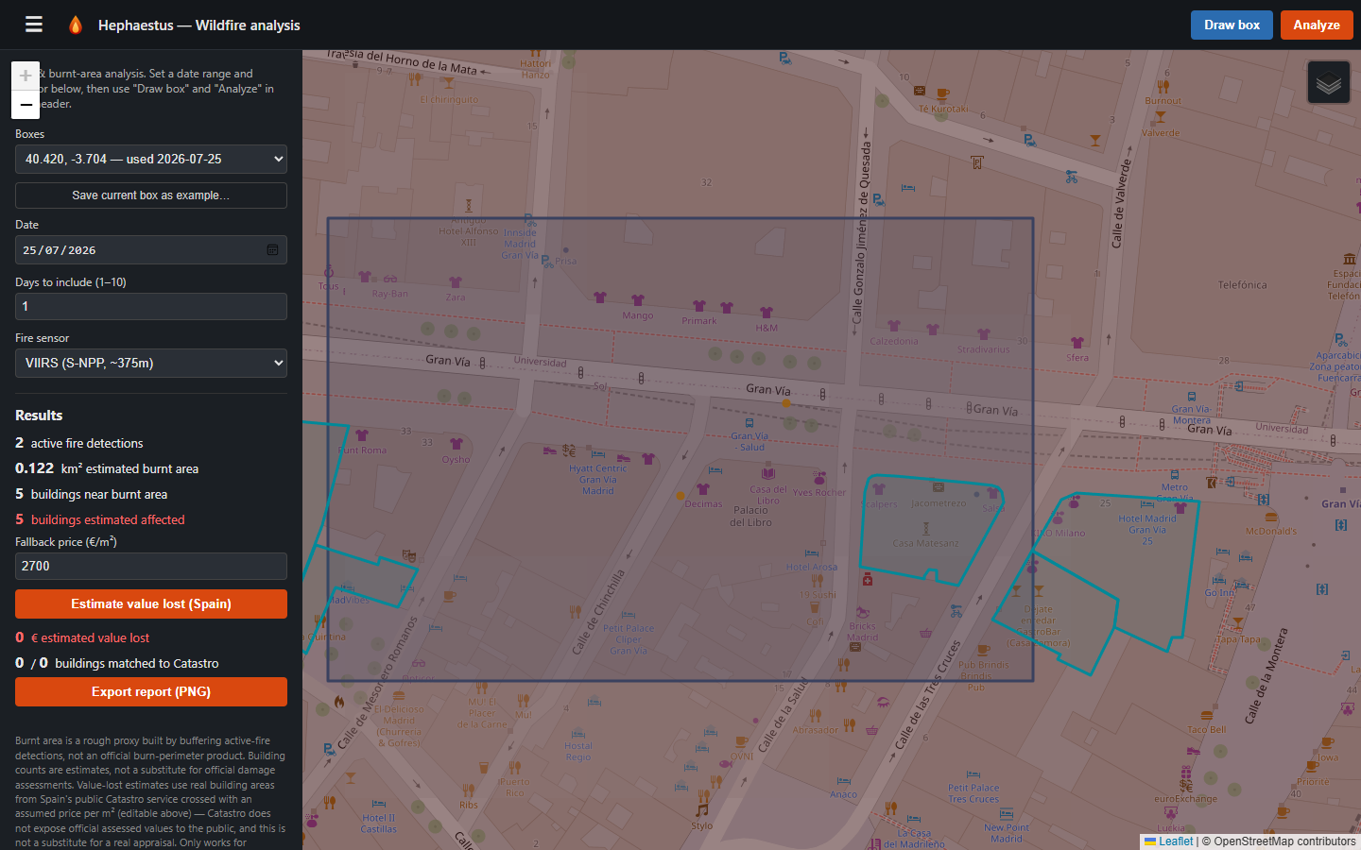
Results after clicking Analyze: sidebar stats plus the map showing the burnt area, a fire detection, and affected-building outlines.
If nothing comes back (no active fire in the box for that date), that is a valid result, not an error; try a different date or a known example box. If the box is too large or a request times out, you will see a clear message telling you so rather than a blank failure.

6. Step 4 — Estimate value lost (Spain only)
Once buildings are affected, the “Estimate value lost (Spain)” button becomes available. Optionally adjust “Fallback price (EUR/m2)” first; this is the assumed price used for buildings that do not have a cadastral match; then click the button.
For each affected building, the app looks up its real official built floor area, land-use type, and construction year from Spain's public Catastro service, then multiplies by a price per square meter (using per-use-type rates where possible) to produce a market-value estimate. Buildings with no cadastral match (outside Spain, or an unmapped parcel) fall back to their OpenStreetMap footprint area times floor count at the fallback price.
Results shown include:
- Total estimated value lost
- How many buildings matched a real Catastro record versus were priced by fallback
- If relevant: buildings that could not be checked due to a Catastro request error, or were skipped because Catastro's hourly request quota was exceeded
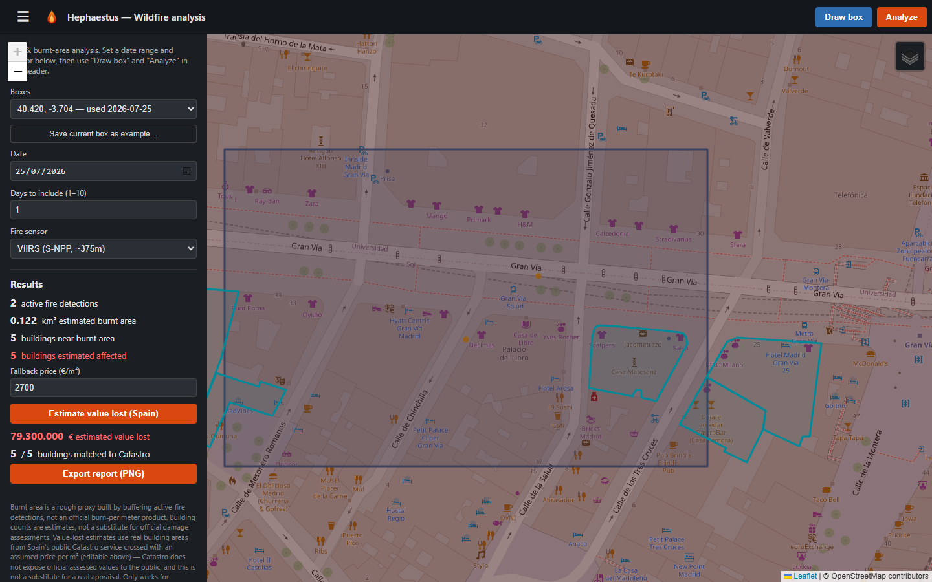
Value-lost results added to the sidebar after clicking “Estimate value lost (Spain)”.
This only works for buildings in Spain: Catastro is a Spanish public service and does not cover other countries.

7. Step 5 — Export the PNG report
Click “Export report (PNG)” to render and download a self-contained image you can save, print, or share. It includes:
- A title/stats bar (date, sensor, detections, buildings affected, total value lost)
- The map: basemap, burnt area, affected buildings colored and sized by estimated value, fire detections colored by nearby value, the top-5 municipality boundaries by value with labels, and a locator inset showing the containing region and country
- A legend, placed directly below the map
- A value-by-municipality table (top 15, with the rest summarized in an “Others” row, plus a TOTAL row)
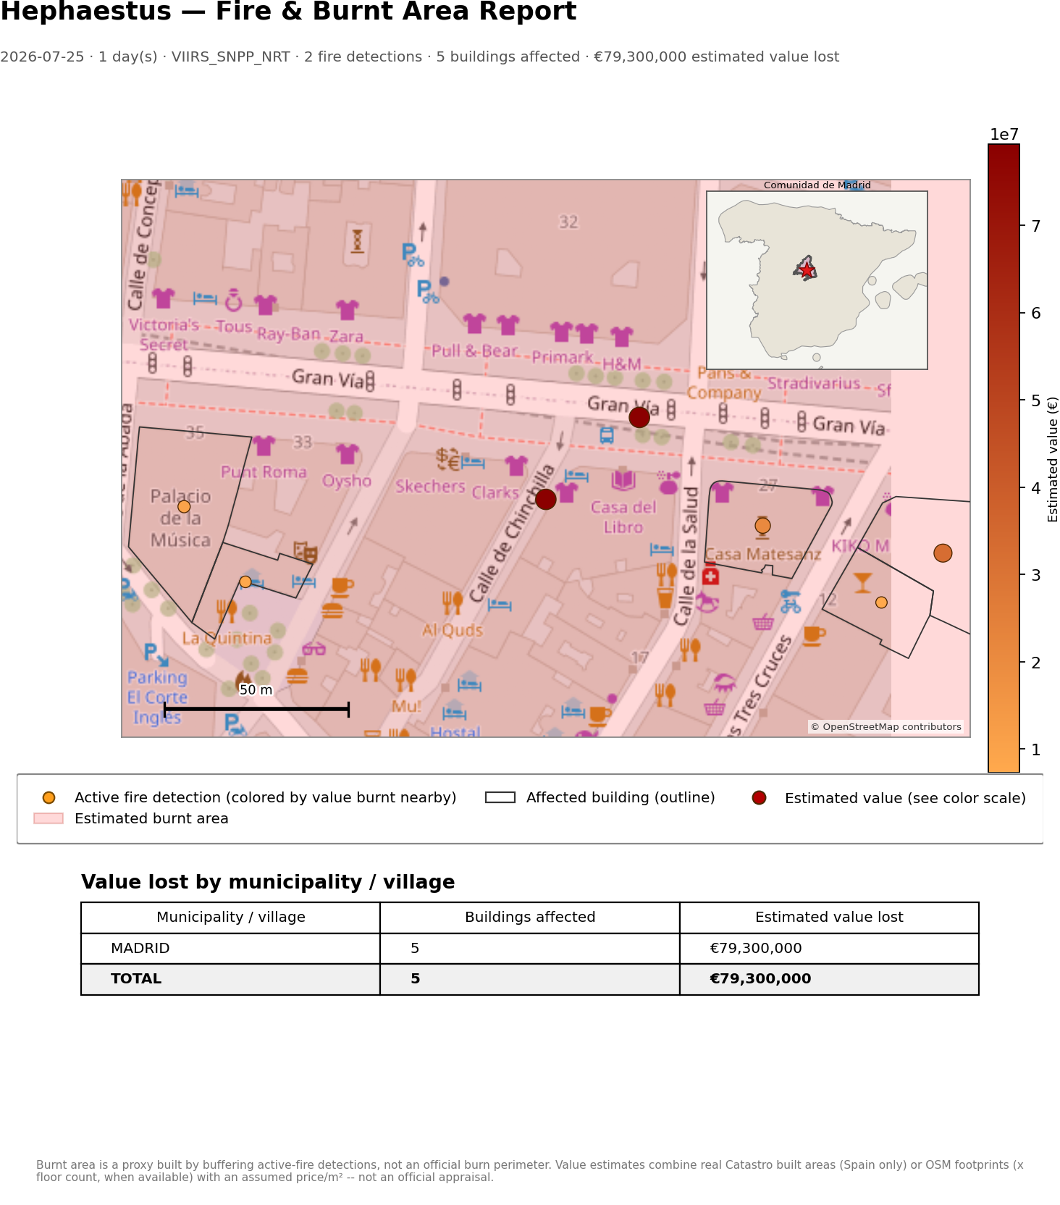
The exported PNG report for this example analysis.
The report can take a little while to generate: it fetches municipality and region boundaries live to draw the locator inset and boundary outlines, so a short wait after clicking Export is normal, especially on a slow connection.

8. Other things worth knowing
- Switching basemap: use the layer control in the map's top-right corner to switch between OpenStreetMap and Esri World Imagery satellite view.
- Recent boxes: every analysis you run is automatically remembered in the “Boxes” dropdown, so re-running it later, for example with a different date, is one click.
- Mobile-friendly layout: on a narrow screen, the sidebar collapses behind the menu button in the header so the map has room; tap it to bring the sidebar back as an overlay.
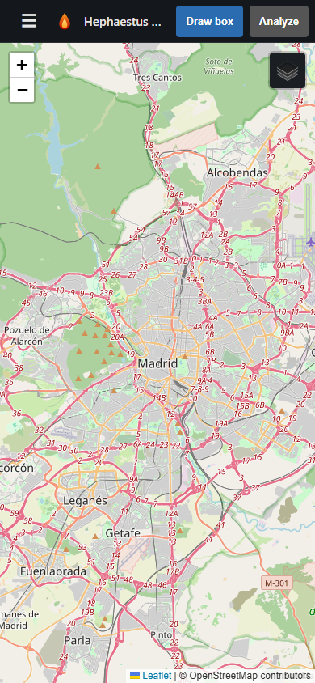  Collapsed (map full-width) | 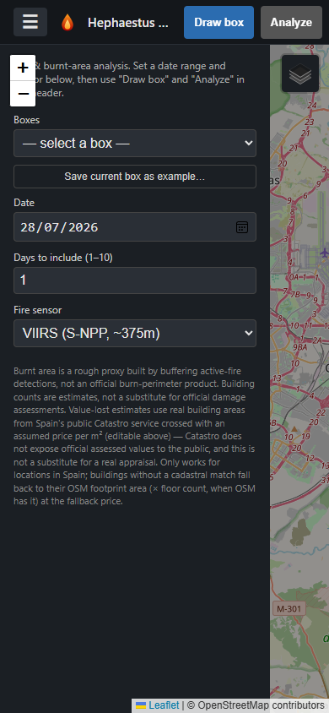  Sidebar opened via the menu button

9. Limitations: read before relying on the numbers
This is a rapid-assessment tool, not a substitute for official damage assessment:
- Burnt area is a rough geometric proxy built by buffering active-fire point detections, not a mapped burn perimeter; compare to official products (for example MTBS, MCD64A1) for that.
- Building counts are estimates based on that proxy, not a substitute for an official damage assessment.
- Value-lost estimates combine real Catastro built areas (Spain only) or OSM footprints (times floor count, when available) with an assumed price per square meter; this is not an official appraisal. Catastro does not expose official assessed values to the public.
- Value-lost estimation only works for locations in Spain.

