Map generator documentation (v1.0)

Goal:

The map generator software is written in python 2.7 and bash (it is an improved version of an original script created by J Victores, roboticsLab UC3M). Its main goal is to generate reallistic interior maps, so better and more compelling simulated experiments can be carried.

Requirements

Ubuntu 16.04 or higher
ROS kinetic
Gazebo 7
Python 2.7
lxml library
shutil library
numpy library

Basic usage:

The map generator uses a CSV file (random.csv) to create the final 3d model. The user just needs to fill the corresponding CSV with the desired numbers, according to the distribution and wanted size. Once an MxM surface of numbers is written the CSV can be saved. The accepted characters are:

Character | Description (VxH)
0 | Floor (1x1)
1 | Wall (1x1)
2 | Vertical door (2x1)
3 | Horizontal door (1x2)
4 | Table (1x1)
5 | Sofa (1x1)
6 | Bed (2x3)
7 | Chair (1x1)

Afterwards the user can execute the .sh file, administrative permision will be required while execution. This step will create a new .world file in sdf language that can be attached to an existing launcher or can be executed with the provided one with the following command:

- roslaunch random.launch

Materials, models and expandability:

The materals and textures are stored in the materials directory the generator has 5 programmed textures, each of them is assosiated to a material in the repeated.material file inside the scripts subfolder. Moreover the software also uses some materials from the Gazebo files. See the table:

Material | Texture | Where is it used?
Repeated/seamless | seamless_texture.png | Walls
Repeated/Wood | wood2.jpg | Table
Repeated/Wood2 | wood3.jpg | Chair
Repeated/Wood3 | wood4.jpg | --------------
Repeated/sofa | sofa.jpg | Bed and sofa
Gazebo/Wood | ----------------- | Floor

Materials can be expanded via the materials file (using .jpg or .png formats). Meshes can also be added, but only .dae format has been tested (.stl might work also).
The hitbox of each material is defined by a box object that corresponds to the dimensions of the model. However, for the doors an specific hitbox for the frame and blade has been implemented in order to have a more accurate result.

Example:

CSV file
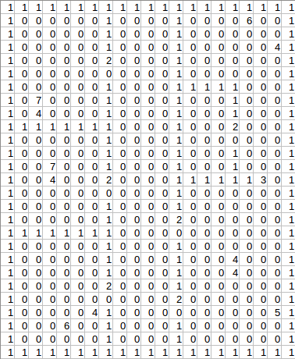

Final 3D map
