Apply for Approval of App Permissions.

**Step 1.** Login to your Facebook Developers account.

Link is here : <https://developers.facebook.com/>

And Go To **My Apps** & select the App you created.

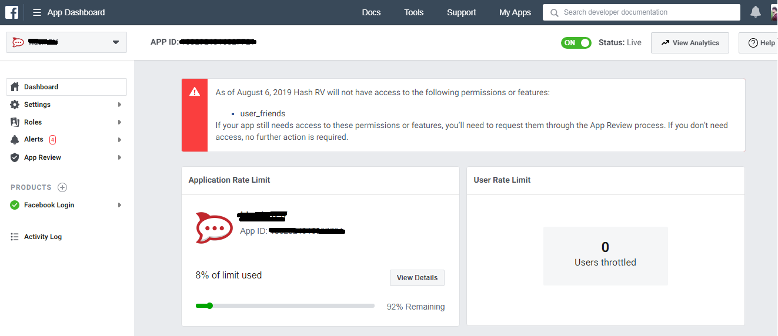

Screenshot: Dashboard of my Facebook App.

**Step 2.** In the Dashboard, we have option **App Review,** click on it and visit **Requests** page.

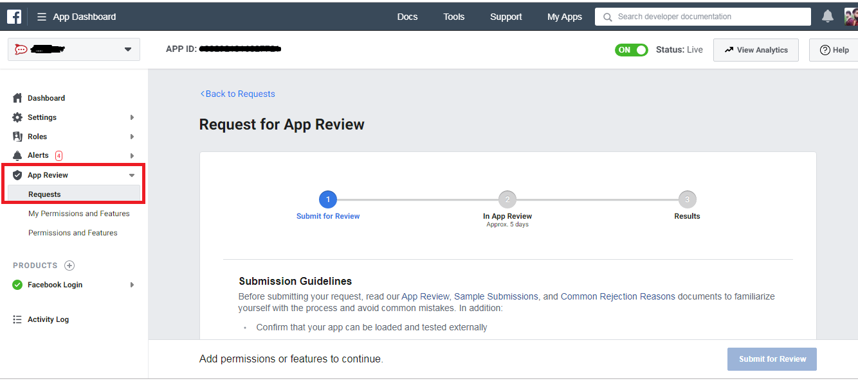

Requests Page of App Review.

**Step 3.** Scroll down the **Requests** page and click on **Add Additional Permissions and Features**.

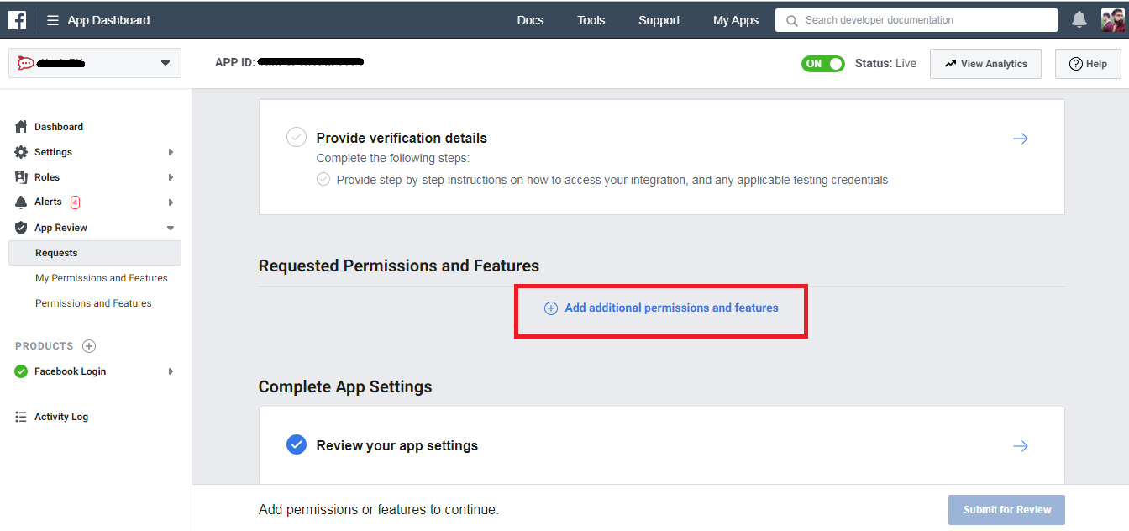

Requests page Showing Add Additional Permissions and Features

**Step 4.** Find **manage_pages** and **read_insights** Permissions and click on **Request** button on right side of both permissions.

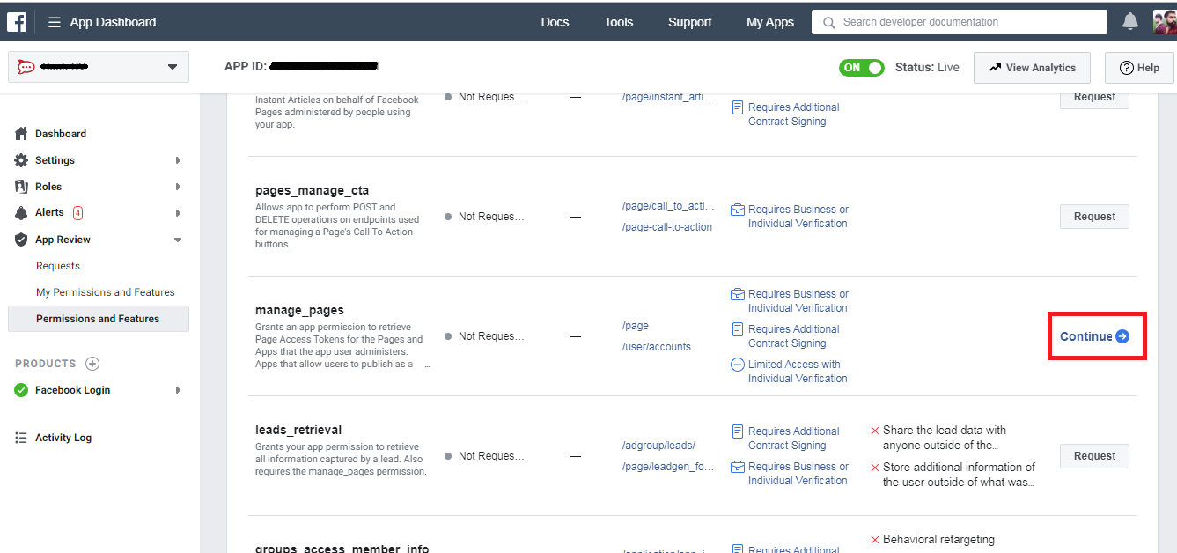

**Permissions and Features** page clicked on Request in front of **manage_pages**

**Step 5.**  Scroll the page to Top and click on **Continue the Request** button.

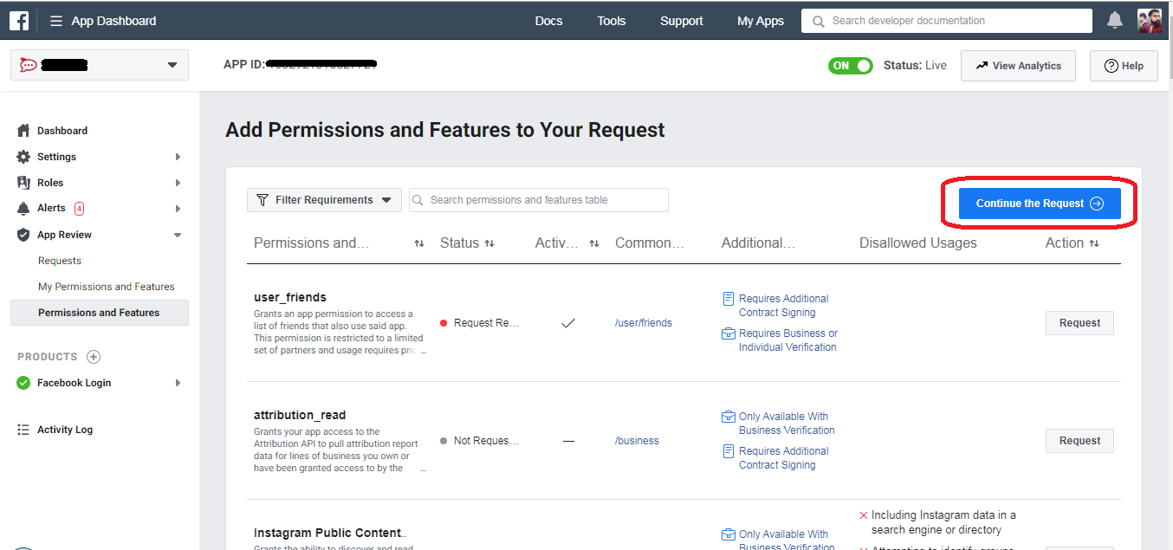

Showing Continue to Request button

**Step 6.** Provide necessary data to following options:

* Complete App Verification
* Requested Permissions and Features

And Submit for the Review.

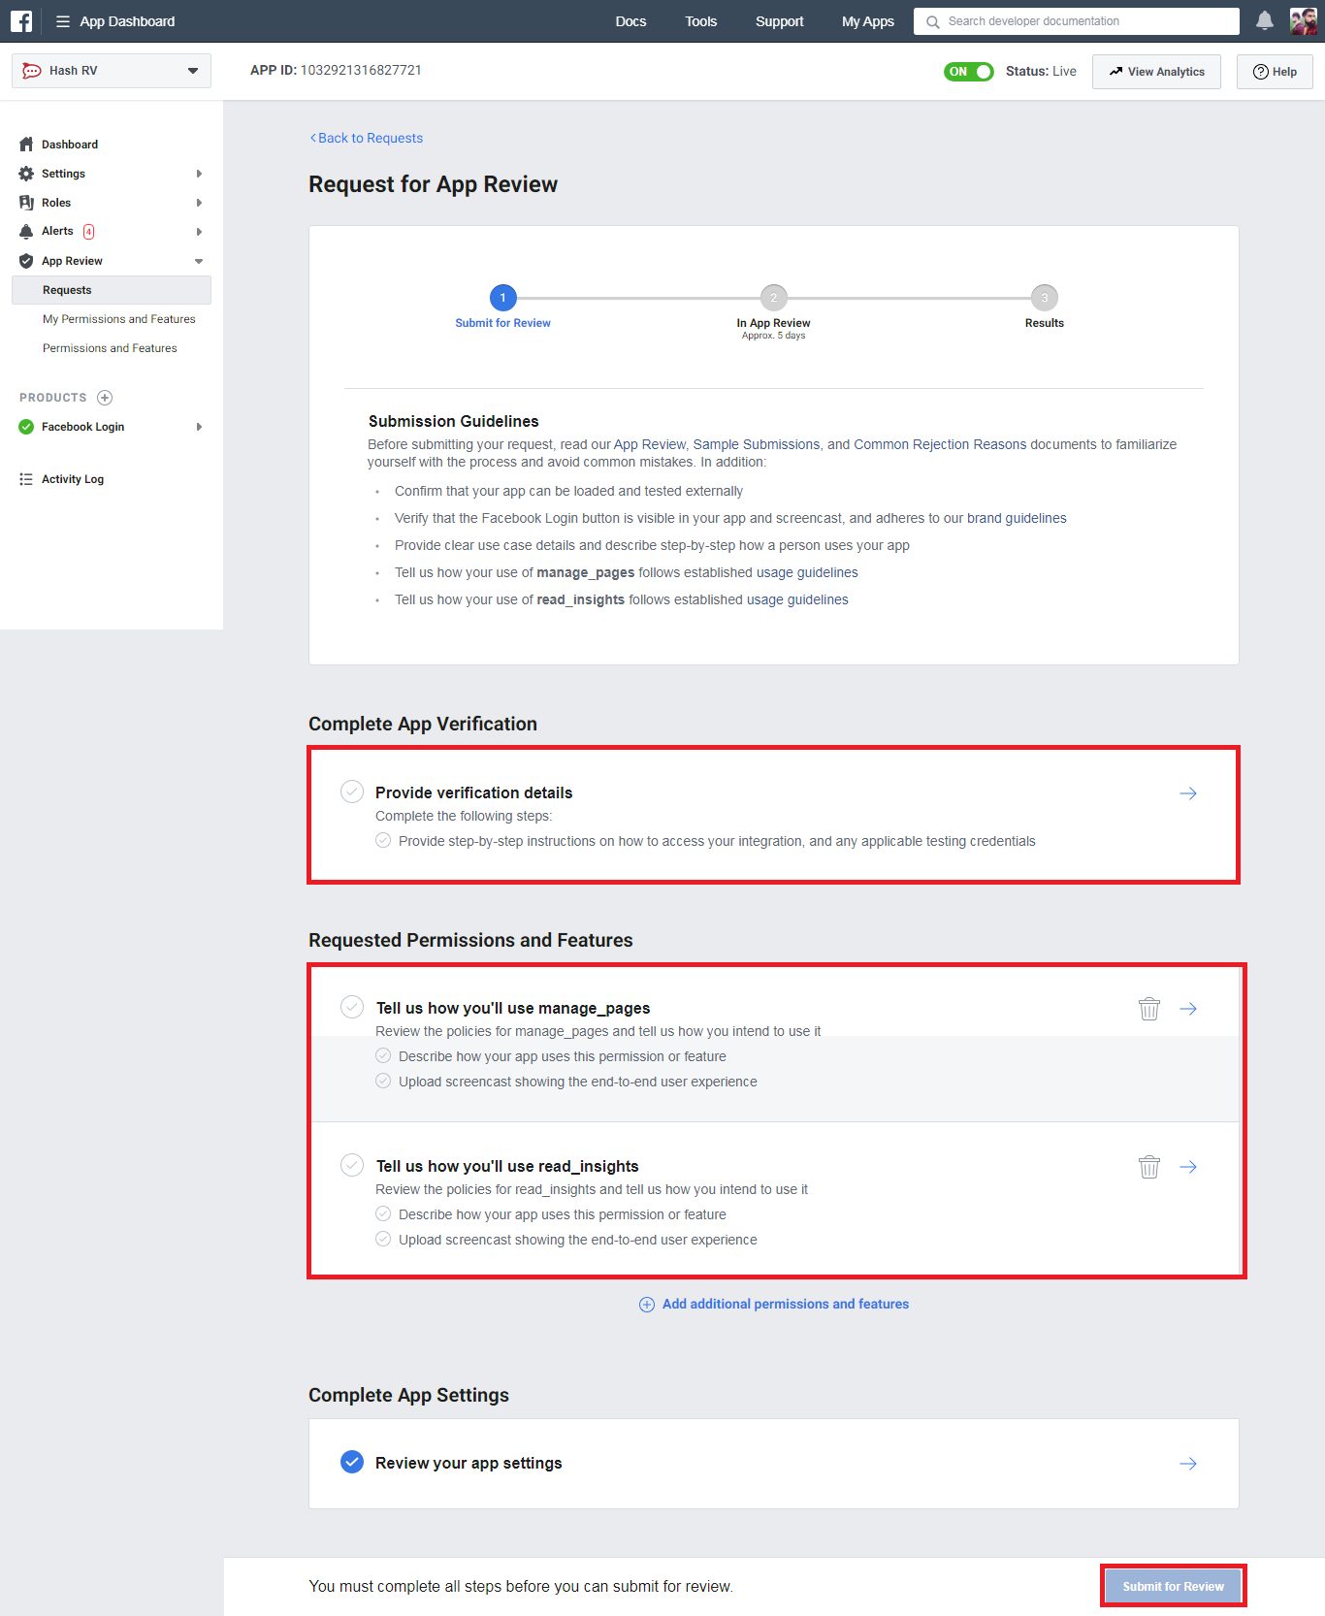

Submission page of Verification of App

App Verification.

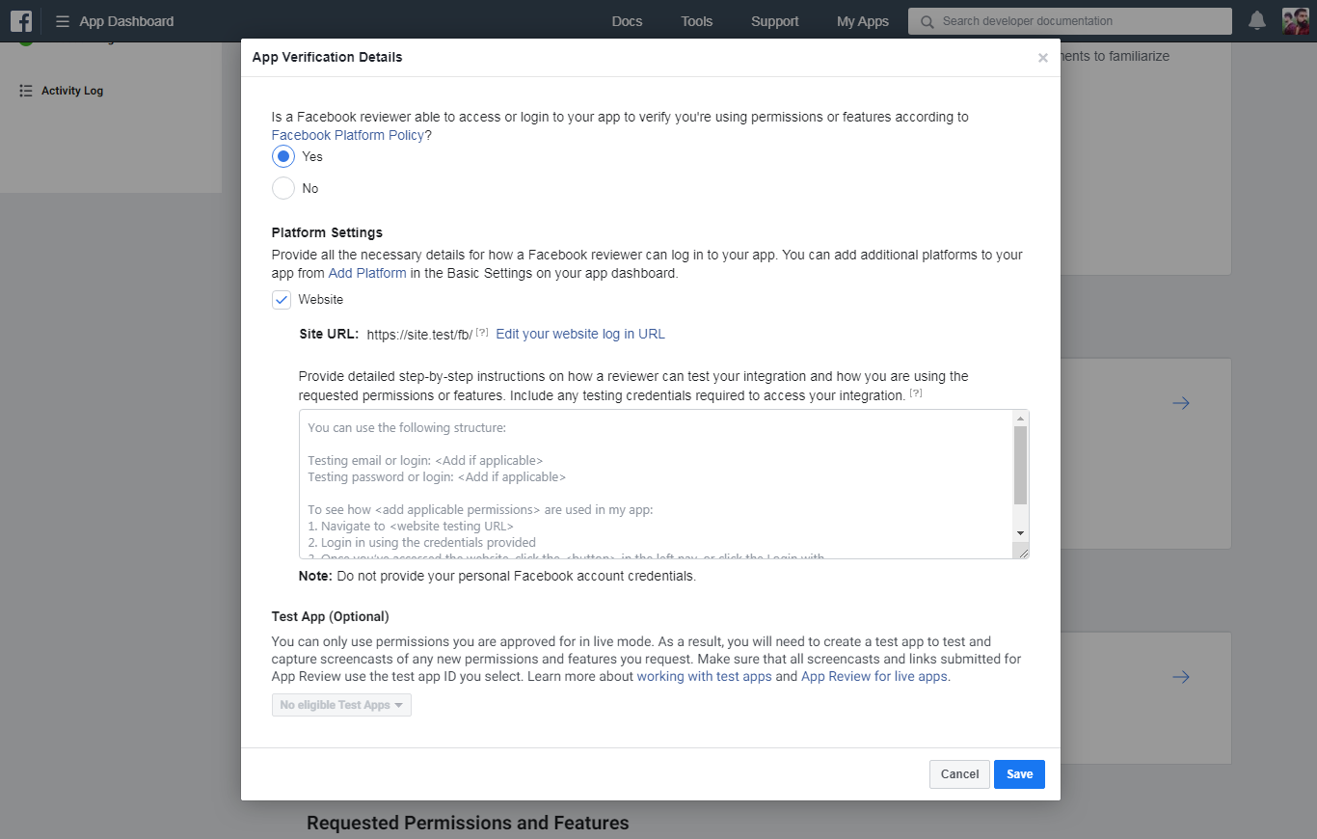

Requested Permissions and Features.

