USER’S MANUAL

***PEMS***

*(Evaluation Version)*

**Employee Management System**

April, 2020

**TABLE OF CONTENTS**

1.0 GENERAL INFORMATION 1

1.1 SYSTEM OVERVIEW 2

1.2 USER ROLES 3

1.3 SUPERADMIN 3

1.4 SALES MANAGER 3

1.5 SALES PERSON 3

1.6 HR 3

1.7 REFERENCES 4

1.8 AUTHORISED USE PERMISSION 4

1.9 POINT OF CONTACT 4

1.10 ORGANISATION OF THE MANUAL 4

2.0 SYSTEM SUMMARY 6

2.1 SYSTEM CONFIGURATION 7

2.2 RECOMMENDED BROWSERS 7

2.3 DATA FLOW 8

2.4 USER ACCESS 9

3.0 GETTING STARTED 11

3.1 LOGGING IN 12

3.2 SYSTEM DASHBOARD 12

3.3 SYSTEM MENU 13

3.4 PROFILE 14

4.0 MANAGING EMPLOYEE 16

4.1 ADD NEW EMPLOYEE 17

4.2 ADD LEVEL 17

4.3 ADD DIVISION 18

4.4 VIEW INVITATION LIST 19

4.5 VIEW EMPLOYEE 19

4.6 LOGIN AS / DELETE EMPLOYEE 20

5.0 MANAGING RECRUITMENT 21

5.1 ADD INTERVIEWERS 22

5.2 VIEW INTERVIEWERS 22

5.3 ADD JOB POSITIONS WITH STEPS 23

5.4 ADD INTERVIEW STATUS 23

5.5 ADD CAREERS STEPS PAGE 24

5.6 VIEW/EDIT/DELETE CAREERS STEPS 24

6.0 MANAGING PROJECTS 25

6.1 ADD PROJECTS 26

6.2 VIEW/EDIT PROJECTS 26

6.3 ADD PROSPECTS 27

6.4 SCHEDULE APPOINTMENTS 27

6.5 VIEW SCHEDULED APPOINTMENTS 28

7.0 MANAGING SALES TEAM 29

7.1 VIEW SALES TEAM 30

7.2 VIEW MANAGER/ TEAMS 30

7.3 ASSIGN MANAGERS31

7.4 ADD WEEKLY SALES REPORTS 31

7.5 VIEW WEEKLY SALES REPORTS 32

# 1.0 GENERAL INFORMATION

**1.0 GENERAL INFORMATION**

## 1.1 System Overview

PEMS is an Employee Management System Web Application.

## 1.2 User Roles

|  |  |
| --- | --- |
| **User Role** | **Capabilities** |
| Super Admin | This is the apex user account that can control the whole system. Super Admin can manage users and all of the. |
| Sales Managers | The Manager who manage Sales team and Sales. |
| Sales Person | The Sales Person manage sales. |
| HR | The HR hires and manage employee. |
| Applicant | Applicant participate in hiring process. |

## 1.3 Super Admin

* + 1. Super Admin is the most powerful user account and can control everything.
    2. Every minor and major function within PEMS – right from creating Job Position and add employee as Interviewer – can assign Sales Team to Sales Manager. This means 100% control over each user and a bird’s eye view of each project performed via PEMS.
    3. These functions are built into the Super Admin account in addition to the all other functions of all the current user levels. Even, Super Admin has the login access to any User with one click.
    4. Can add Training Materials for Users.
    5. Can add Locations/Divisions/Counties/Regions.

## 1.4 Sales Manager

The Sales Manger level is assigned to the manager who manage their team of Sales person and Week Reports. The Sales Manger has following rights:

1. Can manage its Sales Team.
2. Can watch Week Sales Reports generated by Sales Person.
3. Blog post created by Sales Manger visible on Sales Person Dashboard.

## 1.5 Sales Person

The Sales Person level is assigned to the user who works in sales, arrange meeting with Clients and generate Week Sales Reports. The Sales Person has following rights:

1. Create Projects Niches.
2. Add Contact of organization as clients.
3. Set appointments and follow-ups schedule with clients.
4. Can get contact of its Sales Manager.

## 1.6 HR

The HR would be responsible to perform the some Super Admin activities like Recruitment and Employee

management. The HR has following rights:

1. Create Job Position.
2. Add interviewers
3. Update Applicant’s assigned interviewer.
4. Add Employees.
5. Delete Employee
6. Organize Employee list.
7. Can Login to any employee’s Account though one click.
8. Assign Team to Managers.

## 1.7 Applicant

The Applicant would be the participant of Interview process and Schedule interview within the Organization.

## 1.8 References

Following tools/ software were used to prepare this document:

1. Apple Pages - 6.0
2. Adobe Photoshop CC
3. Google Chrome - Version 56.0.2924.87 (64-bit)

## 1.9 Point of Contact

In case of any technical or sales query, you can reach us using the information given below:

**Phone:** +91 -- (Sales and General queries)

+91 9906 212151 (Technical Support)

**Email:** [pems@neovora.com.br](mailto:pems@neovora.com.br).

## 1.10 Organization of the Manual

The manual has been modularized into the following section to make it easy to read and use:

1.0 General Information

2.0 System Summary

3.0 Getting Started

4.0 Managing Employee

5.0 Managing Recruitment

6.0 Managing Projects

7.0 Managing Sales Team

# 2.0 SYSTEM SUMMARY

**2.0 SYSTEM SUMMARY**

## 2.1 System Configuration

The DATS has been developed with utmost care and attention to the details. The programming languages and software tools used have been picked form the top most stack used all over the world. The server setup has been done taking care of the capability of the software and various tests are conducted so that server configuration matches the requirement of the system.

The server configuration is as under:

* Server type: Cloud
* 4 GB RAM
* 4 CPU cores
* Unlimited storage
* Unmetered bandwidth
* Unlimited email notifications
* SSL secure
* Hacking, theft protection

## 2.2 Recommended Browsers

* Google Chrome
* Firefox
* Safari
* IE 9+
* Opera

## 2.3 Data Flow

The following diagram represents the flow of data in the PEMS:

LOGIN

SALES MANAGER

HR

SALES PERSON

SUPERADMIN

- Add Project

- Update Project

- Add Prospect

- Update Prospect

- Schedule Appointments

- Schedule Follow-up

- Create Week Sales Report

- Add Job Positions

- Add Interviewer

- Add Interview Step

- Add Interview Status

- Create Portal Refer link

- Delete/ Update Job Positions

- Delete Interviewer

- Delete/ Update Interview Status

- View Applicants

- Assign Interviewer to Applicant

- Score Applicant

- Reschedule Interview

- Add Employee

- Delete Employee

- Employee List

- Assign as Interviewers

MANAGING RECRUITMENT

MANAGING EMPLOYEE

- Create Sales Team

- Assign Manager

- Generate Week Sales Report

- Manager Contact

MANAGING PROFILE

MANAGING SALES TEAM

MANAGING PROJECT

PEMS

The following diagram represents the flow of data in the PEMS Career Portal:

Applicant

LOGIN

PEMS Career

Schedule / Reschedule

Interview

## 2.4 User Access

Based on the modules available in the PEMS, the various user levels have following access capabilities:

|  |  |  |  |  |
| --- | --- | --- | --- | --- |
| **Capability** | **Super Admin** | **HR** | **Sales Person** | **Sales Manager** |
| View Applicants |  |  |  |  |
| Applicant Score |  |  |  |  |
| Interviewer Assign |  |  |  |  |
| Add Employee |  |  |  |  |
| Edit Employee |  |  |  |  |
| Login to any Employee |  |  |  |  |
| Delete Employee |  |  |  |  |
| Add Job Position |  |  |  |  |
| Add Interview Steps |  |  |  |  |
| Edit Job Position |  |  |  |  |
| Edit Interview Steps |  |  |  |  |
| Add Project |  |  |  |  |
| Add Prospect |  |  |  |  |
| Schedule Appointment |  |  |  |  |
| Add Week Sales Report |  |  |  |  |
| View Week Sales Report |  |  |  |  |
| Manager assign |  |  |  |  |
| Create Sales Team |  |  |  |  |
| View Manager assigned |  |  |  |  |
| View Sales Team |  |  |  |  |
| Add Sales Training |  |  |  |  |
| View Sales Training |  |  |  |  |
| Add Recruitment Training |  |  |  |  |
| View Recruitment Training |  |  |  |  |
| Who is Online |  |  |  |  |
| Add Blog |  |  |  |  |
| View Blog |  |  |  |  |

# 3.0 GETTING STARTED

**3.0 GETTING STARTED**

## 3.1 Logging In

To login into PEMS, open your favourite browser and type the URL provided to you

url.PNG

Press Enter, and you will see the Login screen, enter your login credentials and press Sign In

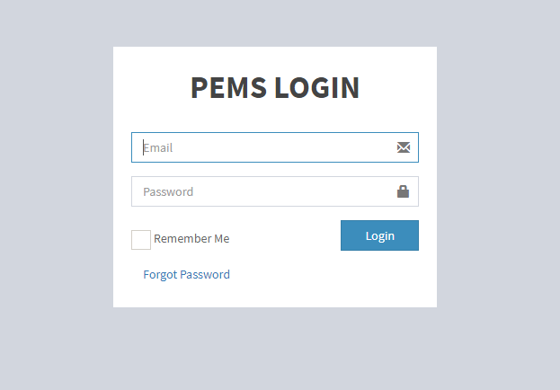

## 3.2 System Dashboard

After logging in, you will see the Dashboard screen according to your Role

i.e. for **Super Admin**

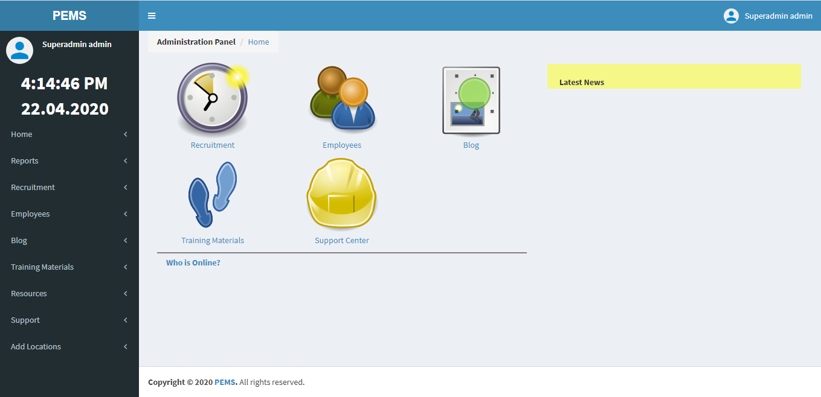

For **HR:**

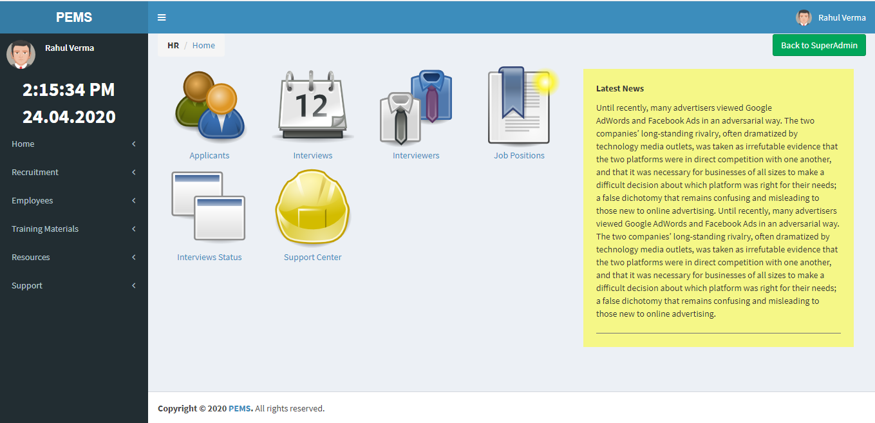

For **Sales Manager:**

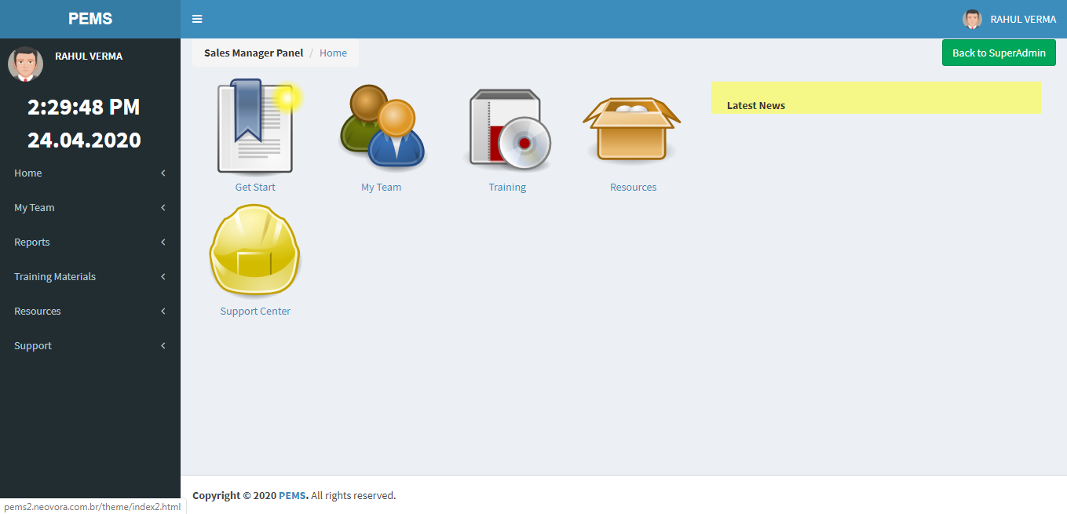

For **Sales Person:**

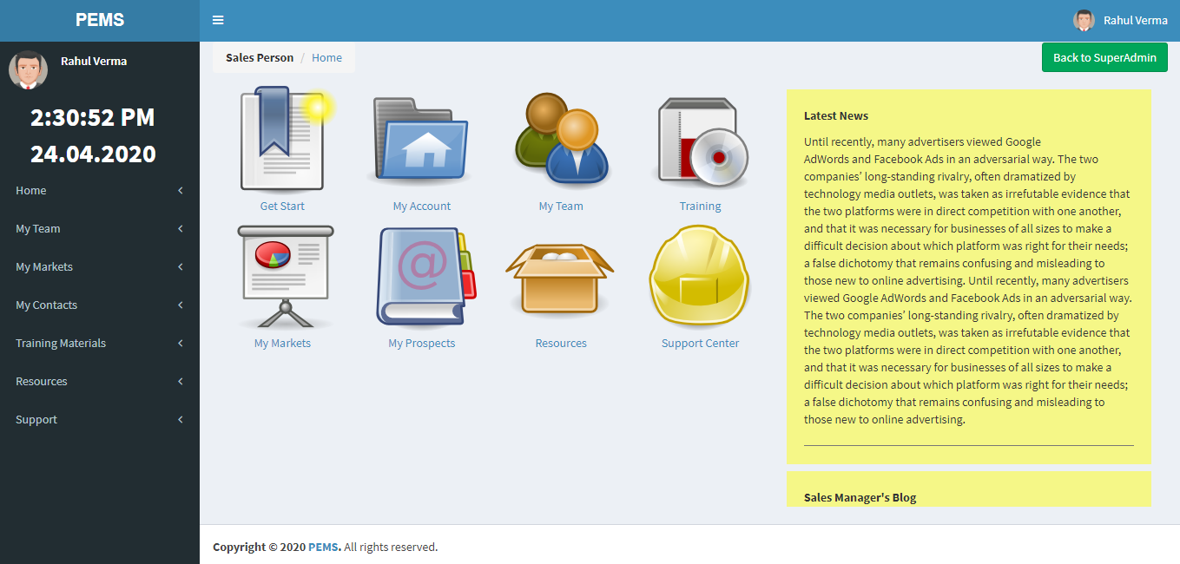

## 3.3 System Menu

The system menu can always be seen on the left hand side of the browser window.

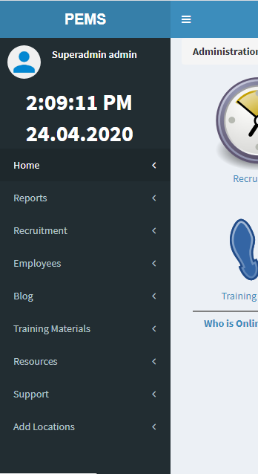

Use this button to squeeze the menu and make work area wider.

Navigation Links

Squeezed menu will look like this

## Profile

To edit your profile click on the button on the top right corner of the window

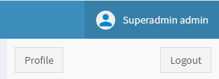

Now click here to edit profile Sign out button

# 4.0 MANAGING EMPLOYEE

**4.0 MANAGING EMPLOYEE**

**4.1 Add New Employee**

Before adding Employee, you need to Add Level (Role) and Division (Territory) for the employee, by clicking on these Buttons.

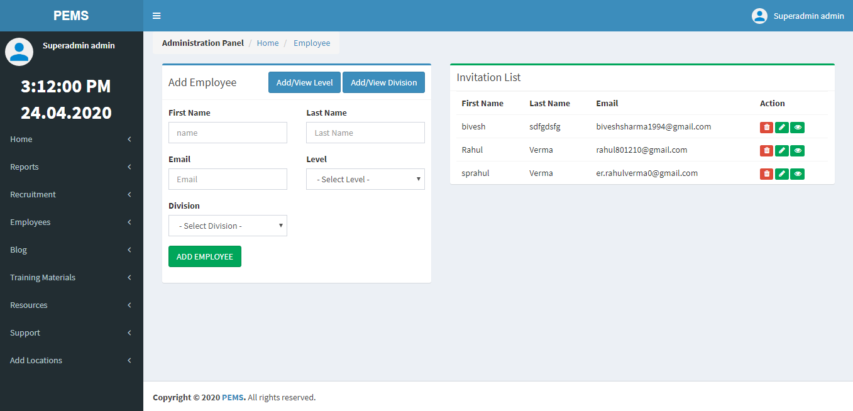

Then add Employee with details.

* 1. **Add Level**

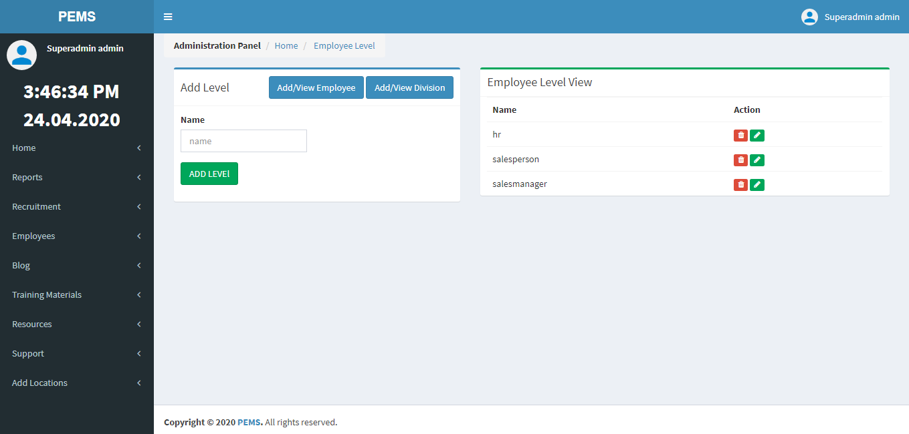

* 1. **Add Division**

Before Adding Division, you have to Add Region from Add Locations Section.

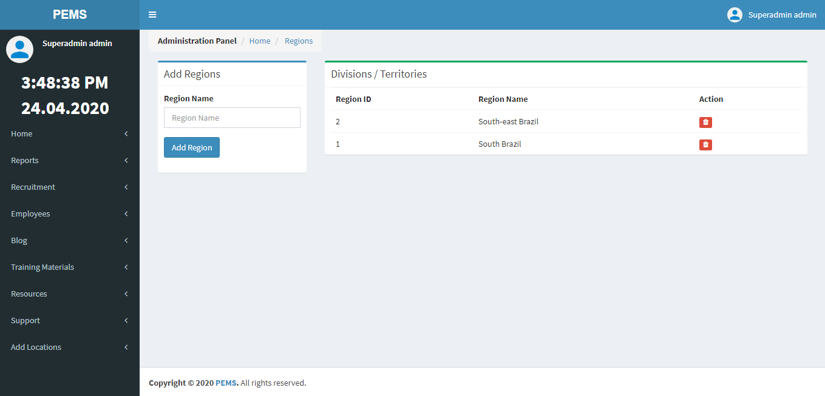

After adding Region, now we can Add Division.

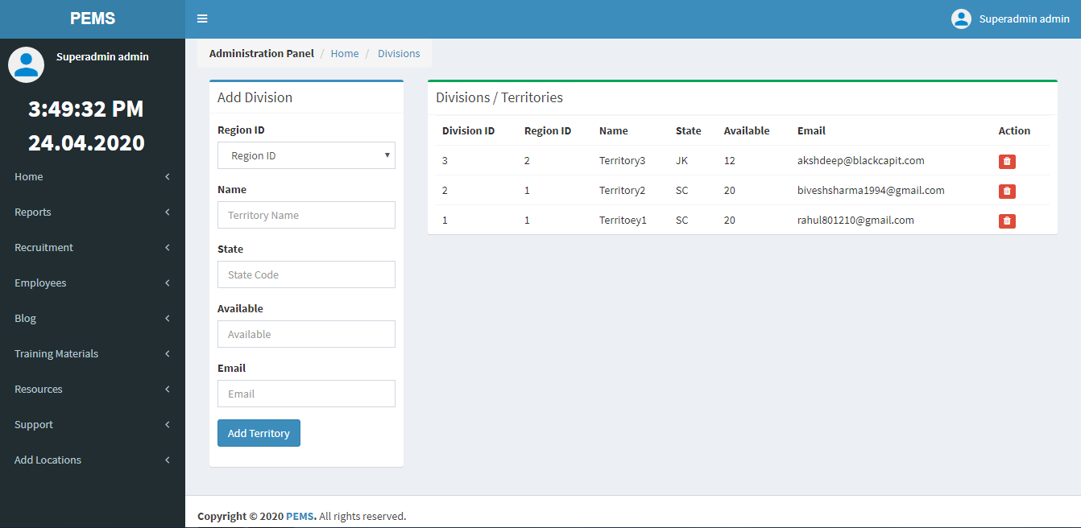

* 1. **View Employee Invitation List**



* 1. **View Employee List**

Employee registered with Invitation Link, and added to Employee List.

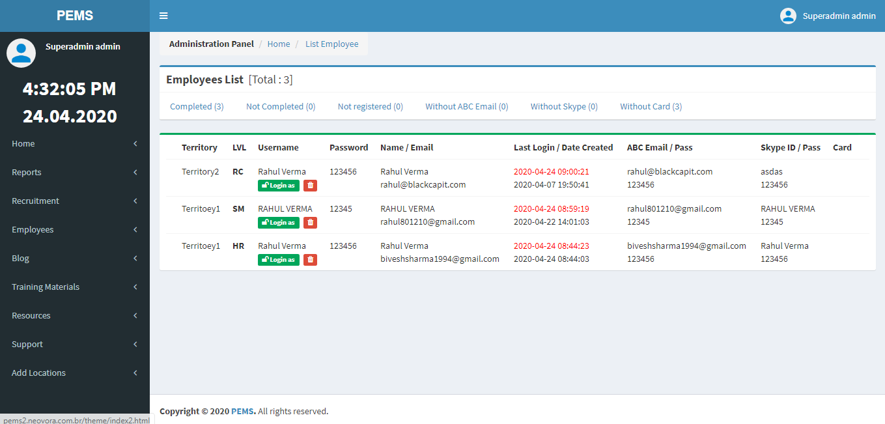

**4.6 Login as and Delete Employee**

Super Admin and HR has power to Login as any Employee with one click and Delete.



# 5.0 MANAGING RECRUITMENT

**5.0 MANAGING RECRUITMENT**

**5.1 Add Interviewers**

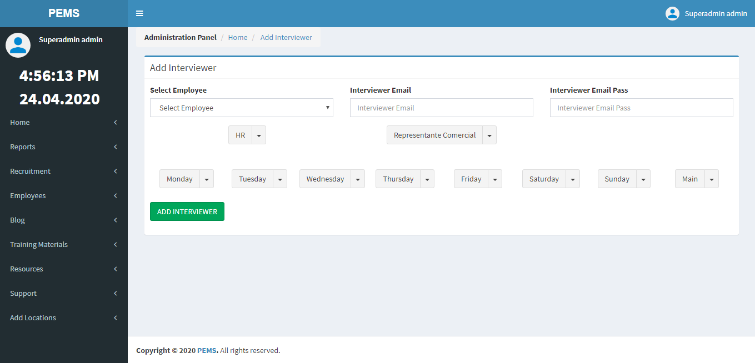

Add Interviewer from Employee List

**5.2 View Interviewers**

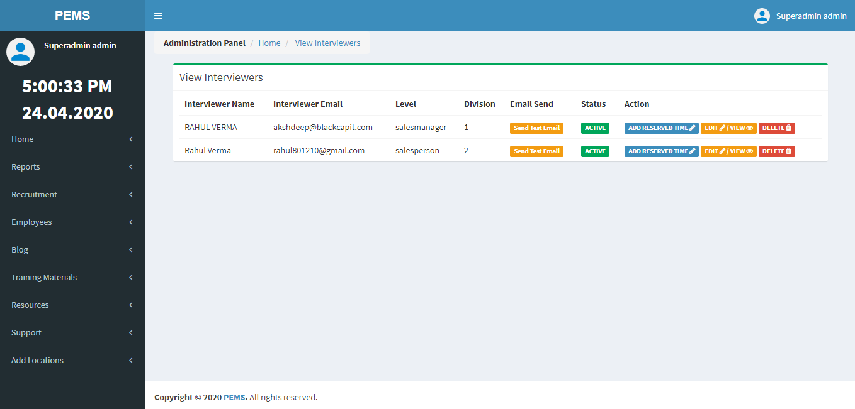

* 1. **Add Job Position with Steps**

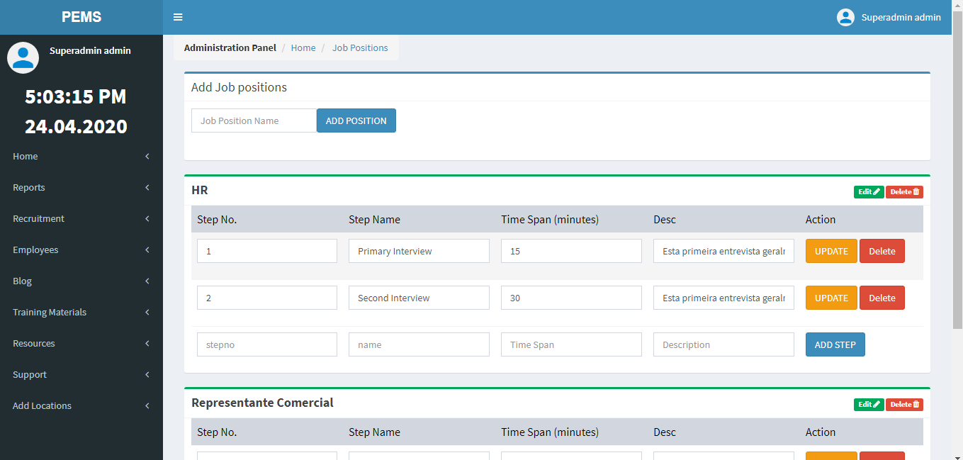

**5.4 Add Interview Status**

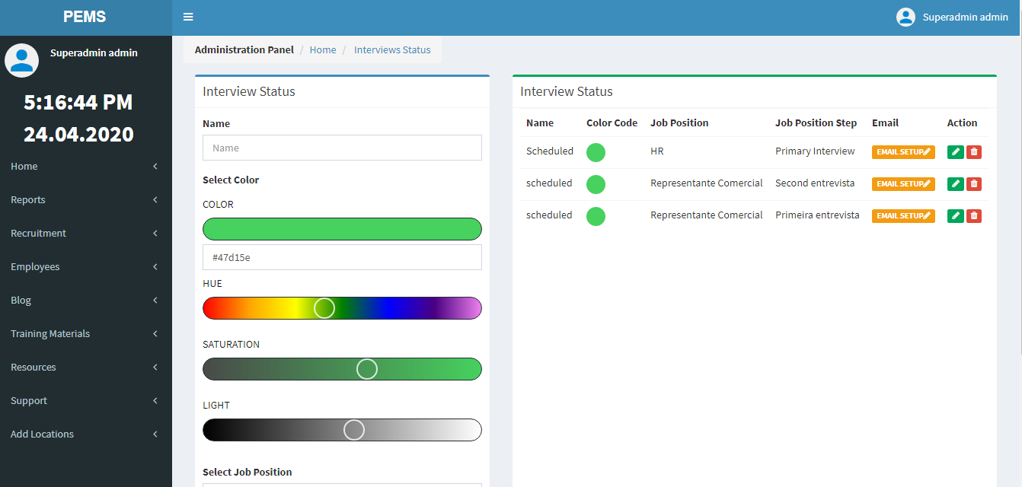

**5.5 Add Careers Steps**

Add Careers Step from Add Steps Page in Recruitment module, to get details and ask questions from Applicants.

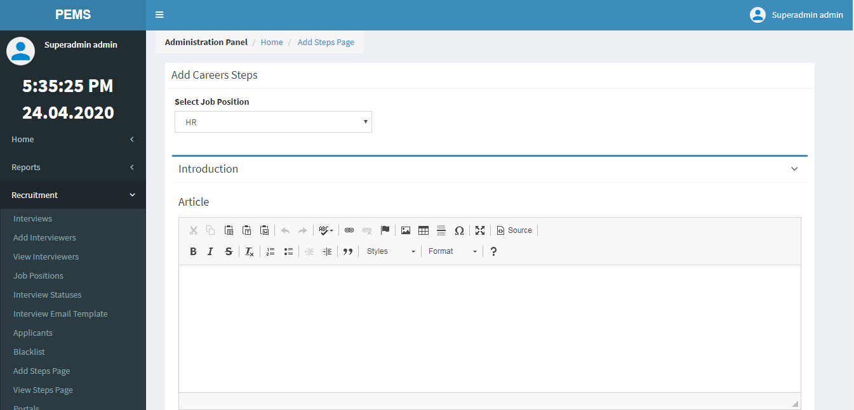

**5.6 View/Edit/Delete Careers Steps**

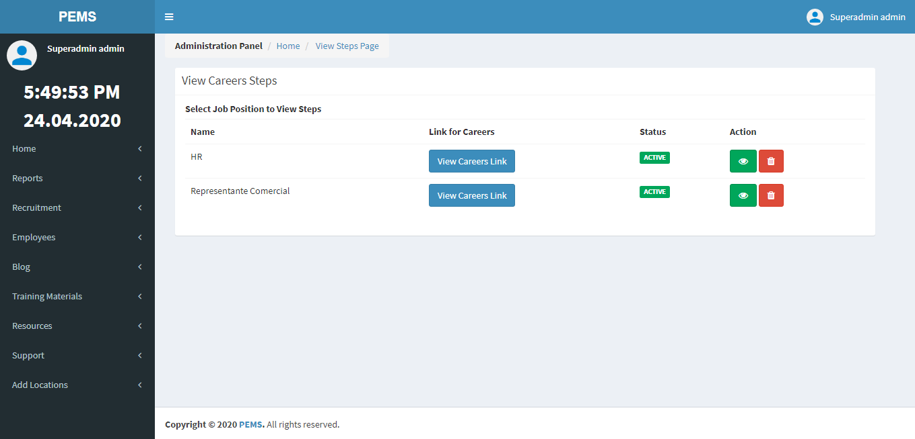

Careers Link for Applicants

View / Edit

Delete Careers Steps

# 6.0 MANAGING PROJECTS

**6.0 MANAGING PROJECTS**

**6.1 Add Projects**

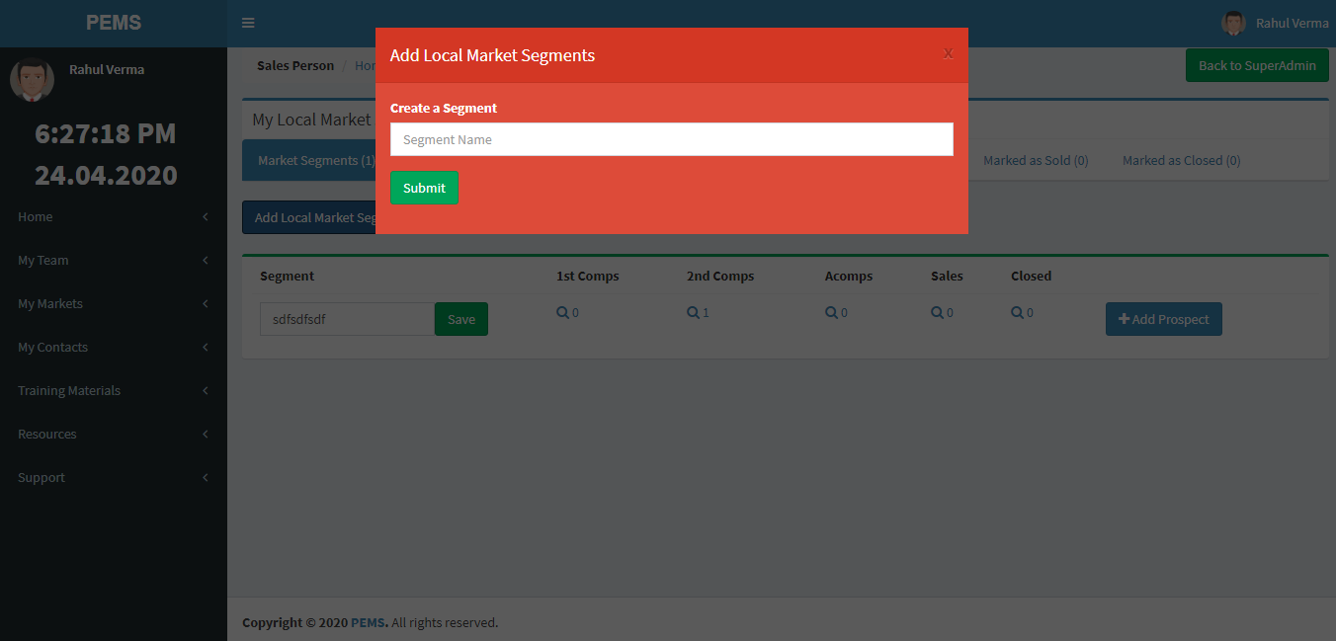

Project Name

**6.2 View/Edit Projects**

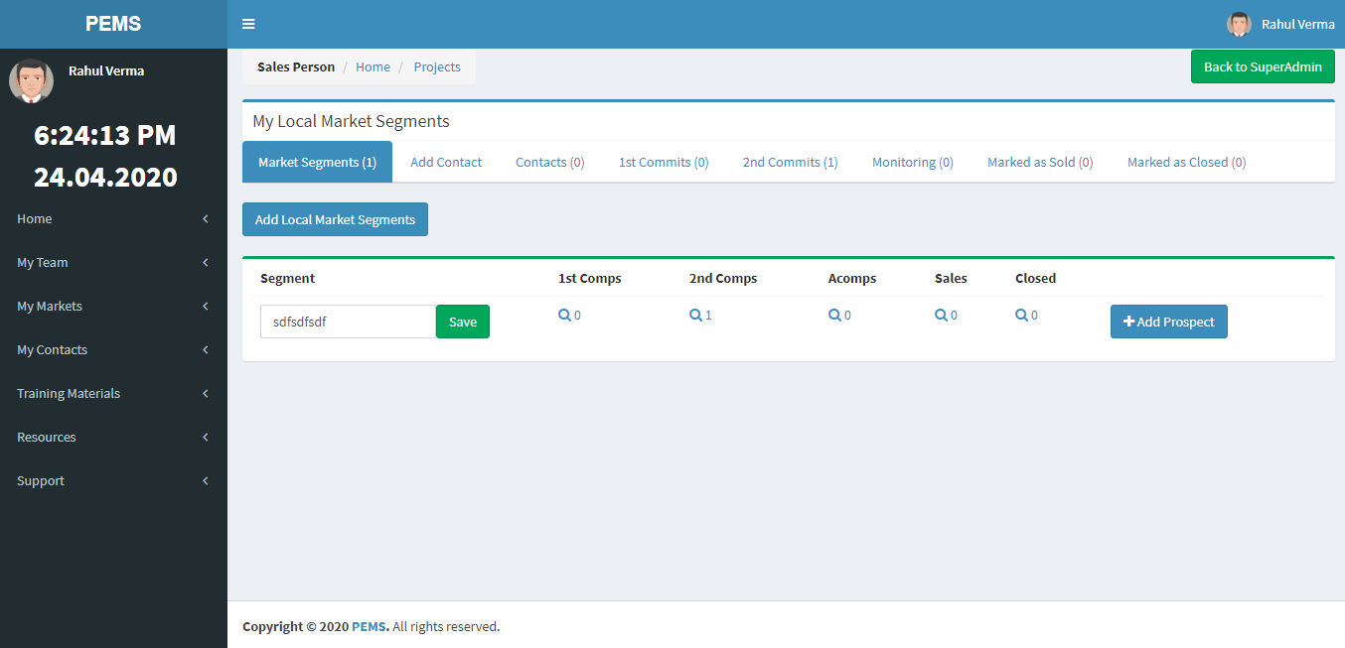

Closed

Sales

Follow ups

Prospects with 2nd

Appointment

Prospects with 1st Appointment

Update Project Name

* 1. **Add Prospects**

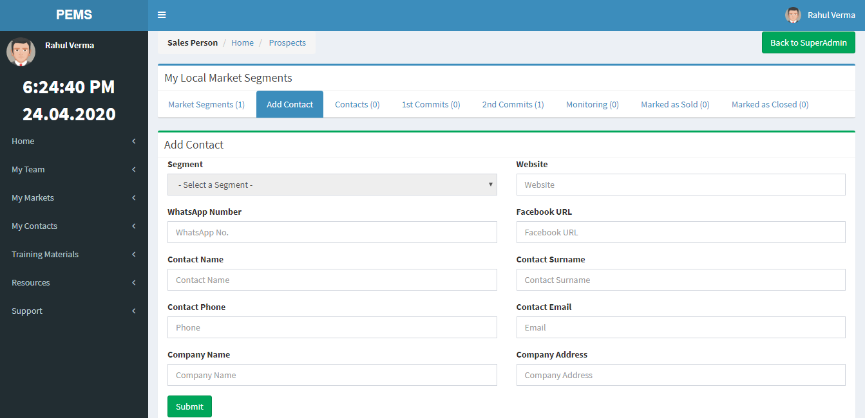

* 1. **Schedule Appointments**

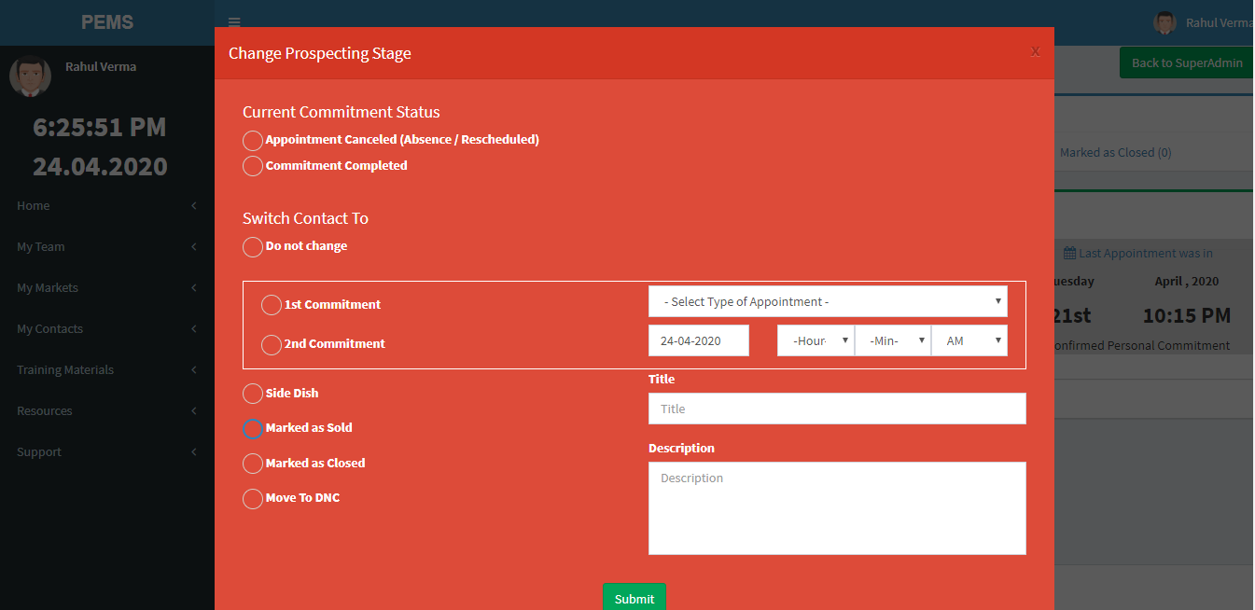

**6.5 View Scheduled Appointments**

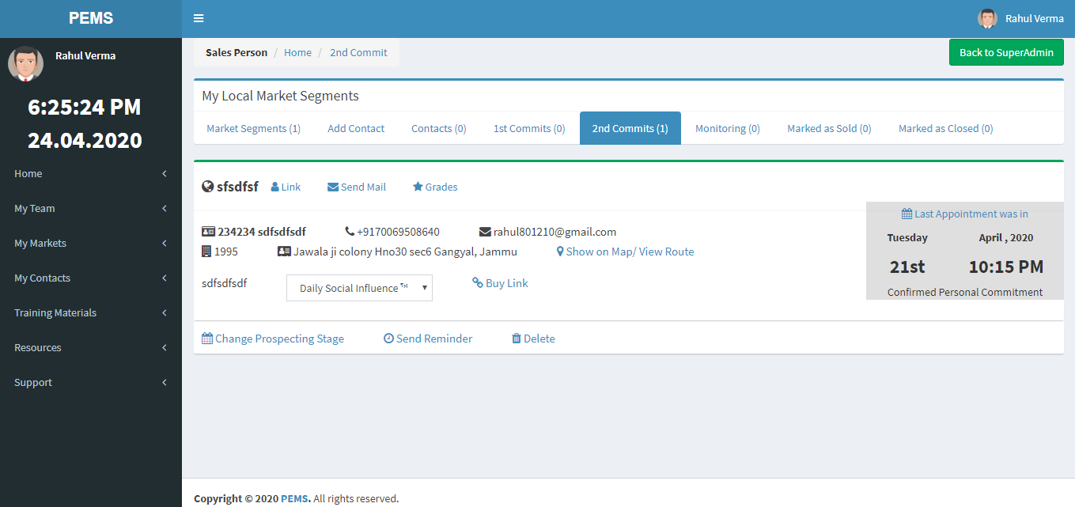

Delete Prospect

Details of Prospects

Scheduled Appointments Date & Time

Schedule Appointments

# 7.0 MANAGING SALES TEAM

1. **MANAGING SALES TEAM**

* 1. **View Sales Team**

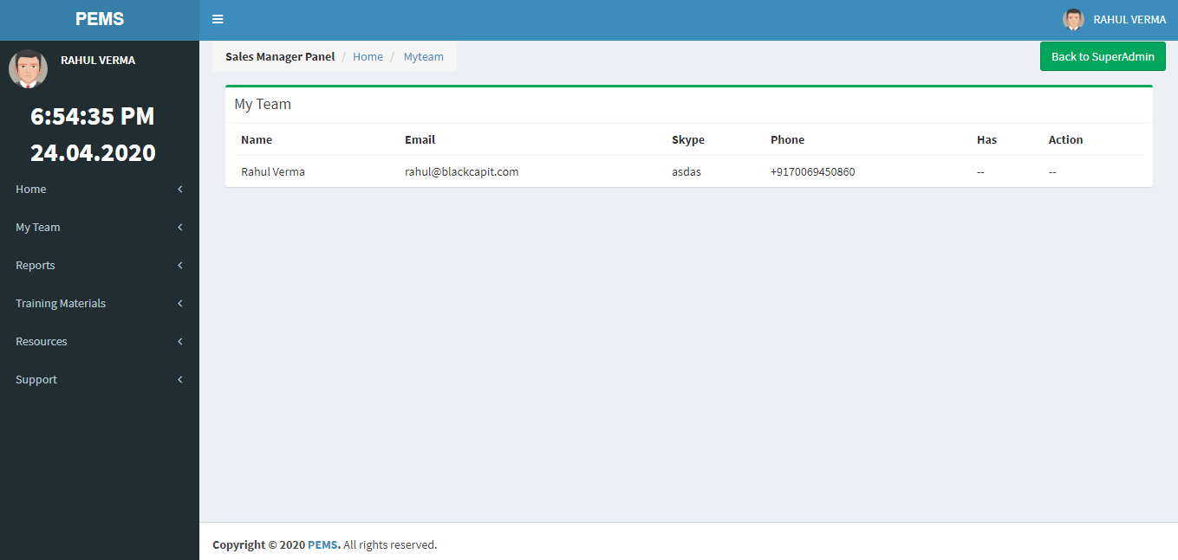

**7.2 View Managers/ Teams**

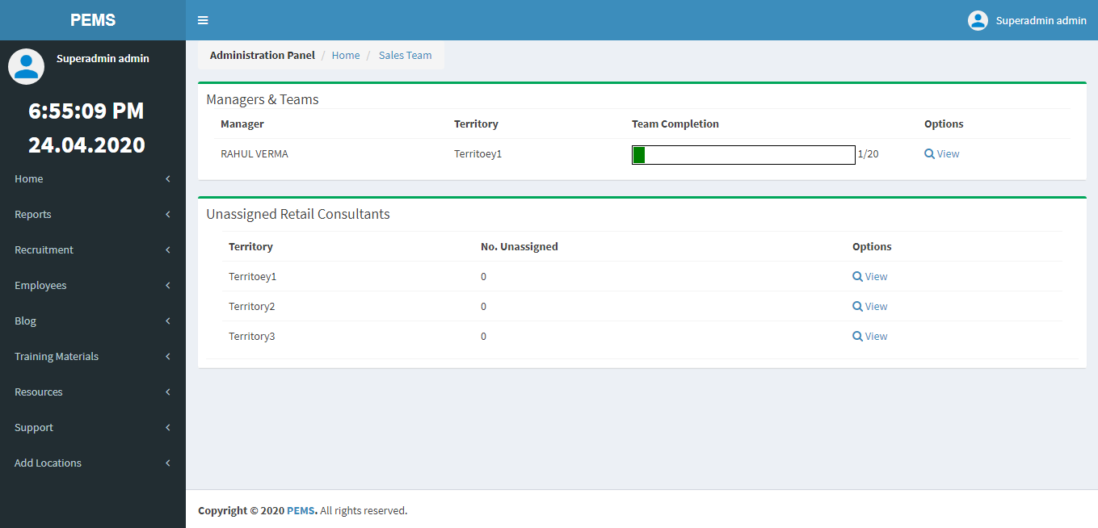

**7.3 Assign Manager/ Create Team**

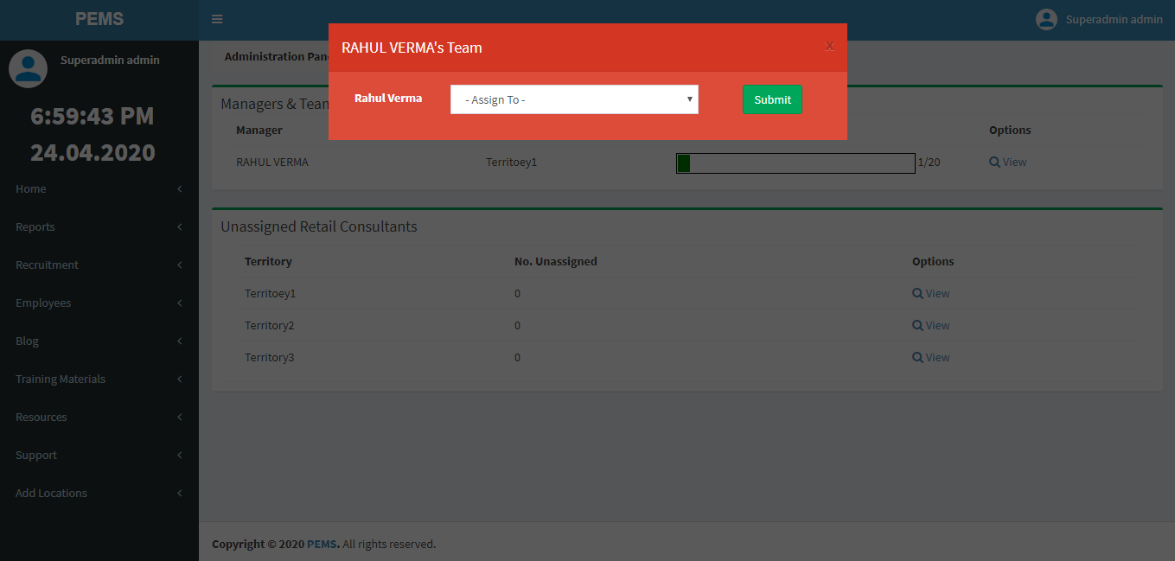

**7.4 Add Weekly Sales Reports**

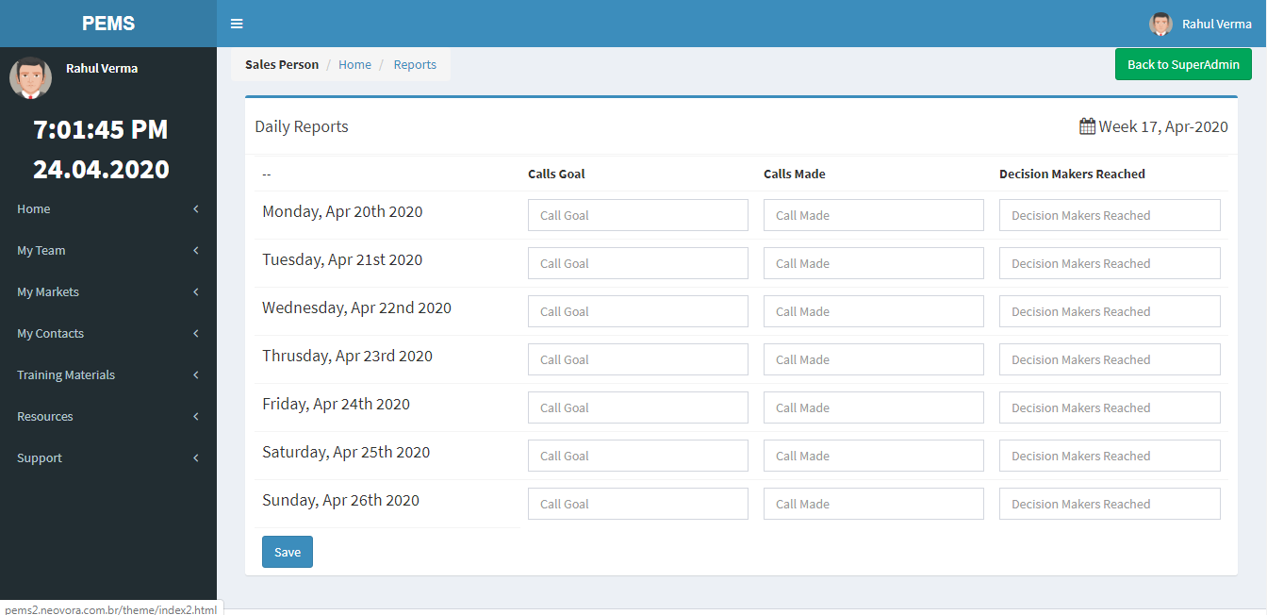

**7.5 View Weekly Sales Reports**

