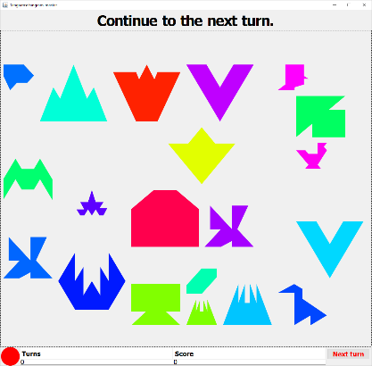Tangrams

Thank you for participating in the study! You will be playing an online game with one other person. You both will be presented with a board of tangrams like the one shown to the right.

# Goal

The goal of the game is to score as many points as possible by correctly guessing the piece which will be moved in the next turn as chosen by the computer: By selecting the correct piece, you gain one point. If you select the wrong piece, you lose *two* points but are allowed to try again. The two players are allowed to communicate as much as they want about before each selection in order to help the selecting player guess the correct piece to move.

# Play

Each player has one of two roles: Either the “instructor” — the player who can see which piece will move in the next turn — or the “selector” — the player who must select the piece to be moved. At the top of the board, you will receive instruction about your current role, e.g.:



## As instructor

One of the players will be instructed to proceed to the next turn via a dialog box on the screen.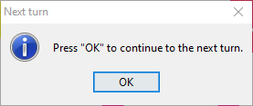

When the player clicks “OK”, a piece will be randomly highlighted with a dashed box around it, as shown on the right: This is the piece which the other player must guess.

## As selector

Once a piece has been chosen at random, the other player must then try to select this piece with the help of the instructor: Only the instructor can see which piece is highlighted, while the selector’s board appears unchanged. The selector will receive instruction at the top of the board:



When instructed to do so, the player should click on the piece they believe is the piece which the instructor can see highlighted. The players can take as much time as they need to choose. The instructor will be notified of whether the selector chose the correct piece or not.

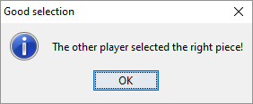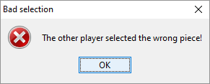

# Scoring

Your score is shown at the bottom of the board:



# Starting the game

## User name

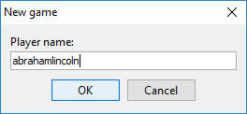When the program starts, you will be presented with a dialogue box for entering your player name — enter something descriptive, creative and/or unique (this data will be anonymized, don’t worry):

## Game number

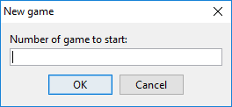After entering your username, you will be prompted to enter the number of the specific variant of the game you are to play, which will be given to you by the experiment supervisor:

Please be sure to enter the number *exactly* as it is given to you, else your system won’t be able to connect with that of your partner! Thanks a lot for your time and have fun tangramming!