C:\Program Files (x86)\Python36-32\Scripts

Add the path of your python scripts to your environment variable path as below [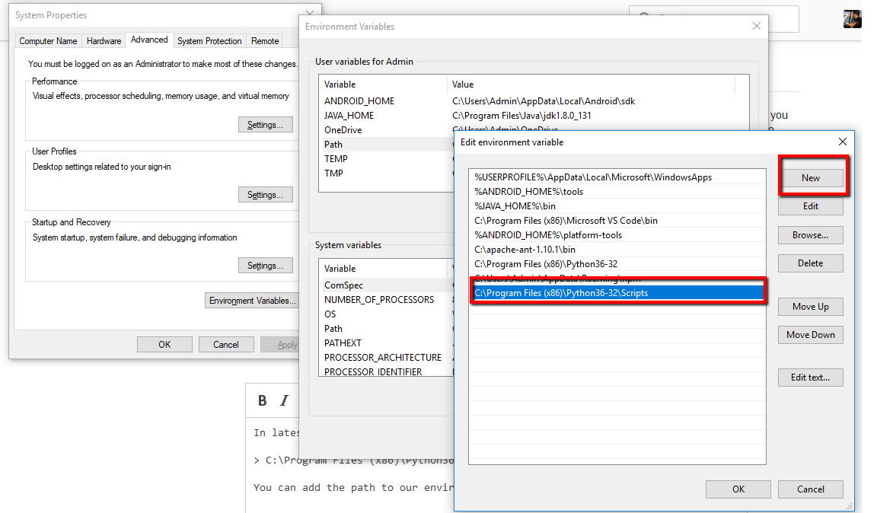](https://i.stack.imgur.com/mrYSt.png)

1. Make sure you close your command prompt or git after setting up your path. Also should you **open your command prompt in administrator mode**. This is example for windows 10.
2. In cmd.exe, **install line by line**:

pip install dash==0.22.0

pip install dash-renderer==0.13.0

pip install dash-html-components==0.11.0

pip install dash-core-components==0.26.0

pip install plotly –upgrade

pip install pandas

pip install pymongo

To View Locally (Preferred)

1. Navigate to the **non-administrator cmd prompt**, navigate to the **folder with the extractToMongo.py file**,

enter: py extractToMongo.py

1. Navigate to the folder with the extractToMongo.py file,

enter: py app.py

To View Online (Not Preferred because Heroku does not retrieve all datasets from MongoDB properly)

1. Go to web page at <https://choose-your-future-industry.herokuapp.com/>

Screenshot of Step 3:

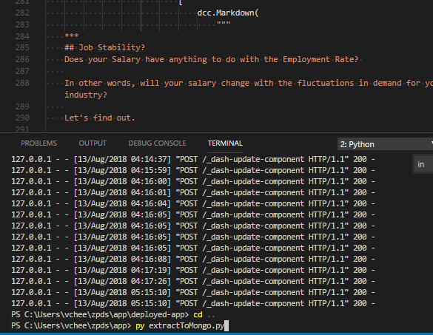

Screenshot of Step 4:

