E-MAIL

**Electronic mail** - often abbreviated as **e-mail** or **email** - is any method of creating, transmitting, or storing primarily text-based human communications with digital communications systems. Historically, a variety of electronic mail system designs evolved that were often incompatible or not interoperable. With the proliferation of the Internet since the early 1980s, however, the standardization efforts of Internet architects succeeded in promulgating a single standard based on the **Simple Mail Transfer Protocol (SMTP)**, first published as Internet Standard 10 in 1982.

Modern e-mail systems are based on a store-and-forward model in which e-mail computer server systems, accept, forward, or store messages on behalf of users, who only connect to the e-mail infrastructure with their personal computer or other network-enabled device for the duration of message transmission or retrieval to or from their designated server. Rarely is e-mail transmitted directly from one user's device to another's.

While, originally, e-mail consisted only of text messages composed in the ASCII character set, virtually any media format can be sent today, including attachments of audio and video clips.

**Origin**

E-mail predates the inception of the Internet, and was in fact a crucial tool in creating the Internet.

MIT first demonstrated the **Compatible Time-Sharing System (CTSS) in 1961**. It allowed multiple users to log into the IBM 7094 from remote dial-up terminals, and to store files online on disk. This new ability encouraged users to share information in new ways. E-mail started in 1965 as a way for multiple users of a time-sharing mainframe computer to communicate. Although the exact history is murky, among the first systems to have such a facility were SDC's Q32 and MIT's CTSS.

E-mail was quickly extended to become *network e-mail*, allowing users to pass messages between different computers by 1966 or earlier (it is possible that the SAGE system had something similar some time before).

The ARPANET computer network made a large contribution to the development of e-mail. There is one report that indicates experimental inter-system e-mail transfers began shortly after its creation in 1969. Ray Tomlinson initiated the use of the "**@**" sign to separate the names of the user and their machine in 1971. The ARPANET significantly increased the popularity of e-mail, and it became the killer app of the ARPANET.

**Working of E-Mail**

The diagram to the right shows a typical sequence of events that takes place when Alice composes a message using her mail user agent(MUA). She enters the e-mail address of her correspondent, and hits the "send" button.

1. Her MUA formats the message in e-mail format and uses the Simple Mail Transfer Protocol(SMTP) to send the message to the local mail transfer agent(MTA), in this case smtp.a.org, run by Alice's Internet Service Provider(ISP).
2. 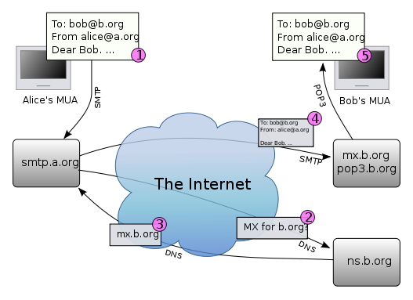The MTA looks at the destination address provided in the SMTP protocol (not from the message header), in this case bob@b.org. An Internet e-mail address is a string of the form localpart@exampledomain.com, which is known as a Fully Qualified Domain Address(FQDA). The part before the @ sign is the local part of the address, often the username of the recipient, and the part after the @ sign is a domain name. The MTA looks up this domain name in the Domain Name System to find the mail exchange servers accepting messages for that domain.
3. The DNS Server for the b.org domain, ns.b.org, responds with an MX Record listing the mail exchange servers for that domain, in this case mx.b.org, a server run by Bob's ISP.
4. smtp.a.org sends the message to mx.b.org using SMTP, which delivers it to the mailbox of the user bob.
5. Bob presses the "get mail" button in his MUA, which picks up the message using the Post Office Protocol(POP3).

That sequence of events applies to the majority of e-mail users. However, there are many alternative possibilities and complications to the e-mail system:

* Alice or Bob may use a client connected to a corporate e-mail system, such as IBM Lotus Notes or Microsoft Exchange. These systems often have their own internal e-mail format and their clients typically communicate with the e-mail server using a vendor-specific, proprietary protocol. The server sends or receives e-mail via the Internet through the product's Internet mail gateway which also does any necessary reformatting. If Alice and Bob work for the same company, the entire transaction may happen completely within a single corporate e-mail system.
* Alice may not have a MUA on her computer but instead may connect to a webmail service.
* Alice's computer may run its own MTA, so avoiding the transfer at step 1.
* Bob may pick up his e-mail in many ways, for example using the Internet Message Access Protocol, by logging into mx.b.org and reading it directly, or by using a webmail service.
* Domains usually have several mail exchange servers so that they can continue to accept mail when the main mail exchange server is not available.

E-mail messages are not secure if email encryption is not used correctly.

It used to be the case that many MTAs would accept messages for any recipient on the Internet and do their best to deliver them. Such MTAs are called**open mail relays**. This was very important in the early days of the Internet when network connections were unreliable. If an MTA couldn't reach the destination, it could at least deliver it to a relay that was closer to the destination. The relay would have a better chance of delivering the message at a later time. However, this mechanism proved to be exploitable by people sending unsolicited bulk e-mail and as a consequence very few modern MTAs are open mail relays, and many MTAs will not accept messages from open mail relays because such messages are very likely to be spam.

**E-Mail Addresses**

User-ID’s

Synonyms for User-ID are ‘**user name**’ and ‘**account name**’.

In most settings, userid’s have mnemonic meaning. These userid’s are easy to remember. ISP’s sometimes perform the unfortunate practice of handing users their next available letter or number combination as a userid. Their behavior is akin to that of a division of motor vehicles. Also, many users keep the same userid for years, so it is worthwhile selecting a good one the first time around.

Passwords

A Password is a secret code that authenticates user to the computer. This is done simply to check that the user is who he say he is. Without having passwords to authenticate users as a security measure, others could gain access to your account and perform unwanted operations. On most computer systems, password will have to meet basic criteria in order to be allowed. That is, the computer system requires these conditions to be met as a security measure.

A good password should :

* Be at least five characters long.
* Contain non-alphabetical symbol such as &,%, or !
* Contain a number.
* Posses uppercase and lowercase letters.

Case is significant in passwords. The drawback is that these are hard to remember. One school of thought is if you are going to be logging in a multiuser system, pick fairly easy-to-remember password and change them regularly. Another alternative is to set a good password and stick with it. Avoid writing passwords, especially in on-line files.

Domain Names

A **hostname** that identifies a computer or computers on the Internet. These names appear as a component of a Web site's URL is known as a **Domain Name**.

Every country has it’s own top-level domain name. It is easy to track down a listing of all country codes on-line. There have been many proposals to expand the number of top level domain names. The decision involves economics and politics as much as technology. In November 200, the **International Corporation for Assigned Names and Numbers (ICANN)** approved the creation of seven new top-level domain names in an effort to relive the overloaded **.com** 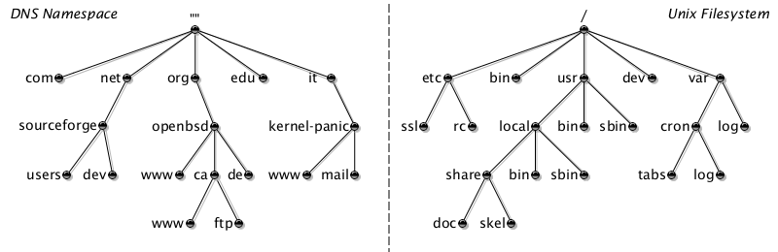domain names.

The new generic top-level domain names are **areo** (for the aviation industry), **biz** (for businesses), **coop** (for cooperatives), **info** (for general use), **museum** (for museums), **name** (for individuals), and **pro** (for professionals). Despite ICANN’s approval, several hurdles must be overcome before registration can begin. In total, including all country codes, there are more than 250 top-level domain names.

**E-Mail : Advantages and Disadvantages**

Advantages

As in the early days of Telephone, the original users of e-mail only had a limited number of people with whom they could communicate. Now that email is more prevalent, some of it’s advantages are clear :

* **Convenience** – No trips to the post office and no need to search for stationary and stamps. E-Mail makes publishing and discussing very easy.
* **Speed** – E-Mail is fast, based on the speed of the underlying communication network.
* **Inexpensive** – The cost of sending a message is very small.
* **Printable** – A hard copy is easy to obtain. But, an electronic copy of a message should be kept for own records.
* **Reliable** – Although messages are occasionally lost. Many mail systems will notify the sender if an email message was undelivered.
* **Global** – Increasingly, people and business all over the world are using email.
* **Generality** – E-Mail is not limited to text, but allows the transfer of graphics, programs and sounds.

Disadvantages

Despite all advantages, everyone everywhere doesn’t have access to email.

* **Misdirection**
* **Interception**
* **Forgery**
* **Overload**
* **Junk**
* **No Response**

**Message Components**

In most email clients, before the message a list of items are shown which are as follows :

* **Date**
* **Sender Name**
* **Size** (byte)
* 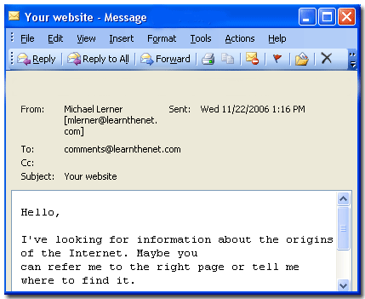**Subject Line** (usually truncated)

Sometimes, additional symbols are used to flag whether or not message has been already viewed or not.

The first five lines of the message are referred to as the email header. Each mail client can show slightly different email header.

While most parts of the email are self-explanatory, a brief mention of some are given to familiarize with the terminology :

* **From** : The field indicates who sent the message and when. Time is represented using a 24-hour clock.
* **Date** : The field repeats the date and includes an interesting feature. Since email is sent throughout the world, a reference by the mailer to GMT lets us deduce when the user sent the message in relation to our local time.
* **To** : The field specifies to whom the message was sent.
* **Subject** : The field provides a hint as to what the message is about.
* **CC** : The field tells that the message was carbon copied to another user.

**Message Composition**

The manner in which an email message is composed may vary from one mail program to another. However, the basic elements remain the same, even if the mail is composed outside the mailer using a simple text editor.

Netiquette

For the most part, when writing a email message, one should follow the rules of informal letter composition. The greeting selected will often set the tone for the message. If the person is a close friend, one would naturally be less formal than if mailing his/her resume to a prospective employer.

The overall tone of the message body is also very important. Email messages seem to inherently direct, so it can be easy to misinterpret, or to phrase a message incorrectly.

Informal rules of network etiquette, or netiquette, suggest practicing restraint when using email to express opinions or ideas, especially when the message will be read by people who don’t know the sender well. When the message is informal, a common practice is to use a smiley ☺ or a wink ;-) to indicate something said in jest. These little symbols and others like them are called emoticons and resemble little sideways faces.

Typing a message in capital letters is considered “**shouting**” and doing so signals that the sender is either an email novice, very angry, excited or ignorant of the rules of netiquette. Not following the rules of netiquette may result in flaming by someone who took offence to what is said. A **flame** is a nasty response from the offended party. Flaming often happens on mailing lists when one user does not show consideration for others on the list.

Composition

For sending email to friends or people you know, simply type in a message as you would say it. For people you don’t know, or with whom you had little conversation, be slightly more formal and proofread the message. When applying for jobs or communicating with people for the first time, proofread and spell check the message. Many mail applications have an in-built spell checker. A message littered with typos may offend and will certainly distract.

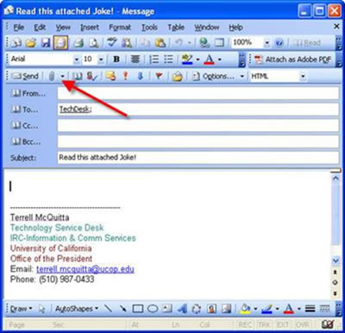

Message should always be signed or must be ended with a **signature file**. If signature file is opted, many mailers will automatically append it to all the messages send. The file should contain standard contact information. Also, try to limit the size of signature file as too much can be annoying. Also, if you have frequent correspondence with a person, don’t bother to include your signature file with every message.

Before sending the mail, you sometimes have the opportunity to **attach files** that you would like to append to the message. Some mailers may also let you insert a file or a graphic at any point in the message body.

**Submitted By :**

**Name : Rohit Aggarwal**

**Roll No. : 7CS-097**