INTERNET

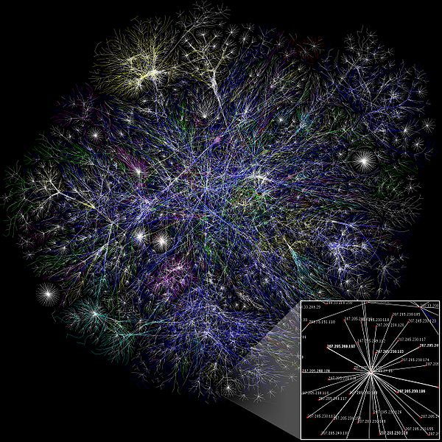Internet is an interconnection between several computers of different types belonging to various networks all over the world. The Internet is a global network of interconnected computers, enabling users to share information along multiple channels. Typically, a computer that connects to the Internet can access information from a vast array of available servers and other computers by moving information from them to the computer's local memory. The same connection allows that computer to send information to servers on the network; that information is in turn accessed and potentially modified by a variety of other interconnected computers. A majority of widely accessible information on the Internet consists of inter-linked hypertext documents and other resources of the **World Wide Web** **(WWW)**. Computer users typically manage sent and received information with web browsers; other software for users' interface with computer networks includes specialized programs for electronic mail, online chat, file transfer and file sharing.

**Figure 1 : Visualization of the various routes through a portion of the Internet**

The movement of information in the Internet is achieved via a system of interconnected computer networks that share data by packet switching using the standardized **Internet Protocol Suite (TCP/IP)**. It is a "network of networks" that consists of millions of private and public, academic, business, and government networks of local to global scope that are linked by copper wires, fiber-optic cables, wireless connections, and other technologies.

**History of Internet**

In 1969, the **Department of Defence (DOD)** of United States of America started a network called **ARPANET (Advanced Research Projects Administration Network)**. It was started with one computer in California and three in Utah. Later, The military allowed universities to join the network for sharing the hardware and software Resources. Then it grew bigger and gave birth to the present – day very popular Internet.

University students' appreciation and contributions

New findings in the field of communications during the 1960s, 1970s and 1980s were quickly adopted by universities across North America. Examples of early university Internet communities are Cleveland FreeNet, Blacksburg Electronic Village and NSTN in Nova Scotia. Students took up the opportunity of free communications and saw this new phenomenon as a tool of liberation. Personal computers and the Internet would free them from corporations and governments (Nelson, Jennings, Stallman).

Graduate students played a huge part in the creation of ARPANET. In the 1960s, the network working group, which did most of the design for ARPANET's protocols, was composed mainly of graduate students.

**Growth of Internet**

Although the basic applications and guidelines that make the Internet possible had existed for almost two decades, the network did not gain a public face until the 1990s. On 6 August 1991, CERN, a pan European organization for particle research, publicized the new World Wide Web project. The Web was invented by English scientist Tim Berners-Lee in 1989.

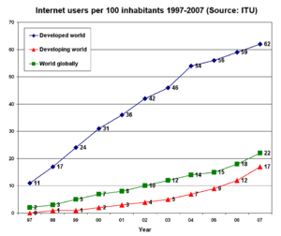An early popular web browser was **ViolaWWW**, patterned after HyperCard and built using the X Window System. It was eventually replaced in popularity by the Mosaic web browser. In 1993, the **National Center for Supercomputing Applications** at the **University of Illinois** released version 1.0 of Mosaic, and by late 1994 there was growing public interest in the previously academic, technical Internet. By 1996 usage of the word Internet had become commonplace, and consequently, so had its use as a synecdoche in reference to the World Wide Web.

**Figure 2 : Graph of internet users per 100 inhabitants between 1997 and 2007 by International Telecommunication Union**

Meanwhile, over the course of the decade, the Internet successfully accommodated the majority of previously existing public computer networks (although some networks, such as FidoNet, have remained separate). During the 1990s, it was estimated that the Internet grew by 100% per year, with a brief period of explosive growth in 1996 and 1997.This growth is often attributed to the lack of central administration, which allows organic growth of the network, as well as the non-proprietary open nature of the Internet protocols, which encourages vendor interoperability and prevents any one company from exerting too much control over the network.

Using various statistics, AMD estimated the population of internet users to be 1.5 billion as of January 2009.

**Internet Structure**

There have been many analyses of the Internet and its structure. For example, it has been determined that both the Internet IP routing structure and hypertext links of the World Wide Web are examples of scale-free networks.

**Figure 3 : A sample Network Diagram**

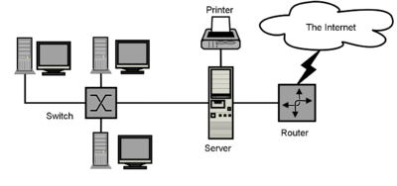Similar to the way the commercial Internet providers connect via Internet Exchange Points, research networks tend to interconnect into large sub-networks such as the following:

1. **GEANT**
2. **GLORIAD**
3. **The Internet2 Network** (formally known as the Abilene Network)
4. **JANET** (the UK's National Research and Educational Network)

These in turn are built around relatively smaller networks. See also the list of Academic Computer Network Organization. Computer Network Diagrams often represent the Internet using a cloud symbol from which network communications pass in and out.

**ICANN**

ICANN headquarters in **Marina del Rey, California, United States**

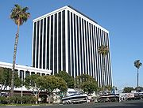**The Internet Corporation for Assigned Names and Numbers (ICANN)** is the authority that coordinates the assignment of unique identifiers on the Internet, including domain names, Internet Protocol (IP) addresses, and protocol port and parameter numbers. A globally unified namespace (i.e., a system of names in which there is at most one holder for each possible name) is essential for the Internet to function. ICANN is headquartered in Marina del Rey, California but is overseen by an international board of directors drawn from across the Internet technical, business, academic, and non-commercial communities. The US government continues to have the primary role in approving changes to the root zone file that lies at the heart of the domain name system. Because the Internet is a distributed network comprising many voluntarily interconnected networks, the Internet has no governing body. ICANN's role in coordinating the assignment of unique identifiers distinguishes it as perhaps the only central coordinating body on the global Internet, but the scope of its authority extends only to the Internet's systems of domain names, IP Addresses, protocol ports and parameter numbers.

**Figure 4 : ICANN headquarters in Marina Del Rey, California, United States**

On November 16, 2005, the World Summit on the Information Society, held in Tunis, established the **Internet Governance Forum (IGF)** to discuss Internet-related issues.

**Working of Internet**

When information is passed from one computer system to another it is broken up into pieces called Packets using the TCP Protocol. Using the IP Protocol, a message consisting of not more than 1500 bytes or characters is put into a packet. Each packet has the address of the sender and the destination. These addresses are called IP Addresses.

The packets are passed from one network to another until they reach their destination. At the destination the TCP software reassembles the packets into a complete message. If packets are lost or damaged, a request is sent to resend them. It is not necessary for all the packets in a single message to take the same route through the Internet or for the same message to take the same route each time it is send.

Network Benefits

* **Provide Convenience** : Computers on a network can backup their files over the network.
* **Allow Sharing** : Networked computers can share resources, such as disks and printers.
* **Facilitate Communications** : Sending and receiving E-Mail, transferring files, and video conferencing are examples of how networks promote communication.
* **Generate Savings** : Networked computers can provide more computing power for less money. Several small computers connected on a network can provide as much as or more computing power than a single, large computer and will cost much less. Also, since resources can be shared, not everyone needs their own peripherals, which can result in a substantial cost saving.
* **Provide Reliability** : If one part of the network is down, useful work may still be possible using a different network path.
* **Simplifies Scalability** : It is relatively easy to add more computers to an existing network.

Physical Components

In addition to the various software protocols, the internet includes a host of physical components as well. These components include servers, routers, and the networks themselves. Servers are computers that answer requests for services, such as list servers, mail servers, and news servers.

A router is a special purpose computer that directs data packets along the network. Routers can detect whether part of the network is down or congested and can then re-route traffic. Think of a router as a highly efficient and well functioning traffic cop.

Networks provide the physical means to transport packets of information. The following mediums are used :

* **Copper Wires**, which transmit messages as electrical impulses.
* **Fibre-Optic Cables**, which use light waves to transmit messages.
* **Radio Waves, Microwaves, Infra Red Light and Visible Light**, which all carry messages through air.

**ISP (Internet Service Provider)**

Internet connections are provided by **INTERNET SERVICE PROVIDERS** who install a main server and through the server give connections to users. Server is a computer with high storage capacity and memory. It is in turn connected to other servers installed at different places in the world through satellites. Connections issued through the server are allotted private place on the servers in order to store the e-mails for the connected users.

Some of the ISP’s are :

1. **VSNL** (Videsh Sanchar Nigam Limited)
2. **MTNL** (Mahanagar Telephone Nigam Limited)
3. **Mantra Online**
4. **Net Cracker**
5. **Satyam**

**Common Uses**

E-mail

The concept of sending electronic text messages between parties in a way analogous to mailing letters or memos predates the creation of the Internet. Even today it can be important to distinguish between Internet and internal e-mail systems. Internet e-mail may travel and be stored unencrypted on many other networks and machines out of both the sender's and the recipient's control. During this time it is quite possible for the content to be read and even tampered with by third parties, if anyone considers it important enough. Purely internal or intranet mail systems, where the information never leaves the corporate or organization's network, are much more secure, although in any organization there will be IT and other personnel whose job may involve monitoring, and occasionally accessing, the e-mail of other employees not addressed to them. Today you can send pictures and attach files on e-mail. Most e-mail servers today also feature the ability to send e-mail to multiple e-mail addresses.

The World Wide Web

Many people use the terms Internet and World Wide Web (or just the Web) interchangeably, but, as discussed above, the two terms are not synonymous.

[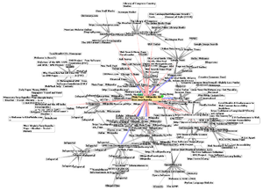](http://en.wikipedia.org/wiki/File:WorldWideWebAroundWikipedia.png)The World Wide Web is a huge set of interlinked documents, images and other resources, linked by hyperlinks and URLs. These hyperlinks and URLs allow the web servers and other machines that store originals, and cached copies of, these resources to deliver them as required using **HTTP (Hypertext Transfer Protocol)**. HTTP is only one of the communication protocols used on the Internet.

Web services also use HTTP to allow software systems to communicate in order to share and exchange business logic and data.

**Figure 5 : Graphic representation of a minute fraction of the WWW, demonstrating hyperlinks**

Remote access

The Internet allows computer users to connect to other computers and information stores easily, wherever they may be across the world. They may do this with or without the use of security, authentication and encryption technologies, depending on the requirements.

This is encouraging new ways of working from home, collaboration and information sharing in many industries. An accountant sitting at home can audit the books of a company based in another country, on a server situated in a third country that is remotely maintained by IT specialists in a fourth. These accounts could have been created by home-working bookkeepers, in other remote locations, based on information e-mailed to them from offices all over the world. Some of these things were possible before the widespread use of the Internet, but the cost of private leased lines would have made many of them infeasible in practice.

Collaboration

The low cost and nearly instantaneous sharing of ideas, knowledge, and skills has made collaborative work dramatically easier. Not only can a group cheaply communicate and share ideas, but the wide reach of the Internet allows such groups to easily form in the first place. An example of this is the free software movement, which has produced Linux, Mozilla Firefox, OpenOffice.org etc.

Version control systems allow collaborating teams to work on shared sets of documents without either accidentally overwriting each other's work or having members wait until they get "sent" documents to be able to make their contributions.

Business and project teams can share calendars as well as documents and other information. Such collaboration occurs in a wide variety of areas including scientific research, software development, conference planning, political activism and creative writing.

File sharing

A computer file can be e-mailed to customers, colleagues and friends as an attachment. It can be uploaded to a website or FTP server for easy download by others. It can be put into a "shared location" or onto a file server for instant use by colleagues. The load of bulk downloads to many users can be eased by the use of "mirror" servers or peer-to-peer networks.

In any of these cases, access to the file may be controlled by user authentication, the transit of the file over the Internet may be obscured by encryption, and money may change hands for access to the file. The price can be paid by the remote charging of funds from, for example, a credit card whose details are also passed—hopefully fully encrypted—across the Internet. The origin and authenticity of the file received may be checked by digital signatures or by MD5 or other message digests.

Streaming media

Many existing radio and television broadcasters provide Internet "feeds" of their live audio and video streams (for example, the BBC). They may also allow time-shift viewing or listening such as Preview, Classic Clips and Listen Again features. These providers have been joined by a range of pure Internet "broadcasters" who never had on-air licenses. This means that an Internet-connected device, such as a computer or something more specific, can be used to access on-line media in much the same way as was previously possible only with a television or radio receiver. Podcasting is a variation on this theme, where—usually audio—material is downloaded and played back on a computer or shifted to a portable media player to be listened to on the move. These techniques using simple equipment allow anybody, with little censorship or licensing control, to broadcast audio-visual material on a worldwide basis.

**Internet Telephony (VoIP)**.

VoIP stands for Voice-over-Internet Protocol, referring to the protocol that underlies all Internet communication. The idea began in the early 1990s with walkie-talkie-like voice applications for personal computers. In recent years many VoIP systems have become as easy to use and as convenient as a normal telephone. The benefit is that, as the Internet carries the voice traffic, VoIP can be free or cost much less than a traditional telephone call, especially over long distances and especially for those with always-on Internet connections such as cable or ADSL.

VoIP is maturing into a competitive alternative to traditional telephone service. Interoperability between different providers has improved and the ability to call or receive a call from a traditional telephone is available. Simple, inexpensive VoIP network adapters are available that eliminate the need for a personal computer.

**Submitted By :**

**Name : Rohit Aggarwal**

**Roll No. : 7CS-097**