|  |  |  |  |  |
| --- | --- | --- | --- | --- |
|  |  | | | |
|  | |  | | |
| Project: | | Personal Health Monitoring System (PHMS) | | |
| Team No.: | | 3 | | |
| Class: | | CSE 3310; Spring 2017 | | |
| Module: | | System Requirements Analysis (SRA) | | |
| Deliverable: | | SRA Document | | |
| Version: | | [1.0] | Date: | [03/23/2017] |

Contributors:

Prapti Bhaukajee

Saja Abualfoul

Kristoffer Edgard Jorge-Munoz

MD Ibrahim Khalil

Revision History

| Version number | Date | Originator | Reason for change | High level description of changes |
| --- | --- | --- | --- | --- |
| 1.0 | 03/23/2017 | Prapti Bhaukajee  Saja Abualfoul  Kristoffer Edgard Jorge-Munoz  MD Ibrahim Khalil | Initial draft |  |
|  |  |  |  |  |
|  |  |  |  |  |
|  |  |  |  |  |

TABLE OF CONTENTS

1. Introduction and Project Overview 3

2. Objectives 4

2.1 BUSINESS Objectives 4

2.2 SYSTEM Objectives 5

3. Project Context Diagram 6

4. Systems Requirements 7

4.1 “Registration” Requirements 7

4.2 “Vital Signs” Requirements 9

4.3 “Medication” Requirements 11

4.4 “Diet” Requirements 13

4.5 “NOTES” REQUIRMENTS 15

4.7 “Search” Requirements 18

4.8 “MONITORING” Requirements 19

4.9 “Communication” Requirement 21

4.10 “Data Maintenance” Requirements 22

5. Software Processes and UML Diagrams 23

5.1 Hardware and Infrastructure 23

5.2 UML Diagrams 24

5.3 Test Plan 35

5.4 Screen Shots 35

6. Assumptions and Constraints 36

6.1 ASSUMPTIONS 36

6.2 CONSTRAINTS 36

6.3 Out of Scope material 36

7. Delivery and Schedule 37

8. Stakeholder Approval Form 39

Appendix: 40

# 1. Introduction and Project Overview

For this project, our group was assigned to develop an android application that will help users maintain various personal health-related data. The PHMS application will be used to keep track of one’s vital signs, daily medicine intake, or following a diet regiment.

# 2. Objectives

## 2.1 BUSINESS Objectives

The following is a list of business objectives:

**Objective 1**: Registration: System will capture the following personal information:

* Last name, middle name {optional}, first name
* Phone number home, cell
* E-mail address
* Physical address

**Objective 2**: “Vital signs” functionality must be supported that allows the user to register a vital sign/s and add data. The vital signs include the following:

* Glucose level
* Blood Pressure
* Cholesterol
* Weight

**Objective 3**: “Medication” functionality must be supported that contains the medicine list and keeps track of a user’s medication time and the doses. It includes the following data for users:

* Note
* Prescription with dose, date, and time of the medication
* Alarm

**Objective 4**: “Diet” functionality must be supported that allows a user to select a health issue and diet which helps the user to keep track of their food intake. It includes the following customer data:

* Health issue
* Diet

**Objective 5**: “Notes” functionality must be supported that allows the user to create a new note or update an existing note which may contain the information that the user wants to save.

**Objective 6**: Login: System will require all the users to login with a User I.D. and password.

**Objective 7**: “Search” functionality must be supported that allows the user to find stored or general data in the system. The user may enter the following:

* Vital signs
* Medication
* Health issues

**Objective 8**: “Monitoring system” functionality checks if the user is taking the medication on time and also checks the normality of the vital signs.

**Objective 9**: “Communication” functionality must be supported for the system to deliver notifications with the relevant information. It includes the following customer data:

* Phone number
* Email address

**Objective 10**: “Data Maintenance” should allow the user to edit and update their account settings such that the user should be able to edit medication list, emergency contact list, personal information, doctor’s information, etc.

## 2.2 SYSTEM Objectives

The following is a list of system objectives:

**Objective 1**: System will be an android application for mobile platform

**Objective 2**: SQLite will be used as the database or whatever your database is

**Objective 3**: System will use Java for the programming language

**Objective 4**: Search functionality will use Google’s search

**Objective 5**: User interface will be user friendly

# 3. Project Context Diagram

Context Diagram

Registration

Management Data

Medication

Vital Signs

Communication

Notes

Search

Login

Alert/ Monitoring

Diet

# 4. Systems Requirements

## 4.1 “Registration” Requirements

|  |  |
| --- | --- |
| **Requirement Title:** | Registration |
| **Sequence No:** | 001 |
| **Short description:** | Process to create new user profile. |
| **Description:** | The system will provide the functionality such that it will guide the prospective user to create a new account. |
| **Pre-Conditions**: | User must be over 18 years old. |
| **Post Conditions:** | User will enter “Create a New Account” phase. |
| **Other attributes:** | N/A |

|  |  |
| --- | --- |
| **Requirement Title:** | Registration |
| **Sequence No:** | 002 |
| **Short description:** | Process of creating a new user account. |
| **Description:** | The system will ask for a valid email address and password to set up a new account for the perspective user. |
| **Pre-Conditions**: | User must have a valid email address. |
| **Post Conditions:** | User will be registered with an account. |
| **Other attributes:** | N/A |

|  |  |
| --- | --- |
| **Requirement Title:** | Registration |
| **Sequence No:** | 003 |
| **Short description:** | Personal information required for the user profile. |
| **Description:** | The system will require the following personal information.   1. First and last name 2. Gender 3. Age 4. Weight 5. Height |
| **Pre-Conditions**: | N/A |
| **Post Conditions:** | User profile with personal information is created. |
| **Other attributes:** | N/A |

|  |  |
| --- | --- |
| **Requirement Title:** | Registration |
| **Sequence No:** | 004 |
| **Short description:** | Doctor’s information required for the user profile. |
| **Description:** | The system will require the following information.   1. Doctor’s name 2. Past doctor visit dates 3. Upcoming doctor visit dates 4. Annual checkup date |
| **Pre-Conditions**: | N/A |
| **Post Conditions:** | A complete user profile with all the required information is created. |
| **Other attributes:** | N/A |

## 4.2 “Vital Signs” Requirements

|  |  |
| --- | --- |
| **Requirement Title:** | Vital signs |
| **Sequence No:** | 001 |
| **Short description:** | Choosing a vital sign |
| **Description:** | The system will allow the user to choose a vital sign from the following vital signs.   1. Glucose level 2. Blood pressure 3. Cholesterol 4. Weight |
| **Pre-Conditions**: | User must be already registered with an account and logged into the account. |
| **Post Conditions:** | User will be able to successfully select a vital sign. |
| **Other attributes:** | N/A |

|  |  |
| --- | --- |
| **Requirement Title:** | Vital signs |
| **Sequence No:** | 002 |
| **Short description:** | Add data for selected vital sign. |
| **Description:** | After choosing a vital sign, the system will allow the user to add input for a selected vital sign. |
| **Pre-Conditions**: | 1. User must be already registered with an account and logged into the account. 2. A vital sign needs to be already selected. |
| **Post Conditions:** | Data for a selected vital sign will be added. |
| **Other attributes:** | N/A |

|  |  |
| --- | --- |
| **Requirement Title:** | Vital signs |
| **Sequence No:** | 003 |
| **Short description:** | Update/delete data for a selected vital sign. |
| **Description:** | When data for a vital sign already exists in the system, the system will allow the user to add a new input or update the previous data for the selected vital sign. User will also be able to delete an existing data, if necessary. |
| **Pre-Conditions**: | 1. User must be already registered with an account and logged into the account. 2. A vital sign needs to be already selected. 3. Data for a selected vital sign exists. |
| **Post Conditions:** | Previous data for a vital sign will be updated or deleted. |
| **Other attributes:** | N/A |

## 4.3 “Medication” Requirements

|  |  |
| --- | --- |
| **Requirement Title:** | Medication |
| **Sequence No:** | 001 |
| **Short description:** | Search medication in the medicine list (Medication exists) |
| **Description:** | The system shall search if the entered medication is in the list of medicines.  If the medicine is in the list, the system shall check notes for any allergy symptoms.  The system shall notify the user of any allergy symptoms.  The system shall display the medication list.  Input:   * Medication name   Output:   * Allergy symptoms if any |
| **Pre-Conditions**: | The user must be logged in.  The medication should have been entered. |
| **Post Conditions:** | Notes should have been checked.  The individual/user must have been notified of any existing allergy symptoms. |
| **Other attributes:** | The medication should be in the medicine list. |

|  |  |
| --- | --- |
| **Requirement Title:** | Medication |
| **Sequence No:** | 002 |
| **Short description:** | Search medication in the medicine list (Medication does not exist) |
| **Description:** | The system shall search if the entered medication is in the list of medicines.  If the medicine is not in the list, the system shall notify the doctor and check with the doctor if the new medicine can be added to the list. It also shall check the allergy symptoms.  If the doctor approves it and there are no allergy symptoms, the medicine shall be updated in the list. |
| **Pre-Conditions**: | The user must be logged in.  The medication should have been entered. |
| **Post Conditions:** | The medicine list must have been updated.  The system should display the updated list and the user must be able to see it. |
| **Other attributes:** | The medication should not be in the medication list. |

|  |  |
| --- | --- |
| **Requirement Title:** | Medication |
| **Sequence No:** | 003 |
| **Short description:** | Update new prescription |
| **Description:** | After checking notes and updating the medicine list, the system shall update a new prescription for the user.  The system shall include the prescription date, the amount of dose and the time for the medication to be taken. |
| **Pre-Conditions**: | The user must be logged in.  The medicine should be in the list.  The notes should have been checked. |
| **Post Conditions:** | A new prescription should be available for the user. |
| **Other attributes:** | The system shall have an alarm to make sure the user takes the right dose of medication on time. |

## 4.4 “Diet” Requirements

|  |  |
| --- | --- |
| **Requirement Title:** | Diet |
| **Sequence No:** | 001 |
| **Short description:** | Keep Track of user’s food intake. |
| **Description:** | The system shall have a box where the user will enter their diet. The box should be labeled as “Enter Diet”. The user will be able to choose their diet based on their health issues. |
| **Pre-Conditions**: | The user will have signed in already. |
| **Post Conditions:** | The user will select their health issue and diet. |
| **Other attributes:** | There must be a button labeled “Go” that will attempt to record the user’s input. |

|  |  |
| --- | --- |
| **Requirement Title:** | Diet |
| **Sequence No:** | 002 |
| **Short description:** | Contacts a doctor |
| **Description:** | Once the user has selected their diet and health issue, the user will be able to notify the doctor. The doctor will check if the specific diet will be good if not he will notify the user to change their diet. |
| **Pre-Conditions**: | The user should have selected their health issue and diet. Also, doctor’s information should be already in the system. |
| **Post Conditions:** | Doctor will notify the user if their diet is good or not. |
| **Other attributes:** | There should be a button labeled “notify doctor” that will attempt to contact doctor. |

## 4.5 “NOTES” REQUIRMENTS

|  |  |
| --- | --- |
| **Requirement Title:** | Notes |
| **Sequence No:** | 001 |
| **Short description:** | Create a new note |
| **Description:** | The user will select this option if they don’t have any notes or if they would like to create a new one.  The user will then proceed to add information to that note and click “Save” if they want to keep the note. |
| **Pre-Conditions**: | User must be logged in. |
| **Post Conditions:** | If user decides to save, the data will be stored, else the note will be discarded. |
| **Other attributes:** | N/A |

|  |  |
| --- | --- |
| **Requirement Title:** | Notes |
| **Sequence No:** | 002 |
| **Short description:** | Update a note |
| **Description:** | The user will select this option if they want to add or update the information of an already existing note.  The user will then proceed to add or update information to that note and click “Save” if they want to keep the changes. |
| **Pre-Conditions**: | User must be logged in.  There must be an existing note. |
| **Post Conditions:** | If user decides to save, the data will be stored, else the changes will be discarded. |
| **Other attributes:** | N/A |

4.6 “LOGIN” REQUIREMENTS

|  |  |
| --- | --- |
| **Requirement Title:** | Login |
| **Sequence No:** | 001 |
| **Short description:** | Login user |
| **Description:** | User enters username ID and password and selects login.  The user must enter a valid username and password.   * The system will only allow a maximum of 10 invalid attempts before it terminates the application. |
| **Pre-Conditions**: | The user must be registered. |
| **Post Conditions:** | If the information entered is valid, the system allows the user to enter the account and it displays the account information |
| **Other attributes:** | N/A |

|  |  |
| --- | --- |
| **Requirement Title:** | Login |
| **Sequence No:** | 002 |
| **Short description:** | Send user to registration screen |
| **Description:** | The user selects register, if it is the first time opening the application, or if creating a new account. |
| **Pre-Conditions**: | User must not be previously registered. |
| **Post Conditions:** | The account must be confirmed.  The system allows the user to enter the account and it displays the account information. |
| **Other attributes:** | The information entered must be valid. |

## 4.7 “Search” Requirements

|  |  |
| --- | --- |
| **Requirement Title:** | Search |
| **Sequence No:** | 001 |
| **Short description:** | The user has the option to either search for something in the stored data or search on Google. |
| **Description:** | There must be a button labeled as “Search” where the user can search for something specific in the stored data or on Google. |
| **Pre-Conditions**: | User must be logged in |
| **Post Conditions:** | A list that will display the information needed. |
| **Other attributes:** | N/A |

## 4.8 “MONITORING” Requirements

|  |  |
| --- | --- |
| **Requirement Title:** | Monitoring |
| **Sequence No:** | 001 |
| **Short description:** | Check medicine consumption |
| **Description:** | The system shall check if the medicine has been consumed in time.  The system shall check whether the vital signs are normal or not.  Inputs:   * User Name |
| **Pre-Conditions**: | User must be logged in.  User name must be entered. |
| **Post Conditions:** | System should have known if the vital signs are normal or not. |
| **Other attributes:** | For checking the vital signs, the medicine should have been consumed. |

|  |  |
| --- | --- |
| **Requirement Title:** | Monitoring |
| **Sequence No:** | 002 |
| **Short description:** | Notify emergency contact and doctor |
| **Description:** | The system shall notify the emergency contact of the user and the doctor in case the medicine was not consumed in time.  The system shall notify the emergency contact of the user and the doctor in case the vital signs are not normal. |
| **Pre-Conditions**: | The user must be logged in.  Medicine consumption should have been checked.  Vital signs should have been checked. |
| **Post Conditions:** | The doctor and the emergency contact person should have been informed of any discrepancies. |
| **Other attributes:** | N/A |

## 4.9 “Communication” Requirement

|  |  |
| --- | --- |
| **Requirement Title:** | Communication |
| **Sequence No:** | 001 |
| **Short description:** | Check for phone number |
| **Description:** | User will enter their phone number using numbers 0-9. The system will check if the number provided is valid or not. If number is valid it will add it to the system else, it will ask the user to re-enter their number. |
| **Pre-Conditions**: | User must be logged in. |
| **Post Conditions:** | If number is valid a “valid number” message should pop up. |
| **Other attributes:** | N/A |

|  |  |
| --- | --- |
| **Requirement Title:** | Communication |
| **Sequence No:** | 002 |
| **Short description:** | Check for email address |
| **Description:** | User will enter their email address using a valid email address. The system will check if the email is valid or not. If email address is valid, email will be added. Else, it will ask the user to re-enter their email address. |
| **Pre-Conditions**: | User must enter a valid email address. |
| **Post Conditions:** | If email address entered by the user is valid a “valid email address” message should pop up. |
| **Other attributes:** | N/A |

## 4.10 “Data Maintenance” Requirements

|  |  |
| --- | --- |
| **Requirement Title:** | Data Maintenance |
| **Sequence No:** | 001 |
| **Short description:** | Update current information |
| **Description:** | The user will enter “Settings”, then “Accounts Settings.” The user will select what they would like to change and update (i.e. medication list, emergency contact list, doctor information, personal information, etc.).  The user must save, if they want the changes to be permanent. |
| **Pre-Conditions**: | User must be logged in |
| **Post Conditions:** | If user decides to save, the data will be updated, else the changes will be discarded. |
| **Other attributes:** | N/A |

# 5. Software Processes and UML Diagrams

## 5.1 Hardware and Infrastructure

This is a mobile app using android platform. Android Studio would be used as the IDE.

## 5.2 UML Diagrams

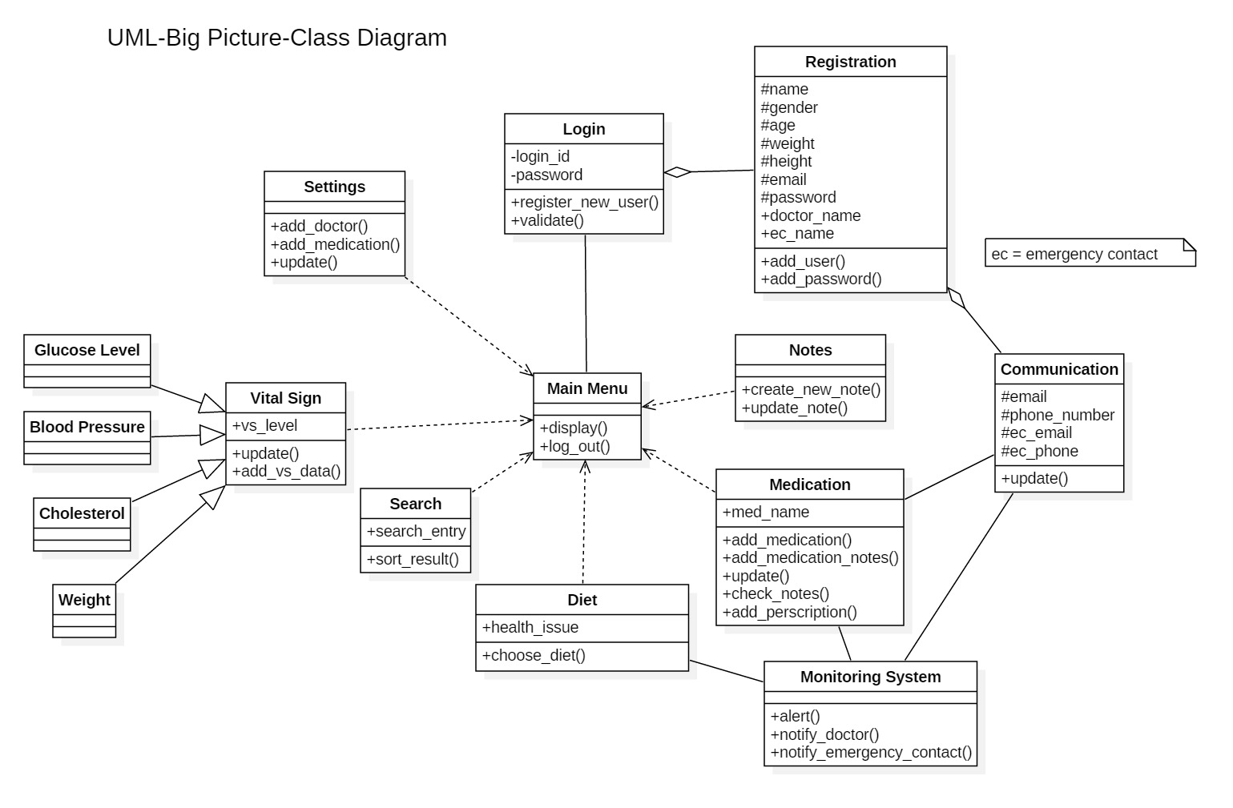

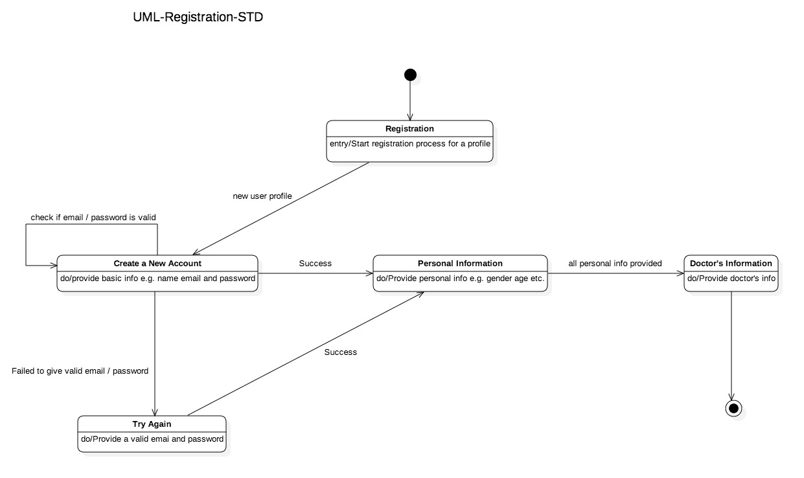

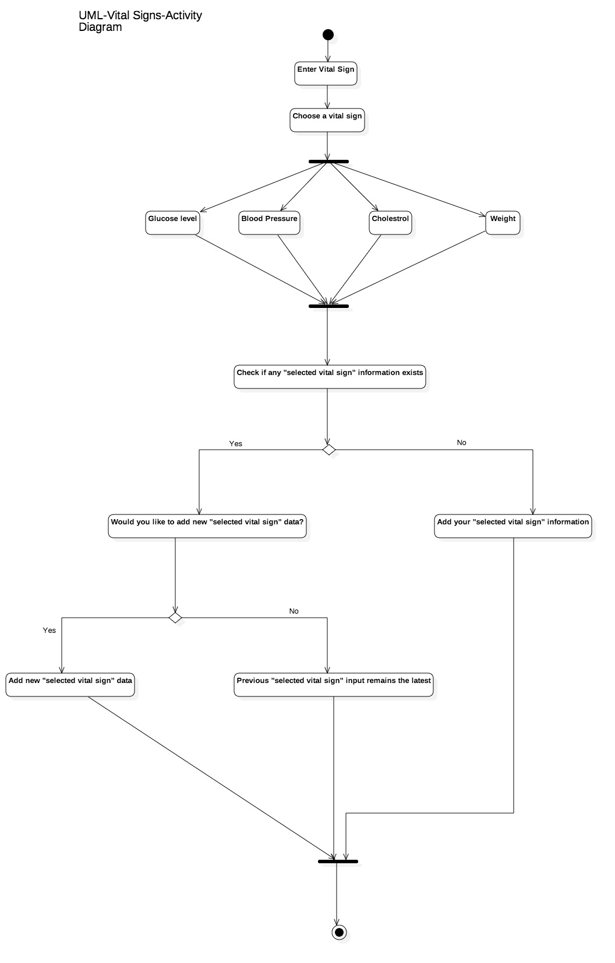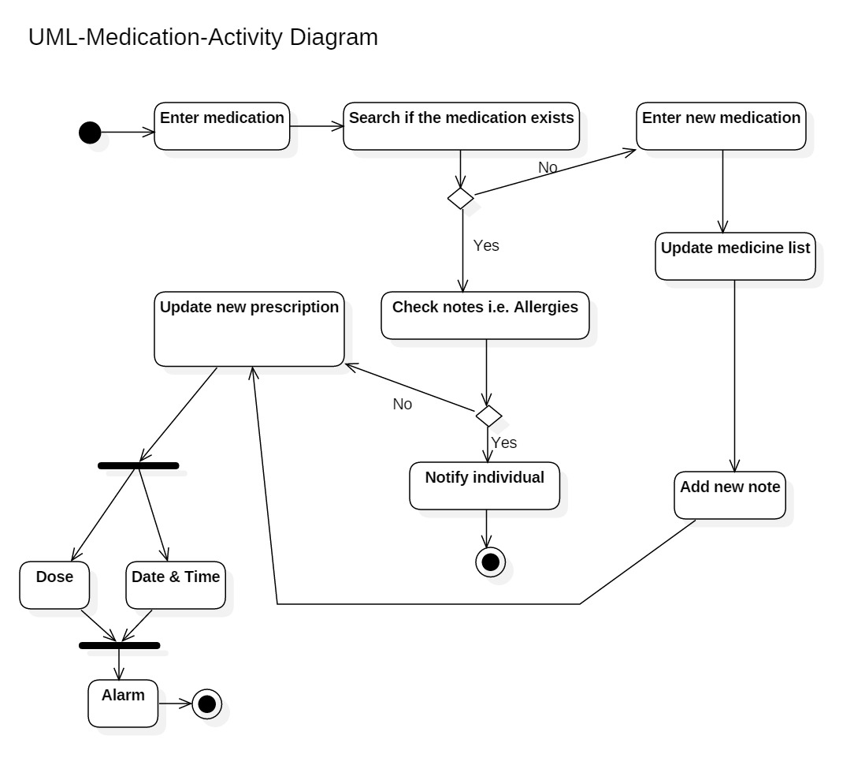

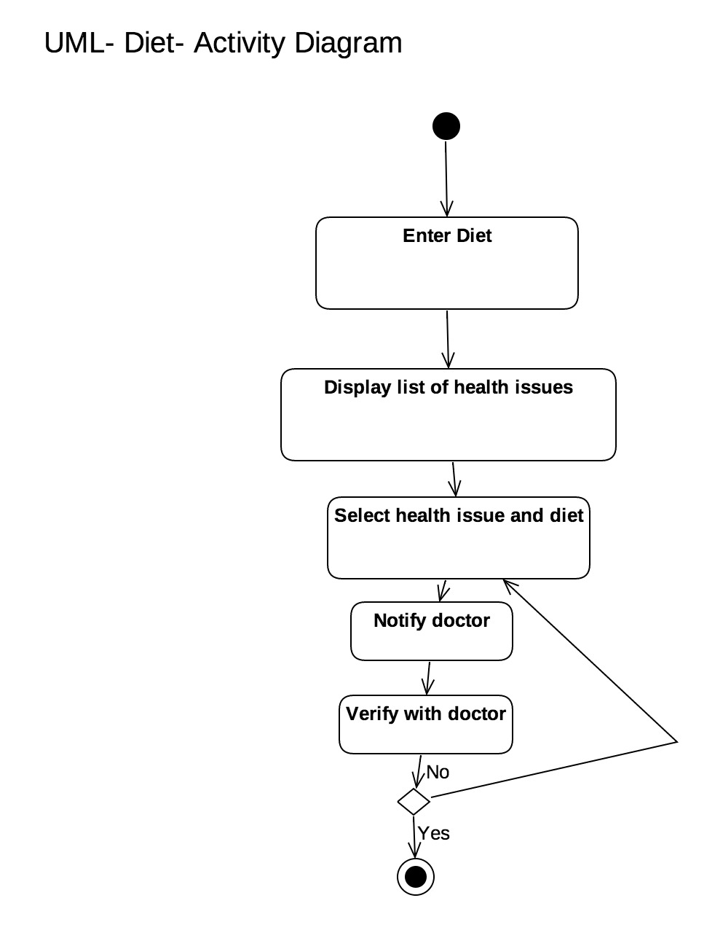

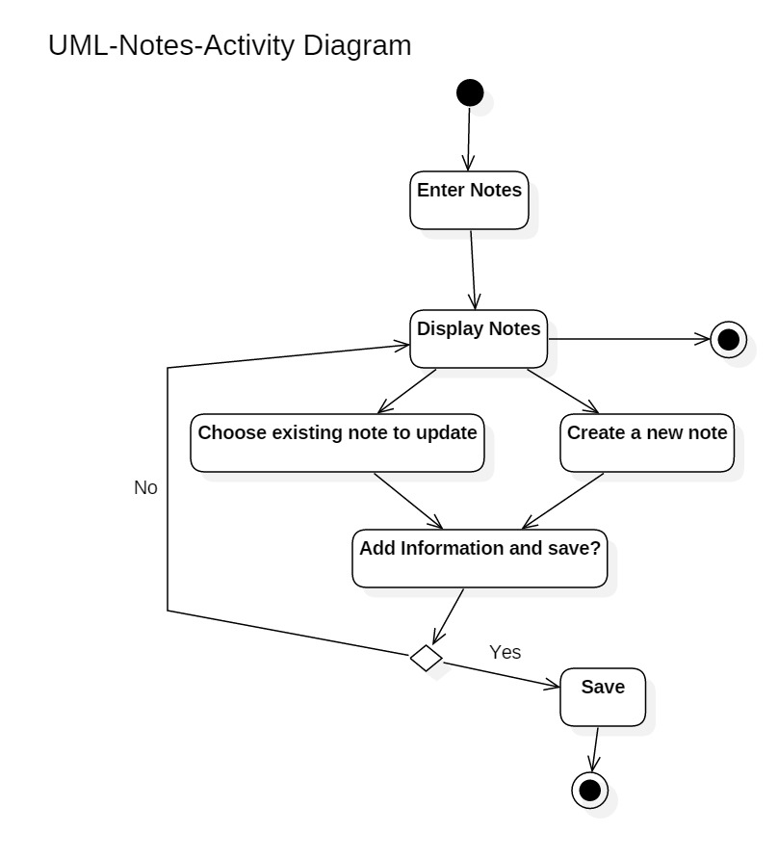

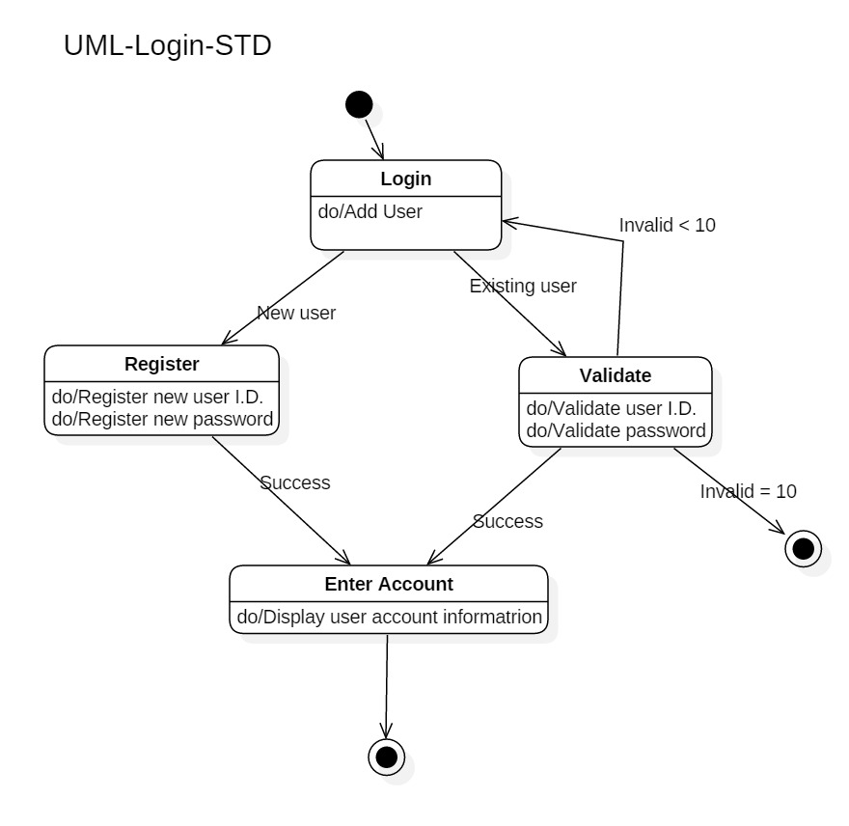

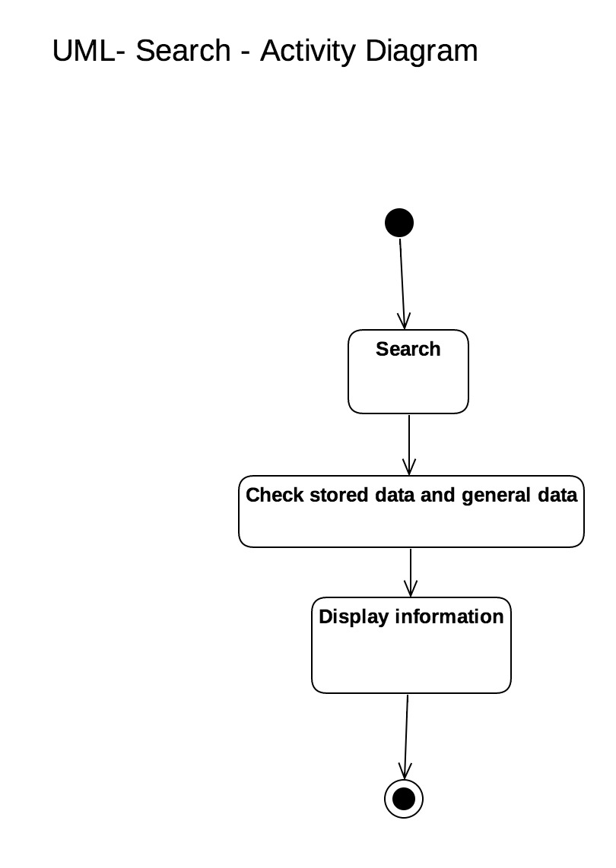

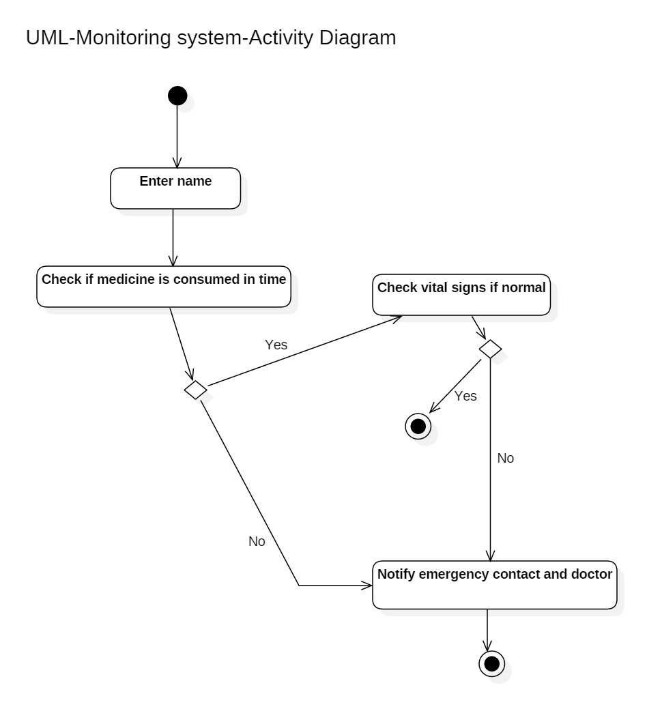

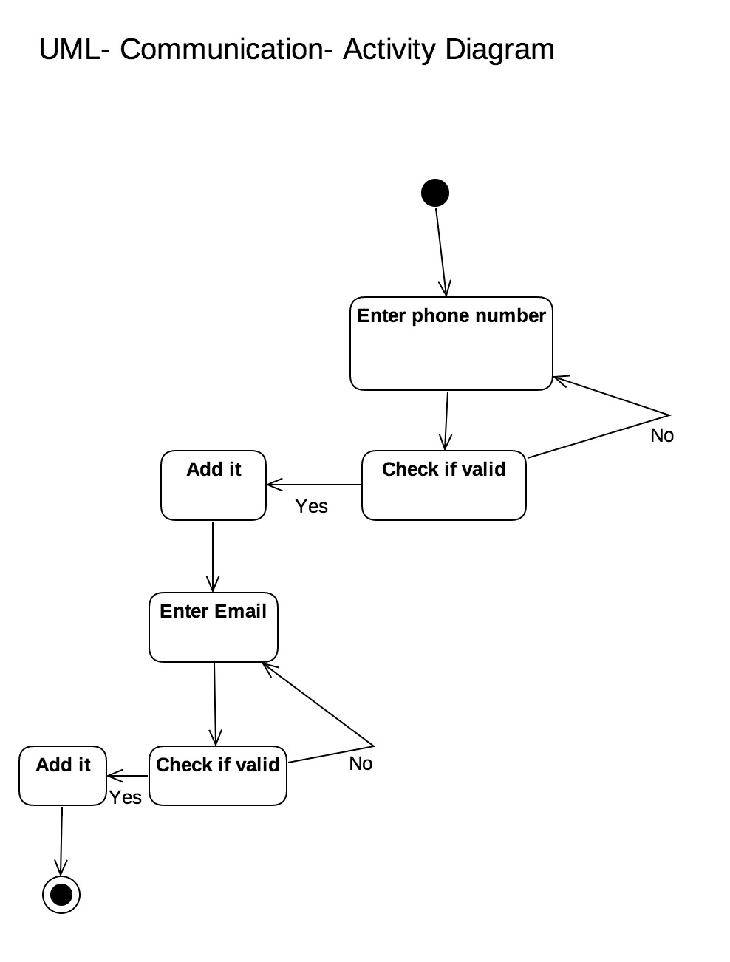

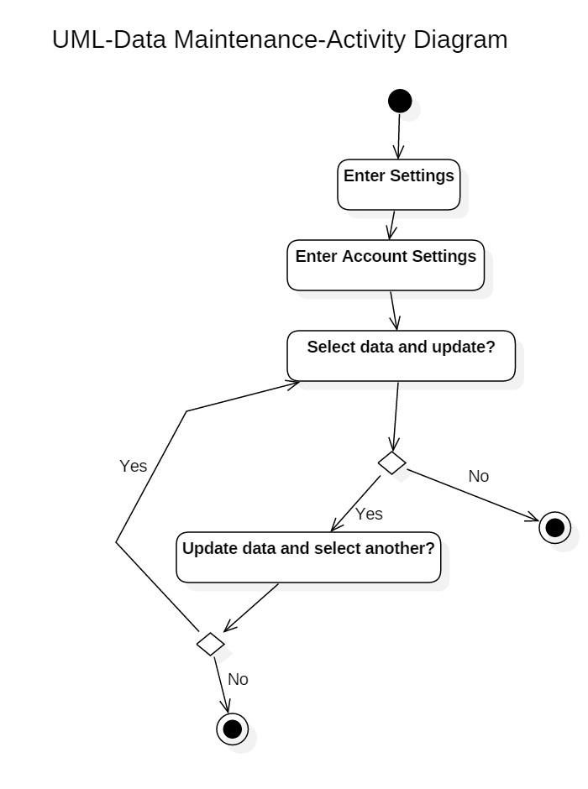

## 5.3 Test Plan

A Test Plan will be provided at a later stage.

## 5.4 Screen Shots

No screen shots available at this time.

# 6. Assumptions and Constraints

## 6.1 ASSUMPTIONS

The following is a list of assumptions:

* Only people older than 18 can use this product
* Only people with not very serious health issues can use this product
* Network issues will be ignored
* Assume there are no advertisements

## 6.2 CONSTRAINTS

The following is a list of constraints:

* Team lacks android development skills
* Team lacks database management skills
* Team schedule is tight

## 6.3 Out of Scope material

The following is a list of “out of scope” material:

* Post Project maintenance is not covered

# 7. Delivery and Schedule

|  |  |  |  |  |
| --- | --- | --- | --- | --- |
| Task/Milestone Description | Anticipated Start Date | Anticipated End Date | Status | Comments |
| Prepare UML diagrams | 2/1/2016 | 2/23/2017 | Complete | UML diagram delivered  Increment 1 Deliverable |
| SRA document (Includes project objectives, Requirements and UML diagrams) | 3/1/2017 | 3/23/2017 | In Progress | Deliverable will be the SRA document. All stakeholders agree on the content of the SRA by signing in section 8.  Increment 2 Deliverable |
| Design: Design big picture, define format, navigation and functionality to include | 3/21/2017 | 4/13/2017 | To Be Completed (TBC) |  |
| Implementation: Home screen design | 3/28/2017 | 4/13/2017 | TBC |  |
| Implementation: Login and registration design | 3/28/2017 | 4/13/2017 | TBC |  |
| Implementation: Vital Signs design | 3/28/2017 | 4/13/2017 | TBC |  |
| Implementation: Medication design | 3/28/2017 | 4/13/2017 | TBC |  |
| Implementation: Diet design | 3/28/2017 | 4/13/2017 | TBC |  |
| Implementation: Notes design | 3/28/2017 | 4/13/2017 | TBC |  |
| Implementation: Search design | 3/28/2017 | 4/13/2017 | TBC |  |
| Implementation: Monitoring system design | 3/28/2017 | 4/13/2017 | TBC |  |
| Implementation: Communication design | 3/28/2017 | 4/13/2017 | TBC |  |
| Implementation: Data Maintenance design | 3/28/2017 | 4/13/2017 | TBC |  |
| Test case design | 3/21/2017 | 4/13/2017 |  | Increment 3 Deliverable |
| External Documentation (i.e. User Manual) | 4/15/2017 | 5/1/2017 |  |  |
| Project presentation | 4/20/2017 | 5/4/2017 |  |  |
| Final Milestone: project delivery |  | 5/4/2017 |  | Increment 4 Deliverable |

# 8. Stakeholder Approval Form

|  |  |  |  |
| --- | --- | --- | --- |
| Stakeholder Name | Stakeholder Role | Stakeholder Comments | Stakeholder Approval Signature and Date |
| Bahram Khalili | Development Mgr |  |  |
| Akshit Singhal | Project Assistant |  |  |
| Saja Abualfoul | Developer |  |  |
| Prapti Bhaukajee | Developer |  |  |
| Kristoffer Edgard Jorge-Munoz | Developer |  |  |
| MD Ibrahim Khalil | Developer |  |  |

# Appendix:

None.