EMPLOYEE EXPENSE TRACKING SYSTEM

SYSTEM DOCUMENTATION

TWIN-CIRCA MARKETING

ESPOSADO VILLAGE, CANNERY SITE

POLOMOLOK, SOUTH COTABATO 9504

**BY:**

**ERRON C. INTILA**

JUNIOR SOFTWARE DEVELOPER

**BENHUR A. PAULO**

SENIOR SOFTWARE DEVELOPER

**RENAROSE JOY P. BOLLINA**

IT ASSISTANT

**DOCUMENT VERSION: 1.0**

**MARCH 2021**

Table of Contents

Introduction 1

Purpose 1

Scope and Limitation 1

Scope 1

Limitation 2

System Overview 3

System Environment 3

System Design Specification 4

Process Specification 4

Data Specification 6

Basic Workflow 7

User Guide 9

Access, Authentication, and Authorization 9

Accessing The Application 9

Managing User Accounts 9

Application Modules 13

Login 13

Dashboard 14

User Profile 15

Expenses 16

Expense Reports 17

Payments 18

Employees 19

Vendors 20

Departments 21

Job Designations 22

Expense Types 23

Activity Logs 24

Settings 25

Notifications 26

Troubleshooting 27

Software Troubleshooting 27

Common Response Errors 27

References 30

Appendices 31

Appendix A (Definition of Terms) 31

Appendix B (Figures) 33

Appendix C (Existing Forms and Reports) 34

# Introduction

The Employee Expense Tracking System is a web-based application that manages travel-related expenses of employees. It allows users to record, submit, track, process, and reimburse employee expenses. The system used to improve and streamline current process, data management and increase response time.

This system documentation has been created to outline the overall system architecture and design. This includes the purpose, scope, design approaches, main component design and system design considerations and specifications. This document also provides an architectural overview of the system to depict different aspects of the system and functions as a foundational reference point for developers.

## Purpose

The main purpose of the system is to facilitate the entry, accumulation, processing, and management of travel-related expenses and employee reimbursement and improve efficiency, accuracy and management by reducing manual operations. The system performs a range of functionalities including:

*Record Keeping*

The system is used in storing data to keep accurate records. Usual data that comprise overall transaction include employee information, vendors, expenses, and payment records. Recording of expenses starts from encoding complete details of an employee and vendor, and then records payment once these expenses have been grouped together into one report. The system provides easy record retrieval and transaction history that can be utilized to process and analyze the data associated with it.

*Workflow Management*

The system can be used to streamline the current process or workflow. From encoding expenses to submitting of expense report, the system can reduce the amount of time needed to generate reports and increase reimbursement process.

*Reporting*

The Employee Expense Tracking System provides an accurate data visualization for reporting and analysis. The system can generate summary of expense reports as well as overall expenses of the company. In addition, the system provides information of remaining revolving fund on each employee.

## Scope and Limitation

### Scope

The project focused on the development of an information system that will track employees’ expenses, process reimbursement, and reduce manual operations. Hence, the system has focused on the following:

* The system will display a form of data visualization that includes total amount of remaining revolving fund and summary of expense records.
* The system will store and display employee records including job designations along with their corresponding departments.
* The system should allow users to monitor their remaining revolving fund.
* The system will store expenses based on expense types and display the list of records.
* The system will store expense report that consists of expenses grouped together and requires approval.
* The system will allow the users to submit, approve, reject, and cancel expense reports, and monitor statuses of each record.
* The system will store payment records for each expense report.
* For security and privacy of the management, the system complies users with different access level that correspond to different roles and permissions.
* The system will store and display vendor records.
* The system will allow users to manage their own profile.
* The system will store records such as departments, job designations, expense types.
* The system will have an activity log to monitor each user transaction.
* The system should generate reports of a specific expense report and summary of expense reports.
* The system will allow users to manage application settings.

### Limitation

The current version of the system does not include:

* Payment System

The current system does not have any system that can be used to settle financial transactions through the transfer of monetary value nor any payment system integration functionalities.

* Recording of Advance Payments

The current system does not allow users to record advance payments to employees before expenses have been incurred. Recording of payments can only be done after the expenses has been recorded within the system.

* Record Mileage Expenses

The system does not have the functionality to record mileage expenses where the expense is calculated based on the distance travelled and the mileage rate.

*(Please note that this is a baseline document and may be updated as system development progresses. Limitations stated can be eliminated and current system features are all subject for improvement)*

# System Overview

This section describes the basic system design goals, functionality and architecture. It includes description of the approach used to develop the system. It also includes high-level descriptions of the system’s hardware, software, database, and security components. In addition, this section includes component and/or contextual diagrams of the system and system components.

## System Environment

This section includes specifications used to develop or support the application. This includes the operating system, the database system, and specific development tools.

Hardware:

Processor: 2GHz processor or more,

Ethernet connection (LAN) OR a wireless adapter (Wi-Fi)

Hard Drive: 120 GB or more

Memory (RAM): 4 GB or above

Display: LCD Monitor

Software:

Operating System: Windows 7 Operating System or newer

Browser: Google Chrome v.51 and above/ Mozilla Firefox v.54 and above/ Microsoft Edge v.14 and above

Development: Microsoft Visual Studio Code version 1.52,

Diagrams: Microsoft Visio 2016

Database GUI Tool: SQLyog Community Edition

Database Management System: MySQL v.10

Server: Linux Operating System, Apache Tomcat 6

Version Control: Git

Application Architecture: Single-Page Application

Languages: HTML, CSS, JavaScript, PHP 7.3

Web Application Frameworks: Vue.js 2.5, Laravel 7.28

UI Libraries: Vuetify 2.3

## System Design Specification

This section includes detailed document providing the complete design and overall process for the information system.

### Process Specification

#### Context Flow Diagram

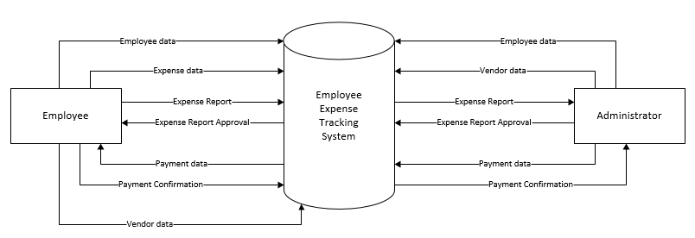

Figure 1 Context Flow Diagram

#### Diagram 0

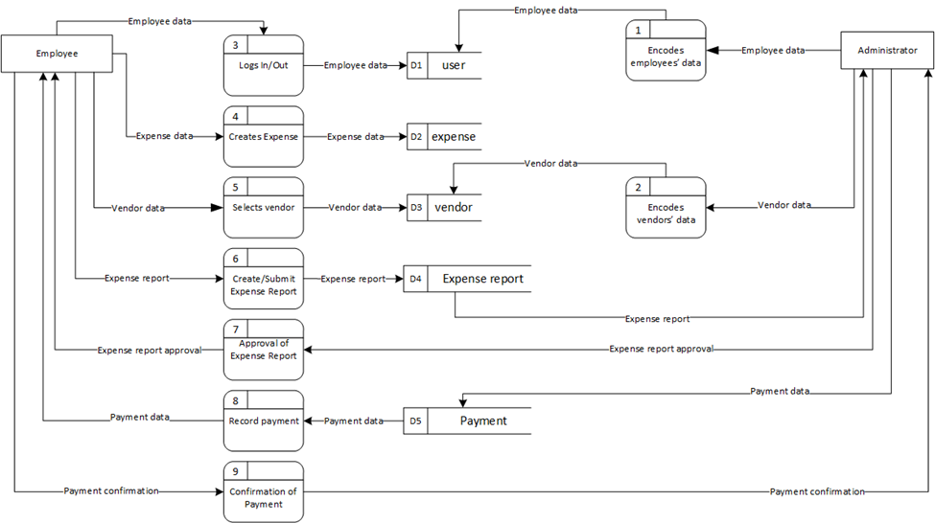

Figure 2 Diagram 0 of the Application

### Data Specification

#### Entity Relationship Diagram

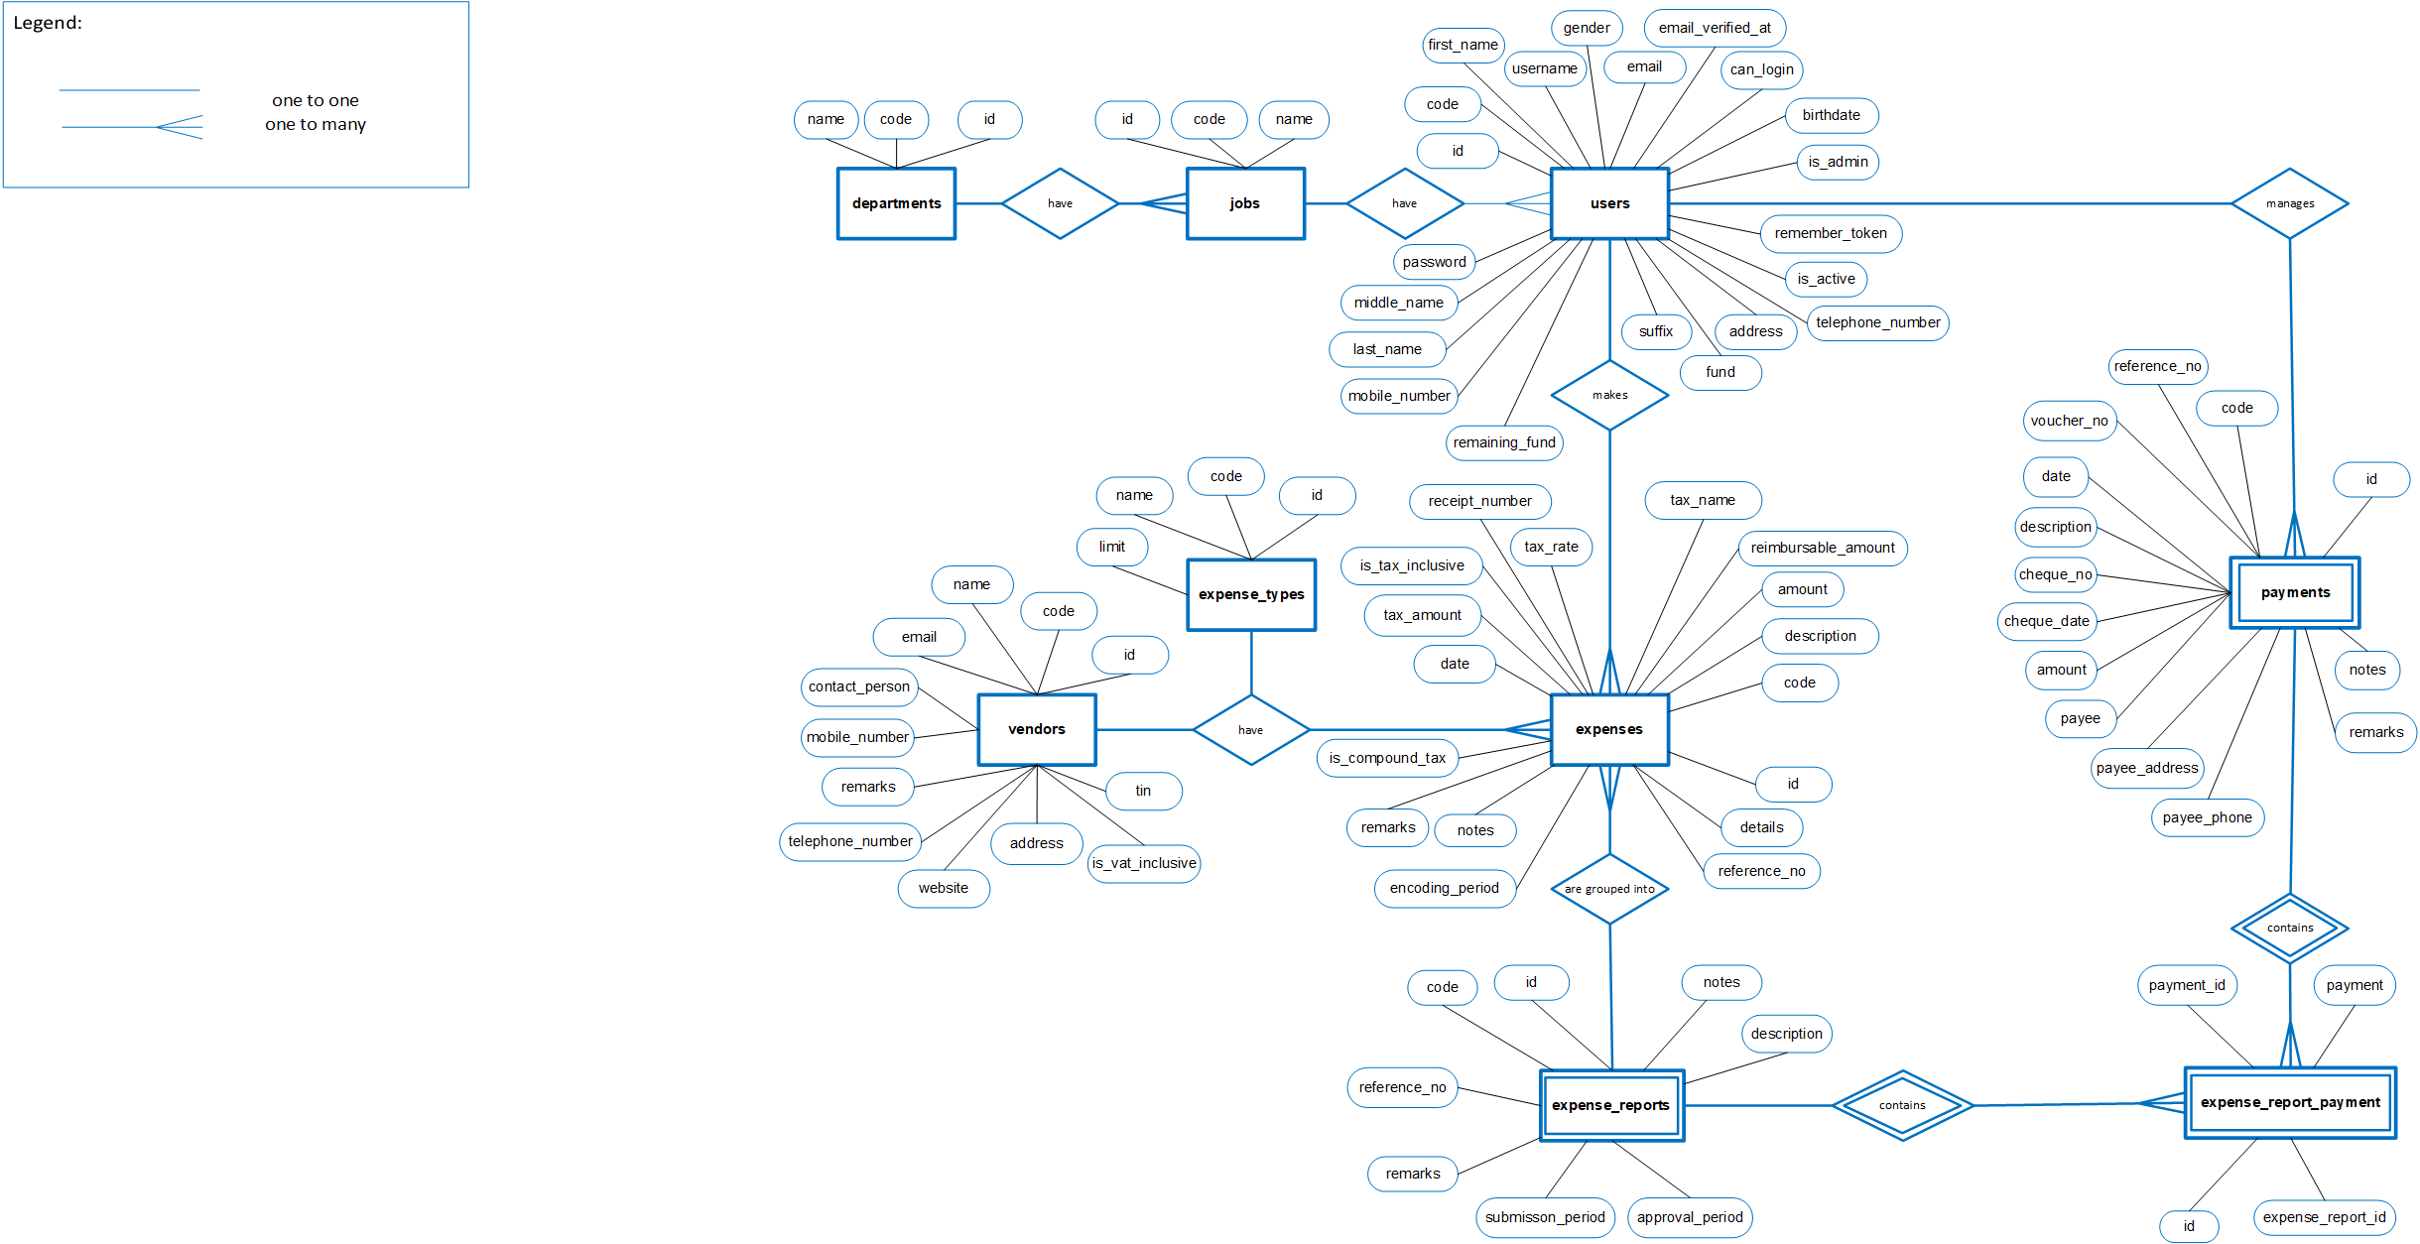

Figure 3 Entity Relationship Diagram

## Basic Workflow

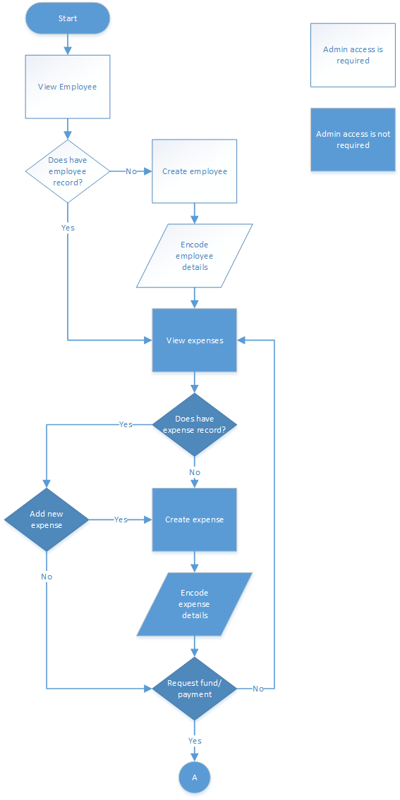

Figure 4 Basic Workflow (1)

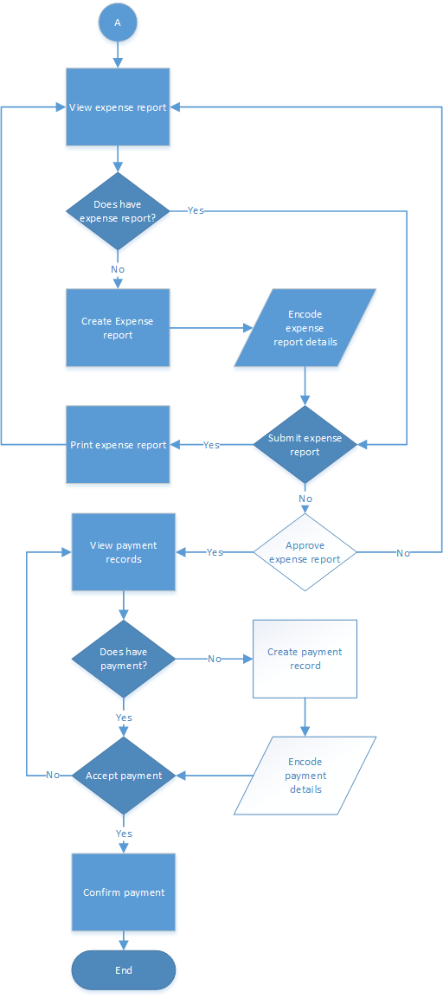

Figure 5 Basic Workflow (2)

# User Guide

## Access, Authentication, and Authorization

This section provides the information needed to access the application as well as manage user accounts. This also include different type of authorization given to a specific user of the system.

### Accessing The Application

Any user can access the application with the recommended browsers listed below and using the following link: [*http://192.168.1.51:82/*](http://192.168.1.51:82/)*.* The computer unit must be connected to the network within the company. To sign in, enter the username and password associated with the account on the login page.

Recommended browsers:

*Google Chrome v.51+*

*Mozilla Firefox v.54+*

*Microsoft Edge v.14+*

### Managing User Accounts

A user account allows you to sign in to the application. By default, the application already has one user account, the Super Admin account. This account can’t be deleted and used mainly on setting up the entire application on first use which includes creation of users for expense management and managing application settings.

#### User Roles

*Standard User*

This role provides basic access to the application. As a Standard user, you can do just about anything you would need to do, such as creating expense, submitting report, and managing user profile.

*Administrator*

This is a special role used for making changes to system settings or managing other user accounts. This role has full access to every setting on the application.

#### Permissions

Here is the list of permissions that can be assigned on different roles:

|  |  |  |
| --- | --- | --- |
| Permission | Standard User | Administrator |
| add users |  | **✓** |
| edit users |  | **✓** |
| delete users |  | **✓** |
| view users |  | **✓** |
| view all users |  | **✓** |
| export users |  | **✓** |
| reset user passwords |  | **✓** |
| edit users fund |  | **✓** |
| restore users |  | **✓** |
| edit permissions |  | **✓** |
| set user activation |  | **✓** |
| add departments |  | **✓** |
| edit departments |  | **✓** |
| delete departments |  | **✓** |
| view departments |  | **✓** |
| view all departments |  | **✓** |
| export departments |  | **✓** |
| add jobs |  | **✓** |
| edit jobs |  | **✓** |
| delete jobs |  | **✓** |
| view jobs |  | **✓** |
| view all jobs |  | **✓** |
| export jobs |  | **✓** |
| add vendors |  | **✓** |
| edit vendors |  | **✓** |
| delete vendors |  | **✓** |
| view vendors |  | **✓** |
| view all vendors |  | **✓** |
| export vendors |  | **✓** |
| restore vendors |  | **✓** |
| set vendor activation |  | **✓** |
| add expense types |  | **✓** |
| edit expense types |  | **✓** |
| delete expense types |  | **✓** |
| view expense types |  | **✓** |
| view all expense types |  | **✓** |
| export expense types |  | **✓** |
| add payments |  | **✓** |
| edit payments |  | **✓** |
| delete payments |  | **✓** |
| view payments | **✓** | **✓** |
| view all payments | **✓** | **✓** |
| export payments |  | **✓** |
| receive payments | **✓** | **✓** |
| add expense reports | **✓** | **✓** |
| edit expense reports | **✓** | **✓** |
| delete expense reports | **✓** | **✓** |
| view expense reports | **✓** | **✓** |
| view all expense reports | **✓** | **✓** |
| export expense reports |  | **✓** |
| submit expense reports | **✓** | **✓** |
| submit expense reports beyond due date | **✓** | **✓** |
| approve expense reports |  | **✓** |
| approve expense reports beyond due date |  | **✓** |
| reject expense reports |  | **✓** |
| duplicate expense reports | **✓** | **✓** |
| add expenses | **✓** | **✓** |
| edit expenses | **✓** | **✓** |
| delete expenses | **✓** | **✓** |
| view expenses | **✓** | **✓** |
| view all expenses | **✓** | **✓** |
| export expenses |  | **✓** |
| add expenses beyond encoding period | **✓** | **✓** |
| add expenses beyond limit | **✓** | **✓** |
| set reimbursable amount | **✓** | **✓** |
| restore expenses | **✓** | **✓** |
| view all activity logs |  | **✓** |
| modify taxes on expense | **✓** | **✓** |
| manage settings |  | **✓** |

## Application Modules

### Login

The Login module is used to enter authentication credentials to access the application. The login form contains a field for the username and another for the password. When the login form is submitted its underlying code checks that the credentials are authentic, giving the user access to the restricted pages. If a user is not able to provide authentic credentials they will not be able to proceed past the login form.

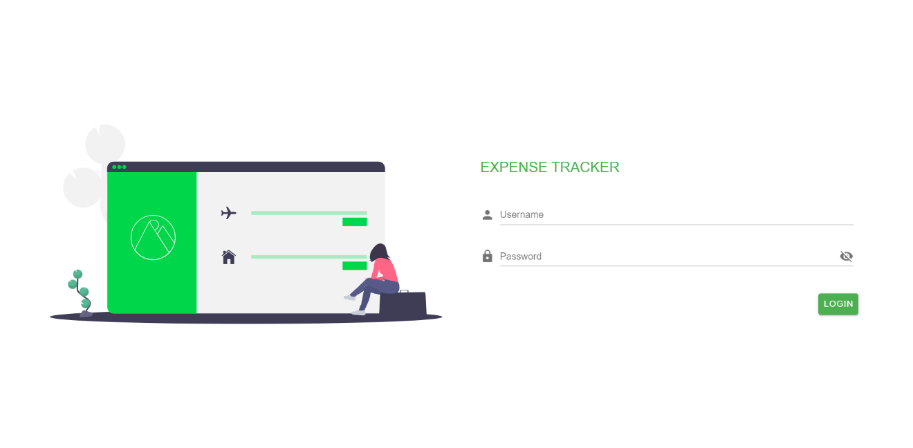

Figure 6 Login Page

### Dashboard

This module provides graphical representation for data visualization represented by charts and graphs. It consists views of key performance indicators and other information relevant to the company’s employee expense management.

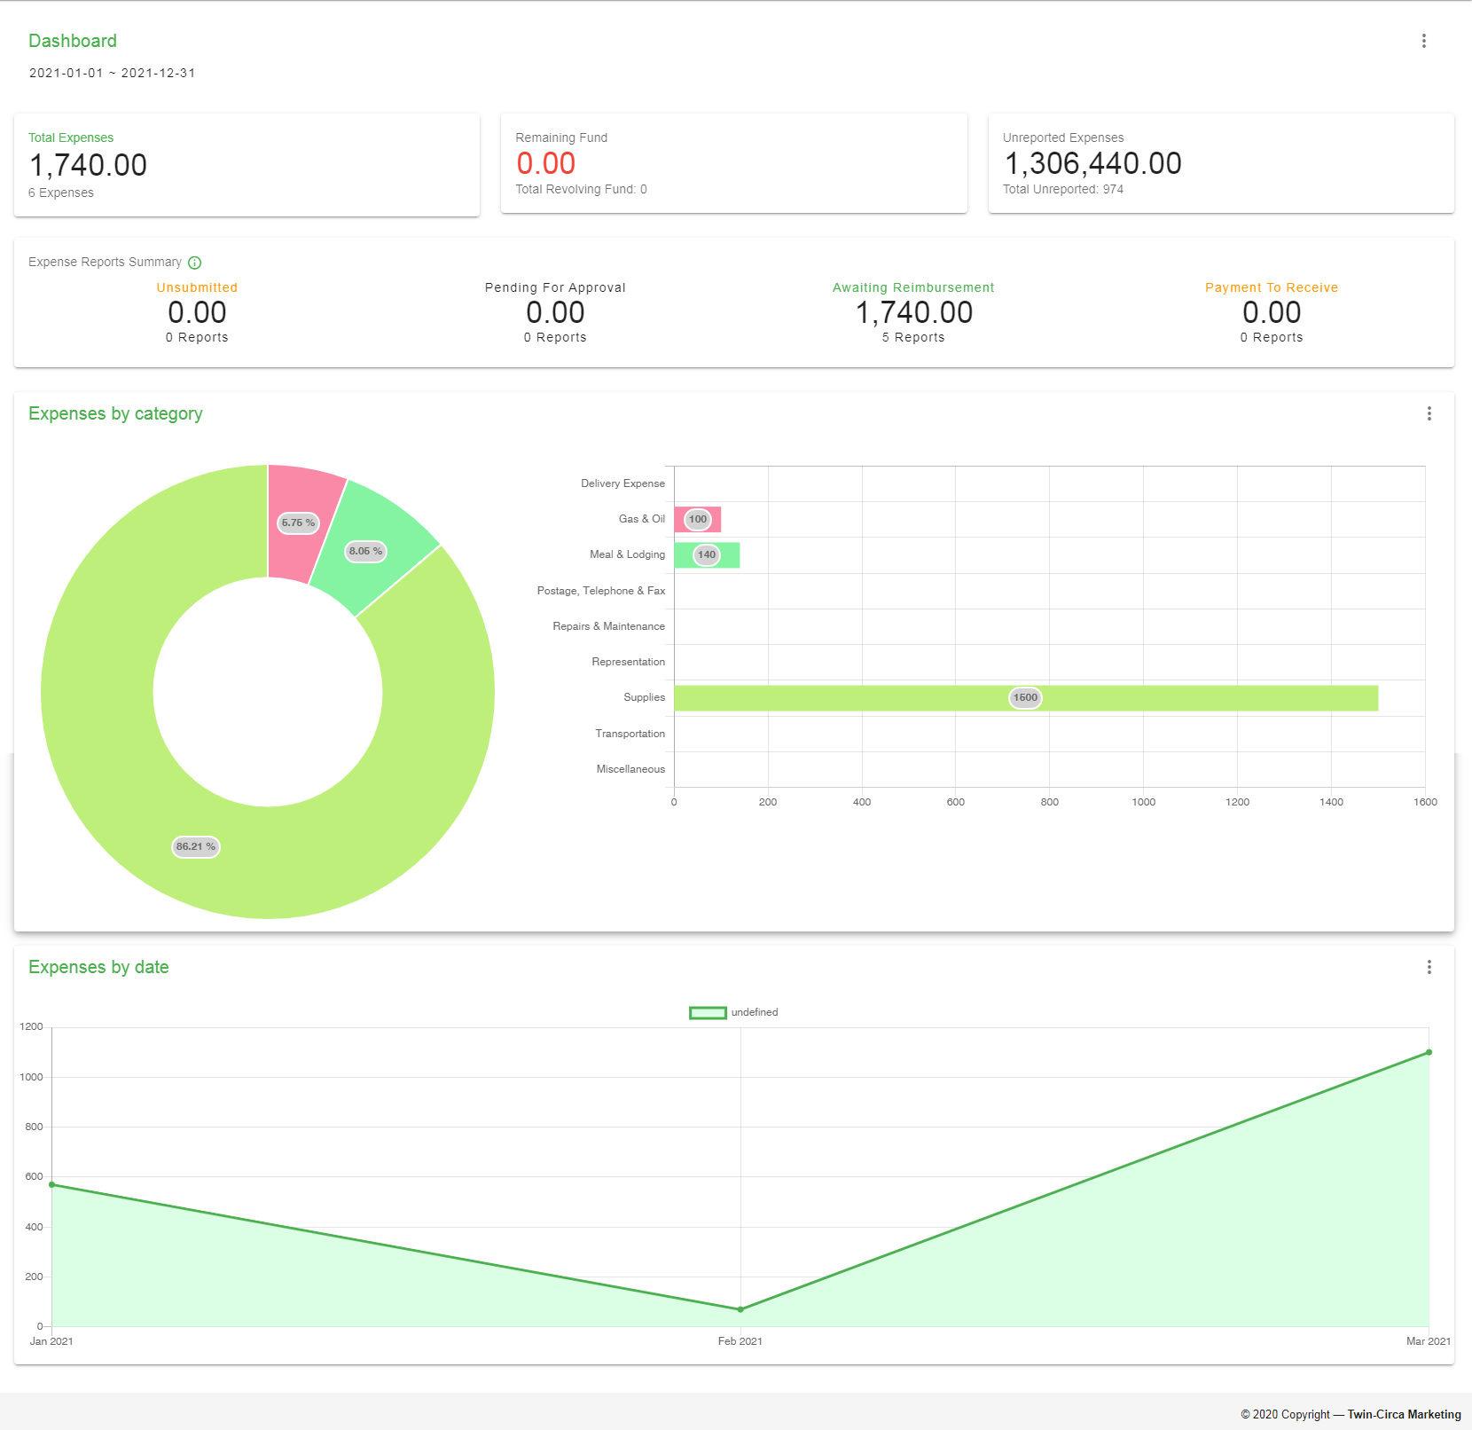

Figure 7 Dashboard Page

### User Profile

This module is a record of personal, user-specific data associated with the user's identity. This also includes settings for updating personal and account information.

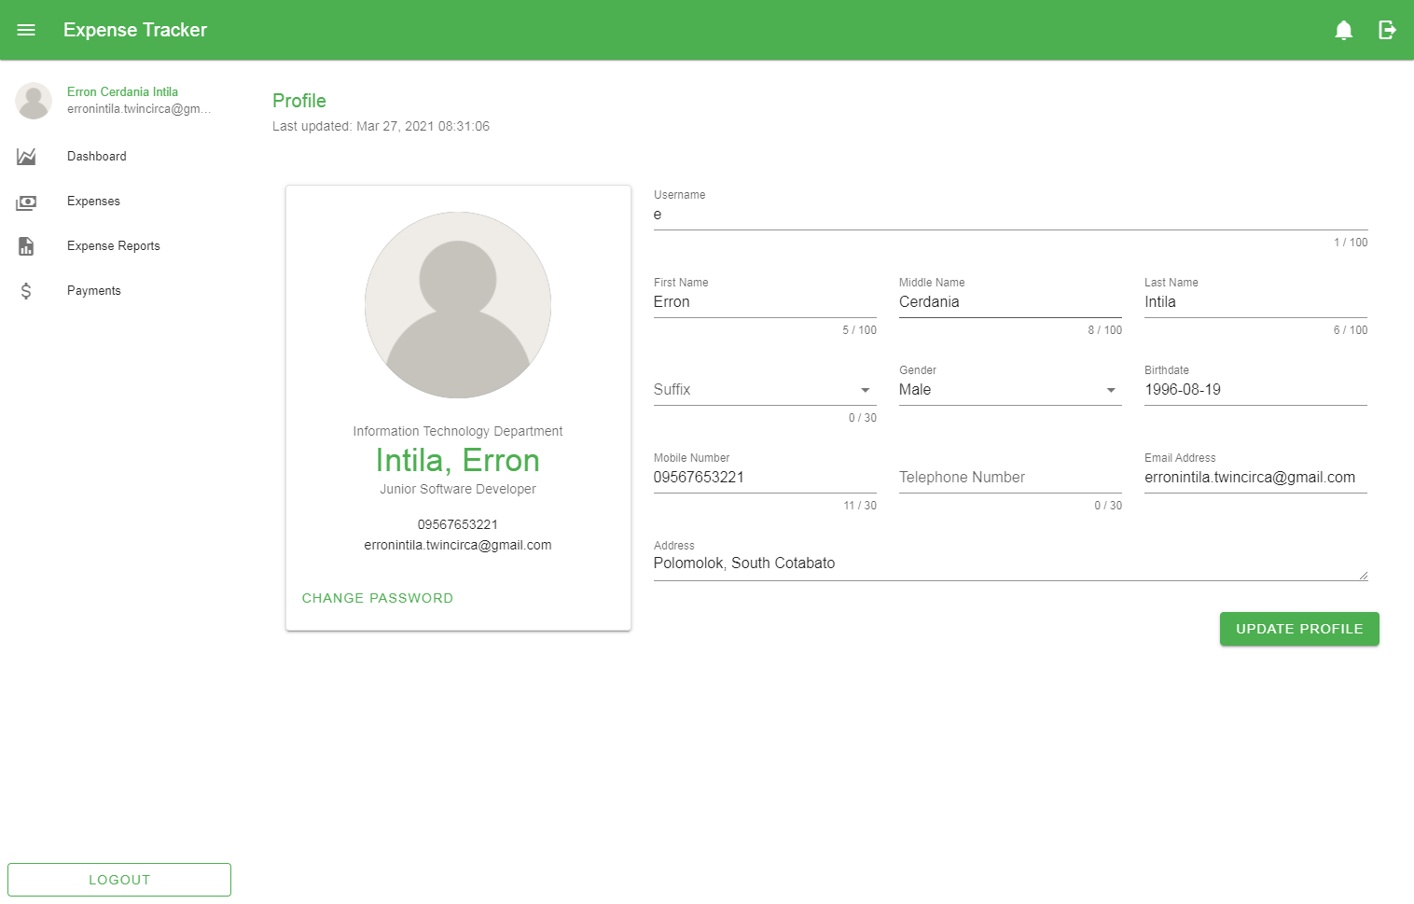

Figure 8 User Profile Page

### Expenses

This module involves management of each employee expenses. This allows the user to view, add, edit, and cancel expenses depending on the user role and level of permissions given.

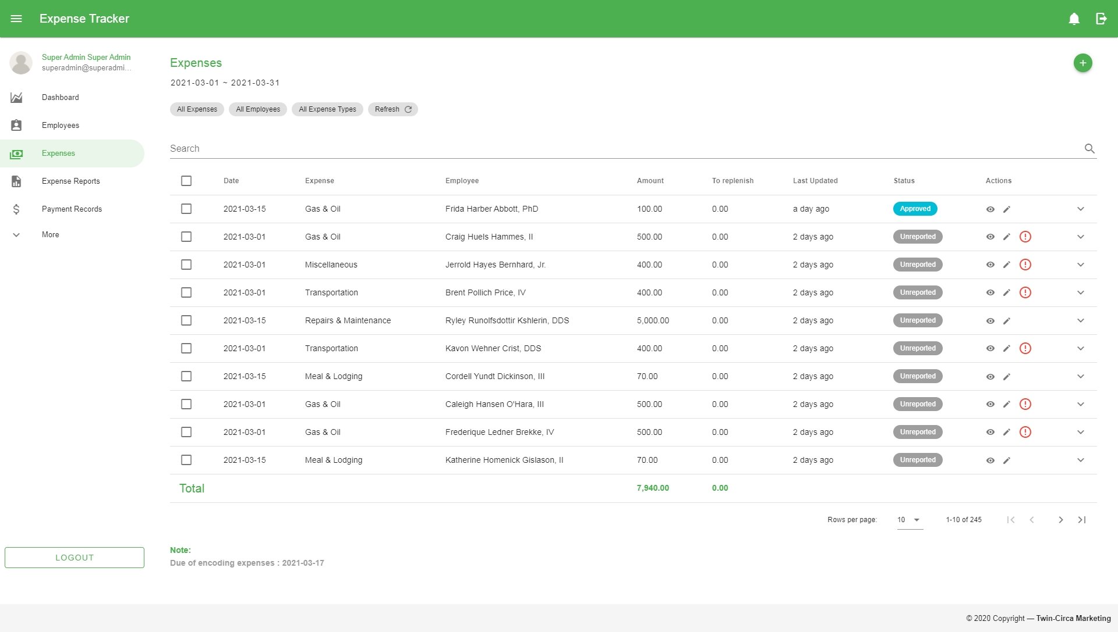

Figure 9 Expense Page

### Expense Reports

This module allows the user to manage created expenses grouped into reports. This involves creation, submission, approval, rejection and cancellation of records. Each record has specific status used mainly for monitoring with regards to employee reimbursement.

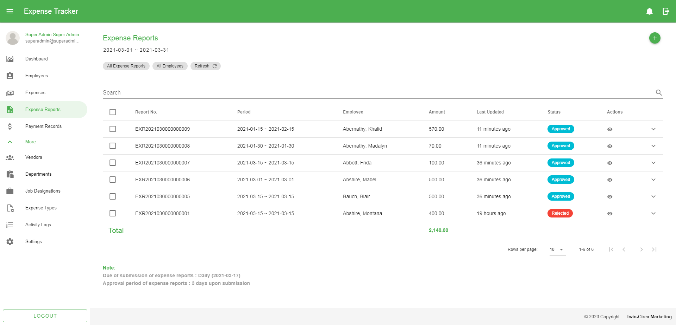

Figure 10 Expense Report Page

### Payments

This module provides record of payments for approved expense reports. This also shows status of transaction whether a certain payment has been created or received by the employee.

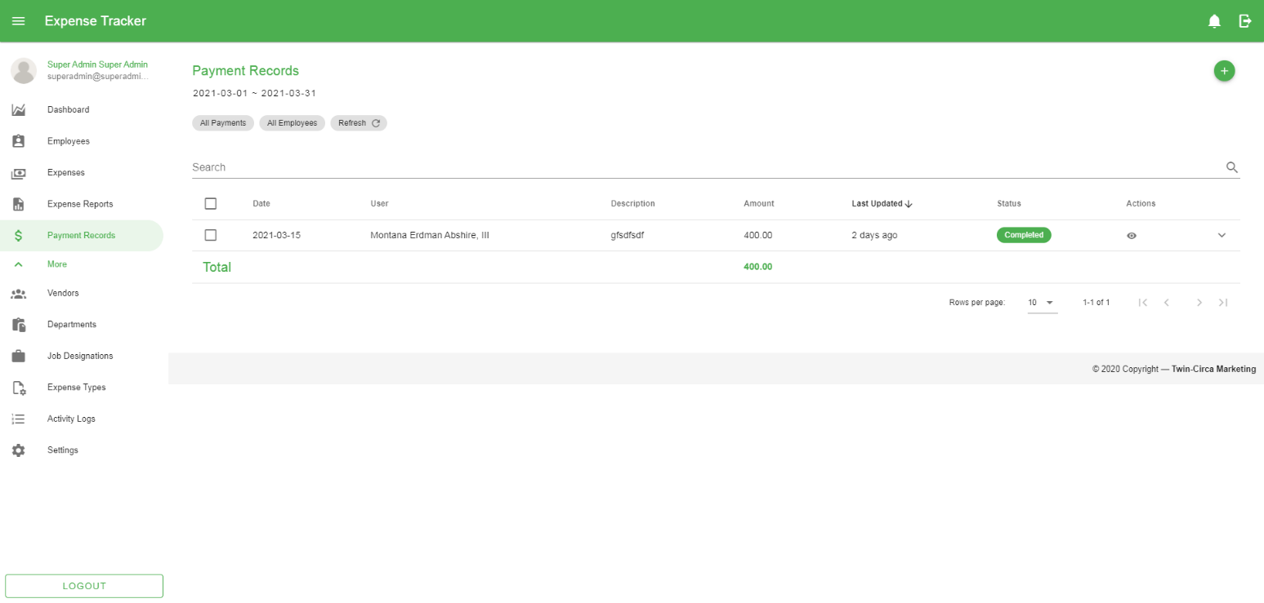

Figure 11 Payment Page

### Employees

This module allows the user to manage employee records. Each employee record is considered a system user accompanied with specific roles and permissions.

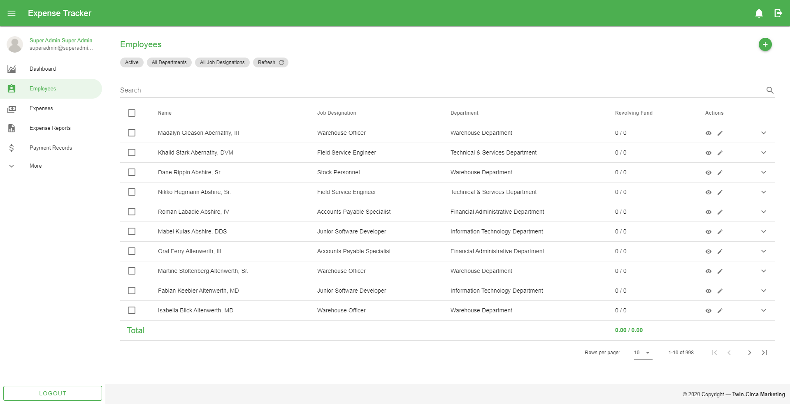

Figure 12 Employee Page

### Vendors

This module provides management of vendor records. This includes creating, updating, and setting activation for each record.

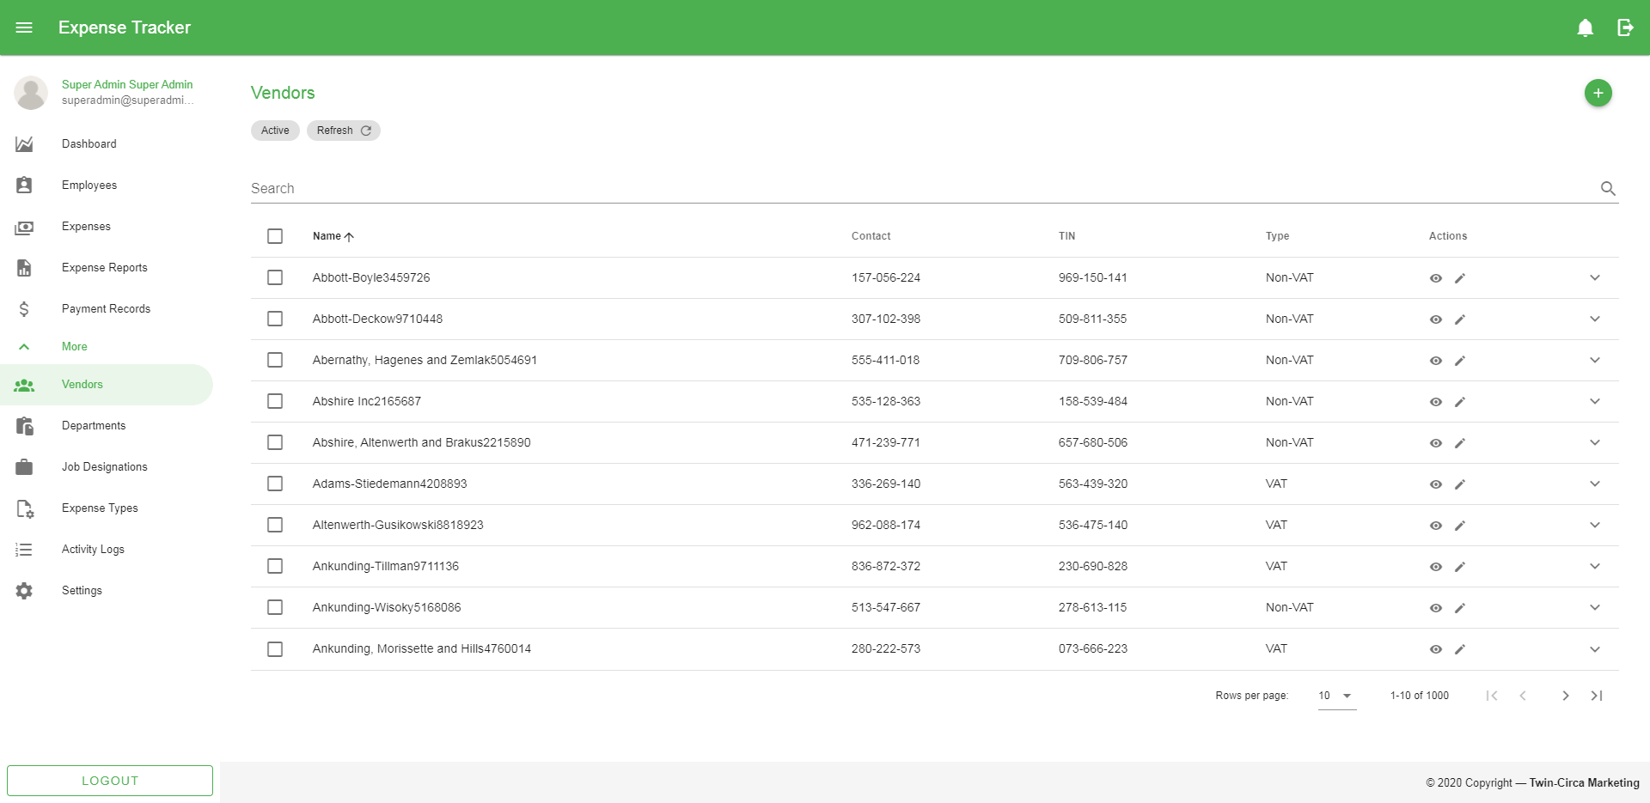

Figure 13 Vendor Page

### Departments

This module allows the user to create, edit, and delete department records used to classify each employee/system user.

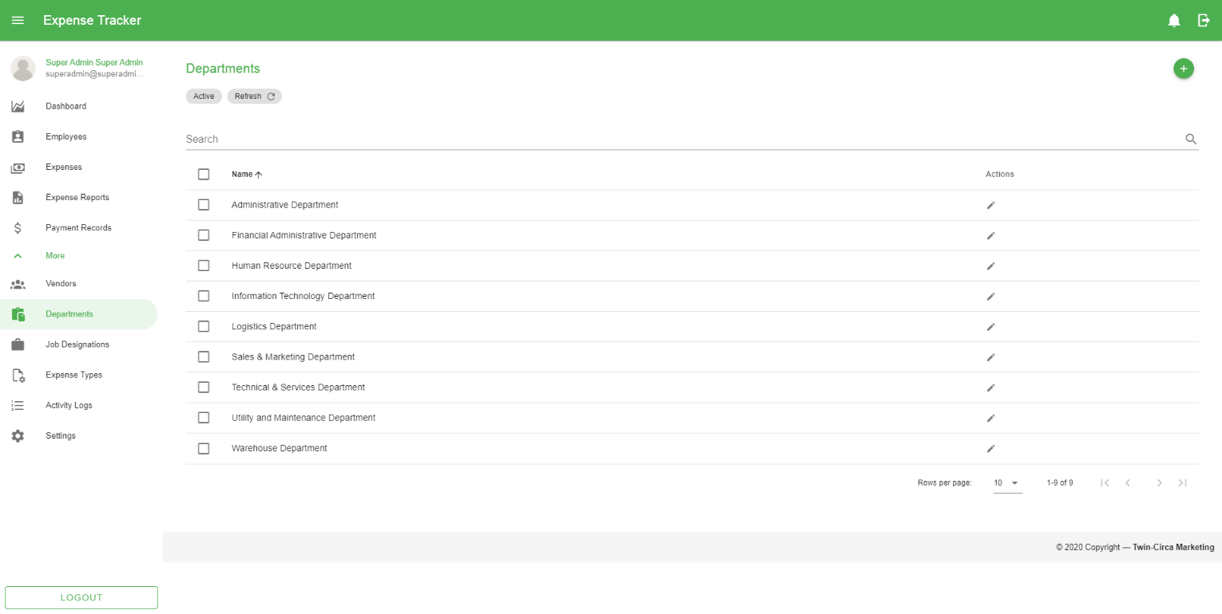

Figure 14 Department Page

### Job Designations

This module provides information about job designation records that can be used upon creating of new employees. This module also allows the user to create, edit, and delete job designation records.

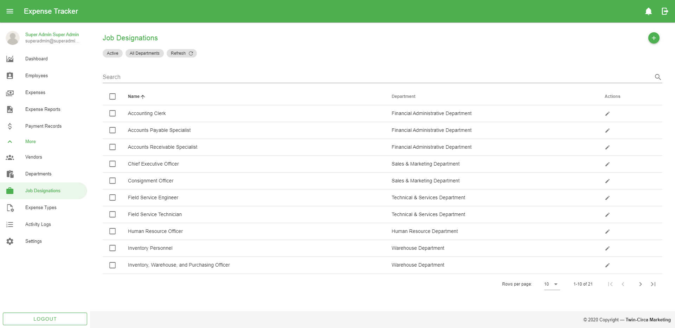

Figure 15 Job Designation Page

### Expense Types

This module allows the user to create, edit, and delete expense type records used mainly on creating of expenses to provide classification when generating reports.

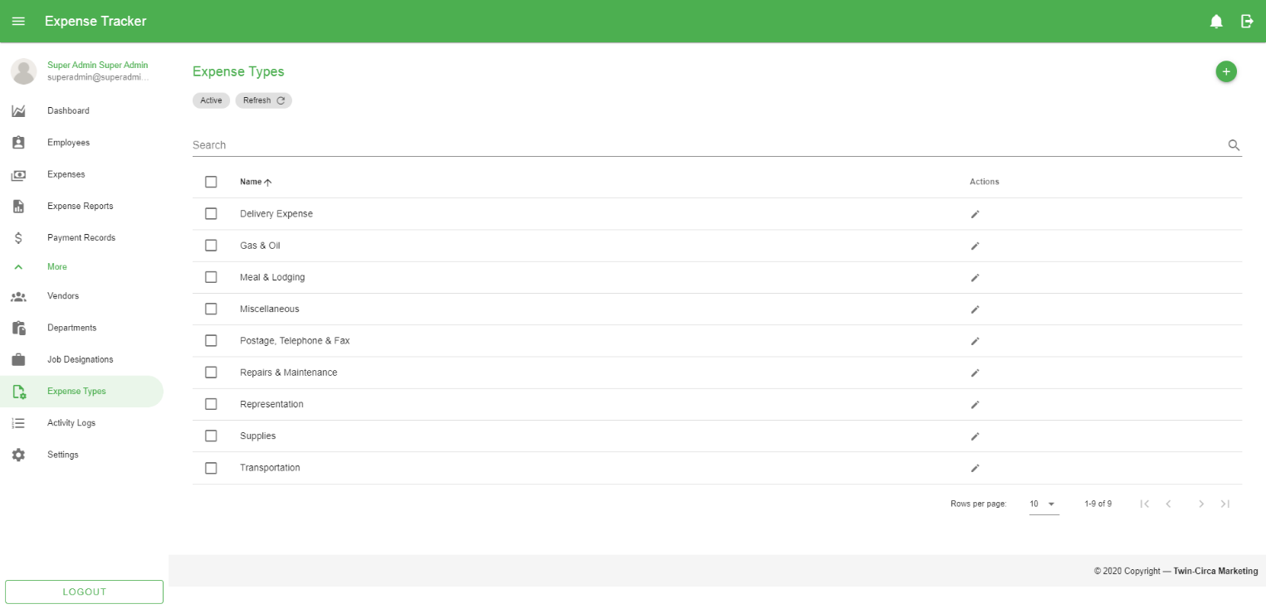

Figure 16 Expense Type Page

### Activity Logs

This module displays user activities within the application.

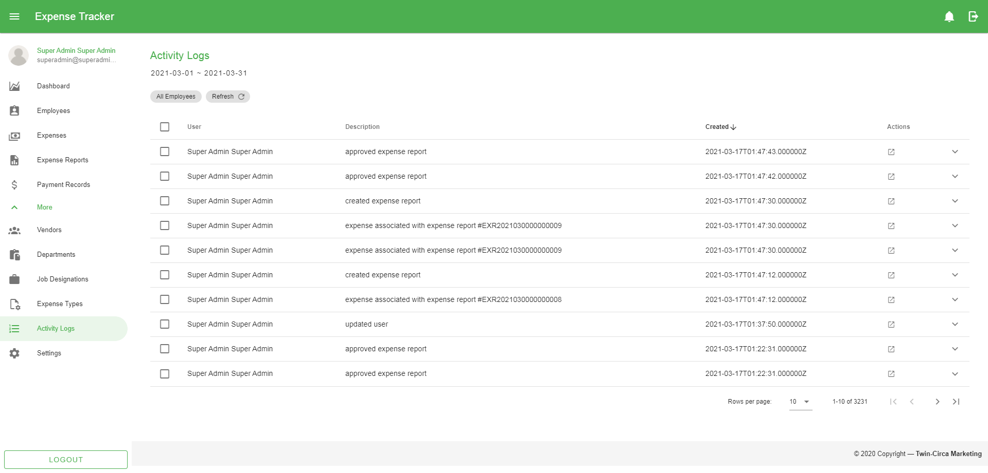

Figure 17 Activity Logs Page

### Settings

This module provides access to the user to set up and maintain the application. This involves configuration on different modules when creating and updating records.

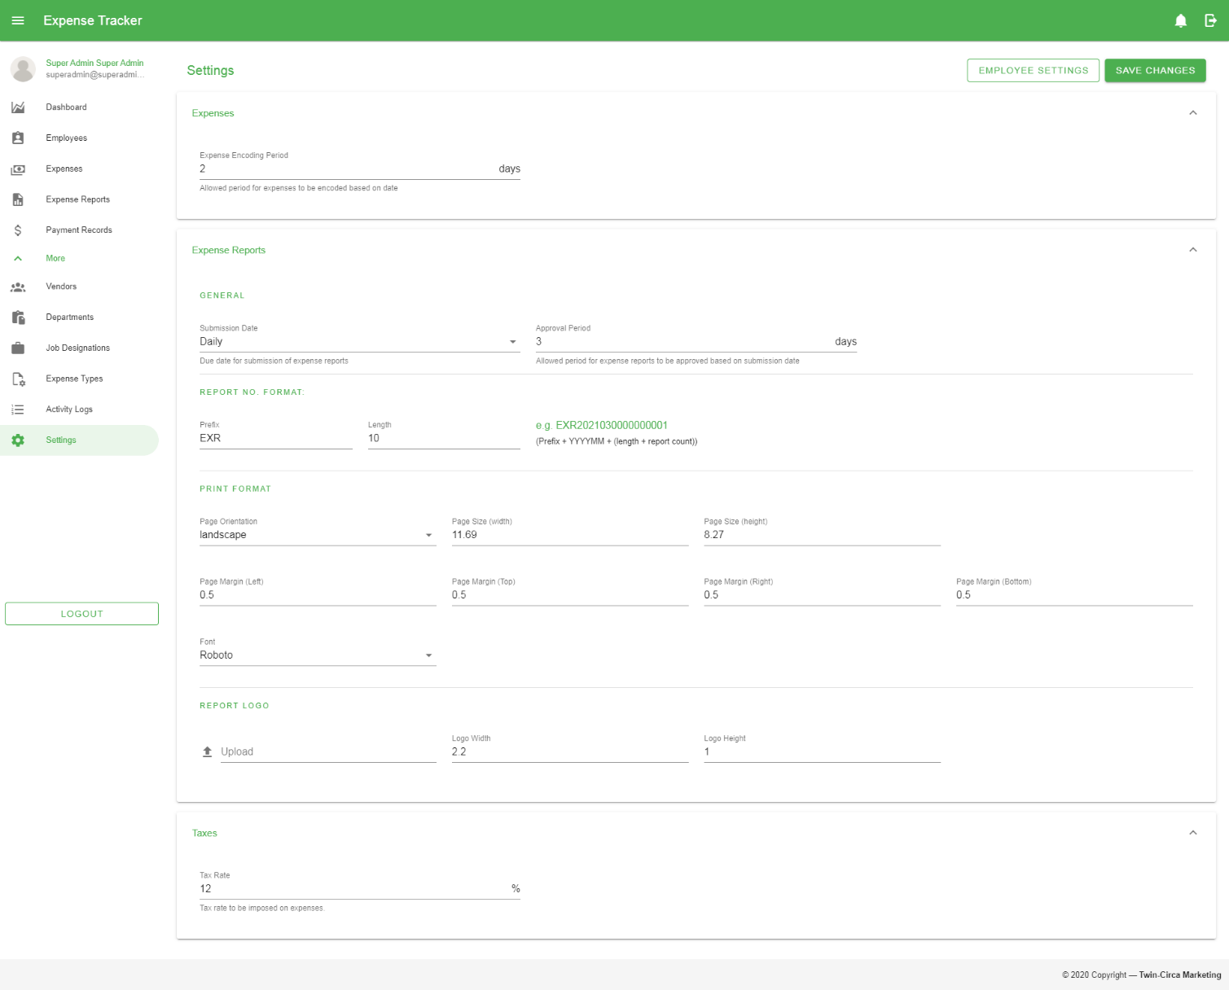

Figure 18 Settings Page

### Notifications

This module provides a message that appears on the right side of the application. This is a way to let the user know that something new has happened within the application (e.g. submitting expense report) to avoid missing transactions that might be worth the attention of the user and appears whether the user is using the application or not.

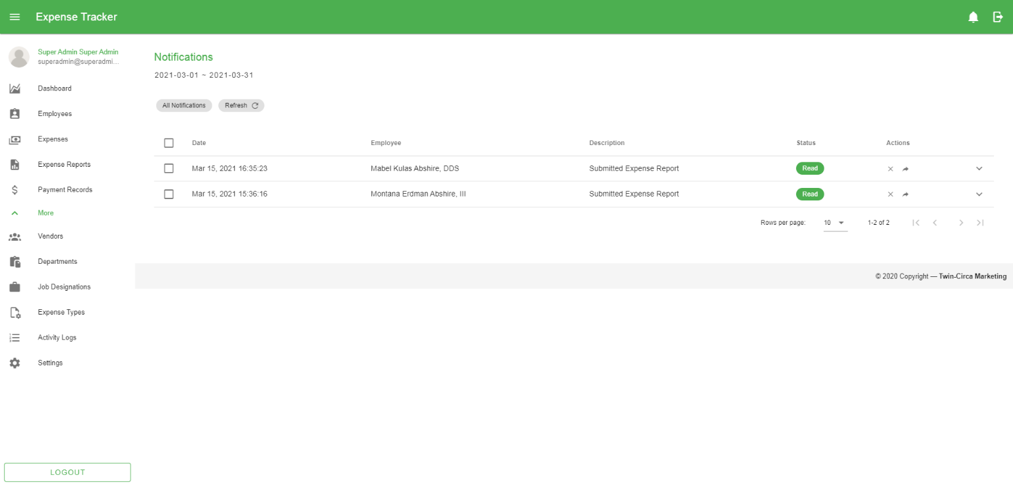

Figure 19 Notification Page

## Troubleshooting

### Software Troubleshooting

#### Unable to Access the Application

* Check if the network cable is connected to the PC.
* Check the browser’s address bar if the URL is correct (*http://192.168.1.99:82/*)
* If the above recommendation were performed but problem still persist, please contact the helpdesk/technician for support.

#### Unable to Sign in to the Application

* + Make sure to enter correct username and password.
* If the above recommendation were performed but problem still persist, please contact the helpdesk/technician for support.

#### Unable to Print the Expense Report

* + Check if the printer is on.
  + Check if the printer is connected to the computer.
* If the above recommendation were performed but problem still persist, please contact the helpdesk/technician for support.

### Common Response Errors

#### 401 Unauthorized

The user is considered unauthenticated. This requires the user to provide valid username and password to login and perform specific actions.

#### 403 Forbidden

The user does not have access rights to the content; that is, it is unauthorized, so the server is refusing to give the requested resource. Unlike 401 Error, the user’s identity is known to the server. The user will be redirected to the error page like the image shown below:

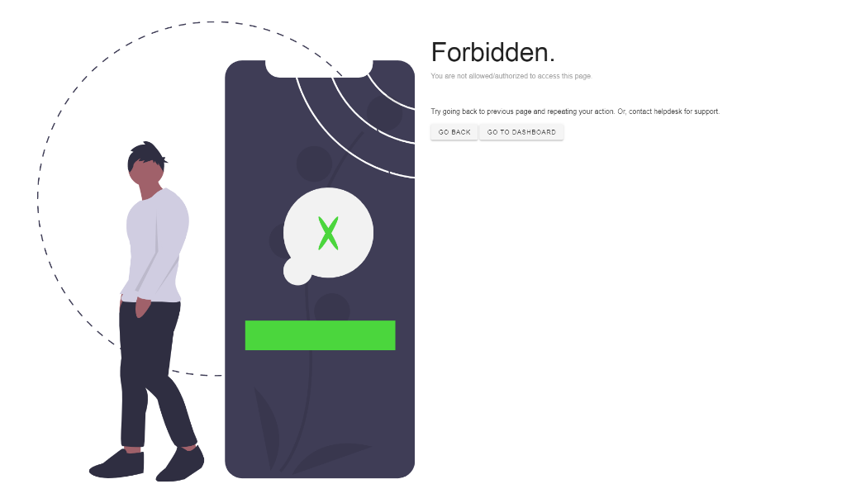

Figure 20 403 Forbidden Page

#### 404 Not Found

The server cannot find the requested resource. This means that the URL or endpoint is valid but the resource itself does not exist. The user will be redirected to the error page like the image shown below:



Figure 21 404 Not Found Page

#### 422 Unprocessable Entity

The request was well-formed but was unable to be followed due to semantic errors.

#### 500 Internal Server Error

This means that the server has encountered a situation that it does not know how to handle. Furthermore, this indicates a problem with the server, not the actual availability of the content. The user will be redirected to the error page like the image shown below:

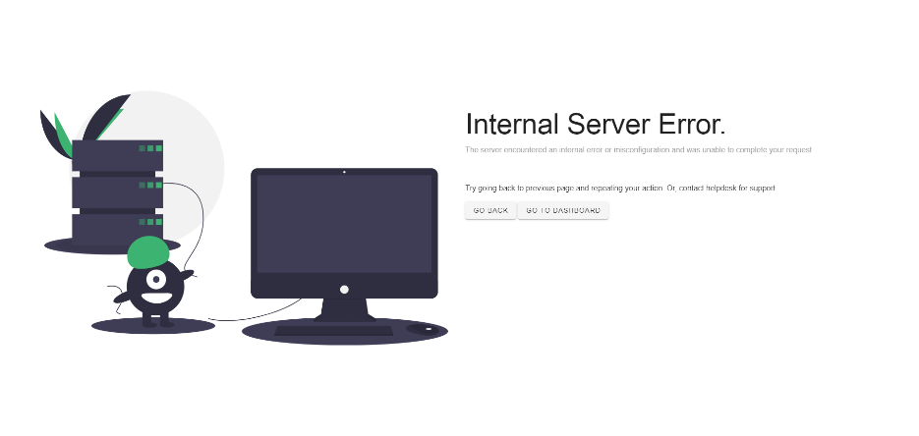

Figure 22 500 Internal Server Error Page

#### 503 Service Unavailable

This means that the server is currently not ready to handle the request. This is a common occurrence when the server is down for maintenance or is overloaded. The user will be redirected to the error page like the image shown below:

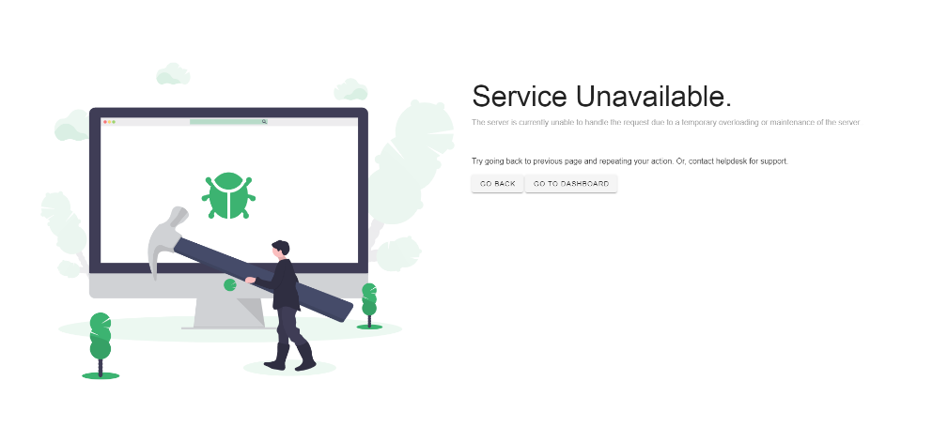

Figure 23 503 Service Unavailable

# References

*https://www.hostinger.ph/tutorials/what-is-apache*

*https://techterms.com/definition/application#:~:text=An%20application%2C%20or%20application%20program,specific%20application%20for%20the%20user.*

*https://docs.oracle.com/cd/A97337_01/ias102_otn/buslog.102/bc4j/bc_awhatisanapplicationmodule.htm*

*https://www.cs.uct.ac.za/mit_notes/software/htmls/ch06s06.html#:~:text=A%20context%20diagram%2C%20sometimes%20called,shown%20as%20a%20single%20process.*

*http://library.ucmerced.edu/data-dictionaries*

*https://techterms.com/definition/database*

*https://www.ques10.com/p/24848/what-is-dfd-explain-level-0-and-level1-dfd-with-su/#:~:text=DFD%20Level%200%20is%20also,its%20relationship%20to%20external%20entities.*

*https://www.visual-paradigm.com/guide/data-modeling/what-is-entity-relationship-diagram/#:~:text=Entity%20Relationship%20Diagram%2C%20also%20known,inter%2Drelationships%20among%20these%20entities.*

*https://economictimes.indiatimes.com/definition/gantt-chart*

*https://en.wikipedia.org/wiki/Git*

*https://www.webopedia.com/definitions/linux-os/#:~:text=The%20Linux%20open%20source%20operating,%2C%20servers%2C%20supercomputers%20and%20more.*

*https://searchoracle.techtarget.com/definition/MySQL*

*https://en.wikipedia.org/wiki/Flowchart#:~:text=A%20flowchart%20is%20a%20type,connecting%20the%20boxes%20with%20arrows.*

*https://www.myaccountingcourse.com/accounting-dictionary/reimbursement*

*https://www.collinsdictionary.com/dictionary/english/replenishment*

*https://www.merriam-webster.com/dictionary/revolving%20fund*

*https://www.paessler.com/it-explained/server*

*https://en.wikipedia.org/wiki/Software*

*https://searchwindowsserver.techtarget.com/definition/system#:~:text=A%20system%20is%20a%20collection,organized%20for%20a%20common%20purpose.&text=A%20computer%20system%20consists%20of,that%20run%20in%20the%20computer.*

*https://www.perforce.com/blog/vcs/what-is-version-control*

*https://techterms.com/definition/windows*

# Appendices

## Appendix A (Definition of Terms)

|  |  |
| --- | --- |
| Apache | A popular open-source and free web server software. |
| Application | A software program that runs on your computer. |
| Application Modules | A logical container for coordinated objects related to a particular task, with optional programming logic. |
| Context Flow Diagram | It identifies the flows of information between the system and external entities. |
| Database | A data structure that stores organized information. |
| Database Management System | A software system that uses a standard method of cataloging, retrieving, and running queries on data. |
| Diagram 0 | A basic overview of the whole system or process being analyzed or modeled. |
| Entity Relationship Diagram | A type of structural diagram for use in database design. |
| Expense | The money spent on something. |
| Gantt Chart | A useful graphical tool which shows activities or tasks performed against time. |
| Git | A software for tracking changes in any set of files. Usually used for coordinating work among programmers collaboratively developing source code during software development. |
| Linux Operating System | A freely distributable, cross-platform operating system based on Unix that can be installed on PCs, laptop, netbooks, mobile, and tablet devices, video game consoles, servers, supercomputers and more. |
| MySQL | An Oracle-backed open source relational database management system based on Structured Query Language. |
| Process Flow Diagram | A type of diagram that represents a workflow or process. |
| Reimbursement | A monetary compensation received to cover for a transaction made previously. |
| Replenishment | The process by which something is made full or complete again. |
| Revolving Fund | A fund set up for specified purposes with the proviso that repayments to the fund may be used again for these purposes. |
| Server | A computer or system that provides resources, data, services, or programs to other computers, known as clients, over a network. |
| Software | A collection of instructions and data that tell the computer how to work |
| System | A collection of elements or components that are organized for a common purpose. |
| Version Control | Allows you to manage changes to files over time. |
| Windows Operating System | A series of operating system developed by Microsoft. Each version of Windows includes a graphical user interface, with a desktop that allows users to view files and folders in windows. |

## Appendix B (Figures)

Figure 1 Context Flow Diagram 4

Figure 2 Diagram 0 of the Application 5

Figure 3 Entity Relationship Diagram 6

Figure 4 Basic Workflow (1) 7

Figure 5 Basic Workflow (2) 8

Figure 6 Login Page 13

Figure 7 Dashboard Page 14

Figure 8 User Profile Page 15

Figure 9 Expense Page 16

Figure 10 Expense Report Page 17

Figure 11 Payment Page 18

Figure 12 Employee Page 19

Figure 13 Vendor Page 20

Figure 14 Department Page 21

Figure 15 Job Designation Page 22

Figure 16 Expense Type Page 23

Figure 17 Activity Logs Page 24

Figure 18 Settings Page 25

Figure 19 Notification Page 26

Figure 20 403 Forbidden Page 28

Figure 21 404 Not Found Page 28

Figure 22 500 Internal Server Error Page 29

Figure 23 503 Service Unavailable 29

## Appendix C (Existing Forms and Reports)

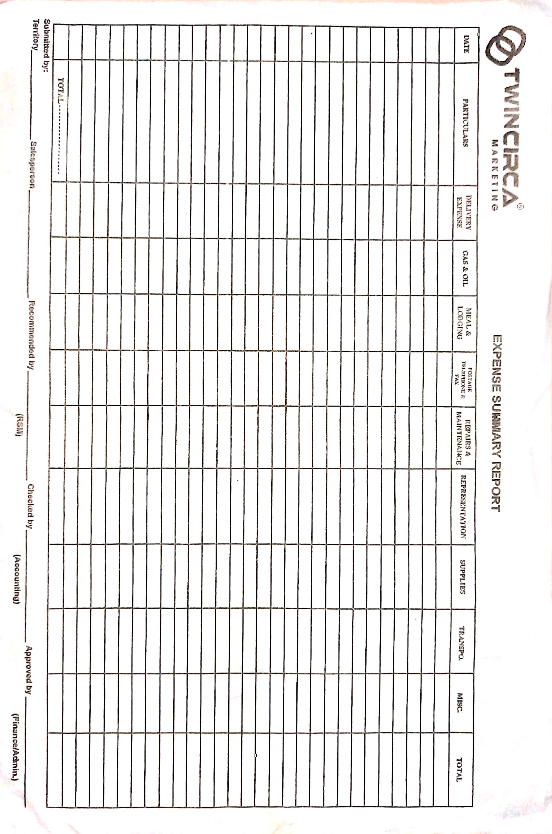

Expense Summary Report

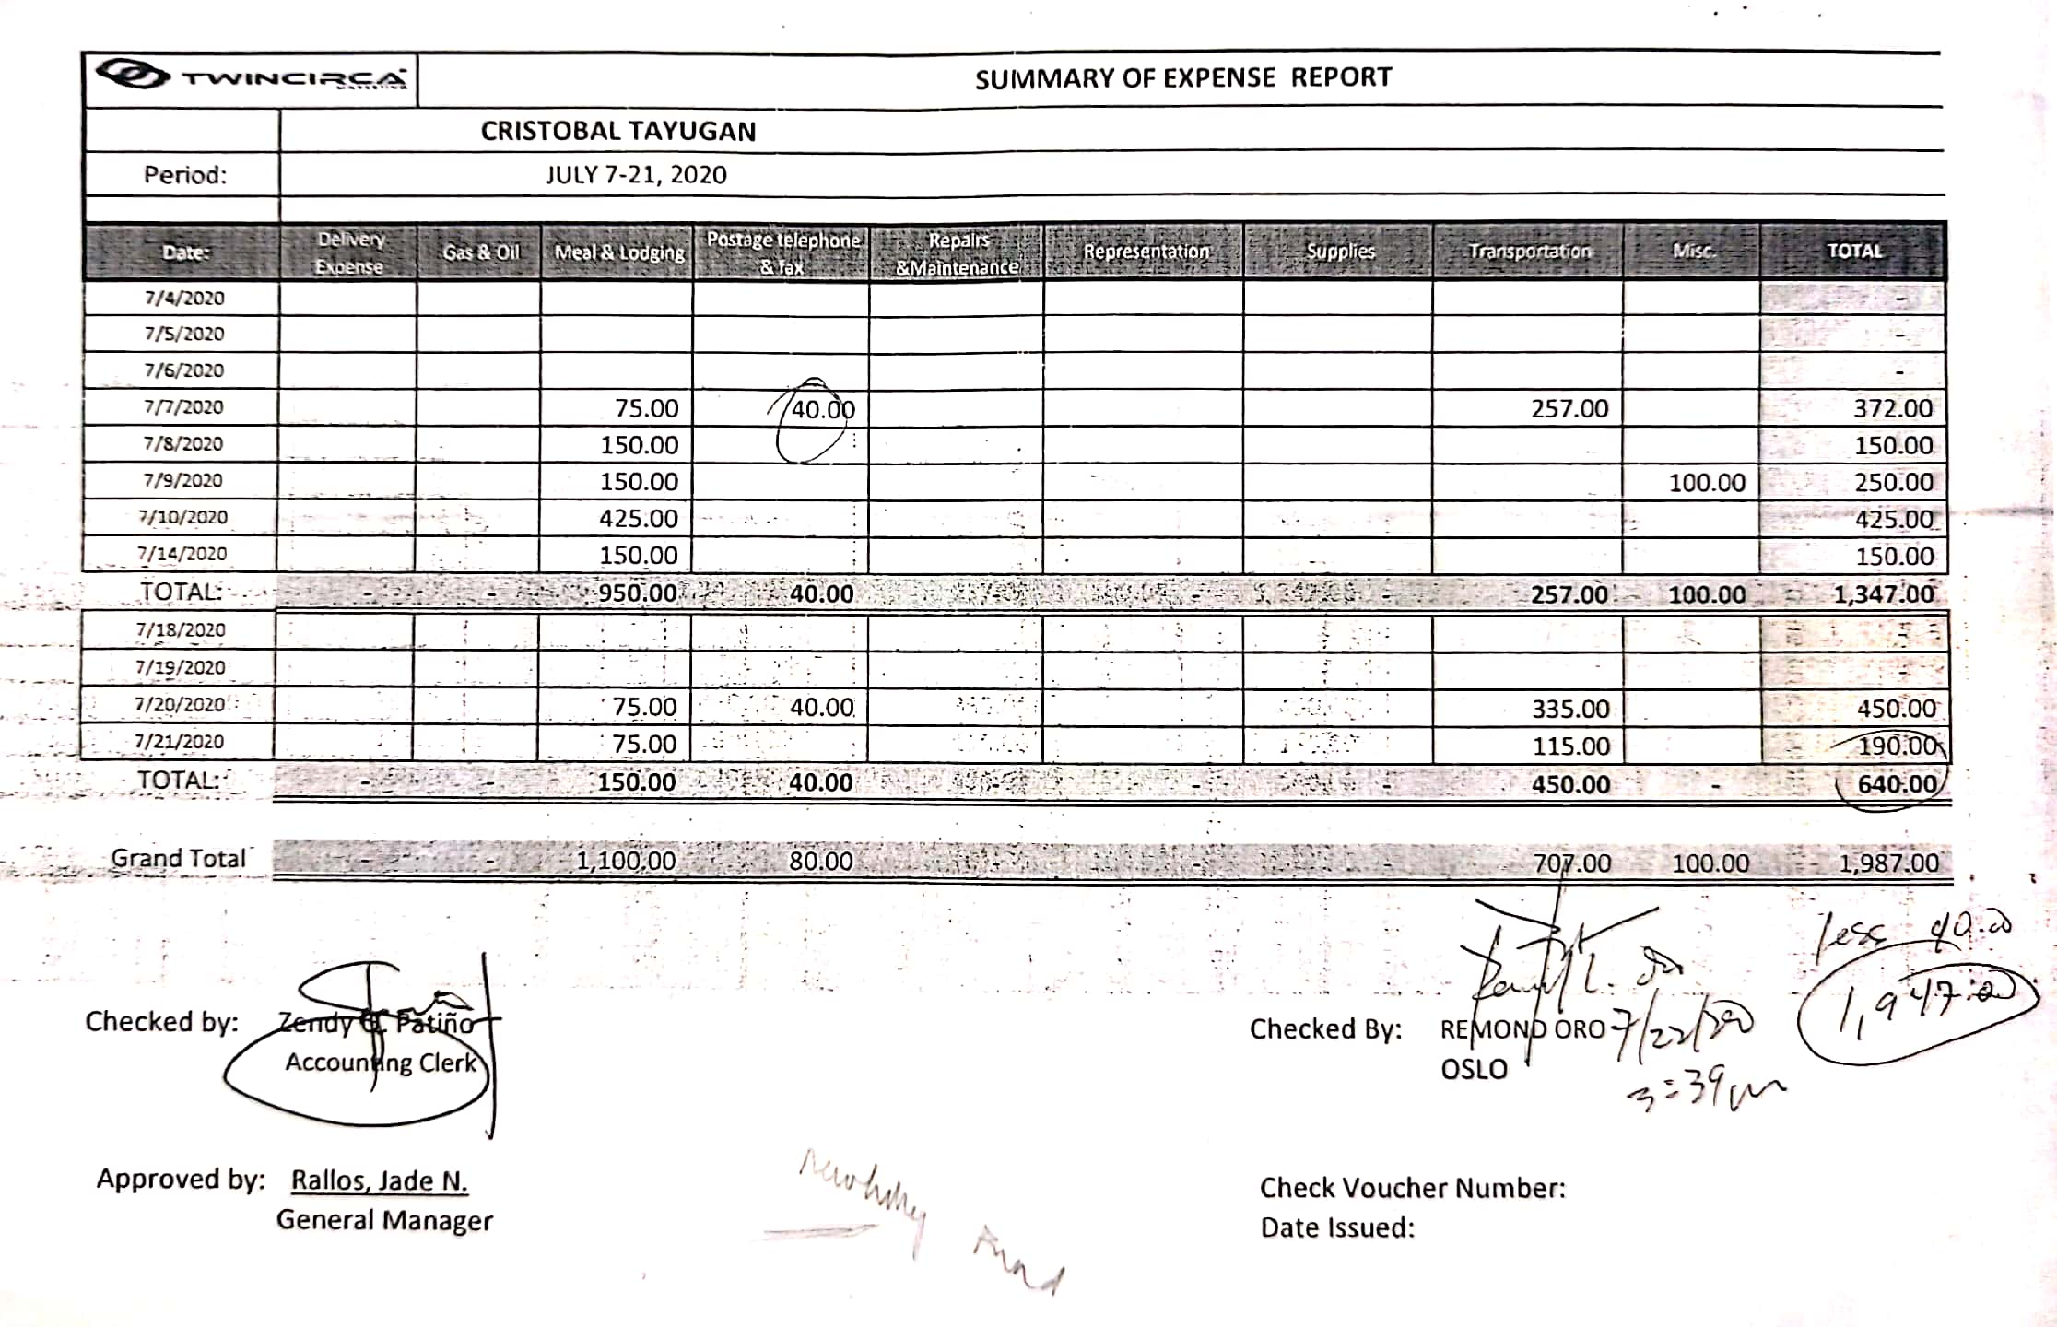

Expense Summary Report grouped by date

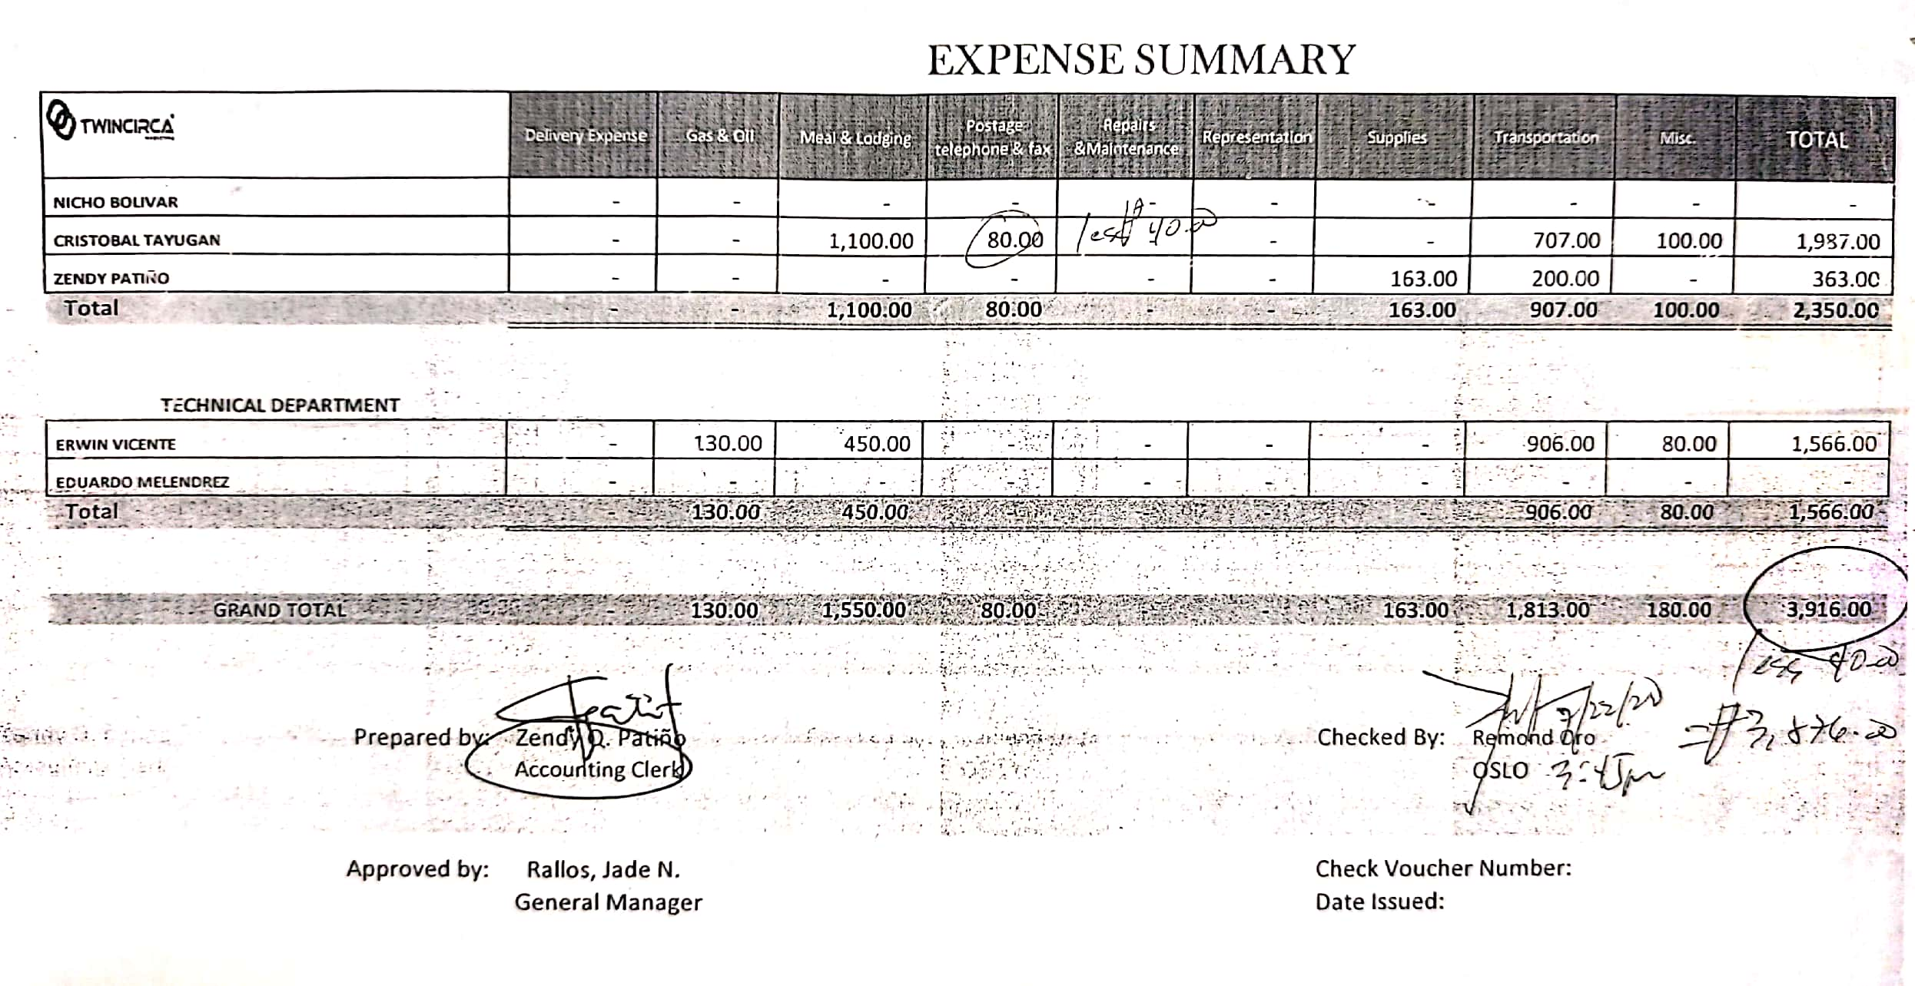

Expense Summary Report grouped by employee

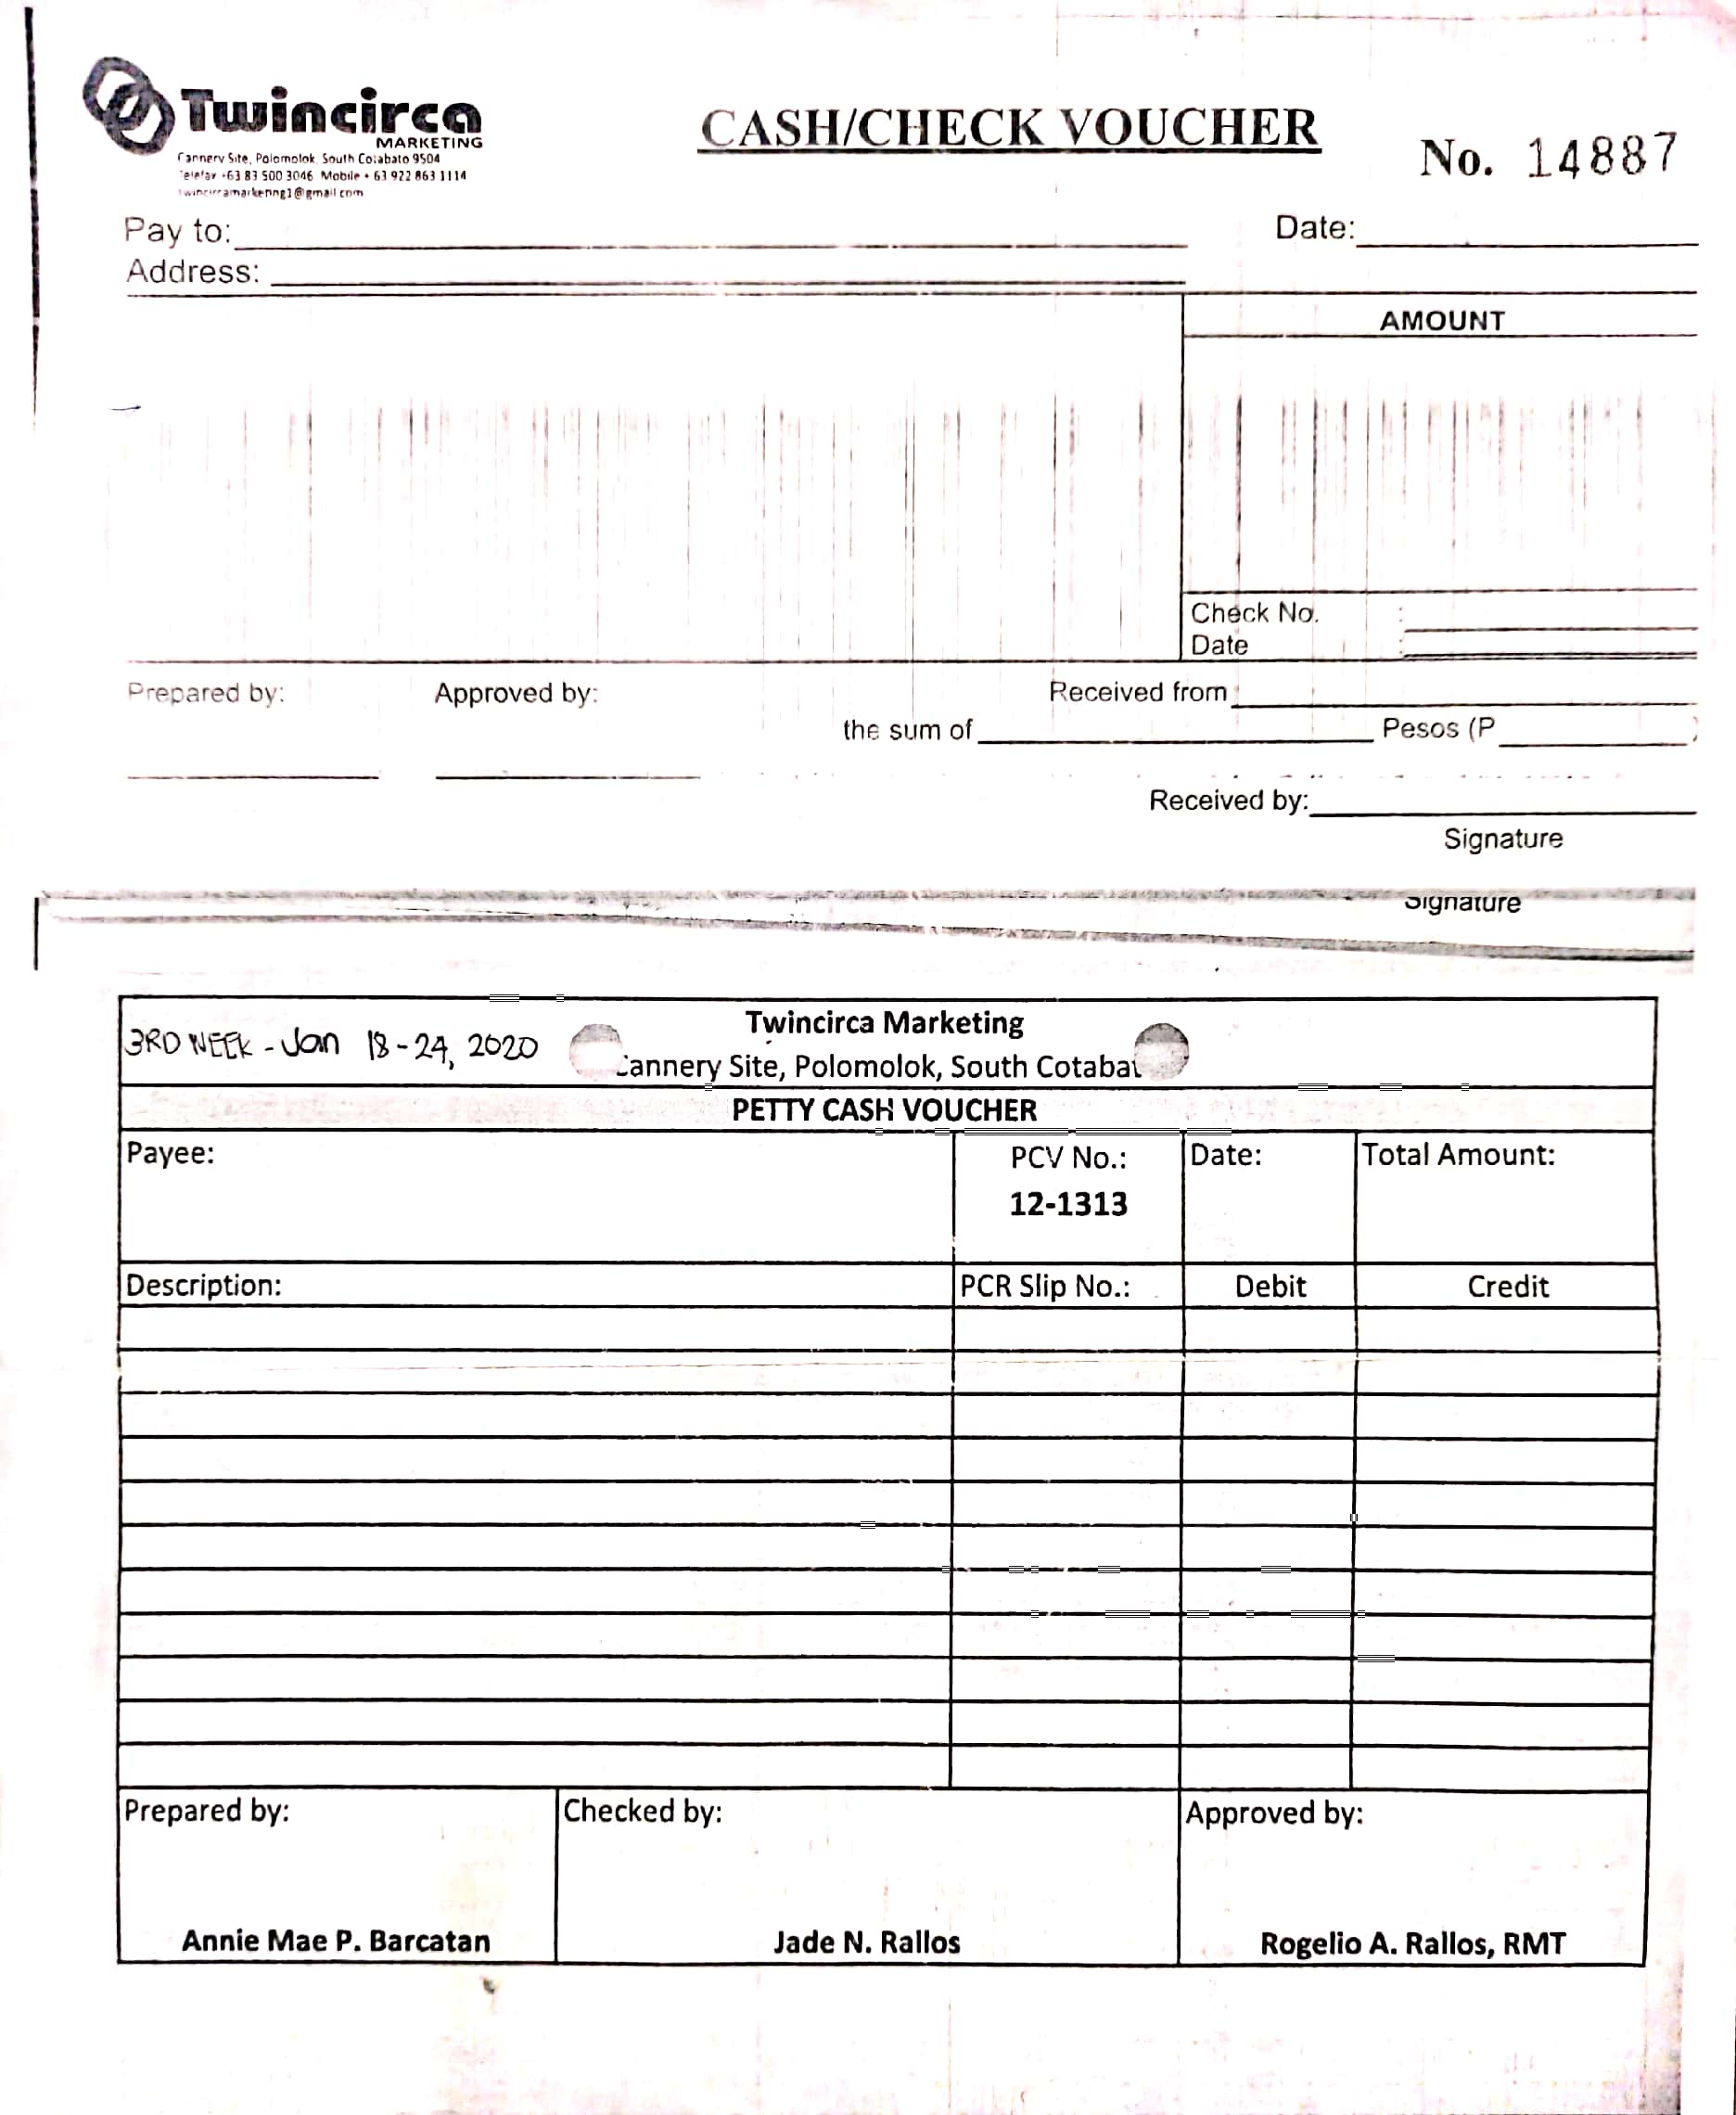

Voucher



Petty Cash Voucher