EMPLOYEE EXPENSE TRACKING SYSTEM

SYSTEM DOCUMENTATION

TWIN-CIRCA MARKETING

ESPOSADO VILLAGE, CANNERY SITE

POLOMOLOK, SOUTH COTABATO 9504

**BY:**

**ERRON C. INTILA**

JUNIOR SOFTWARE DEVELOPER

**BENHUR A. PAULO**

SENIOR SOFTWARE DEVELOPER / DEPARTMENT HEAD

**DOCUMENT VERSION: 1.0**

**DECEMBER 2020**

Table of Contents

Introduction 1

Purpose 1

Scope and Limitation 1

Scope 1

Limitation 2

System Overview 3

System Environment 3

System Design Specification 4

Process Specification 4

Data Specification 6

User Guide 7

Access, Authentication, and Authorization 7

Application Modules 7

Basic Workflow 21

Configuration and Deployment 22

Hardware Requirements 22

Software Requirements 22

Linux Server Configuration 22

Apache Configuration 22

MySQL Configuration 22

Application Deployment 22

Troubleshooting 23

Bibliography 24

Appendices 25

Appendix A (Gantt Chart) 25

Appendix B (Definition of Terms) 26

Appendix C (Existing Forms and Reports) 27

# Introduction

The Employee Expense Tracking System is a web-based application that manages travel-related expenses of employees. It allows users to record, submit, track, process, and reimburse employee expenses. The system used to improve and streamline current process, data management and increase response time.

This system documentation has been created to outline the overall system architecture and design. This includes the purpose, scope, design approaches, main component design and system design considerations and specifications. This document also provides an architectural overview of the system to depict different aspects of the system and functions as a foundational reference point for developers.

## Purpose

The main purpose of the system is to facilitate the entry, accumulation, processing, and management of travel-related expenses and employee reimbursement and improve efficiency, accuracy and management by reducing manual operations. The system performs a range of functionalities including:

*Record Keeping*

The system is used in storing data to keep accurate records. Usual data that comprise overall transaction include employee information, vendors, expenses, and payment records. Recording of expenses starts from encoding complete details of an employee and vendor, and then records payment once these expenses have been grouped together into one report. The system provides easy record retrieval and transaction history that can be utilized to process and analyze the data associated with it.

*Workflow Management*

The system can be used to streamline the current process or workflow. From encoding expenses to submitting of expense report, the system can reduce the amount of time needed to generate reports and increase reimbursement process.

*Reporting*

The Employee Expense Tracking System provides an accurate data visualization for reporting and analysis. The system can generate summary of expense reports as well as overall expenses of the company. In addition, the system provides information of remaining revolving fund on each employee.

## Scope and Limitation

### Scope

The project focused on the development of an information system that will track employees’ expenses, process reimbursement, and reduce manual operations. Hence, the system has focused on the following:

* The system will display a form of data visualization that includes total amount of remaining revolving fund and summary of expense records.
* The system will store and display employee records including job designations along with their corresponding departments.
* The system should allow users to monitor their remaining revolving fund.
* The system will store expenses based on expense types and display the list of records.
* The system will store expense report that consists of expenses grouped together and requires approval.
* The system will allow the users to submit, approve, reject, and cancel expense reports, and monitor statuses of each record.
* The system will store payment records for each expense report.
* For security and privacy of the management, the system complies users with different access level that correspond to different roles and permissions.
* The system will store and display vendor records.
* The system will allow users to manage their own profile.
* The system will store records such as departments, job designations, expense types.
* The system will have an activity log to monitor each user transaction.
* The system should generate reports of a specific expense report and summary of expense reports.
* The system will allow users to manage application settings.

### Limitation

The current version of the system does not include:

* Payment System

The current system does not have any system that can be used to settle financial transactions through the transfer of monetary value nor any payment system integration functionalities.

* Recording of Advance Payments

The current system does not allow users to record advance payments to employees before expenses have been incurred. Recording of payments can only be done after the expenses has been recorded within the system.

* Record Mileage Expenses

The system does not have the functionality to record mileage expenses where the expense is calculated based on the distance travelled and the mileage rate.

* System Notifications

The current system does not notify users on transaction and transaction updates.

*(Please note that this is a baseline document and may be updated as system development progresses. Limitations stated can be eliminated and current system features are all subject for improvement)*

# System Overview

This section describes the basic system design goals, functionality and architecture. It includes description of the approach used to develop the system. It also includes high-level descriptions of the system’s hardware, software, database, and security components. In addition, this section includes component and/or contextual diagrams of the system and system components.

## System Environment

This section includes specifications used to develop or support an application. This includes the operating system, the database system, and specific development tools.

Hardware:

Processor: 2GHz processor or more,

Ethernet connection (LAN) OR a wireless adapter (Wi-Fi)

Hard Drive: 120 GB or more

Memory (RAM): 4 GB or above

Software:

Operating System: Windows 7 Operating System or newer

Browser: Google Chrome v.51 and above/ Mozilla Firefox v.54 and above/ Microsoft Edge v.14 and above

Development: Microsoft Visual Studio Code 1.52,

Diagrams: Microsoft Visio 2016

Database GUI Tool: SQLyog Community Edition

Database Management System: MySQL v.10

Server: Linux Operating System, Windows Server 2008, Apache Tomcat 6

Version Control: Git

Application Architecture: Single-Page Application

Languages: HTML, CSS, JavaScript, PHP 7.3

Web Application Frameworks: Vue.js 2.5, Laravel 7.28

UI Libraries: Vuetify 2.3

## System Design Specification

This section includes detailed document providing the complete design and overall process for the new information system.

### Process Specification

#### Context Flow Diagram

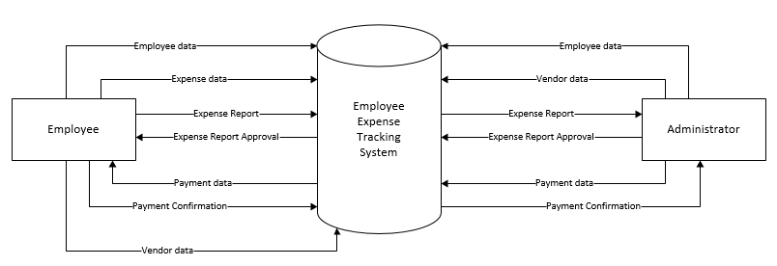

#### Diagram 0

### Data Specification

#### Entity Relationship Diagram

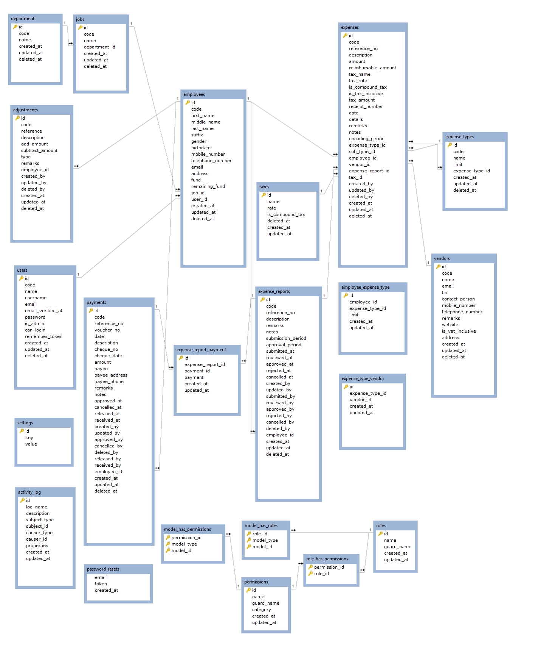

#### Entity Relationship Diagram

# User Guide

## Access, Authentication, and Authorization

Discuss roles and permissions, username password, how to access the system, what link can you access it to, etc.

## Application Modules

Main (including the header, sidebar, and footer)

(note: state all meaning of button with icons only, and status colors)

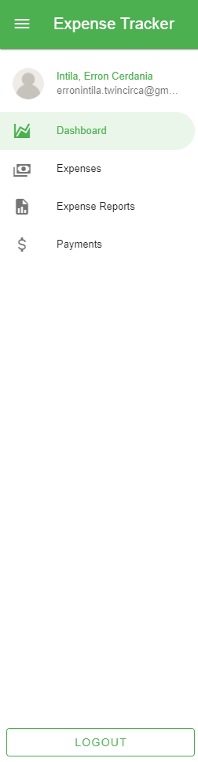 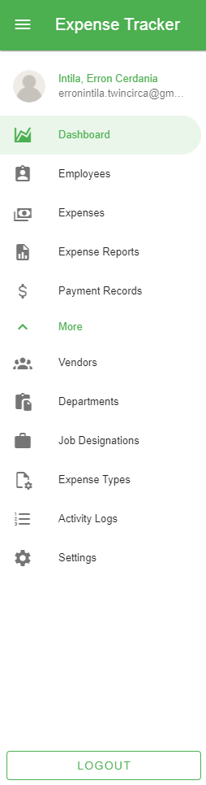

1. Application bar
2. Navigation bar (Standard User)
3. Navigation bar (Administrator)

Dashboard

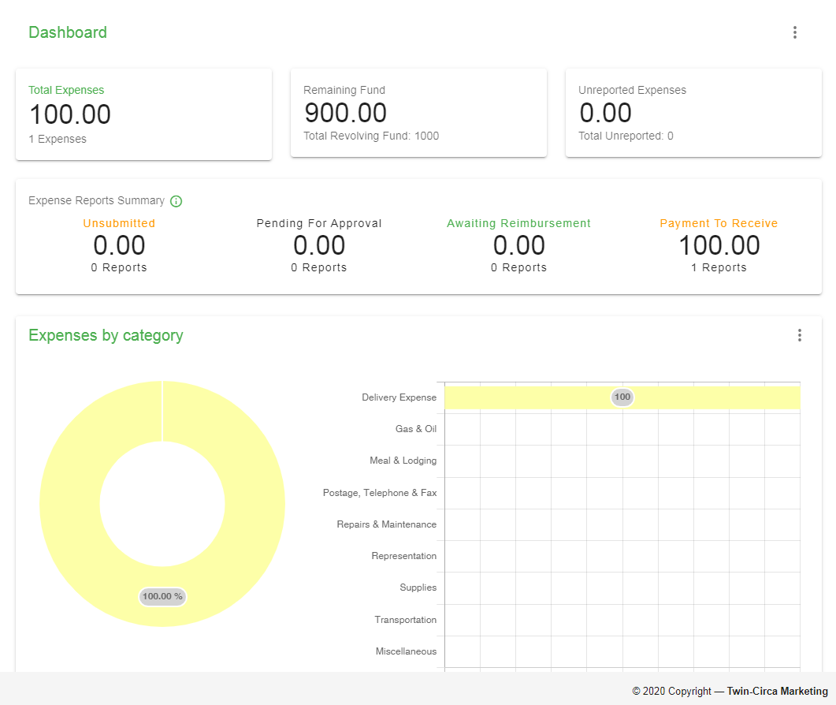

1. Overall Expense Summary
2. Expense Reports Statuses
3. Expenses by category
4. Expenses by date

User Profile

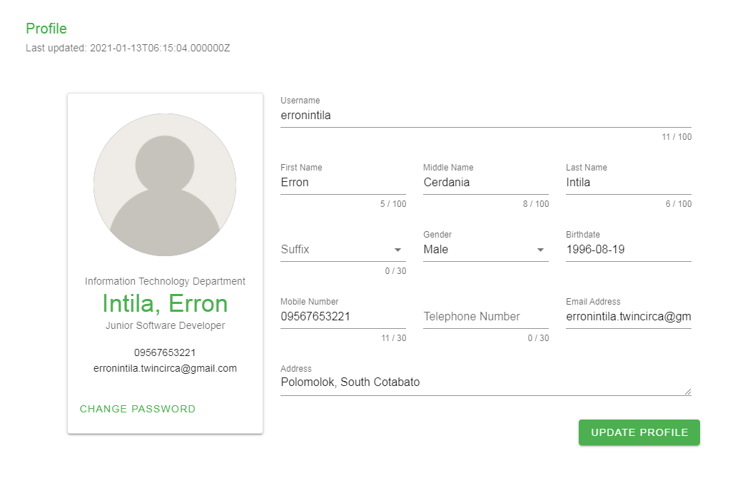

1. Profile Summary
2. User Profile Complete Description
3. Update Profile

Employees

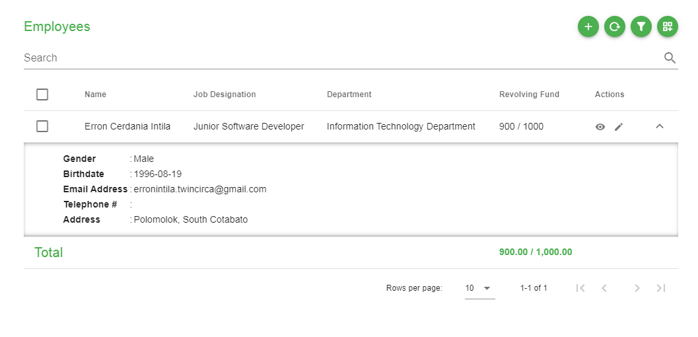

1. Employees List
2. Add Employee
3. Refresh data
4. Filter data
5. More Actions

Expenses

(note: state all statuses and their corresponding colors)

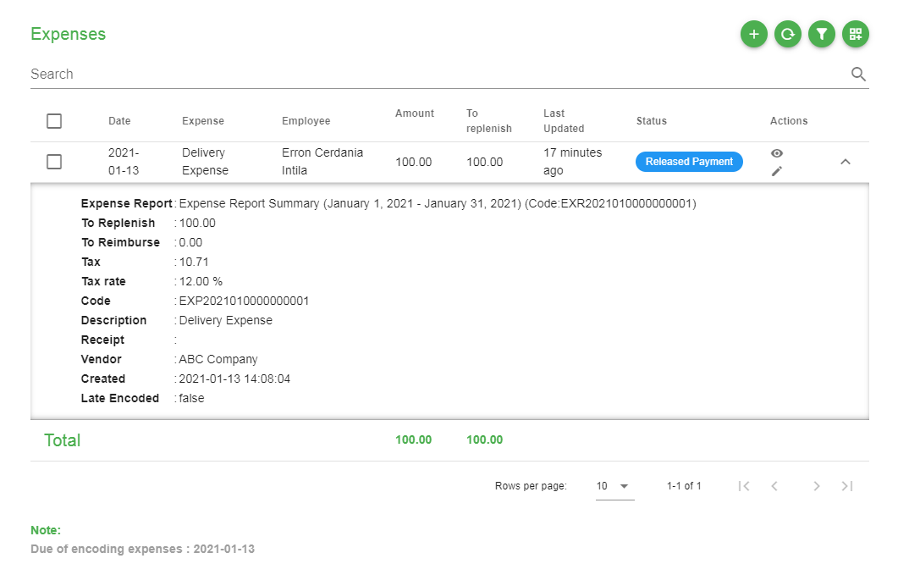

1. Expenses List
2. Add Expense
3. Refresh data
4. Filter data
5. More actions
6. Notes
7. Status

Expense Reports

(note: state all statuses and their corresponding colors)

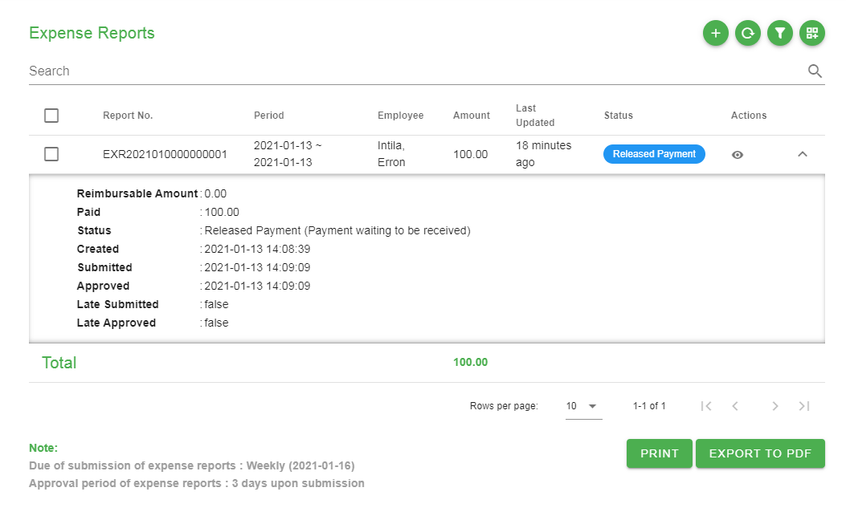

1. Expense Reports List
2. Add Expense Report
3. Refresh data
4. Filter data
5. More Actions
6. Print
7. Export to PDF
8. Status
9. Notes

Payment Records

(note: state all statuses and their corresponding colors)

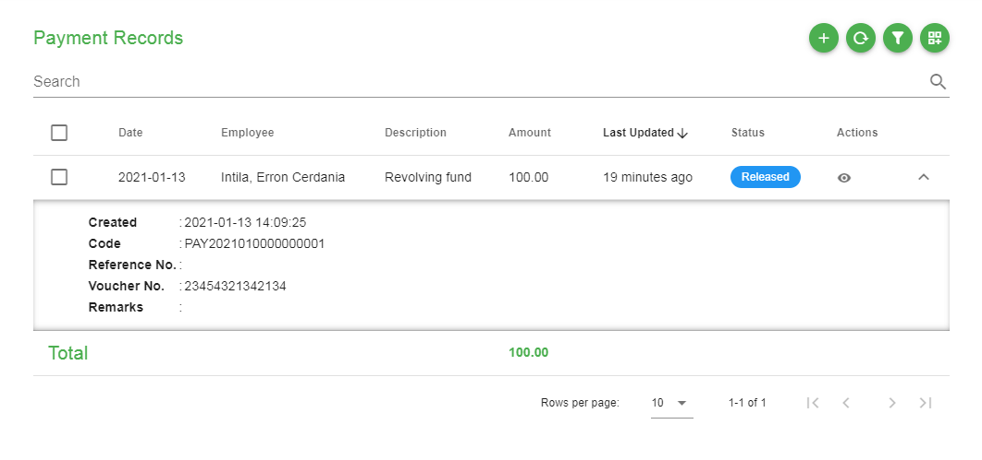

1. Payment Records
2. Add Payment Record
3. Refresh data
4. Filter data
5. More Actions
6. Status

Vendors

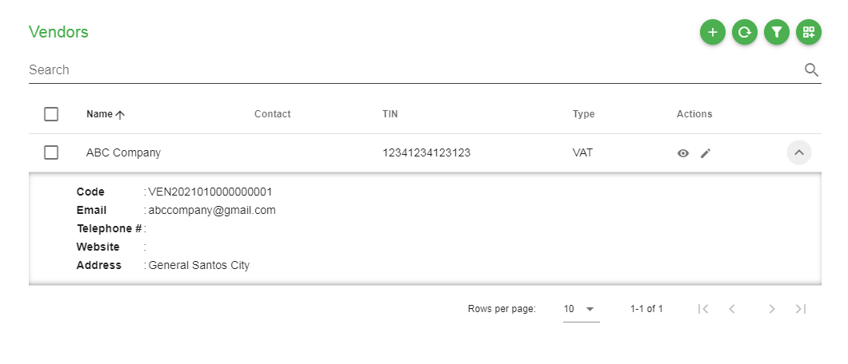

1. Vendors List
2. Add vendor
3. Refresh data
4. Filter data
5. More Actions

Departments

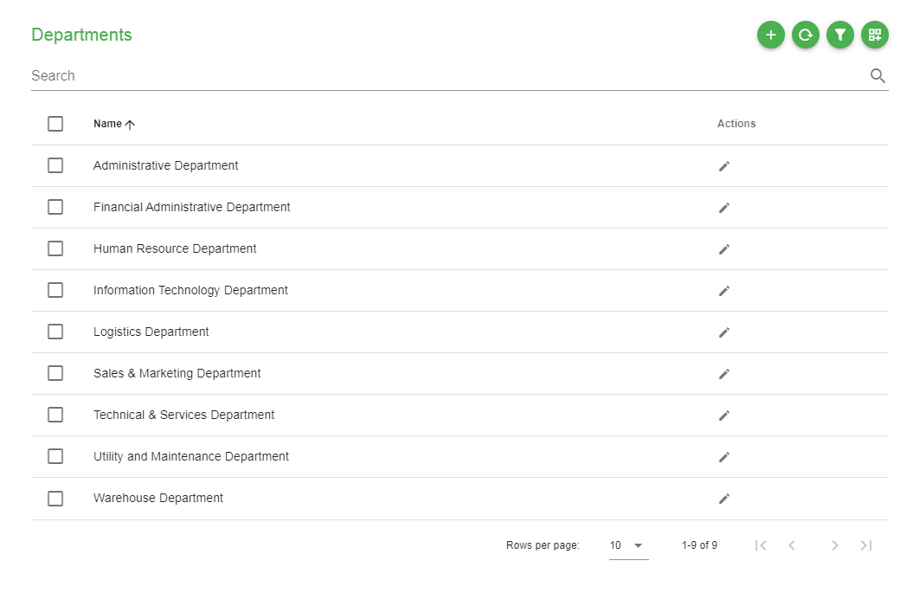

1. Departments List
2. Add department
3. Refresh data
4. Filter data
5. More Actions

Job Designations

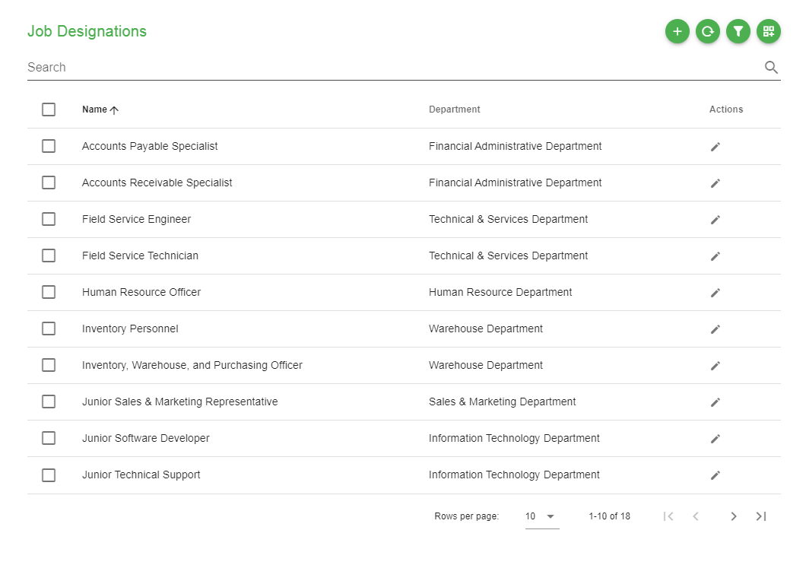

1. Job Designations List
2. Add job
3. Refresh data
4. Filter data
5. More Actions

Expense Types

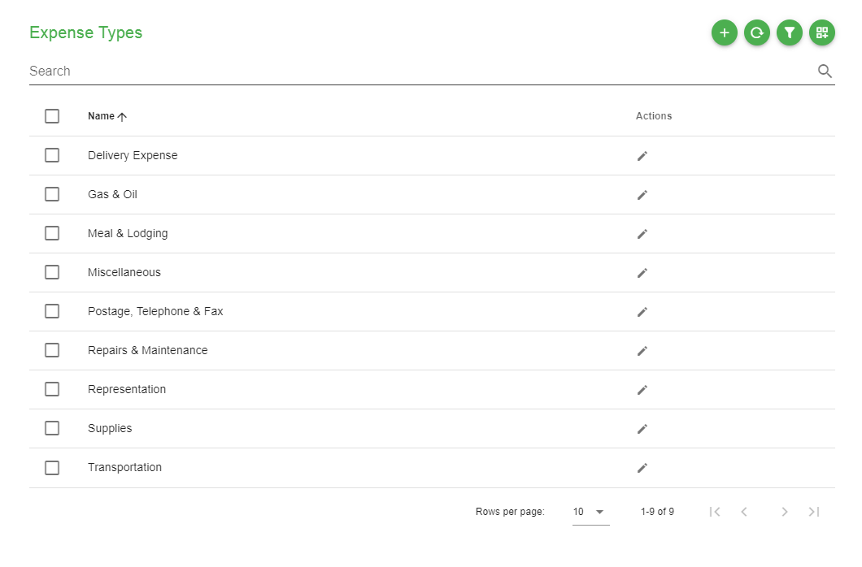

1. Departments List
2. Add department
3. Refresh data
4. Filter data
5. More Actions

Activity Logs

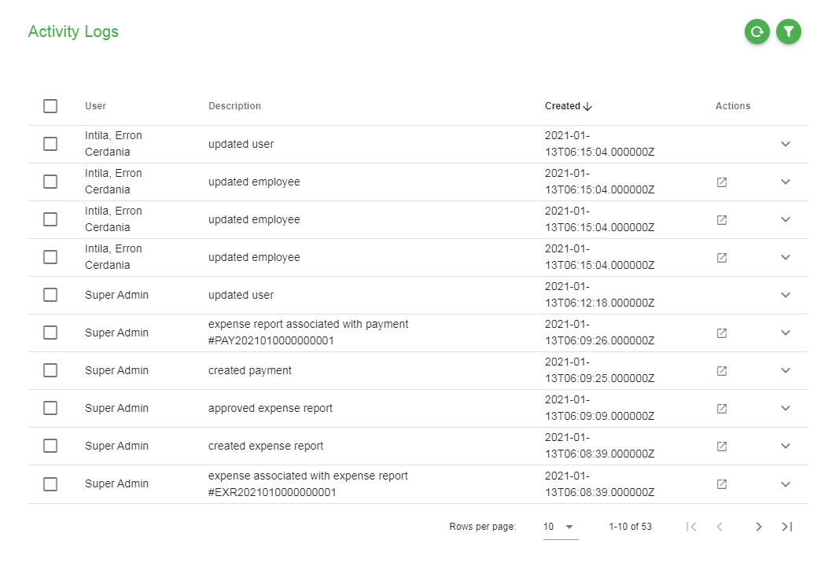

1. Activity Logs
2. Refresh data
3. Filter data

Settings

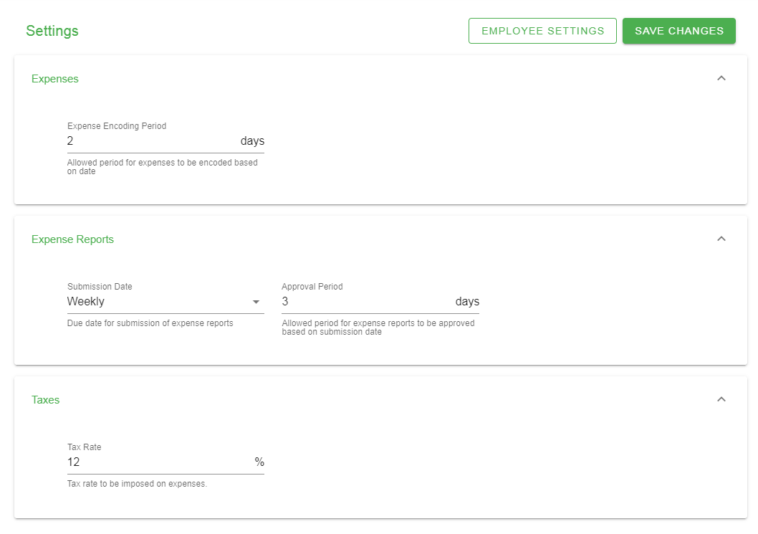

1. Application settings
2. Employee settings

## Basic Workflow

State complete process at least one cycle

For Standard Users:

Create Expense

Create Expense Report

Submit Expense Report

Wait for approval.

After approved, wait for payment to be recorded.

Once payment has been recorded. Mark payment as received.

Expense has been reimbursed.

For Administrators:

Check dashboard for expense reports statuses

Go to Expense Reports page.

Approve or Reject submitted Expense Reports

Encode payment record on specific expense reports

Wait for employee confirmation of recorded payments.

Expense has been reimbursed.

## Configuration and Deployment

### Hardware Requirements

State recommended specifications.

### Software Requirements

State recommended specifications.

### Linux Server Configuration

Tutorial with screenshots

### Apache Configuration

Tutorial with screenshots

### MySQL Configuration

Tutorial with screenshots

### Application Deployment

Tutorial with screenshots

Discuss File/Database Backup and Restoration

## Troubleshooting

These are the common problems that can be encountered blah blah:

Unable to access link

No network connection

Server down/error

Contact helpdesk/technician for support

Unable to login

Invalid username and password

Deactivated account

Contact helpdesk/technician for support

# Bibliography

Andrews, R., Ansari, A., & Currim, I. (2002). Hierarchical Bayes Versus Finite Mixture Conjoint

Analysis Models: A Comparison of Fit, Prediction, and Partworth Recovery. Journal of

Marketing Research, 39, 87-98.

Gerchev I. (2014). The 5 most popular frontend frameworks compared. Available at:

http://www.sitepoint.com/5-most-popular-frontend-frameworks-compared/ [accessed

3.3.2015]

Infosurv. (2016). “Are Open-Ended Questions Qualitative Research?” www.infosurv.com/open-

ended-questions-qualitative-research/ (retrieved on August 6, 2017)

Jiaqin Yang, Jan Flynn and Krista Anderson of Georgia College and State University (2005) E-

Business Application in the Hospitality Industry: A Case StudyCommunications of the

International Information Management Association, Volume 3 Issue

KENPRO, (2016). “Interview Method of Data Collection” www.kenpro.org/interview-method-of-

data-collection-2. (retrived on August 15, 2017)

Larry Hill (2016) ‘Springer-Miller Case Study of Online Booking for Marriot SpaSoft’ Atrio

(retrieved August 7, 2017)

Rayport, J. and Jaworski, B. (2002). Cases in eCommerce. New York: McGraw-Hill Companies,

Inc.

Ryan, M. and Hughes, J. (1998). Using Conjoint Analysis to Assess Women’s Preferences for

Miscarriage Management. Health Economics, 6, 261-273.

SurveyMonkey, “Open-Ended Questions: Your Ticket to Qualitative Data.”

www.surveymonkey.com/mp/open-ended-questions-get-more-context-to-enrich-your-

data/.

# Appendices

## Appendix A (Gantt Chart)

## Appendix B (Definition of Terms)

|  |  |
| --- | --- |
| Apache |  |
| Application |  |
| Application Modules |  |
| Context Flow Diagram |  |
| Data Dictionary |  |
| Database |  |
| Database Management System |  |
| Diagram 0 |  |
| Entity Relationship Diagram |  |
| Expense |  |
| Gantt Chart |  |
| Git |  |
| Linux Operating System |  |
| MySQL |  |
| Process Flow Diagram |  |
| Reimbursement |  |
| Replenishment |  |
| Revolving Fund |  |
| Server |  |
| Software |  |
| System |  |
| Version Control |  |
| Windows Operating System |  |

## Appendix C (Existing Forms and Reports)

Expense Summary Report

Expense Summary Report grouped by date

Expense Summary Report grouped by employee

Voucher

Petty Cash Voucher