**Task: 1**

**Title: Build a Model**

**Technology: Python flask**

**1. Task Description**

Build a Model which can save the. pdf extension in pdf folder, .docx extension in doc folder and .jpg or .png extension in image folder after submitting the form.

I have made a code that can select the file if the file has extensions matches from .pdf,.docx or .png,.jpg. It will move that file to respective extension’s folder.

When you run the code, it will create folder of those 3 extensions and when you select the file from your file explorer it will identify the file if it matches then will move to the respective folder.

**2. Task Output:**

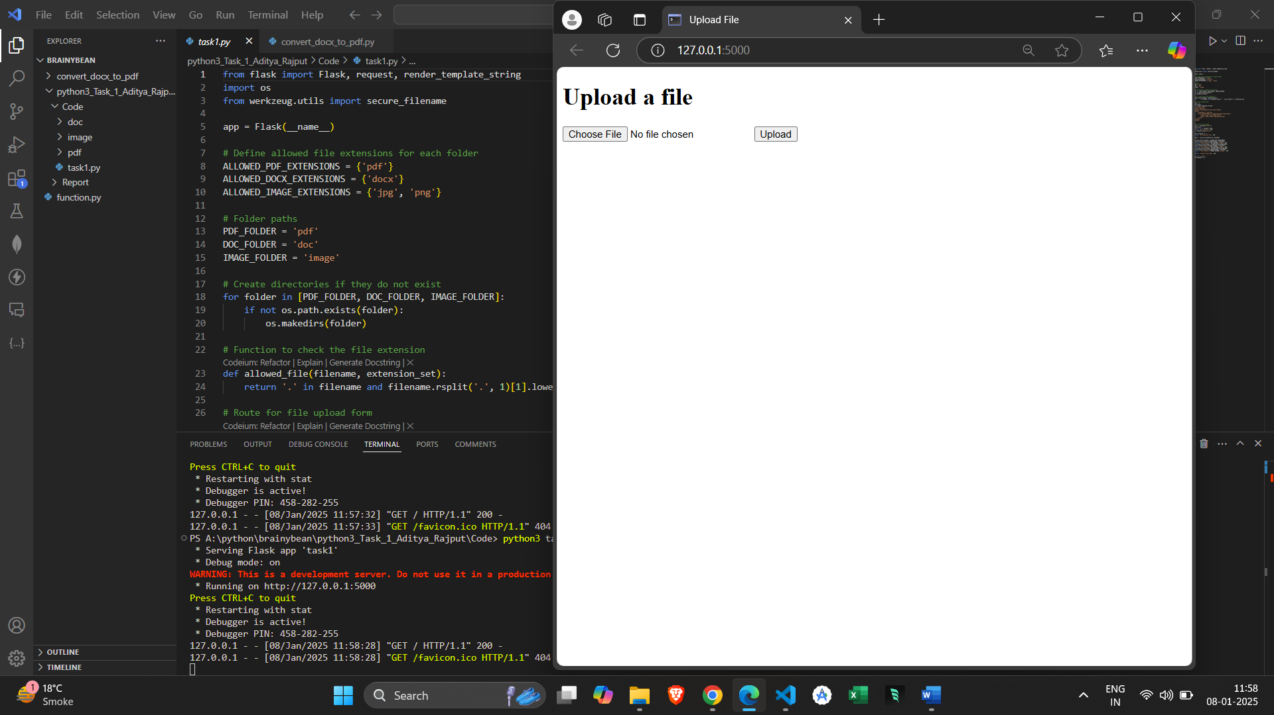

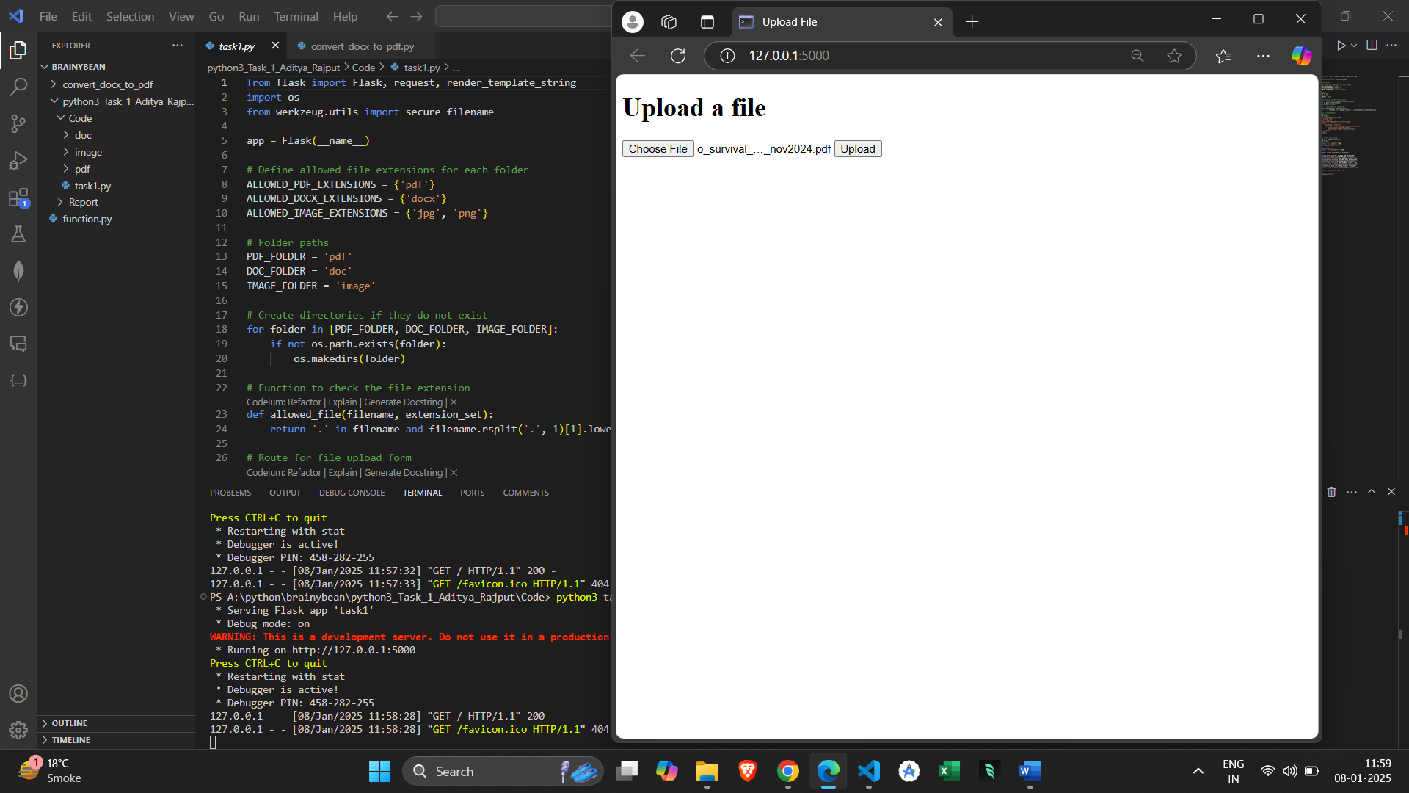

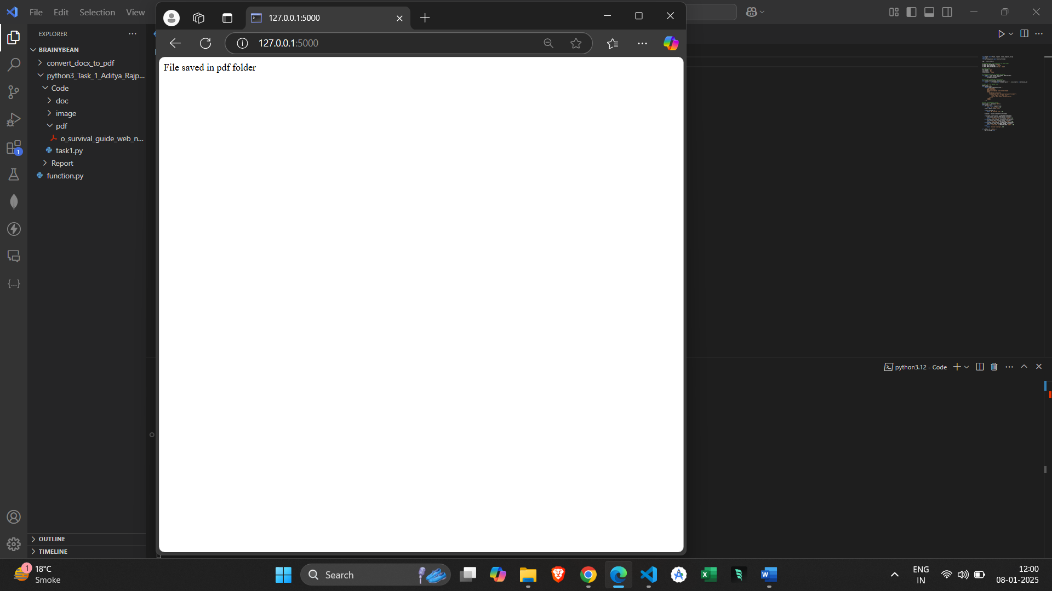

**3. Methods and algorithms used in Task:**

* I have used Flask for creating web form to upload files.
* Used OS Python’s module to check the folders exist or needs to create them.
* Used the werkzeug utility from flask for handling file extensions and save them respectively.
* Folders: pdf, doc, and image folders are created if they don’t exist.
* File Types: Files are checked by extension (.pdf, .docx, .jpg, .png)
* Used HTML form for submission, it allows user to upload a file.
* File handling is there for saving appropriate folder based on its extension.