Task: 2

Title: Color Theme Of django

Technology: Python Django

1. Task Description:

Change the color theme of django superadmin by using internal css in admin.py also use different icon and title.

2. Task Output:

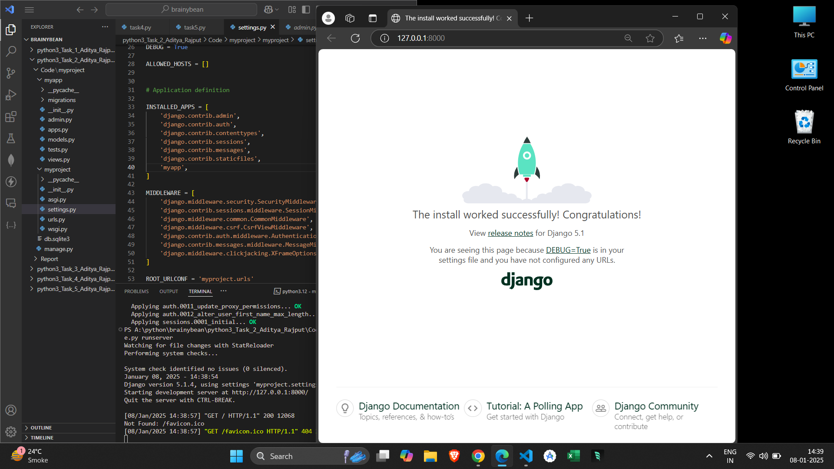

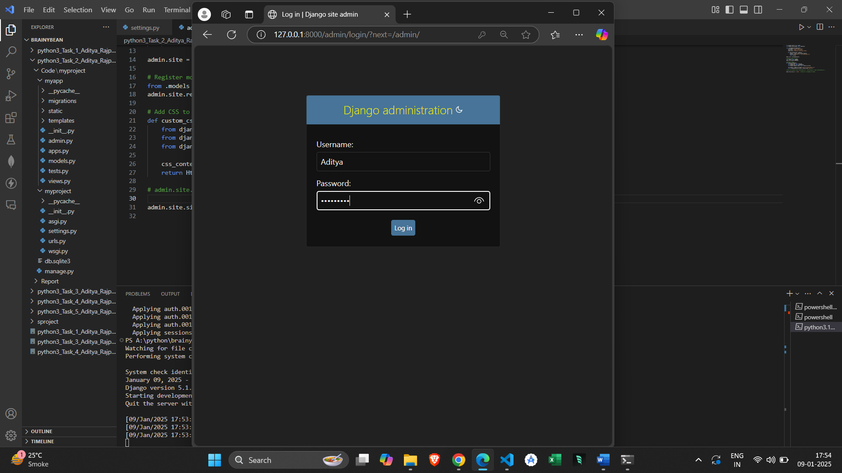

Created superuser

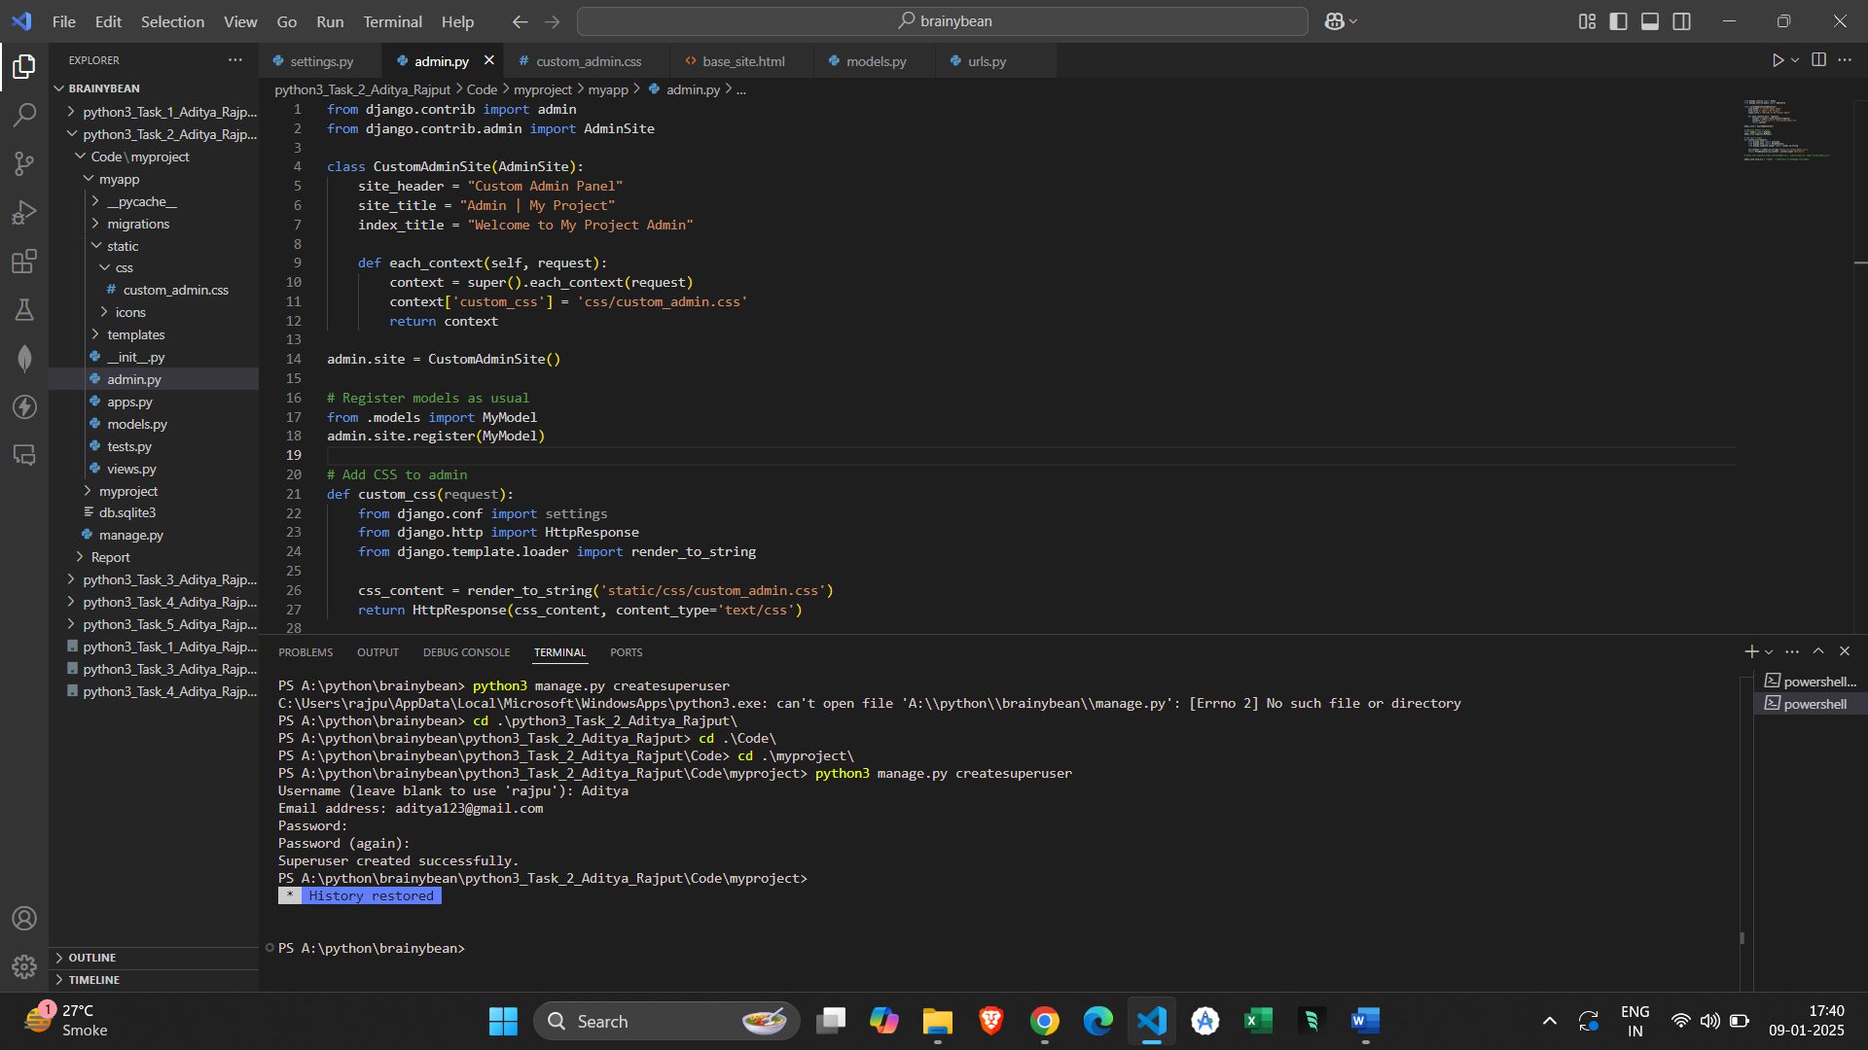

Admin panel before



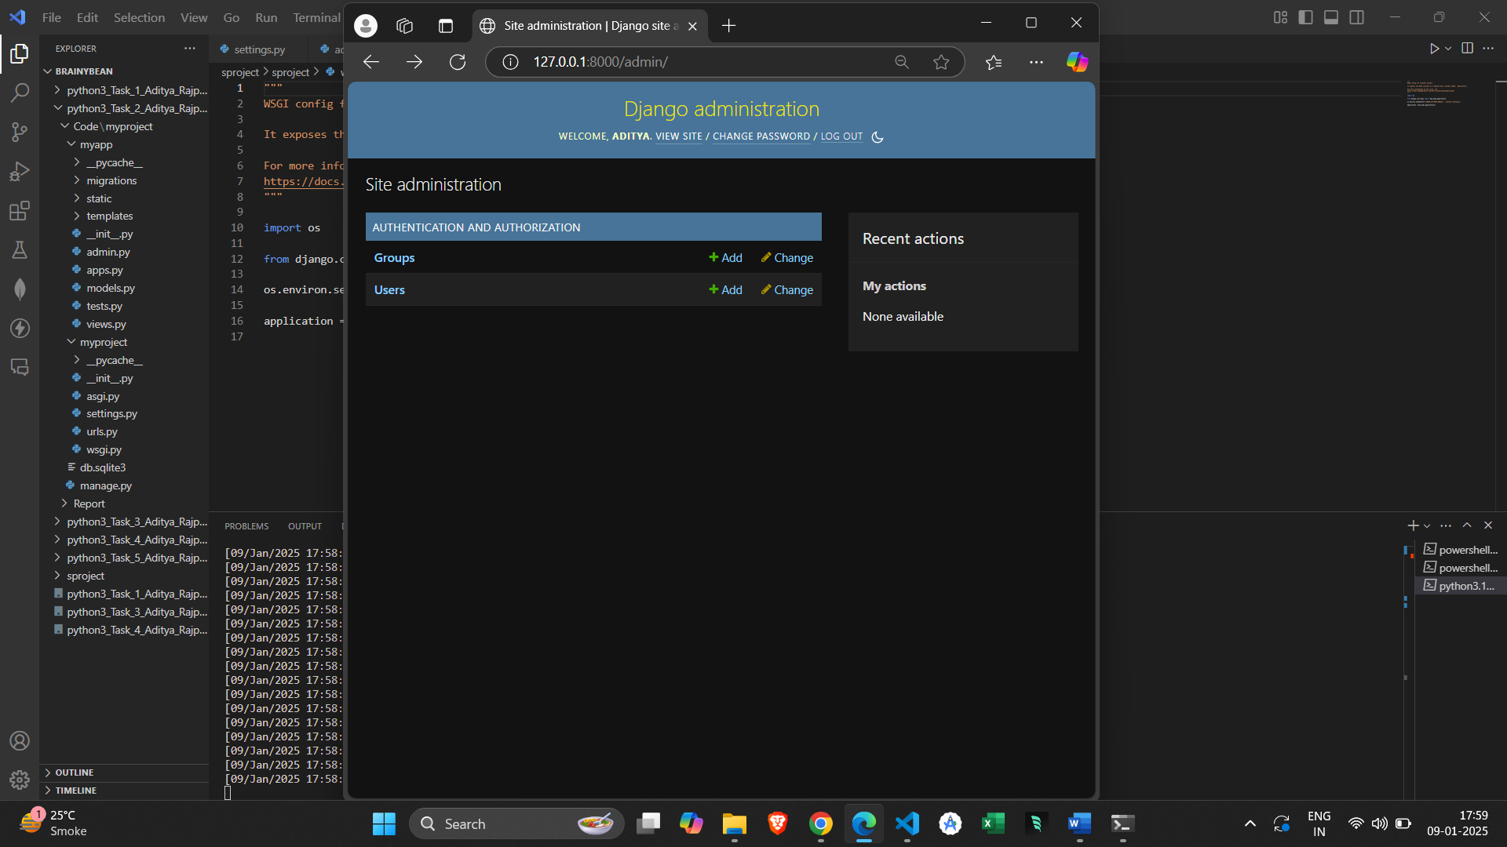

Admin panel after the change

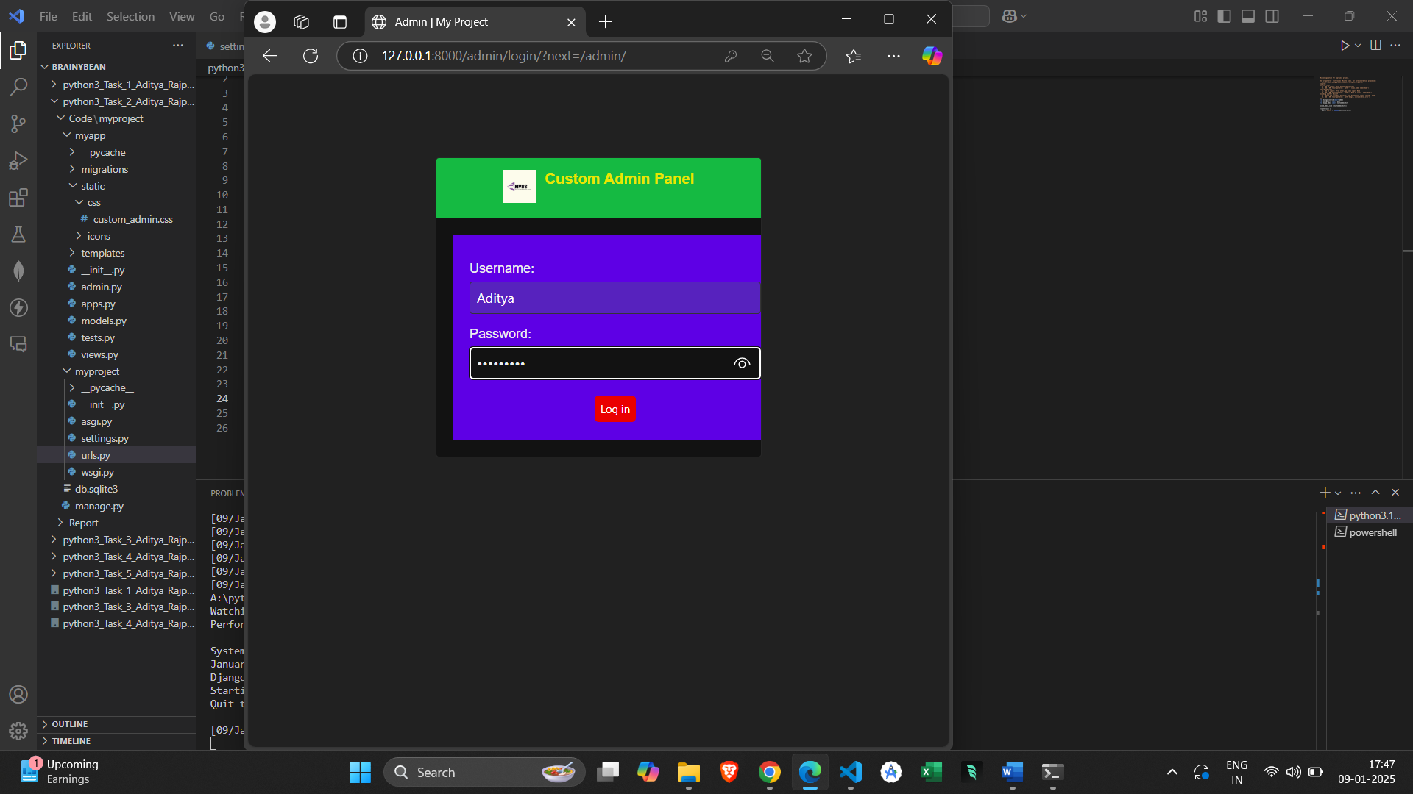

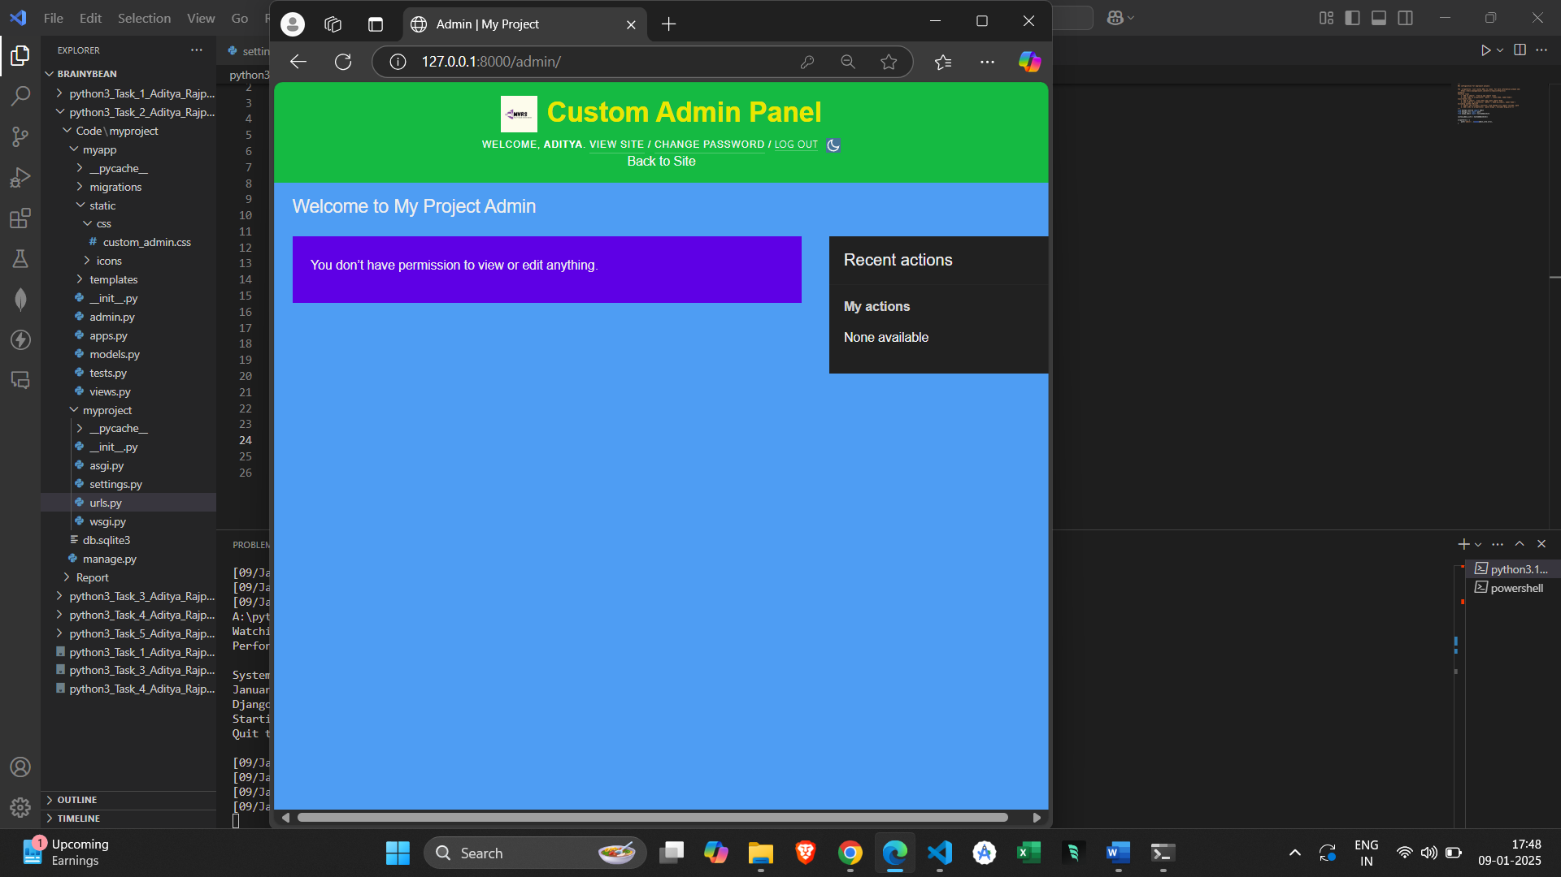

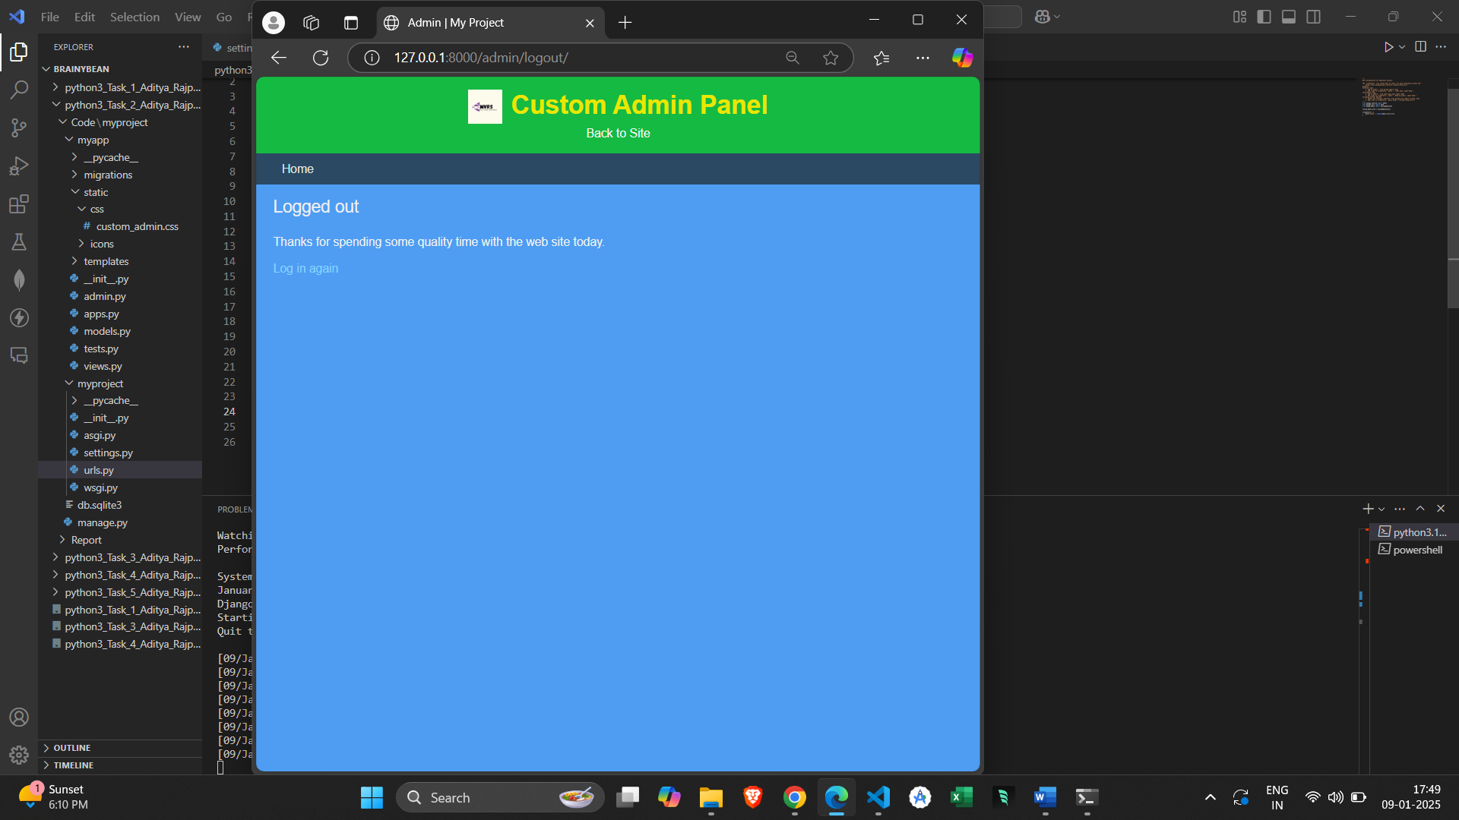

**3. Methods and Algorithms:**

* I have customized the Django admin panel by changing its color using css, updating the title and adding a custom icon.
* Modified a custom admin site class to override the default admin appereance.
* Created a base_site.html and created a css file for color theme.
* Added my Project’s icon to the header area.
* Then registered models with the new custom admin site.
* Used template inheritance to override base_site.html.
* Customized the Adminsite class to include a new header, title and context variables.

Project WorkFlow:

-> Setup:

Created a new Django project and app.

Configured static files and template directories.

-> Customization:

Created a custom admin site (CustomAdminSite).

Modified base_site.html to include new names, icon and styles.

Added css for color themeing.

-> Model Rgistration:

Registered models with the custom admin site.

-> Testing:

Tested the new admin interface to ensure all changes are applied properly.