**Task: 3**

**Title: Function**

**Technology: Python**

**1. Task Description:**

Write a function which will return the all the Tuesday and Friday dates by taking month as an input.

The function will loop through each day of the given month.

It will check if the day is Tuesday (1) or Friday (4) by index.

If true, the date will be added to the list.

**2. Task Output:**

Static for 12th month,2024

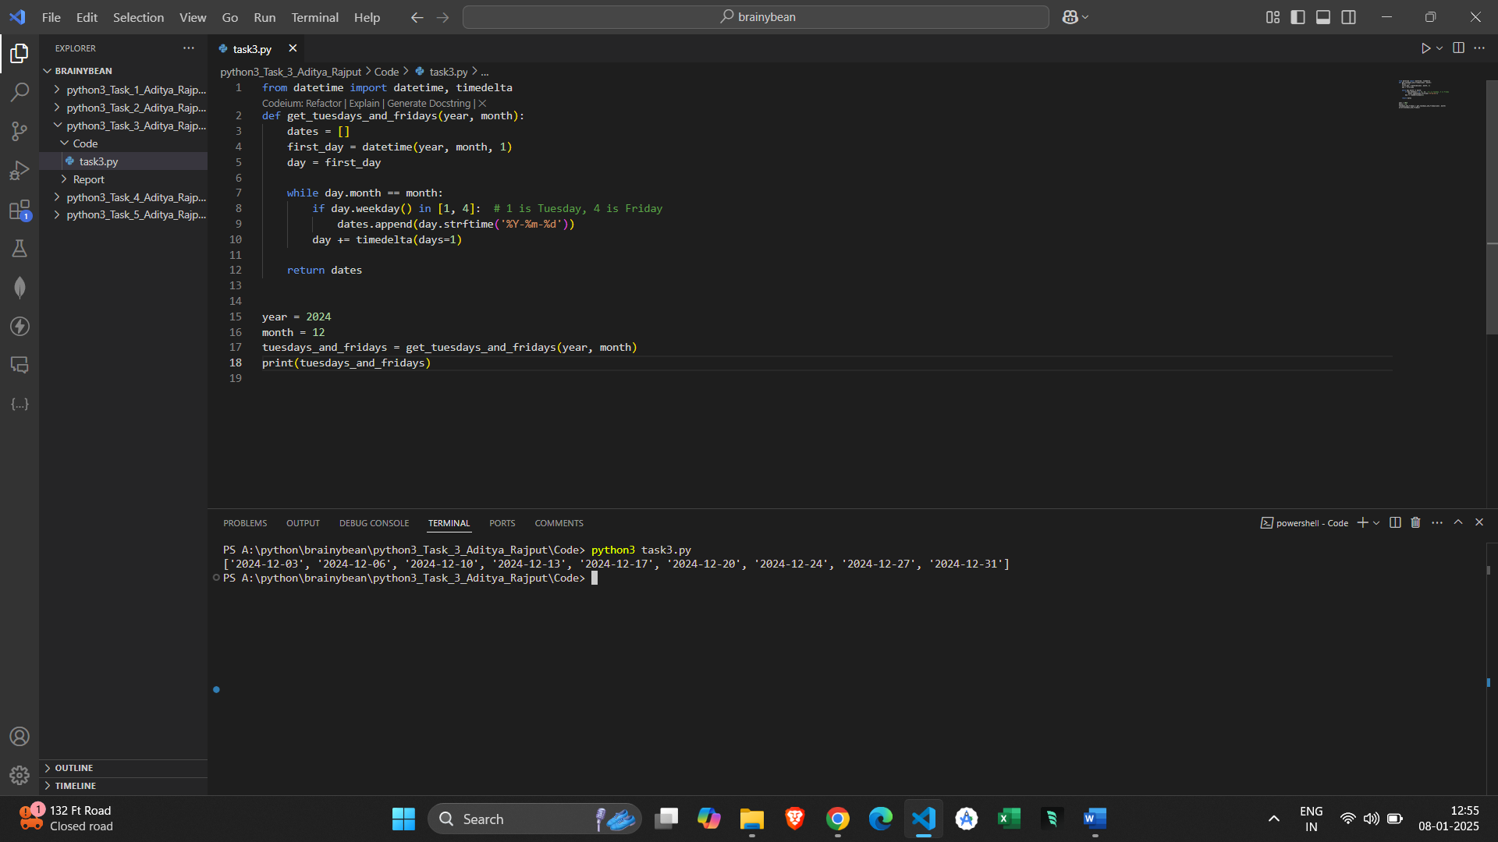

user input for 1st January,2025

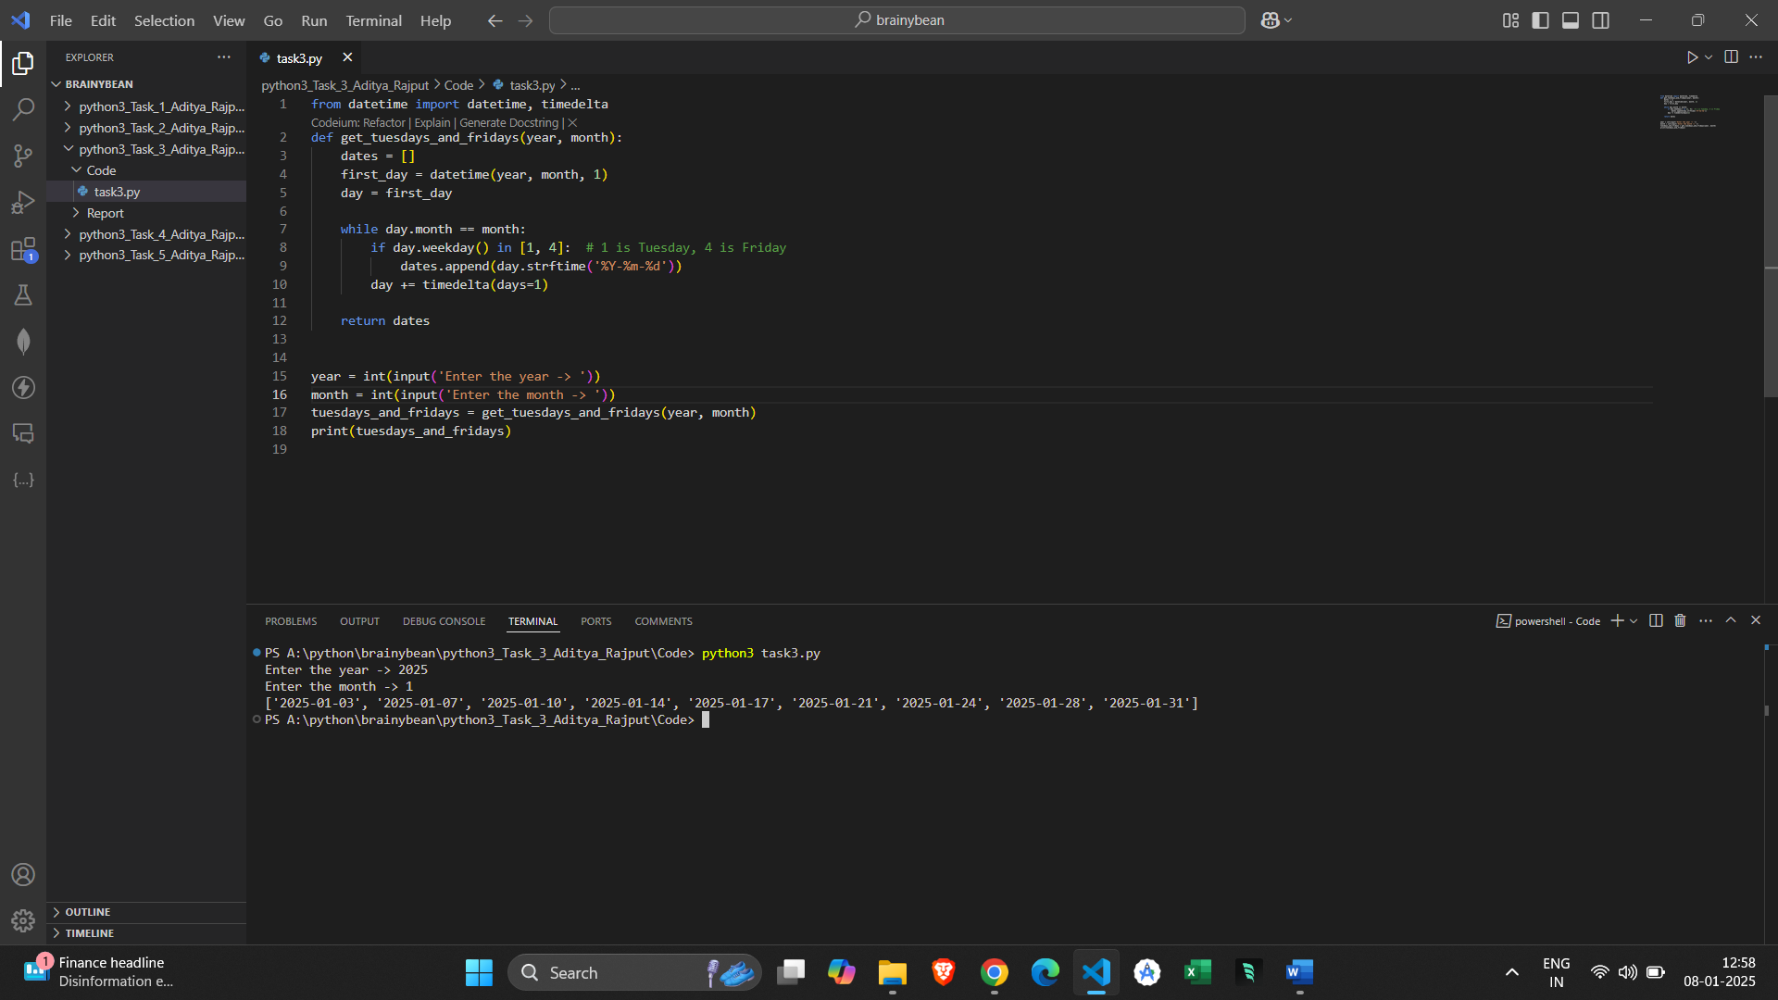

3. Methods and algorithms used in Task:

I have created a function with 2 parameters year & month.

I have used while loop, which will find the days at index [1,4] and after it will append into a list.

For manipulating dates, I have used datetime and timedelta.

Datetime: represents specific points in time (including date and time)

Timedelta: represents the difference between two dates , it is used to add or subtract time.