**Task: 4**

**Title: Convert Docx to PDF**

**1. Task Description:**

Build a function which can convert any .docx to .pdf.

I have to build a function where it identifies the docx file and convert it into pdf.

2. Task Output:

As you can see the “example.docx” file in code section.

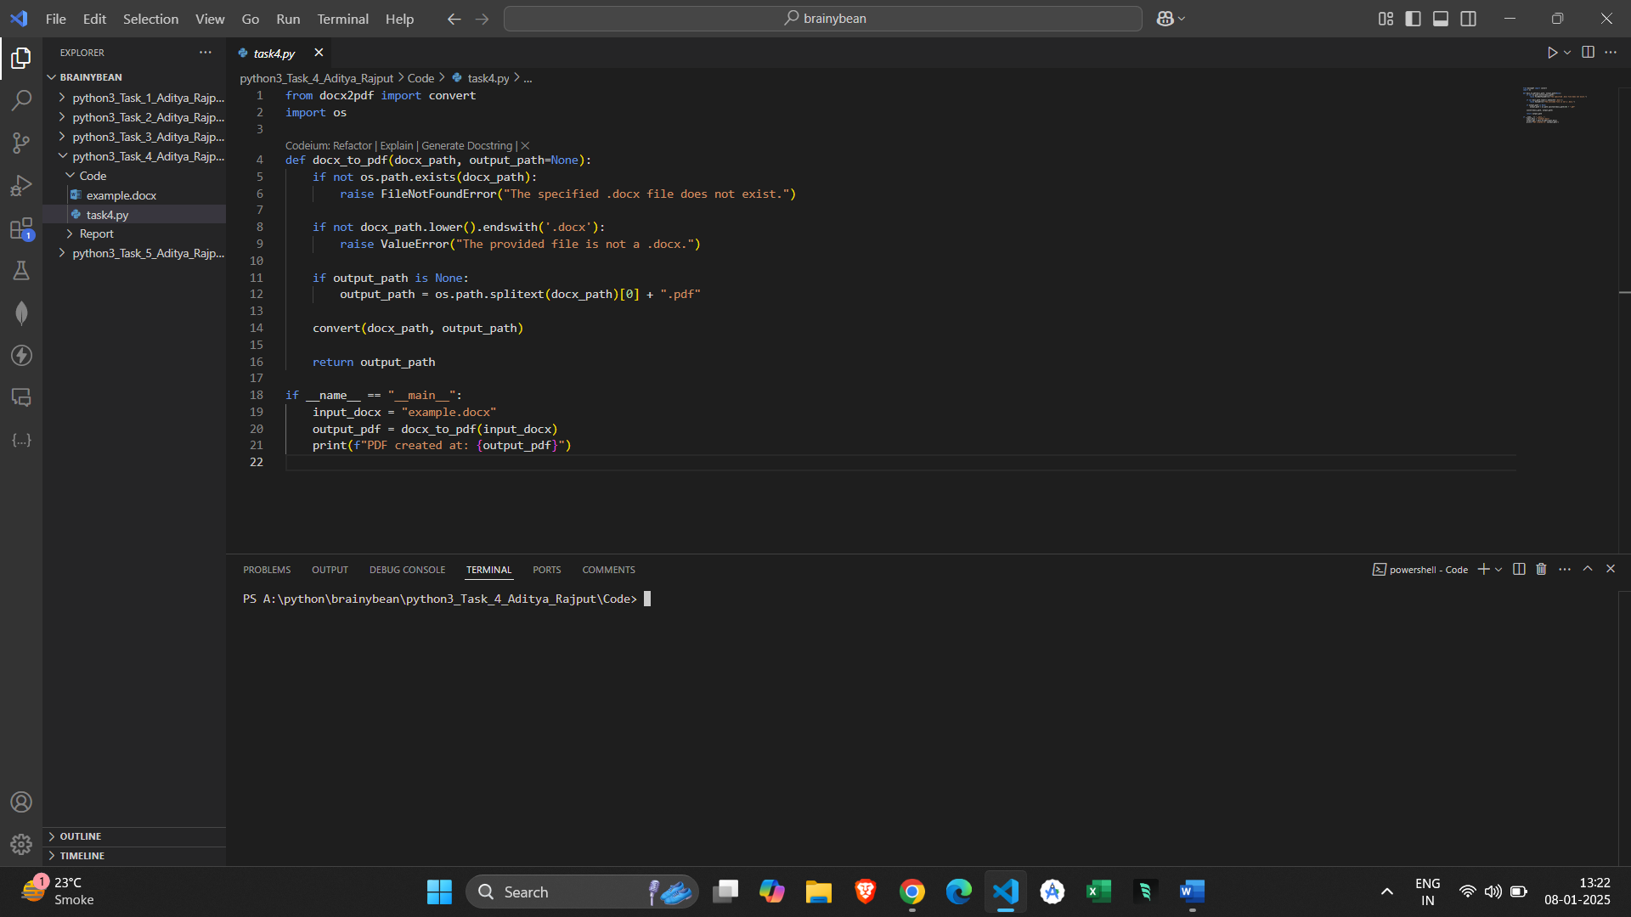

After running code, it will generate the “example.docx” file to “example.pdf”.

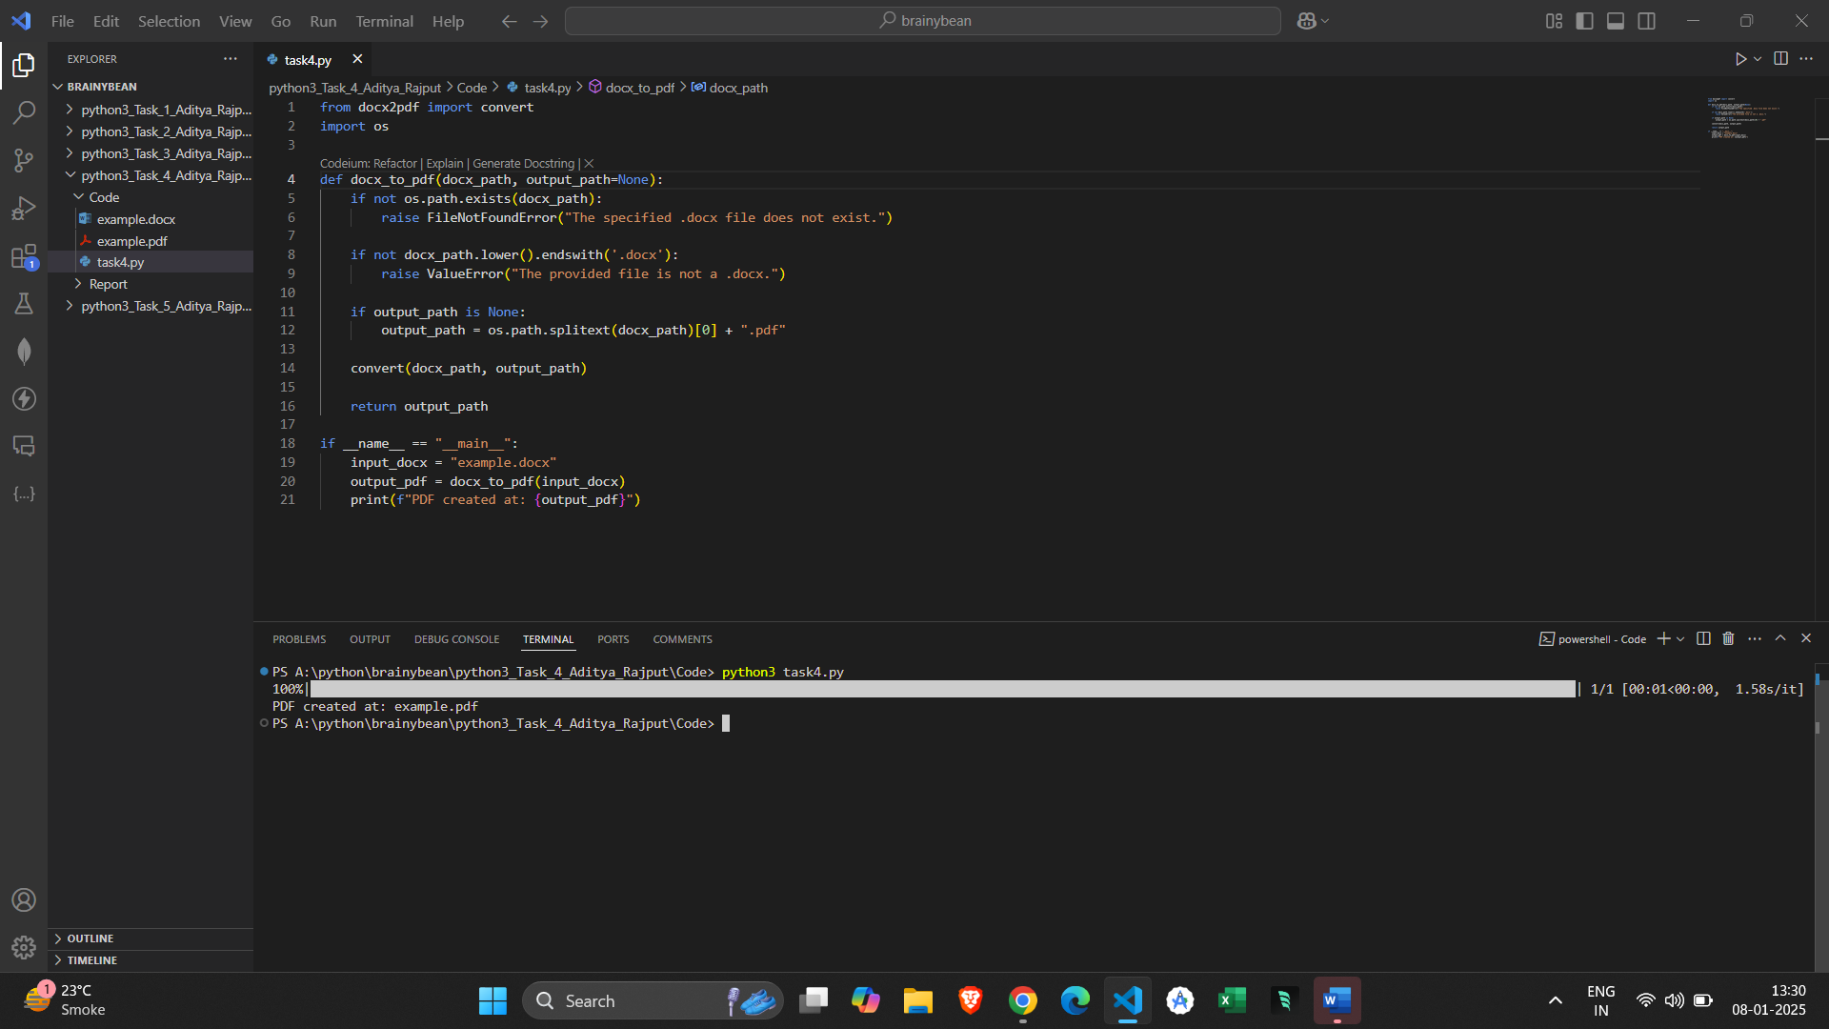

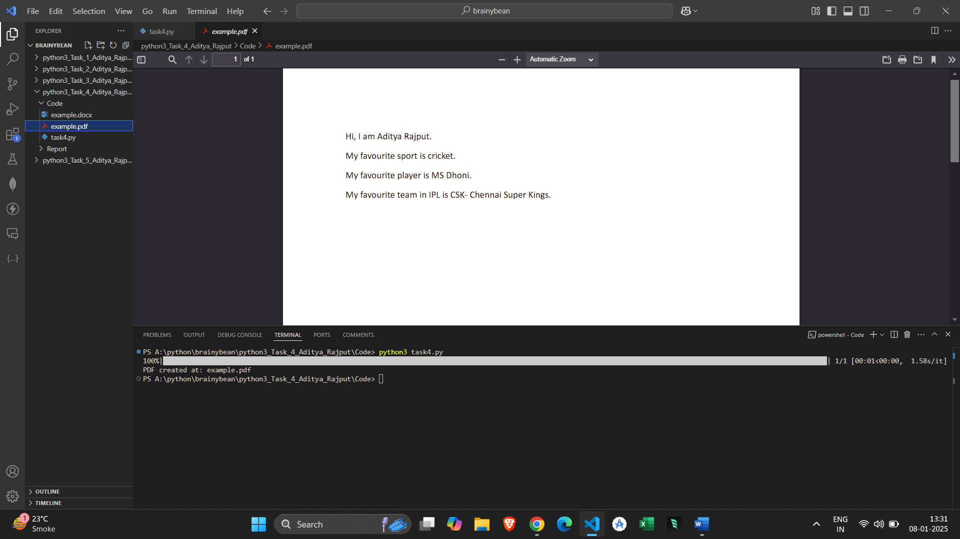

**3. Methods & Algorithms used in the task:**

* I have imported the convert function from the docx2pdf library, which will handle conversion of .docx to .pdf.
* Imported Python’s OS module to provide functions for interacting with system.
* It will help in finding file paths and checks for the existence.
* Defined a function “docx_to_pdf” that takes 2 arguments(docx_path,output_path=none).
* In function, it will check the existence of the file if not then occurs the raised message error.
* It will also validate the file extension for the conversion if not finds then raise valueError.
* Also created the main execution block at the end that will ensures the code only runs when the script is executed directly.