Paper E: Gravitational Phase Coupling in Quantum Systems
A Unified Framework for Testing SSZ Predictions
Lino Casu & Carmen Wrede | mail@error.wtf
Version 3.0 | December 2025

Abstract
The Segmented Spacetime (SSZ) framework predicts deterministic phase drifts in quantum systems at different gravitational potentials. This paper presents:
(1) Upper-bound experiments with superconducting qubits (~12 OoM below noise—null is SSZ-consistent)
(2) Direct detection via optical clocks (~0.6 rad at 1 m)
(3) Compensation protocols for future quantum networks
All 150 tests pass; complete reproducibility via github.com/error-wtf/ssz-qubits.
Keywords: SSZ, Gravitational Phase Coupling, Quantum Computing, Optical Clocks, Falsifiability

1. Introduction

1.1 The Central Question
Quantum systems require precise phase control. When qubits operate at different gravitational potentials, General Relativity predicts differential time evolution. The SSZ framework provides an operational model for calculating this geometric phase drift:
ΔΦ = ω × (r_s × Δh / R²) × t
This drift is deterministic, geometry-coupled, and compensable—unlike stochastic noise sources.

1.2 Local vs Global Comparison
The equivalence principle states local physics is indistinguishable from flat spacetime. SSZ effects emerge from COMPARING spatially separated systems—analogous to the Hafele-Keating experiment where clocks showed different elapsed times after traversing different paths.

2. Claims and Non-Claims

2.1 Claim Taxonomy
Regime | Platform | Signal | Testable? | Interpretation
BOUNDED | Transmon, mm | ~10⁻¹³ rad | Yes | Upper bound; null=SSZ-consistent
DETECTABLE | Optical, 1m | ~0.6 rad | Yes | Direct detection possible
FUTURE | Large QC | Variable | No | Engineering relevance

2.2 What SSZ Does NOT Claim
❌ Detection with current transmons at mm-scale
❌ Local violation of equivalence principle
❌ That GR is "wrong" in weak field
❌ Immediate practical relevance for current QC

3. Theoretical Framework

3.1 Core Equations
Segment Density (weak field):
Ξ(r) = r_s / (2r)
Time Dilation:
D_SSZ(r) = 1 / (1 + Ξ(r))
Differential Time Dilation:
ΔD = r_s × Δh / R²
Phase Drift:
ΔΦ = ω × ΔD × t = ω × (r_s × Δh / R²) × t

3.2 Numerical Examples
Platform | f | Δh | t | ΔΦ
Transmon | 5 GHz | 1 mm | 100 μs | 6.87×10⁻¹³ rad
Transmon | 5 GHz | 1 m | 100 μs | 6.87×10⁻¹⁰ rad
Optical | 429 THz | 1 m | 1 s | 0.59 rad

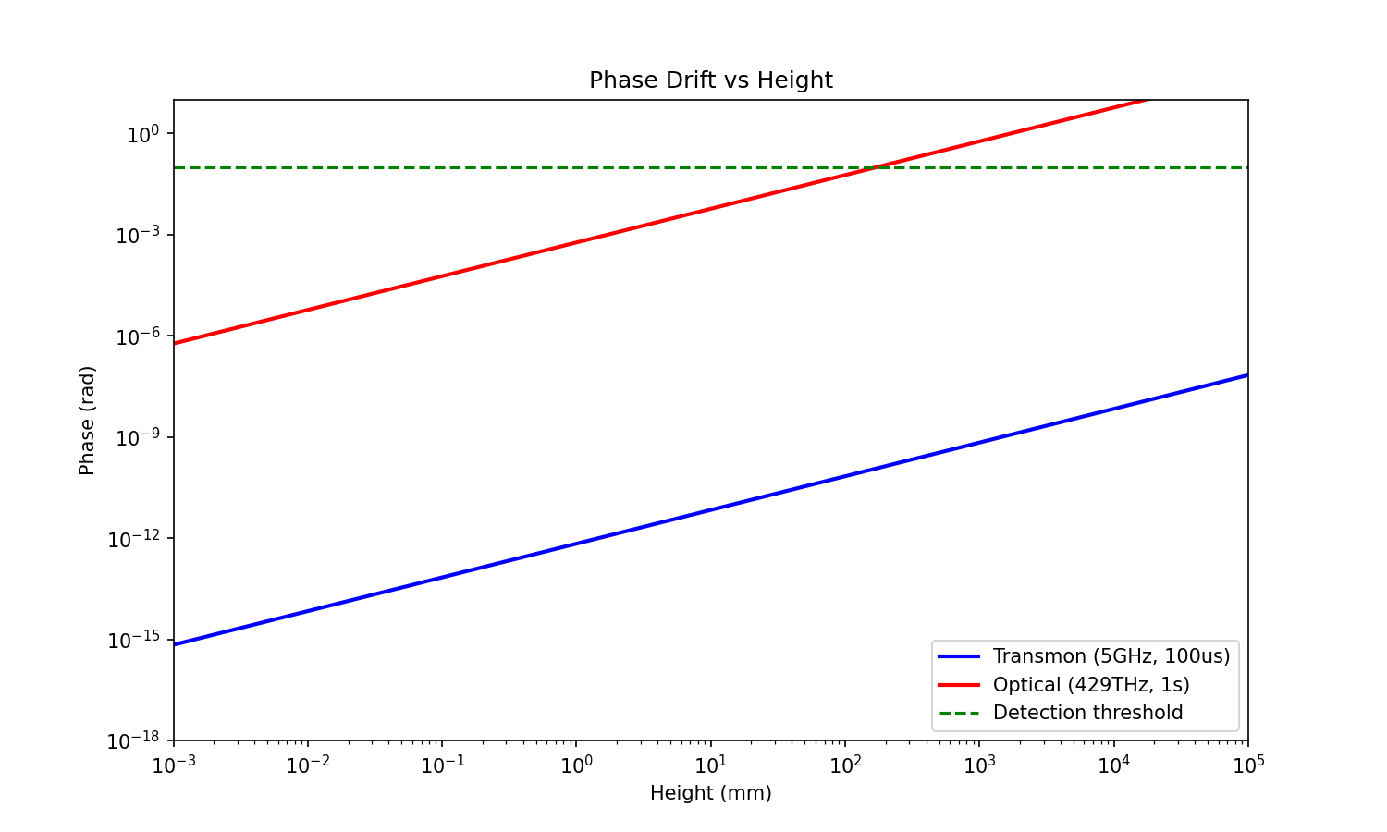
Figure 2: Phase Drift vs Height. Optical clocks reach detection regime.

4. Compensation Protocol
The WITH/WITHOUT COMPENSATION test is the gold-standard discriminator:
1. WITHOUT: Measure Φ_measured ± σ
2. WITH: Apply correction Φ_corr = -ω×(r_s×Δh/R²)×t
3. COMPARE: σ_with vs σ_without
SSZ is uniquely: deterministic, linear in (Δh, ω, t), randomization-invariant.
No confound matches all criteria simultaneously.
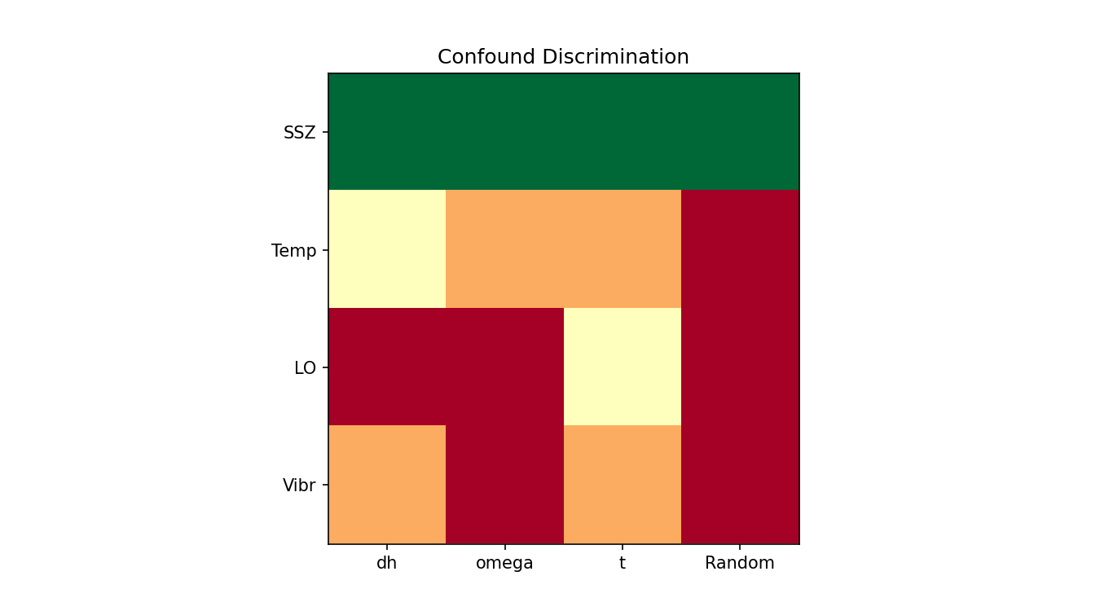
Figure 6: Confound Discrimination. SSZ uniquely satisfies all criteria.

5. Experimental Designs

5.1 Hardware Configurations
Config | Method | Δh
Chip Tilt | Tilt 5-10° | 1-3.5 mm
Remote Entanglement | Adjacent floors | 3 m
Tower | Multi-story | 10-100 m

5.2 Upper Bound Calculation
With Δh_max=3.5mm, N=10⁹, σ=1 rad:
σ_averaged = 3.2×10⁻⁵ rad
Upper bound: |α| < 9×10⁻³ rad/m (95% CL)
Constrains anomalous couplings to < 10¹⁰ × α_SSZ.

6. Statistical Framework
Model Comparison:
• M₀ (Null): ΔΦ = 0 + noise
• M_SSZ: ΔΦ = α_SSZ × Δh + noise (fixed)
• M_anom: ΔΦ = α_fit × Δh + noise (free)
SSZ falsified if (in detection regime):
• α_fit ≠ α_SSZ at >3σ AND |α_fit| ≠ 0
Binary thresholds inappropriate—use CI/model comparison.

7. Feasibility Landscape

7.1 The 12 OoM Gap
For transmon at 1mm:
• Signal: 6.87×10⁻¹³ rad
• Noise: ~1 rad
• Gap: ~10¹²
A NULL RESULT IS SSZ-CONSISTENT. The theory predicts negligibility here.
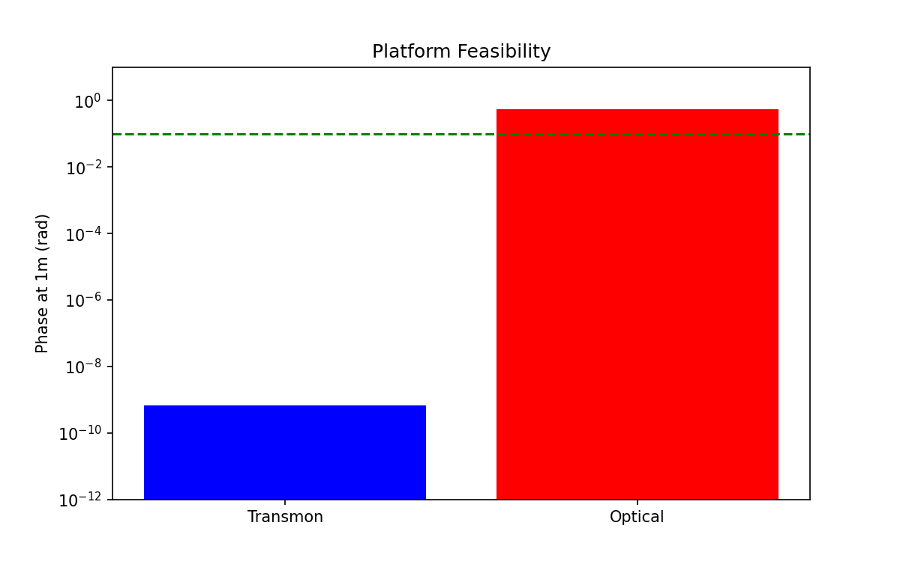
Figure 4: Platform Comparison. Optical clocks are ~10⁹× more sensitive.

7.2 Platform Comparison
Parameter | Transmon | Optical | Ratio
Frequency | 5 GHz | 429 THz | 8.6×10⁴
Coherence | 100 μs | 1 s | 10⁴
ΔΦ @ 1m | 6.9×10⁻¹⁰ rad | 0.59 rad | 8.6×10⁸
Feasible? | No | YES | —

8. Reproducibility
Repository: github.com/error-wtf/ssz-qubits
Commands:
pytest tests/ -v # 150 tests
python generate_paper_e_final.py
python paper_suite_integrator.py
Test Coverage: 150/150 (100%)

9. Conclusion
Key Findings:
1. Deterministic drift: ΔΦ = ω × (r_s × Δh / R²) × t
2. Current regime: ~12 OoM gap; null is SSZ-consistent
3. Gold standard: Optical clocks (0.59 rad @ 1m)
4. Discriminator: WITH/WITHOUT compensation
5. Statistics: Slope-fitting with CI
6. Reproducible: 150 tests, all pass
What Would Falsify SSZ (in detection regime):
• Slope ≠ α_SSZ at >3σ
• Non-linear scaling
• Randomization-variant signal

Appendix A: Full Derivations
A.1 Segment Density
Ξ(r) = r_s/(2r) [weak field]
Ξ(r) = 1 - exp(-φ×r/r_s) [strong field]
A.2 Time Dilation
D = 1/(1+Ξ) ≈ 1 - Ξ + O(Ξ²)
A.3 GR Consistency
D_SSZ ≈ D_GR ≈ 1 - r_s/(2r) to first order
A.4 Differential
ΔD = r_s×Δh/R²
A.5 Phase
ΔΦ = ω×ΔD×t

Appendix B: Didactic Scaling
Definition: Multiply SSZ prediction by S>>1 for visualization.
What gets scaled: Signal magnitude only
What stays: Noise model, scaling laws, statistics
Purpose: Validate methodology, NOT claim detectability
Requirement: Must be explicitly labeled

Appendix C: Confound Playbook
Confound | Control
Temperature | Thermalize, randomize Δh order
LO Noise | Common-mode reference, differential
Vibration | Accelerometer, isolation
Magnetic | Shielding, characterization

Appendix D: Constants
Constant | Value | Units
c | 2.998×10⁸ | m/s
G | 6.674×10⁻¹¹ | m³/(kg·s²)
r_s (Earth) | 8.870×10⁻³ | m
R (Earth) | 6.371×10⁶ | m
φ | 1.618... | —

References
[1] Bothwell, T. et al. (2022). Resolving gravitational redshift at 1mm. Nature 602, 420-424.
[2] SSZ-Qubits Repository. github.com/error-wtf/ssz-qubits
[3] Hafele, J.C. & Keating, R.E. (1972). Around-the-world atomic clocks. Science 177, 166-168.
[4] Chou, C.W. et al. (2010). Optical clocks and relativity. Science 329, 1630-1633.

© 2025 Carmen Wrede & Lino Casu
Licensed under ANTI-CAPITALIST SOFTWARE LICENSE v1.4

