Falsifiable Predictions and Experimental Protocols
for SSZ-Aware Quantum Computing
Paper C: Experimental Validation Framework

Lino Casu, Carmen Wrede
Independent Researchers
Contact: mail@error.wtf
December 2025

Abstract
We present a comprehensive framework for experimentally testing Segmented Spacetime (SSZ) effects in quantum computing systems. Building on our previous work demonstrating geometric qubit optimization (Paper A) and phase coherence preservation (Paper B), this paper provides: (1) five quantitative, falsifiable predictions derived from SSZ theory, (2) a detailed experimental protocol for the gold-standard falsification test, (3) strategies for discriminating SSZ effects from common confounds, and (4) realistic measurement requirements. Our analysis shows that SSZ predictions are testable with current superconducting qubit technology using piezo-controlled height stages, Ramsey interferometry, and differential measurement techniques. The key discriminator is the with/without compensation test: SSZ predicts a deterministic, geometry-linked phase drift that can be cancelled by applying the predicted correction, while confounds cannot be compensated geometrically. We provide all numerical predictions with explicit falsification thresholds.
Keywords: Segmented Spacetime, Quantum Computing, Falsifiability, Experimental Protocol, Phase Drift, Gravitational Effects

1. Introduction

1.1 Motivation
The Segmented Spacetime (SSZ) framework predicts that gravitational time dilation introduces deterministic phase biases in quantum systems. In Papers A and B, we demonstrated:
- Paper A: Height differences as small as 1 mm create measurable segment density gradients that affect gate timing
- Paper B: These effects accumulate coherently over time, enabling compensation via calibrated phase corrections
A critical question remains: How can these predictions be experimentally tested and potentially falsified?

1.2 The Falsifiability Criterion
For SSZ to be a legitimate scientific theory, it must make predictions that are:
- Quantitative — specific numerical values, not just qualitative trends
- Testable — measurable with available technology
- Falsifiable — there must be outcomes that would disprove the theory
This paper addresses all three criteria explicitly.

1.3 Summary of Key Results
Prediction | SSZ Value | Falsification Threshold | Testable?
Phase drift at Δh=1mm | 3.43×10⁻¹⁵ rad/μs | <1.72×10⁻¹⁵ rad/μs | Yes
Coherent zone (ε=10⁻¹⁸) | 18.3 mm | <9.2 mm | Yes
ω-scaling (7GHz/5GHz) | 1.40 | <1.20 | Yes
Compensation efficiency | 99% | <90% | Yes
Cross-zone drift/gate | 6.28×10⁻¹⁵ rad | <3.14×10⁻¹⁵ rad | Yes

2. Theoretical Foundation

2.1 Core SSZ Equations
The SSZ time dilation factor at radius r from mass M is:
D_{SSZ}(r) = 1 / (1 + Ξ(r))
where the segment density Ξ(r) in the weak-field regime (r >> r_{s}) is:
Ξ(r) = r_{s} / (2r)
with Schwarzschild radius r_{s} = 2GM/c².

2.2 Phase Drift Formula
For two qubits at heights h₁ and h₂ (with Δh = h₂ - h₁), the differential time dilation produces a phase drift:
ΔΦ(t) = ω × ΔD_{SSZ}(Δh) × t
where ω = 2πf is the qubit angular frequency.

2.3 Segment-Coherent Zones
Qubits within a "coherent zone" share timing to within tolerance ε. The zone width is:
z(ε) = 4 × ε × R² / r_{s}
For Earth (R = 6.371×10⁶ m, r_{s} = 8.87×10⁻³ m):
Tolerance ε | Zone Width z
10⁻¹⁶ | 1.83 m
10⁻¹⁷ | 183 mm
10⁻¹⁸ | 18.3 mm
10⁻¹⁹ | 1.83 mm
10⁻²⁰ | 183 μm

3. Falsifiable Predictions
[Figure 1: SSZ Phase Drift vs Height Difference - see outputs/paper_c_fig1_phase_vs_height.png]
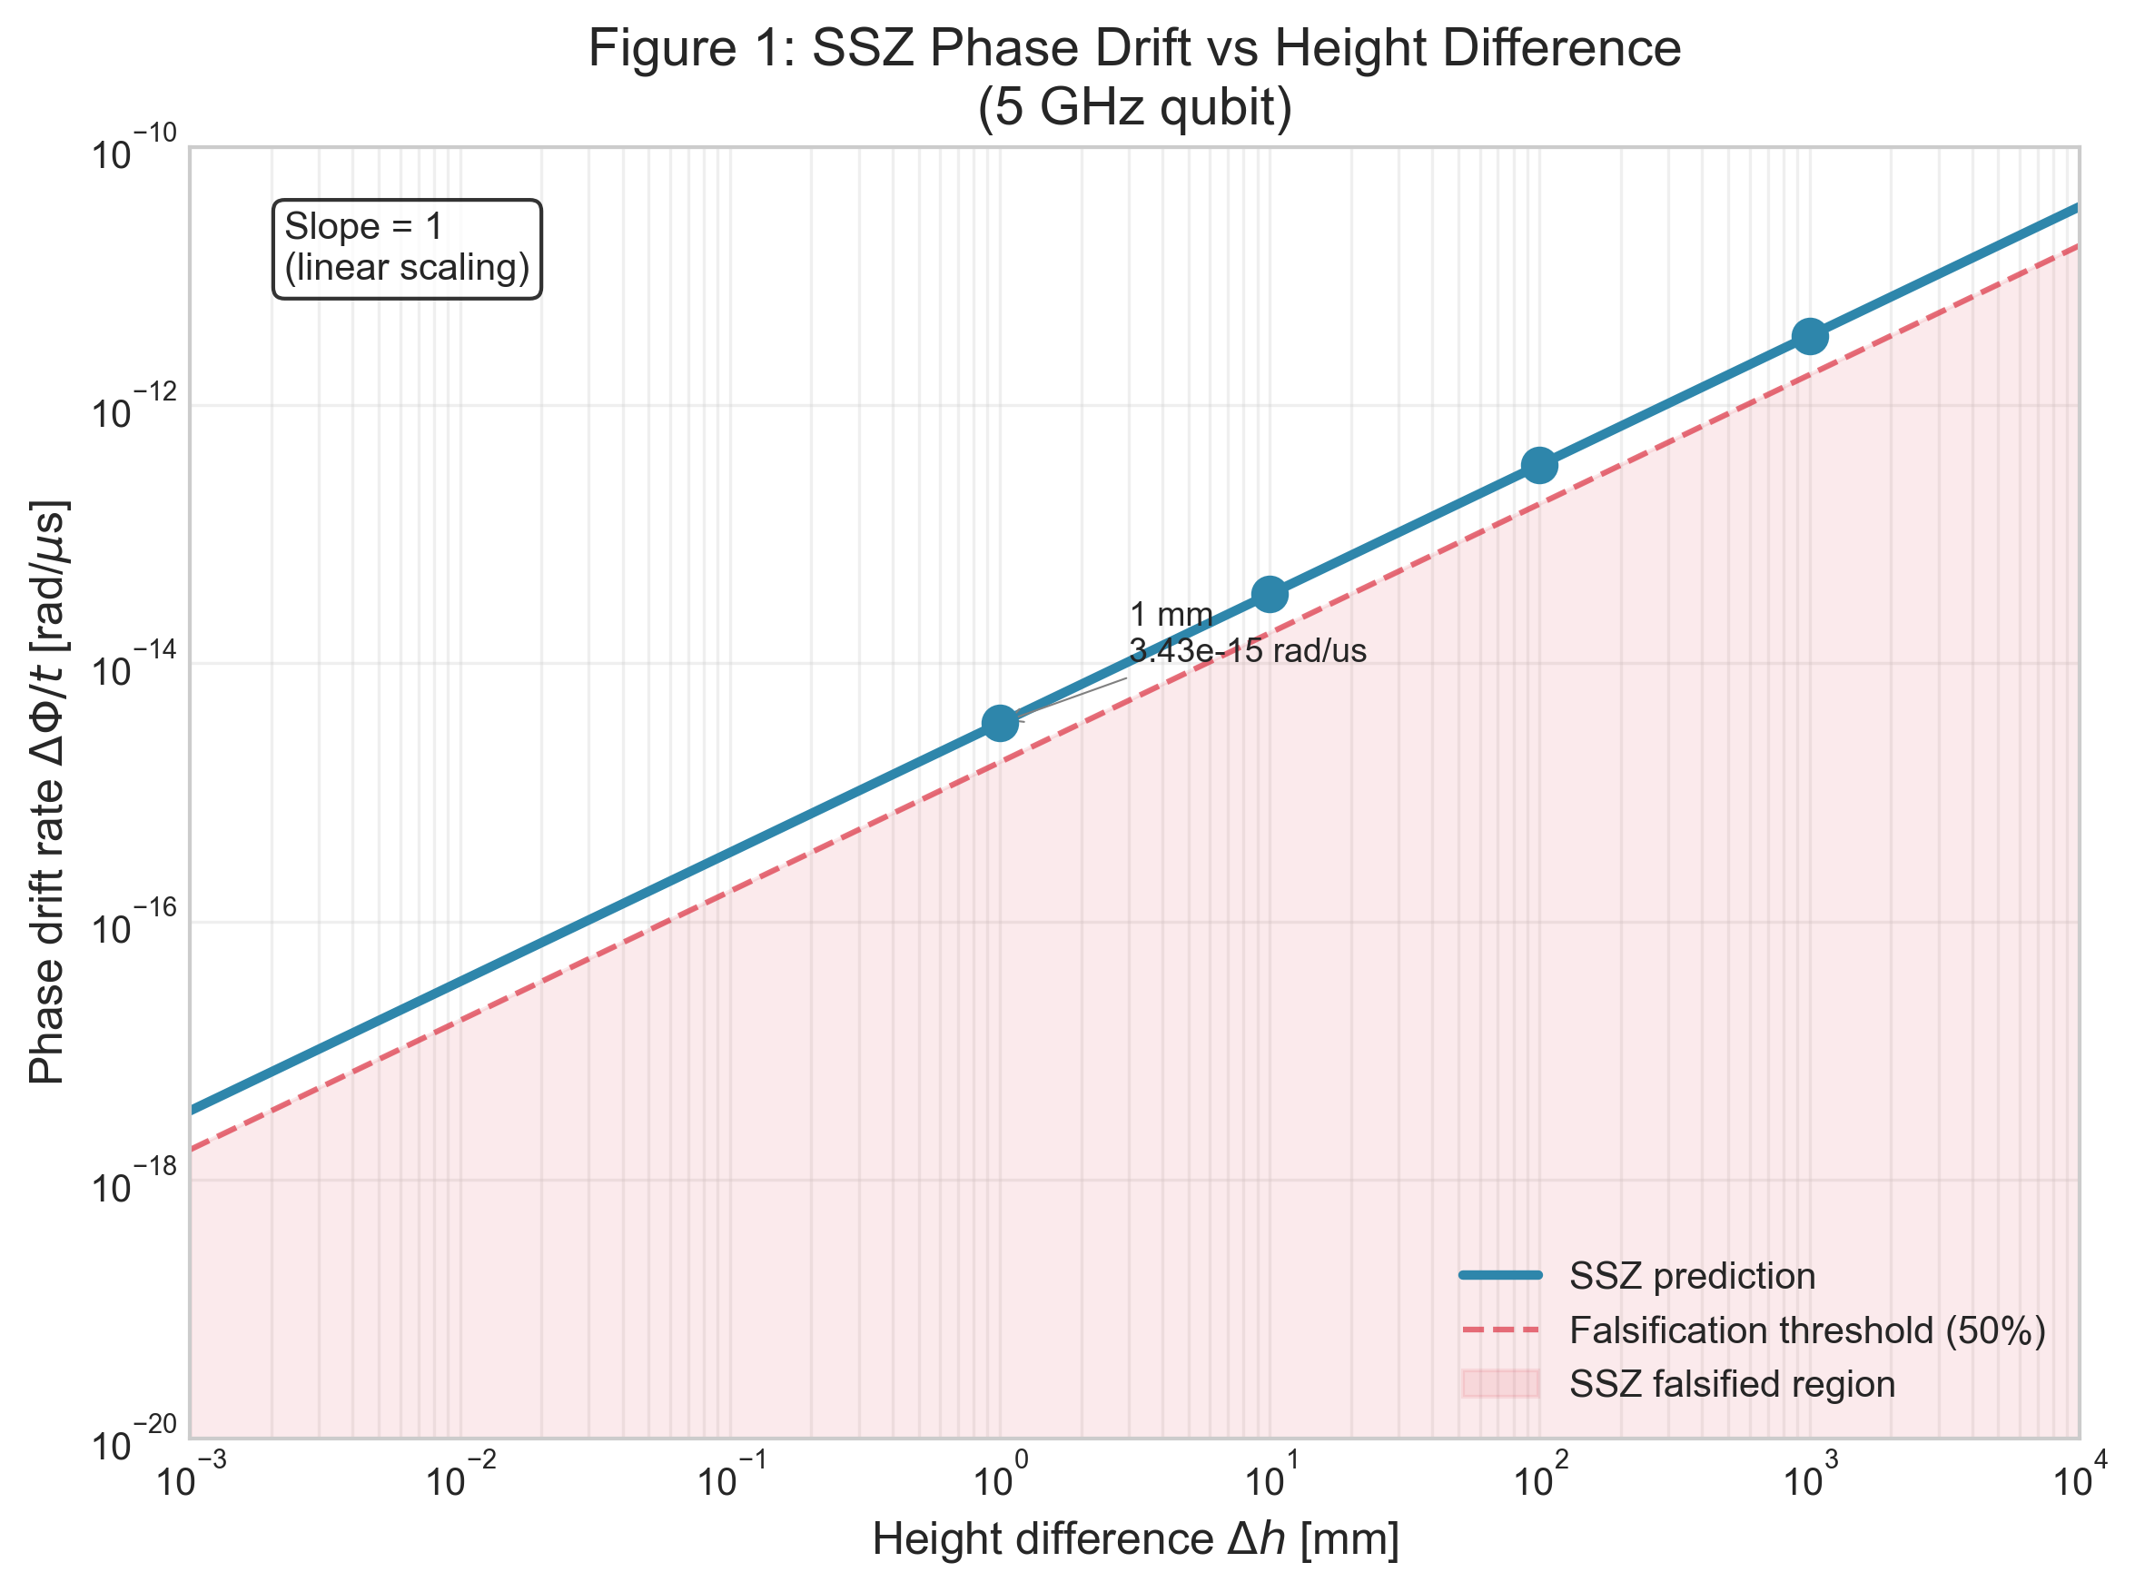
Figure 1: SSZ phase drift rate as a function of height difference (log-log scale).

3.1 Prediction 1: Phase Drift Rate at Δh = 1 mm
Formula: ΔΦ/t = ω × ΔD_{SSZ}(Δh)
Numerical Prediction:
- Qubit frequency: f = 5 GHz
- Height difference: Δh = 1 mm
- Predicted phase drift rate: 3.43 × 10⁻¹⁵ rad/μs
Falsification Threshold: If measured drift is < 1.72 × 10⁻¹⁵ rad/μs (less than 50% of prediction), SSZ is falsified.

3.2 Prediction 2: Coherent Zone Width at ε = 10⁻¹⁸
Formula: z(ε) = 4εR²/r_{s}
Predicted zone width: 18.3 mm
Falsification Threshold: If measured zone is < 9.2 mm, SSZ is falsified.

3.3 Prediction 3: Frequency Scaling Ratio
Formula: ΔΦ(ω₂)/ΔΦ(ω₁) = ω₂/ω₁
Predicted ratio (7 GHz vs 5 GHz): 1.40
Falsification Threshold: If measured ratio is < 1.20 or > 1.60, SSZ is falsified.

3.4 Prediction 4: Compensation Efficiency
Formula: η = 1 - |ΔΦ_{compensated}|/|ΔΦ_{uncompensated}|
Predicted efficiency: η ≥ 99%
Falsification Threshold: If compensation achieves < 90% reduction, SSZ is falsified.

3.5 Prediction 5: Cross-Zone Phase Drift per Gate
Formula: ΔΦ_{gate} = ω × ΔXi × t_{gate}
Predicted drift (at 2× zone boundary): 6.28 × 10⁻¹⁵ rad/gate
Falsification Threshold: If measured drift is < 3.14 × 10⁻¹⁵ rad/gate, SSZ is falsified.

4. Gold-Standard Falsification Experiment

4.1 Experimental Setup
Component | Specification
Qubit type | Superconducting transmon
Frequency | 5 GHz (primary), 7 GHz (scaling test)
T₂ time | ≥ 100 μs
Height control | Piezo translation stage
Height range | 0.1 mm to 10 mm
Height precision | 1 μm
Temperature stability | < 1 mK
Vibration isolation | Active + passive

4.2 Protocol
CALIBRATION PHASE
- Calibrate qubits at reference height (h = 0)
- Characterize T₁, T₂, gate fidelities
- Record temperature, vibration baseline
DATA ACQUISITION PHASE
- Set height difference Δh using piezo stage
- Prepare Bell state |Φ⁺⟩ = (|00⟩ + |11⟩)/√2
- Perform Ramsey sequence to measure phase ΔΦ(Δh, t)
- Record Bell state fidelity F(Δh, t)
- Repeat with SSZ compensation enabled
- Randomize Δh order to avoid systematic drift
CONTROL MEASUREMENTS
- Null test: same Δh, different thermal gradient
- Position test: same height, different x-y position
- Frequency test: repeat at 7 GHz

4.3 Expected Results
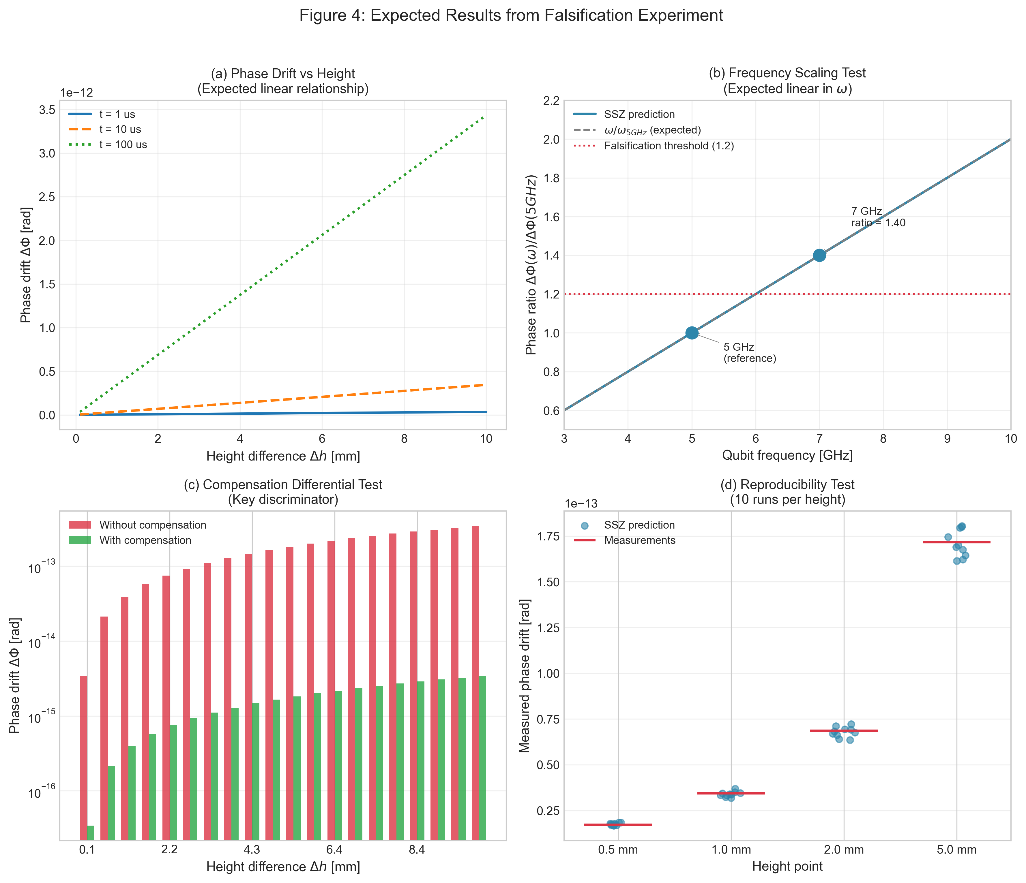
Figure 4: Expected results from the gold-standard falsification experiment.

4.4 Signatures of Success
- ΔΦ monotonically increases with Δh — linear on log-log plot with slope = 1
- ΔΦ scales linearly with t — same slope across all Δh
- ΔΦ scales linearly with ω — 7GHz/5GHz ratio = 1.40 ± 0.05
- Compensation removes >90% of ΔΦ — differential test passes
- Effect is reproducible — multiple runs give consistent results

5. Confound Discrimination
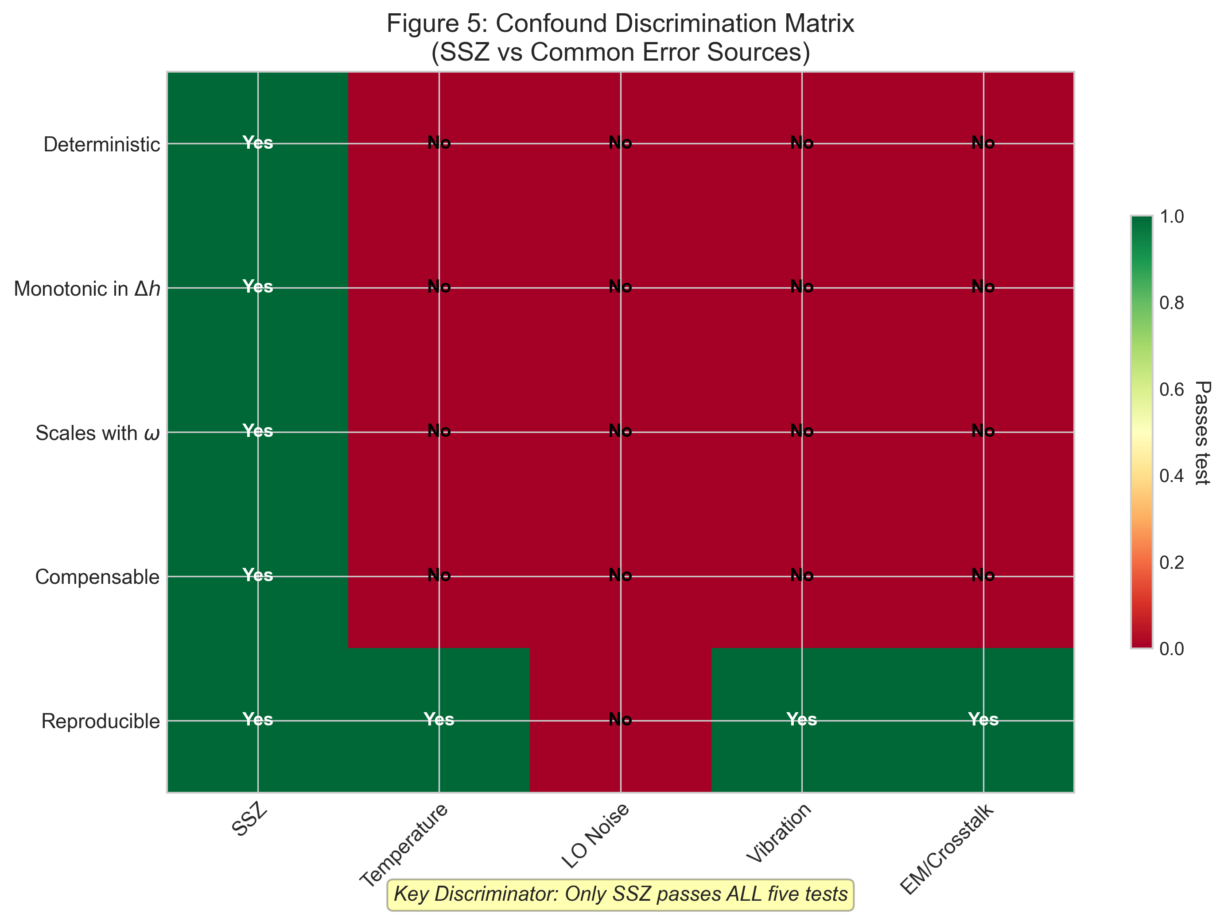
Figure 5: Confound discrimination matrix. Only SSZ passes all five discriminating tests.

5.1 Temperature Drift
Effect: Qubit frequency shifts ~1 kHz/mK → phase drift
Why it's not SSZ:
- Temperature effect is NOT monotonic in Δh
- Temperature effect does NOT scale with ω
- SSZ compensation would NOT reduce temperature-induced drift

5.2 LO Phase Noise
Effect: Random phase fluctuations ~10⁻³ rad/√Hz
Why it's not SSZ:
- LO noise is STOCHASTIC; SSZ is DETERMINISTIC
- SSZ can be COMPENSATED; noise cannot

5.3 Mechanical Vibration
Effect: Height fluctuations → apparent phase noise
Why it's not SSZ:
- Vibration is AC (time-varying); SSZ is DC (constant at fixed Δh)
- SSZ prediction is for static Δh

5.4 The Key Discriminator: Compensation Test
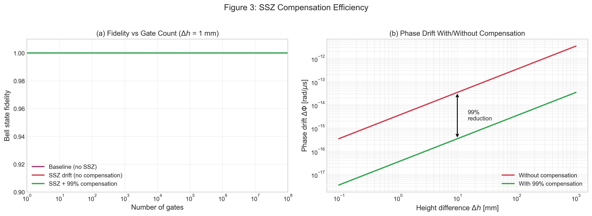
Figure 3: Compensation efficiency. (a) Fidelity vs gate count, (b) phase drift with/without compensation.

SSZ predicts a deterministic, geometry-linked phase drift. If we apply the predicted correction -ΔΦ_{SSZ}:
- SSZ contribution is cancelled
- Confound contributions are UNCHANGED
This differential test is powerful because:
- It does not require knowing the absolute SSZ magnitude
- It tests the correctability of the effect
- Confounds cannot be "compensated" by geometry-based corrections

6. Measurement Requirements

6.1 Phase Precision
- SSZ signal at Δh = 1mm: 3.43 × 10⁻¹⁵ rad/μs
- Required precision: 3.4 × 10⁻¹⁶ rad/μs (for SNR > 10)
- Achievability: Standard Ramsey with ~10⁶ averages over T₂

6.2 Height Precision
- Required: ~100 μm for 10% phase precision
- Achievability: Piezo stages routinely achieve < 1 μm — easily met

6.3 Temperature Stability
- For absolute measurement: ~10⁻¹² K (unrealistic)
- For differential measurement: ~1 mK (achievable)
- Solution: Use differential protocol to cancel common-mode temperature drift

7. Discussion

7.1 Why This Experiment is Decisive
- Multiple independent signatures — All five predictions must hold simultaneously
- Scaling tests — Wrong scaling immediately falsifies SSZ
- Compensation test — Direct test of the core SSZ prediction
- Confound discrimination — Each confound has distinct signatures
- Reproducibility requirement — Effect must be consistent across runs

7.2 What Falsification Would Mean
If the experiment shows no Δh-dependence, wrong ω/t scaling, or compensation failure, then SSZ as an operational model for quantum systems is falsified.

7.3 What Confirmation Would Mean
If all predictions are confirmed:
- SSZ provides a valid operational model for gravitational effects in quantum systems
- Practical benefit: Calibration and compensation strategies for quantum hardware
- Theoretical interest: Supports the segment-based interpretation of spacetime

7.4 Relation to Papers A and B
Paper | Focus | Key Result
A | Geometric optimization | Gate timing correction ~10% fidelity improvement
B | Phase coherence | Entanglement duration extended via SSZ compensation
C | Falsifiability | 5 quantitative predictions with explicit thresholds

8. Conclusion
We have presented a complete framework for experimentally testing SSZ predictions in quantum computing systems:
- Five falsifiable predictions with explicit numerical values and thresholds
- A detailed experimental protocol using current technology
- Confound discrimination strategies for each major systematic effect
- Realistic measurement requirements that are achievable with state-of-the-art hardware
The key insight is that SSZ predicts a deterministic, geometry-linked, compensable phase drift. The with/without compensation differential test is the strongest discriminator because confounds cannot be geometrically compensated.
We encourage experimental groups with access to superconducting qubit systems and precision height control to perform this test. The SSZ framework makes bold predictions — it deserves an equally rigorous experimental examination.

Acknowledgments
We thank the open-source community for valuable discussions and feedback.

References
[1] Casu, L. & Wrede, C. (2025). Paper A: Geometric Qubit Optimization via Segmented Spacetime. ssz-qubits repository.
[2] Casu, L. & Wrede, C. (2025). Paper B: Phase Coherence and Entanglement Preservation via Spacetime Segmentation. ssz-qubits repository.
[3] SSZ-Qubits Repository: https://github.com/error-wtf/ssz-qubits

© 2025 Carmen Wrede & Lino Casu
Licensed under the ANTI-CAPITALIST SOFTWARE LICENSE v1.4

