# Introduction

This XeroPath application is a path generation tool. It generates paths the are to be followed by a robot. The XeroPath application has the following features:

* Support for the West Coast style drivebase
* Support for the swerve style drivebase (experimental, not tested on a real robot)
* Supports sets of paths grouped into path groups (generally autonomous modes)
* Maximum velocity control per robot, path, or waypoint
* For swerve, independent control of the robot heading and the robot facing direction
* Visualization of the path, the velocity profile, and the robot following the path
* Keyboard control of waypoint position and heading for precise waypoint control
* Support for multiple path generation backends
* Undo

# Overview

## Concepts

This program will generate paths to be followed by a robot. The output is a profile that consist of a set of segments for each driven wheel on the robot. Each segment consists of time, heading, position, velocity, acceleration and jerk. The times for each segment in the profile is on a regular cadence or timestep. If the profiles for each wheel are followed, the robot will drive the desired path.

Locations are specified as a set of X and Y coordinates. The origin is at the bottom left hand corner of the field. Note this is not the bottom left hand corner of the drawing but of the playing field for the robot. The X axis extends positive to the right toward the other end of the field. The Y axis extends positive upward. Headings are given in degrees. Zero degrees is pointing along the X axis. Angles increase in a positive direction rotating counterclockwise and in a negative direction rotating clockwise.

The program edits a path database which contains a set of named path groups which in turn contains a set of named paths. By convention, path groups are generally associated with an autonomous mode, but this is a convention and is not required.

A path consists of a set of Waypoints. A Waypoint consists of an X and Y location, a heading, and a velocity. The velocity value limits the maximum velocity of the path from a given Waypoint to the next Waypoint in the path. Note, the velocity value is not honored by all path generators.

The set of waypoints are processed to generate the segments. Each segment contains the per-wheel position, velocity, acceleration, and jerk. This means both the position of the robot for the path and the velocity of the robot for the path are generated.

## Top Level Window

The top level window of the application is shown below. The important parts of the top level window are labeled and described below.

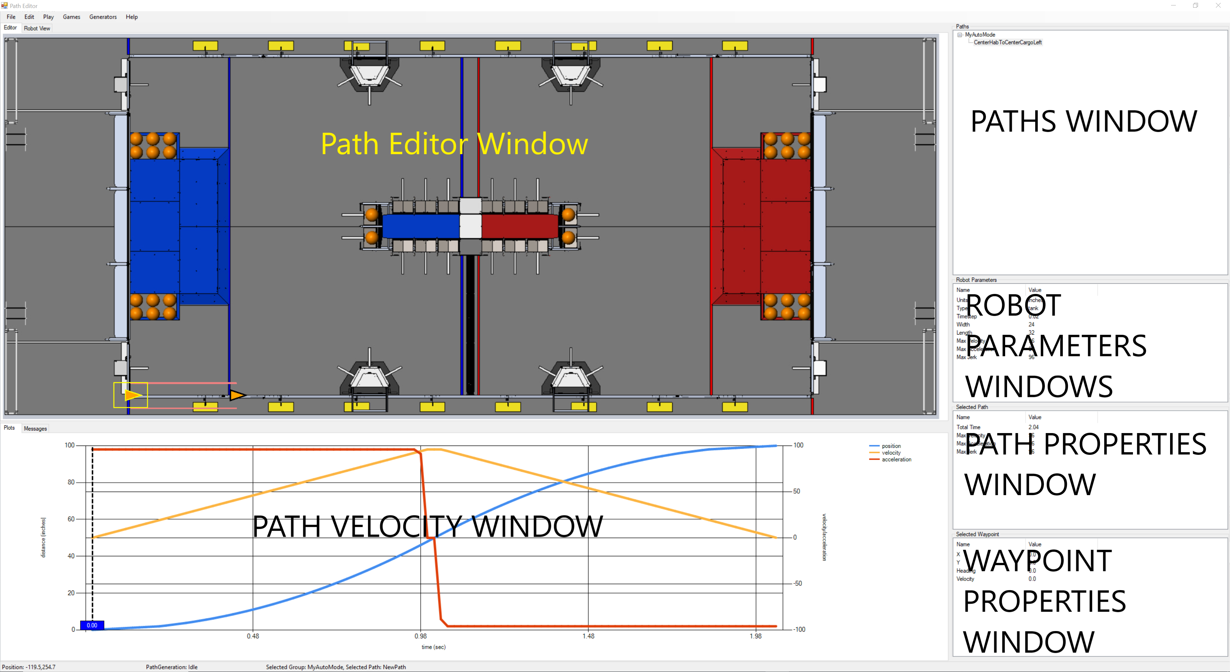

The Path Editor Window is used to edit the current path. It is selected via the Editor tab at the top of the window. Waypoints and be selected and dragged to new locations. The tip of the waypoint can be used to rotate the waypoint. If a Waypoint is selected, the arrow keys can be used to move the waypoint. Holding the shift key while using the arrows keys move the Waypoint with a finer increment. If a Waypoint is selected the Page Up and Page Down keys can be used to rotate the Waypoint. Holding the shift key while using these keys rotates the Waypoint with a finer increment.

The Robot View shows one or more paths in action. Selecting a path and moving the time bar in the Path Velocity Window moves an outline of the robot to the location it would be in at the selected time. The Play/Current Path/Group can be used to show the robot following the path in real time. The Play/Complete Path File will demo all paths stored in the file one after another.

The Path Velocity Window shows the generated velocity profile for the path. The Position is shown on one axis, and the velocity and acceleration are shown on another. The dashed vertical bar (time bar) shows the current time along the path. Moving this current position will move a white dot on the path showing the position on the path within the Path Editor Window. Moving this current position also has an impact on the Robot View window (discussed below).

The Paths Window shows the set of Path Groups and Paths that are part of this path file. Clicking on a Path Group or Path will select this Path Group or Path and change what is displayed in all other windows.

The Robot Parameters Window shows the robot parameters. This includes the following.

|  |  |  |
| --- | --- | --- |
| Parameter | Description | Notes |
| Units | The unit of measurement used in the program. The program supports inches, feet, cm, and meters. | Changing this value will updated all robot parameters, all path parameters, and all waypoints to reflect the new units. |
| Type | The type of drivebase for the robot. | Note, the SWERVE drive is experimental and has not been tested. |
| Timestep | The time interval for the output of the path segment data which includes per wheel position, velocity, acceleration, and jerk. |  |
| Width | The effective width of the robot between the left and right wheels of the robot. | Wheel scrub can make the effective width of the robot differ from the measured width of the robot. This is best obtained via characterization. |
| Length | The length of the robot between the front and back wheels of the robot. |  |
| Max Velocity | The Maximum Velocity allowed for any path. |  |
| Max Acceleration | The Maximum Acceleration allowed for any path. |  |
| Max Jerk | The Maximum Jerk allowed for any path. | Note all backends honor this value. |

The Path Property Window shows the properties for the currently selected path. This includes the following.

|  |  |  |
| --- | --- | --- |
| Parameter | Description | Notes |
| Total Time | The total time required to traverse the path. | This value is read only and appears after the segment generation is complete for a path. |
| Max Velocity | The Maximum Velocity allowed for this path. | If this value exceeds the robot max velocity, the max velocity is limited to the robot max velocity. |
| Max Acceleration | The Maximum Acceleration allowed for this path. | If this value exceeds the robot max accelerations, the max accelerations is limited to the robot max accelerations. |
| Max Jerk | The Maximum Jerk allowed for this path. | If this value exceeds the robot max jerk, the max jerk is limited to the robot max jerk. |
| Start Angle | The starting angle of the front of the robot for this path. Since a swerve drive can move in any direction, this is different than the robot heading as defined by the Waypoints. | Swerve drive only |
| End Angle | The ending angle of the front of the robot for this path. | Swerve drive only |
| Rotation Start Delay | The amount of time to delay at the start of the path before beginning any rotation required of the robot during the path. | Swerve drive only |
| Rotation End Delay | The amount of time before the end of the path when the rotation must be complete. | Swerve drive only |

The Waypoint Property Window shows the properties for the currently selected waypoints.

|  |  |  |
| --- | --- | --- |
| Parameter | Description | Notes |
| X | The X position for this Waypoint. |  |
| Y | The Y position for this Waypoint. |  |
| Heading | The direction the robot is moving. |  |
| Velocity | The maximum velocity for the robot on the current path between this waypoint and the next waypoint on the path. | Not all generators honor per waypoint velocity constraints. |

# Menu Items

***File/New*** Create a new path database. If the existing path database has been modified, but not saved, you will be prompted to save the existing path database before the new path database is created.

***File/Open…*** Open an existing path file and read the contents into the path database replacing the paths that were previously in the database. If the current path database has been modified, but not saved, you will be prompted to save the previous path database before opening the reading the file.

***File/Save*** Save the current path database into the file associated with the database. A file is associated with a path database either when it is opened via ***File/Open*** or when it is initially saved via ***File/Save As***. If there is no file associated with the database, this command reverts to the behavior of the ***File/Save As*** command.

***File/Save As …*** Prompt for a new file name and save the current path database into the new file. The path database is also now associated with the given file and future File/Save operations will save into this same file.

***File/Close*** Create a new and empty path database. If the current path database has been modified and not saved, the user will be prompted to save the database before it is replaced.

File/Generate Paths As … Generate the detailed paths associated with the path database into a directory that is

File/Generate Paths

Edit/Insert Waypoint

Edit/Delete Waypoint

Edit/Add Path Group

Edit/Add Path

Edit/Undo

Edit/Preferences

Demo/Path

Demo/Group

Demo/File

Games/

Generators/

Help/About

Help/Documentation