# Goal

Align the robot with the targets on the field

# Details

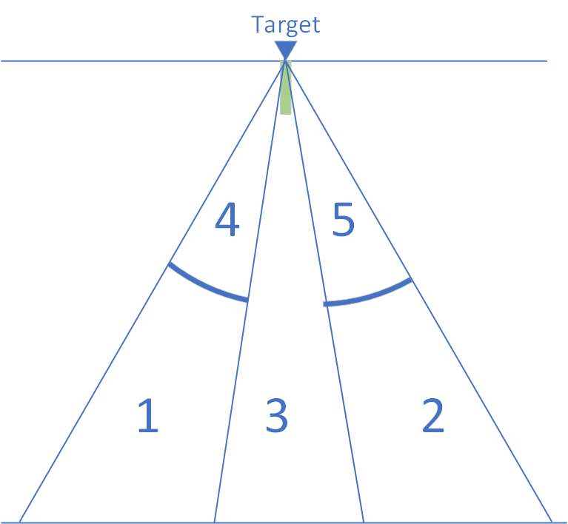

The drawing shows a target with an 18-inch strip of 2 in white tape leading to the target. The tape is shown in green in this diagram. The robot will have three sensors spaced three inches apart in the front and back of the robot to detect the tape. The goal of this action is to guide the robot from its current position to have the sensors on the appropriate side of the robot intersect the tape with an angle as close to zero as possible.

# Vision

Currently the vision system provides threes pieces of information.

First, it provides the angle from a straight line drawn out from the camera to the target. This angle is the target yaw angle.

Second is provides the distance from the camera to the target.

Finally, the camera provides the ratio of the area of the rectangle on the left of the target to the area of the rectangle on the right of the target. This gives an approximation of if the robot if to the left or right of the center line drawn perpendicular to the target.

# Yaw Guidance

Yaw guidance is used in this method in several places. A such it is defined here. Yaw guidance is driving the robot to a target identified by the camera using the yaw angle between the camera and the target. This is basically driving in a straight line to the target. The equations used to drive the left and right side of the tank drive are:

$$left=basepower+k_{yaw}×yaw$$

$$right=basepower-k_{yaw}×yaw$$

This will in effect turn the robot toward the target and then head straight to the target.

# Method

The approach here is a empirical one, but worked reasonably well in trials. The steps are …

1. If the camera is not detecting a target, do nothing and mark the action as done with error.[1]
2. Drive to the target, navigating using Yaw Guidance as described above.
3. Once the YAW is within a threshold, tyaw, (for instance less than 3 degrees), use the distance and the rectangle ratio to determines which of the five regions below the robot is in.
4. Based on the region, go the following:
   1. Region 1: Perform a predefined S curve, right then left, then switch to YAW based guidance to drive to the target.
   2. Region 2: Perform a predefined S curve, left then right, then switch to YAW based guidance to drive to the target.
   3. Region 3: Just continue to use YAW based guidance to drive to the target.
   4. Region 4: Cannot get to the target, stop the action with an error
   5. Region 5: Cannot get to the target, stop the action with an error

# Notes

This is a variation of the algorithm I proposed this weekend. However, what I learned is that we had time for a single S curve before we had to be aligned. Therefore, correctly recognizing this quickly and performing the single S curve would put is in a reasonable place with respect to the target. From there the YAW based guidance should pull us in at a reasonable angle. This will be reliable compared to the original idea and should get us good results.

This also does not require us to get any more accurate information from the camera than we are getting today.

While not handling cases 4 and 5 may seem like a big problem, in fact for autonomous it is up to the path we define where we wind up so we can deal with this case. For the operator control case we must teach the drivers to take the right approach to the target to get the automatic game piece collection and deposit to work.

Later in the season, we may be able to get cases 4 and 5 working by tuning more aggressive S turns to get to the target.

1. We need to think through an error handling mechanism for actions. I have some thoughts on this but will leave this to a future meeting.