**Documentation**

**Name: Aditya Dube**

**Roll No. : 171B017**

**Course: Advanced Programming Lab -1**

**Batch: B1**

**Project Name: Aditya Book Keeper**

**Idea:** This project is based on Python 3.6.5. The basic idea behind this project was to keep the records of my books which I purchase so whenever I am in mood to read any book I can search it on my project by giving any details either author name or title or ISBN no. and It will be displaying in the list box by displaying proper message and moreover I have commented on my code wherever required.

**1st Display Screen:**

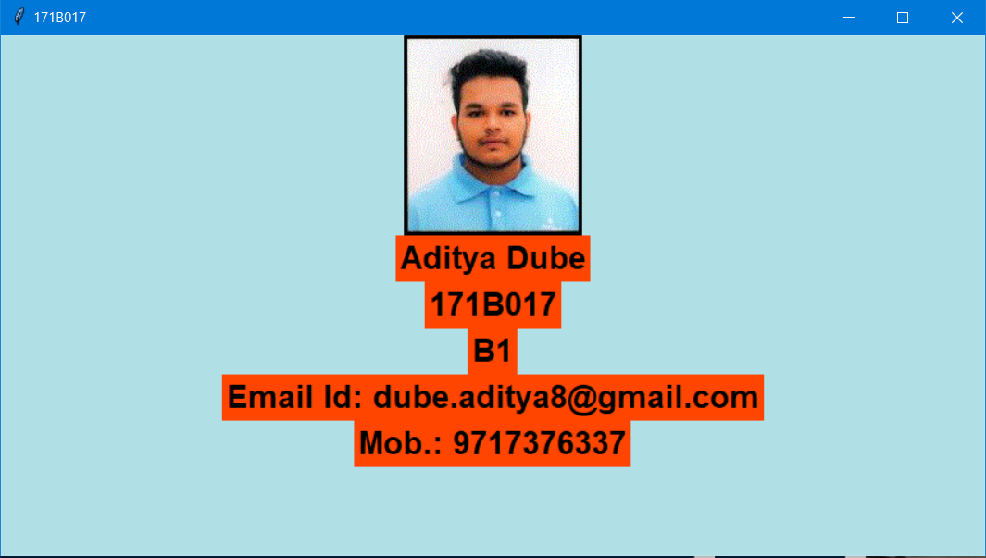

This is my first display which will be displayed when you will open **main.py** file this will come up and when you will take the cursor to the photo which I have inserted in gif format then it will close and my main file will open. I created **splash.py** file and then imported it to my main file by using the import function.

**2nd display Screen:**

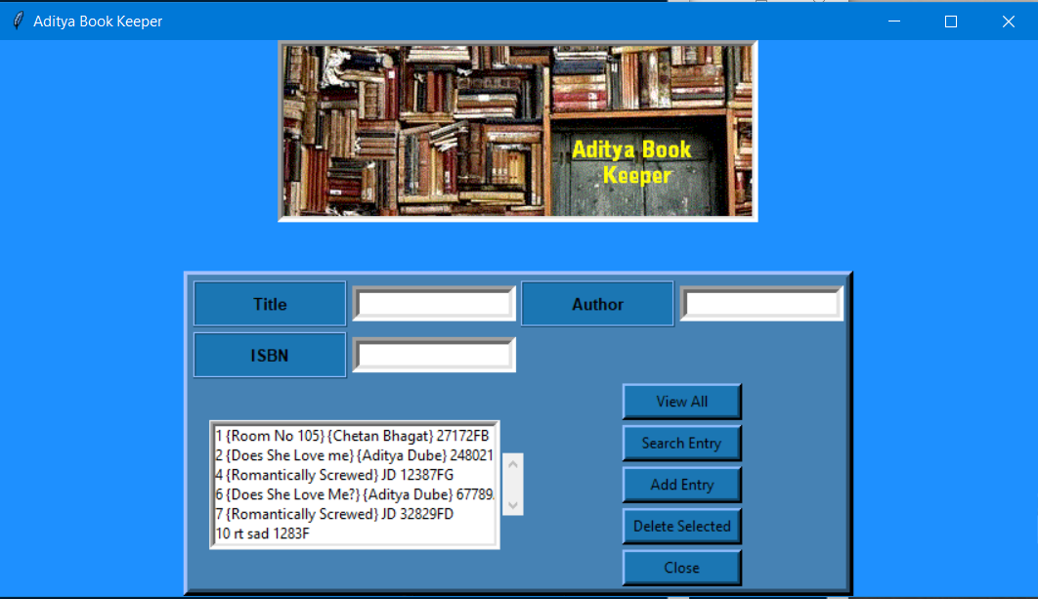

This is my main project after the splash screen is closed by moving the cursor onto the image which is inserted in gif format.

So, I used two frames for making my project 1st frame is used for the picture at the TOP and other frame is used for my entry and list box in bottom which you can see in the following image.

First, I imported all the modules like **Tkinter for the GUI, sqlite3 for the database, tkinter.messagebox for the message to be displayed after every command that is performed and splash** which will come in the starting of the program. **Here Title should be a text, author should be a text and isbn should be an Integer (it can accept characters and integer both).**

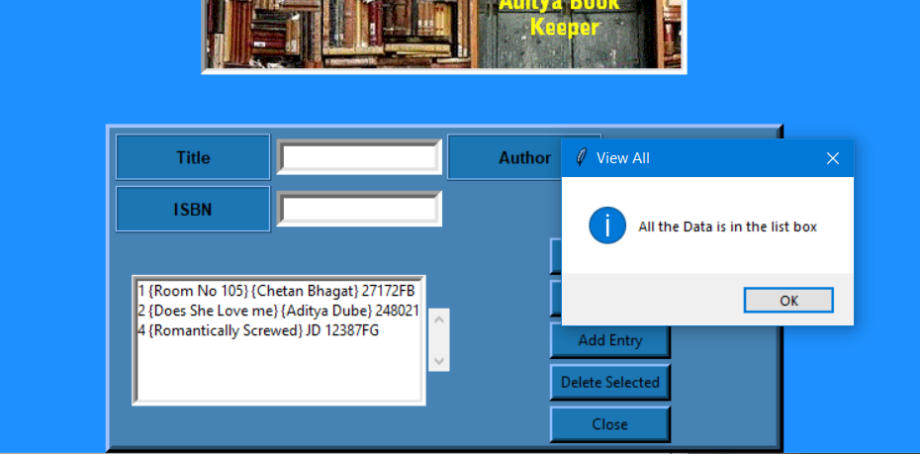

This image tells that when we press the **VIEW ALL** button all the books that are stored in the database will be displayed in the list box.

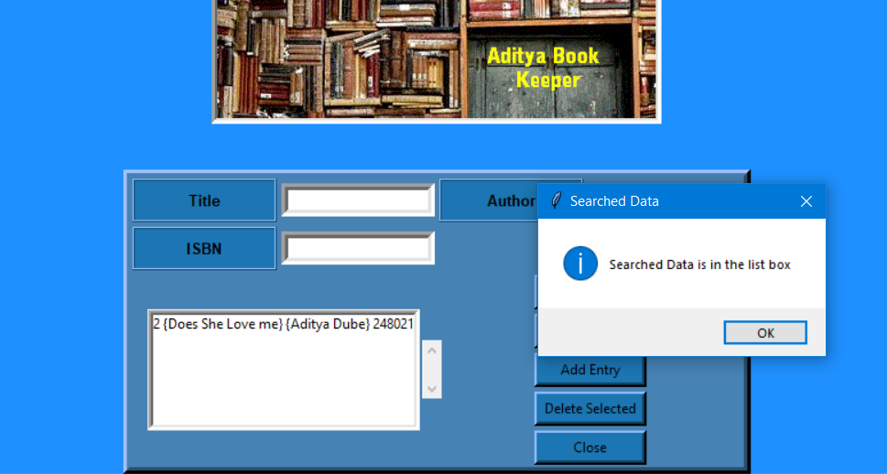

This image tells that when we press the **SEARCH ENTRY** button the book or the author or the isbn you wanted to see will be displayed in the list box. For search entry option you just need to provide only one option i.e. author, title or isbn and the result will be displayed. It is not mandatory to provide all the three option.

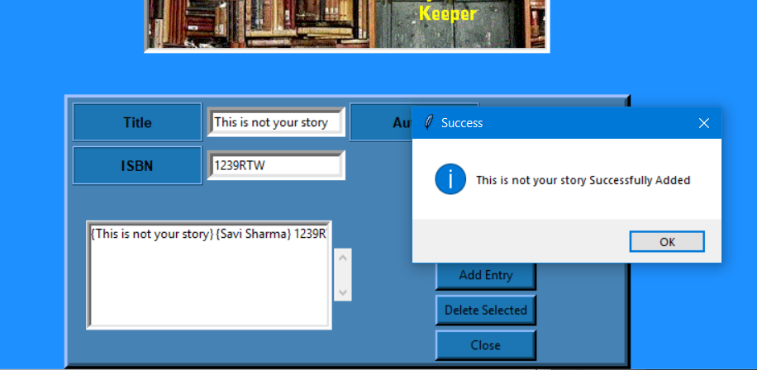

This image tells that when we press the **ADD ENTRY** button it will add the book in the database and display it in the list box. You need to give all the three entries as it is mandatory to provide all the entries, if you won’t enter any entries it will showing the warning message.

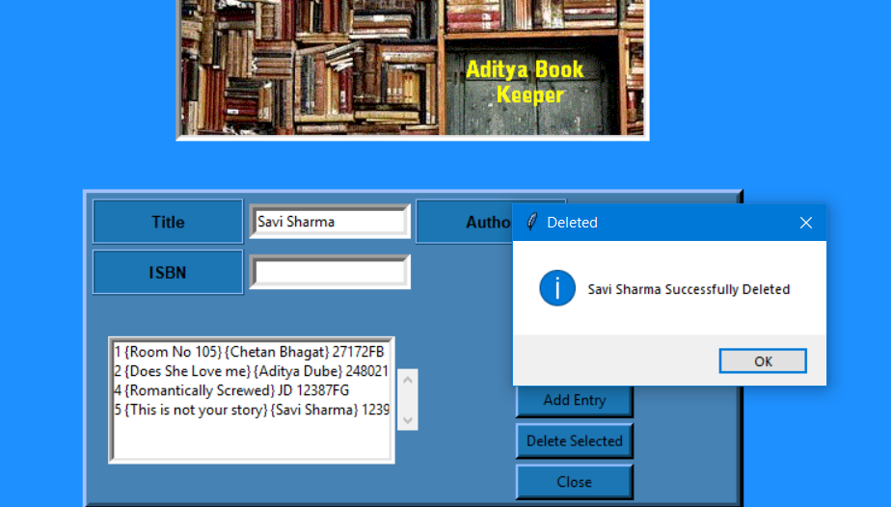

This image tells that when we press the **Delete Selected** button it will delete the selected book from the database by showing the author name message on the screen.

**Variables Used:**

tops is used for the frame above in the picture, and bottoms is the frame used for all the buttons, labels, entry and list box and scrollbar. e1, e2 and e3 are the variables used for the entry in Title, Author and ISBN, while l1, l2 and l3 are the variables used for the labelling of Title, Author and ISBN. List1 is used for List box while sb1 is used for scrollbar. While b1, b2, b3, b4 and b6 are the buttons which are used for View All, Search Entry, Add Entry, Deleted Selected and Close.

**What else I thought to do:**

I thought to add a button option of update in this project but my code wasn’t working for this so I just skipped it, my code for update is there in main.py file I have commented it. And I also tried to add an image on button but wasn’t able to set the width and height so I dropped that idea.

**©Aditya Dube**