Mini Project Report(KCS-554)
on
Title of Project
Submitted in partial fulfillment for award of
BACHELOR OF TECHNOLOGY
Degree
In
COMPUTER SCIENCE & ENGINEERING



2024-2025

Under the Guidance of: Submitted By:

Ms. Chanchal Jayant Anurag Kumar Sahani (2200330100058)
Ms. Samridhi Gulati Adnan (2200330100026)
Aman Raj Kushwaha (2200330100037)
Assistant Professor

DEPARTMENT OF COMPUTER SCIENCE & ENGINEERING
RAJ KUMAR GOEL INSTITUTE OF TECHNOLOGY
DELHI-MEERUT ROAD, GHAZIABAD

Affiliated to Dr. A.P.J. Abdul Kalam Technical University, Lucknow

SYNOPSIS

TABLE OF CONTENTS

CHAPTER NO. TITLE PAGE NO.

SYNOPSIS ii
LIST OF FIGURES x

1. INTRODUCTION 1

1.1 INTRODUCTION TO MINI PORJECT 4
1.1.1 OBJECTIVE 5
1.1.2 SCOPE OF THE PROJECT 7
1.1.3 METHODLOGY 9
1.1.4 DEVELOPMENT STEPS 12
1.2 MOTIVATION 13

2. HARDWARE AND SOFTWARE REQUIREMENTS 14

2.1 HARDWARE REQUIREMENTS 14
2.2 SOFTWARE REQUIREMENTS 15
3. CONCLUSION AND REFERENCES 16

LIST OF FIGURES

CHAPTER NO. TITLE PAGE NO.

1 Figure 1.1: Screenshot of the code 6
2 Figure 2.1: Screenshot of HTML code 23
2 Figure 2.2: Screenshot of CSS code 31
Figure 2.3: Screenshot of JSS code 32
3 Figure 2.4: Screenshot of resources 32

CHAPTER 1
INTRODUCTION

The YouTube Clone project is a simplified representation of the YouTube platform, built using HTML, CSS, and JavaScript. This project focuses on creating a functional and visually appealing interface that mimics the essential features of YouTube. It serves as a practical exercise to strengthen web development skills by implementing responsive design, interactivity, and user-centered design principles.

Key Features
- Homepage Design: Includes a navigation bar, video thumbnails, and a footer.
- Search Functionality: A functional search bar that filters video thumbnails based on user input.
- Video Player Simulation: Clicking on a video thumbnail simulates opening a video player with a description.
- Responsive Design: Ensures usability on desktops, tablets, and mobile devices.

Tools and Technologies
- HTML: Used to create the structure and layout of the application.
- CSS: Used for styling, including layout design, color schemes, and responsive adjustments.
- JavaScript: Provides interactivity, such as handling user actions and dynamically updating content.

This project is an excellent opportunity to enhance your front-end development skills by building a real-world application from scratch. It serves as a foundation for more complex projects and introduces essential concepts of web design and interactivity.

CHAPTER 2

OBJECTIVE OF REPORT

The primary objective of the YouTube Clone project is to design and develop a simplified version of the YouTube platform, focusing on the core features and functionalities using HTML, CSS, and JavaScript. This project aims to enhance the understanding of front-end development by building an interactive and visually appealing web application.
The project seeks to create a responsive user interface that adapts seamlessly across devices, ensuring a user-friendly experience. It also aims to implement basic interactivity, such as a functional search bar for filtering videos and a click-to-play simulation for video thumbnails. Through this project, developers gain hands-on experience in structuring web pages, styling layouts, and adding dynamic behavior using JavaScript.
Ultimately, the project serves as a stepping stone for more advanced web development projects, bridging the gap between theoretical knowledge and practical application.

The primary objectives of the project are:
- To design and implement a user interface similar to YouTube.
- To practice responsive web design techniques for a seamless user experience across devices.
- To incorporate basic JavaScript functionalities for interactivity and dynamic content updates.
- To demonstrate proficiency in front-end web development using HTML, CSS, and JavaScript.

CHAPTER 3

SCOPE OF THE PORJECT

Scope of the Project

The YouTube Clone project demonstrates the foundational concepts of front-end web development by building a simplified version of the popular video streaming platform. The scope of the project is as follows:

- Interface Design:

  - Create a homepage featuring video thumbnails, a navigation bar, and a footer.
  - Design a responsive layout to ensure usability on desktops, tablets, and mobile devices.

- Core Functionalities:

  - Include a search bar that filters video thumbnails dynamically based on user input.
  - Simulate video playback functionality by enabling users to click on thumbnails to view videos and their descriptions.

- Responsiveness:

  - Use CSS media queries to ensure the application is compatible with various screen sizes and resolutions.

- Dynamic Interactions:

  - Implement JavaScript to provide interactive features, such as hover effects and real-time search functionality.

This project is a front-end-only implementation and does not include a backend or database for storing video data, making it ideal for learning and practicing essential web development skills.

CHAPTER 4

METHODOLOGY

The development of the YouTube Clone project followed a systematic approach to ensure the successful completion of a functional and user-friendly web application. The methodology includes the following steps:

1. Requirement Analysis

- Identified the core features and functionalities to replicate a simplified version of YouTube.
- Defined the project scope to include interface design, interactivity, and responsiveness.

2. Design Phase

- Wireframing: Sketched the basic layout of the homepage, including a navigation bar, video thumbnail grid, and footer.
- UI/UX Design: Focused on creating a visually appealing and user-friendly interface using modern web design principles.

3. Development Phase

- HTML:
  - Created the structure of the application, including sections for navigation, content, and footer.
  - Used semantic tags for better readability and accessibility.
- CSS:
  - Styled the application to resemble the YouTube interface with attention to color schemes, spacing, and typography.
  - Used CSS Grid and Flexbox for layout design and alignment.
  - Implemented media queries for responsive design.
- JavaScript:
  - Added dynamic functionalities, such as filtering videos based on search input.
  - Simulated video playback by showing an expanded view of the selected video with details.

4. Testing Phase

- Tested the application across multiple devices (desktop, tablet, and mobile) to ensure responsiveness.
- Debugged and refined the code to fix layout and functionality issues.

5. Deployment Phase

- Deployed the project locally or on a web hosting platform to make it accessible for demonstration and review.

6. Documentation

- Documented the development process, including project objectives, scope, features, and future enhancements.
This structured methodology ensured an organized and efficient approach to achieving the project goals while adhering to best practices in web development.

CHAPTER 5

DEVELOPMENT STEP

- Planning: Identified features, created a wireframe, and set up the project structure.

- HTML Development: Built the webpage structure with sections for navigation, video thumbnails, and footer.

- CSS Styling: Designed the layout using CSS Grid and Flexbox, added color schemes, and ensured responsiveness with media queries.

- JavaScript Interactivity:
  - Implemented a search bar for filtering videos.
  - Added click events to simulate video playback with descriptions.

- Testing: Ensured responsiveness and functionality across devices, debugging as needed.

- Deployment: Hosted the project locally or online for demonstration.

- Documentation: Recorded the process and reviewed for final enhancements.

This concise workflow highlights the essential steps in creating the YouTube Clone.

CHAPTER 6

HARDWARE AND SOFTWARE REQUIREMNETS

• Operating System:
- Windows, macOS, or Linux (any modern version).

• Development Tools:
- Code Editor: Visual Studio Code, Sublime Text, or Atom.
- Web Browser: Latest version of Chrome, Firefox, Edge, or Safari for testing.

• Technologies:
- HTML5: For structuring the webpage.
- CSS3: For styling and responsive design.
- JavaScript (ES6): For adding interactivity and dynamic features.
Additional Tools:
  - Browser developer tools for debugging and testing.
  - Online resources or libraries (if any, like Font Awesome or Google Fonts).
This setup ensures a smooth workflow for developing and testing the YouTube Clone project.

SCREENSHOTS

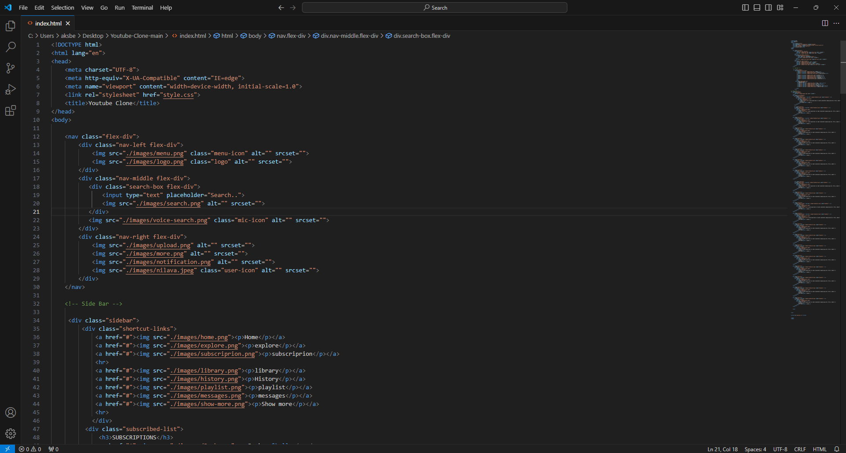
Screenshot of Html Code

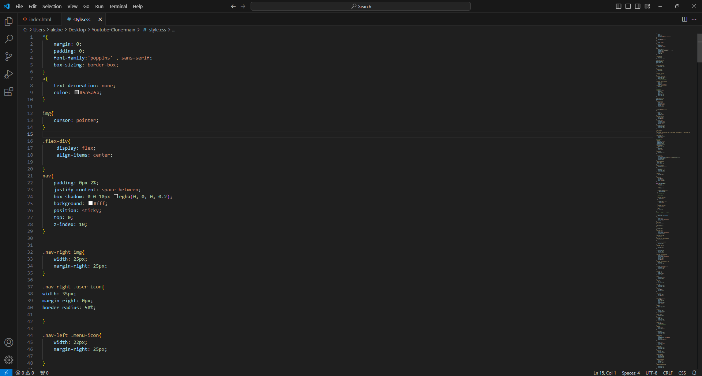
Screenshot of CSS code

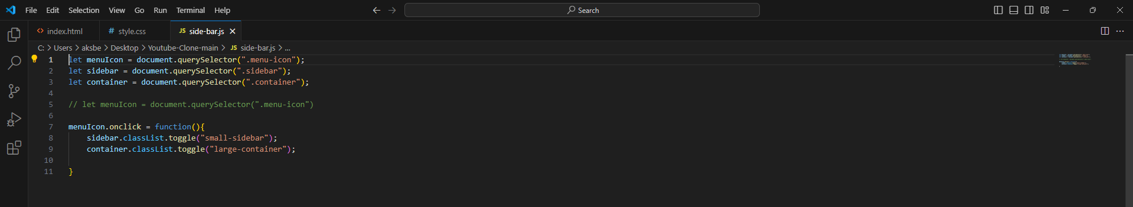
Screenshot of JSS code

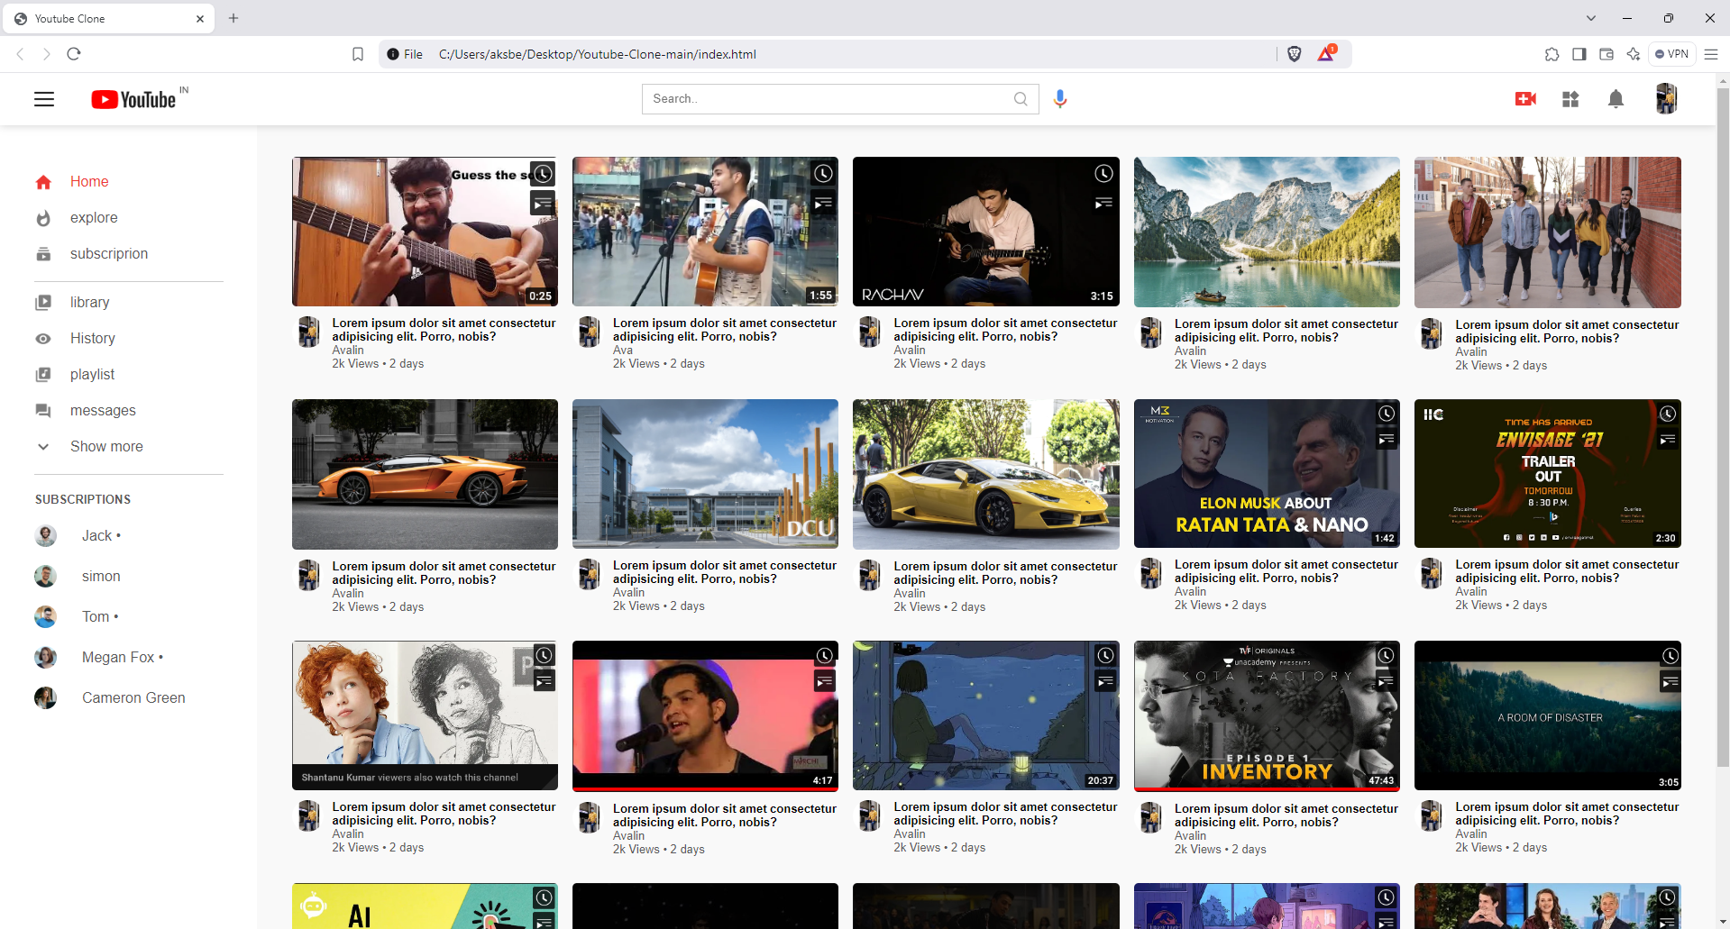
Screenshot of the Porject: Youtube Clone

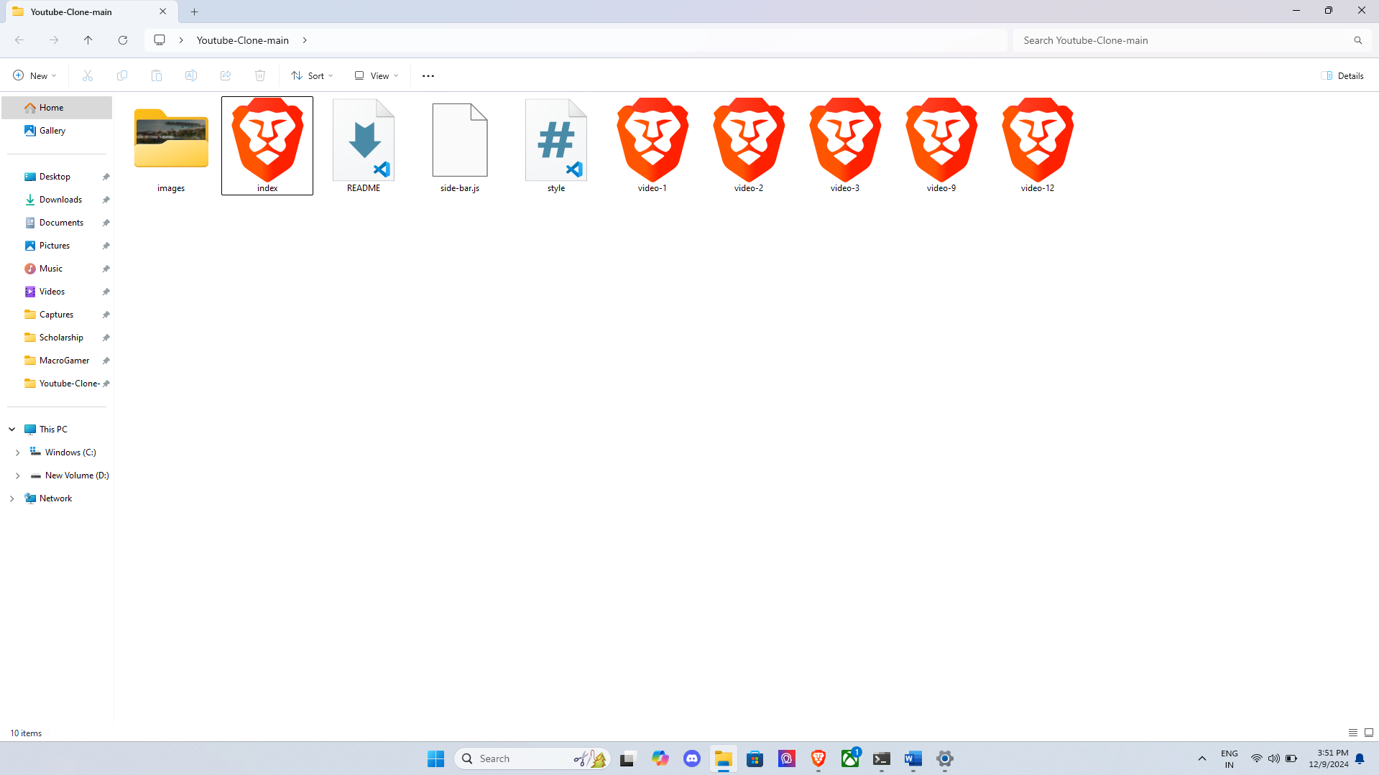
Screenshot of resources

REFRENCES

HTML and CSS References
- HTML Documentation:
  - MDN Web Docs - HTML
  - W3Schools - HTML Tutorial
- CSS Documentation:
  - MDN Web Docs - CSS
  - W3Schools - CSS Tutorial
JavaScript References
- JavaScript Basics:
  - MDN Web Docs - JavaScript
  - W3Schools - JavaScript Tutorial
- DOM Manipulation:
  - MDN Web Docs - DOM
  - JavaScript.info - DOM Introduction

