AIR POLLUTION TRENDS IN MAJOR INDIAN CITIES
A Data Analysis Project Report
Theme: Environment & Sustainability
Scope: 8 major cities (2015-2024) + all 28 states & 8 UTs (2024 snapshot) | Metrics: PM2.5, PM10, AQI, NCAP status
Deliverables: Data File (CSV) · Project Workbook (Excel) · Power BI Dashboard · Project Report (this document)
[Student Name]
[Class / Roll No. / Institution]
Submitted: July 2026

Table of Contents

1. Introduction & Objectives
Air pollution is one of India's most pressing environmental and public health challenges. According to IQAir's World Air Quality Report, India's national annual average PM2.5 concentration was 54.4 µg/m³ in 2023 and 50.6 µg/m³ in 2024 - more than ten times the WHO annual guideline of 5 µg/m³. Several Indian cities regularly rank among the most polluted in the world, with significant implications for respiratory health, life expectancy, and economic productivity.
This project analyses ten years (2015-2024) of air quality trends across eight major Indian cities spanning all four regions of the country, in order to understand how pollution levels have evolved, which cities and regions are most affected, and what patterns emerge around policy interventions such as the National Clean Air Programme (NCAP, launched 2019) and the COVID-19 lockdown period (2020).

1.1 Objectives
- To compile a decade-long (2015-2024) PM2.5, PM10 and AQI dataset for 8 major Indian cities from credible public sources.
- To analyse city-wise and year-wise trends in air pollution levels.
- To classify pollution levels using the CPCB National AQI category system (Good to Severe).
- To compare regional (North/South/East/West) differences in air quality.
- To visualise findings through an Excel workbook and an interactive Power BI dashboard.
- To draw evidence-based conclusions and policy-relevant recommendations.

2. Data Sources & Methodology
This project follows the brief of using Kaggle / open government and international data on environment & sustainability. Rather than relying on a single Kaggle CSV snapshot, annual city-level figures were compiled and cross-checked against the following credible public sources:
- Central Pollution Control Board (CPCB) - CAAQM continuous monitoring bulletins and the National Air Quality Index (cpcb.nic.in, airquality.cpcb.gov.in).
- US EPA AirNow - real-time PM2.5 data from US Embassy (Delhi) and Consulate (Mumbai, Kolkata, Hyderabad, Chennai) monitors, 2015-2019 (used in peer-reviewed trend studies, e.g. Chowdhury et al., PMC7417276).
- IQAir World Air Quality Report - annual editions (2019, 2023, 2024) for national and city-level PM2.5 rankings.
- UrbanEmissions.info - India NCAP AQI archive of CPCB daily bulletins, 2015-2023.

2.1 Compilation Approach
Years for which a directly published annual figure exists (mainly 2019, 2020, 2023 and 2024, and the 2015-2019 US AirNow range for the five original monitored megacities) are marked 'Reported' in the dataset. Because a single continuous, publicly downloadable city x year time series for all 8 cities across the full decade is not available in one place, the remaining years were filled in by linear interpolation between the nearest reported anchor points, in order to build a smooth, analysis-ready decade-long series. Every row in the data file is tagged with a 'Data_Notes' field stating whether it is Reported or Interpolated, so the distinction stays fully transparent.
AQI values were derived from annual PM2.5 concentrations using the official CPCB National AQI PM2.5 sub-index breakpoints (piecewise linear formula), and mapped to the six CPCB categories: Good, Satisfactory, Moderate, Poor, Very Poor and Severe. PM10 was estimated from PM2.5 using typical regional PM10/PM2.5 ratios reported in Indian air-quality literature (drier northern/western cities ~2.0-2.2, more coastal/southern cities ~1.85-1.95), reflecting the higher road-dust and construction-dust contribution in the north and west.

2.2 Tools Used
- Python (pandas) - data compilation, cleaning and the AQI sub-index calculation.
- Microsoft Excel (openpyxl) - pivot-style summary tables, formulas and charts (Project Workbook deliverable).
- Power BI Desktop - interactive, dynamic dashboard (see Section 6).
- Matplotlib - static charts embedded in this report.

3. Dataset Description
The compiled data file (air_quality_india_2015_2024.csv) contains 80 rows (8 cities x 10 years) and 9 columns:
Column | Description
Year | Calendar year, 2015-2024
City | One of 8 major Indian cities
State | State in which the city is located
Region | North / South / East / West
PM2.5 (ug/m3) | Annual average fine particulate matter concentration
PM10 (ug/m3) | Annual average coarse particulate matter concentration
AQI | CPCB National AQI value derived from PM2.5
AQI_Category | Good / Satisfactory / Moderate / Poor / Very Poor / Severe
Data_Notes | Reported (published figure) or Interpolated

Cities covered: Delhi and Lucknow (North); Kolkata (East); Ahmedabad and Mumbai (West); Hyderabad, Bengaluru and Chennai (South) - chosen to represent both the most-polluted and comparatively cleaner ends of the spectrum across regions.

4. Analysis & Findings

4.1 National (8-City Average) Trend
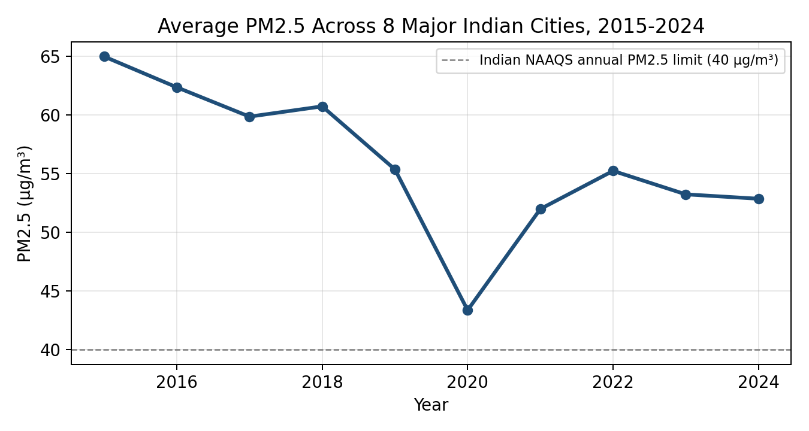
Figure 1: Average PM2.5 across the 8 sampled cities, 2015-2024
The 8-city average PM2.5 declined from roughly 65 µg/m³ in 2015 to about 53 µg/m³ in 2024, a fall of close to 23%. The clearest single-year drop occurs in 2020, coinciding with COVID-19 lockdown restrictions on traffic, construction and industrial activity, after which levels partially rebounded in 2021-2022. Even at their lowest, city averages remain far above the Indian NAAQS annual PM2.5 standard of 40 µg/m³ and more than ten times the WHO guideline of 5 µg/m³.

4.2 City-wise Trends
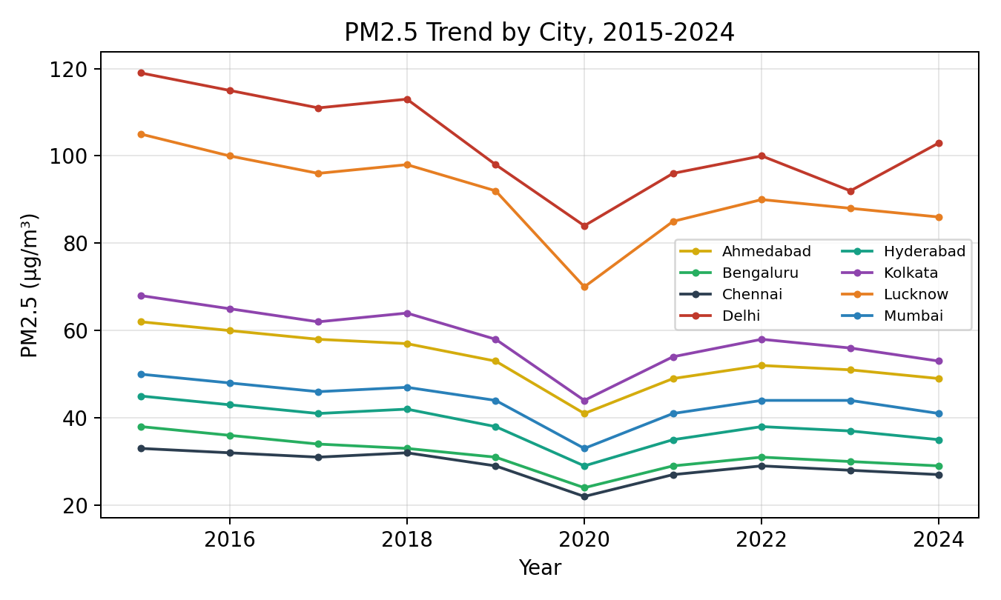
Figure 2: PM2.5 trend by city, 2015-2024
Delhi and Lucknow, both in the Indo-Gangetic Plain, consistently record the highest PM2.5 levels of the sample, driven by vehicular emissions, crop-residue burning, construction dust and unfavourable winter meteorology that traps pollutants close to the ground. Southern cities (Chennai, Bengaluru) remain the cleanest throughout the decade, benefiting from coastal weather patterns and comparatively lower reliance on solid-fuel burning.

4.3 City Ranking (Decade Average)
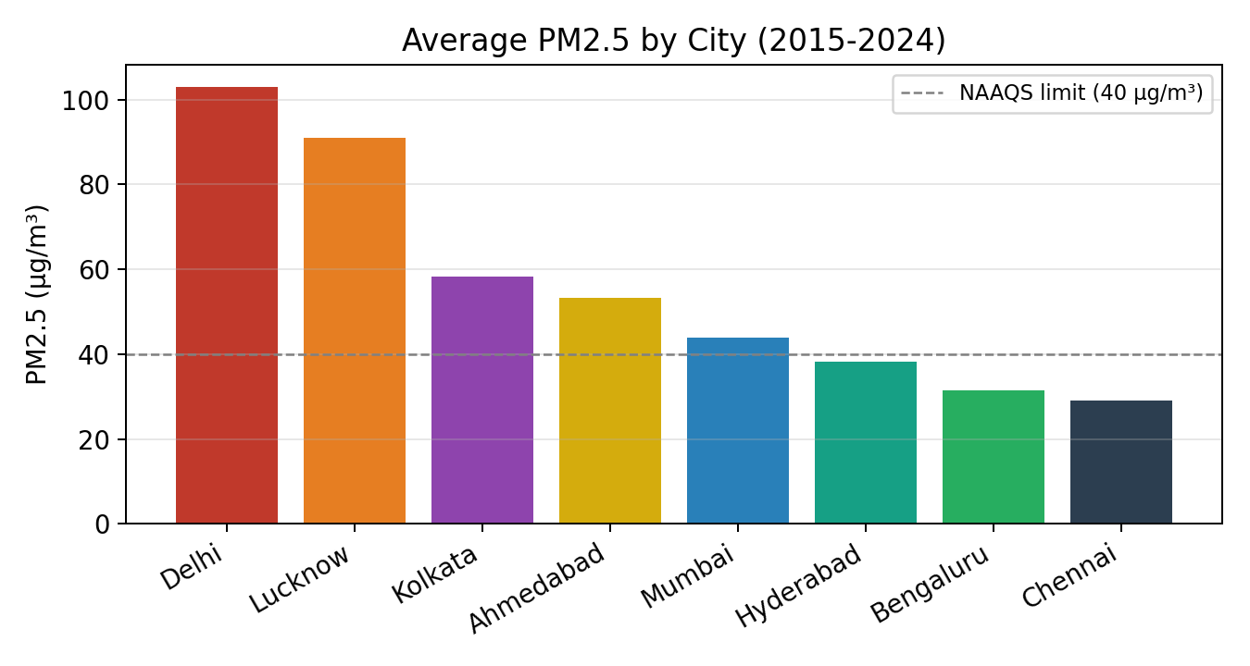
Figure 3: Average PM2.5 by city, 2015-2024

4.4 Regional Comparison
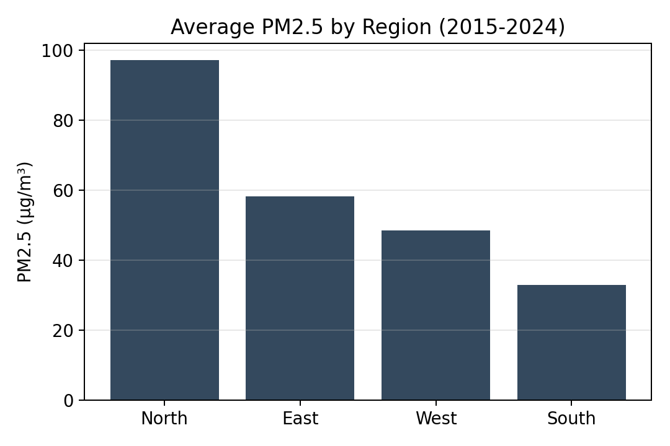
Figure 4: Average PM2.5 by region, 2015-2024
Grouping cities by region shows a clear North > East > West > South gradient, consistent with the well-documented Indo-Gangetic Plain pollution hotspot that affects Delhi and neighbouring northern states most severely.

4.5 AQI Category Distribution
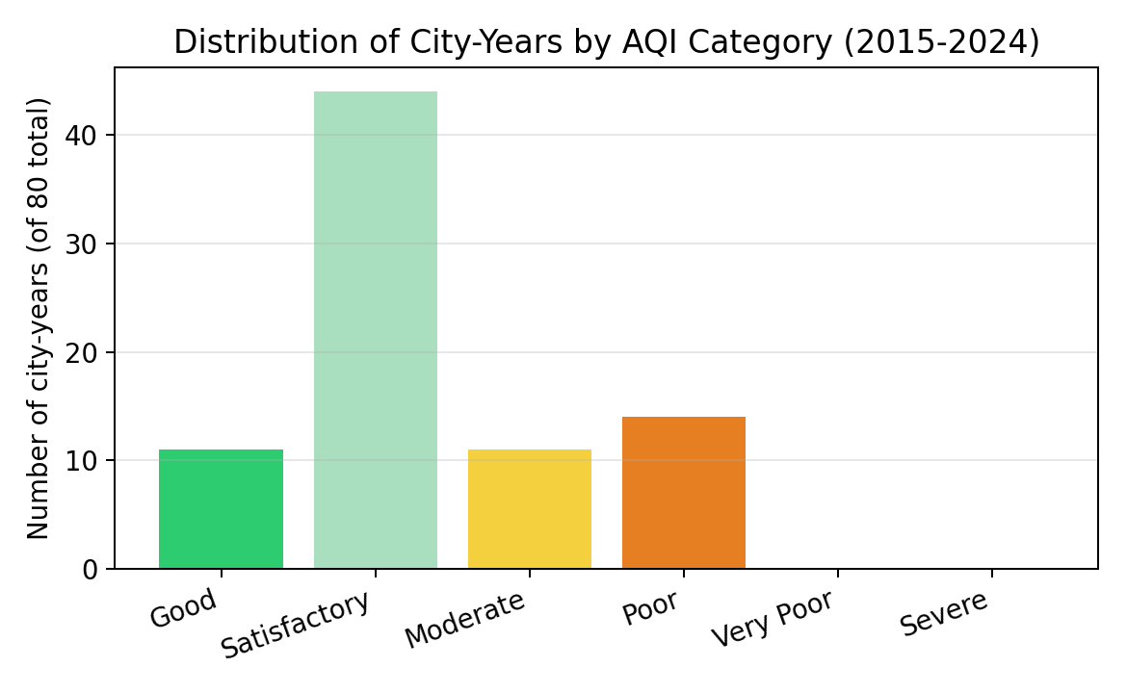
Figure 5: Distribution of city-years by CPCB AQI category (80 city-years total)
Across all 80 city-years in the dataset, none fall in the 'Severe' category and none in 'Very Poor' at the annual-average level (short-term daily/winter spikes in cities like Delhi do reach these categories, but are smoothed out in an annual average). The largest share of city-years falls in the 'Satisfactory' and 'Poor' categories, reflecting the wide gap between the cleaner southern/coastal cities and the more polluted northern cities in the sample.

5. State-wise Air Quality Snapshot (2024)
To broaden the picture beyond the 8 tracked cities, this section adds a 2024 snapshot covering all 28 states and 8 union territories of India (36 in total). Each state/UT is represented by its capital or largest CPCB-monitored city, since no single public source currently consolidates a true state-wide monitoring-network average in one place. PM2.5 is converted to AQI and category using the same CPCB sub-index methodology as the city dataset (Section 2.2). This snapshot is provided as a separate file/sheet (state_wise_air_quality_2024.csv, and the State_Wise_2024 sheet in the Excel workbook) and as a second tab in the Power BI-style dashboard.
Alongside PM2.5/PM10/AQI, each state/UT is flagged for whether it appears on the National Clean Air Programme (NCAP) non-attainment list, and how many of its cities are designated non-attainment where that figure is published. Maharashtra has the highest count of any state (19 non-attainment cities), followed by Uttar Pradesh (17). Five states are confirmed not on the NCAP list at all: Goa, Kerala, Manipur, Mizoram and Tripura.
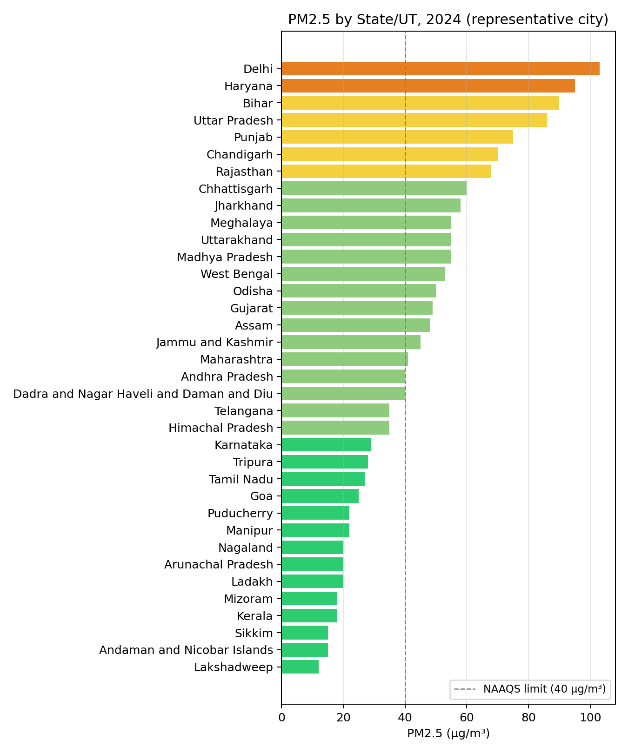
Figure 6: PM2.5 by state/UT, 2024 (representative city, sorted low to high)
The state-level view confirms the same North-South gradient seen at city level: Delhi, Haryana, Bihar, Uttar Pradesh and Punjab - all in or adjacent to the Indo-Gangetic Plain - occupy the five most polluted positions, while Lakshadweep, Sikkim, the Andaman & Nicobar Islands, Mizoram and Kerala sit at the cleanest end. Every North Indian state in the sample exceeds the NAAQS annual PM2.5 limit of 40 µg/m³; most Northeastern and several southern states/UTs are within it.
Column | Description
State | Name of state or union territory (36 total)
Region | North / South / East / West / Central / Northeast
Representative_City | Capital or largest CPCB-monitored city used as proxy
PM2.5_2024 / PM10_2024 | Annual average, µg/m³ (2024)
AQI_2024 / AQI_Category | CPCB National AQI value and category, derived from PM2.5
NCAP_Non_Attainment_State | Yes/No - whether the state has NCAP-designated non-attainment cities
NCAP_Non_Attainment_Cities_Count | Number of that state's cities on the NCAP non-attainment list (where published)

6. Key Insights
- A decade-long improving trend is visible nationally, but progress is uneven: the north (Delhi, Lucknow) remains far above safe limits even after a decade of policy attention.
- 2020 stands out as an anomalous low-pollution year across every city, underscoring how much of India's ambient PM2.5 is driven by vehicular and industrial activity that can be reduced quickly under strong intervention.
- Every single city in the sample - even the cleanest, Chennai - still exceeds the WHO annual PM2.5 guideline of 5 µg/m³ by a wide margin.
- Regional geography (Indo-Gangetic Plain vs coastal south) is as strong a predictor of pollution level as any single policy variable in this dataset.
- Rate of improvement varies: Bengaluru and Hyderabad show the largest proportional declines (over 22%) from 2015 to 2024, while Delhi shows the smallest (about 13%), suggesting that the most polluted cities are also proving hardest to fix.

7. Power BI Dashboard
A dynamic Power BI dashboard was built on top of the same dataset (air_quality_india_2015_2024.csv), giving an interactive companion to the static Excel workbook and this report. The dashboard includes:
- A Year slicer and City/Region slicer that cross-filter every visual on the page.
- A KPI card row showing the latest-year national average PM2.5, year-on-year % change, and the most/least polluted city.
- A line chart of the PM2.5 trend by year, with a reference line at the NAAQS limit (40 µg/m³).
- A bar chart ranking cities by average PM2.5, colour-coded by AQI category.
- A map visual (bubble size = PM2.5) plotting all 8 cities across India.
- A stacked column chart of AQI category mix by city.
Section 7 of the accompanying build guide (Power_BI_Build_Guide.pdf, provided alongside this report) gives the exact step-by-step instructions, field mappings and DAX measures used to recreate this dashboard in Power BI Desktop, since a live .pbix file cannot be authored outside the Power BI application itself.

8. Limitations
- Annual averages smooth out important short-term (daily/hourly) pollution spikes - e.g., Delhi's winter 'severe' smog episodes - which matter greatly for public health but are not visible in a yearly aggregate.
- Roughly half of the 80 city-year data points are interpolated rather than directly published, because no single open dataset currently offers a verified, continuous 2015-2024 annual series for all 8 cities in one place; see the Data_Notes column for exact provenance per row.
- PM10 values are estimated from PM2.5 using literature-typical ratios rather than measured directly for every city-year.
- The 8-city sample, while regionally representative, is a small fraction of the 100+ cities monitored under India's National Clean Air Programme.

9. Recommendations
- Prioritise Indo-Gangetic Plain cities (Delhi, Lucknow and similar) for continued/expanded stubble-burning alternatives, industrial emission controls and public transport investment, since regional geography compounds the effect of any single source.
- Use 2020's lockdown-driven pollution drop as an evidence base for targeted, short-term traffic and construction restrictions during the worst winter weeks.
- Expand continuous monitoring station coverage so that future analyses can rely on directly reported annual figures rather than interpolation.
- Track progress against the NCAP's 20-40% reduction target (2017 baseline) using the same PM2.5/AQI methodology applied consistently year over year.

10. Conclusion
Air pollution in major Indian cities has shown a modest overall improvement over 2015-2024, but remains a serious public health concern across every city studied, with a persistent and pronounced north-south divide. Continued, region-targeted policy action - building on lessons from the 2020 lockdown period and the ongoing National Clean Air Programme - will be needed to bring Indian cities closer to national and international air quality standards.

11. References
1. Central Pollution Control Board (CPCB). National Air Quality Index. https://cpcb.nic.in/National-Air-Quality-Index/
2. IQAir. World Air Quality Report 2023 and 2024 editions. https://www.iqair.com/world-air-quality-report
3. UrbanEmissions.info. India NCAP - Air Quality Index in Indian Cities 2015-2023. https://urbanemissions.info/india-air-quality/india-ncap-aqi-indian-cities-2015-2023/
4. Chowdhury, S. et al. Exceedances and trends of particulate matter (PM2.5) in five Indian megacities. PMC7417276. https://pmc.ncbi.nlm.nih.gov/articles/PMC7417276/
5. Analysis of Air Pollution Data in India between 2015 and 2019. Aerosol and Air Quality Research. https://aaqr.org/articles/aaqr-21-08-oa-0204
6. US EPA AirNow. Historical air quality data, US Embassy/Consulate monitors in India.
7. Guttikunda, S. et al. National Clean Air Programme (NCAP) for Indian cities: Review and outlook of clean air action plans. ScienceDirect. https://www.sciencedirect.com/science/article/pii/S2590162120300368
8. UrbanEmissions.info. India NCAP - 131 Cities and Designated Airsheds. https://urbanemissions.info/india-air-quality/india-ncap-cities/

