Box Out 1

Title: ADSR Envelopes

ADSR stands for Attack, Decay, Sustain, Release.
ADSR envelopes are a major part of most synths and are used to control the timbre of the sound over a duration of time. Usually, an ADSR envelope controls the volume and a separate envelope controls the filter cutoff frequency.

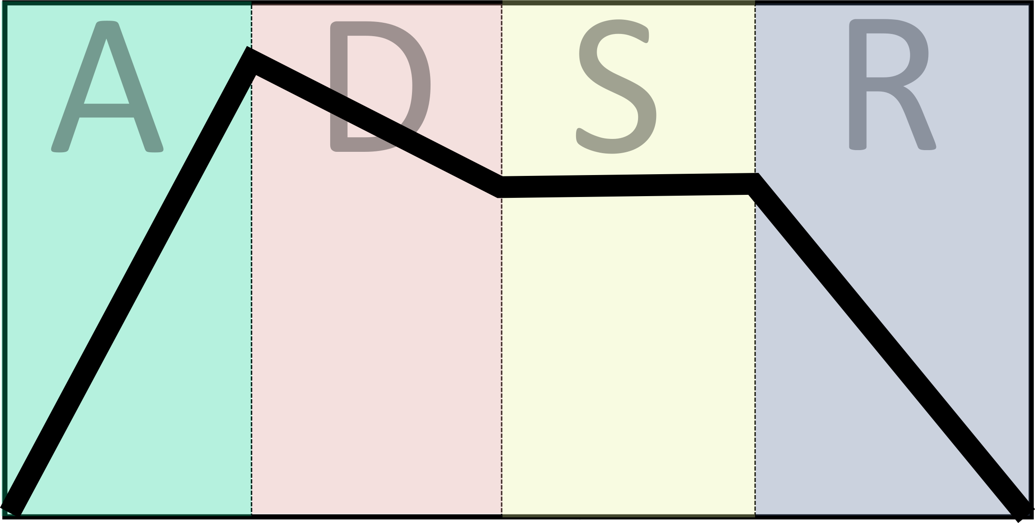

Here is how an ADSR envelope is applied to a volume control:

Attack
The attack value represents the amount of time the sound takes to move from 0 to full volume. Piano type instruments will reach full volume almost instantaneously, whilst a violin stroke fades gradually from 0 to full volume.

Decay
This is the amount of time it takes to move from the attack value (full volume) to the sustain value.
Most physical instruments start off with a loud sound and then quickly fade in intensity.

Sustain
The volume level that the sound will remain at after the decay time (until the note is released). Sustain differs from the other parameters, as it represents a volume level rather than an amount of time.

Release
After a key is released, the envelope enters the release phase. This is the amount of time it takes for the volume level to return to 0.

ADSR envelopes can be used to automate almost any parameter of a synth to create a more natural or interesting sound.

