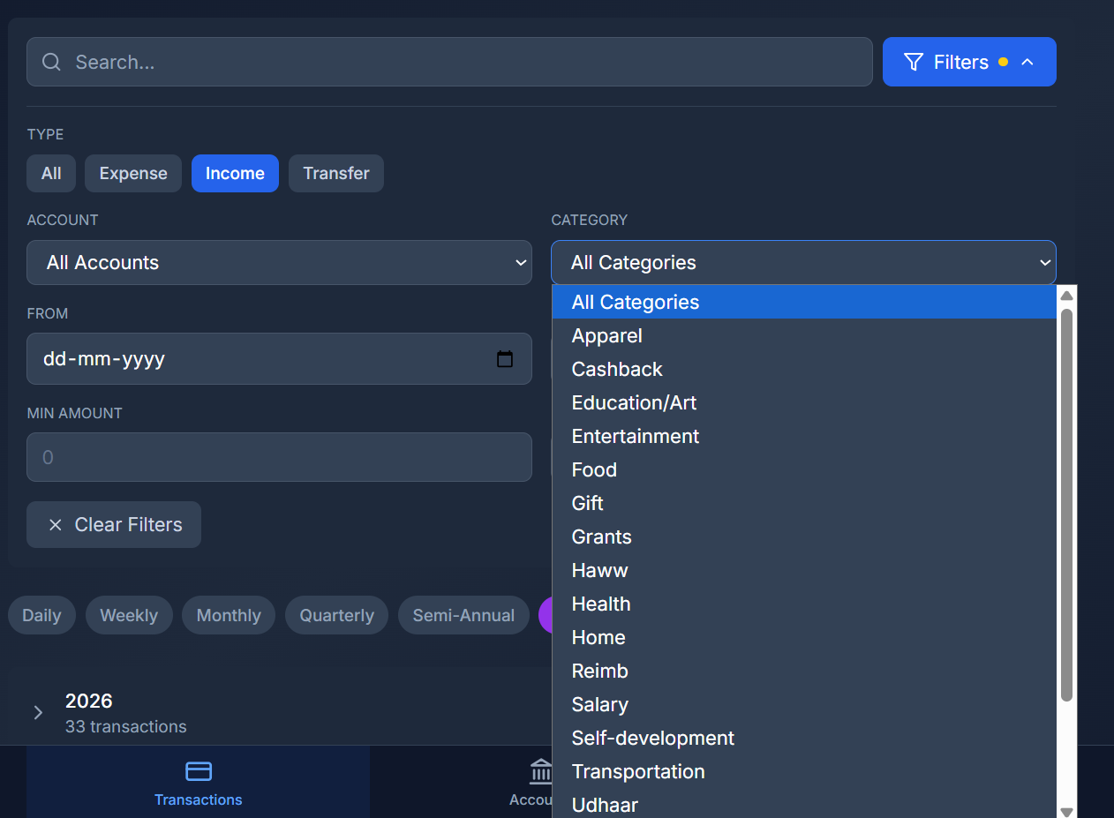
- The categories filter should be in accordance with the expense type selected from the options above

- This stats graph’s x-axis should always have a least count of days. Incase even if the period is set for 2 years, x-axis least count should be in days though the graph can be squeezed up a bit.
