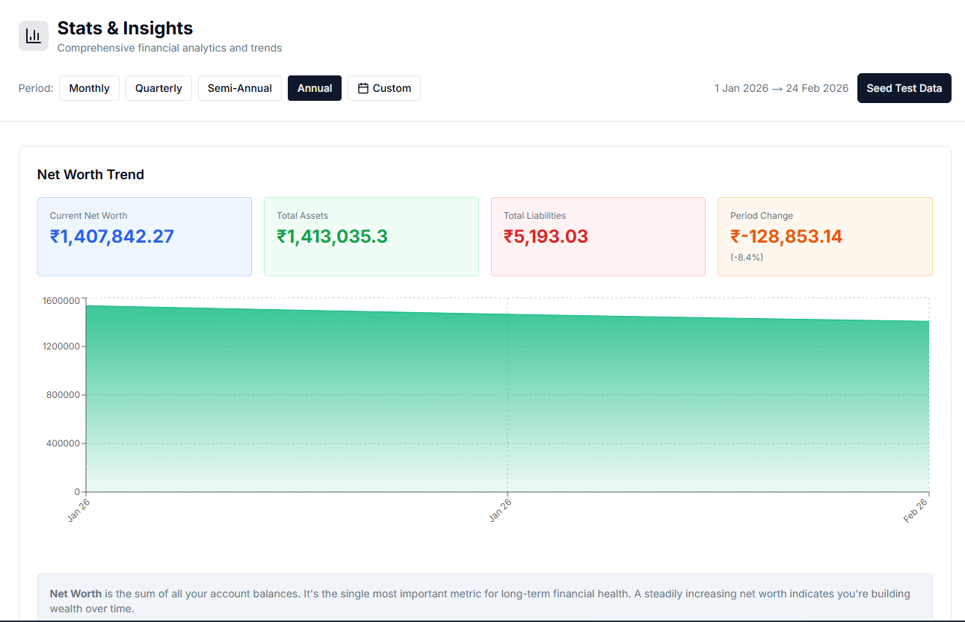
- If a bank detail is changed such that it is marked to be counted as a LIABILITY, the stats page is catering the change after we switch between the tabs. And the filters in stat tab (monthly, quarterly, semi-annual, annual, custom) doesn’t seems to be in line with the graph. I can see the only 2 months when selected semi-annual option (instead of previous 6) and annual option (instead of previous 12)

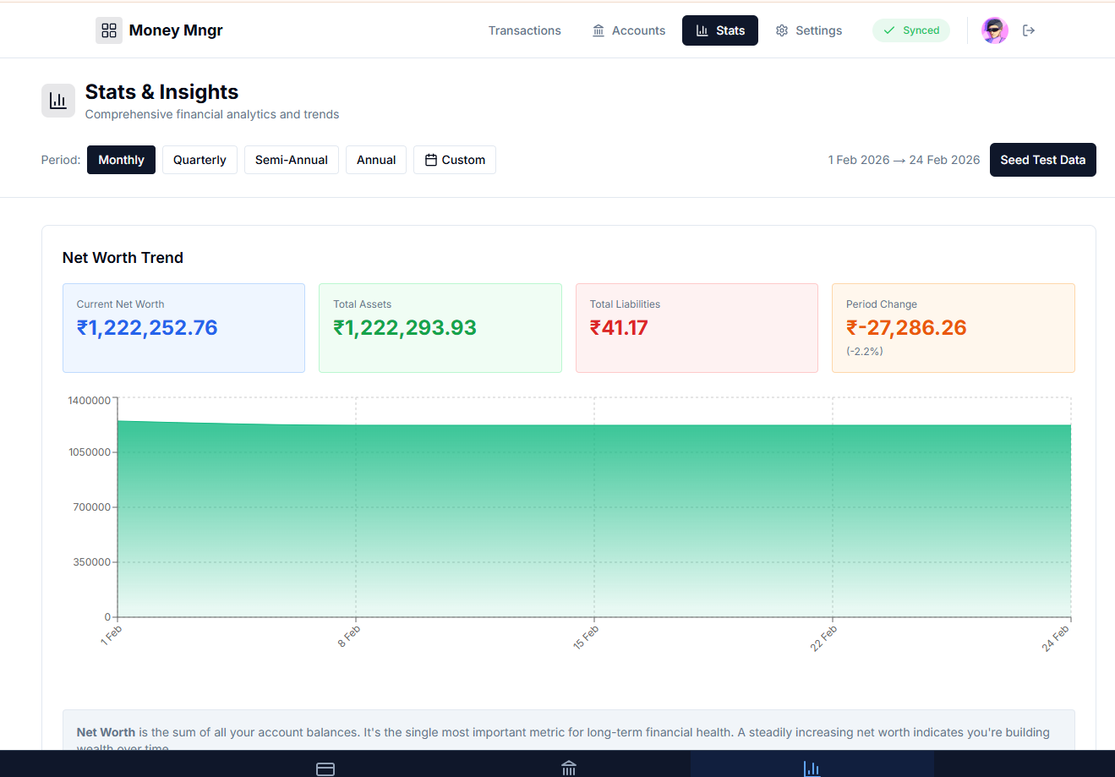
Make the graph type as line with markers & Remove ‘Seed data” button.

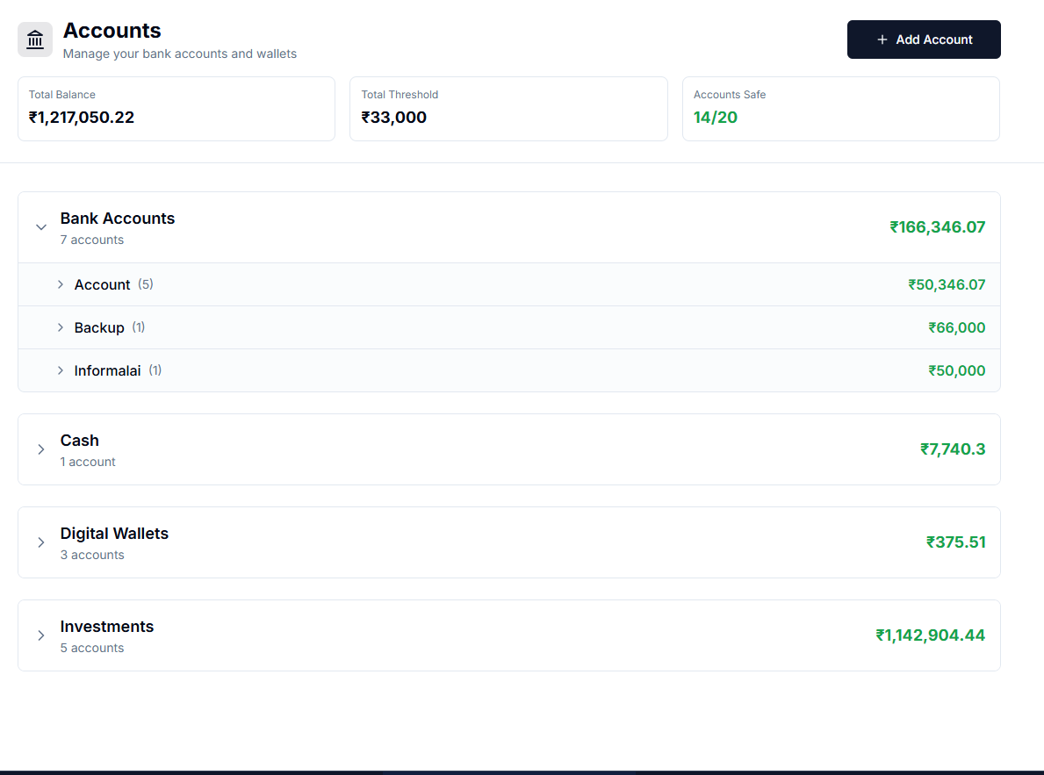
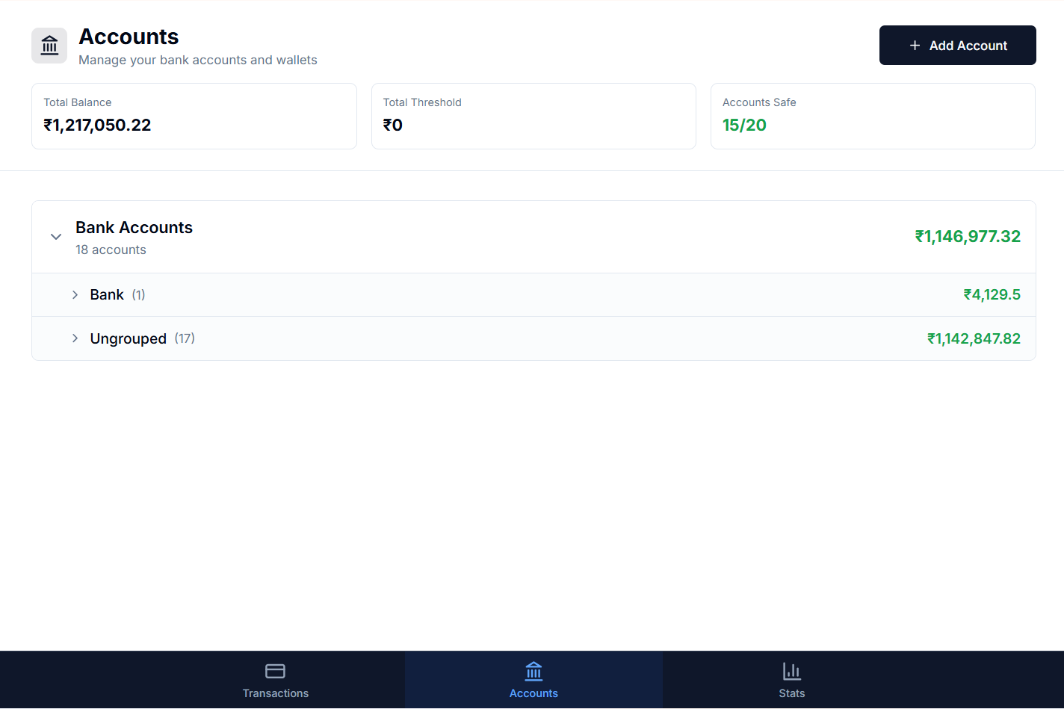
- Only getting the grouping in accounts tab for 4 groups (Bank Accounts, Cash, Digital Wallet, Investments) . if any else type (like Persons) is selected that account is not at all visible.
- The 'linked transaction' option / check box is not for expenses. It’s for ‘Transfer’ option only.
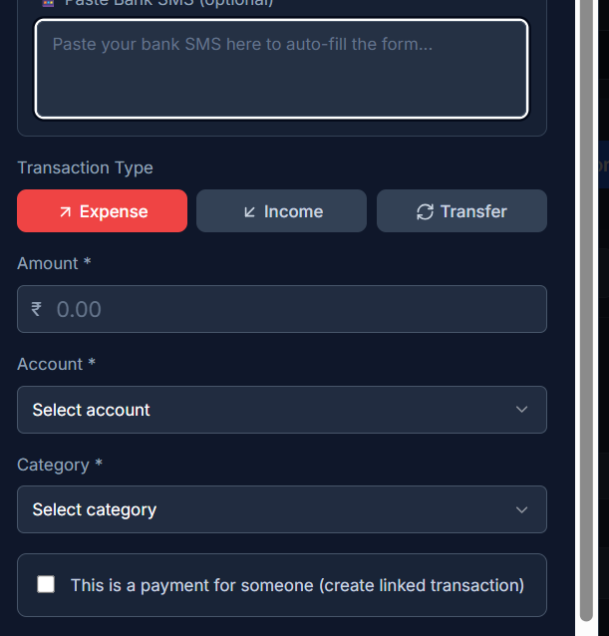
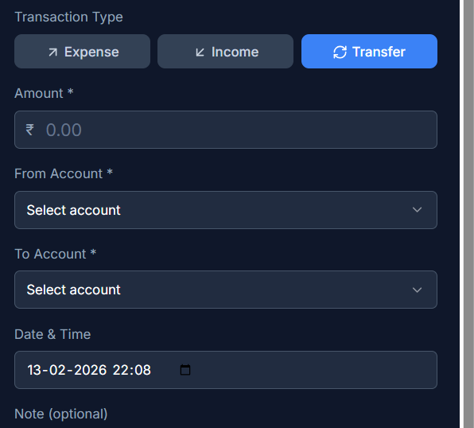

- changing the amounts of transactions in expense/income/transfer is not affecting the bank balance values at all. I observed a complete disconnect, which is fatal for us. Whole objective is affected.
in the below image, the transfer value from 25181 was changed to 2, still the SBI MOD balance remains 6600. It should have been increased.

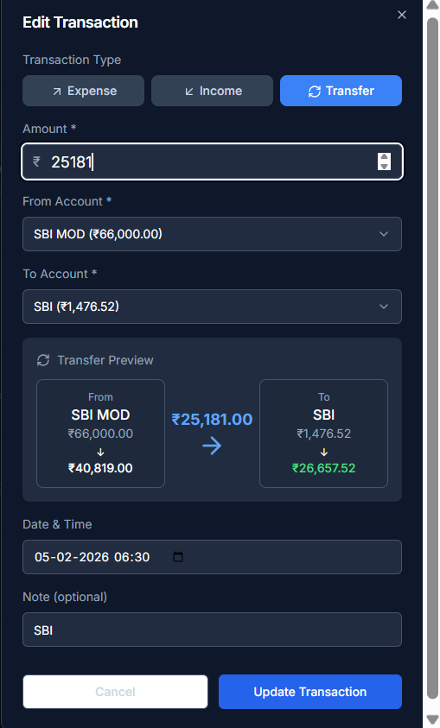
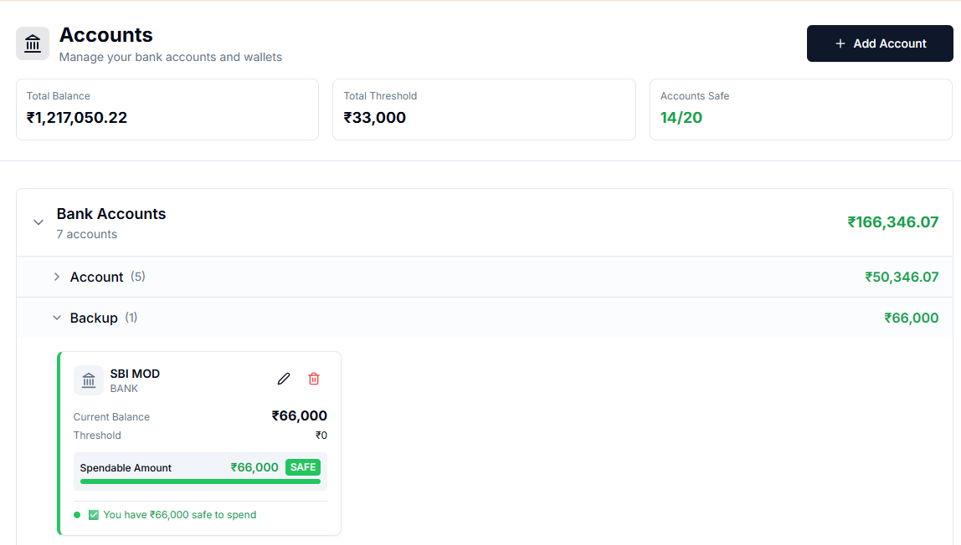
- A] Not getting any option for selecting sub-category. Category options are themselves incorrect. Tagging option should not contradict the category and subcategory mapping.

B] The remaining balance is visible alongside the bank/account name (this gives wrong impression of account name and creates confusion). Remove showing value alongside the accounts.

C] The accounts’ safe available values are not visible while filling an “Expense” transaction. Once any account is selected, the new available safe limit should be visible below the account box. This feature to show the threshold value or the money remaining as per threshold and recurring transactions gives a sense to user to avoid unnecessary future expense from that account. THIS IS THE WHOLE SOUL, that the user gets to know the safe available limit every time when an expense is fed/entered.
(good point : value change is observed in the accounts tab for selected bank after adding/deleting any transaction)
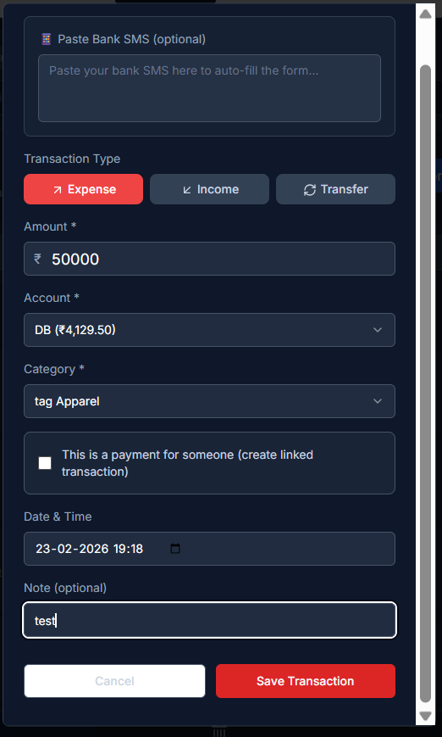

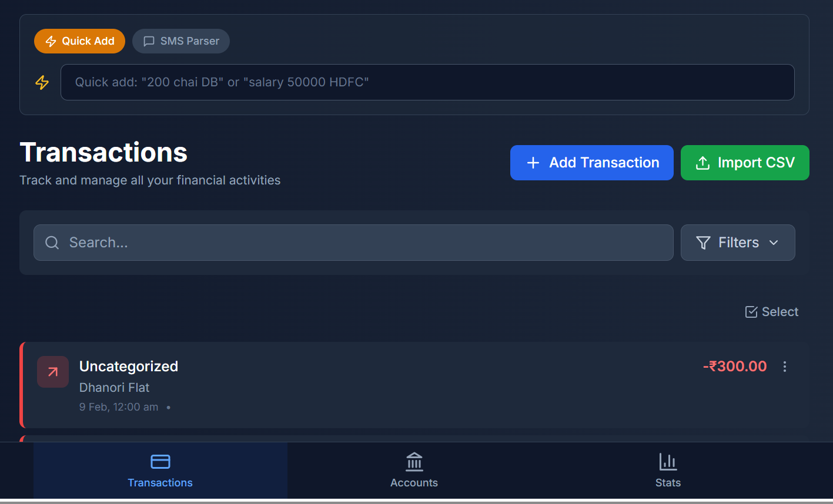
- remove the quick add box from top on transactions tab. It only should be part of "Add Transaction" button.

- Don't want this 'tag ' suffix before category
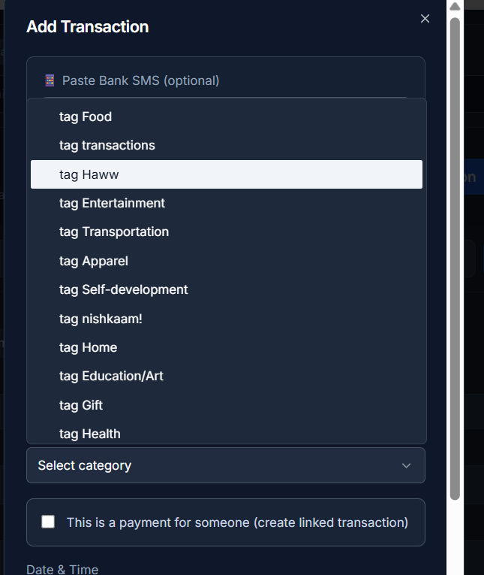

- PWA is not reading the csv correctly hence missing categories & subcategories from every tab, even the mapping in setting tab.
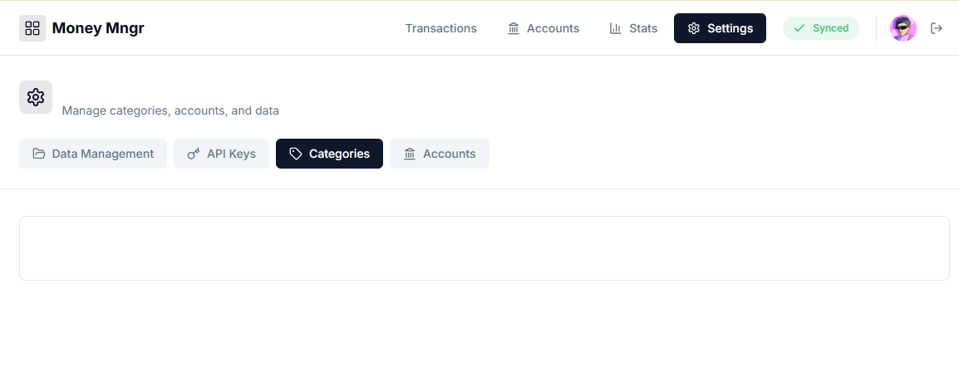
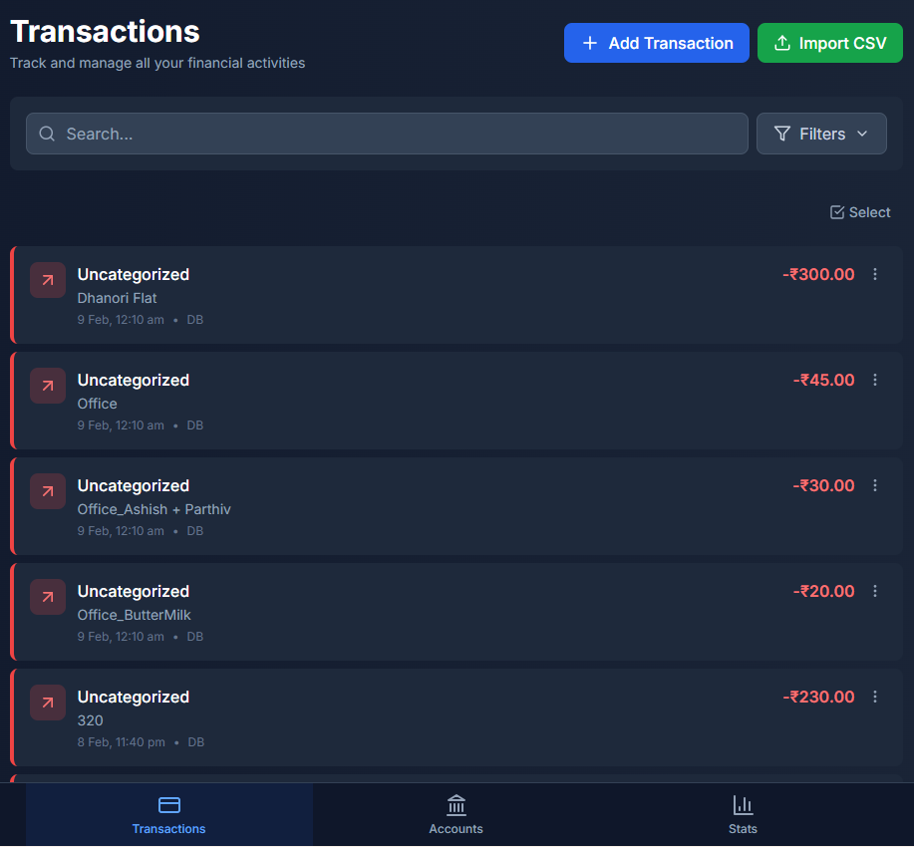

Infact the “Accounts” button on setting tab is not working properly.

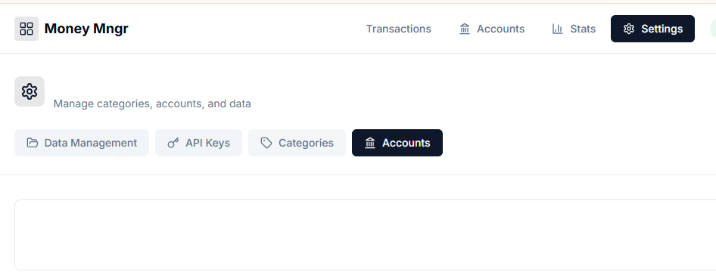
- Only Single value for “Category” is available in dropdown when applying filters.
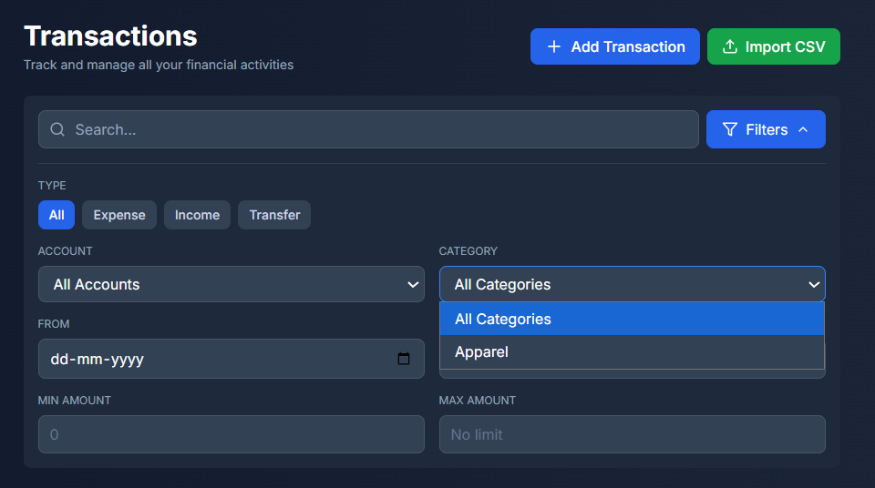

- The values in “Account” dropdown are correct and in proper manner (they don’t show the value alongside).

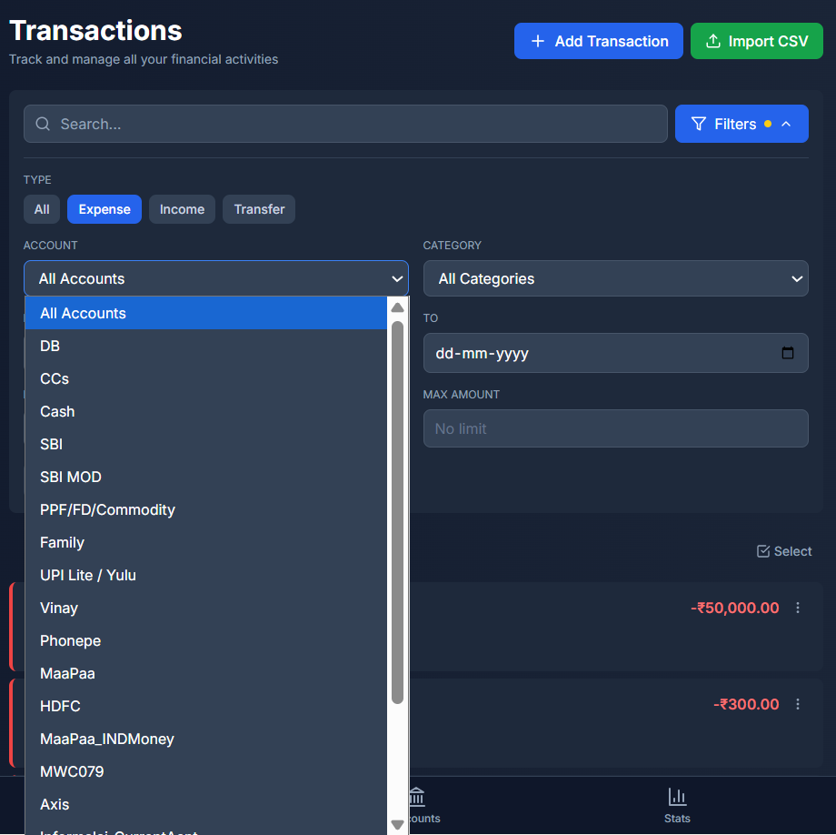

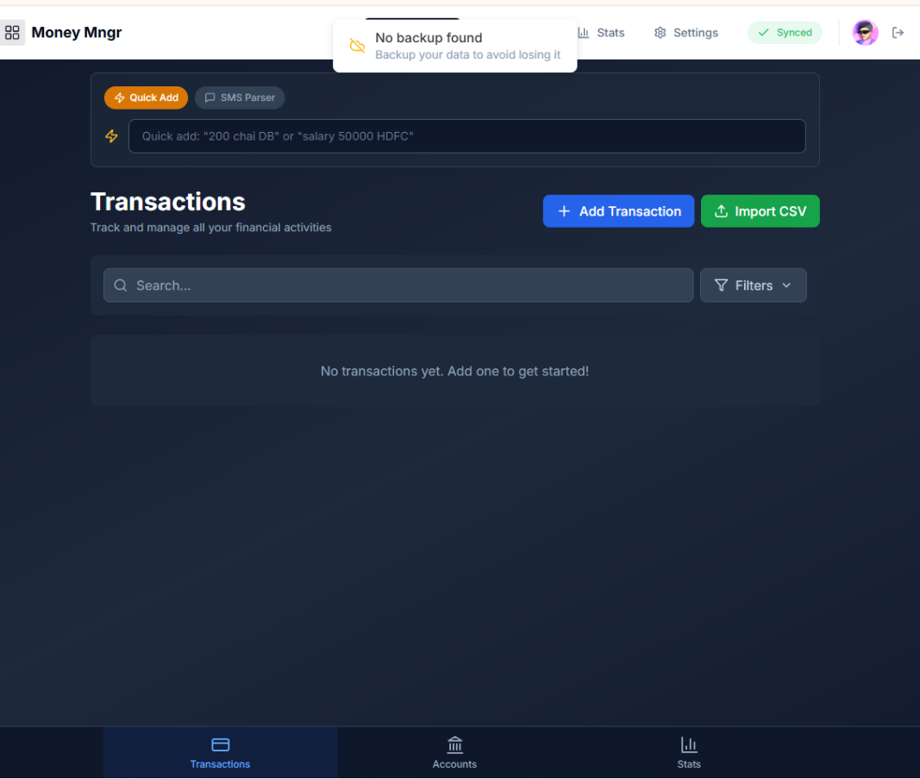
- Transaction page shows a pop-up “No Backup found”, which seems not necessary.

