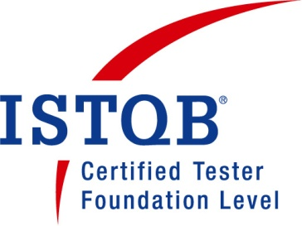 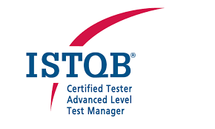  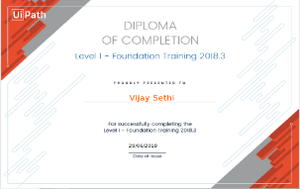

**VIJAY MOHAN SETHI** **Contact Me**

Seeking opportunity as a Test Manager Mobile:91-9711875893 Email: vmsethi@gmail.com

**Profile Summary:**

* 17 years of overall IT experience in Team Management, Water and Agile Methodology, Manual and Automation testing and Environment Lead.
* ISTQB Foundation Level and ISTQB Advanced Level – Test Manager Certified.
* Certified Scrum Master (CSM) having 3 years of experience working on agile projects.
* RPA- UI Path Certified- Foundation level and having basic understanding of automating the business process
* Performing different types of testing such as ST, SIT, UAT, NFT, E2E and Backout testing.
* Adhering to Project Governance i.e., getting project artifacts (TDRA, TRA, System Test Plan, E2E Test Strategy, Test Readiness Review, Test Completion Report, Test Is Completion Report) created and get them reviewed and approved from the project board.
* Experience of implementing automation framework in a team based on Java, Selenium and TestNG framework.
* Experience of performing SOAPUI and Rest API testing.
* Knowledge of performance testing tools- J Meter.
* Knowledge of AWS Cloud and its services.
* Experience of using CI/CD pipeline integration, Version Control such as Jenkins and GitHub
* Experience in doing mobile testing on real devices – iPad, iPhone and Android.
* Experience of performing testing for Web based, Mainframe and ETL based applications.
* Enriched experience of performing testing on various domain such as - Banking- Liquidity Management and UK Cheque Clearing Payments, Life and General Insurance, Annuities, Airline, US Payroll and Customer Messaging.
* Knowledge of Defect Management and Agile tools such as Jira, Zephyr and Confluence.
* Involved in requirement analysis to understand the overall testing scope and based on it produce estimates using WBS Techniques.
* Environment preparation for Dev and Test regions by involving infrastructure resource.
* Identifying risks (write in risk format) and appraise all stakeholders by defining the mitigation strategy.
* Attending stakeholder meetings and Product demonstration are the daily tasks.
* Prepares / updates the metrics dashboard at the end of a phase or at the completion of project
* Monitor test execution, raise issue/concern to the stakeholders.
* Working on Defect Reporting, Verification and Defect Analysis Reports.
* Sending Daily, Weekly and Monthly reports to stake holders.
* Taking care of end-to-end environments activities which involves creation and upgradation of test environments based on Enterprise Cloud Platform (ECP) and extension of test environment on a quarterly basis.

**People Management- Roles and Responsibilities:**

* Handling a team size 4- 5 people with a mix of permanent and vendor resources.
* SOW of Vendor resources
* Plan and arrange Knowledge sharing session to build their skills.
* Coaching and Mentoring of new joiners in team.
* Responsible for the timely and quality deliveries of the tasks assigned to the team.
* Work as point of contact for all people related aspects with the stakeholders.
* Review meetings with the team to monitor progress of projects and provide guidance, develop contingent plans, and arrange resources as needed.
* Monthly catchup with the team in team meeting to discuss issue, concern.
* Regular 1:1 with direct repartees.
* Rewards and recognition for the critical milestone achieved.

**Professional Experience**

**Present Employer –** **NatWest Group**  **Apr 2013 – Till date**

Role – Team Lead Testing

Domain – Customer Messaging/UK Payments/Cash and Liquidity Management

Project Details:

**Customer Messaging Service:** This project is to send bank notifications/alerts to customer via SMS, Email, and Push Notifications. Alerts will be sent to customer real time or in batch on their mobile no and email id’s.

**Cheques Clearing** - This project is to cater the UK Industry need for clearing the check transactions in 2 days (instead of 7 days which currently exists in UK clearing industry). This project was delivered in iterations over the 2 years covering out clearing and in clearing functionalities.

**International Liquidity Investment Management (ILIM):** This project will give customer full visibility, control and optimize use of money worldwide e.g Investment Products like YCDA, GDA, Notice Accounts.

**Responsibilities**:

* Estimating Project (ROM, COM) and create Project Charter/ Plan.
* Environment preparation for Dev and Test regions by involving infrastructure resource.
* Identifying risks (write in risk format) and appraise all stakeholders by defining the mitigation strategy.
* Attending stakeholder meetings and Product demonstration are my daily tasks
* Prepares / updates the metrics dashboard at the end of a phase or at the completion of project
* Creation of test artifacts- Test Strategy/Test Plan/Test Completion Report.
* Working on Defect Reporting, Verification and Defect Analysis Reports.
* Sending Daily, Weekly and Monthly reports to stake holders.

**Aon Hewitt, Gurgoan Feb 2009 – Apr 2013**

**NIIT Technologies, Delhi Mar 2006 – Jan 2009**

**Hewitt Associate, Gurgoan Mar 2005 – Mar 2006**

**Iflexsolutions, Bangalore Jan, 2004 – Mar 2005**

**Domain:** Insurance/Banking/US Payroll/Airline

**Roles:** Individual Contributor/Test Analyst

**Responsibilities**:

* Analyzing the Process and Functional flow of the Applications
* Creating Test Scenarios on the basis of Use Cases, Business Rules and Business Requirement.
* Implementing Quality standard processes.
* Creation of test artifacts- Test Strategy/Test Plan/Test Completion Report.
* Prepare project estimation.
* Update the Risk factor sheet and report of project

**PERSONAL DETAILS:**

Education : B Tech in Electrical, Kurukshetra University

Married : Yes

Sex : Male

Current Location : Faridabad