Group Details
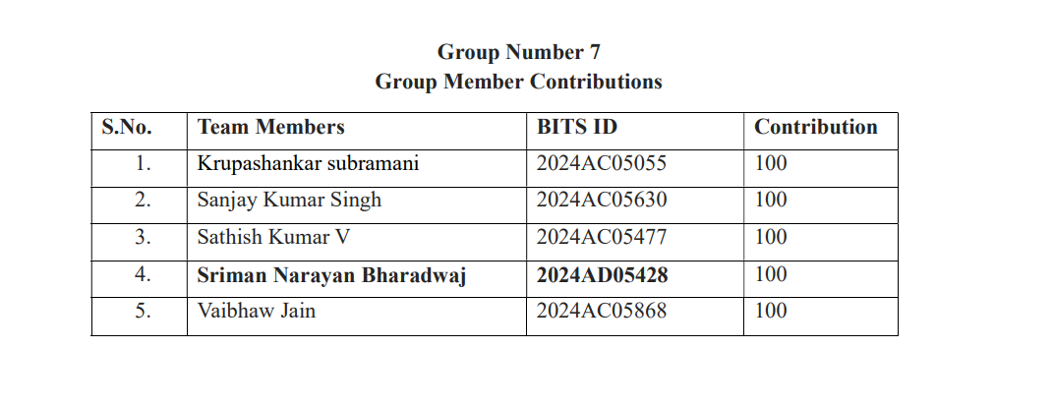

GitHub Repo Link

https://github.com/ersanjay16/Assignment--2-Group7-distributed-K-means

DISTRIBUTED K-MEANS WITH PYSPARK
Codebase Face Sheet

PROJECT OVERVIEW
Project | Distributed K-Means Clustering using PySpark RDDs
Language | Python 3.8+ (PySpark, NumPy, scikit-learn for testing)
Framework | Apache Spark (RDD-based, no MLlib clustering dependencies)
Purpose | Custom parallel K-Means implementation from scratch for understanding distributed computing mechanics
Status | Production-Ready | All tests passing | Overall Score: 8.9/10
Entry Point | spark-submit kmeans_spark.py
FILE INVENTORY
File | Description
kmeans_spark.py | Core implementation: KMeans class + 5 test functions (correctness, performance, convergence, empty clusters, speedup graph)
requirements.txt | Dependencies: pyspark, numpy, scikit-learn, reportlab, matplotlib
README.md | Setup guide, usage examples, API reference, troubleshooting tips
Distributed_KMeans_Report.pdf | Technical report with architecture diagram and speedup analysis
speedup_graph.png | Speedup vs. partitions benchmark visualization
architecture_diagram-K-means_with_spark.jpg | Detailed architecture flowchart (driver-worker communication)
KEY API
KMeans(k, max_iter, tolerance, seed, compute_sse)
fit(rdd, sc) Train the model on an RDD of numpy arrays
predict(rdd, sc) Return cluster labels for each point
centroids Final centroid positions (np.ndarray)
sse_history SSE values per iteration (when compute_sse=True)
ARCHITECTURE
Driver-executor pattern: driver broadcasts centroids each iteration; workers perform vectorized distance computation (NumPy) via mapPartitions; results aggregated with reduceByKey. Handles empty clusters via dynamic re-initialization.
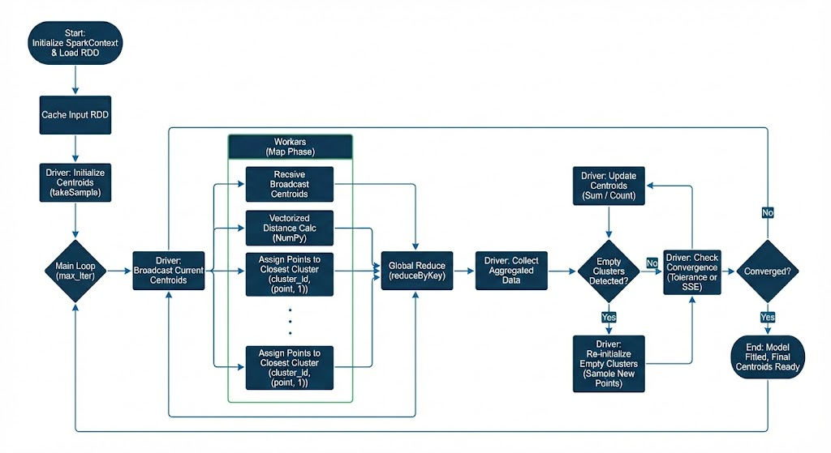
QUICK START
pip install -r requirements.txt
spark-submit kmeans_spark.py

