Project: Application Deployment
(Deploy the given React application to a production ready state)
Application: Clone the below mentioned repository and deploy the application (Run application in port 3000). Repo URL : https://github.com/Vennilavanguvi/Brain-Tasks-App.git

● GitHub Repository: https://github.com/ersaurav88-devops/DevOps-Project-Brain-Tasks.git
● LoadBalancer ARN: arn:aws:elasticloadbalancing:us-east-1:060699023193:loadbalancer/ aef99fdaff6c34e9e825b227eb2e2f44

1. Clone the Repository
Clone Repository from GitHub
git clone https://github.com/Vennilavanguvi/Brain-Tasks-App.git
Move into project folder:
cd Brain-Tasks-App

2. Verify Repository Structure
The repository contains only production build files (dist/) and does not include source code or package.json.
Check files:
dir

3. Create Dockerfile
Create a file named:
Dockerfile
FROM nginx:latest
COPY dist/ /usr/share/nginx/html
RUN sed -i 's/listen 80;/listen 3000;/' /etc/nginx/conf.d/default.conf
EXPOSE 3000
CMD ["nginx", "-g", "daemon off;"]

Screenshot
- Dockerfile content
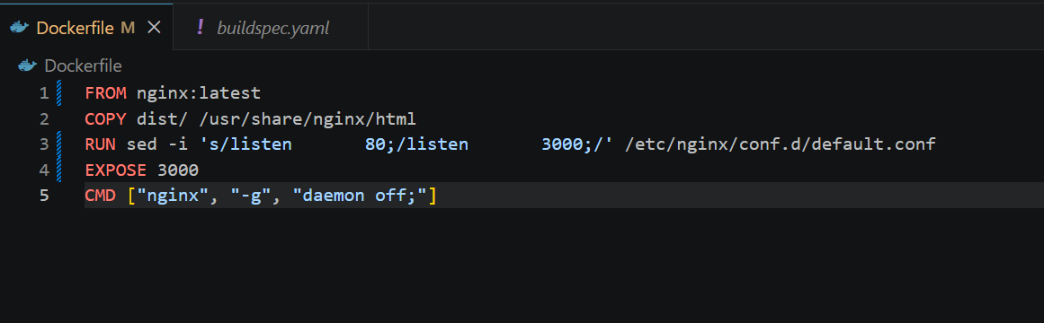

4. Build Docker Image
Run the following command:
docker build -t brain-tasks-app .
Screenshot
Successful docker build output
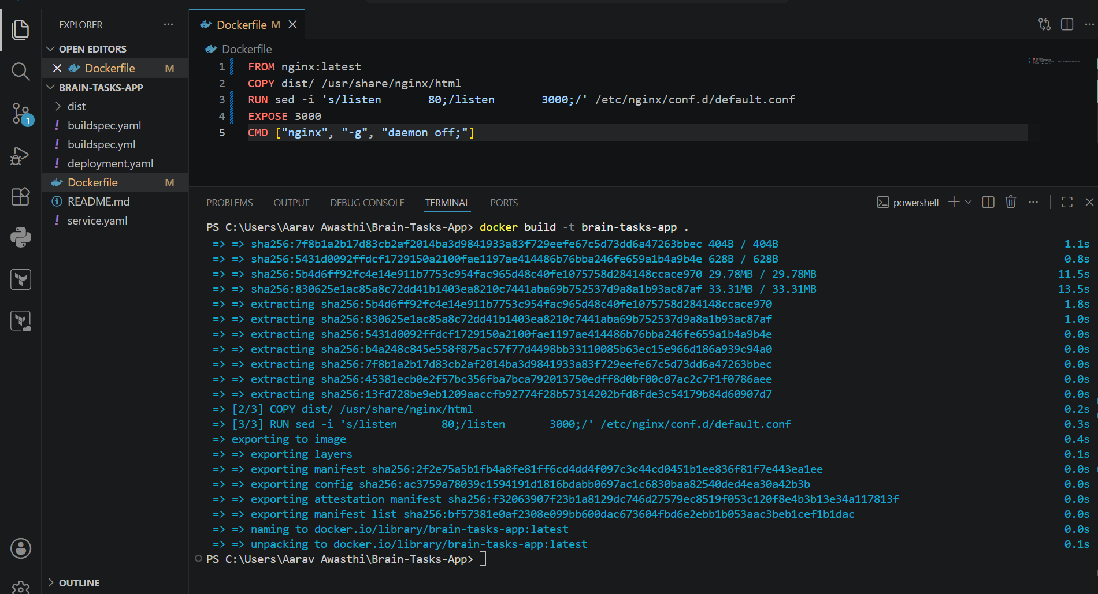

5. Run Docker Container
Run container:
docker run -d -p 3000:3000 --name brain-app brain-tasks-app
Check running containers:
docker ps

6. Access Application
Open browser:
http://localhost:3000

Screenshot
Running Docker container
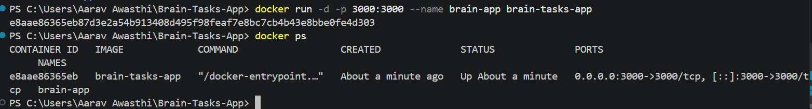
Application running in browser
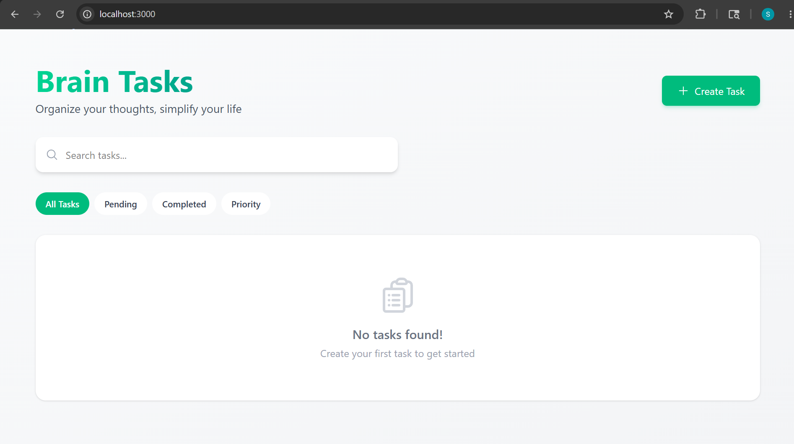

7. Create AWS ECR Repository
Login to AWS Console.
Navigate to:
Amazon Elastic Container Registry (ECR)
Create repository:
brain-tasks-app

Screenshot
ECR repository created
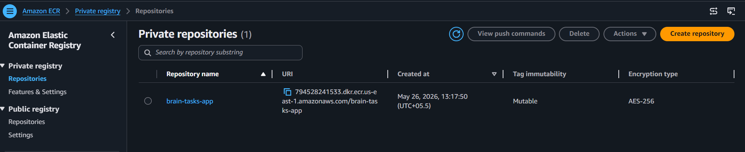

10. Push Docker Image to ECR
docker push 794528241533.dkr.ecr.us-east-1.amazonaws.com/brain-tasks-app:latest
Screenshot
Docker image successfully pushed to ECR
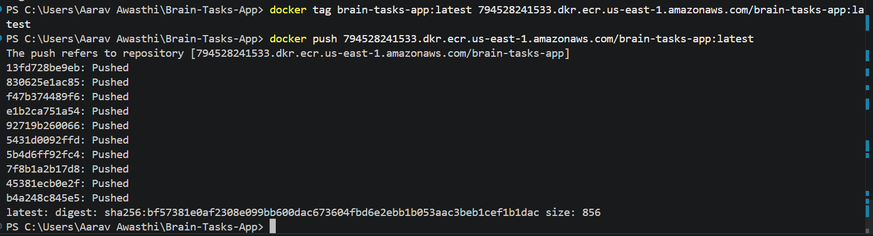
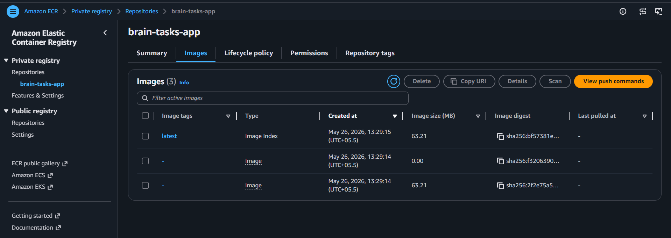
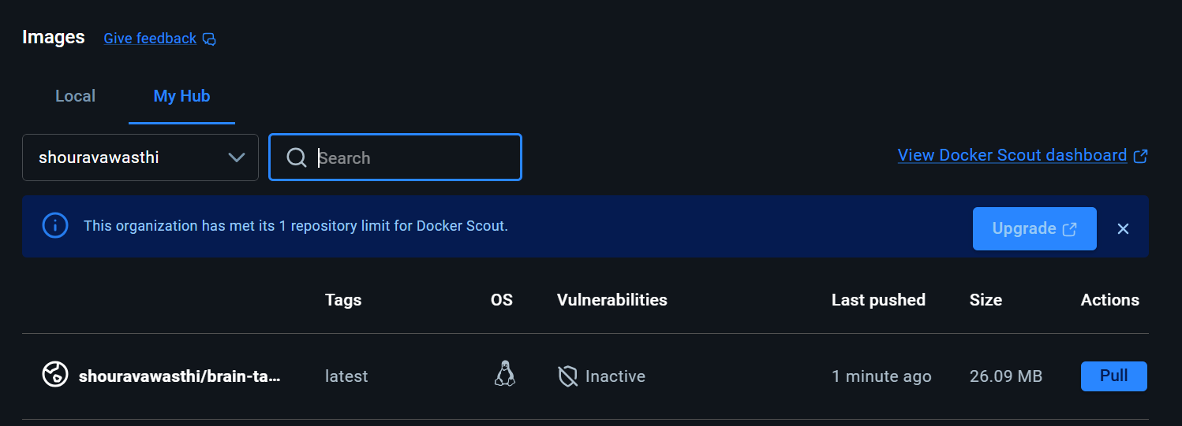

11. Setup AWS EKS Cluster
Create cluster using eksctl:
eksctl create cluster \
--name brain-cluster \
--region us-east-1 \
--nodegroup-name linux-nodes \
--node-type c7i-flex.large \
--nodes 2
--nodes-min 1 \
--nodes-max 3 \
--managed
12. Verify EKS Cluster
Run: kubectl get nodes
Screenshot
Running EKS cluster
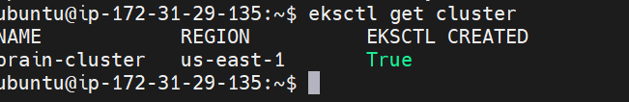
Worker nodes in Ready state
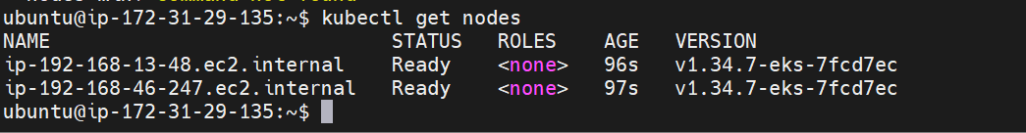

13. Create Kubernetes Deployment File
Create file: deployment.yaml
Content:
apiVersion: apps/v1
kind: Deployment
metadata:
name: brain-tasks-deployment
spec:
replicas: 2
selector:
matchLabels:
app: brain-tasks-app
template:
metadata:
labels:
app: brain-tasks-app
spec:
containers:
- name: brain-tasks-app
image: shouravawasthi/brain-tasks-app:latest
ports:
- containerPort: 3000
14. Create Kubernetes Service File
Create file: service.yaml
Content:
apiVersion: v1
kind: Service
metadata:
name: brain-tasks-service
spec:
type: LoadBalancer
selector:
app: brain-tasks-app
ports:
- protocol: TCP
port: 80
targetPort: 3000

Screenshot
deployment.yaml
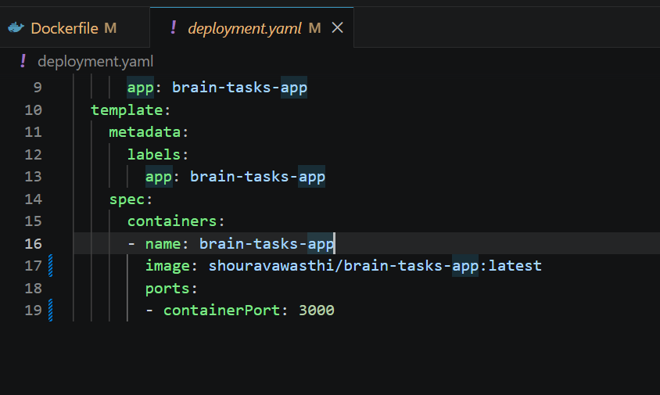
service.yaml
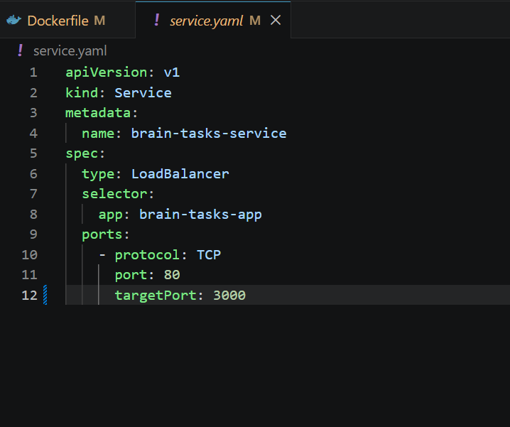

15. Deploy Application to Kubernetes
Apply YAML files:
kubectl apply -f deployment.yaml
kubectl apply -f service.yaml
Verify resources:
kubectl get deployments
kubectl get pods
kubectl get svc

Screenshot
Take screenshot showing:
Deploment
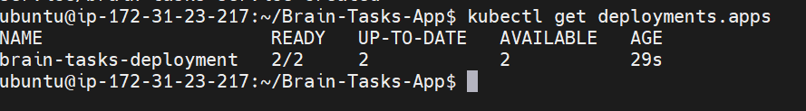
- Running pods
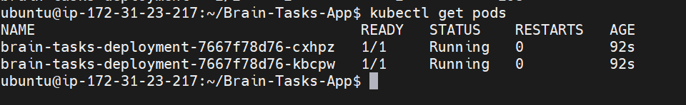
- LoadBalancer service

16. Access Application via LoadBalancer
Copy EXTERNAL-IP from:
kubectl get svc
Open browser:
abf11a4fb09a64410a685bda5f62a45d-1106431807.us-east-1.elb.amazonaws.com
Screenshot : Application accessible from EKS LoadBalancer
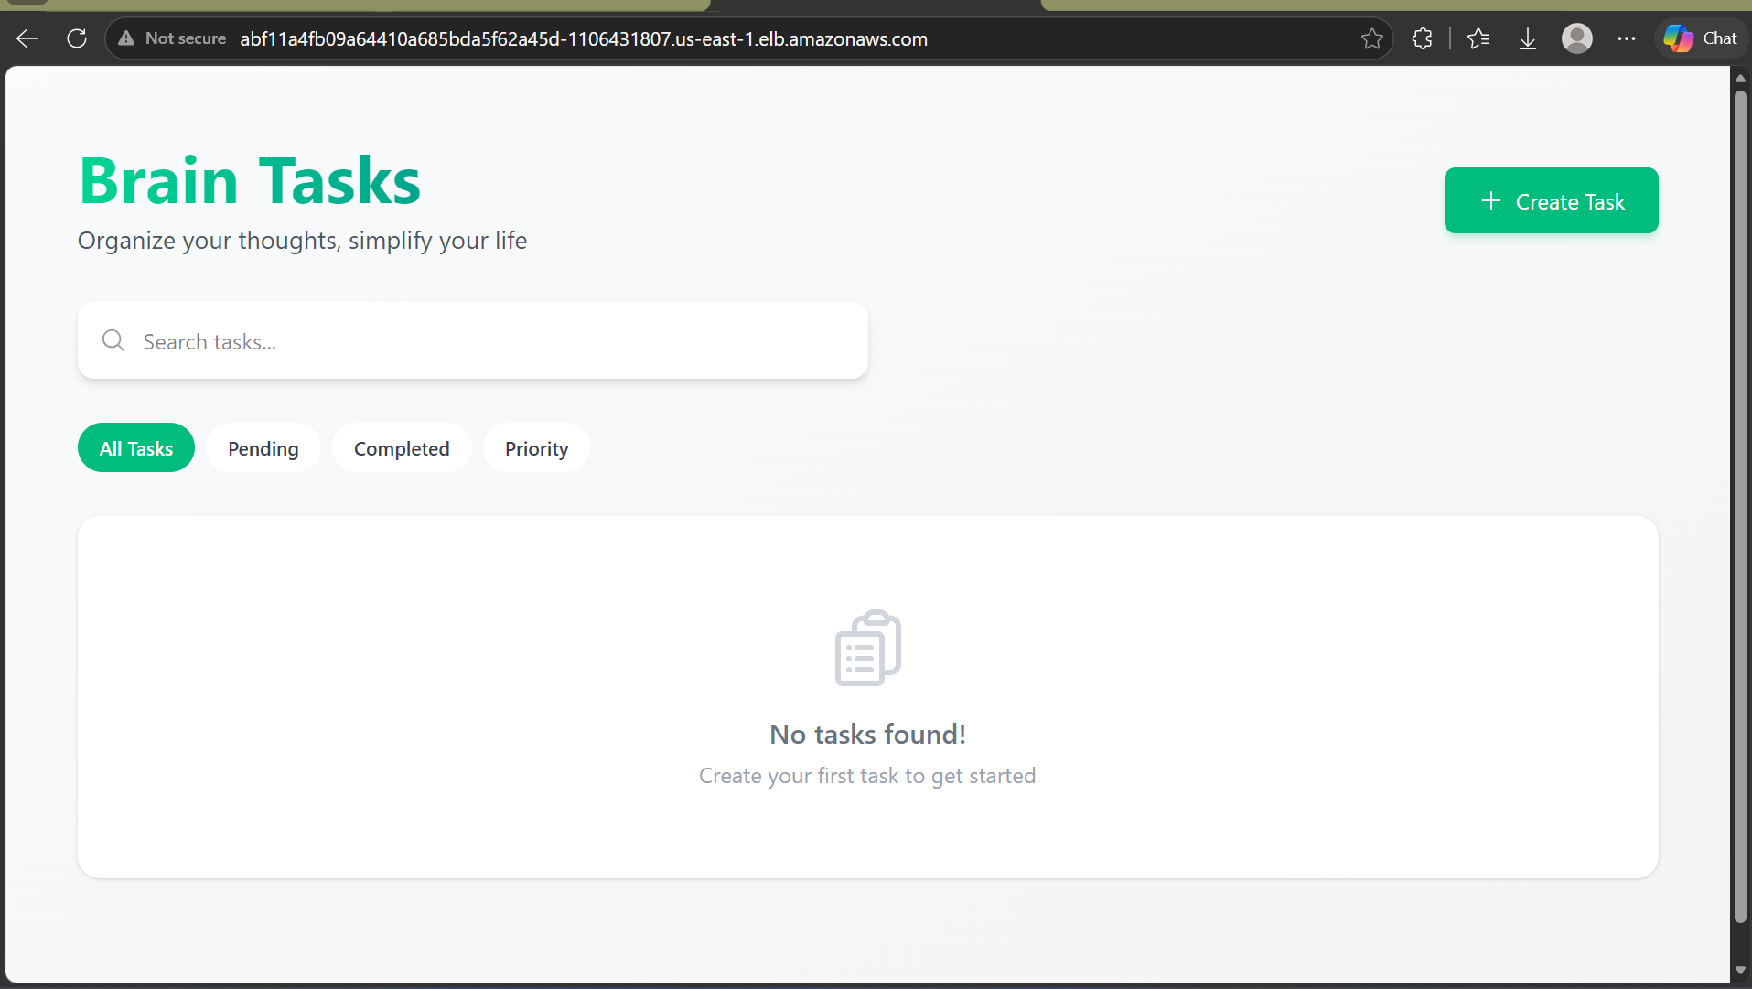

17. Create buildspec.yml File
Create:
buildspec.yml
Add:
version: 0.2

env:
variables:
AWS_STS_REGIONAL_ENDPOINTS: regional

phases:
install:
commands:
- curl -LO "https://dl.k8s.io/release/v1.30.0/bin/linux/amd64/kubectl"
- install -o root -g root -m 0755 kubectl /usr/local/bin/kubectl
- chmod +x kubectl
- mv ./kubectl /usr/local/bin/kubectl
- kubectl version --client

pre_build:
commands:
- echo "Logging in to Amazon ECR..."
- aws ecr get-login-password --region us-east-1 | docker login --username AWS --password-stdin 794528241533.dkr.ecr.us-east-1.amazonaws.com
- echo "Connecting to EKS Cluster..."
- aws eks update-kubeconfig --name brain-cluster --region us-east-1
- aws sts get-caller-identity
- kubectl get nodes

build:
commands:
- echo "Building the Docker image..."
- docker build -t brain-tasks-app .
- docker tag brain-tasks-app:latest 794528241533.dkr.ecr.us-east-1.amazonaws.com/brain-tasks-app:latest

post_build:
commands:
- echo "Pushing the Docker image to ECR..."
- docker push 794528241533.dkr.ecr.us-east-1.amazonaws.com/brain-tasks-app:latest
- echo "Deploying to EKS..."
- kubectl apply -f deployment.yaml
- kubectl apply -f service.yaml
- echo "Deployment Complete!"
Screenshot buildspec.yml file
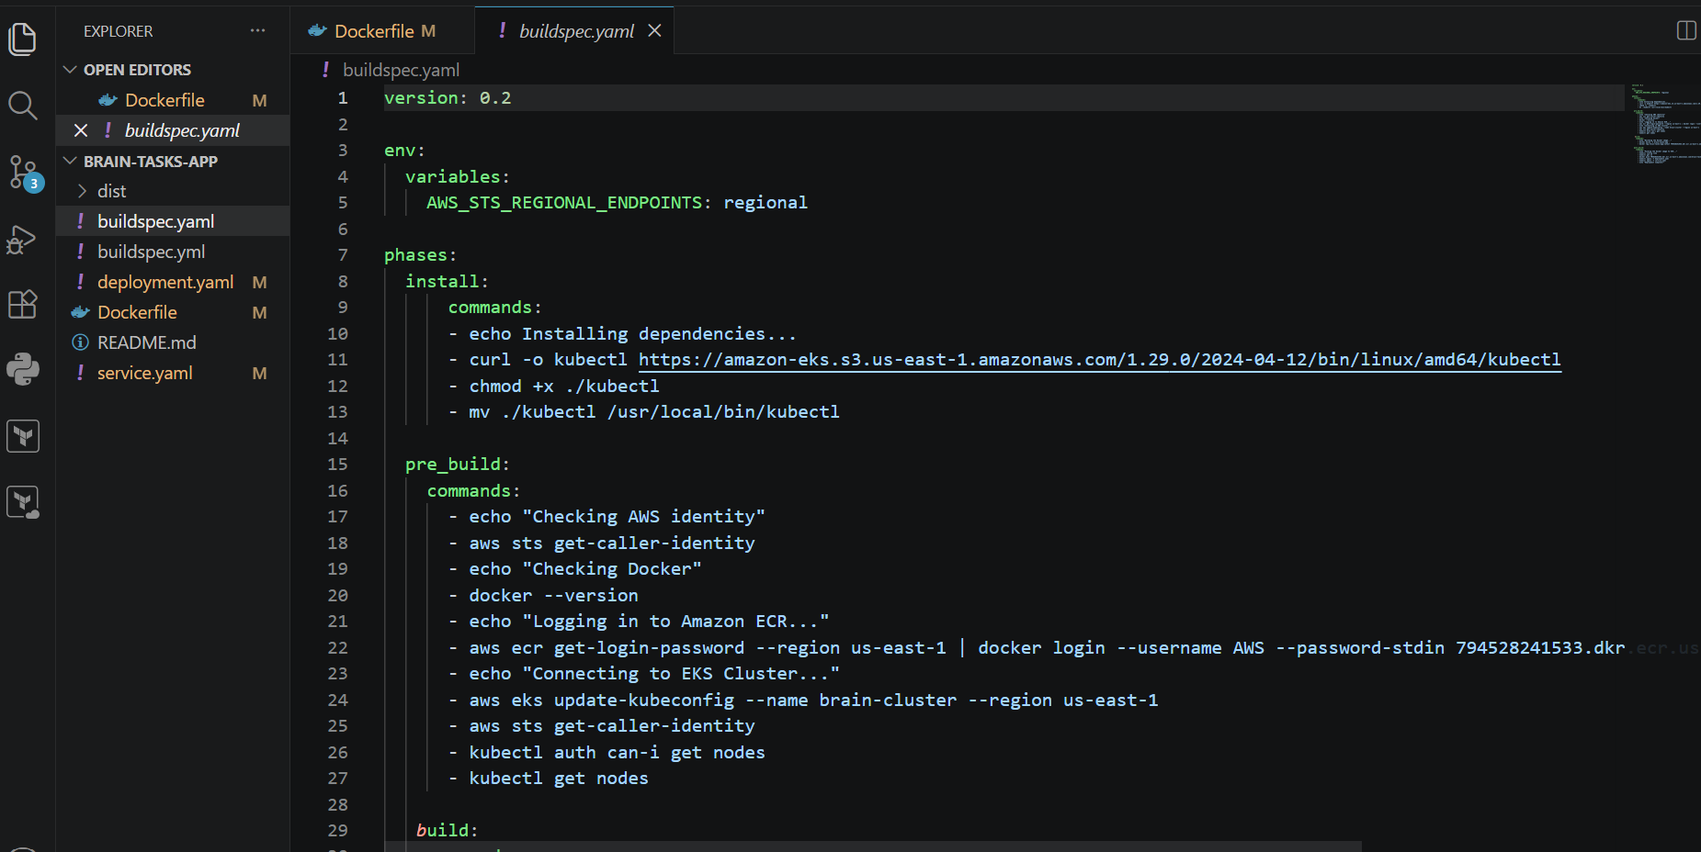

18. Create AWS CodeBuild Project
Configuration:
- Source Provider: GitHub
- Environment: Managed Image
- OS: Ubuntu / Amazon Linux
- Privileged Mode: Enabled

Screenshot:
- CodeBuild project configuration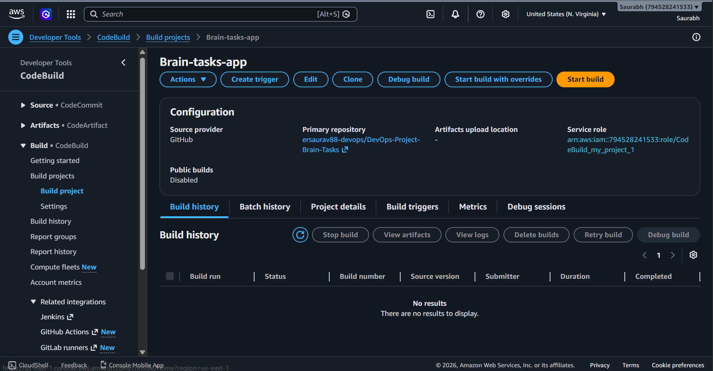
19. Push Project to GitHub using CLI
Initialize repository:
git init
git add .
git commit -m "Initial deployment setup"
Push code:
git push -u origin main

Screenshot
Git push successful
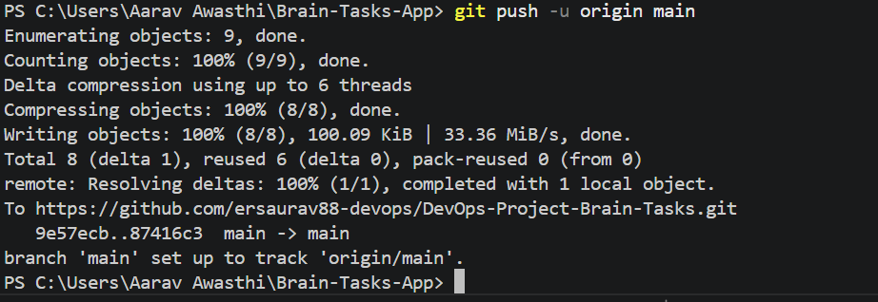
Repository visible on GitHub
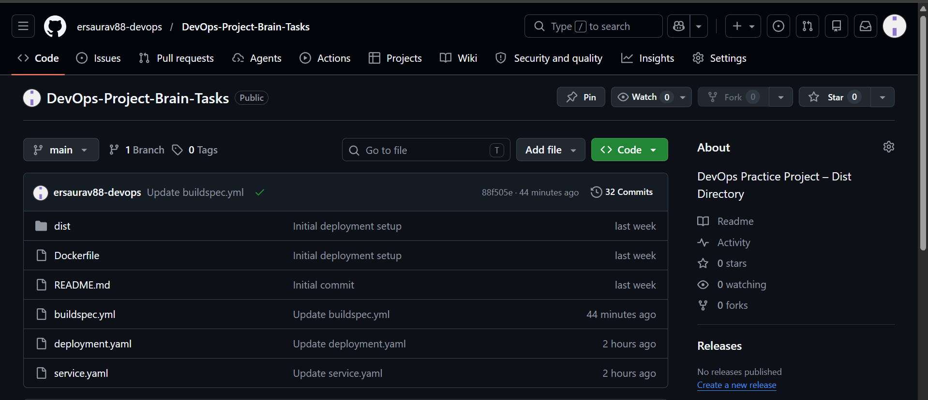

20. Create AWS CodePipeline
Pipeline Stages:
- Source → GitHub
- Build → AWS CodeBuild
- Deploy → Amazon EKS

Screenshot
- CodePipeline stage
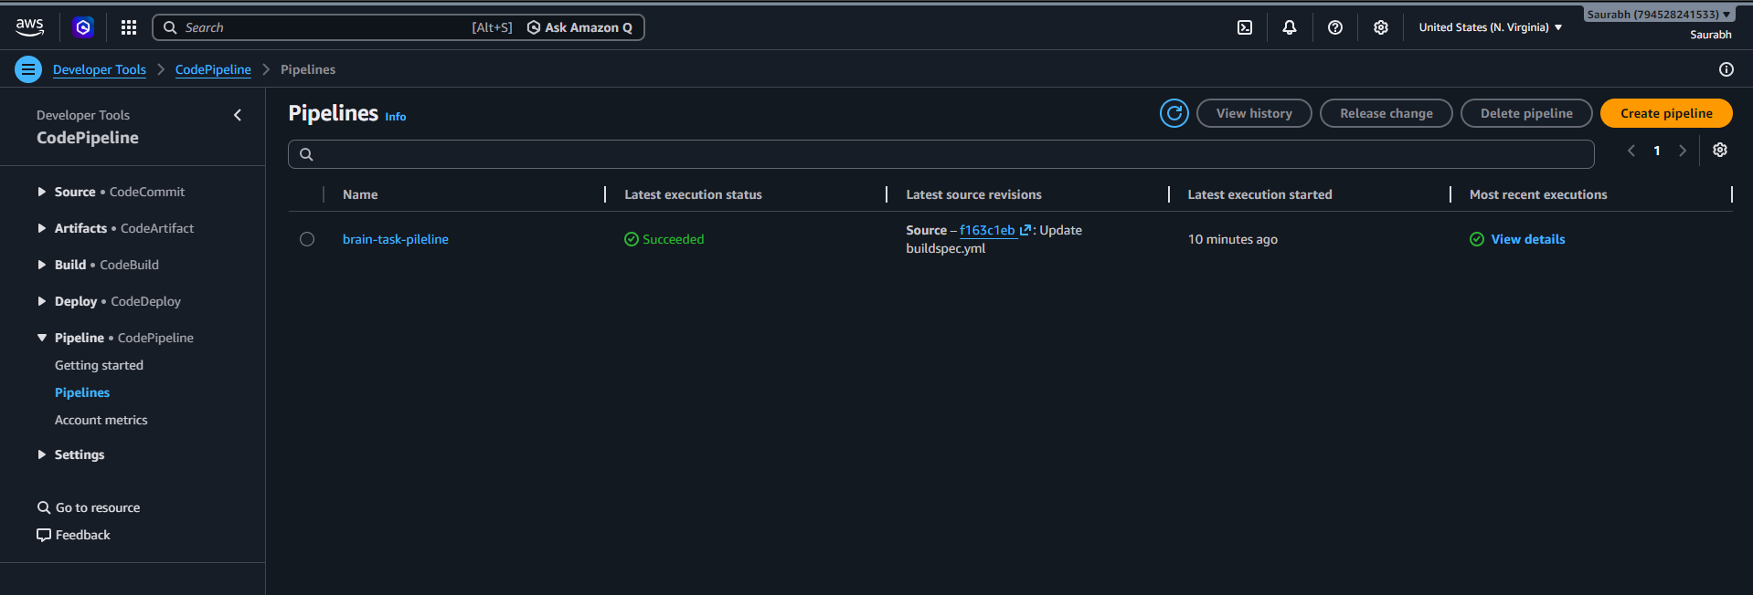
- Successful execution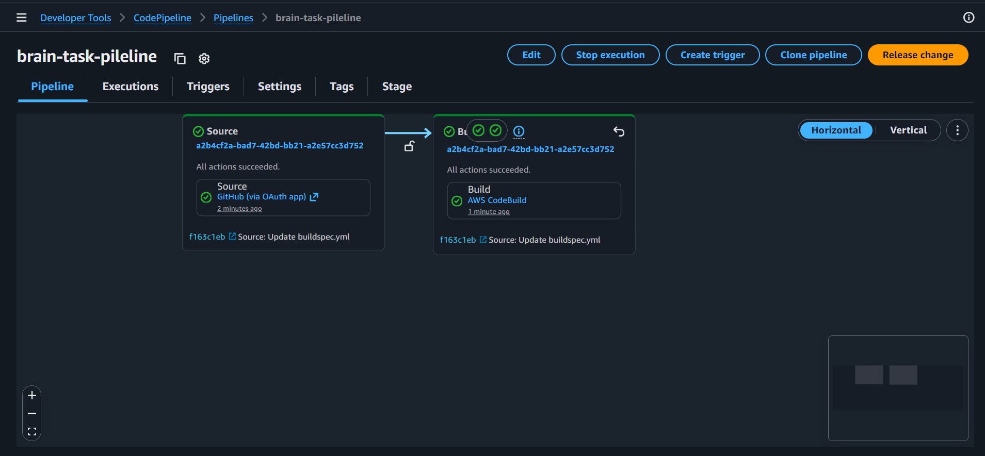

21. Monitoring using CloudWatch Logs
Monitor:
- CodeBuild logs
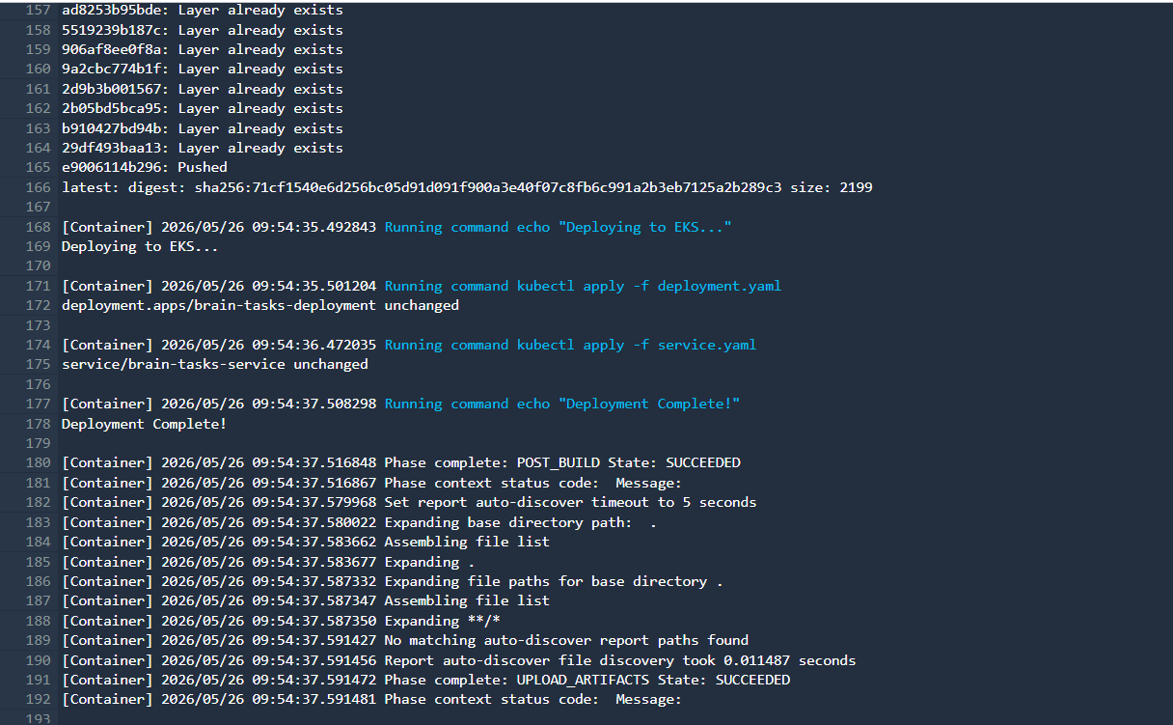

Screenshot CloudWatch Logs
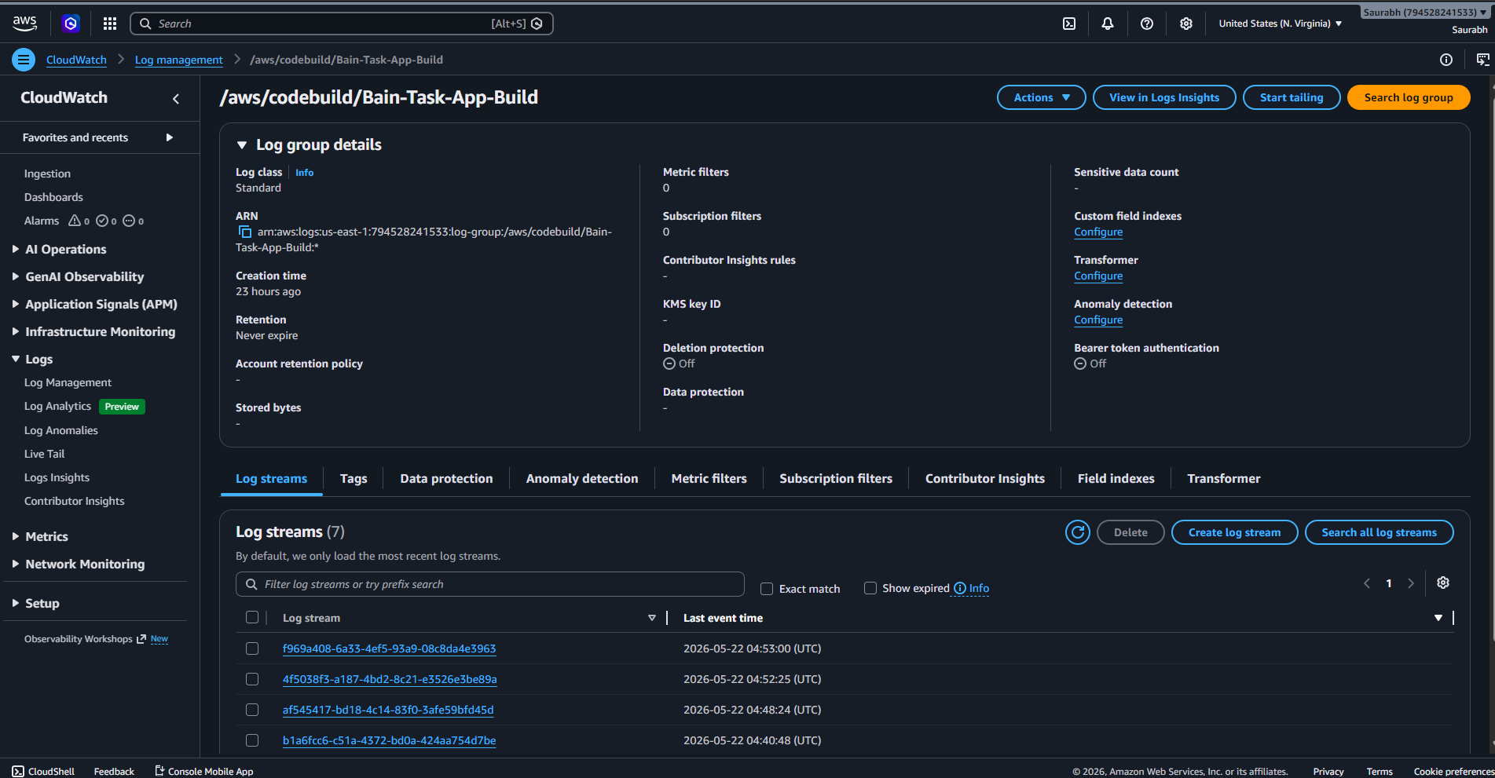
Build logs
