

2022

FORECA WEATHER DOCUMENTATION

TABLE OF CONTENTS

1. DOCUMENTATION 3

1.1. Home page 3

1.2. Forecast page 5

**TABLE OF FIGURES**

Figure 1, Home page prior to search 3

Figure 2, Search form with illegal input 4

Figure 3, Home page with search results 5

Figure 4, City weather forecast 6

# DOCUMENTATION

“Foreca weather” web application allows users to get weather report for a city of their choice. City and weather data is obtained using foreca.com APIs.

## Home page

The main page of this web applications is the home page. Here, the user can search for any city, of which they want to get a weather report.

The Home page consists of 2 sections:

* Navigation bar;
* Result list.

The preview of the page is shown in Figure 1.



Figure 1, Home page prior to search

The navigation bar makes sure that the user can navigate the website freely. It consits of:

* Foreca logo;
* Home button;
* Search form.

Clicking on the Foreca logo redirects the user to the Foreca website at [https://www.foreca.com](https://www.foreca.com/).

Clicking on the Home button opens the Home page.

The search form is only visible when the Home page is open, it is used to search for a desired city. The search text can only contain alphanumeric characters and space, up to 30 symbols. An example of illegal input is shown in Figure 2.

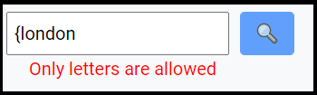

Figure 2, Search form with illegal input

If the search text is valid, the user can click the search button. Clicking the search button displays cities that match the search in the Home page Result list section. An example of a successful search can be seen in Figure 3.

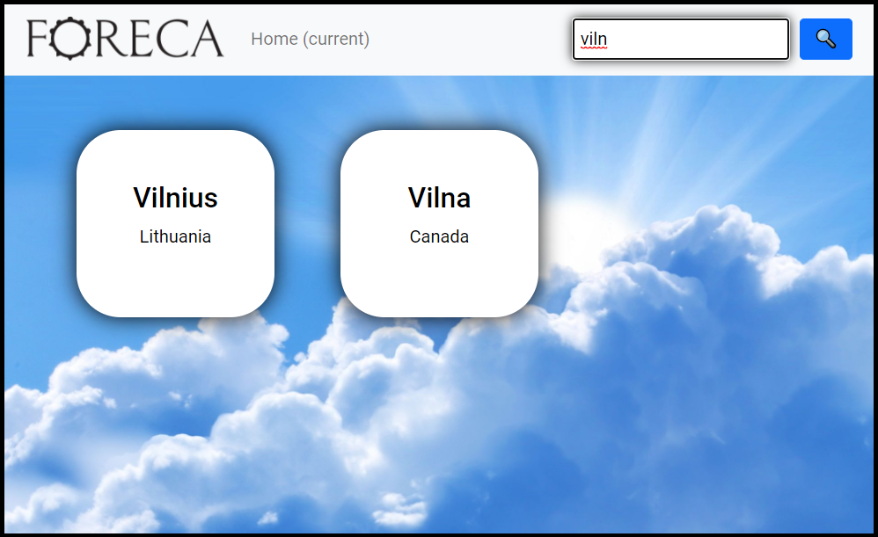

Figure 3, Home page with search results

The user can click on a city card to open weather forecast page for that city.

## Forecast page

The Forecast page displays current and daily weather conditions for a given city. Preview of this page can be seen in figure 4.

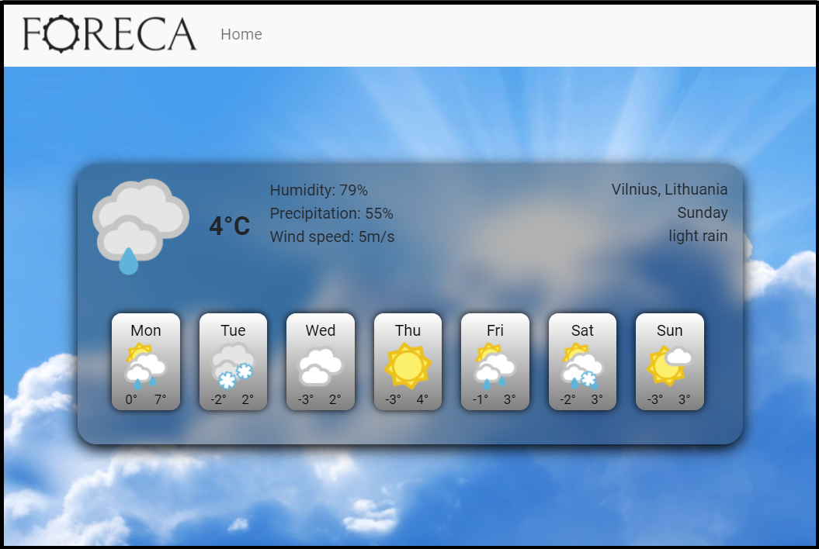

Figure 4, City weather forecast

The Forecast page consists of 2 sections:

* Navigation bar;
* Weather forecast.

The navigation bar in this page does not contain the search form.

The weather forecast section displays the current forecast of the city with the information:

* Icon showing current weather condition in the city;
* Current temperature in the city;
* Humidity;
* Precipitation;
* Wind speed;
* 7 days forecast.

If the page is open on a screen wider than 575 pixels, additional information is displayed:

* Current city and country;
* Current day of the week;
* Weather summary phrase.