CSE-591 - DATA ANALYTICS
Project Final Report
World Happiness Report using Apache Spark
Ersin Akşar – Feyza Özkefe
Işık University, İstanbul – Turkey

Abstract
Happiness is one of the most important components in life, however, qualifying happiness is not such a happy task. For this purpose, the World Happiness Report was created: An annual survey that measures happiness around the globe. It uses six different metrics: (i) healthy life expectancy, (ii) social support, (iii) freedom to make life choices, (iv) Trust (goverment corruption), (v) GDP per capita, and (vi) generosity. Those metrics combined in an index rank countries by their happiness.
In this study, we aimed to show the relationship between these six factors and visualise the world happiness scores that are reported by the Gallup World Poll. This project was made using the Python programming language. We also used the Pyspark library on Python, which includes the Apache Spark framework. Seaborn, matplotlib and plotly libraries were used in visualizations. In our analysis, the factors that affect happiness most and the relationships between each other were looked at and all results were visualized.
1. Introduction

2. Methodology
One hundred and six countries with six metrics to measure happiness are collected from a public database from year 2015 to 2021. The necessary preprocessing on the data has been implemented and merged.
Collected data variables:
Country: Name of the country
Region: The region the country belongs to
Happiness Rank: The rank of the country based on the Happiness Score
Happiness Score: A metric measured based on the happiness scale of 1 to 10.
The English wording of the question is “Please imagine a ladder, with steps numbered from 0 at the bottom to 10 at the top. The top of the ladder represents the best possible life for you and the bottom of the ladder represents the worst possible life for you. On which step of the ladder would you say you personally feel you stand at this time?” This measure is also referred to as Cantril life ladder, or just life ladder in our analysis. (Happiness Score)
Economy (GDP per Capita): In purchasing power parity (PPP) at constant 2017 international dollar prices are from the October 14, 2020 update of the World Development Indicators (WDI).
Family (Social Support): Social support (or having someone to count on in times of trouble) is the national average of the binary responses (either 0 or 1) to the GWP question “If you were in trouble, do you have relatives or friends you can count on to help you whenever you need them, or not?”
Health (Life Expectancy): Healthy life expectancies at birth are based on the data extracted from the World Health Organization’s (WHO) Global Health Observatory data repository (Last updated: 2020-09-28).
Freedom (To Make Life Choices): Freedom to make life choices is the national average of responses to the GWP question “Are you satisfied or dissatisfied with your freedom to choose what you do with your life?”
Trust (Government Corruption): The measure is the national average of the survey responses to two questions in the GWP: “Is corruption widespread throughout the government or not” and “Is corruption widespread within businesses or not?” The overall perception is just the average of the two 0-or-1 responses. In case the perception of government corruption is missing, we use the perception of business corruption as the overall perception. The corruption perception at the national level is just the average response of the overall perception at the individual level.
Generosity: Generosity is the residual of regressing national average of response to the GWP question “Have you donated money to a charity in the past month?” on GDP per capita.

3. Results
Table 1. Summary Statistics for the year 2019 World Happiness Report Results
Variable | Mean | Std Dev | Min | Max
Happiness Score | 5.40 | 1.11 | 2.85 | 7.76
Economy | 0.90 | 0.39 | 0.00 | 1.68
Family | 1.20 | 0.29 | 0.00 | 1.62
Health | 0.72 | 0.24 | 0.00 | 1.14
Trust | 0.11 | 0.09 | 0.00 | 0.45
Generosity | 0.18 | 0.09 | 0.00 | 0.56

Table 2. Summary Statistics for the year 2020 World Happiness Report Results
Variable | Mean | Std Dev | Min | Max
Happiness Score | 5.47 | 1.11 | 2.50 | 7.80
Economy | 0.86 | 0.37 | 0.00 | 1.53
Family | 1.15 | 0.28 | 0.00 | 1.54
Health | 0.69 | 0.25 | 0.00 | 1.13
Trust | 0.13 | 0.11 | 0.00 | 0.53
Generosity | 0.18 | 0.10 | 0.00 | 0.56

Table 3. Summary Statistics for the year 2021 World Happiness Report Results
Variable | Mean | Std Dev | Min | Max
Happiness Score | 5.53 | 1.07 | 2.52 | 7.84
Economy | 0.97 | 0.40 | 0.00 | 1.75
Family | 0.79 | 0.25 | 0.00 | 1.17
Health | 0.52 | 0.21 | 0.00 | 0.89
Trust | 0.13 | 0.11 | 0.00 | 0.54
Generosity | 0.17 | 0.09 | 0.00 | 0.54

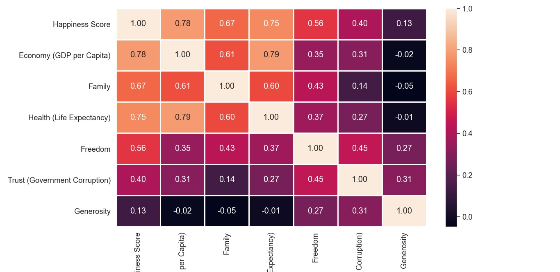
Graphic1
Graphic1 also includes a correlation matrix that examines the relationship of Happiness Score , Economy , Family, Health, Trust Generosity parameters with each other. When you look closely at this matrix, it is seen that it is the economic parameter that shows the highest correlation with the number of happiness. It has a correlation value of 0.78. Then comes health with 0.75. The point here is that the correlation between economy and health is greater than the correlation between the happiness score and the happiness score separately. Therefore, it is understood that the relations between economy and health with each other are more than the happiness score. Based on this, in order for a country's happiness score to be high, not only the economy or not only health scores, but also these two parameters must be high together.

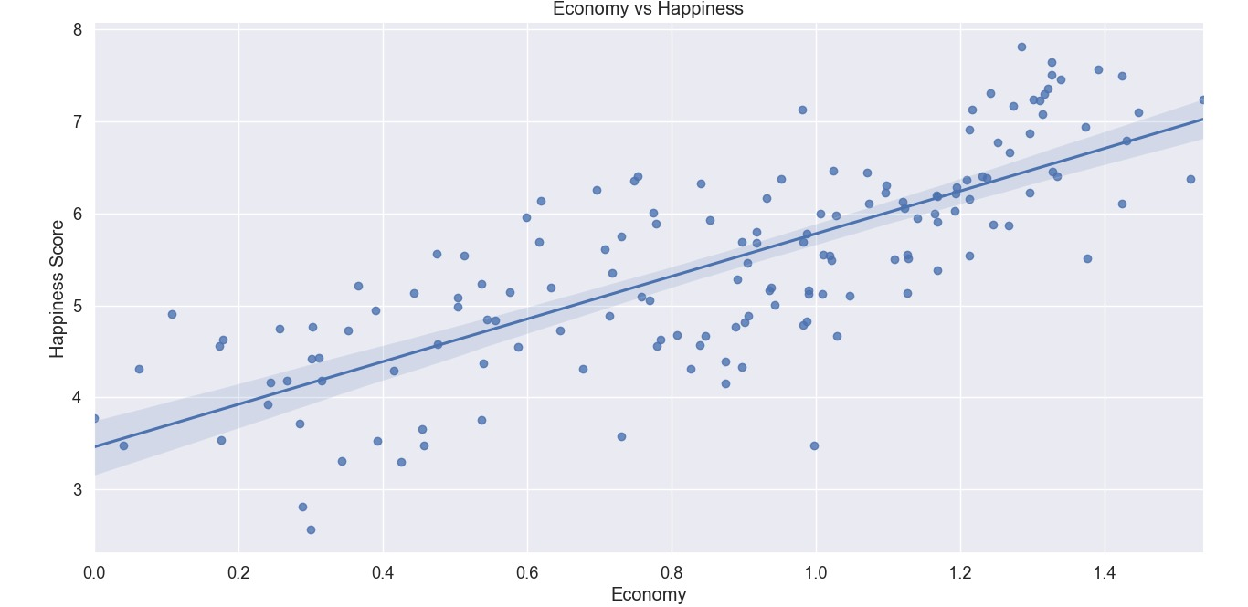

Graphic2
According to the results observed and obtained in Graph 1, we can look at graph 2 to take a closer look at the relationship between economics and happiness. In Chart 2, we can see that the relationship between happiness score and economy is linear. Chart 2 is drawn using 2020 data.

Yine aynı şekilde sağlık ve mutluluk puanı arasındaki ilişkiyi incelemek için grafik 3 e bakabiliriz.

Tablo 1 de Happiness Score , Economy ,Family, Health,Trust Generosity parametrelerinin birbirleriyle ilişkilerini inceleyen korelasyon matrisi bulunmaktadır. Bu matrise yakından bakıldığıda görülmektedir ki mutluluk sayısı ile en yüksek korelasyonu gösteren ekonomi parametresidir. 0.78’lik bir korelasyon değerine sahiptir. Sonrasında 0.75 ile sağlık gelmektedir. Burada dikkat çeken nokta ekonomi ve sağlık arasındaki korelasyonun ayrı ayrı mutluluk puanıyla aralarındaki korelasyon değerinden fazla olmasıdır. Dolayısıyla buradan ekonomi ve sağlığın birbirleriyle olan ilişkilerinin mutluluk puanıyla olna ilişkiden daha fazla olduğu anlaşılmaktadır. Buna dayanarak bir ülkenin mutluluk puanının yüksek olması için sadece ekonomi ya da sadece sağlık puanlarının değil bu iki parametrenin de beraber yüksek olması gerekmektedir.

Grafik 1 de gözlemlenen ve elde edilen sonuçlara göre ekonomi ve mutluluk ilişkisine yakından incelemek için grafik 2 ye bakabiliriz. Grafik 2 de mutluluk puanı ve ekonomi arasındaki ilişkiyinin lineer olduğunu görebiliriz. Grafik 2 2020 verileri kullanılarak çizdirilmiştir.

