 | 

DENSE VS FOCUSED ON DQN FOR REINFORCEMENT
LEARNING

Bachelor’s Thesis

Ersin ÇEBİ
217SE2407D
Supervised by
Dr. F.Boray TEK

June 2020

DENSE VS FOCUSED ON DQN FOR REINFORCEMENT
LEARNING

Abstract

An important objective of the area of AI is to produce fully autonomous agents that interact with the environment to learn optimal behavior. The development of adaptive and efficient AI algorithms has been a longstanding challenge. RL is a principal mathematical system for autonomous learning guided by experience. Although in the past RL had some success, previous approaches lacked scalability and were inherently limited to relatively low-dimensional issues. This is because RL algorithms have the same complexity problem as other algorithms: memory complexity, computational complexity, and sample complexity, for machine-learning algorithms. The objective of this system is to develop an application for reinforcement learning and compare the efficiency of dense and focus layers.

Focusing neurons can generate unique connection maps for a problem. The new model uses no other tool than the back-propagation algorithm to learn its focus parameters which control the receptive field locations and apertures. So neurons can learn and adapts itself.

TABLE OF CONTENTS

Abstract
Acknowledgements
TABLE OF CONTENTS
LIST OF FIGURE
DEFINITIONS, ACRONYMS AND ABBREVIATIONS
1. Introduction 7
1.1 Purpose of the System.....................................................................................................7
1.2 Scope of the System........................................................................................................7
1.3 Objectives and Success Criteria of the Project................................................................8
2. Literature Review 9
3. Proposed Method..................................................................................................................18
4. Implementation Details 20
5. Tests and Experiments 20
6. Conclusion and Future Work 21
References 22

LIST OF FIGURES

Figure 2. 1 ANNs performing simple logical computations 9
Figure 2. 2 Linear threshold unit 9
Figure 2. 3 Multi-Layer Perceptron 10
Figure 2. 4 Activation functions and their derivatives 11
Figure 2. 5 The role of activation function 11
Figure 2. 6 Deciding next Q-value on the table, according to the previous action that taken 12
Figure 2. 7 Reinforcement Learning using a neural network policy 12
Figure 2. 8 Agent decision diagram 13
Figure 2. 9 1 Neural network policy 15
Figure 2. 10 Calculating weight. 16
Figure 2. 11 Double DQN. . 16
Figure 3. 1 The focusing neuron model. 17
Figure 4. 4 Tracking on Bobot Data-set for Ja, Jb and K Videos. 22
Figure 4. 5 Tracking on Bobot Data-set for L Video. 23

LIST OF TABLES
Table 2. 1 Result on Bobot Dataset with Scale Grid Approach 3
Table 3. 1. 1 Error Values of Each Video for the Transition Sigma=5 9
Table 3. 1. 2 Error Values of Each Video for the Transition Sigma=19 9
Table 3. 1. 3 Error Values of Each Video with Best Parameter Values 10
Table 3. 3. 1 Error Values of Each Video with Transition Sigma Related Size of the Object………. 11
Table 3. 4. 1 Error Values of Each Video with Reference Image with Hue Value of the Image…….12
Table 3. 5. 1 Error Values of Each Video with Reference Image with Laplace 12
Table 3. 6. 1 Error Values of Each Video with Reference Image with Co-occurrence Matrix 13
Table 3. 8. 1 Error Values of Each Video with Combination of Hue and Saturation Value 15
Table 3. 8. 2 Error Values of Each Video with Combination of 5 Channel Reference Image (Rgb, Laplace, Co- occurrence) 15
Table 4. 1 Optimization of Tracking Parameters Experiment Results 16
Table 4. 2 Transition Sigma Related Size of the Object Experiment Results 16
Table 4. 3 Reference Image with Hue Value of the Image Experiment Results 16
Table 4. 4 Reference Image with Laplace Experiment Results 16
Table 4. 5 Reference Image with Co-occurrence Matrix Experiment Results 17
Table 4. 6 Combination of Reference Image of Hue and Saturation Value Experiment Results 17
Table 4. 7 Combination of 5 Channel Reference Image (Rgb, Laplace, Co-occurrence) Experiment Results 17
Table 4. 8 Our Results On Bobot Dataset 18

DEFINITIONS, ACRONYMS AND ABBREVIATIONS
Focused: Focus scales weights and changes the variance of propagated signals.
Mu: Represents the focus center and controls the receptive field locations.
Sigma: Acts as the aperture of the focus’s size control.
Python: Python is an interpreted, object-oriented, high-level programming language with dynamic semantics.
Keras: Kerasis a Python-friendly open-source library for numerical computation that makes machine learning faster and easier.
Colab: Google Colab is a free cloud service and now it supports free GPU! You can; improve your Python programming language coding skills. develop deep learning applications using popular libraries such as Keras, TensorFlow, PyTorch, and OpenCV.
DENSE: A dense layer is just a regular layer of neurons in a neural network. Each neuron receives input from all the neurons in the previous layer, thus densely connected.
Q-learning: A model-free reinforcement learning algorithm to learn a policy telling an agent what action to take under what circumstances.
DQN: The DeepMind system used a deep convolutional neural network.
chapter one
IntroductIon
There are supervised and unsupervised learning techniques, Reinforcement Learning is under unsupervised learning technique. In unsupervised learning, the training data is unlabeled. The system tries to learn without a teacher. So basically the agent observers the environment and learns how to reach the endpoint or the goal that defined.
When we think about the concept of learning, one of the first things that come to our mind is interaction-based learning. While babies are playing games, waving their arms, or looking left and right, there is no teacher telling them what to do in their heads.
Reinforcement Learning agents have clear goals, they can feel the characteristics of their environment and choose the actions that will be effective in their environment. In the basic structure, the agent shows an action according to the environment, it is called policy and expects a response from the environment. The resulting reactions are subject to a predefined reward system. In line with the award won, the agent is trained and understands how wrong or right he is doing. The agent should try various actions and gradually choose the ones that look best. The purpose of this system is to design a reinforcement learning application and compare the Dense and Focusing layer’s efficiency.
The focus idea is coming from the paper (Tek, 2018)[1]. The Focusing Neuron Model has no recurrent architecture, my thesis is about implementing a Recurrent Neuron Model based on Focusing Neuron Model.
  - PURPOSE OF THE SYSTEM
The aim of the system is to design an accurate and efficient reinforcement learning DQN model that provides easy to implement, more effective than Dense neural networks and time-efficient. The system allows users to use different optimizers, loss functions as they wish. Also, there is an option for a focussed layer for users so users can compare two-layer efficiency.
  - SCOPE OF THE SYSTEM
The project is based on a new approach to reinforcement learning that can learn its receptive field and so its local connections in a topological structure. In Keras, you assemble layers to build models. A model is a graph of layers. The most common type of model is a stack of the layer of the sequential model. By using Keras’s Dense model I will implement and develop a structure for the project.

  - OBJECTIVES AND SUCCESS CRITERIA OF THE PROJECT
Following objectives are we plan to achieve:

1. Development of the new model
2. Testing of a new model
3. Development of a simple user interface to demonstrate model dynamics
4. Application and comparison of the model in common tasks

Success criteria of the project are to get more accurate results than a
The dense model with less computation.

1. More Effective than SimpleRNN
2. Easy to implement
3. Time Efficiency

chapter TWO
LITERATURE REVIEW
Artificial neural networks are scalable computing structures, that can be applied with high precision to a wide range of time series able to predict problems. [4] The artificial neuron simply activates its output when more than a certain number of its inputs are active.

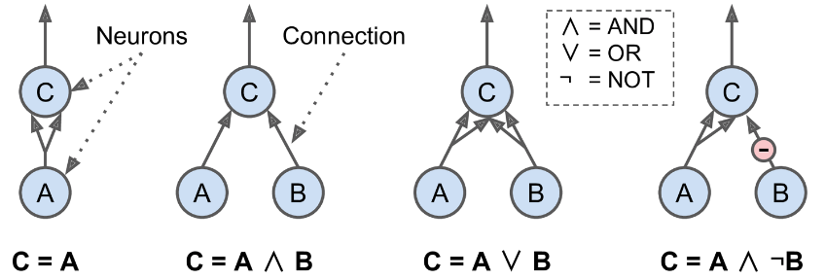

Figure 2-1. ANNs performing simple logical computations [3]

In the modern sense, the perceptron is an algorithm for learning a binary classifier called a threshold function: a function that maps its input x to an output value f(x). [5] A perceptron is a unit with weighted inputs that produces a binary output based on a threshold. An ANN node also sums weighted inputs, but instead of producing a binary output of 0 or 1 based on a threshold, it instead produces a graded value between 0 and 1 based on how close the input is to the desired category. The perceptron consists of 4 parts. One input layer, weights and bias, net sum, and activation function.

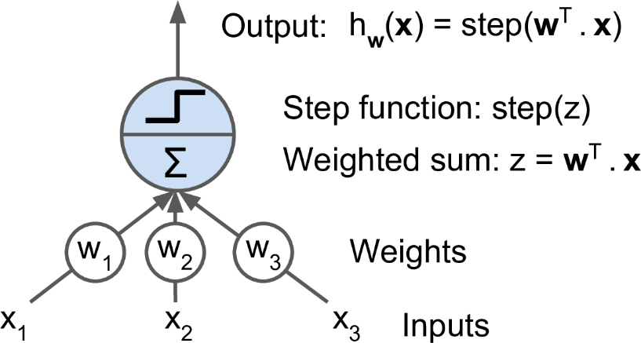
Figure 2-2. Linear threshold unit[3]

The operations of the Backpropagation neural networks can be divided into two steps: feedforward and backpropagation. [6] In the feedforward step, an input pattern is applied to the input layer and its effect propagates, layer by layer, through the network until the output is produced. The network's actual output value is then compared to the expected output, and an error signal is computed for each of the output nodes. Since all the hidden nodes have, to some degree, contributed to the errors evident in the output layer, the output error signals are transmitted backward from the output layer to each node in the hidden layer that immediately contributed to the output layer.

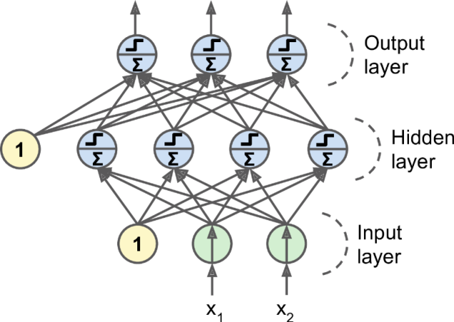

Figure 2-3. Multi-Layer Perceptron[3]

Once the error signal for each node has been determined, the errors are then used by the nodes to update the values for each connection weights until the network converges to a state that allows all the training patterns to be encoded. The Backpropagation algorithm looks for the minimum value of the error function in weight space using a technique called the delta rule or gradient descent [6]. The weights that minimize the error function is then considered to be a solution to the learning problem. The network behavior is analogous to a human that is shown a set of data and is asked to classify them into predefined classes. Like a human, it will come up with theories about how the samples fit into the classes.

Activation functions are mathematical calculations, which evaluate a neural network's results.[7] The function is applied to each neuron in the network and helps determine if it should be activated or not, based on whether the input of each neuron is relevant to the prediction of the model. Activation functions also help to normalize each neuron 's output to a range of between 1 and 0 or -1 to 1.
An additional feature of activation functions is that they must be computationally efficient, and for each data sample, they are measured through thousands or even millions of neurons.

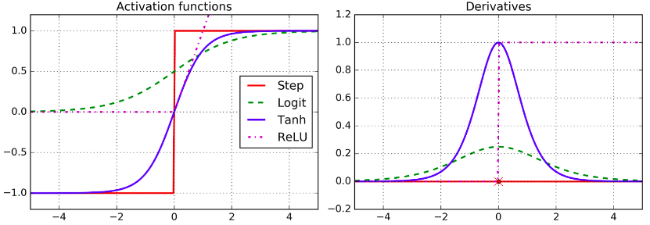

Figure 2-4. Activation functions and their derivatives[3]

The activation function applies a step rule (convert the numerical output into +1 or -1) to check if the output of the weighting function is greater than zero or not [5]. Step function gets triggered above a certain value of the neuron output; else it outputs zero. Sign Function outputs +1 or -1 depending on whether neuron output is greater than zero or not. Sigmoid is the S-curve and outputs a value between 0 and 1. If ∑w.x > 0, output is +1, else -1. The neuron gets triggered only when weighted input reaches a certain threshold value.

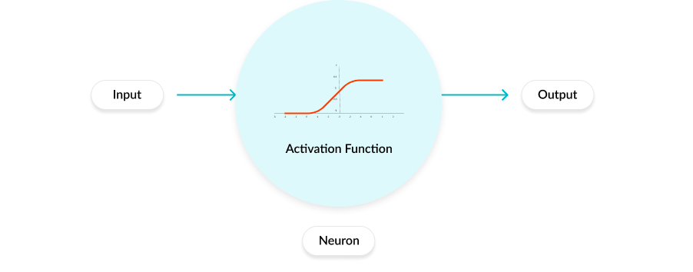
Figure 2-5. The role of activation function[8]

Q-LEARNING
There are plenty of ways of reinforcement learning[9]. One is q learning, this approach uses dynamic programming principles. Firstly we set random actions for states in the environment, this is called creating q-table. Q-table is a nested array that contains, actions on a specific state. Then we run our test on that table and get a Q value on every iteration. This q value calculated with an equation in Figure 2-6:

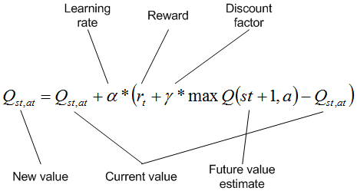
Figure 2-6: Deciding next Q-value on the table, according to the previous action that taken [10]

There is another way of q-learning, it’s called Deep Q-learning [9]. In deep learning, each level learns to transform its input data into a slightly more abstract and composite representation. In an agent training application, the raw input may be a matrix of actions; the first representational layer may abstract the action and encode states; the second layer may compose and encode arrangements of states; the third layer may encode an action on a state, and the fourth layer may predict a proper outcome that the action of the current state.

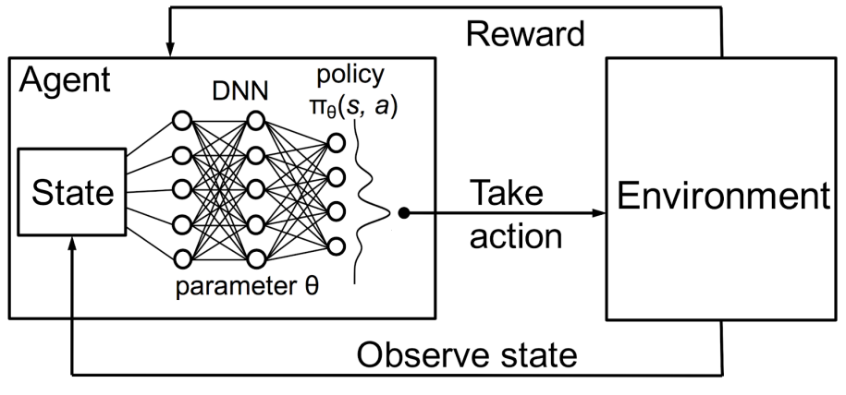
Figure 2-7: Reinforcement Learning using a neural network policy [11]

GYM ENVIRONMENT
The gym library gives us an agent and environments together. An agent is an artificial intelligence entity that has certain goals, must always remain watchful about things that can come in the way of these goals, and must, at the same time, pursue the things that help in attaining these goals. Because according to the actions of its environment the agent gets either prize or penalty.
According to the problem we give to the agent, the agent takes action. So, what decides this problem and action? The answer is the environment, the environment in the region available for the agent to navigate, and includes all the places the agent can go to, including the obstacles that the agent could crash in to. So the primary task of the agent is to explore the environment, understand how the actions it takes affect its rewards, be cognizant of the obstacles that can cause catastrophic crashes or failures, and then master the art of maximizing the goals and improving its performance over time.
Figure 2-8. shows the basic action taking the process of an agent according to its environment.

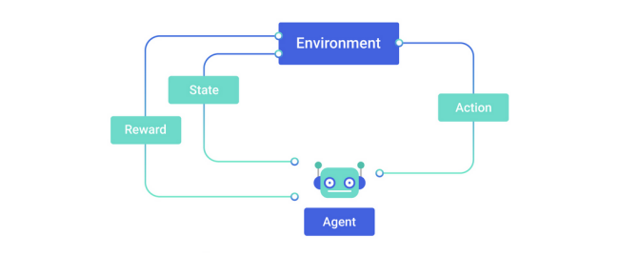

Figure 2-8: Agent decision diagram [12]

We said that the agent takes actions according to its environment, by the outcome of the previous action by meaning that the state(observation), reward, the agent does make these choices by the policy [9]. The policy is the algorithm that determines the action of the agent can use in the environment. we use DQN as a policy, that takes all observation as input and creates output and agent takes those outputs and decides the best action.

POLICY LEARNING
A policy defines the guidelines for an agent's behavior at a given state [9]. In mathematical terms, a policy is a mapping from a state of the agent to the action to be taken at that state. As a coder of the agent, we expect the best outcome from it, but the policy is not always deterministic, by mean that, it is possible that the policy takes only random actions, there is a chance policy does not observe the environment, it is called a stochastic policy. It is usually denoted as π(a_{t}|s_{t}) – that is, it is a conditional probability distribution of taking an action a_{t} in a given state s_{t}. Policies can be deterministic, wherein the exact value of a_{t} is known at s_{t}, or can be stochastic where a_{t} is sampled from a distribution – typically this is a Gaussian distribution, but it can also be any other probability distribution.
The other way of policies genetic algorithms. In this type of policies we run for example 100 agents in an episode at the same time and choice the best ones, let say there is 20 succeeded, in the next episode you create 4 offspring each of the successful agents for the next generation.

Q-LEARNING WITH NEURAL NETWORKS(DQN)
Reinforcement learning is an unsupervised learning technique, that is why first we should create data to process, this data is unlabeled and we come up with this data according to the conditions of our environments [9]. An environment limits the agent’s actions according to the problem, this problem might be driving a car, a walking person, etc. We could create our own environment by using different libraries but there is OpenAI Gym. The gym gives us plenty of problems with the environment itself, these problems are solved in an environment, each environment has its own action space, observation space, and state variables.

In the agent training, we will use the Keras Sequential model with layer Dense and Focused [9]. While running tests users can switch between Dense and Focused layers. Focused layer it’s a receptive field in the spatial domain inputs and by using the back-propagation algorithm to learn its focus parameters that control the receptive field locations and apertures, the action space of an environment can be too small. That is why we added a large size Dense layer before switch part of the model, in case of choosing Focused as a layer, so the Focused layer can work more efficient.

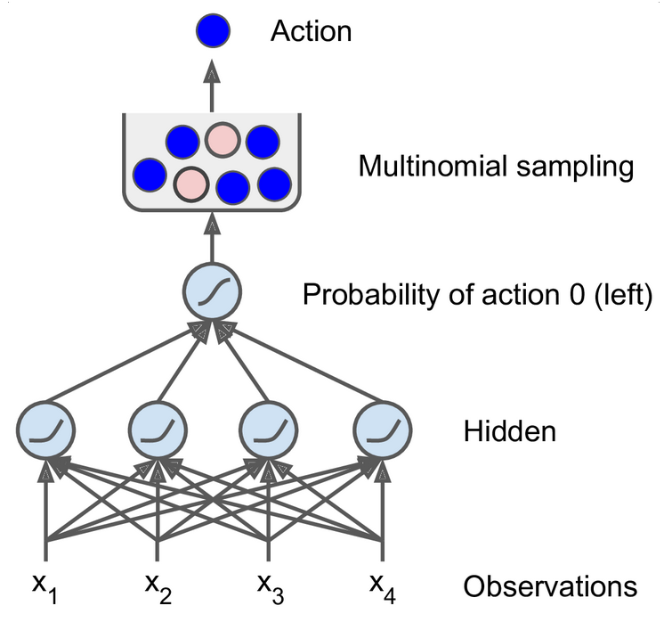

Figure 2-9: Neural network policy [9]

FIXED Q-VALUE
DQN has some variants, one is fixed q-value targeting. Deep Q Networks take as input the state of the environment and output a Q value for each possible action. The maximum Q value determines, which action the agent will perform. But the same weights apply to both the target and the predicted value. It is like making circles around the same path.

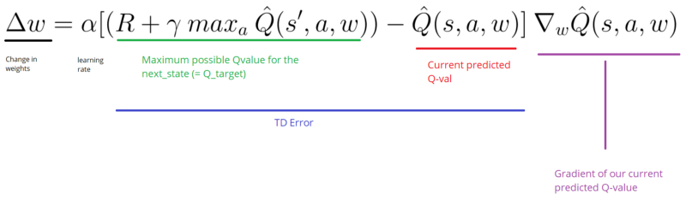

Figure 2-10: Calculating weight [13]

We move the output closer to the target, but we also move the target. So, we end up chasing the target and we get a highly oscillated training process. For overcoming this problem we use two models [9]. One is for the agent, the other is for the online working model. Instead of update the weight on each run, for example we calculate them on every 50 runs. This way we updated much less often the target model than the online model, as an outcome our Q-Value targets are more stable.

DOUBLE DQN
There is also a method called Double DQN [15]. In Double DQN the solution involves using two separate Q-value estimators, each of which is used to update the other. Using these independent estimators, we can unbiased Q-value estimates of the actions selected using the opposite estimator. We can thus avoid maximization bias by disentangling our updates from biased estimates. On the other hand, the Target network is responsible for the evaluation of that action.

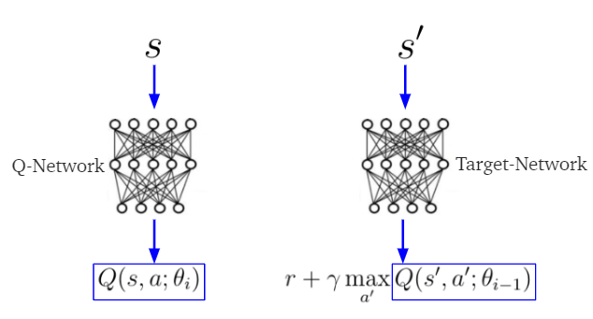
Figure 2-11: Double DQN [14]
Q-network selects the best action with the best Q-value of the next state [15]. Target Network calculates the estimated Q-value with action that selected. Update the Q-value of Deep Q Network based on the estimated Q-value from Target Network. Update the parameters of Target Network based on the parameters of Deep Q Network per several iterations. Update the parameters of Deep Q Network based on defined optimizer function.
chapter THREE
PROPOSED MeThod
The Focused layer implementation allows people to test the datasets by trained Focused layer. It trained faster than the Dense layer and comparable accuracy rate to Dense. Focusing neurons can generate unique connection maps for a problem. The new model uses no other tool than the back-propagation algorithm to learn its focus parameters which control the receptive field locations and apertures. So neurons can learn and adapts itself.
In this project, we replace the dense layers in deep q learning with focused neurons. For each environment observation space taken for input size and action space taken as output size.

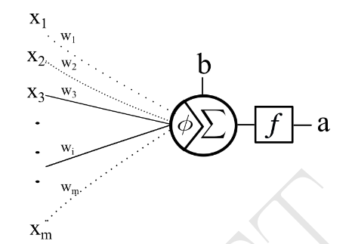
Figure 3-1: The focusing neuron model[1]

Here the focus attachment φ allows the neuron to change its receptive field and adjust the aperture size[1].

In our tests, we use three different gym-environment to create train-test data. we run both Focused layer and Dense layers and take several graphs, such as loss and accuracy, also create score graphs for each Focused layer, Dense runs, also search for a trend. While training the environments on building model block environments creates 10K to 130K dimensional data and we run 600 iterations for each, not all agents show ascending trend.
One way is playing with the functions defined(loss, activation functions) and changing neuron count for each layer, but it might drive you to an endless road because it’s like a BlackBox, you can not be sure the result and values you have given are right for each environment and agent. We will try to find out which parameters are best.
chapter FOUR
IMPLEMENTATION DETAILS
In this project, we replace the dense layers in deep q learning with focused neurons. We will construct deep q-networks of focusing neurons for the following problems:

- CartPole:
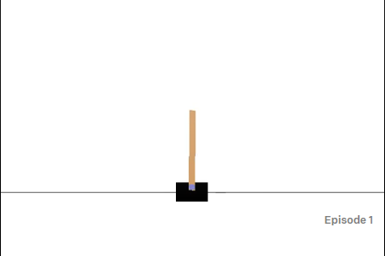
Figure 4-1: CartPole-v1[16]

A pole is attached by an un-actuated joint to a cart, which moves along a frictionless track[16]. The pendulum starts upright, and the goal is to prevent it from falling over by increasing and reducing the cart's velocity.
There are two actions taken, right and left moves, respect to these observation points is called Box() observation in the OpenAI Gym, and they are not discrete; Cart Position, Cart Velocity, Pole Angle, Pole Velocity At Tip

- Input(4)-Neuron(32)-Neuron(32)-Output layer(2)
- Acrobot:
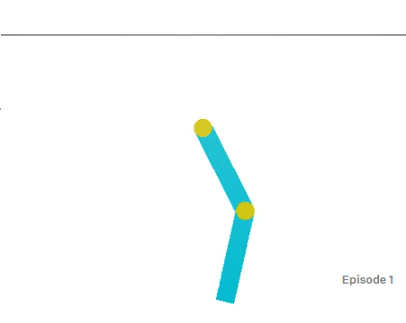
Figure 4-2: Acrobot-v1[17]

Acrobot is a 2-link pendulum with only the second joint actuated. Initially, both links point downwards[17]. The goal is to swing the end-effector at a height at least the length of one link above the base.
The observation space is a numpy array in this environment. State calculation, [cos(theta1) sin(theta1) cos(theta2) sin(theta2) thetaDot1 thetaDot2]
The action is either applying +1, 0 or -1 torque on the joint between the two pendulum links.

- Input(6)-Neuron(32)-Neuron(32)-Output layer(3)
- MountainCar:
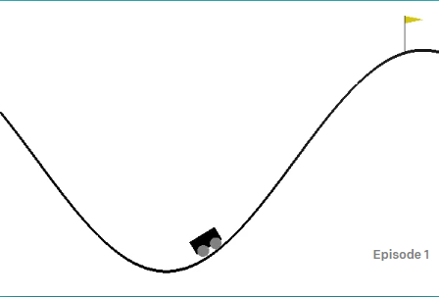
Figure 4-3: MountainCarContinuous-v0[18]
A car is on a one-dimensional track, positioned between two mountains. The goal is to drive up the mountain[18].
The observation space is a two dimensions that contains position and velocity.

The action space is push left, right, and no push. The action space is takes floating values between +1 and -1. It is not discrete so we need to discretize the action space to 10.

- Input(2)-Neuron(32)-Neuron(32)-Output layer(10)

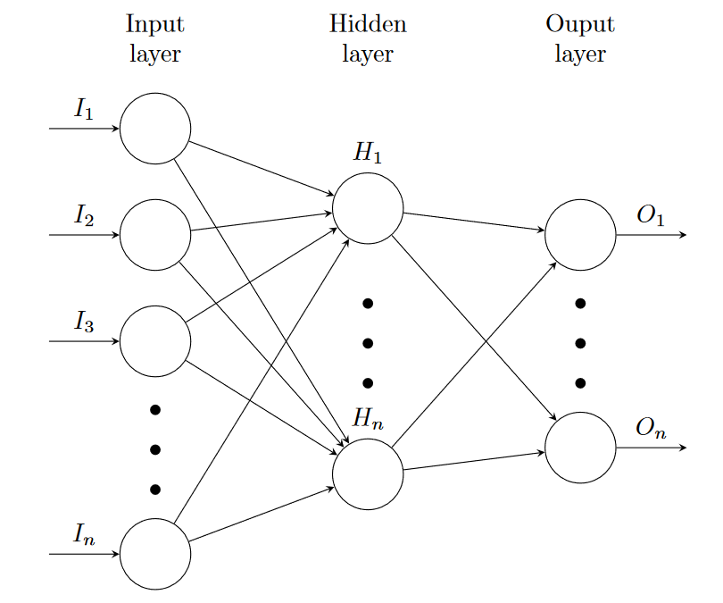
Figure 4-4: Neural network representation
For each environment observation space taken for input size and action space taken as output size.
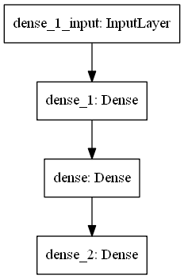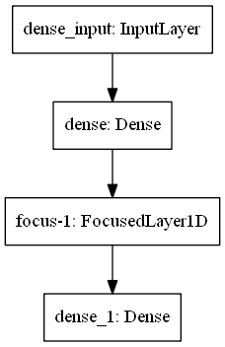
Figure 4-5: Neural network layers

chapter FIVE
TESTS, and EXPERIMENTS

In this part we will discuss the test results for each environment. As sigma value we use .25, .2, .1 and .05 to evaluate the results.

- CartPole:

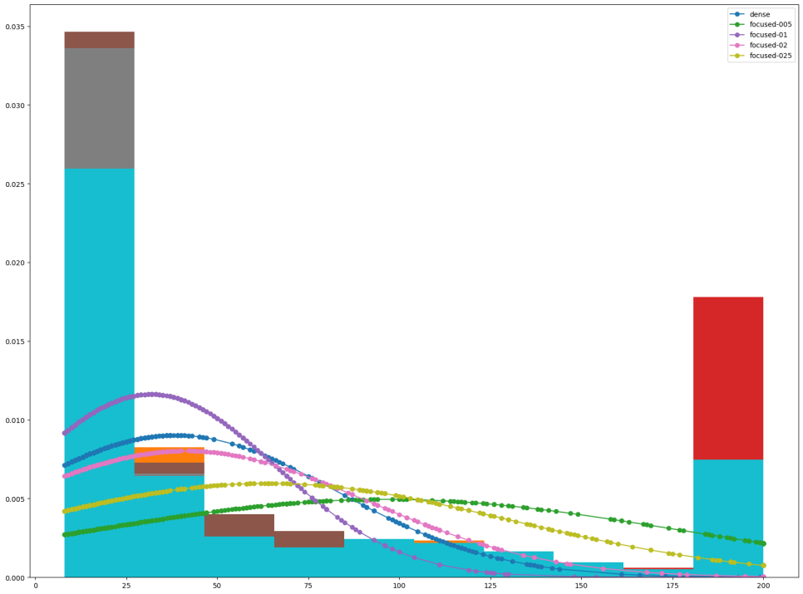
Figure 5-1: CartPole dense and focused score value distributions

In this representation we see the score distributions of the CartPole problem. Also we measure the score curve area to decide which sigma value is better for solving this problem.

- Area Under dense Curve 22990.0
- Area Under focused-0.05 Curve 57696.0
- Area Under focused-0.1 Curve 18919.0
- Area Under focused-0.2 Curve 24641.0
- Area Under focused-0.25 Curve 38196.0

According to this results we decided to sigma value .05 is better to solve this problem. Lets also see the score trend comparison with dense neuron of focused neuron with sigma .05.

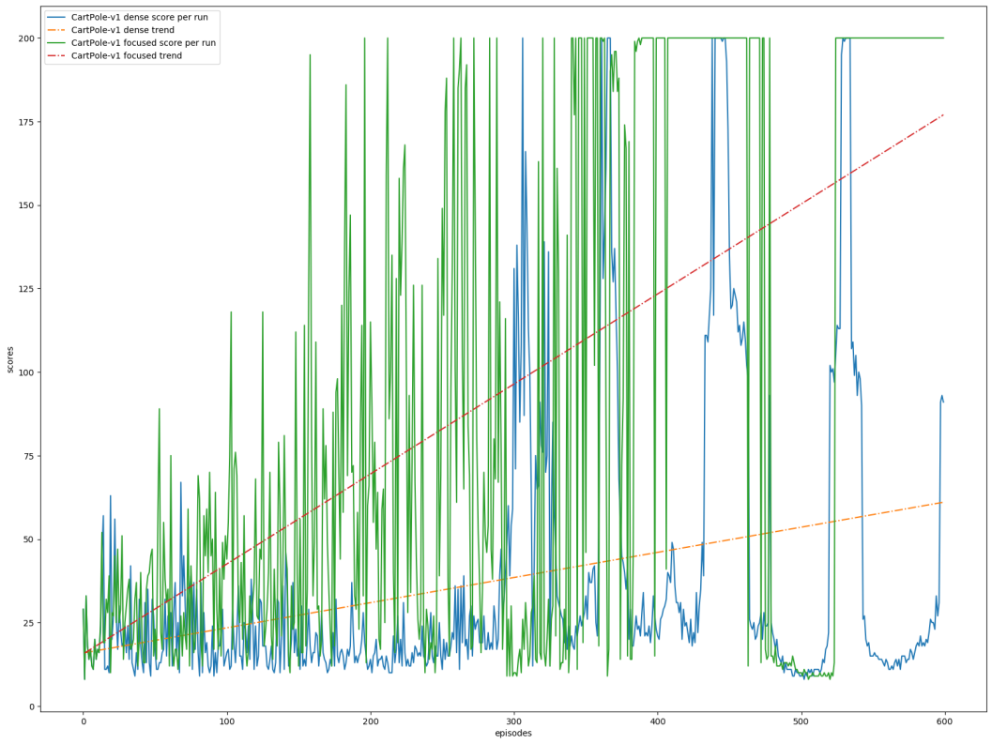
Figure 5-2: CartPole score trend of focused(sigma .05) and dense

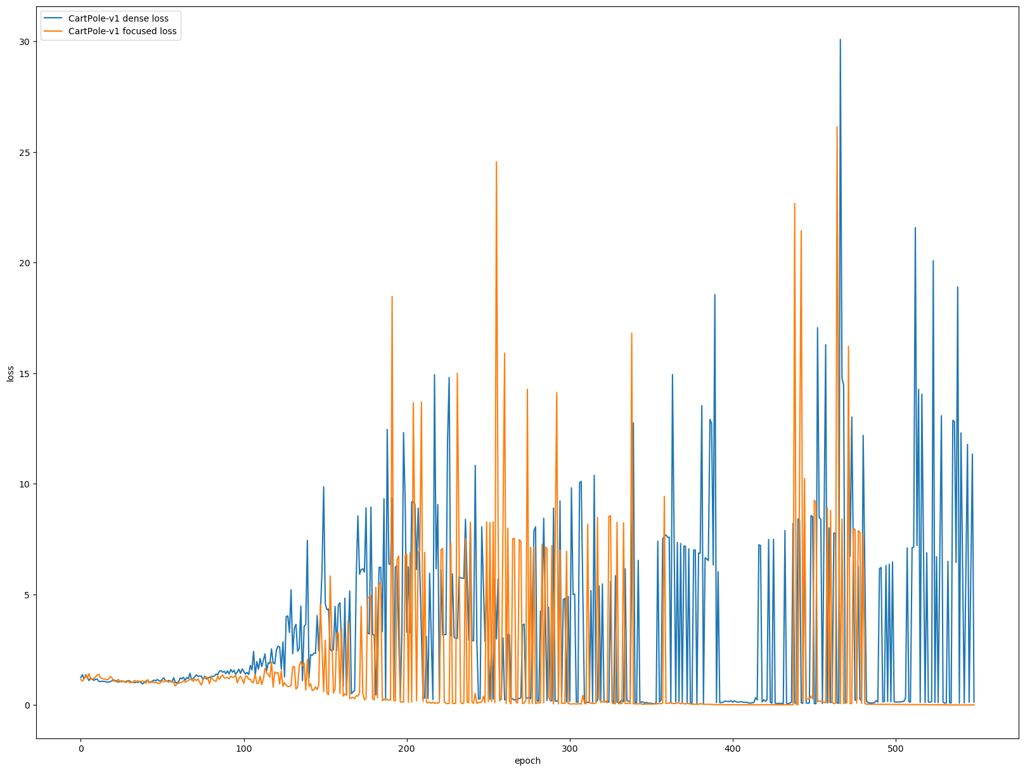

Figure 5-3: CartPole score trend of focused(sigma .05) and dense

- MountainCar:
Area Under dense Curve -8847.269245070718
Area Under focused-005 Curve -8969.718654453294
Area Under focused-01 Curve -7147.111283395016
Area Under focused-02 Curve -8194.177929543108
Area Under focused-025 Curve -9165.748260067994

loss areas of focused-01
Area of Dense: -8847.269245070718
Area of Focused: -7147.111283395016

ttest:
statistic: -11.151027489360999
pvalue: 1.5226142272798123e-27

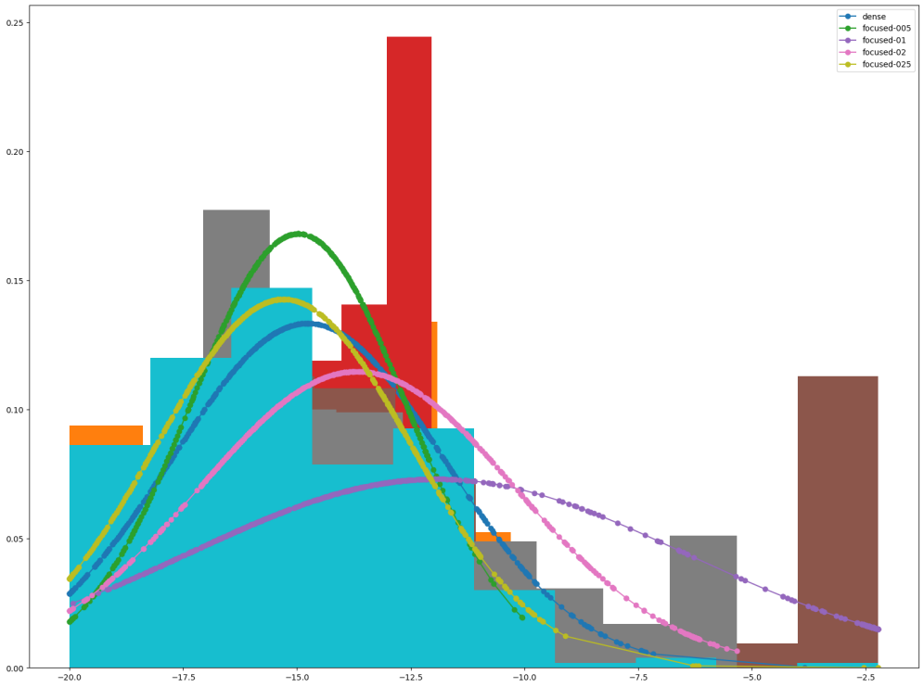

Figure 5-4: MountainCar dense and focused score value distributions

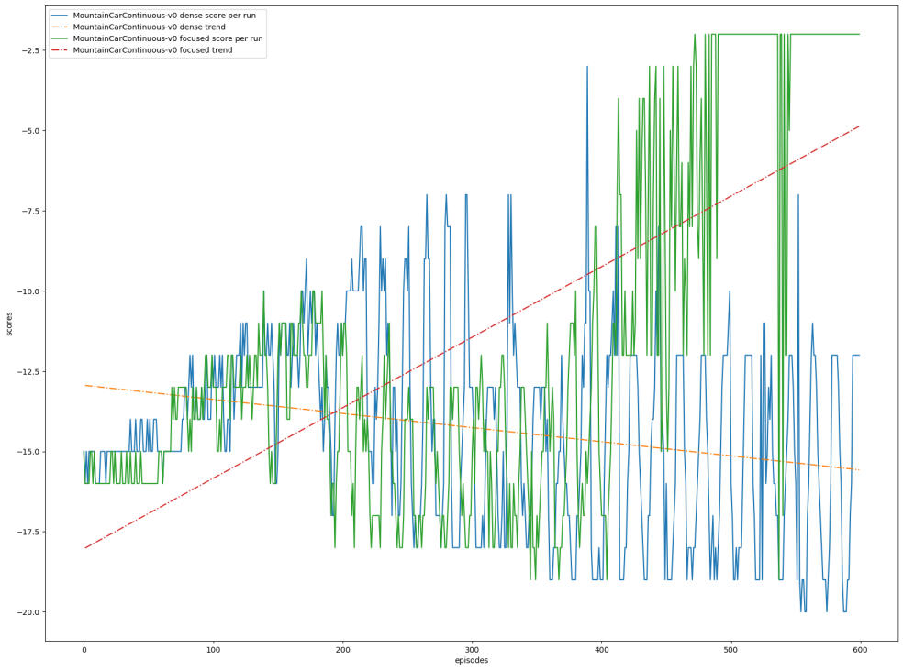

Figure 5-5: MountainCar score trend of focused(sigma .1) and dense
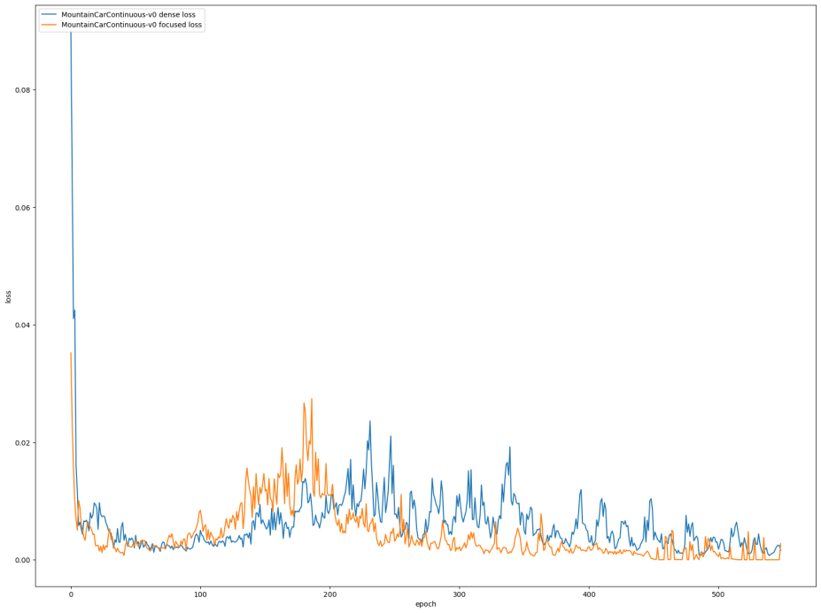

Figure 5-3: MountainCar score trend of focused(sigma .1) and dense

- Acrobot:
Area Under dense Curve -117293.5
Area Under focused-005 Curve -113961.0
Area Under focused-01 Curve -107789.0
Area Under focused-02 Curve -102255.0
Area Under focused-025 Curve -113158.0

loss areas of focused-02
Area of dense 614.7205757629126
Area of focused 815.2219126047567

ttest:
statistic: -13.277667545492406
pvalue: 1.2347315664584795e-37
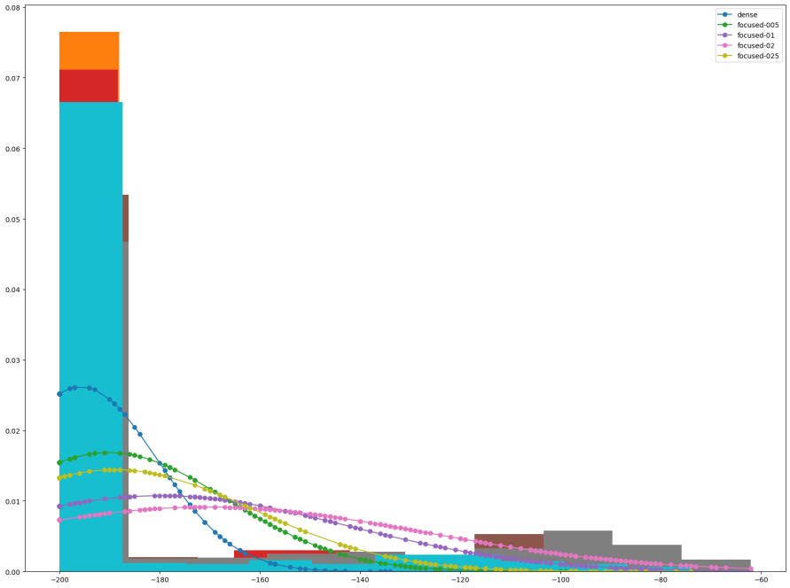
Figure 5-4: Acrobot dense and focused score value distributions
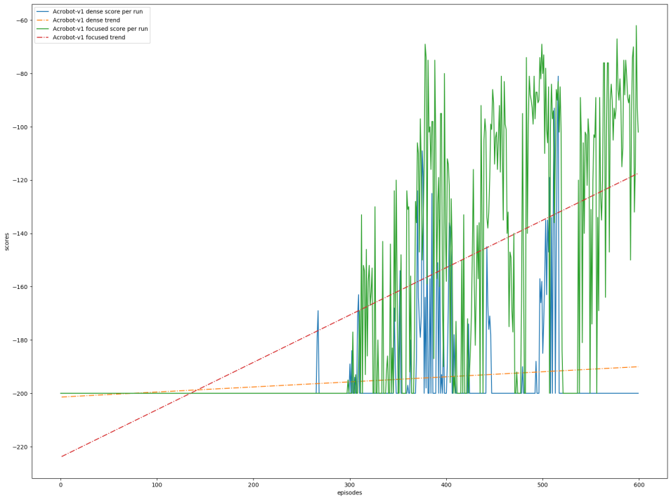
Figure 5-5: Acrobot score trend of focused(sigma .2) and dense

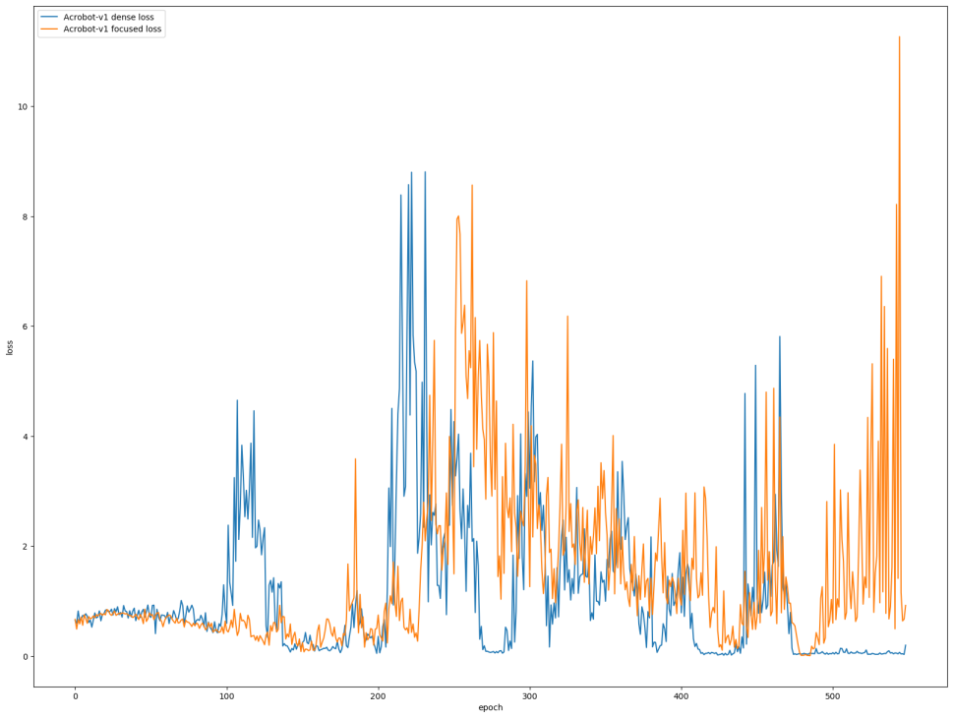
Figure 5-3: Acrobot score trend of focused(sigma .2) and dense

chapter SIX
conclusions and future work

REFERENCES
- Tek, F. Boray \An Adaptive Locally Connected Neuron Model: Focusing Neuron." ArXiv.org, 31 July 2019, https://arxiv.org/abs/1809.09533.
- Online:https://github.com/btekgit/FocusingNeuron-Keras, date accessed: Feb 2020
- Géron, Aurélien. “Neural Networks and Deep Learning.” Mar. 2018, https://learning.oreilly.com/library/view/neural-networks-and/9781492037354/.
- McCulloch, Warren S., and Walter Pitts. ”A logical calculus of the ideas immanent in nervous activity.” The bulletin of mathematical biophysics 5.4 (1943): 115-133.
- Rosenblatt, Frank. ”The perceptron: a probabilistic model for information storage and organization in the brain.” Psychological review 65.6 (1958): 386.
- VanderPlas, Jake. Python data science handbook: essential tools for working with data. ” O’Reilly Media, Inc.”, 2016.
- Farhadi, Farnoush. Learning Activation Functions in Deep Neural Networks, ProQuest Dissertations Publishing, 2017.
- Online:https://missinglink.ai/guides/neural-network-concepts/complete-guide-artificial-neural-networks/, date accessed: May, 2020
- Géron, Aurélien. Hands-on machine learning with Scikit-Learn and TensorFlow: concepts, tools, and techniques to build intelligent systems. " O'Reilly Media, Inc.", 2017.
- Online:https://www.ibm.com/developerworks/ssa/library/cc-reinforcement-learning-train-software-agent/index.html, date accessed: May 2020
- Online:https://ithelp.ithome.com.tw/articles/10228127, date accessed: May 2020
- Online:https://miro.medium.com/max/2000/1*BgOahnFLqAbYl4_eIUBTLg.jpeg, date accessed: May 2020
- Online:https://www.freecodecamp.org/news/improvements-in-deep-q-learning-dueling-double-dqn-prioritized-experience-replay-and-fixed-58b130cc5682/, date accessed: May 2020
- Online:https://devhunteryz.wordpress.com/2019/02/10/kendi-kendine-ogrenen-yz-ajanlari-bolum-ii-derin-q-ogrenme/amp/, date accessed: May 2020
- Hasselt, Hado van, Guez, Arthur, and Silver, David “Deep Reinforcement Learning with Double Q-learning.” ArXiv.org, 22 Sep 2015, https://arxiv.org/abs/1509.06461
- Online:https://gym.openai.com/envs/CartPole-v1/, date accessed: Jan 2020
- Online:https://gym.openai.com/envs/Acrobot-v1/, date accessed: Jan 2020
- Online:https://gym.openai.com/envs/MountainCarContinuous-v0/, date accessed: Jan 2020
Note that, every entry in above list, must be cross referenced in main text.

