**Introduction**

Trabzon is one of the big cities in the Turkey where 1 million people lives. As a resident of this beautiful city, I decided to use Trabzon in my project. The city divided into 18 districts in total.

As an investor, you will want to select a district that does not have your target business model enough so you can be the one of the first. Being one the first in a business can be a benefit.

That is why I wanted to cluster districts and then show the most popular venues in particular district. I will show the clusters on the map so it will be easy to read.

**Data** **Description**

I have used Foursquare API to get the most common venues of given district of Trabzon. Since there is no reliable source for coordinates of the cities, I had to hard code them. It was one of biggest issue of the project. Since I am a resident of Trabzon, I did not suffer on that part, but it would be a problem if I work on a city that I do not know.

**Methodology**

I used python folium library to visualize geographic details of Trabzon and its districts, and I created a map of Trabzon with districts places on it. I used latitude and longitude values to get the visual as below.

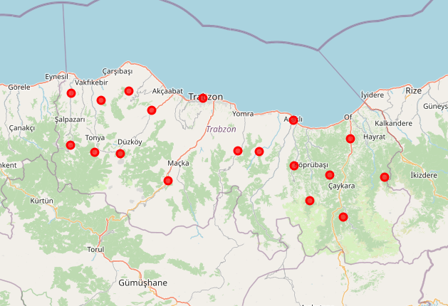

I used Foursquare API to explore the districts and segment them. Then I have used K-means algorithm to cluster my city. I selected 4 as K value. While clustering, I also printed Trabzon’s 1-5 most common venues. Here is the table after my implementations.

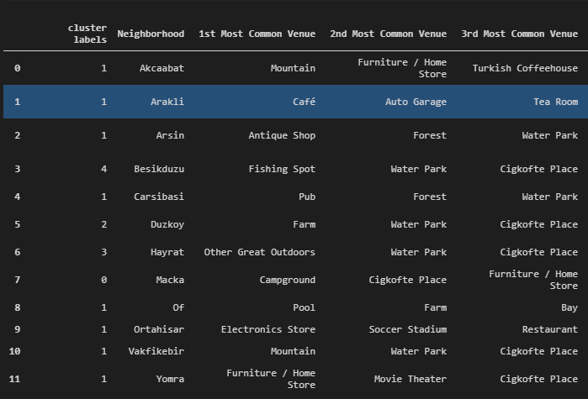

**Results**

After all coding and visualization work, I ended up with clustered city map and most common venues for each district. Any investor can take advantage of this study to decide about their possible investment. Also, city authorities use this city to manage their districts. 